Application of the Algorithm for Automated Search of the Minimum Coefficient of Stability of Earth Dam Slopes by the Method of Circular Cylindrical Sliding Surfaces
Shovkat Normatov^{1, a)} and Turajonov Kodirjon^{2, b)}
¹ Institute of Mechanics and Seismic Stability of Structures named after M.T. Urazbaev, Uzbekistan Academy of Sciences, Tashkent, Uzbekistan
^{a)} Corresponding author: shovkatnormatov871@gmail.com
^{b)} q.turajonov@gmail.com
Abstract. The article is devoted to calculating the stability of earth dam slopes using the circular cylindrical sliding surface method. In contrast to the conventional approach described in regulatory documents, the article proposes an alternative method for determining the center of the sliding circle, which allows for a more accurate assessment of the stability coefficient. The main attention is to find the minimum value of the stability coefficient, reached on the sliding surface. The article considers the theoretical foundations of the circular cylindrical sliding surface method, including the Coulomb limit equilibrium equation and proposes an algorithm for determining the most dangerous centers and radii of slip curves. A program for the automated calculation of slope stability was developed, which allows considering various geometric parameters of slopes and the inhomogeneity of the soil massif. The program was tested for several options of initial data, including various values of soil cohesion and the angle of internal friction. The calculation results showed that a decrease in soil cohesion and the angle of internal friction leads to a reduction in the stability coefficient.

INTRODUCTION
In the construction and operation of industrial, transport, and earth structures, the issue of slope stability of soil massifs arises. The stability of soil massifs is generally understood as their ability to withstand shear forces for a long time, maintaining their shape. The stable position of slopes is determined by the corresponding stress-strain state under force effects. At an unfavorable combination of various factors, the soil massif, bounded by slopes, can go into a non-equilibrium state and lose its stability. Most existing methods for calculating the slope stability of a soil massif were developed to obtain the slope stability coefficient. All calculation methods for assessing the degree of stability of slopes and sides are based on the application of the limit equilibrium theory, which considers the ultimate stress state of the soil massif.
The variety of mining-geological and technical conditions of the construction sitesof dams or the development of opencast mining has led to the creation of numerous methods (calculation schemes) for calculating slope stability. There are currently about 150 of them [3]. The variety of methods, techniques, and approaches to calculate slope stability has led to the need to classify them according to certain criteria. The main criterion in the classifications in [4-6] is the shape of the failure (slip) surface. According to this classification, four classes of methods for determining slope stability parameters are distinguished [5]:
a) constructing a contour of a slope, at all points of which the limit equilibrium condition is satisfied; in this case, a system of differential equilibrium equations is solved together with the limit state condition, the principles of which are given in [7];
b) constructing a contour of a slope, along which the condition of equality of the tangent inclination angle to the shear resistance angle is satisfied (the principles of this method are given in [8]);
c) constructing a sliding surface in the slope area, along which the limit equilibrium condition is satisfied (calculation methods of this class are the most numerous and are included in the KMK, they are based on the adoption of one or another form of the sliding surface in the calculation schemes: plane, circular cylindrical, in the form of a logarithmic spiral, complex curvilinear, broken, etc.);
d) constructing a sliding surface in the slope area, along which the special limit equilibrium condition is satisfied (for inhomogeneous and anisotropic media).

STATEMENT OF THE PROBLEM
In practice, a method for assessing the stability and seismic resistance of slopes of dams, embankments, quarry sides, etc. is widely used, which assumes the fulfillment of the limit equilibrium condition (ultimate stress state) along the inner boundary of a certain region of the near-slope zone of soil. The boundary of this region is considered the expected surface of failure (slip surface). The above methods are fundamentally based on solving the Coulomb limit equilibrium equation. The limit stress state, i.e. the limit equilibrium equation (Coulomb's law) has the following form [1-3]:
, ()
where σ, τ - are the normal and shear stresses acting on the areas of the sliding surface, C is the cohesion of the soil mass, φ is the angle of internal friction.
Calculation of the stability of slopes of dams, embankments, or quarry sides consists of determining the minimum stability coefficient for the adopted outline of the transverse profile of the soil mass and is performed for the largest unfavorable cross-sections of characteristic areas of the massifs. Currently, when designing earth dams and developing quarries, the slope stability is calculated using the method based on circular cylindrical sliding surfaces (CCSS). Swedish engineers Peterson and Gultin, based on studies of clay soil collapse, proposed this method in 1916. KMK recommended calculating slope stability using the circular cylindrical sliding surface methods (the method proposed by VODGEO Research Institute); it consists of finding such radii and positions of the centers of the slip curves at which the stability coefficient will be the lowest. There are various approaches and methods for determining the geometric center of the CCSS [9-15]. The simplest and most widely used methods are given in [9-15]: the dam’s calculation is made for several points of the centers of the slip curves, selected in the so-called area of the centers of the most dangerous curves (Figure 1). This area is located between two straight lines reconstructed from the center of the slope at an angle of 85º and perpendicular to the dam base. Between these lines, two circular arcs are drawn from the center of the slope with radii depending on the size of the slopes and the height of the dam.
Several center points are taken in this area, successively approaching the most dangerous area. From each point, a sliding circle is drawn with such a radius that it passes through the dam crest and captures part of the base to a depth of H/2, H - is the dam’s height. Within the sliding curve, the slope and the base of the dam are divided into several sections (columns) of the same width, depending on the radius of the sliding curve. The midline of the initial section (column) is on the vertical line, dropped from the center of the sliding curve. The numbering of the middle lines above the slope is positive, and below the slope, it is negative. The initial midline has number "0" (Figure 2).
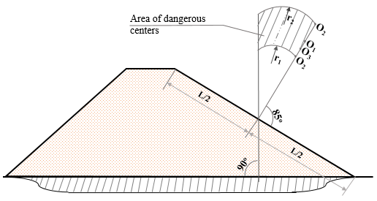
FIGURE 1. Scheme for determining the area of dangerous centers of the CCSS
For each section, the weight of the section and all forces acting on the section are determined. The angle α between the vertical line dropped from the center of the sliding curve and the line drawn from this center to the center of the base of each section is determined by the sine of the angle: sin α = bn/R, - is the serial number of the section, b - is the width of the section, R - is the radius of the CCSS.
The stability coefficient is calculated by the following formula:
, ()
where - is the sum of all retaining forces, - is the sum of all shear forces [9].
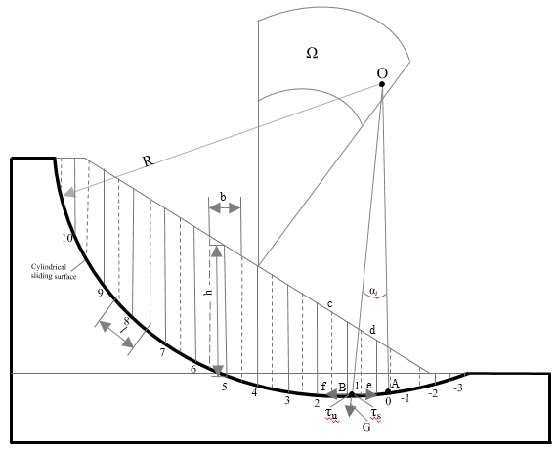
FIGURE 2. Slope stability calculation scheme using the CCSS method
Slope stability testing in [10] and other publications is reduced to determining the stability coefficient, equal (excluding lateral pressure forces) to the ratio of the moment of the retaining forces (friction and cohesion) to the moment of the shear forces:
. ()
The stability coefficients determined through (2) and (3), are practically equivalent. At the ultimate stress state of the soil massif, formula (3), proposed by K. Terzaghi [9], takes the following form:
, ()
where - is the ultimate value of the shear stress, determined using the ultimate stress state (1); is the shear stress acting along the expected collapse curve (surface). With (1), the stability coefficient using the Terzaghi method has the following form [9, 12-14]:
. ()
Based on the analysis of the methods for calculating the stability of soil structures, the following can be stated:
a) the stability of slopes of earth dams, hills, and quarry sides in engineering calculations is determined mainly by the CCSS method. In this method, sliding surfaces are pre-set based on the results of long-term field observations of landslide, slope, and quarry side collapses;
b) circular cylindrical sliding surfaces (failure surfaces) can be considered the most justified surfaces along which loss of stability of slopes and quarry sides occurs; this is confirmed by the results of field observations over the past hundred years;
c) calculation formulas using the CCSS method are the simplest and most convenient for determining soil strength coefficient and slope stability. Another advantage of these formulas is that they use the main strength indicators of soils - cohesion and the angle of internal friction, which are known and present the main characteristics of the rock massif.
The method for the CCSS calculation includes two procedures:
a) determining the most dangerous centers of the CCSS;
b) finding the dangerous radii of the CCSS.
After this, the slope stability of the soil massif is assessed. As noted above, there are many ways to determine the center of the CCSS. The most accurate definition of the center of the CCSS is given in [12]: an expected area of dangerous centers is divided into grids and the stability coefficient is calculated for the nodal points. Then, based on the determined values of the stability coefficient, an isoline of these values is plotted.
In the methods given in [12] and other publications by foreign researchers, the radius of the CCSS practically does not vary and is considered equal to the minimum segment from the center of the CCSS to the base, i.e. it is considered that the CCSS passes through the intersection point of the slope and the base (for identical or the most stable bases, such a statement is considered true) [12-14]. However, for engineering practice, such an approach requires knowledge of mathematical disciplines and the intervention of intermediate works, which is unacceptable for engineers and designers.
Thus, from the analysis of the methods for calculating the stability and strength of slopes of soil massifs, it follows that there is no single approach to determining the expected center and radius of the CCSS.
We propose one of the methods for determining the center and radius of the CCSS and the slope stability coefficient (Appendix A). For this, an algorithm was created and a program for calculating the stability of the slope of a soil massif was compiled. In addition to the mechanical and strength characteristics of the massif, the geometric data of the slope massif are specified as initial data (Figure 5): the initial coordinate is attached to the slope intersection with the base; coordinates of the slope top are x_{A},y_{A} (point A); the area of the sought-for dangerous centers of the CCSS – left part (x-coordinate of point B) x_{B}≈5÷10·x_{A} and upper part (y-coordinate of point C) y_{C}≈5÷10·y_{A}, to determine the radius of the CCSS - x-coordinate of point а x_{a}≈1,1÷1,5·x_{A}. The area of the expected center of the CCSS (area OABC in Figure 3) is divided into N_{x} and N_{y} subareas (grids). For each node of this grid, varying the values of the radius of the CCSS from R_{a} to the smallest (equal to the value of the distance from the center to the slope), the stability coefficient is calculated using formula (2), and the radius at which the smallest value of the coefficient is observed is determined. Next, from all the nodes, using the values of the stability coefficient, we find the center of the CCSS. The created program prints out ten such centers (coordinates of the centers), the corresponding radii of the CCSS, and the values of the stability coefficient.

NUMERICAL RESULTS AND THEIR ANALYSIS
It should be noted that by taking sufficiently large values for N_{x} and N_{y}, it is possible to determine with the necessary accuracy the sought-for center and radius of the CCSS. The calculation program was modified for the sequential determination of the center and radius of the CCSS: based on the 10 center values found, a new area of sought-for centers is automatically compiled, including these centers, and then the search for the next - new - centers and radii of the CCSS is repeated. Calculations have shown that 2-3 stages of such calculations are sufficient for the optimal determination of the center and radius.
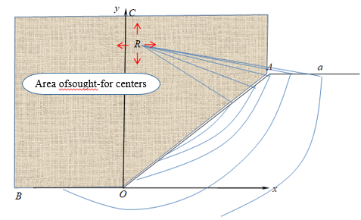
FIGURE 3. Scheme for specifying the initial geometric data
Note, that the program is designed so that it is possible to specify a different profile of the slope (two-, three- or multi-stage, input in the form of a function) and consider the inhomogeneity of soil.
The performance of the compiled program was verified by assessing the stability of the soil slope using the Terzaghi method, i.e., formula (5). The calculations were conducted for different options of the initial data (see Table 1).
TABLE 1. Calculation options
Options | Density, ρ, kg/m³ | Cohesion, C, kPa | Cohesion, C, kPa, tgφ | Dam height, H, m | Slope, | (K_{ust})_{min}
1 | 2600 | 30 | 0.56 | 160 | 1.1 | 1.779
2 | 2600 | 20 | 0.56 | 160 | 1.1 | 1.6623
3 | 2600 | 40 | 0.56 | 160 | 1.1 | 1.8830
4 | 2600 | 50 | 0.56 | 160 | 1.1 | 1.9791
5 | 2600 | 30 | 0.42 | 160 | 1.1 | 1.4123
6 | 2600 | 30 | 0.36 | 160 | 1.1 | 1.2522
The result of the first calculation option is given in Table 2. The most unfavorable surface of possible collapse is shown in Figure 4. As seen from the calculation results of this option, the value of the stability coefficient is 1.779, i.e. the slope is quite stable.
TABLE 2. Results of the first calculation option
K_{ust} | Radius, m | Coordinates of the center of the CCSS |  | Boundaries of expected sliding
K_{ust} | Radius, m | R_{x}, m | R_{y}, m | X_{left} ,m | X_{right} ,m
1.3222 | 531.1725 | -30.4416 | 530.6918 | 0.9304 | 357.6291
1.3223 | 535.4221 | -30.4416 | 535.0464 | 1.1621 | 359.3709
1.3223 | 526.9304 | -30.4416 | 526.3373 | 0.6809 | 355.8873
1.3223 | 549.0514 | -37.6992 | 548.1101 | 0.8637 | 358.5000
1.3223 | 553.3264 | -37.6992 | 552.4646 | 1.0322 | 360.2418
1.3224 | 513.3906 | -23.1840 | 513.2736 | 0.9374 | 356.7582
1.3224 | 544.7833 | -37.6992 | 543.7555 | 0.6785 | 356.7582
1.3224 | 517.6123 | -23.1840 | 517.6282 | 1.2335 | 358.5000
1.3224 | 522.4823 | -23.1840 | 521.9827 | 0.0346 | 361.1127
1.3224 | 509.1771 | -23.1840 | 508.9190 | 0.6225 | 355.0164
FIGURE 4. - Profile of the surface of expected collapse
The subsequent results of the calculation options are given in Tables 3-5.
TABLE 3. Calculation results. Option 2
K_{ust} | Radius, m | Coordinates of the center of the CCSS |  | Boundaries of expected sliding
K_{ust} | Radius, m | R_{x}, m | R_{y}, m | X_{left} ,m |  | X_{right} ,m
1.2844 | 574.6578 | -51.1840 | 572.3827 | 0.0227 |  | 357.1127
1.2844 | 587.7944 | -58.4416 | 585.4464 | 1.4902 |  | 355.3709
1.2844 | 583.4785 | -58.4416 | 581.0918 | 1.4482 |  | 353.6291
1.2845 | 569.7386 | -51.1840 | 568.0282 | 1.5276 |  | 354.5000
1.2845 | 601.5865 | -65.6992 | 598.5101 | 1.4145 |  | 354.5000
1.2845 | 605.9220 | -65.6992 | 602.8646 | 1.3928 |  | 356.2418
1.2845 | 592.1161 | -58.4416 | 589.8010 | 1.5178 |  | 357.1127
1.2846 | 574.0394 | -51.1840 | 572.3827 | 1.6188 |  | 356.2418
1.2846 | 610.2628 | -65.6992 | 607.2192 | 1.3579 |  | 357.9836
1.2847 | 619.7616 | -72.9568 | 615.9283 | 1.3205 |  | 355.3709
TABLE 4. Calculation results. Option 3
K_{ust} | Radius, m | Coordinates of the center of the CCSS |  | Boundaries of expected sliding
K_{ust} | Radius, m | R_{x}, m | R_{y}, m | X_{left} ,m | X_{right} ,m
1.3564 | 476.5766 | -2.4416 | 476.5824 | 0.0253 | 360.7418
1.3564 | 493.4602 | -9.6992 | 494.0006 | 1.3853 | 360.7418
1.3565 | 506.9159 | -16.9568 | 507.0643 | 0.9698 | 359.8709
1.3565 | 489.2804 | -9.6992 | 489.6461 | 1.0059 | 359.0000
1.3566 | 485.1099 | -9.6992 | 485.2915 | 0.6064 | 357.2582
1.3566 | 502.7127 | -16.9568 | 502.7098 | 0.6354 | 358.1291
1.3568 | 511.1276 | -16.9568 | 511.4189 | 1.2852 | 361.6127
1.3568 | 475.9133 | -2.4416 | 476.5824 | 1.4267 | 359.8709
1.3568 | 471.7688 | -2.4416 | 472.2278 | 0.9822 | 358.1291
1.3569 | 480.9490 | -9.6992 | 480.9370 | 0.1866 | 355.5164
TABLE 5. Calculation results. Option 4
K_{ust} | Radius, m | Coordinates of the center of the CCSS |  | Boundaries of expected sliding
K_{ust} | Radius, m | R_{x}, m | R_{y}, m | X_{left} ,m | X_{right} ,m
1.3882 | 460.7122 | 5.9360 | 460.8307 | 0.3182 | 361.6127
1.3883 | 478.1304 | -1.3216 | 478.2490 | 0.2524 | 362.4836
1.3885 | 460.0402 | 5.9360 | 460.8307 | 1.6877 | 360.7418
1.3886 | 473.3196 | -1.3216 | 473.8944 | 1.2117 | 359.8709
1.3887 | 455.9306 | 5.9360 | 456.4762 | 1.1882 | 359.0000
1.3888 | 477.4681 | -1.3216 | 478.2490 | 1.6461 | 361.6127
1.3888 | 495.6819 | -8.5792 | 495.6672 | 0.1288 | 363.3546
1.3889 | 464.8302 | 5.9360 | 465.1853 | 0.7989 | 363.3546
1.3889 | 490.8453 | -8.5792 | 491.3126 | 1.1756 | 360.7418
1.3889 | 469.1813 | -1.3216 | 469.5398 | 0.7566 | 358.1291
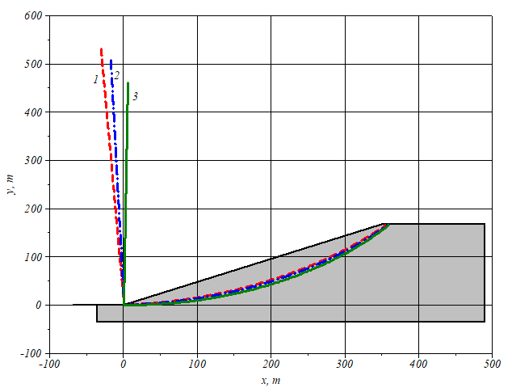
FIGURE 5. - Centers and radii of the CCSS for options 2-4 (curves 1-3, respectively)
As seen from the option in Table 2, the calculations were performed for the dam geometry. In the initial data, the values of soil cohesion and the tangent of the angle of internal friction varied. From the results of the dam slope stability assessment, it can be concluded that a decrease in soil cohesion leads to a decrease in the value of the stability coefficient (options 1-4); a decrease in the tangent of the angle of internal friction also leads to this conclusion. For options 1-4, the centers and radii of the CCSS and their locations are shown in Figure 5.
Note that the presented results do not claim to be a complete study of the dam slope stability, but only show the operability of the developed methodology and calculation program.

CONCLUSION
The use of a large number of calculation methods in engineering practice for assessing the stability of soil massifs indicates the complexity of the problem and the incompleteness of the process of finding a solution that would satisfy researchers and designers.
Determining the most dangerous circular-cylindrical sliding surface using existing methods using a selected area does not guarantee finding the minimum value of the stability coefficient, since several local minima may exist in other areas.
The diversity of interpretations of the stability coefficient indicates that it provides only a relative assessment of stability, revealing a measure of stability within the framework of the calculation assumptions of the applied method; therefore, developing a universal method for quantitative assessment of stability remains an unsolved problem.
A method for determining the center and radius of the CCSS was developed and implemented on a computer. By comparing the results obtained with those from other methods, the advantage of the approach and the area providing the minimum stability coefficient, lying outside the selected area when using conventional techniques, are shown.
Based on the above, the following conclusions can be drawn.
The method of circular cylindrical sliding surfaces is an effective tool for assessing the stability of slopes, especially under inhomogeneous soil conditions.
The proposed algorithm and program allow for more accurate determination of dangerous sliding surfaces and minimization of the stability coefficient. The calculation results confirm that the method of circular cylindrical sliding surfaces can be successfully applied to analyze the stability of earth dams and other engineering structures.

Acknowledgments
This study was made possible thanks to budgetary funding from the M.T. Urazbaev Institute of Mechanics and Earthquake Resistance of Structures of the Academy of Sciences of the Republic of Uzbekistan. We express our sincere gratitude to the Academy for its ongoing support and contribution to the advancement of scientific research.

references
- K. Terzaghi, Theoretical Soil Mechanics (John Wiley & Sons, Inc., New York, 2001), pp. 321–325.
- H. Lin, W. Zhong, W. Xiong and W. Tang, “Slope Stability Analysis Using Limit Equilibrium Method in Nonlinear Criterion,” Sci. World J. 4, 1–7 (2014).
- M. Usarov, G. Ayubov, D. Usarov and G. Mamatisaev, “Spatial Vibrations of High-Rise Buildings Using a Plate Model,” in Lecture Notes in Civil Engineering, edited by N. Vatin et al. (Springer, 2022), pp. 403–418.
- M. Usarov, G. Mamatisaev, G. Ayubov, D. Usarov and D. Khodzhaev, “Dynamic calculation of boxed design of buildings,” in IOP Conference Series: Materials Science and Engineering 883(1), edited by T. Sultonov et al. (Published under licence by IOP Publishing Ltd, 2020), 012186.
- M. Usarov, G. Mamatisaev and D. Usarov, “Calculation of compelled fluctuations of panel buildings,” in E3S Web Conf: Construction Mechanics, Hydraulics and Water Resources Engineering 365(4), edited by D. Bazarov et al. (E3S Web Conf IV International Scientific Conference,2023) (02002).
- M. Usarov, D. Usarov and G. Mamatisaev, “Calculation of a Spatial Model of a Box-Type Structure in the LIRA Design System Using the Finite Difference Method,” in E3S Web Conf: Construction Mechanics, Hydraulics and Water Resources Engineering, 403(2), edited by A. Manakov et al. (International Scientific Siberian Transport Forum TransSiberia, 2022), 1267–1275.
- B. Khusanov and O. Khaydarova, “Stress-strain state of earth dam under harmonic effect,” in E3S Web Conf: Hydrotechnical Construction and Melioration 97(7), edited by A.Volkov et al. (XXII International Scientific Conference “Construction the Formation of Living Environment” (FORM-2019)), (05043).
- Khusanov Bakhtiyar, and Rikhsieva Barno, “Numeric Simulation of Subsidence of Loess Soil under Wetting in a Limited Area,” J. Adv. Res. Fluid Mech. Therm. Sci. 104(2), 1–18 (2023).
- K. Sultanov, and S. Umarkhonov, “Dynamic behavior of earth dams under short-term semi-harmonic loads,” in E3S Web Conf: Environmental Protection Engineering 420(1), edited by Kokoreva J et al. (E3S Web Conf EBWFF 2023 - International Scientific Conference, 2023) (07014).
- J.M. Duncan, “Factors of Safety and Reliability in Geotechnical Engineering,” J. Geotech. Geoenvironmental Eng. 126(4), 307–316 (2000).
- N.R. Morgenstern, and V.E. Price, “The Analysis of the Stability of General Slip Surfaces,” J. Géotechnique 15(1), 79–93 (1965).
- N. Barton, and S. Bandis, “Review of predictive capabilities of JRC-JCS model in engineering practice,” Int. J. Rock Mech. Min. Sci. Geomech. Abstr. 28(4), A209 (1991).
- Z. Zhang, C. Chang, and Z. Zhao, J. Adv. Civ. Eng. 2020(1), 2-8 (2020).
- K. Bakhtiyar, N. Shovkat, and K. Ozodaxon, “On one method for assessing the soil slopes stability,” in AIP Conf. Proc: International Conference on Actual Problems of Applied Mechanics edited by Khayrulla Khudoynazarov et al. (AIP Conf. Proc: -2021), 030012.
- K. Sultanov, S. Umarkhonov, and S. Normatov, “Calculation of earth dam strain under seismic impacts,” in AIP Conf. Proc: International Conference on Actual Problems of Applied Mechanics, edited by Kh. Khudoynazarov et al. (International Conference on Actual Problems of Applied Mechanics - APAM-2021), 030008.

