Experimental Studies of a Rational Option for Seismic Reinforcement of a Reinforced Concrete Frame of a
Multi-Story Frame Building
Anvar Yuvmitov ^{1, a)}, Khamidulla Sagdiev ^{1, b)}, Salimjon Toshpulatov^{1, c)},
Zukhriddin Sobirov^{1, d)}, Dilmurod Akhundjanov^{1, e)} and Sukhrob Bozorkulov ^{2, f)}
¹Institute of Mechanics and Seismic Stability of Structures named after M.T.Urazbaev, Uzbekistan Academy of Sciences, 100125, Tashkent, Dormon yuli, 40, Uzbekistan
²Tashkent University of Architecture and Civil Engineering, 100011, Tashkent, Yangishakhar Street, 9a, Uzbekistan
^{a)} Corresponding author: anvar.sayfullaevich@mail.ru
^{b)} khamidullasagdiev@gmail.com
^{c)} toshpolatovsalimjon@gmail.com
^{d)} zuxriddinsobirov77@gmail.com
^{e)} dilmurod.88@mail.ru
^{f)} cssukhrob@gmail.com
Abstract. Given that the main territory of the Republic of Uzbekistan is seismically hazardous, large-scale measures are being taken to improve and ensure the seismic resistance of buildings and structures. One of the leading areas of research is theoretical and experimental studies in the field of seismology and seismic resistance of buildings and structures. Currently, in the construction practice of developed countries, there are several methods for anti-seismic reinforcement of load-bearing structures of buildings and structures, but the degree of their influence on the seismic resistance of buildings has not been sufficiently studied experimentally. In view of the above, this article considers the urgent task of developing new reinforcement methods and structural solutions for seismic protection systems that are cost-effective, structurally acceptable, technologically simple to use, and capable of increasing the service life of the reinforced structure by several years.

Introduction
Recently, the development of the earthquake-resistant construction industry has been carried out not only by improving methods for calculating the earthquake resistance of buildings and structures, but also by using modern devices that absorb the energy of seismic forces. In this direction, various devices have been developed based on the calculation method of seismic analysis of buildings and structures using devices with nonlinear properties [1-3].
In addition, in recent decades, so-called "active" methods of seismic protection have been increasingly used in modern earthquake-resistant construction. Unlike the "passive" method, which consists of strengthening the building structure, the "active" method of seismic protection is aimed at reducing seismic loads on structures through the use of special structural devices, such as disconnectable connections, sliding belts, kinematic foundations, vibration dampers, etc.
At the same time, the quality of the design of buildings and structures using special seismic protection systems significantly depends on the determination of the amplitude-frequency characteristics, dynamic characteristics of the system, and dynamic behavior of buildings and structures under wave-like foundation movements and earthquakes of varying intensity. The main goal is to provide for various seismic protection measures for buildings and structures that contribute to reducing seismic loads [4-6].

Materials, methods and objects
The consequences of strong earthquakes have revealed the behavior and vulnerability of load-bearing structures in various building systems. Analysis of the consequences of strong catastrophic earthquakes has shown that frame structures are vulnerable to strong earthquakes [7-8]. As a result of strong earthquakes that have occurred around the world, damage and destruction have occurred in the load-bearing structures of frame buildings. Analysis of the damage caused by strong earthquakes has revealed serious damage to buildings with reinforced concrete frames compared to other structural systems. In the structures of multi-story reinforced concrete frame buildings, along with cracks and plastic deformations, cases of collapse were mainly observed. The analysis showed that the degree of damage to structures depends on the intensity of the earthquake, the building structure, the quality of building materials, construction technology, operating conditions, and a number of other factors. During an earthquake, reinforced concrete structures of frame buildings can be subjected to various types of damage, including cracks and destruction at the joints of vertical and horizontal load-bearing structures, as a result of insufficient strength and weak reinforcement of columns and beams, etc. [9-10].
In view of the above, research institutes around the world are conducting extensive experimental and theoretical studies on the seismic reinforcement of reinforced concrete structures using modern seismic protection [11-12] devices.
The calculation of reinforced concrete structures taking into account various types of reinforcement, as well as the use of seismic protection devices for buildings and structures during seismic impacts, have been sufficiently developed and widely implemented in the field of earthquake-resistant construction [13-14].
This article presents the results of experimental studies on the reinforcement of reinforced concrete frames using modern existing methods, as well as the application of a damper device developed by the authors of this work. The main objective is to compare the effectiveness of various solutions for the anti-seismic reinforcement of reinforced concrete frames during seismic impacts based on the results of experimental studies.

Statement of the problem
In this article, the term "anti-seismic reinforcement" refers not only to increasing the stiffness characteristics of reinforced concrete frames using various modern reinforcement methods, but also to increasing the dissipative properties of structures using seismic protection devices during seismic impacts.
It is well known that the theory and practice of earthquake-resistant construction is impossible without verifying the results of theoretical calculations and full-scale experimental studies [15]. This approach is generally accepted throughout the world in order to ensure the safety of the population and the territory of the country.
Currently, conducting experimental studies of building structures in real size is a laborious task, given the existing experimental base and equipment for creating dynamic effects. There is a general trend towards minimizing costs and ensuring high quality of designed structures, taking into account the possibility of repeating several series of experimental studies using object modeling based on the theory of extended similarity. This direction is developing quite naturally, since the use of the modeling method allows for the most effective and rapid resolution of issues related to the experimental testing of reinforced concrete structures under load [16-17]. Based on physical modeling according to A.G. Nazarov's extended similarity theory, frame elements and a reinforced concrete frame were manufactured on a 1/3 scale (Fig. 1).
To achieve the set goal, it was necessary to fulfill the above requirements. This required experimental and theoretical research. For experimental research, a U-shaped reinforced concrete frame reinforced with steel reinforcement was manufactured with a cross-section of 0.14 x 0.14 m and a total length of 2.0 m. The beams were manufactured in wooden molds. The inner surface of the molds was covered with metal sheets. As working reinforcement in the tension zone, 2Ø10 or 2Ø10ShKA reinforcement bars were installed, in the compression zone - 2Ø10ShKA, as clamps - Ø 4 or Ø6ShKA reinforcement bars with a pitch of 0.15 (0.1) m (Figure 1). The steel reinforcement designed for the clamps was attached to the longitudinal reinforcement with mild steel wire. Reinforcement cages were installed and secured in the forms at the site. The reinforced concrete cage samples were made of heavy concrete of class B20.

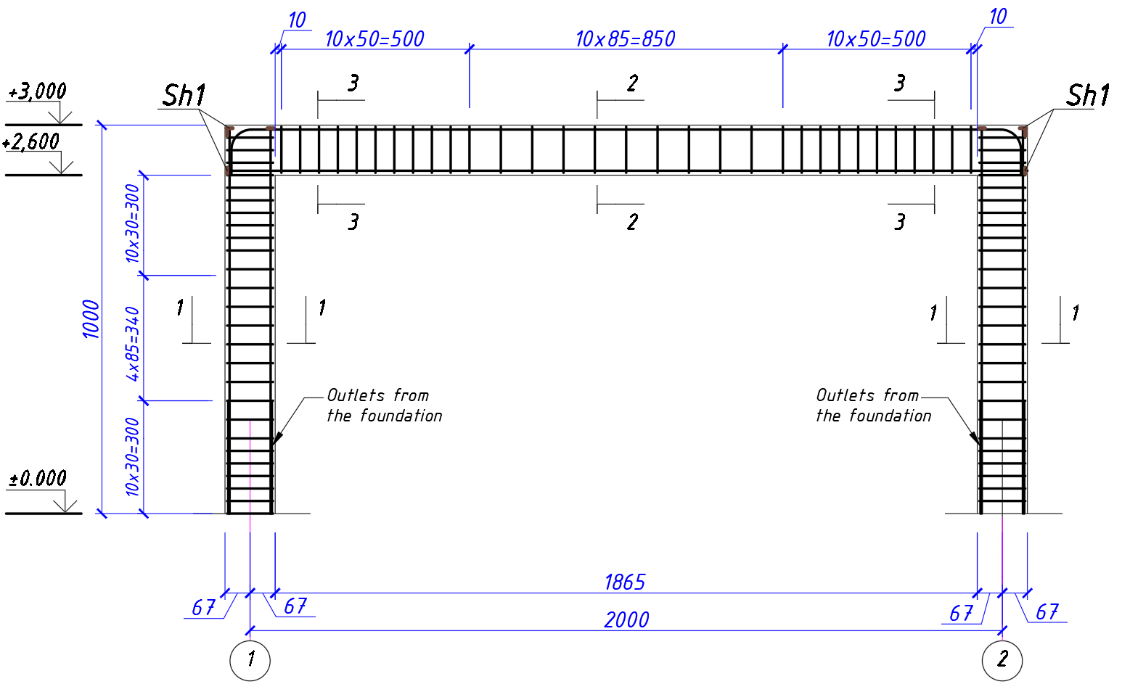
FIGURE 1. General schematic view of a reinforced concrete frame model
It is known that in practice, earthquake-resistant construction uses various damper devices with different nonlinear properties. Dampers are usually manufactured in a factory and used after detailed testing of their nonlinear properties on a special test bench under cyclic loads. In contrast to existing damping devices, a new device with dry or corresponding viscous friction has been developed. The general diagram, sections, general view, and details of the damper device proposed to increase the seismic resistance of a frame building are shown in Figures 2-4.
FIGURE 2. General view of the damper device
FIGURE 3. Cross-section along A-A and B-B of the damper device
FIGURE 4. Cross-section along C-C and D-D of the damper device
Figures 5-6 show the results of changes in the pull force of the damper device and displacement during damper piston sliding in the form of curves.
The curves shown in the figures were obtained using the following compositions of materials used in the damper device tests: 1-rubber granules; 2-rubber granules with steel chips; 3-rubber granules with gravel; 4-hemp thread; 5-rubber granules and hemp thread.

FIGURE 5. Dependence of the thrust force of the damper device on displacement with the number of revolutions of the threaded screw at n=0 and n=1

FIGURE 6. Dependence of the thrust force of the damper device on displacement with the number of revolutions of the threaded screw at n=2 and n=3
During experimental studies, after preparing models of reinforced concrete frames without reinforcement and with reinforcement, without a damper and with a damper device installed, oscillatory processes were initially studied in order to investigate the dynamic and dissipative characteristics of the system. Experimental studies of the vibration of a reinforced concrete frame with a damper device were carried out without the use of a power jack, which creates a static load, i.e., the power jack did not participate in the dynamic vibration process of the structure. The results of a detailed study of the dynamic characteristics and dissipative properties of the damper device are presented below in the form of graphs.
Figure 7 below shows a schematic representation of a reinforced concrete frame without reinforcement, without a damper (a) and with a damper device (b). Before starting the experimental studies, test trials of the reinforced concrete frame were carried out under small loads. Dynamic disturbance was created by pulling the reinforced concrete frame with a traction device (8), and as a result of a sharp break in the guide cable at the points of attachment to the frame (5), the frame oscillated, taking into account the types of structural reinforcement, damper, and no damper device used. The acting force was measured with a force dynamometer, the displacement with an indicator and a strain gauge measuring channel, and the acceleration of the reinforced concrete frame oscillations was recorded with an accelerometer (Fig. 7).
(a) Reinforced concrete frame without reinforcement and without a damper
(b) Reinforced concrete frame with damper reinforcement
FIGURE 7. Reinforced concrete frame without reinforcement: 1-50t jack, 2- reinforced concrete frame B20, 3-three-component accelerometer CMG-5TS-M installed on a moving beam, 4- IR10MN clock indicator and displacement strain gauge, 5-fastening device, 6-1.6 t dynamometer, 7-guide cable, 8-towing device, 9-transverse support, 10-longitudinal support, 11-hydraulic pump, 12-friction damper
The stiffness and dissipative properties were studied taking into account various reinforcement options, in particular, the reinforcement of the reinforced concrete frame with carbon fiber fabric manufactured in Russia and Turkey, steel profiles in the form of a jacket, angular steel ribs, cross-shaped ties, and participating brickwork.
During the experimental studies, vibrations were recorded using a special winch to pull the reinforced concrete frame, both with and without a damper device with various types of reinforcement (Figs. 8-9).
t, с
U, m
Displacement of reinforced concrete frame without damper

t, с
U, m
Displacement of reinforced concrete frame with damper
FIGURE 8. Displacement of reinforced concrete frame before and after installation a damper device (5 mm pull)
Displacements of reinforced concrete frame reinforced with X-shaped connection without damper

U, m
t, с
U, m
Displacement of reinforced concrete frame reinforced with X-shaped bracing with damper

t, с
FIGURE 9. Displacement of reinforced concrete frame reinforced with X-shaped brace before and after installation of the damper device (1 mm pull)

Analysis of results
As a result of analyzing the experimental studies based on the constructed graphs, it was established that, in the optimal case, the resistance force of the damper device corresponds to n=6 and the damper device is filled with loose material consisting of rubber granules mixed with crushed stone.
The displacement of the reinforced concrete frame model without reinforcement was 0.003 m, and after installing the damper device, it was 0.0023 m. In addition, in this series of experimental studies, the acceleration of the reinforced concrete frame model without the damper was 1.5 m/s², and after installation, it was 1.4 m/s².According to the results of this series of experiments, the effect of the damper in reducing displacement was 24%, and when taking into account the effect of acceleration, it was 7%.
The displacement of the reinforced concrete frame model reinforced with an X-shaped steel connection without a damper device was 0.0015 m, and after installing the damper device, it was 0.0012 m. In addition, in this series of experimental studies, the acceleration value of the reinforced concrete frame model without a damper was 1.5 m/s², and after installation, it was 1.3 m/s². According to the results of this series of experiments, the effect of the damper in reducing displacement was 20%, and when taking into account the effect of acceleration, it was 13%.

Conclusion
When comparing the results obtained, the most rational option for dissipating seismic energy, taking into account the influence of the damper device according to the data of a series of experimental studies, is to reinforce the reinforced concrete frame with carbon fiber fabric manufactured in Russia. In the other options of the series of experiments, a rational effect can also be obtained, but only by changing the parameters of the dissipative properties of the damper device after conducting detailed experimental studies.

Acknowledgments
This research was carried out under the budgetary funding topics of the M.T. Urazbaev Institute of Mechanics and Seismic Resistance of Structures of the Academy of Sciences of the Republic of Uzbekistan.

References
- A. Fukukita, T. Saito, and K. Shiba, “Control Effect for 20-Story Benchmark Building Using Passive or Semiactive Device,” Journal of Engineering Mechanics 130(4), 430–436 (2004).
- Z. Liang, G.C. Lee, G. F. Dargush and J. Song, Structural Damping: Applications in Seismic Response Modification, (CRC Press., 2012), pp. 132-153
- A. Moustafa, Ed., Earthquake-Resistant Structures - Design, Assessment and Rehabilitation, (InTech, Feb. 29, 2012), pp 13 – 32. Doi: 10.5772/2460.
- A. W. Taylor, A. N. Lin and J. W. Martin, Earthquake Spectra 8, 279– 303 (1992)
- E. N. Farsangi and A. Adnan, “Seismic Performance Evaluation of Various Passive Damping Systems in High and Medium-Rise Buildings with Hybrid Structural System,” Gazi University Journal of Science 25 (3),
pp. 721–735 (2012)
- Kazuhiko Kasai, “Seismic Performance of Building Protective Systems: Evaluations from Full-Scale Lab Tests and Actual Earthquake Observations,” in Annual Technical Conference of the Australian Earthquake Engineering Society-2013 Conference, (Hobart, Tasmania, 2013) pp.196 – 221. https://aees.org.au/wp-content/uploads/2015/06/19-Kasai-Kasuhiko.pdf
- M. A. Axmedov, Prevention of emergency situations, elimination of their consequences earthquake (Izd. Navruz, Tashkent, 2019) pp. 323.
- https://www.inbusiness.kz/ru/news/silnejshie-zemletryaseniya-poslednih-let-hronologiya-katastrof
- https://www.statista.com/statistics/263105/development-of-the-number-of-earthquakes-worldwide-since-2000/
- https://phys.org/news/2024-01-powerful-earthquakes-dead-destroy-japan.html/
- N. V. Koronovskii va V. A. Abramov, “Earthquakes: Causes, Consequences, Prognosis,” Journal Sciences about Earth 12 (Moscow, 1998) pp. 71-78(in Russian)
- E. So and S. Platt, Earthquakes and their Socio-Economic Consequences, (University of Cambridge, United Kingdom 2014) pp. 43. https://www.researchgate. net/publication/33113194
- A.I. Malganov, V.S. Plevkov and A.I. Polishchuk, Restoration and strengthening of building structures of emergency and reconstructed buildings (atlas of schemes and drawings) (Tomsk, 1990) pp. 320.
- Anil K. Chopra, Dynamics of Structures. Theory and applications to earthquake engineering, 3rd edition (Pearson Education, 2011) pp. 844.
- Т. Rashidov, Sh. Takhirov, H. Sagdiyev and N. Nishonov, “Future world-class laboratory on earthquake resistance of structures and new horizons of research aimed at solving the needs of the Republic of Uzbekistan in this field,” Uzbek Journal “Problems of Mechanics” 1, 2019, pp. 95-101.
- D. A. Mkhitaryan, Experimental modeling of concrete and reinforced concrete structures on static loading, (Publishing house of the Academy of Sciences of the Armenian SSR, Yerevan, 1987), pp. 132.
- A. G. Nazarov, On Mechanical Similarity of Solid Deformable Bodies, (Yerevan, Izd. of the Academy of Sciences of Armenia, 1965) pp. 218.

