Efficiency of Using Friction Damper Type Seismic Protection Systems in Buildings with Various Design Solutions
Anvar Yuvmitov ^{1,a)}, Khamidulla Sagdiev ^{1,b)}, Bakhtiyorjon Egamberdiev^{2,c)}, Salimjon Toshpulatov^{1,d)}, Mirjalol Kholikov^{1,e)} and Khasanjon Sherniyozov^{1,f)}
¹Institute of Mechanics and Seismic Stability of Structures named after M.T.Urazbaev, Uzbekistan Academy of Sciences, 100125, Tashkent, Dormon yuli, 40, Uzbekistan
²Fergana State Technical University Rating Indicators, 150100, Fergana city, Fergana Street 86, Uzbekistan
^{a)} Corresponding author: anvar.sayfullaevich@mail.ru
^{b)} khamidullasagdiev@gmail.com
^{c)} baxti170793@gmail.com
^{d)} toshpolatovsalimjon@gmail.com
^{e)} xoliqovmirjalol93@gmail.com
^{f)} sh.hasanjon@gmail.com
ABSTRACT. The article presents the operational features of active seismic protection systems, allowing analyzing the possibilities of ensuring seismic safety of construction objects. For effective assessment of seismic protection systems and practical application, it is recommended to develop the main principles of classification, expressing the main properties and patterns of operation embedded in them, to obtain maximum information on technical solutions and interaction processes of elements of their design. A new design solution of a friction damper is proposed; elements of the proposed friction damper are developed and designed, and a test is conducted to determine the dissipative and rigidity characteristics for further application in the practice of seismic-resistant construction.

Introduction
In recent decades, there has been an increased interest in seismic protection systems worldwide due to their high efficiency and reliability compared to traditional methods and ways of ensuring seismic resistance of construction projects. The widespread use and application of methods of active seismic protection systems in construction practice is hampered by insufficient study of the systems by specialists, the lack of results of their extensive testing in natural conditions, and in conditions of strong earthquakes. It should be noted that there are many systems and elements of active seismic protection of various design solutions that allow combining systems and their elements [1-10]. The operation of seismic protection systems is based on different physical principles, which makes it difficult to directly compare active systems. The implementation of promising ideas in specific construction projects allows for the rational use of material and technical resources, and most importantly, it allows for a high level of efficiency and reliability of seismic protection of construction projects. In this regard, a systematic approach should be organized to determine the features of the operation of active seismic protection systems, allowing for the analysis of the possibilities of ensuring seismic safety of construction projects [11-12].
For effective evaluation of seismic protection systems and their practical application, it is necessary to use the basic principles of classification that allow expressing the main properties and operating laws embedded in them, using the minimum possible means to obtain the maximum information, since each classification element represents the properties and features of a whole series or group of similar technical solutions and processes of interaction of their design elements. Modern classification of active seismic protection systems is based on the operating principle of seismic protection, its structural units and elements (systems with elastic shock absorbers and supports; with sliding belts or sliding supports; with high dissipative characteristics, etc.), on the design (frame or ring energy absorbers, racks with spherical end surfaces, etc.). Identification of seismic protection systems is associated with the complexity and structural heterogeneity of construction projects, the multifactorial and multicomponent nature of seismic impact. Seismic protection systems can simultaneously include different elements and thus go beyond the system limitations, which can lead to diversity and, as a consequence, to uncertainty of choice [13]. Regular behavior of systems and properties of elements can be identified based on the use of the results of extensive theoretical and experimental studies of active seismic protection systems under static and dynamic loading.

Materials, methods and objects of study
Friction dampers allow the building to move elastically and dissipate energy by damping the vibrations of the building during earthquakes. Thanks to friction dampers, the building can withstand earthquakes without significant damage to the load-bearing structures; they increase seismic safety and ensure the stability of non-load-bearing elements of the structure subject to earthquakes, reducing the acceleration of the floors. This, in turn, provides significant cost savings, since the structural elements can be optimized to reduce costs and is an ideal solution for seismic modernization of high-rise buildings with various design solutions. Friction dampers have a number of advantages among active seismic protection systems, namely, low cost of the device, simple design and methods of their installation in structures, rectangular hysteresis loop, the greatest energy dissipation per "loading-unloading" cycle; they do not require special maintenance, and their parallel installation with other active seismic protection systems is possible, etc. Seismic friction dampers are manufactured, adjusted, and tested individually in accordance with the design solution, loads, and movements that occur during strong earthquakes. The test should be carried out quasi-statically to record the transfer of static friction into dynamic, as well as any changes in the sliding load when moving the damper structural elements [14-15].
Earthquake engineering specialists are working to improve, test, and implement new methods of seismic protection of buildings and structures. The most promising direction for increasing seismic protection is seismic insulation of buildings, which ensures the detuning of the building's vibration frequencies from the prevailing frequencies of the impact. This is what allows us to reduce the mechanical energy received by the structure from the foundation, change the natural frequency of the building's vibration to avoid resonance with external impacts by changing the mass, rigidity, and damping of the structure. This can be achieved by adjusting the geometric dimensions of the elements, their material, or adding special damping devices. Experts offer a variety of seismic protection system devices, which can be classified into three groups [16-17].
The first direction is the use of pure seismic insulation of buildings, arranged in the foundation. These are rubber-metal supports of various modifications of low and high damping. Friction sliding supports are also widely used, allowing for sliding with friction of the above-ground part of the building under intensive impact. Seismic insulation of the building using sliding supports and sliding belts, made in the form of a series of supports located between the building foundation and above-ground structures at the intersections of longitudinal and transverse walls, helps to significantly reduce the horizontal loads on the supporting above-ground structures of the building when they slip relative to the foundation. In this case, part of the energy transmitted to the structure is spent not on overcoming the resistance of the connections in the structure, but on overcoming the forces of sliding friction. With weak vibrations, the acceleration of the foundation is transferred to the building as with a rigid connection to the foundation. With an increase in the acceleration of the foundation, due to the low coefficient of sliding friction in the supports, the building begins to slide relative to the foundation, limiting the inertial forces arising in the upper floors. From this moment on, the forces from seismic loads in the elements of the supporting structures remain virtually unchanged. To limit mutual horizontal movements of the building and foundation, elastic (rubber-metal) and rigid (reinforced concrete) limiters are introduced into the seismic isolation system, and elastic limiters of vertical movements help prevent the separation of the building from the foundation [18-19].
The next direction is the use of damping devices that help absorb energy and are located in places that receive the main load from an earthquake. Depending on the type of energy absorption, the following damping devices are found in practice: frictional, viscous, dry friction, plastic, hysteresis types, and others. According to the results of theoretical and experimental studies, it was proven that damping elements reduce the value of seismic impacts by almost 2 times compared to a conventional building without damping devices. In various countries, damping devices are being developed and implemented in practice in earthquake-resistant construction, in particular in the construction of multi-story and high-rise buildings, bridges, and overpasses, and others. Viscous friction dampers with elastic connections have become widespread in construction practice. The elastic connection is usually implemented in the form of springs with a viscous liquid in a cylinder. When the shock absorber is deformed, energy is lost due to viscous friction in the cylindrical tray. In viscous and dry friction dampers, the friction work decreases sharply with a decrease in oscillation amplitudes. To maintain efficiency, it is advisable to keep the extent of energy dissipation by the damper unchanged, which also requires maintaining the invariance of the system oscillation amplitudes. A dry friction damper, when used in frame buildings in a frame cell of X-shaped and L-shaped connections, usually provides rigidity of frame buildings in the transverse and longitudinal directions. During an earthquake, dry friction appears in the friction damper due to the difference in floor displacements caused by the displacement of structural elements. Such dampers are often found in various types in the construction industry and are mainly used in high-rise buildings. The effect of such a damper is manifested during an earthquake due to dry friction by a sharp decrease in the oscillation amplitude, and the building does not fall into the resonant oscillation mode [20-21].
The third direction is the use of dynamic vibration dampers (DVD) on the upper floors of tall buildings. In this case, with the predominance of the vertical component of seismic action, the installation of a dynamic damper on the upper floor can be a more effective method of seismic protection than seismic isolation of the foundation, which protects the building from horizontal impacts only. DVD is effective in damping resonant vibrations in structures with low attenuation and significantly increases the logarithmic decrement of vibrations of tall flexible structures. A dynamic damper used to reduce the seismic response of a building consists of a rigid element or block, elastic ties connecting the mass of the damper to the building structures, and damping elements installed in parallel with the elastic ties. If the main period of the natural vibrations of the building coincides with one of the predominant periods of seismic action, the mass of the damper begins to vibrate with amplitudes significantly exceeding the amplitudes of the vibrations of the building. The elastic and dissipative forces arising in the damper elements, acting on the building, reduce the amplitude of its oscillations. Depending on the design of the elastic connection, dynamic dampers are divided into spring, pendulum, and combined types, consisting of a massive block, supported or suspended in various ways on the upper structures of the building. Damping is ensured by dry friction forces in sliding supports, or by internal friction arising from bending deformations of the upper part of the cables during vibrations of the damper mass. Often, viscous dampers are additionally installed to ensure damping [22-23].
For high-rise construction, as a rule, the following combination is used: seismic isolation is located on the lower floor, and dampers of various designs are installed along the height of the building. However, research into active seismic protection systems has begun relatively recently, and the data obtained are not yet sufficient for conclusions about their effectiveness and reliability. Justification of various design solutions that provide active seismic protection of buildings of various heights and their reliable operation under seismic impact is a pressing issue for areas of high seismicity.

Statement of the problem
Recently, in the construction of buildings and structures, special attention in the Republic of Uzbekistan has been paid to the issues of using active seismic protection devices to increase the seismic resistance of unique buildings. For example, high-rise bank buildings built in “TASHKENT CITY”. In these buildings (on the floors), four dampers with viscous friction were installed, which absorb 130 tf vibrations per cycle. In this regard, one of the important issues is to increase the seismic resistance of buildings and structures by developing generally available active seismic protection devices using local materials to ensure the seismic resistance of buildings and structures. In the cities of the republic, there is a generally accepted trend to build a flexible floor on the roof of a multi-story building of the terrace type made of lightweight structures (Fig. 1). Based on the analysis of the work, we have developed a new design solution for a friction damper, which relates to solving the problem of seismic-resistant construction by damping building vibrations during earthquakes.
  а) | 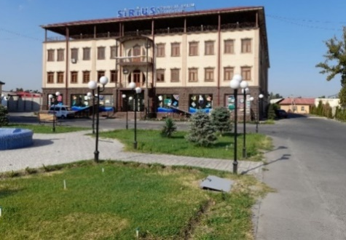  b)
a) - Yangi Shakhar Street, Building 3A, Tashkent: b) - Fergana Street, Building 130A, Fergana
FIGURE 1. Multi-story buildings with a roof terrace
The proposed friction damper in the form of columns made of a square section profile is installed on the roof of multi-storey buildings in operation and under construction by fastening to the main supporting structures. A lightweight canopy made of steel columns on the roof of the building is erected using lightweight steel trusses connected by purlins to ensure the rigidity and stability of the canopy, equipped with plates on the surface of the profile wall, elastic elements, anchors for fastening the plates, nuts, and washers with elastic elements for fastening to the plates and columns. The supporting part of the plates is welded to the columns to show the displacement of the plates relative to the wall of the columns during vibrations of the lightweight canopy. The friction damper of the lightweight canopy column is provided with plates on four sides for efficient operation of the damper device regardless of the direction of seismic forces acting through the foundations of a multi-story building (Fig. 2).
The essence of the design is explained by the drawings in Fig. 2, which shows a column with a friction damper a), adapted for installation on the roof of multi-story buildings (general view of one of the columns of the lightweight canopy of multi-story buildings), figure b) shows a section of the column with a friction damper, and auxiliary fastening elements. The column with the damper is attached to the main supporting structure with bolted connections. Stiffeners are provided to ensure the rigidity and strength of the column supporting part. In this case, the long side of the oval hole in the channel plate is determined based on the calculation of the relative movement of the plate from the main column of the lightweight canopy by the possible permissible maximum horizontal movement of the column of the upper floor of the building. Figure c) shows a cross-section along the height of the column with the main and auxiliary elements of the friction damper indicated. Figure d) shows the elastic fastening of the pad to the main column using a spring, washer, and nut.
The friction damper of multi-story buildings is a column of square cross-section 9, attached to support plate 11 by means of anchor bolts 3 and nuts 1, attached to the upper end of the supporting structure 12. To ensure the rigidity of the fastening of the supporting part of the column with the plate, stiffening ribs 10 are installed. Studs 8 with threaded outlets were installed along the height of the column, passing through the cross-section and welded to the wall of column 9. Steel pads made of a rolled channel section 4 are installed on four sides along the height of column 9, rigidly fastened to the lower and upper ends without fastening with the column to cause dry friction during relative bending deformation of the column with the pad. Holes are made along the height of the pad and in the middle of the wall for possible movement of pin 8 relative to the pad of channel 4, where the pins are located on the sides of the column. The pads made of rolled channel section are secured with washer 5, elastic elements 7, and nuts 6 to demonstrate the elastic normal force of the pad by the column wall. During an earthquake, the light canopy on the roof performs bending vibrations with a different amplitude-frequency response relative to the insulated building.

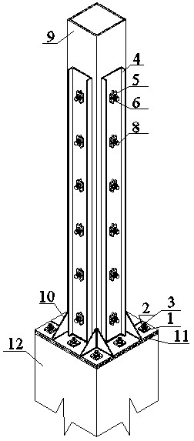  a). | 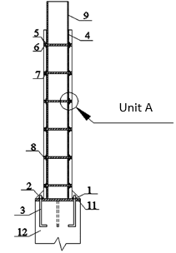  b). | 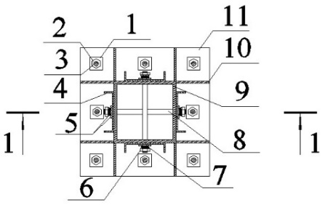  c).  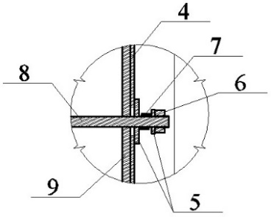  d).
FIGURE 2. a - general view of the friction damper; b - 1-1 section of the friction damper; c - view of the friction damper from above: 1 - washer, 2 - nut, 3 - anchor bolt, 4 - channel plate, 5 - washers, 6 - nuts, 7 - elastic element, 8 - stud, 9 - square section column, 10 - stiffening ribs, 11 - support plate, 12 - reinforced concrete supporting column of the building; d - unit A of the friction damper
The friction damper of multi-story buildings operates as follows. When exposed to a calculated horizontal seismic load exceeding the friction forces in the elements of the square-section column 9 and the steel pads made of the rolled section of channel 4, relative slips occur with their elastic fastening. When the columns bend, the pads made of the channel are displaced relative to the rigid fastening of the supporting part of the column, and a friction force arises in the wall to absorb the energy of seismic vibrations of the lightweight canopy. The lightweight canopy is designed so that, due to its mass, under vibrations, the canopy operates as an inertial damper and significantly affects the amplitude-frequency response of the isolated building. High-frequency vibrations of the lightweight canopy with a damper can negatively affect the seismic resistance of the isolated building due to a change in the phases of its vibrations. During bending vibrations of the columns, a dry friction force appears between the walls of the columns and the pads. This friction damper for multi-story buildings will enhance the seismic resistance of structures, operational reliability, and durability of operation under significant seismic impacts.

Analysis of results
The friction damper has a low response threshold and provides much greater energy dissipation. Under the vertical component of the calculated seismic impact, the friction damper does not work, and under the horizontal direction of the seismic impact, it significantly affects the seismic resistance of a multi-story building with the correct selection of mass, rigidity, and dissipative characteristics of the friction damper, taking into account the different intensities of the amplitude-frequency response of seismic impact. In addition, the reliability of the load-bearing structures of multi-story buildings increases, and the damping capabilities of the upper floor with a light canopy and friction dampers reduce seismic forces and prevent damage to load-bearing structures under intense seismic impacts.
Before starting serial experimental studies on a model of a multi-story building, the dissipative characteristics of a steel plate as an elastic element of the developed friction damper were studied (Fig. 3). The steel plates were tested with and without steel, aluminum, and plastic pads with a change in the working length, and springs for fastening the pads with the main elastic plates (Fig. 4). The dimensions of the elastic plate were bxhxl: 0.0372x0.005x0.851 m. In the middle of the height of the elastic plate, holes were made with an M5 thread opening with a step of 0.05 m. The number of holes, taking into account the lower support part of the plate at a distance of 0.26 m, was 12 pcs with a step of 0.05 m. An M12 bolt was welded to the upper end for fastening additional masses 0.5 kg, 1.5 kg, and 2.5 kg. As a result of measuring the bending rigidity of the plate by weighing the load, the rigidity of the plate with a hole and pads made of different materials was determined.
The results of measurements of the bending rigidity of the main elastic plate and the pad plate made of different materials are given in Table 1. Considering the length of the plates and their pads, the calculated rigidities along the working length are given in Table 2. A series of experimental studies was conducted for all types with a change in the main parameters of the rigidity of the elastic plate and the number of pads, changing the material and the number of springs.
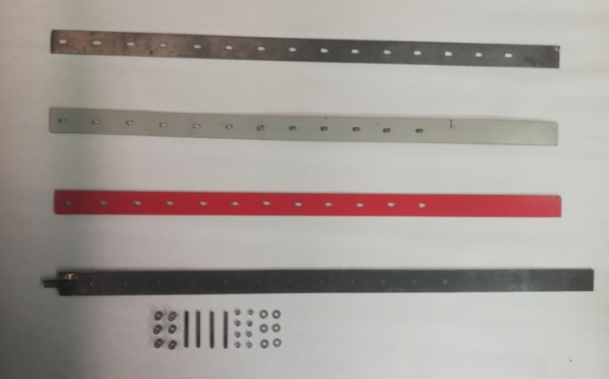  a) | 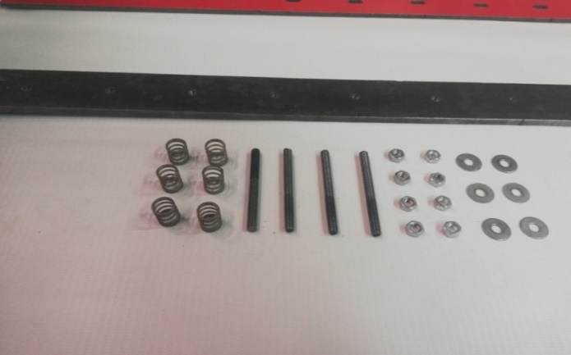  b)

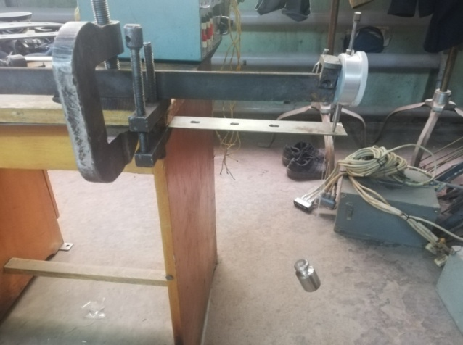  c) | 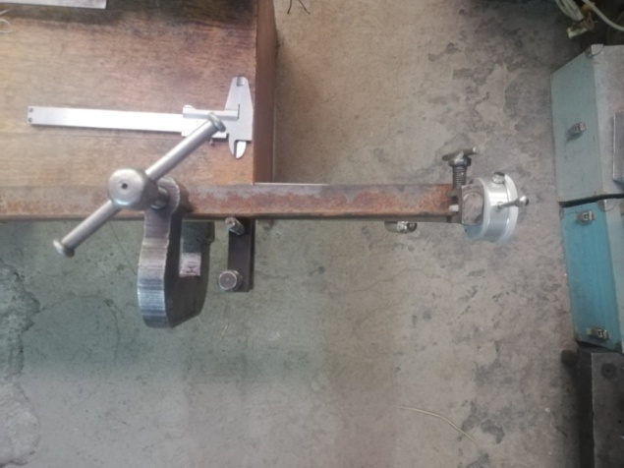  d)
- friction damper parts; b) Fastening element; c) Process for determining the bending stiffness of a steel plate; d) steel plate deflection measurements.
FIGURE 4. The process of measuring the bending rigidity of an elastic plate made of a steel pad with oval holes
When determining the true bending rigidity of a steel base plate with 8 holes from a rigidly attached support part, the length was 0.398 m. The load was applied in the middle of the cantilever beam at a distance of 0.219 m from the support, and 0.179 m from the free end. The diameter of the threaded hole was 0.005 m with a step of 0.05 m. The thickness of the cantilever plate was 0.005 m, and the moment of inertia of the cross section of the fragment was Ix = 0.03785 cm⁴.
When determining the true bending rigidity of an elastic pad made of a steel sheet with 12 oval-shaped holes from a rigidly attached support part, the length was 0.198 m. The load was applied to a cantilever beam at the free end of an elastic plate of 0.198 m long. The diameter of the threaded holes was 0.005 m at a step of 0.05 m along the length of the plate. The size of the oval hole was: width - 6 mm; length - 12 mm. The thickness of the cantilever plate is 0.002 m, and the moment of inertia of the cross-section of the elastic steel plate is Ix = 0.0064 cm⁴.
When determining the true bending rigidity of elastic pads made of aluminum sheet with 12 oval-shaped holes from a rigidly attached support part, the length was 0.188 m. The load was applied to a cantilever beam at the free end of the plate. The diameter of the threaded holes was 0.005 m at a step of 0.05 m along the length of the plate. The size of the oval hole was: width 6 mm; length 12 mm. The thickness of the cantilever plate was 0.0038 m, and the moment of inertia of the cross section of the plate was Ix = 0.0166 cm⁴.
When determining the true bending rigidity of elastic pads made of plastic sheet with 12 oval-shaped holes from a rigidly attached support part, the length to the free end of the plate was 0.137 m. The load was applied to the cantilever beam at the free end of the plate at a distance of 0.137 m. The size of the oval hole, with a width of 6 mm and a length of 12 mm, was located in 0.05 m increments along the length of the plate. The thickness of the cantilever plate was 0.0035 m.
As a result of the measurement, the stiffness of one spring on a fragment of the friction damper was с= 4000 N/m.
TABLE 1. Results of elastic plate testing
№ | Type of elastic plate | Dimensions of the elastic plate, (bxhxl), m |  | Weighed load, N  and the corresponding deflection of the free end, m |  | Average value of the bending stiffness of the elastic plate, N/m
1. | Steel plate with threaded holes |  | 0.0372х0.005х0.851 | 2 N – 0.0001 m  4 N – 0.00021 m  6 N – 0.00034 m | 20000  19047  17647
2. | Steel plate with oval holes |  | 0.0363х0.002х0.8 | 2 N – 0.0009 m  4 N – 0.00193 m  6 N – 0.00297 m | 2222  2072  2020
3. | Aluminum plate with oval holes |  | 0.0362х0.0038х0.798 | 2 N – 0.00145 m  4 N – 0.00318 m  6 N – 0.00498 m | 1379  1257  1204
4. | Plastic plate with oval holes |  | 0.0362х0.0035х0.798 | 1 N – 0.0023 m  2 N – 0.01015 m  4 N – 0.02258 m | 435  197  177

TABLE 2. Results of testing elastic plates taking into account pads
№ | Type of elastic plate | Average values of rigidity at the working length of the plates, N/m |  |  | Reduced modulus of elasticity of the material with holes, kgf/cm²
№ | Type of elastic plate | 0.35 m | 0.45 m | 0.65 m
1. | Steel plate with threaded holes | 4626.6 | 2178.3 | 722.8 | 1850015
2. | Steel plate with oval holes | 271 | 128 | 42 | 605361
3. | Aluminum plate with oval holes | 198.5 | 93.4 | 31 | 171360
4. | Plastic plate with oval holes | 16.1 | 7.6 | 2.5 | 17870
The subsequent studies will present the methodology for developing a model of a multi-story building and installing the developed friction damper with a recording measuring complex used for testing. The methodology for the experimental study of a model of a multi-story building with friction dampers on a seismic platform and the dependence of dissipative properties on the rigidity characteristics of the friction damper at different intensities and frequency spectrums of dynamic (seismic) impacts will be presented. The instrumental data from a series of experimental studies on a model of a multi-story building with a friction damper will be compared with the results of theoretical studies. Based on the results of theoretical and experimental studies of the proposed friction dampers, calculation methods and recommendations for their use in multi-story buildings located in seismically active regions of the republic will be developed.

Conclusion
A brief analysis of existing seismic protection systems in the practice of earthquake-resistant construction is given, and the main types of devices are determined depending on design solutions and features of multi-story buildings. It is established that in multi-story frame buildings, various seismic protection devices are used, in particular, viscous or dry friction dampers, depending on the number of storeys and geometric dimensions of multi-story buildings.
One of the main disadvantages of damper devices of various types is their cost and service life. Based on a detailed analysis and considering local conditions, a new design solution for a friction damper for widespread use in multi-story frame buildings is proposed.
Elements of the proposed friction damper are developed and designed, accounting for dissipative and rigid characteristics for further use in earthquake-resistant construction. A fragment of the proposed friction damper was manufactured, and tasks were set for a detailed analysis of dissipative properties and their influence on the dynamic characteristics of multi-story buildings based on theoretical and experimental studies.

Acknowledgments
This study was conducted based on budgetary financing of the Institute of Mechanics and Seismic Stability of Structures named after M.T. Urazbaev of the Uzbekistan Academy of Sciences.

References
- S. V. Polyakov, L. Sh. Kilimnik, and A. V. Cherkashin, Modern Methods of Seismic Protection of Buildings (Stroyizdat, Moscow, 1989), pp. 120 – 145. (in Russian)
- Ya. M. Aizenberg, Seismic Isolation and Adaptive Systems of Seismic Protection (Science, Moscow, 1983),
pp. 15 – 50. (in Russian)
- R. Enokida and C. Yenidogan, “Seismic response estimation of multi-story structures equipped with a cost-effective earthquake protection system,” Buildings 15(17), 3233 (2025).
- A. S. Abou-Hallawa, “Seismic analysis of R.C multi-story buildings controlled by tuned mass dampers,” Sinai International Scientific Journal 1(2), 65–74 (2024).
- H. S. Sagdiev, D. F. Rumi and G. T. Ayubov, “Seismic analysis of console and spatial models of buildings with seismic protection,” Journal of Scientific and Technical special issue, 39 – 43(2017).
- T. A. Belash, Unconventional Methods of Seismic Protection of Transport Buildings and Structures (Moscow, 2017), pp. 5 – 40. (in Russian)
- X. Zhang and J. Zhang, “Experimental investigation of the seismic behavior of a multi-story building with flexible floors,” Buildings 15(15), 2661 (2025).
- M. G. Melkumyan, “Study of the efficiency of single- and dual-mass dynamic vibration dampers on a model of a frame building during vibration tests,” Journal of Civil Engineering 5, 23–29 (2012).
- Sh. H. Min and H. D. Lee, “Measurement of the tension of friction damper bolts using a manufactured load cell,” Journal of the Korean Society of Steel Construction 31(3), 171–178 (2019)
- M. Setareh, J. K. Richey, T. M. Murray, J. H. Koo and M. Ahmadian, “Semiactive tuned mass damper for vibration control,” Journal of Structural Engineering (ASCE) 133(2), 242–250 (2007). https://doi.org/10.1061/(ASCE)0733-9445(2007)133:2(242)
- S. P. Timoshenko, Vibration Problems in Engineering (Nauka, Moscow, 1967), pp. 9 – 69. (in Russian)
- B. G. Korenev and I. S. Sheinin, “Device for damping vibrations of mechanical systems,” Bulletin of Inventions 23, (1962).
- Kh. S. Sagdiev, Z. R. Teshaboev, V. A. Galiaskarov, Kh. O. Sherniyozov and B. N. Mirzakobilov, “Instrumental and calculation assessment of seismic resistance of a building on seismic isolating supports,” Uzbek journal “Problems of Mechanics” 2–3, 170–173 (2017).
- A. Fukukita, T. Saito and K. Shiba, “Control effect for 20-story benchmark building using passive or semiactive device,” Journal of Engineering Mechanics 130(4), 430–436 (2004). https://doi.org/10.1061/(ASCE)0733-9399(2004)130:4(430)
- D.R. Teruna, T.A. Majid and B. Budiono, “Experimental Study of Hysteretic Steel Damper for Energy Dissipation Capacity,” Advances in Civil Engineering 2015, 1–12 (2015).
- Yu. G. Chernyshev, L. P. Chernysheva and N. N. Lapteva, “Seismic isolating foundation (Author’s Certificate No. 962558),” Bulletin of Inventions 35, USSR (filed Sept. 23, 1980; published Sept. 23, 1982) (in Russian).
- M. Nakashima, P. Pan, D. Zamfirescu and R. Weitzmann, “Post-Kobe approach for design and construction of base-isolated buildings,” Journal of Japan Association for Earthquake Engineering 4(3), 259–264 (2004).
- B. Wang, W. Yan and H. He, “Mechanical performance and design method of improved lead shear damper with long stroke,” Shock and Vibration (Hindawi, London, 2018), 31–37. https://doi.org/10.1155/2018/1623103
- A. A. Bubis, A. Ya. Yun, S. O. Petryashev, and N. O. Petryashev, “Methodology for calculating a building with a seismic isolation system in the form of rubber-metal supports,” Earthquake-Resistant Construction: Safety of Structures 2, 31–35 (2012).
- “Shock absorbers inspire UGM students to invent quake-resistant building foundation,” The Jakarta Post (July 27, 2019), available at https://www.thejakartapost.com/youth/2019/07/27/shock-absorbers-inspire-ugm-students-to-invent-quake-resistant-building-foundation.html
- N. Varadarajan and S. Nagarajaiah, “Wind response control of building with variable stiffness tuned mass damper using empirical mode decomposition, Hilbert transform,” Journal of Engineering Mechanics 130(4), 451–458 (2004).
- R. W. Chan and F. Albermani, “Experimental study of steel slit damper for passive energy dissipation,” Engineering Structures 30(4), 1058–1066 (2008).
- H. Kurino, J. Tagami, K. Shimizu, and T. Kobori, “Switching oil damper with built-in controller for structural control,” Journal of Structural Engineering (ASCE) 129(7), 895–904 (2003).

