Stress-State of Kizilsay Earth Dam under Static Loads
Akhrorbek Numonov^{1, a)} , Karim Sultanov^{1, b)}, Mirziyod Mirsaidov ^{1,2, c)},
and Ziyoda Urazmukhamedova^{1,d)}
¹ Institute of Mechanics and Seismic Stability of Structures named after M.T.Urazbaev, Uzbekistan Academy of Sciences. Tashkent, Uzbekistan.
²Tashkent Institute of Irrigation and Agricultural Mechanization Engineers, National Research University. Tashkent, Uzbekistan.
^{a)} Corresponding author: a.t.numonov@gmail.com
^{b)} sultanov.karim@mail.ru
^{c)} mirsaidov1948@mail.ru
^{d)} ziyoda-tiiame@mail.ru
Abstract. In a water environment, various stress sources act on the dam body together. The degree to which these factors are taken into account determines the proximity of the modeling results to real conditions and the degree of their application in engineering analysis. The fully water-filled nuclear earth dam was assessed under two different conditions. If in the first approach, the hydraulic impact was considered only as hydrostatic pressure, then in the second approach, it was more comprehensive, analyzing the volumetric forces arising from the filtration flow within the dam body, as well as the pore pressure. Calculations were performed using the MIDAS GTS NX software. This program allows for the joint assessment of the stress-strain state (SSS) of the soil and filtration processes, increasing the reliability of the modeling results. The Mohr-Coulomb model, widely used in geotechnics, served as the basis for describing the physical and mechanical properties of the soil.

INTRODUCTION
In recent years, the requirements for the stability and safety of hydraulic structures, in particular, earth dams, have been increasing. Natural disasters, fluctuations in water levels, filtration processes, and other external influences significantly affect the stability of dams. Accurate assessment of the stress-strain state of such structures is a key factor in their reliable design and safe operation. Filtration processes, external loads, and the maximum water level have a particularly significant impact on the dam's stability. Conducting a comprehensive analysis based on reliable mathematical models, taking these factors into account, is one of the main conditions for ensuring safety in engineering.
The first scientific ideas about water movement in the soil body were developed by Henry Darcy in the 18th century [1]. He was a French engineer who conducted research on water passage through soil and developed Darcy's law, named after him. Darcy’s Law describes how water moves through saturated soil and is the foundation of hydrogeology and soil physics.
By 1931, the American scientist L.A. Richards [2] developed the basic mathematical model for describing the movement of water in an unsaturated soil. In this model, it is determined how water moves under non-saturated conditions depending on the water potential in the soil and the water movement.
In works [3-5], the properties of soils, hydraulics, stability analysis, construction practices, soil permeability, filtration processes in dam structures, and factors affecting dam safety are described in detail.
In work [6] one of the main contributions to the study of soil physics and hydrology, especially to the modeling of unmoistened soils, was the Van Genuchten model, which proposed an empirical equation for predicting the hydraulic permeability of unmoistened soils based on groundwater pressure and saturation.
In the work [7], a simple method for determining the hydraulic permeability of unsaturated soil using moisture retention data is presented. By integrating the soil water retention curves with theoretical dependencies, the method allows for effective assessment of permeability without extensive experiments.
In the work [8], the importance of accurate forecasting models for determining the unsaturated hydraulic permeability (K) from groundwater retention data is emphasized, in which empirical expressions for describing the water retention curve are considered and a five-parameter equation adapted to different soil types is applied.
The works [9,10] are devoted to the models of soil deformation prone to moisture. It was observed that the degree of soil moisture influences its stress-strain state. The study demonstrated on mathematical models how the physical and mechanical properties of loess soils, including density and volumetric compression modulus, change depending on moisture content.
In the works [11,12], measures for planning construction work and preventing their deformation are considered based on soils that lose their volume and settle when saturated with water and tend to expand. In addition, technical solutions, experimental results, and methods that allow such soils to be strong and durable are presented.
[13] investigated the relationship between Gardner and Van Genuchten-Muallem models when describing relative water permeability in soil. He proposed new formulas and successfully applied them at an average saturation level.
The article [14] discusses the issues of determining filtration processes and operational parameters of phosphogypsum sludge storage facilities. The authors analyzed the physicochemical properties of phosphogypsum sludge and studied their influence on the filtration process.
[15] several laboratory models were created, in which the central clay core and various sizes and shapes of the lower horizontal filter were used. Models were tested on a hydraulic flume, and parameters such as filtration flow, pore pressure, and dam stability were analyzed.
The works [16,18] show the determination of filtration processes in dams using the finite element method. The water flow rate, material permeability, pressure impact, and erosion risk were analyzed, and the dam's hazardous zones were identified. Methods for reducing filtration by comparing different materials and design solutions have been proposed.
In the work [17], the stress-strain state of earth dams associated with filtration was studied. The authors analyzed the influence of water flow in the dam structure on mechanical stresses and deformations through mathematical modeling. It has been shown how filtration processes affect the strength and stability of the dam material, as well as the occurrence of critical deformation zones.
In the work [19], the issues of modeling the stress-strain state of earth dams, taking into account non-uniform states, are considered. In the work [20], three-dimensional states of earth dams were analyzed, and it was shown that the interactions between structural elements are an important factor determining stability. In the work [21-24], the deformation state and strength characteristics of earth dams under static loads were studied, and the main parameters influencing stability were determined.

Materials and methods
The model of the projected Kizilsay earth dam is considered to evaluate the SSS of earth dams taking into account the structural heterogeneous feature of the structure under the action of mass forces, hydrostatic water pressure.
During the construction of the dam, it was established that the physical and mechanical characteristics of the soil in the supporting prisms and core, according to the project, should be as follows:
- dam height 83 m, dam crest width 10 m, upstream slope m₁= 2.5 m, downstream slope m₂=2.1 m.
- modulus of elasticity of the soil in the supporting prisms E=3100 kgf/cm2, specific weight γ=2.0 t/m3, Poisson's ratio ν=0.30, soil coefficient of adhesion C=0.5, angle of internal friction φ=36°.
- modulus of elasticity of soil in the core E=2780 kgf/cm2, specific weight γ=1.8 t/m3, Poisson's ratio ν=0.37, soil coefficient of adhesion C=0.5, angle of internal friction φ=16°.
To build a mathematical model of the inhomogeneous soil dam Kizilsay in the state of plane deformation, we consider a deformable solid body (Fig. 1) occupying the volume S=S₁+S₂+S₃, interacting with the water medium in the reservoir.
This inhomogeneous system occupying the volume S represents the model of the Kizilsay earth dam. Here S₁, S₃ are the dam support prisms and S₂ is the dam core. The lower part ∑u of the earth dam (Fig. 1) is considered as absolutely rigidly fixed to the foundation. To ensure continuity of deformations and stresses at the boundaries of regio
ns S₁, S₂, S₃, we use "continuity conditions".
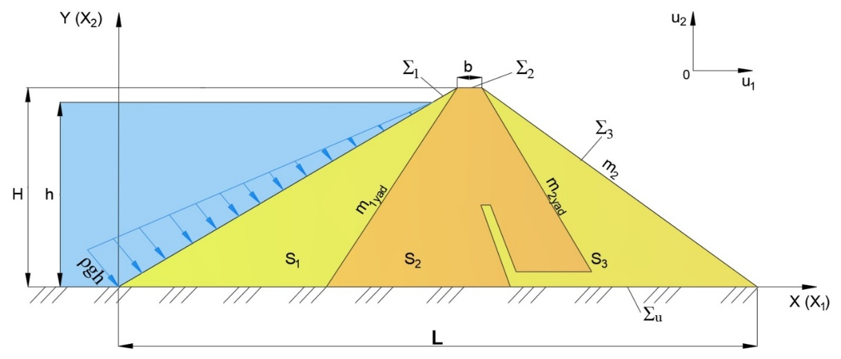
FIGURE 1. Flat model of the ground dam of the Kizilsay reservoir
It is required to determine the field of displacements, deformations and stresses occurring in the inhomogeneous plane-deformable system S (Fig. 1), which is under the influence of forceps and. Here L is the cross-sectional length of the dam base; b is the width of the dam crest; m₁is the upstream slope; m₂ is the downstream slope; m_{1yad}, m_{2yad} represent the slopes of the dam core.
To model the deformation process occurring in the system (Fig. 1), the variational equation and kinematic boundary condition based on the principle of possible displacements, according to which the sum of virtual work done by active forces is zero, is used, namely [7, 33]:
(1)
(2)
Here $\vec{u}$, $ε_{ij}$, $σ_{ij}$ are the components of displacement vectors, strain and stress tensors, respectively; $δ\vec{u}$, $ε_{ij}$ are the isochronal variation of displacements and strains; is the vector of mass forces; p is the hydrostatic pressure of water acting on the surface $S_{p}=(h-x_{2})$ - denotes the depth of the point of the dam pressure surface from the water level;
$\vec{u}={\{u}_{1,}u_{2}\}=\{u,v\}$- components of the displacement vector of the dam points; $\vec{x}={\{x}_{1,}x_{2}\}=\{x,y\}$ -coordinates of the dam points; when solving the plane problem, indices i, j take values i, j=1,2.
In the variational equation (1.1), the following generalised Hooke's law [7,33] is used for mutual expression of stress and strain tensors reflecting physical and mechanical properties of the material in each part of the system:
(3)
Here σ_{x}, σ_{y} and τ_{xy} are normal and tangential stresses, μ, λ are Lame constants:
The relationship between strain tensors and displacement vectors is expressed by the following Cauchy relations
(4)
Here $ε_{x}$, $ε_{y},$and ${}_{xy}$are the relative linear and angular strain.
Using the mathematical model (1.1) - (1.4) it is required to determine the displacement vector $\vec{u}(\vec{x})$, strain tensors and stress tensors $ε_{ij} (\vec{x})$, occurring $σ_{ij} (\vec{x})$ at arbitrary points of the earth dam, satisfying the variational equation (1.1) and relations (1.3), (1.4) at any possible displacements, taking into account kinematic conditions (1.2), being under the action of mass forces $\vec{f}$ and hydrostatic water pressure p
To solve this problem using the finite element method, a methodology, algorithm and computer programme have been developed, which are detailed in [42].

Results
In assessing the stress-strain state, a dam structure with a core located in the centre of the dam was considered (Fig.1). The stress components (σ_{x}, σ_{y}, τ_{xy)} arising under the dam's own weight are determined. Further, in determining the SSS (i.e : σ_{x}, σ_{y}, τ_{xy}) of the dam, in addition to the self-weight of the earth dam, the hydrostatic water pressure due to different filling of the reservoir is taken into account. According to the found values (σ_{x}, σ_{y}, τ_{xy)}, isolines and isopoles of the uniform distribution of stress components over the body of the earth dam were constructed.

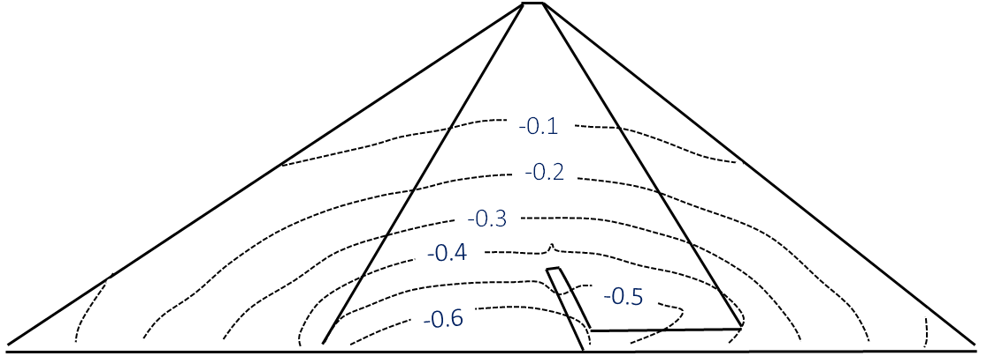
(а) , MPa
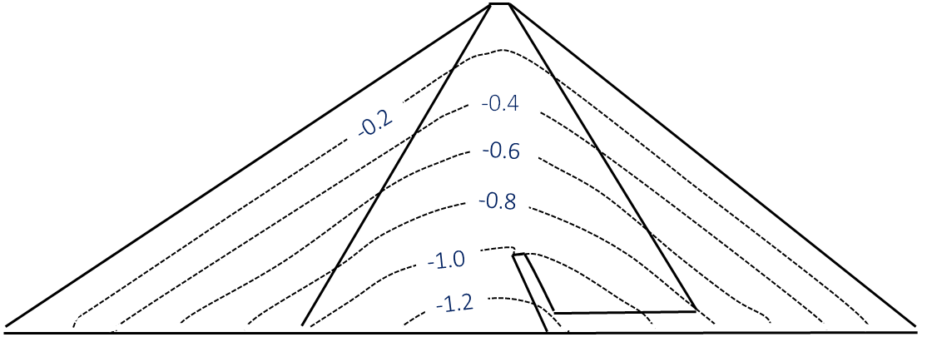
(b) , MPa
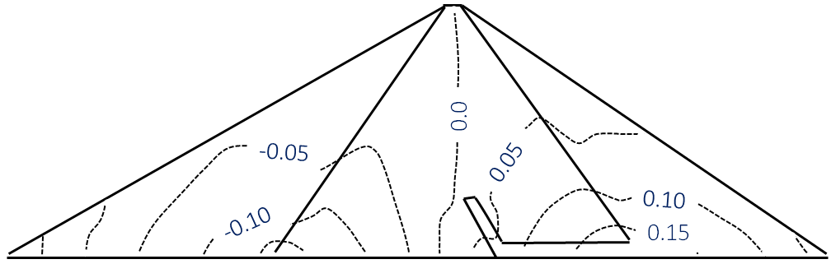
(c) , MPa
FIGURE 2. Isolines of stress distribution, in the body of inhomogeneous Kizilsay soil dam under the influence of mass forces
From the obtained results (the results obtained under the action of mass forces only) it can be seen (Fig. 2a) that the maximum value of the normal horizontal compressive stress σ_{x} under the action of mass forces falls on the lower part of the dam with the central core (Fig. 2a), its value is - 0.65 MPa. In the lower part of the upper prism of the dam, which is connected to the base, this stress σ_{x} has a small positive value and creates conditions for bulging. This is due to the fact that the dam under the action of mass forces tends to displace the soil located in the lower part of the upstream slope of the dam. Since the slope is greater in the upper prism than in the lower prism, the area tending to be displaced occupies a much larger area in this prism than in the lower prism (Fig. 2 a).
If we analyse the isolines of the distribution of the normal compressive stress σ_{y} in the vertical direction (Fig. 2b), in the central core of the dam the value of this stress is -1.2 MPa and this stress occurs in the lowest part of the dam. The smallest value of this stress is distributed along the dam contour. At the same time, small values of this stress occur in the upper part of the core and along the contour of the dam, as there is no action of vertical external loads on these surfaces.
The results of the tangential stress τ_{xy}, shown in Fig. 2c, show that the distribution of this stress is significantly different compared to the two cases described above.
In a soil dam with a central core, the resulting tangential stresses are τ_{max}= -0.2 and + 0.15 MPa. The differences of these stresses at the top and bottom of the dam are insignificantly different due to the small difference, due to the difference of slope coefficients (Fig.2c).
The results obtained under mass forces and hydrostatic water pressure alone are shown on Fig 3. The results of the distribution of stress component isolines (σ_{x}, σ_{y}, τ_{xy}) in the body of Kizilsay earth dam under the action of mass forces and hydrostatic water pressure obtained for a fully filled reservoir using the author's developed programmed and certified program package
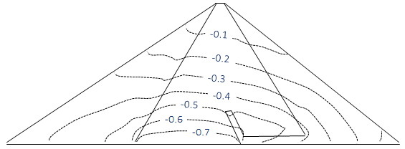 | 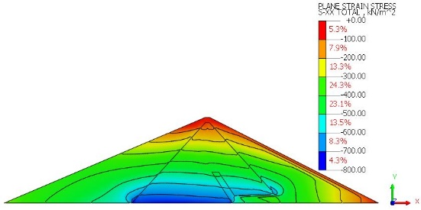
(a) , MPa | (d) , MPa
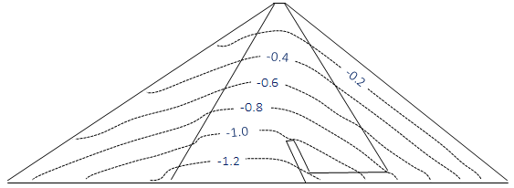 | 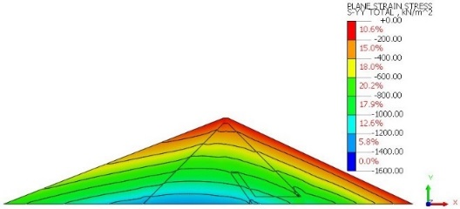
(b) , MPa | (e) , MPa
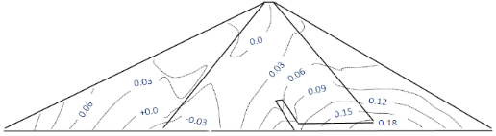 | 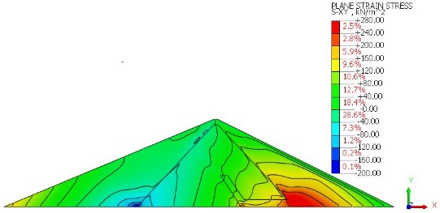
(c) , MPa | (f) , MPa
FIGURE 3. Isolines of stress components distribution in the body of the Kizilsay earth dam arising under the action of mass forces and hydrostatic water pressure for a fully filled reservoir: on the left (a,b,c) are the results obtained with the developed programme, on the right (d,e,f), the results obtained with the software

Discussion
The analysis of these results (Fig. 3a) shows that the value of the horizontal maximum normal stress σ_{x} in the Kizilsay earth dam with a central core reaches -0.8 MPa. At that (Fig. 4). in the lower part of the upper prism of the dam, which is connected to the base, the positive value of the stress σ_{x} disappears, because the hydrostatic pressure creates the opposite stress.
At the same time, the analysis of the distribution of σ_{y} over the dam body shows that the maximum value of the vertical normal stress σ_{y} is at the lower part of the dam centre, mainly on the side of the upper thrust prism, and its value is σ_{y}= -1.4 MPa (Fig. 3b). The lowest value of this stress is on the upper part of the lower thrust prism - in the zone from the base to 1/3 of the dam height and up to the top of the dam.
Analysis of the distribution of tangential stress τ _{ху} over the dam body shows that its maximum value reaches up to 0.20 MPa (Fig. 3c). The almost symmetrical distribution of this stress disappears due to the action of hydrostatic pressures.
From the results obtained, it can be seen that the computer program developed by the author shows approximately the same result as the Midas GTS NX software. This once again confirms the correctness of the results that can be obtained using the developed mathematical model, computational algorithm and software.

Conclusions
1. With the help of the developed program on computer and licensed software isolines of uniformly distributed values of stress components (σ_{x}, σ_{y}, τ_{ху}) are constructed and stress state of the designed Kizilsay earth dam is evaluated considering the effects of self-weight and hydrostatic water pressure.
2. It has been established that the maximum value of normal horizontal stress σ_{x} arising in the dam body with a central core under the action of mass forces is approximately σ_{x}= - 0,65 MPa (or - 650000 Pa) and it has been established that in this value of the slope of the upper slope in its lowest part a positive stress σ_{x} arises in a small area.
3. It has been established that under the action of mass forces and when the reservoir is completely filled, the maximum value of horizontal normal stress σ_{x} in the Kizilsay earth dam reaches -0.8 MPa. Under the action of hydrostatic water pressure, the resulting positive value σ_{x} in the lower part of the upstream slope disappears.
4. It is established that in the Kizilsay earth dam with a central core, the value of the maximum tangential stress under the combined action of mass forces and hydrostatic pressure is approximately τ_{max}= 0.20 MPa, and, mainly, this value occurs in the parts of the dam connected to the base, as well as in the joints of the prism with the core.

Acknowledgements
The article was carried out at the expense of budgetary financing of the Institute of Mechanics and Seismic Stability of Structures named after M.T.Urazbaev, Academy of Sciences of the Republic of Uzbekistan.

References
- M. Mirsaidov, D. Juraev, & P. Matkarimov, “Assessment of stress–strain state of earth dams considering the spatial operation of structures,” in International Conference in Ensuring Seismic Safety and Seismic Stability of Buildings and Structures, Applied Problems of Mechanics, AIP Conference Proceedings 3265, edited by R. A. Abirov (AIP Publishing, Melville, NY, 2025), 050020. https://doi.org/10.1063/5.0265149
- N. M. Pinyol & E. E. Alonso, International Journal of Civil Engineering 17(4), 501–513 (2019)
- E. Lo & L. Pelecanos, “Building dams on rock or soft soil – frequency-domain analysis of dynamic dam–foundation interaction,” in Proceedings of the 20th Biennial Conference of the British Dam Society (20th BDS), edited by A. Pepper et al. (ICE Publishing, Swansea, UK, 2018), pp. 113–122. https://doi.org/10.1680/sdar.64119.113
- Z. Fu, S. Chen & G. Li, Journal of Hydrodynamics 31(1), 152–168 (2019). DOI: 10.1007/s42241-018-0145-z
- M. Wang, J. Chen & W. Xiao, KSCE Journal of Civil Engineering 22(10), 3980–3987 (2018)
- M. Mirsaidov, “Strength of earth dams considering the elastic-plastic properties of soils,” in IV International Scientific Conference “Construction Mechanics, Hydraulics and Water Resources Engineering” (CONMECHYDRO-2022), E3S Web of Conferences 365, edited by D. Bazarov (EDP Sciences, Les Ulis, France, 2023), 03001. https://doi.org/10.1051/e3sconf/202336503001
- M. M. Mirsaidov, Theory and Methods of Calculation of Ground Structures for Strength and Earthquake Resistance (Fan, Tashkent, 2010), 312 pp.
- M. M. Mirsaidov, T. Z. Sultanov & J. A. Yarashev, “Assessment of stress–strain state of earth dams considering elastoplastic properties of soils,” in VI International Scientific Conference CONMECHYDRO 2024, AIP Conference Proceedings 3286, edited by D. R. Bazarov (AIP Publishing, Melville, NY, 2025), 040008.
- Z. Li, T. Wang, W. Ge, D. Wei & H. Li, Water 11(11), 2305 (2019). https://doi.org/10.3390/w11112305
- X. Fu, C. Gu, H. Su & X. Qin, International Journal of Environmental Research and Public Health 15(5), 886 (2018). DOI: 10.3390/ijerph15050886
- Q. Zhong, Y. Shan & J. Liu, Dam Engineering (2020). DOI: 10.5772/intechopen.92893
- S. H. C. Teixeira, P. R. de Paiva, T. F. de Souza Junior & E. Conte, Civil Engineering (2021). DOI: 10.21203/rs.3.rs-528290/v1
- M. P. Sainov, D. S. Gapeev, and G. M. Kudryavtsev, Internet Journal “Science 9(6) (2017). https://naukovedenie.ru/PDF/72TVN617.pdf
- X. Gu, D. Dias, C. Carvajal, L. Peyras, and P. Breul, Bull. Eng. Geol. Environ. 81, 40 (2022). https://doi.org/10.1007/s10064-021-02512-y
- D. Kai, L. Zefa, L. Xiang, C. Chen, S. Jinbao, C. Jiankang, and W. Zhenyu, Front. Earth Sci. (2021). https://doi.org/10.3389/feart.2021.675900
- J. Ehiorobo and R. Ehigiator-Irughe, J. Niger. Assoc. Math. Phys. 19, 493–498 (2011).
- A. S. Bidar, M. Isari, R. Tarinejad, and S. Maghami, Bull. Earthq. Sci. Eng. 6(1), 23–34 (2019).
- I. Konstantinov, S. Kuzmin, A. Savchenko, P. Boychenko, and D. Nagornya, “Allowance for sequence of mass concrete dam erection on soils during its stress–strain analysis,” in MATEC Web of Conferences 73, edited by et al. (EDP Sciences, Les Ulis, France, 2016), 01005. https://doi.org/10.1051/matecconf/2016
- F. Zheng and Y. Li, “Deformation characteristics and a safety monitoring model of high arch dam affected by valley narrowing deformation,” in IOP Conference Series: Earth and Environmental Science 861, edited by et al. (IOP Publishing, Bristol, 2021), 042040. https://doi.org/10.1088/1755-1315/861/4/042040
- N. A. Nariman, T. Lahmer, and P. Karampour, Struct. Civ. Eng. 13(2), 303–323 (2019). https://doi.org/10.1007/s11709-018-0462-x
- A. Arbain, A. Z. Mazlan, M. H. Zawawi, and M. R. MohdRadzi, “Vibration analysis of Kenyir dam power station structure using a real scale 3D model,” Civil Environ. Eng. Rep. 29(3), 48–59 (2019). https://doi.org/10.2478/ceer-2019-0023
- M. K. Jafari and M. Davoodi, Can. Geotech. J. 43(10), 997–1014 (2006). https://doi.org/10.1139/t06-059
- A. M. Belostotsky, P. A. Akimov, and N. T. N. Luong, “Methodology of numerical modelling of three-dimensional system ‘Base–Dam–Reservoir’ under static loads and seismic effects,” in Problems of Applied Mathematics and Computational Mechanics, Collection of Scientific Papers No. 20, edited by et al. (ASV, Moscow, 2017), pp. 364–377. https://doi.org/10.22337/9785432302663-87-94
- G. L. Kozinetc and P. V. Kozinetc, Mag. Civ. Eng. 113(5), 1–8 (2022). https://doi.org/10.34910/MCE.113.12
- J. C. Galván et al., Eng. Anal. Bound. Elem. 144, 67–80 (2022)
- A. Arbain et al., “Vibration analysis of Chenderoh dam physical model spillway structure due to the effect of water spilling: numerical and experimental validation,” in IOP Conference Series: Materials Science and Engineering 815, edited by et al. (IOP Publishing, Bristol, 2020), 012020. https://doi.org/10.1088/1757-899X/815/1/012020
- R. Vipparthy, “Static and free vibration analysis of a gravity dam under the influence of hydrostatic pressure using ANSYS finite element models” (GMRIT JNTUK, 2022). https://doi.org/10.21203/rs.3.rs-1823407/v1
- A. Altunışık et al., Nat. Appl. Sci. J. 4(1), 22–29 (2021). https://doi.org/10.38061/idunas.851853
- S. Chakraborty et al., “Natural frequency of earthen dams at different induced strain levels,” Eng. Geol. 248, 340–345 (2019). https://doi.org/10.1016/j.enggeo.2018.12.008
- S. R. Jafari and M. P. Khiavi, Civ. Eng. J. 5(12), 2614–2625 (2019). https://doi.org/10.28991/cej-2019-03091437
- Q. Li et al., “Dynamic characteristics of tailings dam with geotextile tubes under seismic load,” Rev. Adv. Mater. Sci. (2021). https://doi.org/10.1515/rams-2021-0046
- M. Raja and B. Maheshwari, Open J. Civ. Eng. 6(2), 75–83 (2016). https://doi.org/10.4236/ojce.2016.62007
- M. A. Koltunov, A. S. Kravchuk, and V. P. Maiboroda, Applied Mechanics of Deformable Solid Body (Visshaya Shkola, Moscow, 1983), pp. 135-141.

