Application of active fault models for seismic hazard assessment in low-activity areas of Western Uzbekistan
Roman Ibragimov ^{1,a)}, Tatyana Ibragimova ¹ , Murodjon Mirzaev ¹
and Sarvar Ashurov ¹
¹Institute of Seismology named after. G. Mavlyanov, Academy of Sciences of the Republic of Uzbekistan, 3 st. Zulfiyakhanum, 100028 Tashkent, Uzbekistan
^{a)} Corresponding author: ibrroma@yandex.ru
Abstract. Given the low seismicity typical of western Uzbekistan, located on the Turan Plate, assessing seismic hazard based solely on instrumental earthquake catalogues leads to an underestimation of the actual seismic hazard. At the same time, historical data testify to destructive earthquakes in the past, and tectonic features indicate the presence of active faults capable of generating strong events. This paper uses the example of the Kungrad district (Republic of Karakalpakstan) to show that the integration of earthquake catalogues, historical seismological data and the AFEAD database of active faults provides more reliable results for probabilistic seismic hazard analysis. The harmonised HECCA catalogue and the database of active faults in Eurasia were used as source data, and the CRISIS software package was used for calculations. Three alternative models of seismic sources were considered: area sources, seismogenic zones, and active faults in the Earth's crust. A comparative analysis showed that models based on earthquake catalogues significantly underestimate maximum magnitudes and calculated accelerations, while the fault model generates more conservative scenarios consistent with historical earthquakes. The results obtained indicate a calculated PGA value of approximately 0.10–0.11g, which corresponds to an intensity of I=7 points on the MSK-64 scale for the study area. This is higher than when using only instrumental data and should be taken into account when designing high-responsibility facilities.

Introduction
Seismic hazard assessment is a key stage in the design of infrastructure facilities, including power plants and wind farms. In a number of regions of Central Asia, particularly in the Turan Plate, modern instrumental seismicity is weak, creating an illusion of relative safety. However, historical evidence points to the occurrence of destructive earthquakes in the past, and the tectonic features of the region demonstrate the presence of active faults that are potentially capable of generating strong seismic events.
Traditional methods of seismic hazard assessment, based solely on earthquake catalogue data, are limited in such conditions and can lead to a significant underestimation of seismic hazard. In recent years, an approach that integrates historical seismological data, earthquake catalogues, and information on modern active faults in the Earth's crust has become increasingly popular. This approach allows for a more complete assessment of the potential seismic effect and the formation of reasonable risk assessments for high-responsibility facilities.
The aim of this study is to demonstrate that the use of an active fault model in combination with historical data allows for a reasonable assessment of seismic hazard in an area with low current seismicity, using the example of the Kungrad district of the Republic of Karakalpakstan (Western Uzbekistan).
Source materials and analysis methods
To analyses the seismicity of the study area, we used the HECCA earthquake catalogue - Harmonised Earthquake Catalogue for Central Asia [1], which covers the republics of Kazakhstan, Kyrgyzstan, Tajikistan, Turkmenistan, Uzbekistan, as well as a 300-kilometre buffer zone from the borders of these states. It includes 77,376 historical and instrumental seismic events up to and including 2020 in the magnitude range from Mw = 3.0 to Mw = 8.5. The minimum representative magnitude of the HECCA catalogue, estimated by various methods, varies in the range of magnitudes 4.0 ≤Mw≤ 4.5. In terms of time slices, events in this catalogue with a magnitude of Mw≥3.5 are representative since 1985, with Mw≥5.0 since 1930, and with Mw≥6.0 since the mid-19th century [1].
A map of earthquake epicentres in the study area that occurred during the historical and instrumental observation periods, compiled from this catalogue, is shown in Figure 1. No strong earthquakes have been recorded in the immediate vicinity of the construction site (R≤50 km). However, within the same seismically active structures in which the site is located, there have been a number of strong earthquakes, including the Kunya-Urgench earthquake of 1208 (M=6.1), which occurred west of the site, and three powerful Gazly earthquakes with a magnitude of M>7, which occurred east of it. In addition to these seismic events, there have been a number of earthquakes with a magnitude of M≥5.0, dating back to 1925, 1933, 1982 and 1983. These data suggest the possibility of strong earthquakes in the future, despite the low level of modern background seismicity.
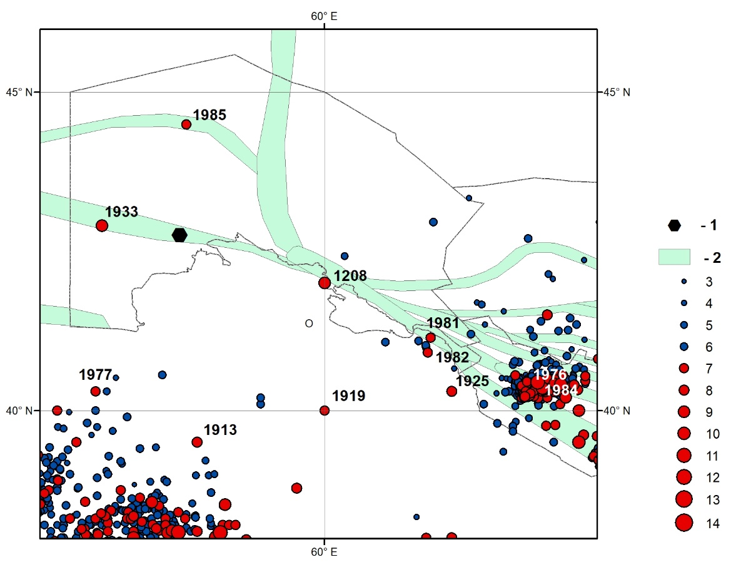
FIGURE 1. Map of epicentres of noticeable and strong earthquakes during the historical and instrumental observation period in the vicinity of the construction site: 1 – site location; 2 – seismogenic zones; earthquake epicentres 3 – M=3.0; 4– M=3.5; 5 – M=4.0; 6 – M=4.5; 7 – M=5.0; 8 – M=5.5; 9 – M=6.0; 10 – M=6.5; 11 – M=7.0; 12 – M=7.5; 13 – M=8.0; 14 – M=8.5;

MATERIALS, METHODS, AND OBJECTS OF STUDY
We used the Active Fault Database of Eurasia (AFEAD) [2], which contains information on the morphology and kinematics of each fault, with quantitative indicators of late Quaternary displacements (RATE attribute). Faults are divided into three ranks according to their displacement rates: more than 5 mm/year – rank 1; from 1 to 5 mm/year – rank 2; less than 1 mm/year – rank 3.
To quantitatively assess seismic hazard, we use a probabilistic approach [3, 4] and its software implementation CRISIS [5]. Within this approach, the probability of exceeding each fixed level of seismic impact over a certain period of time is estimated for each point in the studied area. The implementation of probabilistic seismic hazard analysis (PSHA) involves the construction of two models:
- a model of seismic sources surrounding the point under study;
- a seismic effect model that predicts the magnitude of seismic impact at the point under study from each seismic event occurring within the seismic sources.
Three alternative models of seismic sources were considered:
1. Area sources — homogeneous seismological provinces (Fig. 2).
2. Seismogenic zones [6] — areas identified based on comprehensive seismotectonic data (Fig. 3).
3. Active faults in the Earth's crust — a model based on AFEAD (Fig. 4).
The parameterisation of the area source model, including the determination of the maximum possible earthquake, the recurrence parameters of earthquakes of various magnitudes, and the predominant kinematic type of movement in earthquake foci, was based on data from the catalogue used. The seismic potential of area sources (Mmax) was estimated by adding 0.3‒0.5 M magnitude units to the magnitude of the maximum observed earthquake (Mobsmax) in this source. The estimates of earthquake recurrence parameters were obtained using the least squares method and the Aki-Utsu maximum likelihood method [7].
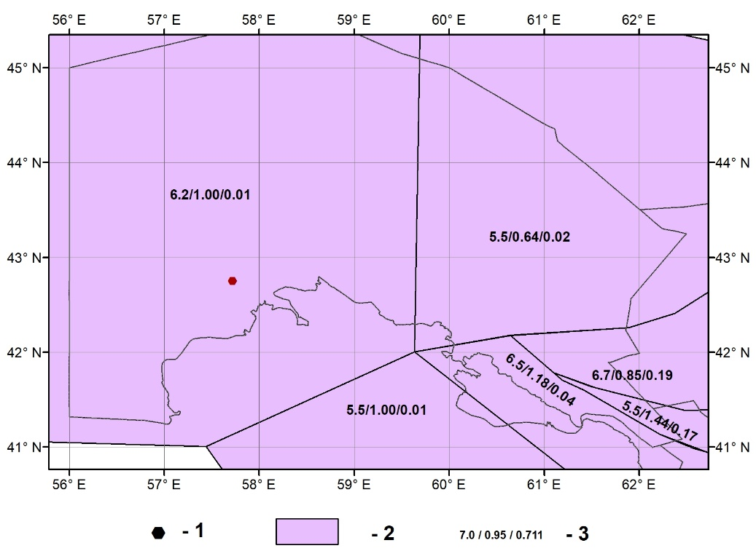
FIGURE 2. Schematic map of area sources: 1 – site location; 2 – area source contours; 3 – estimates of seismic potential Mmax, parameter b, and seismic activity reduced to magnitude M=4.0
The maximum possible earthquake magnitude Mmax for seismogenic zones was calculated based on seismotectonic data [6]. The leading factor in its determination was the scale of the processes characterising the deformation and destruction of rocks (rupture length, depth of its formation, size and degree of consolidation of blocks undergoing displacement as a single whole in [6]. The displacement along the rupture depends on the amplitude and speed of tectonic movements, the composition and strength properties of the rocks. The magnitude of the maximum possible earthquake was determined as the upper limit of the magnitudes of earthquakes recorded in various seismogenic zones with similar seismotectonic parameters. The main characteristics used in comparing structures in [6] were: geological development history, intensity and direction of recent and modern movements, large-scale comparability of tectonic structures, and their integrity from the point of view of seismotectonic processes.
The faults in the AFEAD database are differentiated into four classes (A, B, C, D) according to the degree of expression (reliability) of modern geodynamic activity – attribute CONF [2]. Based on the classification according to this attribute, we considered three different variants of seismic source models in the form of active faults: A+B, A+B+C, A+B+C+D.
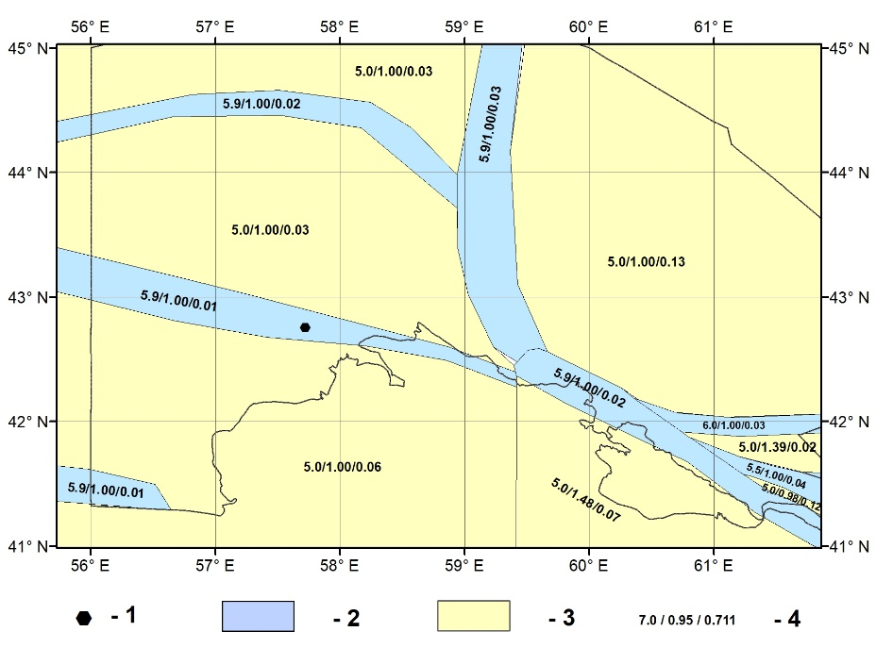
FIGURE 3. Schematic map of seismogenic zones: 1—site location; 2—sources located in the seismogenic zone; 3—sources outside the seismogenic zone; 4—estimates of seismic potential Mmax, parameter b, and seismic activity reduced to magnitude M=4.0.
The seismic potential values in the active fault model were based on empirical relationships by Wells, Coppersmith [8], Leonard [9], and others. Estimates of earthquake recurrence on active faults were determined using relationships [10, 11] based on data on displacement rates at each fault.
Modern ground motion prediction equations (GMPE) for shallow active crust and stable regions [12-15] were used as laws of attenuation of seismic effects with distance.
Epistemic uncertainties were taken into account using a logical tree apparatus.
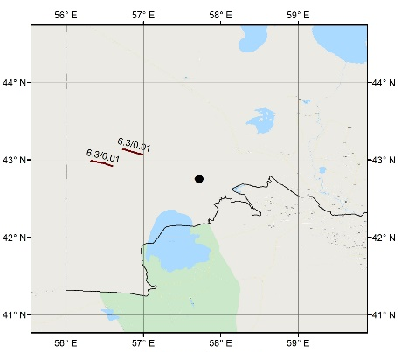 | 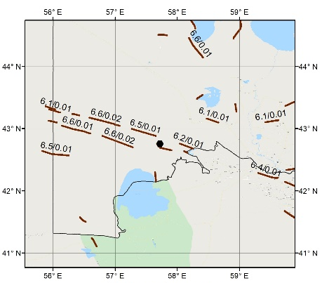 | 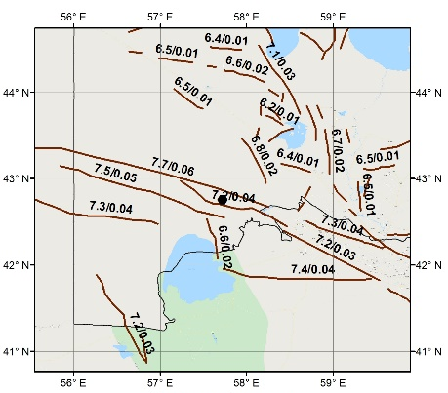
a | b | c
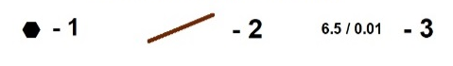
FIGURE 4. Models of seismic sources in the form of active faults in the Earth's crust with different classes of reliability of modern geodynamic activity: a) A+B; b) A+B+C; c) A+B+C+D. Legend: 1- site location; 2- fault geometry; 3- seismic potential (in the numerator) and seismic activity reduced to magnitude M=5.0 (in the denominator)

ANALYSIS OF RESULTS
A comparison of hazard estimates using different seismic source models showed that model 1 (area sources) and model 2 (seismogenic zones) give underestimated estimates of maximum magnitude and acceleration levels, while model 3 (active faults) produces more conservative scenarios consistent with historical data.
The seismic hazard curves obtained from the logical tree calculation show that for a probability of P=0.95 of not exceeding the seismic impact level over 50 years, the calculated PGA is 0.10–0.11g, which corresponds to an intensity of I=7 on the MSK-64 scale.
The results confirm that limiting the analysis to instrumental data alone in regions with low current seismicity leads to an underestimation of the real risk. In such conditions, the integration of the active fault model with historical data is a prerequisite for a reliable assessment of seismic hazard.
The application of the active fault model has two key advantages:
1. It allows for the consideration of potential scenarios of strong earthquakes that have not yet manifested themselves in the instrumental period.
2. It provides spatial specification of seismicity sources, which is critical for engineering calculations.
A comparison of the obtained estimates with the OSR-2017 normative maps [16] showed that national standards generally reflect the level of seismic hazard, but probabilistic analysis using active faults provides more conservative estimates, which are important for the design of high-responsibility facilities such as wind farms.

CONCLUSION
In conditions of low modern seismicity but with a history of destructive earthquakes, the use of active fault models in combination with earthquake catalogues provides a sound and reliable assessment of seismic hazard.
For the Kungrad area (Western Uzbekistan), it has been shown that:
• despite the absence of strong local events during the instrumental period, earthquakes with magnitudes of M=6–7.3 occurred at a distance of 100–300 km in the historical past;
• the use of only area and zonal models underestimates the risk;
• the integration of active faults increases the calculated value of Mmax to 7.0 and is consistent with historical data;
• the calculated intensity of impact at the site is I=7 points on the MSK-64 scale, which should be taken into account in the design.
Thus, an approach based on a combination of earthquake catalogues, historical data and active fault models is the most promising for assessing seismic hazard in areas with moderate or low modern seismicity.

REFERENCES
- V. Poggi, S. Parolai, N. Silacheva, A. Ischuk, K. Abdrakhmatov, Z. Kobuliev, V. Ismailov, R. Ibragimov, J. Karaev, P. Ceresa, M. Santulin, and P. Bazzurro, Nat. Hazards Earth Syst. Sci. 25(2), 817–842 (2025). DOI: 10.5194/nhess-25-817-2025
- E. Zelenin, D. Bachmanov, S. Garipova, V. Trifonov and A. Kozhurin, Earth System Science Data 14(10), 4489–4503 (2022). https://doi.org/10.5194/essd-14-4489-2022.
- C.A. Cornell, Bulletin of the Seismological Society of America 58, 1583-1606 (1968).
- R.K. McGuire, Seismic Hazard and Risk Analysis. (Earthquake Engineering Research Institute, Oakland, California, 2004), pp. 240
- M. Ordaz, A. Aguilar and J. Arboleda, CRISIS2007. Program for Computing Seismic Hazard. Available from: https://ecapra.org/topics/crisis-2007 (Last Accessed March 31, 2016).
- R.N. Ibragimov, U.O. Nurmatov and O.R. Ibragimov, “Seismotectonic method for assessing seismic hazard and issues of seismic zoning”, in Seismic zoning and earthquake forecast in Uzbekistan, edited by K.N. Abdullabekov (State Enterprise “Institute of HYDROINGEO”, Tashkent, 2002), pp. 59-74.
- A. Kijko and A. Smit, Bull. Seismol. Soc. Am. 102(3), 1283–1287 (2012). DOI: 10.1785/0120110226
- D.L. Wells and K.J. Coppersmith, Bulletin of the Seismological Society of America 84(4), 974-1002(1994).
- M. Leonard, Bulletin of the Seismological Society of America 104, 1971–1988 (2014)
- J.G. Anderson and J.E. Luco, Bulletin of the Seismological Society of America 73, 471–496(1983).
- R.R. Youngs and K.J. Coppersmith, Bulletin of the Seismological Society of America 75, 939–964 (1985).
- N.A. Abrahamson, W.J. Silva and R. Kamai. Earthquake Spectra 30(3), 1025-1055 (2014)
- K.W. Campbell and Y. Bozorgnia, Earthquake Spectra 30(3), 1087 – 1115 (2014).
- B.S.-J. Chiou and R.R. Youngs, Earthquake Spectra 30(3),1117-1153 (2014).
- G.M. Atkinson and D.M. Boore, Bull. Seismol. Soc. Am. 96(6), 2181–2205 (2006). DOI: 10.1785/0120050245
- T.U. Artikov, R.S. Ibragimov, T.L. Ibragimova and M.A. Mirzaev, Geodesy and Geodynamics 11(4), 273-294 (2020). DOI: 10.1016/ j.geog.2020.03.004

