Development of a Seismosoil Models Catalog based on Soil Seismic Parameters
B.U. Aktamov ^{1, a)}, V.A. Ismailov ^{1, b)}, Sh.I. Yodgorov^{1, c)}, Sh.B. Avazov^{1, d)},
R.B. Teshaeva^{1, e)} and D.D. Jumaev^{1, 2, f)}
¹Institute of Seismology, Academy of Sciences of the Republic of Uzbekistan. 3 Zulfiyakhonim Street, 100128, Tashkent, Uzbekistan
²Institute of Geology and Geophysics, Ministry of Mining Industry and Geology. 64 Olimlar Street, 100164, Tashkent, Uzbekistan.
^{a)} Corresponding author:b.u.aktamov@gmail.com
^{b)} vakhit.mbm@gmail.com
^{c)}sh.i.yodgorov@gmail.com
^{d)}shuhrat.2016avazov@gmail.com
^{e)}teshaeva.ruhsora.93@bk.ru
^{f)}dostonbekjumayev777@gmail.com
Abstract. This study analyzes methods for developing seismosoil models aimed at assessing the dynamic properties of soils and determining seismic hazard. These models, which play a crucial role in evaluating seismic impacts on buildings and structures, are based on key parameters such as shear-wave velocity (Vs), soil density, and dynamic elasticity modulus. The developed models serve as a reliable source for assessing construction sites and provide engineering recommendations for reducing seismic risk.

INTRODUCTION
In recent years, targeted measures have been implemented to protect the population and territories from seismic hazards, and opportunities have been provided to conduct scientific research in the fields of seismology and earthquake-resistant construction at the level of international standards. Seismosoil models are being developed to account for seismic waves propagating through various soil layers and their effects, which play an important role in assessing the seismic hazard associated with buildings and structures. Seismosoil models are primarily applied in evaluating the dynamic properties of the ground and their influence to seismic actions. Computational methods make it possible to determine the amplitude–frequency characteristics of soil layers and, accordingly, the modified characteristics of vibrations on the free surface of a site or at points within the medium [1-5]. To carry out calculations using this method, it is necessary to define the initial seismic input in the form of an accelerogram and/or a response spectrum, and to construct seismogeological models of the soil layer. For this purpose, real accelerograms of three earthquakes, corresponding to the seismological conditions of the study area in terms of their mechanisms (normal faulting and reverse faulting) and the nature of seismic wave propagation, were obtained [2, 4, 6–8].

METHODOLOGY
The Multichannel Analysis of Surface Waves (MASW) method, developed by researchers Stokoe and Park (1999), is widely used in evaluating the seismic properties of soils through shear wave velocity (Vs). This method makes it possible to determine the dynamic parameters of soil layers by studying the propagation velocity of Rayleigh waves. In the studies of E. Shujirō (2018), the passive MASW method was applied to analyze the seismic properties of deep soil layers using natural seismic signals [2–4, 9].
Research by Boore (2003) and Yamanaka (2007) demonstrated that the MASW method, through inversion of the obtained data, is a reliable tool for assessing seismic hazards. Based on the calculated dispersion values, the variation of shear wave velocities in the vertical direction was successfully modeled [4, 8, 10].
The application of the MASW method in research is of particular importance for assessing seismic impacts on infrastructure facilities. Studies by researchers such as E. Shujirō and Park have shown that this method is effective for evaluating seismic hazards in large cities and for determining the dynamic properties of building foundations [8–11]. In general, the MASW method is considered one of the reliable and effective techniques for determining dynamic characteristics, and it plays a key role in assessing the shear wave velocity of soils [4, 9, 11–14].
This study was conducted for the city of Tashkent, focusing on an assessment of the local soil conditions. For this purpose, the Multichannel Analysis of Surface Waves (MASW) method was applied. The results obtained through this approach provide valuable insights into evaluating the seismic properties of the soil [8, 12, 15–16].
In engineering-seismological and geotechnical–geophysical investigations, a seismosoil model is constructed. This model characterizes how the engineering–geological layers respond to seismic wave propagation [17–19]. The model incorporates key parameters such as soil lithology, density, shear wave velocity (Vs), compressional wave velocity (Vp), moisture content, and other important properties [1, 2, 4].
In the ProShake software, the input data for constructing the shear wave velocity (Vs) profile of soil layers include lithological characteristics, layer thickness, shear wave velocity (Vs, m/s), and the dynamic shear modulus (U, kPa/m) [4, 10].
In seismic investigations, the propagation velocity of seismic waves through the soil is determined. Using the density values of soil layers, the dynamic shear modulus can be calculated. Specifically, in seismic exploration, the product of the layer’s density and the gravitational acceleration (9.81 m/s², g) is applied to derive the value of the dynamic shear modulus U (kPa/m).
The dynamic shear modulus is related to the average volumetric density of the layer according to the following relation:
(1)
ρ – density of the soil layer (g/cm³);
g – gravitational acceleration (9.81 m/s²) [1–4].
From seismic survey data, the velocity of shear-wave propagation in soil layers is determined through the interpretation of seismograms. The average shear-wave velocity (Vs30) for the upper 30 meters (engineering-geological layer) is obtained by calculating the shear-wave velocities of each soil layer within this depth [4, 7].
(2)
where:
- V_{s30}– average shear-wave velocity for the soil layers up to 30 meters deep;
- hi – thickness of each soil layer;
- Vsi – shear-wave velocity of each soil layer [1–3, 7, 11, 20].
Data obtained from engineering-seismological and geological-geophysical investigations carried out to study the seismic properties of soils are used to develop a seismo-soil model (Table 1).

TABLE 1. Engineering-seismological properties of soils at Point №197 in Tashkent City
Lithology | Depth (m) | Layer Thickness (m) | Shear-Wave Velocity (Vsᵢ), m/s | Density (ρ), g/cm³ | Dynamic Elastic Modulus (U), kPa/m
Loam and sandy loam | 0.00 | 1.16 | 396.6 | 1,77 | 17,36
Loam and sandy loam | 1.16 | 1.45 | 397.9 | 1,77 | 17,36
Loam and sandy loam | 2.60 | 1.81 | 221.8 | 1,67 | 16,38
Loam and sandy loam | 4.41 | 2.26 | 510.7 | 1,82 | 17,85
Loam and sandy loam | 6.67 | 2.82 | 618.1 | 1,89 | 18,54
Gravel, crushed stones | 9.49 | 3.53 | 729.2 | 1,94 | 19,03
Gravel, crushed stones | 13.02 | 4.41 | 949.3 | 1,99 | 19,52
Gravel, crushed stones | 17.43 | 5.51 | 1106.7 | 2,00 | 19,62
Gravel, crushed stones | 22.95 | 6.89 | 1052.9 | 2,00 | 19,62
Gravel, crushed stones | 29.84 | 170.2 | 1191.2 | 2,20 | 21,58
Total | 200.00 | -----
The Vs30 value determines the characteristics of soils in terms of amplifying or attenuating seismic waves. The shear-wave velocity of each layer reflects its density and degree of strength. The Vs30 value is considered one of the key factors in assessing the stability of soils when used as a foundation [1, 4–5]. Synthetic accelerograms were used as input accelerograms (Figure 1).
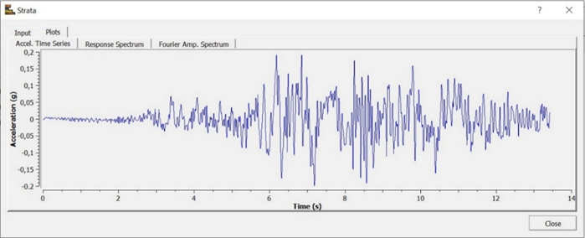
FIGURE 1. Synthesized accelerogram for the Tashkent City area, PGA = 0.2 g
The accelerogram was normalized and adjusted to match the acceleration values corresponding to the first-category soils distributed at depths of 70–250 m in the Tashkent area, consisting of dense Neogene-age conglomerates and cemented loess.
Geological structure and physical properties of soils serve as the initial data for modeling the soil response to seismic impacts. Such modeling is based on the thin-layer method as well as the finite element method. This approach allows accounting for the resonance properties of soil layers and assessing the influence of soil conditions on vibration amplitude, frequency spectrum, and duration [8–10]. Based on this approach, 728 seismo-soil models were developed for Tashkent City. It should be noted that in constructing these seismo-soil models, seismic survey results were utilized, particularly variations in the Vs30 values of soils up to 30 meters depth.
For each study point, an important indicator of engineering seismology—the soil response spectrum to seismic impacts—was constructed [9–10]. The response spectra of soil layers make it possible to analyze variations in the soil response across different spectral ranges, with the smallest variation observed at Point 197 (Figures 2a,b).
As a result of modeling, graphs were obtained showing the maximum acceleration of soils and the variation of the response spectrum with depth.

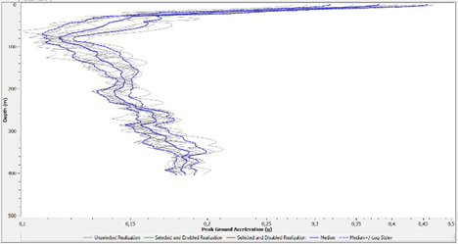 | 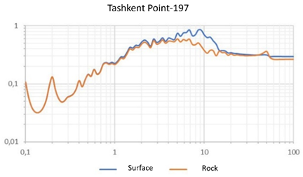
(a) | (b)
FIGURE 2. (a) Peak ground acceleration profile of the observation point and (b) Response spectrum of the soil layer at different depths
In this geological column, based on borehole data, the lithological composition, layer thickness, and depth of rock formations are presented.
Within the first 30 meters of depth, the rock layers are distributed as follows:
• Colluvial soils: 0.0–0.9 m
• Sandy loam–loam: 0.9–3.3 m
• Gravel–pebble deposits: 3.3–30.0 m
In addition, based on seismic survey results, the shear-wave velocities of seismic waves propagating through soil layers up to 30 meters deep were determined (Figure 3). A comparison of borehole data with shear-wave velocities in soil layers shows that the velocity is lower in sandy loam layers, while it is higher in gravel–pebble layers [15–17].
These indicators can be explained by the attenuation capacity of seismic waves during propagation through soils. In other words, the lower the soil density, the higher the attenuation of seismic waves; conversely, in solid rock, the attenuation is lower, which in turn determines the velocity values [22–26].
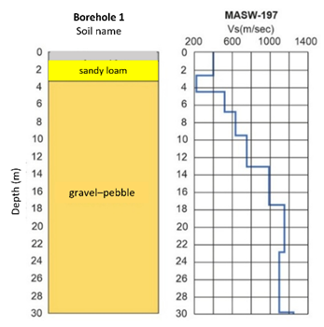
FIGURE 3. Engineering-geological column and the scheme of Vs30 variation with depth
Seismo-soil models perform the following main functions:
• Determination of dynamic soil properties: studying soil layers and their influence on seismic wave propagation. [27–30]
• Analysis of structural seismic stability: evaluating the strength and stability of buildings and structures under seismic loads [11–12].
• Development of seismic risk mitigation measures: designing advanced technologies and structural solutions to improve seismic resistance of buildings and reduce seismic vulnerability. [28-31].
• Modeling of seismic wave propagation: identifying how seismic waves travel through different soil layers, which allows calculating the intensity of seismic impacts [9–12].
• Seismic hazard assessment: evaluating seismic hazards and identifying high-hazard zones caused by tectonic movements and their forces [33, 37–40].

RESULTS
The developed seismo-soil models are primarily aimed at assessing the propagation of seismic wave motions on the earth’s surface and evaluating the seismicity of areas designated for various constructions (Figure 4).
Based on the obtained soil data, a seismo-soil model is developed (Figure 4). This model is used to assess the seismic hazard of a given area, determine the dynamic properties of soil layers, and provide engineering recommendations for construction.
Seismo-soil models serve as an essential source for making reliable decisions under various seismic conditions and construction projects, thereby ensuring the seismic safety of buildings and structures [21-22, 27-30].
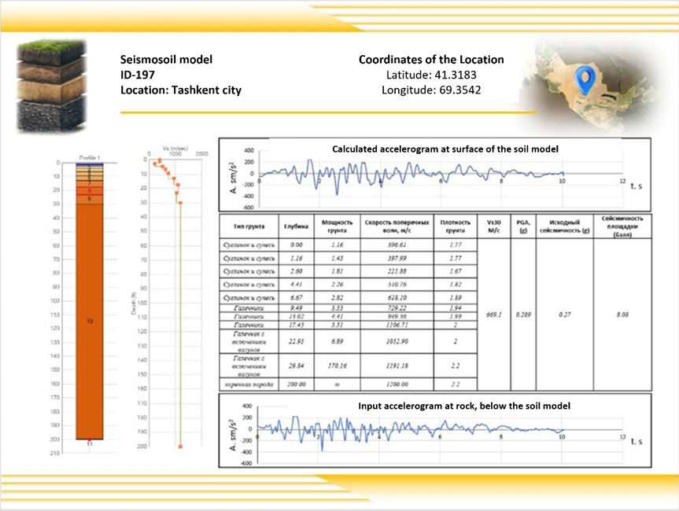
FIGURE 4. Seismo-soil model for Point-197

DISCUSSION
Within the framework of this study, the seismic properties of soils were investigated, and based on the results, a catalog of seismo-soil models was developed (Figure 5). Using the MASW method, seismic wave velocities were determined, and the dynamic parameters of soil layers were evaluated. When compared with existing geotechnical data, it was revealed that in some areas low-velocity layers exist, which significantly influence the level of seismic hazard [32, 36–39].
The findings indicate that the MASW method is effective in assessing the seismic properties of soils. The data obtained through this method can be widely applied in engineering geology and seismic hazard assessment [2, 6–9]. Based on regional analyses, soils were classified according to their seismogenic characteristics, which will play an important role in urban planning and the design of infrastructure projects.
At the same time, certain limitations were identified during the study. In particular, in some areas, ensuring signal quality when applying the MASW method and the need to compare results with other methods became apparent [23-26]. Future studies should focus on improving seismic models and integrating them with other geophysical methods. The developed catalog of seismo-soil models, based on the obtained results, can serve as an important source of information for seismic hazard assessment and the construction of reliable foundations.

CONCLUSION
As a result of this study, 728 seismo-soil models were developed and analyzed for the Tashkent City area. In assessing the seismic properties of soils, parameters such as shear-wave velocity (Vs), density, and the dynamic elastic modulus played a key role. Using the “ProShake” software, the obtained results were analyzed with accelerograms, and response spectra were calculated.
The seismic characteristics identified during the study serve as an important source for assessing the seismic stability of building and structure foundation soils, as well as for developing engineering recommendations aimed at reducing seismic risk. The obtained results can be used as a reliable database in construction practices and in seismic hazard assessment. It is recommended that future studies focus on improving modeling methods and developing similar seismo-soil models for other regions.

Acknowledgments
The fundamental project of the Institute of Seismology of the Academy of Sciences of the Republic of Uzbekistan, titled "Assessment of seismic risk at various levels in seismically active areas and development of scientific foundations for reducing earthquake damage," along with the applied project #AL-8924073457, "Development of a macroseismic database platform for building and structure damage in epicentral zones during strong earthquakes," granted by the Agency for Innovative Development.
The authors appreciate the constructive suggestions of the editors and reviewers.

References
- V. A. Ismailov, Sh. I. Yodgorov, A. S. Khusomiddinov, E. M. Yadigarov, Sh. B. Allayev and B. U. Aktamov, Geomech. Geoeng. 18, 1–21 (2023).
- T. U. Artikov, R. S. Ibragimov, T. L. Ibragimova and M. A. Mirzaev, Geodynamics & Tectonophysics 3, 606-623 (2020).
- James Kaklamanos, Ashly Cabas, Stefano Parolai and Philippe Guéguen, Bulletin of the Seismological Society of America 111 (4), 1665–1676(2021)
- Hashash, Youssef M. A.; Phillips Camilo and Groholski David, “Recent Advances in Non-Linear Site Response Analysis,” International Conferences on Recent Advances in Geotechnical Earthquake Engineering and Soil Dynamics. 8, 1-22 (2010).
- A. S. Aleshyn, V. V. Pogrebchenko and S. N. Nikitin, Earthquake Eng. Safety Struct. 2, 38-53 (2021).
- Ayele Chala and Richard Ray, Periodica Polytechnica Civil Engineering, 68(2), 403–410, (2024).
- Y. Guzel, M. Rouainia and G. Elia, Computers and Geotechnics, 121(12), 103444, (2020).
- A. S. Aleshyn and S. E. Ivanov, J. Seismol. Geotech. 15(2), 55–63 (2000).
- V. I. Ulomov, Geotech. Mech. 10(2), 15-29 (1995).
- A. V. Kalinina, S. M. Ammosov, V. V. Bykova and R. E. Tatevossian, 54(4), 499–513, (2018).
- V. A. Ismailov, Sh. I. Yodgorov, A. S. Khusomiddinov, E. M. Yadigarov, B. U. Aktamov and Sh. B. Avazov, Nat. Hazards Earth Syst. Sci. 24, 2133–2146 (2024).
- E. Yadigarov, A. Khusomiddinov, A. Mansurov and Kh. Islamov, “Question on the Necessity of Seismic Microzonation in Urban Areas (on the Example of Gulistan City),” in International Conference: “Ensuring Seismic Safety and Seismic Stability of Buildings and Structures, Applied Problems of Mechanics” AIP Conference Proceedings 3265, edited by R.A. Abirov et al. (AIP Publishing, Tashkent, 2025), 040008.
- O. O. Erteleva, F. F. Aptikaev, S. Barua, R. Biswas, A. Kalita, S. Deb and J. R. Kayal, Probl. Eng. Seismol. 38(3), 5–21 (2011).
- F. F. Aptikaev and O. O. Erteleva, Earthquake Eng. Safety Struct. 5, 23–25 (2008).
- Halida Yunita, Hendriyawan and Dedi Apriadi, Journal of Engineering and Technological Sciences 47(1), 57-75 (2015).
- D. Apriadi, S. Likitlersuang and T. Pipatpongsa, Computers and Geotechnics 49, 100-110 (2013).
- F. F. Aptikaev and O. O. Erteleva, Earthquake Eng. Safety Struct. 4, 4-7 (2001).
- F. F. Aptikaev and O. O. Erteleva, Earthquake Eng. Safety Struct. 2, 15–19 (2012).
- J. Bozorov, N. Oripov, E. Yadigarov, and A. Khusomiddinov, “Assessment of seismic impact change through engineering-technical reinforcement of loess soils,” in International Conference: “Ensuring Seismic Safety and Seismic Stability of Buildings and Structures, Applied Problems of Mechanics” AIP Conference Proceedings 3265, edited by R.A. Abirov et al. (AIP Publishing, Tashkent, 2025), 040003.
- B. Aktamov, S. Yodgorov, and S. Avazov, “Seismic risk assessment of residential buildings in the city of Jizzakh in terms of economic indicators,” in 6th Int. Conf. for Physics and Advance Computation Sciences: ICPAS2024, (Baghdad, Iraq, 2025), 040011.
- A. A. Misliniyati, R. Amri, K. Mase and L. Z. Hardiansyah, Journal Ilmiah Teknik Sipil dan Teknik Kimia, 9(2), 161-176 (2024).
- R. Misliniyati, L. Z. Mase, M. Irsyam, Hendriyawan and A. Sahadewa, J. Eng. Technol. Sci., 51, 772–790 (2019).
- L. Z. Mase, S. Likitlersuang and T. Tobita, Soil Dyn. Earth. Eng. 114, 113–126 (2018).
- R. Misliniyati, L. Z. Mase, M. I. Hendriyawan and A. Sahadewa, J. Eng. Technol. Sci. 51, 772-790 (2019).
- L. Z. Mase, S. Likitlersuang, T. Tobita, S. Chaiprakaikeow and S. Soralump, Journal of Earthquake Engineering 1, 1-24, (2018).
- M. A. Nuriga,·B. G. Gidday and A. Lulseged, Innovative Infrastructure Solutions 470, 1-17 (2025).
- L. Z. Mase, S. Likitlersuang, and T. Tobita, Earthquake, Engineering Journal, 22(3), 291-303 (2018).
- H. Matinmanesha and M. Saleh Asheghabadib, Procedia Engineering 14, 1737–1743 (2011).
- L. Z. Mase, S. Likitlersuang, and T. Tobita, Soil Dynamics and Earthquake Engineering, 114(1), 113-126 (2018).
- J. Visuvasam and S. S. Chandrasekaran, Innov Infrastruct Solut 4(1), 1-19 (2019).
- A. Khusomiddinov, S. Yodgorov, F. Sadirov, E. Yadigarov, B. Aktamov and S. Avazov, “Estimation of the seismic intensity increments in Tashkent region,” in ICPPMS–2021, AIP Conference Proceedings 2432 edited by J.Razzokov, (AIP Publishing, Tashkent, 2022), 030034.
- B. Ozturk, A. F. Hussein, M. Hesham E. Naggar and H. Chen, Soil Dynamics and Earthquake Engineering 187, 109013 (2024).
- H. Qiang, D. Xiuli, L. Jingbo, L. Zhongxian, L. Liyun, Z. Jianfeng, Earthq Eng Eng. 8, 263–73 (2009).
- L. Su, H. P. Wan, S. Abtahi, Li. Y and X. Z. Ling, Can Geotech J, 57, 497–517 (2020).
- A. I. Valsamis and G. D. Bouckovalas, Soil Dynam Earthq Eng, 34, 99–110 (2012).
- A. F. Hussein and M. H. Naggar, Acta Geotech, 18, 1543–68 (2023).
- A. Zerwer, G. Cascante and J. Hutchinson, J Geotech Geoenviron Eng, 128, 250–61 (2002).
- S. Aslan, B. Fatahi and B. Samali, International Journal of Geomechanics, 15, 211-121 (2014).
- M. H. T. Rayhani and M. H. Naggar, International journal of geomechanics 13, 336-346 (2009).

