Comparative Analysis of the Main Analysis parameters of Domestic and Foreign Standards Seismic Design of Moment-Resisting Frame Buildings
Vladimir Kondratyev^{1, a)} and Odil Abbasov^{2, b)}
¹ Samarkand State University of Architecture and Civil Engineering, Samarkand, Uzbekistan
² Scientific & production association «ELXOLDING» Co. Ltd., Samarkand, Uzbekistan
^{a)} corresponding author: vkondratev1958@mail.ru
^{b)} odilabbosov12@gmail.com
Abstract. The article compares the main calculation parameters for determining seismic loads on moment-resisting frame buildings used in domestic KMK2.01.03-19 [1] and methods used in the standards of Russia, the European Union and the USA. When calculating seismic loads under the same conditions according to the specified standards, a significant discrepancy in the results obtained is observed. As a result of the conducted computational analysis of the two models, the values of seismic loads on frame buildings, determined according to domestic and foreign seismic design standards, were compared.

INTRODUCTION
While working on changes and additions to KMK 2.01.03-19 «Construction in seismic areas» [1] The important is-sue of seismic loads remained virtually untouched. Given the widespread construction of high-rise frame buildings, we believe this issue remains relevant. Therefore, to assess the situation, the authors deemed it necessary to conduct comparative calculations using international standards.
Criteria to select foreign design standards to be compared with KMK, the authors chose the following:
- a high level of development of the scientific base and practical experience in applying selected foreign standards in the design of earthquake-resistant buildings;
- the widespread use of selected norms not only in the respective countries where they are legally in force, but also in many other states geo-graphically distant from them.
According to the authors the following foreign standards meet the specified criteria:
- SP 14.13330.2018 «Construction in seismic areas» [2] are an up-dated version of SNiP II-7-81*, which largely became the basis for the standards of most states in the territory of the former USSR;
- Eurocode 8 (EN 1998-1-2004/2012) [3]– operates in the territory of the European Union countries, has been implemented or is being implemented in Belarus, Ukraine, Kazakhstan;
- Uniform Building Code (UBC-97 – USA) [4] - one of the most authoritative normative documents in the field of earthquake engineering, which was the result of many years of joint work between the American Society of Civil Engineers (ASCE) and the Society of Civil Engineers of California (SEAOC). UBC-97 became the prototype for national codes in India, Pakistan, the Arab countries of the Middle East, and countries in Southeast Asia and the Pacific region;
- ASCE-7-10 (7-16, 7-22) «Minimum design loads for buildings and structures» [5]-The USA equivalent of the «Loads and Impacts» code, in which the seismic loads section was modernized to incorporate a database created using probabilistic seismic hazard analysis (PSHA) for the entire United States and the implementation of new information technologies in design. These codes have been or are being implemented in Asian countries that previously adopted UBC-97.

METHODOLOGY OF COMPARATIVE ANALYSIS
Structures have the ability to dissipate seismic energy through the nonlinear behavior of their elements and other mechanisms. This ability allows for the avoidance of explicit nonlinear analysis during design, by performing an elastic analysis based on a response spectrum whose ordinate values are scaled down relative to those of the elastic response spectrum.
The response spectrum with reduced ordinate values is hereinafter referred to as the «design spectrum». Reduction of the elastic response spectrum is achieved by introducing reduction factors in various variations, which will be discussed below.
Based on the above, as well as the widespread use of this technique in international design practice, the methodology of the comparative analysis used consisted of calculating seismic loads and comparing them for 2 models of reinforced concrete moment-resisting frame structures ac-cording to 5 regulatory documents, taking into account the main parameters, which were adopted as:
1. Design spectrum curve, as a derivative of the standardized elastic spectrum curve, obtained taking into account the relevant design factors (responsibility, regularity, dissipation, and others), modified by multiplication (or division – for European and American codes) by the reduction factors. The procedure for converting from the elastic to the design spectrum curve is clear from Fig.1.
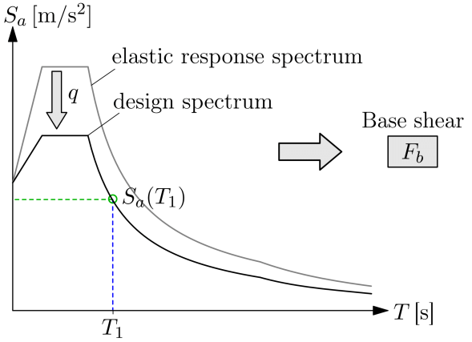
FIGURE 1. Scheme of transition from elastic to calculated spectrum curve.
For visual examination, the elastic spectrum curves for the five standards under consideration for the first of the models under consideration are presented in Figure 2. Curves according to KMK [1] and SP-14 are generated for an 8-intensity degree zone by MSK scale - macroseismic intensity scale and type «2» soils, and for European and USA standards – for zones with a peak ground acceleration of PGA=0.2g and type «C» soils according to Eurocode 8 and type «D» for UBC-97 and ASCE 7-10. When generating the curve according to SP-14-2018, the dissipation co-efficient K_{ψ}=1,3 was taken into account.
2. Reduction coefficients in the following variations:
- KMK 2.01.03-19 [1] - r is the reduction coefficient determined ac-cording to clause 2.22; for reinforced concrete columns at the level of inelastic deformations μ=5, r=0.85μ^{(-0.67)}=0.29;
- SP-14-2018 -Coefficient K₁, taking into account the permissible damage to buildings and structures according to Table 5.2 for buildings with a reinforced concrete frame without vertical diaphragms or ties K₁=0.35;
- Eurocode 8 - behavior factor q, determined according to clause 5.2.2.2 and recommended for reinforced concrete moment-resisting frames q=3. Taking into account that r=1/q, in the European edition the reduction factor r=0.33;
- UBC-97 and ASCE 7-10 – response modification factor R, an analogue of the European behavior factor q. In the latest editions of the standards for reinforced concrete moment-resisting frame structures, R=3 is recommended, just like in Eurocode 8. That is, the reduction coefficient in the American edition is r=1/R=0.33.
3. Soil conditions – Soil classification for selecting the spectrum curve type, despite its importance, is highly specific and varies across countries. For the purposes of this analysis, soil type «2» for 8-intensity degree zone in Tashkent was adopted, and we a priori assume that, in terms of shear wave velocity, V_{s30} is equivalent to soil type «2» according to SP-14, as well as soil type «C» according to Eurocode 8 and soil type «D» ac-cording to UBC-97 and ASCE 7-10, for which 180 m/s<V_{s30}<360 m/s.
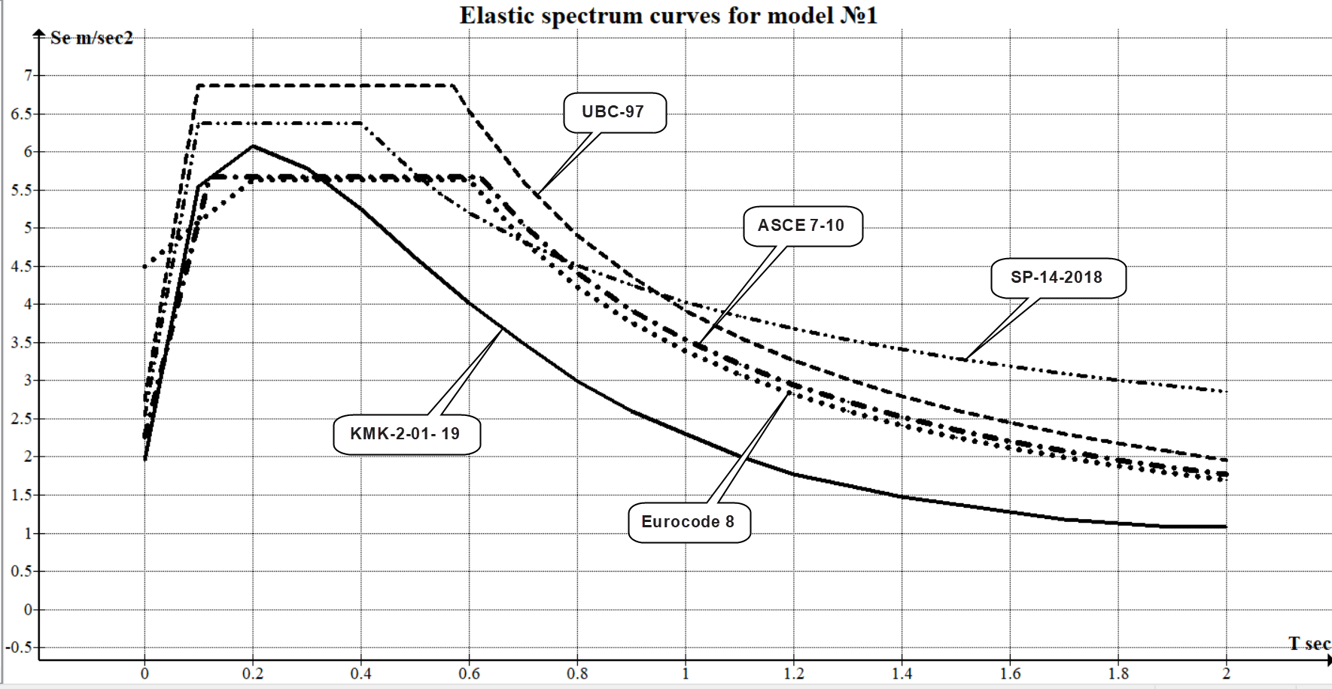
КМК 2.01.03-19 | SP-14-2018 | Eurocode-8 | UBC-97 | ASCE 7-10

FIGURE 2. Elastic spectrum curves for model No.1.

DESCRIPTION OF CALCULATION MODELS AND THE ACCEPTED CALCULATION PROGRAM
Description of models
Two models of flat reinforced concrete frames of 3 and 9 floors on category «2» soils, designed for the 8-intensity degree zone of Tashkent, were adopted as calculation models.
Model No. 1 (Fig.3) is adopted similarly to the model from Example No. 2 [6]. The reason for this is the ability to verify the results of the modal analysis using the frequency parameters of the model with machine calculation, as well as to evaluate the authors' conclusions using regional spectrum curves for the city of Tashkent, similar to the spectrum curves of the KMK [1]. The cross-section of the 1st floor columns section is 40x60 cm; 2 and 3 floor columns section – 40x40 cm; beams 40x50 cm; concrete B20. The loads are accepted in accordance with [6].
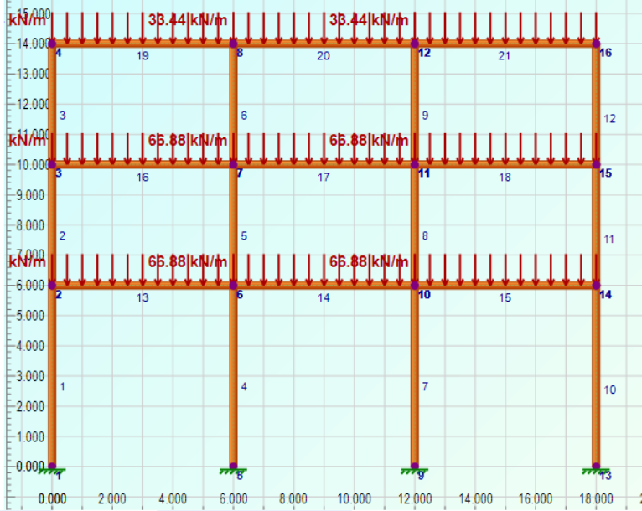
FIGURE 3. Calculation scheme of model No.1.
Model No. 2 (Fig. 4) – 3-span 9-storey frame; column pitch 6 m; floor height 3 m; column section of floors 1-2 – 50x50 cm; 3-9 columns section – 40x40 cm; beams 40x50 cm; material – B20 concrete.
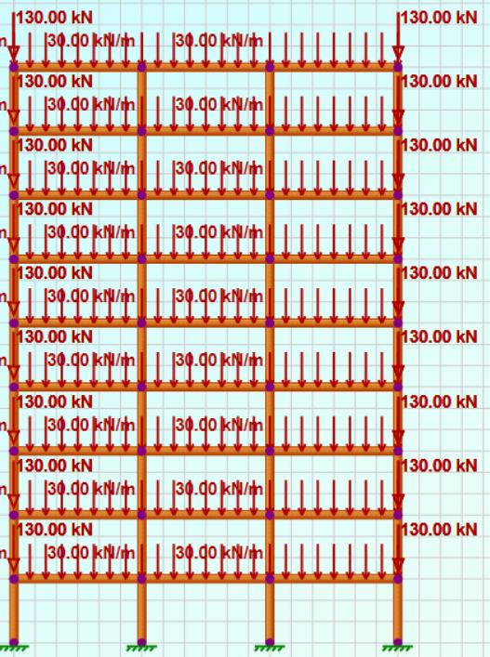 | 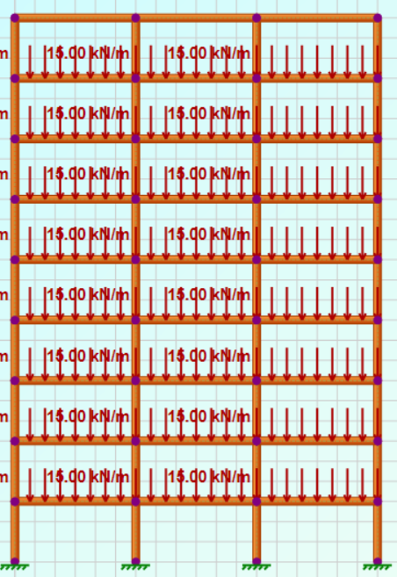
(a) | (b)
FIGURE 4. Analysis scheme of model No.2.
Selecting analysis software.
The authors had the opportunity to use such well-known software packages for calculating frame buildings as ETABS (CSI product), StaadPro (Bentley product), RFEM (Dlubal product), LIRA-SAPR (LIRA-SAPR product)
However, taking into account the specifics of the stated goals and objectives, as well as the structure of the input data and output results, the authors settled on the program «2DFrame Dynamic Edition» (Engissol product), which, with a simple interface, allows you to quickly enter and change the initial calculated spectrum curves and output the necessary results, including frequency characteristics, design forces for given load combinations and support reactions, including the total seismic load (base shear).

RESULTS OF THE ANALYSIS
All model calculations were performed in a linear setting. The seismic load on the building (base shear) Fb was determined as the sum of the horizontal support reactions of the first-floor columns.
Analysis results for model No.1.
The results of the modal analysis are presented in Table 1 (screen-shot of the 2DFrame report).
TABLE 1. Result of modal analysis model No.1
Mode | Period  (sec) | Frequency  (Hz) | Mass X (tons, metric) | Cum. Mass X (tons, metric) | Rel. Cum. Mass X (%)
1  2  3  4 | 0.85  0.27  0.18  0.13 | 1.18  3.66  5.62  7.87 | 278.17  23.99  4.58  0.00 | 278.17  302.16  306.74  306.74 | 90.68  98.51  100.00  100.00
The seismic load (equal to the total horizontal support reaction) when analysis using the design spectrum curves and the percentage of calculated reinforcement of the first floor columns according to the reinforced concrete design standards for structures are given in Table 2.
TABLE 2. Seismic load on the frame and the design percentage of reinforcement of the first floor columns for model No.1
Norms | KMK 2.01.03-19 | SP-14-2018 | Eurocode-8 | UBC-97 | ASCE 7-10
Seismic load F_{b}, kN  Relation to KMK  Reinforcement %  Relation to KMK | 197  1  2.07  1 | 430  2.18  3.23  1.56 | 374  1.9  2.96  1.43 | 434  2.2  3.26  1.57 | 390  1.97  3.03  1.46

FIGURE 5. Seismic load on the frame of model No.1.
Analysis results for model No. 2
The results of the modal analysis are presented in Table 3 (screen-shot of the 2DFrame report).
TABLE 3. Result of modal analysis model No.2
Mode | Period  (sec) | Frequency  (Hz) | Mass X  (tons, metric) | Cum. Mass X (tons, metric) | Rel. Cum. Mass X (%)
1  2  3  4  5  6  7  8 | 0.85  0.27  0.18  0.13  0.18  0.15  0.15  0.14 | 1.18  3.66  5.62  7.87  5.54  6.57  6.85  7.13 | 278.17  23.99  4.58  0.00  14.22  0.00  0.12  8.64 | 278.17  302.16  306.74  306.74  842.36  842.36  842.36  851.12 | 79.63  90.17  94.67  97.30  98.97  98.97  98.99  100.00
When forming spectrum curves according to the KMK2.01.03-19 [1] for model No.2 of a 9-story frame, in contrast to the first model, the number of storeys coefficient K_{t}=1+0.1 (n_{st}-5)=1.4 was taken into account ac-cording to clause 2.17, that is, the curve was raised relative to the curve for model
No.1 by 40% with unchanged curves of foreign standards.
The seismic load (equal to the total horizontal support reaction) when calculated using the design spectrum curves and the percentage of calculated reinforcement of the first floor columns according to the design standards for reinforced concrete structures are given in Table 4.
TABLE 4. Seismic load on the frame and the design percentage of reinforcement of the first floor columns for model No.2
Norms | KMK 2.01.03-19 | SP-14-2018 | Eurocode-8 | UBC-97 | ASCE 7-10
Seismic load F_{b}, kN  Relation to KMK  Reinforcement %  Relation to KMK | 346  1  3.74  1 | 712  2.06  5.24  1.4 | 434  1.25  4.11  1.1 | 504  1.46  4.35  1.16 | 452  1.31  4.15  1.11

FIGURE 6. Seismic load on the frame of model No.2.

CONCLUSIONS
Comparative results of seismic load calculations for only two design models of the moment-resisting frame according to 5 standards showed the following:
1. Estimated seismic loads according to KMK standards2.01.03-2019 [1] significantly lower than foreign standards – from 100% for buildings up to 5 storeys to 25-46% for buildings above 5 storeys, with a corresponding reduction in column reinforcement.
In the opinion of authors, this is due to the reduced parameters of the spectrum curve according to the KMK 2.01.03-2019 [1], which require additional attention and revision;
2. It is necessary to reconsider the role and significance of the K_{st} coefficient, which, back in SNiP II-7-81*, took into account the risk of brittle failure of building structures with increasing number of stories, particularly in the long-period of the spectrum curve, the excess of which, in real-world conditions, was assumed to be relatively greater than in the short-period section. Currently, this factors are derived from Russian SP-14-2018, and was not included in other foreign standards at all;
3. The standards for determining reduction factors in accordance with paragraph 2.22 also require revision by assigning them directly to the type and materials of structures, as is practiced in foreign standards, and not through the “level of inelastic deformations.”

References
- KMK 2.01.03-19, Construction in seismic areas (Ministry of Construction of the Republic of Uzbekistan, Tashkent, 2019).
- SP 14.13330.2018, SNiP II-7-81 - Construction in seismic areas (Stroyizdat, Moscow, 2018).
- European Committee for Standardization. Eurocode 8, Design of Structures for Earthquake Resistance Part 1: General Rules (Seismic Actions and Rules for Buildings. EN 1998-1:2004 ECS, Brussels, 2004).
- UBC Uniform Building Code (International Conference of Building Officials, Whittier, California, USA, 1997).
- ASCE/SEI 7-10, Minimum Design Loads for Buildings and Other Structures (American Society of Civil Engineers, Washington, DC, 2010).
- A.I. Martemyanov, Design and construction of buildings and structures in seismic areas (Stroyizdat, Moscow, 1988).

