Earthquake Prediction Using Artificial Intelligence with the Results of Mathematical Modeling of the Stress State of the Earth's Crust
Ikram Atabekov ^{1, a)}
¹ Institute of Seismology, Zulfiyahanum Str. 3, Tashkent, 100128, Uzbekistan

^{a)} Corresponding author: atabekovi@mail.ru
Abstract. A regional model of the Western Tien Shan and the Afghan-Tajik Basin was developed, reproducing stress and velocity distributions and demonstrating good agreement with GPS data and earthquake focal mechanism solutions. The model's numerical results were combined with seismological, tectonic, and morphological characteristics to conduct machine learning using a hybrid Kolmogorov-Arnold network coupled with an LSTM platform. The training results successfully confirmed that combining geodynamic modeling with artificial intelligence provides a powerful approach to practical prediction of future earthquake locations and magnitudes in regions with high seismic risk.

Introduction
Earthquake prediction remains one of the most complex and pressing problems in science. Uzbekistan has experienced numerous devastating earthquakes, highlighting the need for reliable seismic hazard assessment. Numerical stress field modeling has become an effective tool for establishing the relationship between geodynamic processes and seismic hazard. However, a gap remains between physical models and forecasting systems capable of predicting the location and magnitude of future earthquakes. This study bridges this gap by integrating numerical modeling of the Earth's crustal stress-strain state with artificial intelligence methods. We integrate the results of the numerical model into a hybrid deep learning architecture (a Kolmogorov-Arnold network combined with LSTM), which allows us to explore spatial-magnitude patterns of seismic activity and assess the potential for earthquake prediction.

Materials, methods, and objects of study
The results of numerical experiments conducted in [1] can serve as a physical basis for modeling modern movements of the Western Tien Shan and the Afghan-Tajik depression (Fig.1) using the Stokes equations.
The averaged Stokes equations of horizontal displacement ¯v(x1,x2) and pressure ¯p(x1,x2) applied to some depths of the earth's crust have the following form[2]:
(1)
(2)
where F (F1, F2) is a vector with components
(3)
(4)
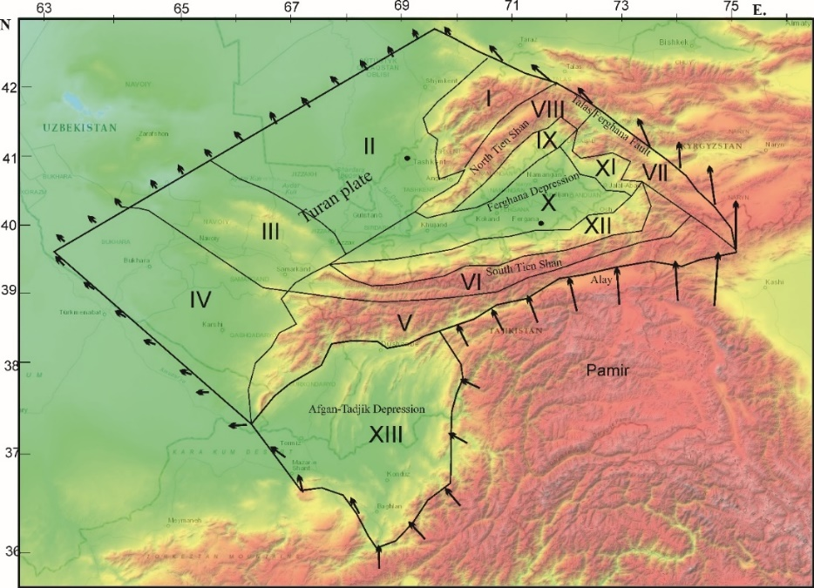
FIGURE 1. The territory of the studied area
In these formulas, σ_{ij} with a bar is the initial stress reconstructed in [1], H(x₁, x₂) is the topography of the Earth's surface, h=const is depth of lithosphere, ρ is the density and µ is the viscosity coefficient, Δ is the two-dimensional Laplace operator. k_{z} is the coefficient which appears in averaging[3]. The functions as w(x₁, x₂, x₃) were averaged by the following formula:
(5)
The vertical velocity of displacements on the Earth's surface is obtained by averaging of the incompressibility equation (2), assuming v₃(x₁, x₂, h) = 0:
(7)
The equations (1-4) were solved by boundary element method.

RESULTS AND ANALISING
The obtained velocity fields [4] were identified by all existing GPS data for studied area[5-18] (fig.2). Based on the velocity of movements and pressures, tangential stresses (Fig. 3) and map of directions of the main stress vector (Fig. 4) were constructed, which were also verified with the available instrumental data.
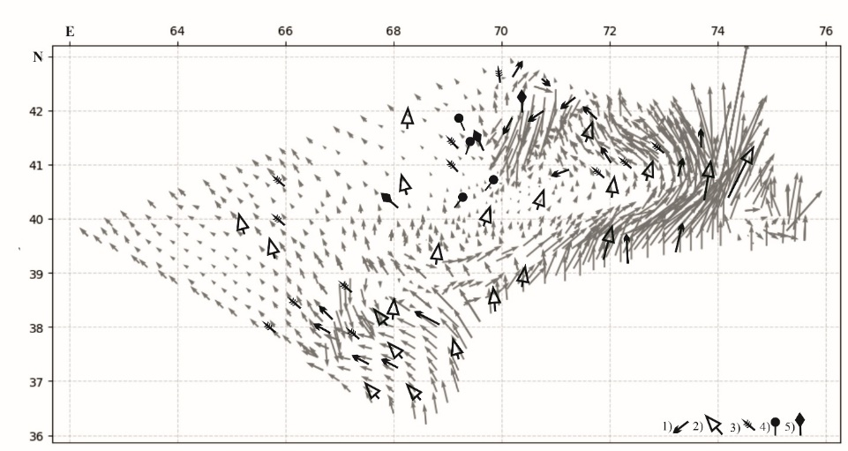
FIGURE 2. Recent horizontal velocity pattern of the Tien Shan and Afgan-Tadjik depression and comparison with instrumental data calculated relative to stable parts of the Eurasian plate: 1) –[5-13]; 2)-[14-15] ; 3)-[16] ; 4)-[17] ; 5)-[18]
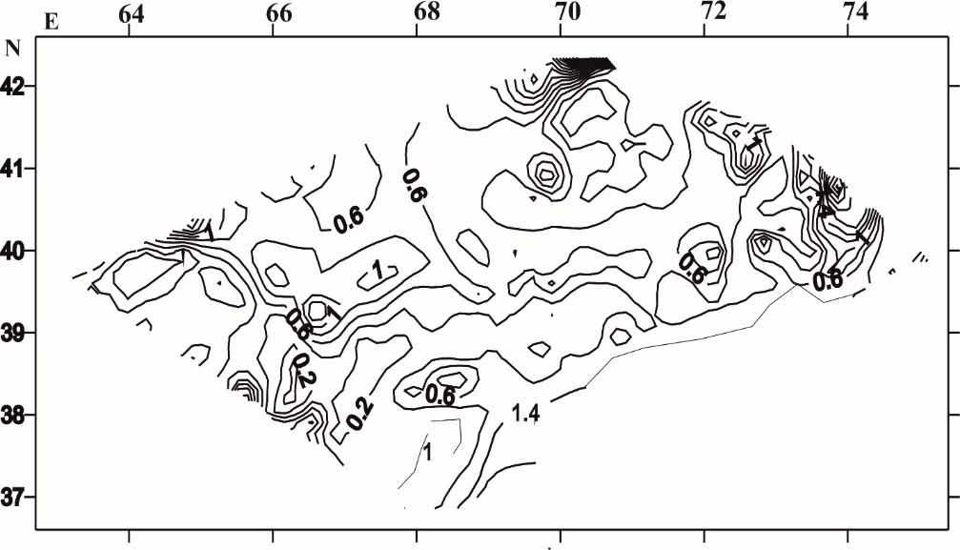
FIGURE 3. Tangential stresses (kbars) at depths of 15 km of the earth's crust of the Western Tien Shan and the Afghan-Tajik depression
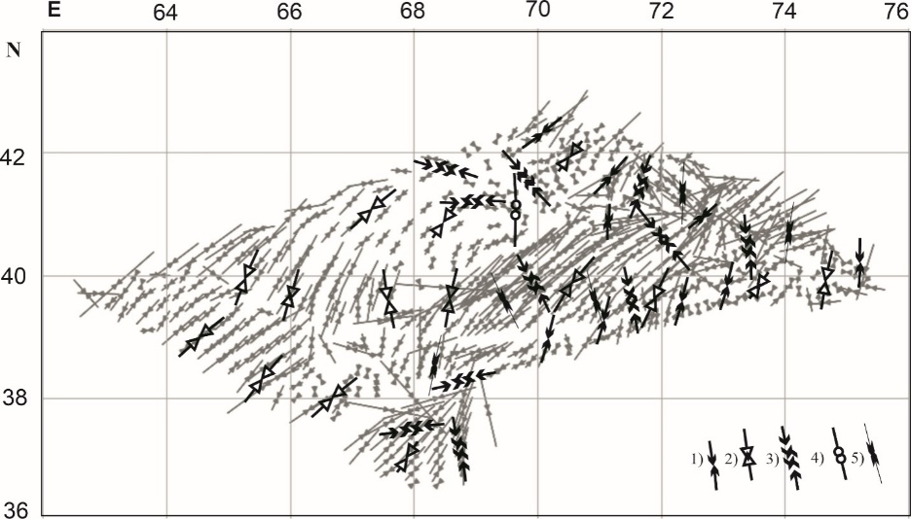
FIGURE 4. Comparison of the direction of the maximal vector of horizontal stresses σ₁ (gray opposite arrows) according to the numerical model of the stress-strain state with the directions given in the works of various authors: 1 – [5]; 2 – [14-15]; 3 – [19]; 4 – [17]; 5- [20-21]
The results of the geodynamic model were combined with seismological and morphological data to form the input featheres for machine learning. The combined classification Kolmogorov-Arnold Network (KAN) with regression LSTM model (TKAN)[] trained on these data. The TKAN model was tested on the independent events of Western Tien Shan for 2023 year (fig.5-6). The model forecasts highlighted zones of elevated seismic hazard, which coincided with the locations of strong earthquakes with magnitude M<5.2 that occurred in 2023. In the area under consideration, all earthquakes except only one had magnitudes less than M=5.2. The predicted magnitudes were also consistent with the observed values, confirming the practical potential of combining numerical stress modeling with artificial intelligence.
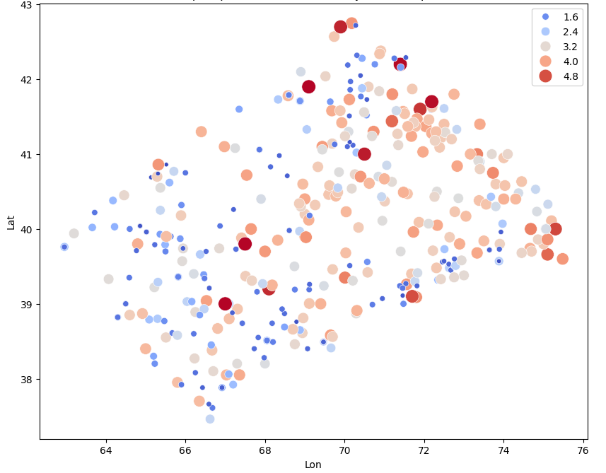
FIGURE 5. Locations of predicted by the combined classification and regression model TKAN for 2023. Accuracy of geographic coordinates predicted events (with magnitude 3.9<M<5.2) is ΔL=±0.1
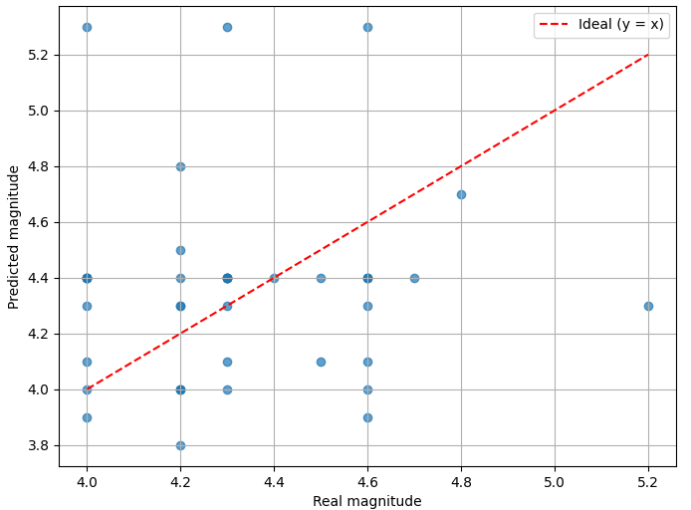
FIGURE 6. Magnitudes discrepancy between actual and predicted earthquakes. A y=x match is considered ideal. Accuracy of predicted magnitudes (3.9<M<5.2) is ΔM=±0.4
The earthquake forecast for the future, taking into account events up to December 31, 2024, is shown in Figure 7.
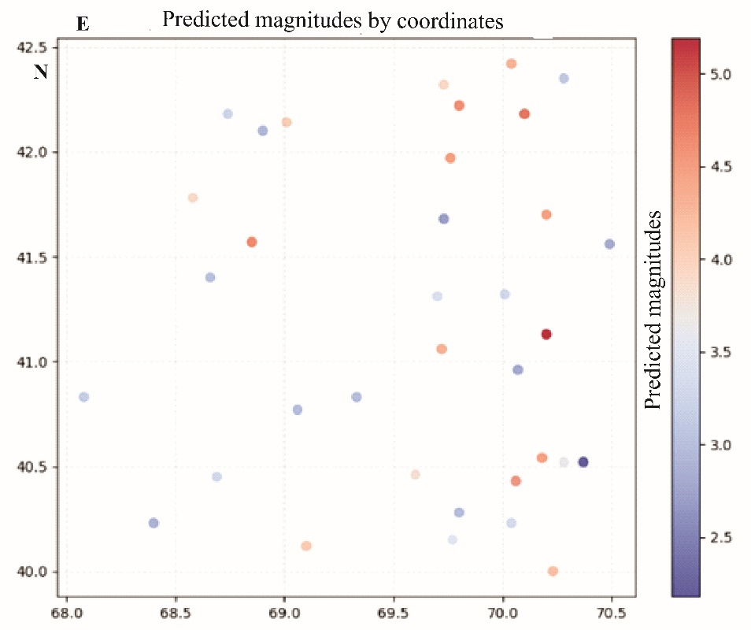
FIGURE 7. The earthquake forecast for the future

Analysis of results
This study demonstrates that integrating stress modeling with machine learning methods enables the effective simulation and prediction of seismic events. The agreement between the simulated and instrumental data indicates that the geodynamic structure is well reproduced by the numerical model. This allows us to confidently state that the obtained stress fields are suitable for assessing long-term tectonic loads and can be used as input for predictive algorithms. The ability of the TKAN model to identify high-hazard zones before strong earthquakes occurs underscores the practical validity of this approach. Combining physically based stress modeling with data-driven learning bridges the gap between geodynamic processes and probabilistic earthquake forecasting. Our model does not predict precise timing, but it helps narrow the area where the probability of future earthquakes is highest.

Conclusion
This study presents a novel framework that combines numerical stress–strain modeling with machine learning to predict seismicity in Western Tien Shan.
The model highlighted high-risk zones in the Western Tien Shan prior to the strong earthquakes, demonstrating both scientific validity and practical value.

References
- I. Atabekov, Geodesy and Geodynamics 11(4), 293–299 (2020).
- I. U. Atabekov, Izv., Phys. Solid Earth 57, 110–119 (2021).
- I. U. Atabekov Izv., Phys.Solid Earth 59(1), 1-14 (2023).
- I. Atabekov, Geodesy and Geodynamics, 2025, (in print).
- A.V. Zubovich and Sh.A.Mukhamediev, Geodynamics & Tectonophysics 1(2), 169–185 (2010).
- A. V. Zubovich, X.Wang, Y.G. Scherba, G.G. Schelochkov, R. Reilinger, R. and C. Reigber, et al., Tectonics, 29(6), TC6014 (2010).
- Z.Liu, Y.Wang, S.Vaidya, F. Ruehle, J.Halverson, M.Soljačić, Th.Y.Hou and M.Tegmark, arXiv:2404.19756. (2024) https://doi.org/10.48550/arXiv.2404.19756
- A. N. Kolmogorov, Reports of the USSR Academy of Sciences 108(2), 179–182. [In Russion] (1956)
- C. Reigber, G.W. Michel, R. Galas, D. Angermann, J. Klotz, J.Y. Chen, A. Papschev, R. Arslanov, V.E. Tzurkov and M.C. Ishanov, Earth and Planetary Science Letters 191, 157-165 (2001).
- A.V. Zubovich, Modern geodynamics of areas of intracontinental collisional mountain building (Central Asia), (Chief editor N.P. Lavrov, M. Scientific world, 2005), pp. 201-219, [In Russian]
- A.V. Zubovich, V. I. Makarov, S. I. Kuzikov, O. I. Mosienko and G. G. Shchelochkov, Geotectonics, 41(1), 13–25 (2007).
- A. Ischuk, R. Bendick, A. Rybin, P. Molnar, Sh. F. Khan, S. Kuzikov, S. Mohadjer, U. Saydullaev, Z. Ilyasova, G. Schelochkov and A.V. Zubovich, Journal of Geophysical Research: Solid Earth 118, 2408–2416 (2013).
- A.V. Zubovich, T. Schöne, S. Metzger, O. Mosienko, Sh. Mukhamediev, A. Sharshebaev, and C. Zech, Tectonics 35, 283–292(2016).
- G. Zheng, H.Wang, T.J.Wright, Y. Lou, R. Zhang, W. Zhang, and N.Wei, Journal of Geophysical Research: Solid Earth 122, 9290–9312 (2017).
- M. Wang and Z.‐K. Shen, Journal of Geophysical Research: Solid Earth 125, e2019JB018774,(2020).
- I.M. Alimukhamedov,Z.F. Shukurov, A.V. Zubovich, S. Mohadjer, O.I. Mosienko, S.S. Radjabov, F.H. Sadirov, F.H. Tukhtameshov, B.G. Abdurakhmonov and K.I. Kuchkarov, Tectonics. (in print) (2025)
- D. Fazilova, M. Makhmudov and B. Khalimov, Geodesy and Geodynamics 16(2), 137-146 (2025).
- Z.F. Shukurov, Y.A. Nurmatov, F.Kh. Sadirov and Kh.O. Allaev. Reports of the Academy of Sciences of the Republic of Uzbekistan 4, 87-92[In Uzbek] (2022)
- T.L. Ibragimova, R.S. Ibragimov, M.A. Mirzaev and Yu.L. Rebetsky, Geodynamics & Tectonophysics 12(3), 435–454 (2021)
- M.L. Zoback and J. Geophys. Res.: Solid Earth 97(B8), 11703–11728 (1992).
- O.Heidbach, M. Rajabi, X. Cui, K. Fuchs, B. Müller, J. Reinecker,K. Reiter, M. Tingay, F.Wenzel, F. Xie, M.-O. Ziegler, M.L. Zoback and M. Zoback, Tectonophysics 744, 484–498 (2018).

