Analysis and Mapping of Secular Geomagnetic Variations Based on Data From the INTERMAGNET Network and Magnetometric Stations in Uzbekistan
Valijon Yusupov^{1 a)}
¹Institute of Seismology of the Academy of Sciences of the Republic of Uzbekistan, Tashkent, Uzbekistan
^{a)} Corresponding author: valijon.yusupov@mail.ru
Abstract. T This study investigates the secular and absolute variations of the Earth's geomagnetic field across Uzbekistan and the broader Central Asian region using data from both national magnetometric stations and the global INTERMAGNET network. INTERMAGNET (International Real-time Magnetic Observatory Network) is a global platform that enables real-time monitoring, processing, and analysis of high-resolution geomagnetic data through more than 150 international observatories. Uzbekistan currently operates 15 magnetometric stations, with datasets integrated alongside those from 16 international INTERMAGNET observatories. As a result, high-resolution maps of absolute and secular geomagnetic field variations have been developed. These maps serve as critical tools for seismic forecasting, geodynamic modeling, and natural disaster preparedness. The study categorizes geomagnetic changes into two main types: (1) global and regional variations caused by core dynamics and external sources like solar winds, and (2) local anomalies associated with tectonic processes and seismic activity. The absolute geomagnetic field map is shown to be particularly useful in identifying seismically active zones, monitoring geodynamic trends, detecting seismic precursors, and enhancing earthquake resilience in infrastructure. The research emphasizes the importance of continuous geomagnetic monitoring for improving earthquake preparedness and advancing scientific understanding of subsurface geophysical processes. The integration of national data with INTERMAGNET standards opens new prospects for high-accuracy geophysical mapping and risk mitigation across Central Asia.

Introduction
The Earth’s geomagnetic field is a dynamic natural shield that protects life on the planet from external cosmic influences such as solar winds, radiation, and charged particles. Its long-term changes, known as secular variations, reflect complex geodynamic processes occurring within the Earth’s core and the interactions with space weather phenomena. Accurate monitoring and mapping of these variations are essential for various scientific and practical applications, including geophysical research, seismic hazard assessment, navigation, and space weather prediction.
Since the late 20th century, the International Real-time Magnetic Observatory Network (INTERMAGNET) has provided a robust scientific platform for global, continuous, and high-resolution monitoring of the Earth’s magnetic field. The network comprises over 150 magnetic observatories worldwide, equipped with advanced magnetometric instruments that meet stringent international standards. These observatories enable automated, real-time data acquisition, processing, and analysis, facilitating timely detection of geodynamic processes and geomagnetic anomalies linked to seismic events.
Uzbekistan hosts approximately 15 national magnetometric stations, some of which have been integrated with the INTERMAGNET network’s data. This integration allows for the combined analysis of local and international datasets, thereby enhancing the precision of geomagnetic field models and maps for the region. Notably, the Yangibazar Magnetic Observatory plays a pivotal role in continuous data collection and monitoring.
This study aims to analyze secular and absolute geomagnetic variations over Uzbekistan and the Central Asian region by leveraging data from both national magnetometric stations and the INTERMAGNET global network. The research focuses on developing detailed geomagnetic maps (fig. 1) reflecting absolute field values and secular trends, which serve as vital tools for seismic forecasting, geophysical modeling, and disaster preparedness. Understanding the spatial and temporal characteristics of these variations contributes significantly to assessing seismic risks and advancing geodynamic knowledge in this tectonically active region.

MATERIALS AND METHODS
Data Collection. To construct secular variation maps of the geomagnetic field over Uzbekistan, we utilized long-term observational data from 15 national magnetometric stations and 16 international INTERMAGNET observatories. The datasets include continuous recordings of geomagnetic field components (declination, inclination, and total intensity) spanning several decades, ensuring sufficient temporal coverage to analyze secular trends.
Data Preprocessing. The raw geomagnetic data were preprocessed to remove short-term disturbances such as magnetic storms and diurnal variations. Filtering techniques, including low-pass filters and trend smoothing algorithms, were applied to isolate long-term secular changes from transient fluctuations. Data quality control was conducted to exclude erroneous or incomplete records.
Trend Analysis. Secular variations were quantified by calculating yearly averages of geomagnetic components at each station. Linear regression and polynomial fitting methods were used to model the temporal evolution of the magnetic field at discrete measurement points. Statistical tests ensured the significance and stability of observed trends.
Spatial Interpolation and Mapping. Using Geographic Information System (GIS) tools, spatial interpolation methods such as kriging and spline interpolation were applied to the station-based secular variation data. This approach enabled the creation of continuous, high-resolution maps illustrating the spatial distribution of secular changes across the study area.
Validation and Comparison. The generated secular variation maps were validated by comparing with existing global geomagnetic field models (e.g., IGRF) and independent regional studies. Discrepancies were analyzed to refine interpolation parameters and improve map accuracy.
Software and Tools. Data processing and analysis were conducted using specialized geophysical software packages, including MATLAB for statistical analysis and Python libraries for data handling. GIS software such as ArcGIS or QGIS was employed for spatial interpolation and map visualization.

RESEARCH RESULTS
The International Real-time Magnetic Observatory Network (INTERMAGNET) is a globally recognized scientific initiative that plays a central role in monitoring the Earth’s magnetic field. It comprises a coordinated network of over 150 magnetic observatories distributed across different continents. Each observatory is equipped with advanced, high-precision magnetometric instruments that conform to rigorous international standards, ensuring data quality and consistency. The core mission of INTERMAGNET is to enable continuous, real-time observation of the Earth’s geomagnetic field through the collection, transmission, and automated processing of magnetometric data. This capability is crucial for detecting geomagnetic disturbances, both global and local, which may be indicative of natural phenomena or potential hazards.
One of the key advantages of INTERMAGNET is its standardized data processing and reporting protocols, which make it possible to compare geomagnetic measurements from diverse geographic locations. This harmonization of methods enhances the reliability and global usability of the data. As a result, scientists and researchers can investigate a wide range of geomagnetic phenomena, such as secular variation (the slow drift of the magnetic field over decades), the effects of solar activity, and localized magnetic anomalies associated with tectonic and volcanic activity. The network’s data are also integral to the generation and updating of international geomagnetic models like the International Geomagnetic Reference Field (IGRF), which are essential for navigation, satellite operations, and geophysical exploration.
In addition to its scientific contributions, INTERMAGNET data serve practical purposes related to natural disaster preparedness and mitigation. One particularly important application is the study of geomagnetic anomalies that may occur before earthquakes. By analyzing changes in the Earth’s magnetic field in tectonically active regions, researchers aim to identify potential precursors to seismic events. While the field of earthquake forecasting remains complex and under development, data from INTERMAGNET offer valuable insights that could eventually lead to more effective early warning systems. Ultimately, INTERMAGNET functions not only as a foundation for cutting-edge geophysical research but also as a tool for improving global seismic resilience. Its role in both theoretical and applied science underscores its importance in understanding Earth's dynamic systems and protecting human populations from natural hazards.
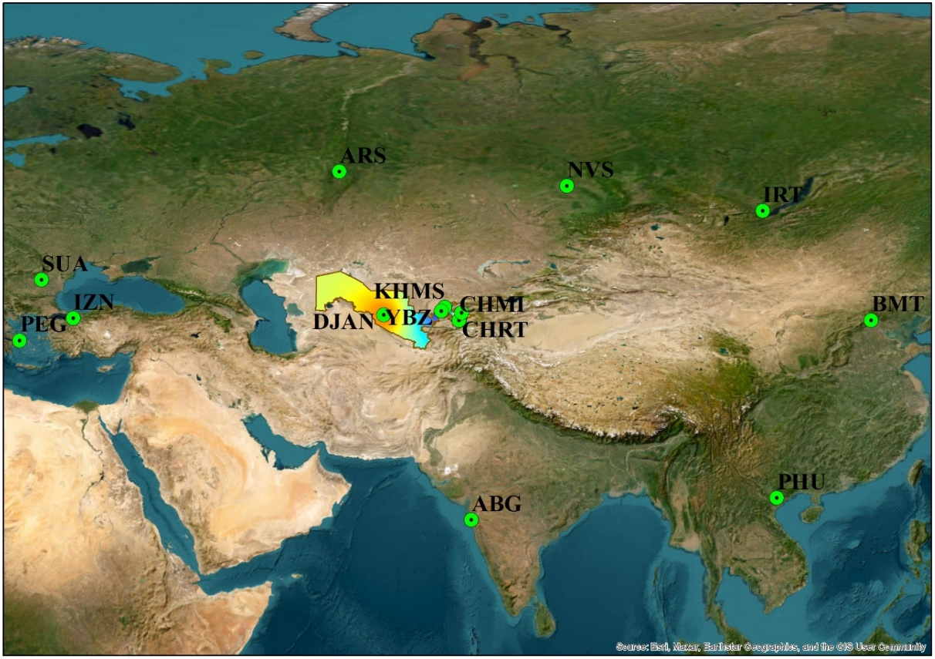
FIGURE 1. A map of 15 magnetometric stations situated in Uzbekistan and 16 international permanent magnetometric observatories incorporated into the INTERMAGNET database.

Based on the data from 15 magnetometric stations located in Uzbekistan and 16 international permanent magnetometric stations included in the INTERMAGNET database, maps reflecting the secular variations of the Earth’s absolute geomagnetic field were developed (fig. 2). This work is widely used not only for scientific analysis but also for seismic forecasting, geophysical modeling, and emergency preparedness.

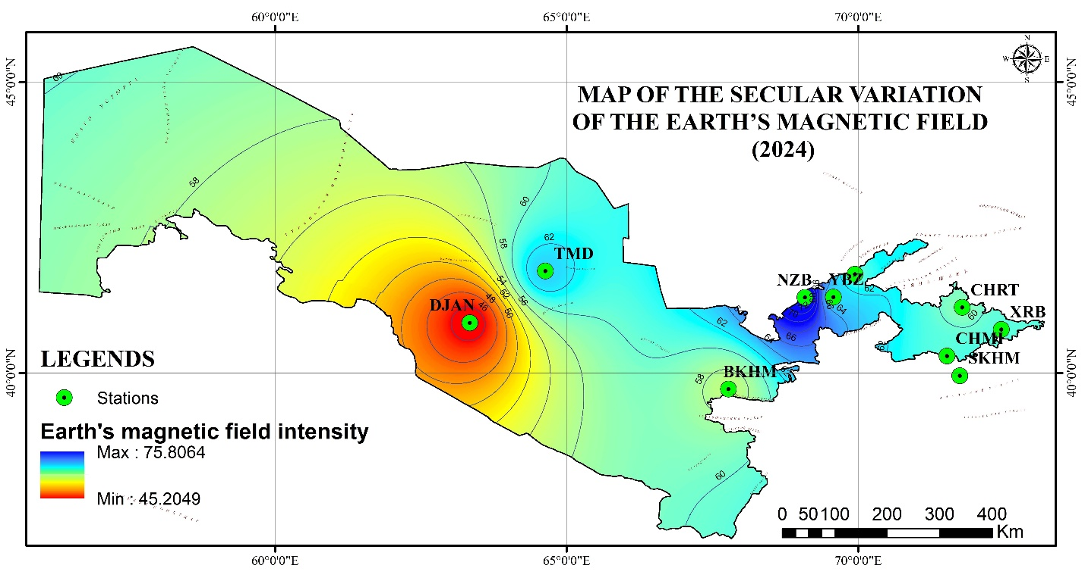
FIGURE 2. Map of secular variations of the Earth's magnetic field (Yusupov V.R. 2025).
A comprehensive analysis of the geomagnetic field status and its absolute variations in the Central Asian region was conducted. According to the study results, the observed changes in the geomagnetic field are classified into two main groups based on their different sources:
Global and regional variations — These primarily arise from dynamic processes within the Earth’s core (such as flows of liquid metal) and external sources in the Earth’s magnetosphere and ionosphere (such as solar winds and radiation belts). These variations are observed globally, including Central Asia, and may exhibit annual, decadal, or secular trends.
Local anomalies — Such variations are often associated with seismogeodynamic activity. Movements of tectonic plates, tectonic faults, and geophysical changes occurring before or after earthquakes are important factors contributing to the emergence of local geomagnetic anomalies.
The absolute Earth magnetic field map is a crucial geophysical information source that shows the precise, regionally distributed values of the geomagnetic field on the Earth’s surface. This map holds particular importance for continuous monitoring and analysis of seismogeodynamic processes due to the following aspects:
Identification of seismically active regions: Local anomalies in the Earth’s magnetic field are often related to mechanical stresses, tectonic movements, or fault systems in the Earth’s crust. These anomalies are visually represented on the map, enabling early detection of areas with high seismic risk.
Monitoring dynamic changes: Tracking temporal variations in absolute magnetic field values allows assessment of geodynamic activity trends beneath the surface, supporting seismic forecasting and analysis.
Searching for seismic precursors: Abnormal changes in the Earth’s magnetic field may be observed prior to strong earthquakes. The absolute magnetic field map facilitates analysis of the initiation points and dynamics of these changes, which can serve as seismic precursors.
Enhancing earthquake resilience: Regional magnetic field maps aid in engineering-geophysical evaluations to assess and improve the seismic resistance of buildings and infrastructure, preparing them for strong earthquakes.
Primary resource for scientific research and modeling: Absolute magnetic field data serve as the foundational input for constructing geophysical models, understanding processes in the Earth’s core and mantle, and conducting geodynamic simulations.
Furthermore, regular updates of these maps ensure the accuracy and effectiveness of seismogeodynamic analyses. Maps developed from data collected by magnetometric stations in Uzbekistan are considered one of the key tools for improving seismic safety in the country.
The analysis shows that monitoring local variations in the magnetic field in seismically active regions like Central Asia plays a crucial role not only in geophysical research but also in practical measures for earthquake forecasting and preparedness.

DISCUSSION OF THE RESULTS.
The results of this research provide a comprehensive understanding of the geomagnetic field behavior in Uzbekistan and the wider Central Asian region. By integrating long-term observational data from 15 national magnetometric stations and 16 international observatories from the INTERMAGNET network, the study effectively mapped both absolute values and secular variations of the Earth’s magnetic field. These maps are not only valuable for advancing geophysical knowledge but also for practical applications, including seismic hazard assessment, regional geodynamic analysis, and infrastructure planning in seismically vulnerable areas.
One of the key findings is the distinction between global/regional secular variations and local geomagnetic anomalies. Global and regional variations, driven by large-scale processes in the Earth’s outer core, show gradual and consistent changes in magnetic field strength and direction over time. These trends align well with international geomagnetic models such as the IGRF. In contrast, local anomalies are more abrupt and spatially limited, often linked to tectonic stress, fault activity, and crustal deformation. These local variations are particularly relevant for identifying seismically active zones and understanding pre-earthquake geophysical signals.
The geomagnetic maps developed in this study offer multiple benefits. They help visualize areas of increased tectonic stress, support the identification of possible seismic precursors, and assist civil defense and urban planning efforts in strengthening infrastructure resilience. Scientifically, the data contribute to modeling deep Earth processes, enhancing our understanding of the geodynamo and its interaction with lithospheric activity. These outcomes show that geomagnetic monitoring can serve as both a research tool and an applied method for disaster risk reduction.
The integration of national and international datasets is a significant strength of this research. Combining the dense spatial coverage of local stations with the temporal stability of global observatories has allowed for more accurate interpolation and validation of geomagnetic trends. This approach improves the precision of regional models and enables detection of subtle anomalies that might otherwise be overlooked. Moreover, the long-term nature of the data series used allows for confident trend analysis and provides a reliable baseline for future studies.
Despite its contributions, the study also highlights certain limitations. Station density remains insufficient in some geologically complex areas, affecting spatial resolution. In addition, data inconsistencies and calibration issues at some stations may influence long-term analyses. To strengthen the research further, expanding the network of high-quality magnetometric stations and conducting multidisciplinary studies—combining geophysical, seismic, and geodetic data—is essential. Future efforts should also focus on confirming the role of geomagnetic anomalies as seismic precursors, which could significantly improve earthquake prediction capabilities in the region.

CONCLUSIONS
This study highlights the critical role of integrating data from Uzbekistan’s 15 national magnetometric stations and 16 international permanent stations from the INTERMAGNET network to develop detailed maps of the Earth’s absolute geomagnetic field secular variations. The resulting maps provide valuable insights into both global/regional and local geomagnetic changes, which are essential for understanding the complex geodynamic processes occurring beneath the Earth’s surface.
The ability to identify and monitor local geomagnetic anomalies associated with seismic activity enables earlier detection of seismically active zones and supports improved earthquake forecasting and risk mitigation efforts. Furthermore, the continuous updating and analysis of absolute geomagnetic field data contribute significantly to advancing geophysical modeling, enhancing seismic safety, and aiding emergency preparedness in Uzbekistan and the broader Central Asian region.
Overall, the integration of national and international geomagnetic observations proves indispensable for both scientific research and practical applications related to seismic hazard assessment, making this approach a vital component of modern geophysical monitoring systems.

ACKNOWLEDGEMENTS
The authors would like to express their sincere gratitude to Professor S.Kh. Maksudov and A.I. Tuychiev for their valuable input and participation in scientific discussions that significantly contributed to the interpretation of the research findings. This work was carried out with the financial support of the Institute of Seismology and the Academy of Sciences of the Republic of Uzbekistan, within the framework of institutional budgetary funding. Additional support was provided by the Agency for Innovative Development under the Ministry of Higher Education, Science and Innovation of the Republic of Uzbekistan, through State Scientific Project grants FL-9524115127 and AL-582205639. The authors gratefully acknowledge this support, which enabled the continuation and advancement of long-term seismomagnetic research in Uzbekistan.

REFERENCES
- C.C. Finlay and N. Olsen, Earth Planets Space 68, 112 (2016).
- N. Gillet, D. Jault, C.C. Finlay and N. Olsen, Geophys. J. Int. 199, 813–830 (2014).
- V. Lesur, I. Wardinski, M. Rother and M. Mandea, Geophys. J. Int. 183, 1216–1230 (2010).
- T.J. Sabaka, L. Tøffner-Clausen, N. Olsen and C.C. Finlay Geophys. J. Int. 200, 1596–1626 (2015).
- G. Hulot, C. Eymin, B. Langlais, M. Mandea and N. Olsen, Nature 416, 620–623 (2002).
- P. Alken, E. Thébault and Beggan C., et al., Earth Planets Space 73, 49 (2021).
- W. Brown, S. Macmillan and C. Beggan Earth Planets Space 73, 173 (2021).
- V. Yusupov, A. Soloviev and R. Sidorov, Russ. J. Earth Sci. 22(6), 2–14 (2022).
- V. Yusupov and E. Khakimov, Earthquake 3(2), (2025).
- S.Kh. Maksudov, V.R. Yusupov, E.N. Khakimov, K.A. Sagdullaeva, B.B. Shakhriyev and S.X.Nazarov, Russ. J. Earth Sci. 25, ES4009 (2025).

