The Modern Geodetic Instruments for Determining Movements in Zones of Active Tectonic Faults
Khodjimetov Alinazar^{1, a)}, Toychiev Khojiakbar², Shukurov Zukhriddin³, Tukhtameshov Fayzulla^{1,4} and Allamberdiev Iskandar⁵
¹ Academy of Banking and Finance, Movarounnahr Str. 16, Tashkent, 100000, Uzbekistan,
² National University of Uzbekistan, University Str. 4, Tashkent, 100174, Uzbekistan,
³Institute of Seismology, Zulfiyakhanum Str. 3, Tashkent, 100128, Uzbekistan,
⁴Institute of Astronomy, Astronomy Str. 33, Tashkent, 100052, Uzbekistan,
⁵Institute of Geology and Geophysics, Olimlar Str. 64, Tashkent, 100164, Uzbekistan.
^{a)} Corresponding author: maxturon@mail.ru
Abstract. The article presents the results of determining modern movements of the Earth's crust in the area where the Karjantau and Tavaksay faults intersect using GNSS devices. Modern Galaxy G1+ GNSS devices from the Chinese company South were used in field studies. The measured data were processed using TBC and GAMIT-GLOBK software. The role of modern geodetic instruments in the study of active tectonic fault zones is described.

Introduction
Research on recent horizontal movements of the Earth's crust is being conducted at geodynamic test sites in the Republic of Uzbekistan. Quantitative methods for studying recent Earth's crust movements include high-precision geodetic measurements. Due to the complexity of performing measurement work, little attention has been paid to the study of horizontal movements. Previously, measurements were mainly carried out in specific areas, around hydraulic structures, in large cities, and in epicentral regions of strong earthquakes. As a result, the relationship between horizontal movements of the Earth's crust and seismicity has been poorly studied. The first steps in studying horizontal movements of the Earth's crust were taken in the 1960s-1970s in Central Asia, and the reduction method was used in the study and processing of recent horizontal movements [1].
Based on the analysis of GNSS results obtained in recent years, V.I. Ulomov acknowledged the significance of horizontal tectonic movements, which are crucial for the development of the Earth's crust and the entire lithosphere, including research conducted in the regions of Russia and Central Asia. It has been demonstrated that GNSS can not only provide accurate and high-quality information about modern geodynamics but also effectively address issues related to comprehensive monitoring [2].
It is known that in the Karjantau fault zone, 7 earthquakes with magnitudes ranging from 6 to 8 have been recorded over the past 80 years. These include the 1937 Pskem earthquake (M=6.5), the 1959 Burchmulla earthquake (M=5.7), the 1966 Tashkent earthquake (M=5.3), the 1971 Abay earthquake (M=4.4), the 1977 Tavaksay earthquake (M=5.3), the 1980 Nazarbek earthquake (M=5.5), and the 2008 Tashkent earthquake (M=4.7). A total of 41 strong and more powerful earthquakes have occurred in the Tashkent region [3].
The territory of Tashkent city and its adjacent districts is one of the most densely populated regions of the Republic of Uzbekistan according to demographic indicators. Furthermore, considering the location of many industrial facilities of significant importance for the economic development in these regions, it is crucial to conduct geological, geophysical, and geodetic surveys to assess the seismic condition of the region.
Research objectives: to study the geological and tectonic structure and seismicity of the Karjantau deep fault and its surrounding territories; to analyze previous geodetic works; to conduct geodetic measurements and thereby investigate the horizontal and vertical movements in the area where the Karjantau deep fault intersects with the Tavaksay fault and adjacent territories.
The research employed modern space geodetic methods - GNSS surveying (using GNSS equipment from the Chinese company South). GNSS data processing was carried out using TBC and GAMIT-GLOBK software, and the obtained results were summarized and compared with geodynamic processes.
The Karjantau fault extends along the southeastern part of the Karjantau range, first identified by V.N. Veber in 1934. It runs from the village of Khandaylik in the northeastern direction, along the right bank of the Pskem River, and the Paleozoic deposits continue to the point where they rise above the Mesozoic-Cenozoic deposits. It continues as a flexural-disjunctive fault zone in the southwestern direction, passing beneath the Mesozoic-Cenozoic sediments of the Keles, Nazarbek, and Tashkent depressions, and reaches the Syrdarya river. Its total length is 150 km, and it is considered a seismically active region [4].
From a geological perspective, the structure and developmental characteristics of this region were studied by
T.N. Dalimov, V.A. Arapov, V.V. Mikhailov, V.N. Tkachev, and numerous other researchers. Particularly after the strong earthquakes that occurred on April 26, 1966, in Tashkent (M=5.3) and December 6, 1977, in Tavaksay (M=5.0), extensive studies were conducted on the southeastern part of the Karjantau uplift and its adjacent territories [3].
The Chatkal-Kurama Range has a complex geological structure and is part of the Middle Tien Shan. This region is divided into two formational-structural parts: The Karatau-Naryn and Beltau-Kuramin districts. Three distinct structural layers are clearly identifiable here, each belonging to one of three tectonic cycles [5].
It was noted that the region's bedrock consists of Lower Proterozoic formations, including metamorphosed, heavily altered rocks, granite-feldspar schists, gneisses (a mixture of feldspar, gravel, and schistose rocks), liquid marbles, quartzite’s, and amphibolite’s, as well as shale layers [6,7,8].
Beneath the Caledonian formations, this area consists of metamorphosed sedimentary-volcanic sequences dating back to the Early Paleozoic, Silurian, and Devonian periods. It has been noted that these rocks were eroded during isoclinal uplifts in zones of extension along northwestern latitudes [6,7,8].
The Hercynian structural layer is separated from the Caledonian layer at a regionally disproportionate angle. This layer consists of volcanogenic-sedimentary formations from the Middle Devonian and Permian periods and is characterized by rift-block tectonics [6,7,8].
The levels of these structures reflect the geological history of the area in terms of age, dynamics, and significance. A relatively ancient state is observed in latitudinal faults; these areas are considered to have the form of ruptures and uplifts dating back to the Middle Carboniferous period. The faults appear as ruptures and displacements in the northeastern direction. Diabase and acidic porphyry layers are associated with these areas. The mixing of orogenic layers is observed in the area of the northeastern rift, which is relatively young [6,7,8].
The Alpine structural layer formed during the Mesozoic and Cenozoic eras. Two stages are distinguished in the history of its development [6,7,8].
The first includes the Triassic-Pliocene period. This area belongs to the subplatform regime and consists mainly of sedimentary rocks, clusters of rock complexes with relatively weak tectonic movements. However, in the layers belonging to the Middle Cretaceous period, restructuring begins, and a period of subsidence and uplift occurs along the northeastern latitudes [6,7,8].
The second stage has an orogenic character, belongs to the Eocene-Anthropogenic period, and ends with the modern epoch [6,7,8].
Neogene period. Neogene deposits include continental layers of sufficient thickness consisting of reddish and brown Skalas sandstones. In this area, the Neogene layer is divided into three formations:
a) Keles formation (brick-reddish, mostly with fine soil) - Oligocene-Lower Miocene;
b) Chirchik formation (reddish-brown, with fine soil or gravel-sand) - Miocene;
c) Mirzarabat formation (light brown, conglomerate) - Pliocene.
The Keles formation exposes the Sumsar layer. Its base consists mainly of spotted sandy-marly rocks, large scattered effusive rocks, and, in some cases, quartz-siliceous rocks dating back to the Paleogene period. This formation consists mainly of siltstones, brick-red marly clays, which are homogeneous, non-layered, dense, and sometimes merge with the Sumsar stratum. The thickness of this formation is 50-150 meters [6,7,8].
The Chirchik Formation has a limited distribution. The layers of this formation consist of reddish-brown and thin-bedded siltstones, clays and siltstones, sandstones, and loose conglomerates. In the upper part of the section, mainly in the gravelly sand layer within the Paleogene limestone’s, oyster remains have been found. This layer is characterized by signs of alluvial origin. The thickness of this formation is 140-400 meters [6,7,8].
The Mirzabat series is relatively widespread and characterized by a fairly homogeneous composition. This layer penetrates the siliceous Skala series, while the upper surfaces of the marine Paleogene layer are subject to erosion. The layer consists mainly of reddish-brown siltstones, with sand and conglomerates also present in its composition. The thickness of this series reaches 700 meters [6,7,8].
Quaternary period. The Quaternary period is characterized by widespread distribution in the territory. This layer differs from the low-mass layer of the Neogene period and forms deluvial, eluvial, alluvial, and proluvial layers. The following Quaternary deposits have been identified in the region:
Eopleistocene - QI
Pleistocene - QII
Holocene - QIII
The Eopleistocene complex layer has relatively limited development and is characterized by an eroded denudation surface layer, corresponding to the section of eroded soils [6,7,8].
The Pleistocene complex layers are composed of loess and loess-like clays with high carbonate content, forming two terraces. Gravel is also abundant in these layers [6,7,8].
The Holocene complex layers contribute to the formation of terraces, watersheds, and watercourses [6,7,8].
The Tashkent region was formed mainly as a result of uplift deformations during the Hercynian period. Relatively large morph structures include the Karjantau Range - Karjantau anticline (southern slope), the Chirchik syncline, the northern slope of the Alizor Range, and a number of local structures. The Karjantau anticline is bounded by the Karjantau fault on the side of the Chirchik syncline (Fig.1) [6,9].

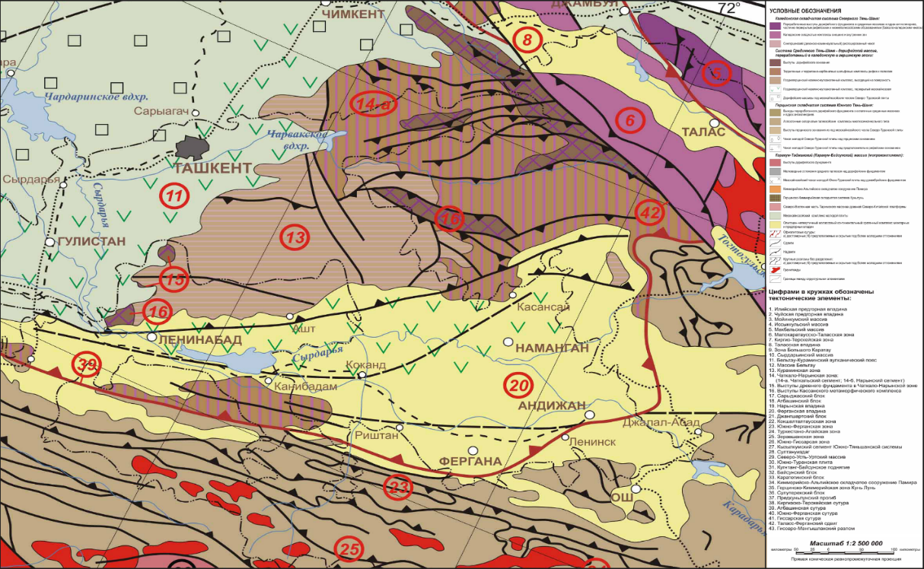
FIGURE 1. Tectonic map of Tashkent and adjacent areas [10]
The Karachatau fault along latitude and the Kokpak fault along longitude are located in the Tavaksay geodynamic test site. The Karjantau fault runs along the southeastern slopes of the eponymous range. It is characterized by the clear manifestation of Paleozoic rocks in Mesozoic-Cenozoic sediments along its entire length. The slope of the sliding surface in the northeastern direction is 40-45°. The vertical amplitude of the thrusts is 3000 meters. Displacements along the thrust lines reach amplitudes of up to 100 m on the Chirchik River terrace in the Karachаtau sequence. Apparently, faults dating back to the Paleozoic period were actively developing during the Quaternary period. The fault activity indicates that earthquake epicenters of different energy classes are located in this area. In particular, this is confirmed by the earthquake in Tavaksay that occurred on December 6, 1977 [6,9].
Active faults in the city of Tashkent and its surroundings are characterized by diverse orientations. Among them, the Karjantau fault is the most seismically active. This fault zone is characterized as a period of fault formation with left-lateral uplifts and displacements in the northeastern direction. The fault zone extends in stages (from northeast to southwest), starting from the Talas-Fergana fault and adjoining the West Tian Shan fault. The Karjantau fault in its modern structure is bounded by sub latitudinal uplifts and depressions. The fault zone consists of a series of structural blocks (from northeast to southwest), northern faults - along the western and meridional directions, and was active during the Holocene (Ugam, Kumbel, Aksakata, Kokpak, Almalyk, Chimkent-Dushanbe and others), bounded by faults [6,9].
The modern structure of the region was formed during the Alpine period of tectogenesis. Unlike the Hercynian period, in the New stage, the uplifts and associated faults developed on the other side, i.e., in a northeastern direction. Quite large uplifts are the Karjantau, Chatkal, and Kurama uplifts, with the Chirchik-Mirzachul and Angren synclinal regions located between them. These structures have been complicated by late, young, and modern movements of the Earth's crust [6,9].
The Tavaksay Geodynamic Test Site was established in 1978 following the Tavaksay earthquake, initiated by scientists from the Institute of Seismology of the Academy of Sciences of the Republic of Uzbekistan. V.G. Leukhin, V.N. Yem, R. Ilyasov, A.M. Morokhov, S.A. Irushkin, A.S. Sattarov, B.S. Saidkhonov, Z.M. Zhumaniyozova,
Sh.Kh. Abdullayev, and other specialists actively participated in studying the geodynamic test site. The Tavaksay geodynamic test site is one of the areas in Uzbekistan where geodetic observations are conducted systematically (regularly) [11].
The results of regular geodetic observations (since 1978) are described in detail in the published works of
D.Kh. Yakubov, A.R. Yarmukhamedov, and others. The intersection zone of the Karjantau and Tavaksay faults, in terms of area and displacement amplitude, is one of the active tectonic zones of the Tashkent region [11].

Materials, methods, and objects of study
The first instrumental observations of vertical tectonic movements at the Tavaksay geodynamic test site were conducted at repeat observation points from June 1978 to 1985. From 1985 to 1990, the measurements were interrupted. In May 1990, work on measuring quantitative tectonic characteristics was resumed and continued until 1995. All leveling results are detailed in the works of D.Kh. Yakubov and A.R. Yarmukhamedov [11].
At the Tavaksay Geodynamic Test Site, special triangulation survey work, i.e., linear-angular measurement work, was carried out in 18 cycles from 1979 to 1984. In June 1993, 1st class trilateration and 2nd class high-precision leveling were conducted [11].
As a result of comparing the results of an electronic distance meter and special triangulation surveys, D.Kh. Yakubov, A.R. Yarmukhamedov, et al. (1978-1985) came to the following conclusion: typically, before strong earthquakes at the Tavaksay test site, processes of stretching were initially observed, followed by compression. The development of tectonic events at the geodynamic test site demonstrates the possibility of studying both vertical and horizontal movements and conducting specialized research to identify criteria for seismotectonic activity of the Earth's crust and precursors for earthquake prediction [11].
Additionally, to determine the quantitative characteristics of modern tectonic movements of the Earth's crust, comprehensive geological-geophysical and geodetic studies were conducted at the Tashkent Geodynamic Test Site in early 2016. The results of this research can be considered the first steps in quantitatively assessing deformations of the Earth's crust [3].
As part of the research work on assessing the seismic activity of the Karjantau deep fault based on a complex of geological, geophysical, and geodetic methods, field observations using a tachometric instrument were conducted quarterly at the Tavaksay geodynamic test site, specifically on 06.05.2016, 11.07.2016, and 14.12.2016. Below, in Fig.2, a plan view of the points where geodetic measurements were carried out at the Tavaksay geodynamic test site is shown [3].
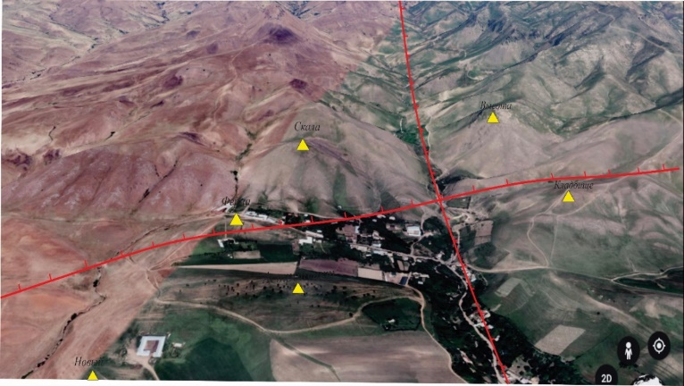
FIGURE 2. Diagram of the geodetic point locations at the Tavaksay geodynamic test site
The distances between geodetic points are: "Ferma" and "Skala" 507 m, "Skala" and "Kladbishe" 651 m, "Kladbishe" and "Visota" 472 m, "Visota" and "Noviy" 268 m, "Noviy" and "Astropunkt" 645 m, "Astropunkt" and "Ferma" 696 m. A three-dimensional terrain model was created using GIS technologies based on radar space imaging data collected in the research area Fig.3.
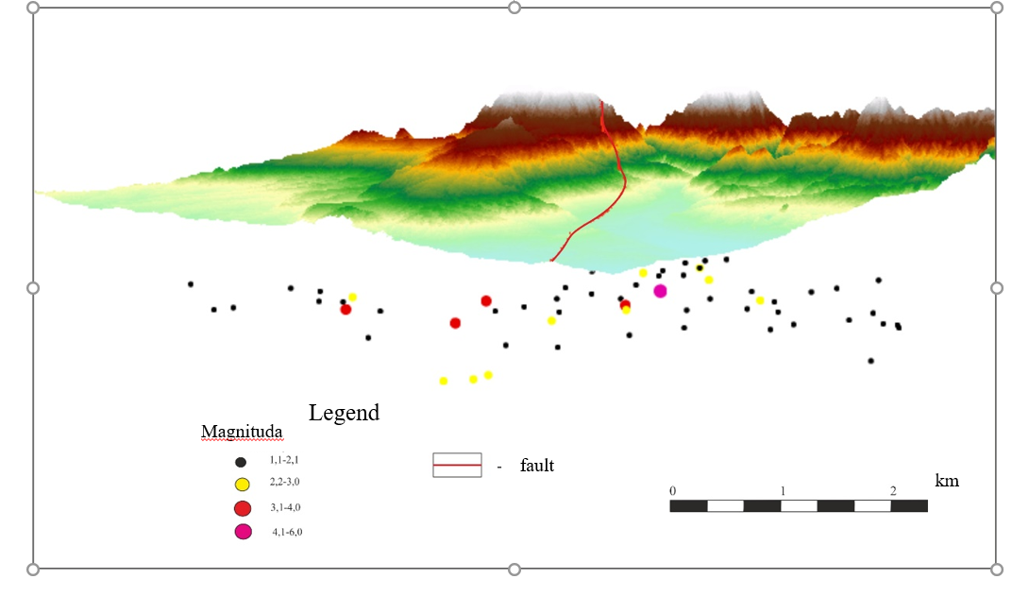
FIGURE 3. 3D model of the relief and seismicity of the Tashkent region
As a result of the conducted research, the outcomes of tachometric measurements carried out in 2016 at the Tavaksay geodynamic polygon were processed and analyzed using the same system as the leveling results from 1979. Consequently, 36-year vertical movements of benchmarks were determined (Fig.4) [3].
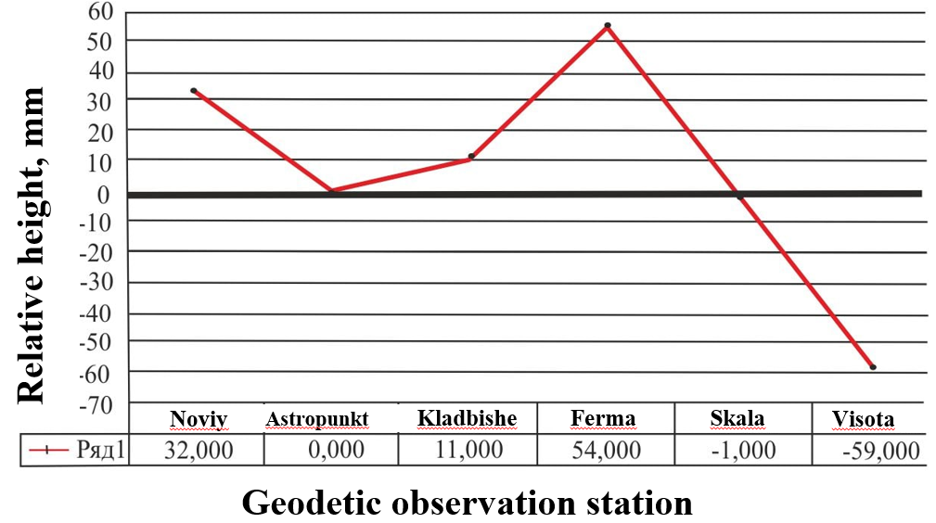
FIGURE 4. Graph of 36-year vertical movements of benchmarks at the Tavaksay geodynamic polygon [3]
Figure 4 shows the relative "Visota" values in mm. At the "Skala" and "Visota" points located north of the Karjantau fault, subsidence of the Earth's crust of -1 mm and -59 mm was observed. At the "Noviy", "Kladbishe" and "Ferma" geodetic points located in the southern part, rises in the Earth's crust of 32 mm, 11 mm, and 54 mm respectively were observed [3].
It has been established that the magnitude of vertical movements of the Earth's crust at the "Ferma" and "Visota" points has increased significantly compared to other points. This is likely related to these points being located close to the Karjantau deep fault (Fig.5) [3].
Based on the information presented above, it is clear that continuing comprehensive geodetic monitoring at the Tavaksay micropolygon is crucial.
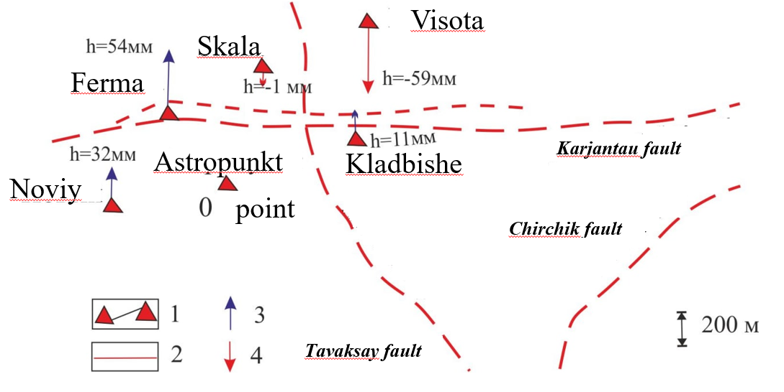
1-triangulation points, 2-faults, 3-vertical movement (+), 4-vertical movement (-)
FIGURE 5. Plan map of 36-year vertical movements of benchmarks at the Tavaksay geodynamic testing ground [3]
In light of the above, observations using modern geodetic instruments were conducted twice in 2022 (on 10.04.2022 and 21.08.2022). GNSS devices manufactured by the Chinese company South were used (Fig.6).
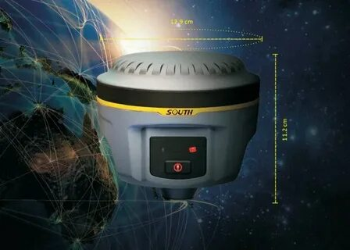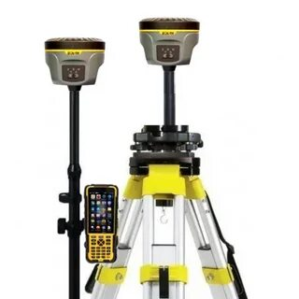

FIGURE 6. South Galaxy G1+ GNSS Device
GNSS - global navigation satellite systems include the following systems: US GNSS; Russian GLONASS; Chinese BeiDou; French DORIS; European Galileo and others [12,13].
GNSS systems consist of space segments (navigation satellite systems), ground segments (users, devices, etc.), and control segments (central control point, ground antennas). With the help of GNSS, it is possible to reliably and accurately obtain precise coordinates, altitude, exact time, as well as the speed and direction of modern Earth's crust movements. To determine the location of a receiver on Earth, we need to know the coordinates X, Y, H; therefore, to determine them, we need to receive signals from at least four satellites [14,15].
The scheme of radio signal transmission from navigation satellites and measurement of "pseudo" distances to ground receivers is shown in (Fig.7).
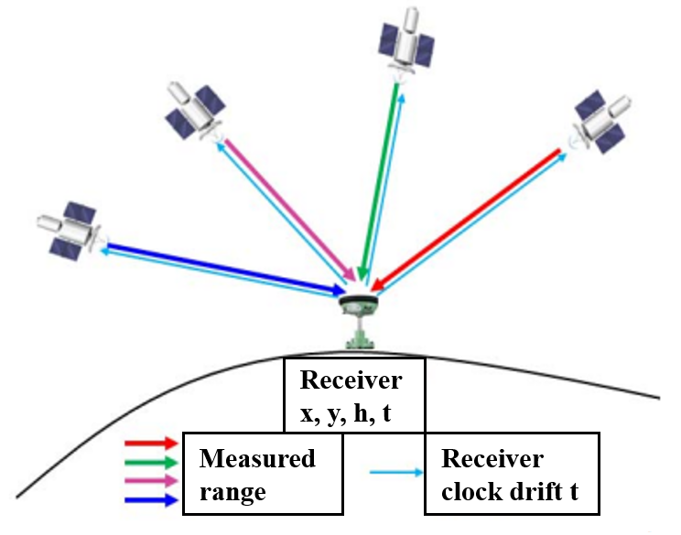
FIGURE 7. Diagram of satellite signal reception by ground devices
The modern South GNSS Galaxy G1+ equipment operates in two different modes: RTK and static. Research work was carried out in static mode, with observations conducted at 6 stations: Base-2108, Astropunkt-2598, Ferma-2566, Kladbishe-4391, Visota-4132, Skala-2411. For the base in static mode, a point next to the Astropunkt was selected. Two GNSS geodetic instruments were set up: the first was installed at the base point (remaining there until the completion of measurements), while the second was used to measure other points.
TBC (South Geomatics Office) and GAMIT-GLOBK software were used to interpret the obtained data. The points are connected to the base (Fig.8). After interpreting the vector lines between the points, the points were linked to each other using mathematical calculations.
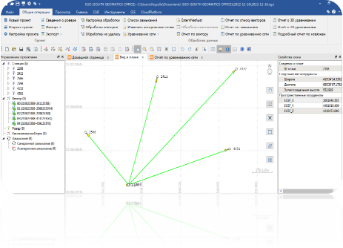 | 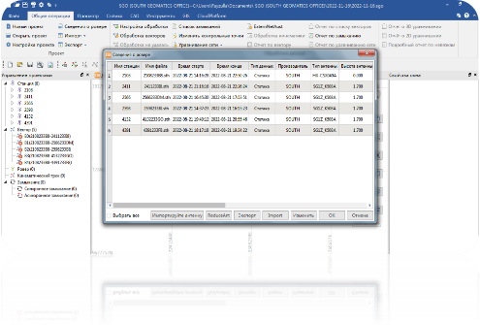
FIGURE 8. The process of interpreting the obtained data in the TBC program
Detailed processing of GNSS data was carried out using the GAMIT-GLOBK program developed by scientists at the Massachusetts Institute of Technology, which runs on the Linux/Unix operating system. The advantage of the program is its semi-automatic operation [16,17,18].
GNSS data available on the Internet, GNSS data from partner organizations, and measured GNSS data are collected for processing in the form of a GNSS data flow diagram shown below.
In the first stage of processing using the GAMIT program, GNSS data measured by partner organizations and in field conditions are entered into the system along with data from global GNSS networks. This essentially standardizes all GNSS device characteristics. Since the processing is semi-automatic, it is necessary to input all data for processing. The reason why GNSS data has not been fully processed to date is precisely due to the aforementioned reason [18].
"Raw" data measured in field conditions is transmitted to a computer. GNSS data is then converted to RINEX format using a special program called TEQC [18].
When processing in GAMIT is halfway complete, graphs reflecting the accuracy of GNSS station h-files are generated. The accuracy of h-files is verified using these graphs. If we are satisfied with the accuracy of the h-files, we proceed to the next steps. Otherwise, we return to the first step and check that everything is in place and correct, after which the process resumes [18].
In the final stage of processing using the GAMIT program, time series of point coordinates and a point velocity table are obtained. This table shows the average annual horizontal and vertical motion velocities of GNSS stations [18].
After verifying the correctness of the h-files, they are added, i.e., glx-files are created, and all of this is brought to a general state. Generalized glx files are processed by the GLOBK program [18].
In GLOBK, data processing is semi-automatic, and mainly 2 types of results are obtained:
1. Time series of point coordinates [16,17,18,19].
2. Catalog of benchmark velocities [16,17,18,19].

Conclusion
The obtained data were interpreted using modern software (TBC). During the analysis, the results of the 1st measurement were subtracted from the results of the 2nd measurement, and the vertical and horizontal movements of the points were determined. The largest changes were observed at Ferma-2566, Kladbishe-4391, and Visota-4132.
From this, it can be seen that, based on the results of previous 36-year geodetic work, changes were mainly observed at the Ferma-2566, Kladbishe-4391, and Visota-4132 points.
Taking into account all the above information, it is recommended to use modern geodetic equipment in the future and to continuously monitor the vertical and horizontal movements of the Karjantau and Tavaksay faults and other active zones of the Earth's crust.

Acknowledgments
This research was conducted as part of project No. FL-8824063217, supported by the Agency of Innovative Development under the Ministry of Higher Education, Science, and Innovation of the Republic of Uzbekistan.

References
- A.R. Yarmukhamedov, I.M. Ergeshov, I.S. Valiyev and A.S. Sattarov, Study of the manifestation of modern tectonic movements of the Earth's crust using the geodetic method at the Tavaksay geodynamic polygon in connection with seismicity (Tashkent, IS AS RUz, 2006), 146 p.
- V.I. Ulomov, Dynamics of the Earth's Crust in Central Asia and Earthquake Prediction (Fan, Tashkent, 1974), 216 p.
- Z.F. Shukurov, V.R. Yusupov and E.M. Yadigarov, “Analysis of vertical movement of the Earth's surface in the area of intersection between the Karjantau and Tavaksay faults,” Geology and Mineral Resources 3, 55-58 (2017).
- V.N. Veber, “Methods of Geological Survey,” Field Geology. 2nd expanded ed. - Leningrad; Moscow; Grozny; Novosibirsk, pp. 193-208(1934).
- V.I. Popov, History of Depressions and Uplifts in the Western Tian Shan (Fan, Tashkent, 1938) p. 349.
- V.A. Arapov, Volcanism and Tectonics of the Chatkal-Kurama Region (Fan, Tashkent, 1983) pp. 27-60.
- V.V. Mikhailov, “The Bolgali volcanogenic suite of the Chatkal-Kurama region and its ore content,” Geology and Mineral Resources 6. pp. 19-22 (2012).
- V.N. Tkachev, “Working geological basis of the Chatkal-Kurama region. Sheets XVII, XVIII, XXII, XXIII, XXIV, XXVIII-XXX, XXXIV, XXXV,” Report No. 32996 for 2001-2004.
- N.P. Vasilkovsky and M.P. Repnikov, Tectonics and Seismicity of the North-Eastern Part of the Tashkent Region (Fan, Tashkent, 1940), pp. 127.
- http://www.geokniga.org/maps/6680. Tectonic map of Uzbekistan and adjacent territories, scale: 1:2500000. 2004.
- A.R. Yarmukhamedov, Morphostructure of the Middle Tien Shan and its relationship with seismicity (Fan, Tashkent, 1988) pp.164.
- K.M. Antonovich, “Ways of development of GNSS technologies in geodesy,” Interexpo Geo-Siberia 1(1),
pp. 44-49 (2006).
- M.G. Mustafin, A.I. Kazantsev, “Space Geodesy and Geodynamics. Methods and Technology of Performing Geodetic Works,” (St. Petersburg: Saint Petersburg Mining University, 2017), 23 p.
- A.A. Genike and G.G. Pobedinsky, “Global Satellite Positioning Systems and Their Application in Geodesy,” 2nd ed., revised and expanded. (Moscow, 2004), p.355.
- V.N. Kharisova, A.I. Perova and V.A. Boldina, “Global Satellite Radio Navigation System GLONASS,” (Moscow, 1998), p.400.
- T.A. Herring, B.W. King and S.C. McClusky, “GAMIT. Reference manual. GNSS analysis at MIT. Release 10.3,” (EAPS. MIT. 2006), p.182.
- T.A. Herring, B.W. King and S.C. McClusky, “GLOBK: Global Kalman filter VLBI and GNSS analysis program. Release 10.3,” (EAPS. MIT. 2006) p. 87.
- V.R. Yusupov, Z.F. Shukurov and E.M. Yadigarov, “Analysis of the geomagnetic field and vertical movement near the intersection of Karjantau and Tavaksay faults in Uzbekistan,” Journal "Geodesy and Geodynamics" 12(2), 102-109 (2021). https://doi.org/10.1016/j.geog.2021.01.002
- A.N. Mansurov, “Automation of calculating the velocities of geodetic marks based on GNSS observations,” KGUSTA Bulletin 6, 10-15 (2014).

