Determining the Location of Active Faults Passing Through the Fergana Valley
Zukhriddin Shukurov ^{1,a)} , Ulfat Nurmatov ^{1,b)}, Saydulla Kultayev^{1,c)},
Salimjon Khusanboyev^{1, d)} and Shokhrukh Ismatov^{1, e)}
¹Institute of Seismology, Academy of Sciences of the Republic of Uzbekistan. 3 Zulfiyakhonim Street, 100128, Tashkent, Uzbekistan
^{a)} Corresponding author: zukhriddin85@mail.ru
^{b)} ulfat.nurmatov@mail.ru
^{c)} qultayevsaydulla0221@gmail.com
^{d)} salimjonxusanboyev@gmail.com
^{e)} Ismatovshohruh134@gmail.com
Abstract. This article presents the results of complex radiometric and magnetometric observations conducted in the Fergana valley. As a result of the complex instrumental geophysical observations, the location and directions of the zone of active tectonic faults passing through the territory of the Fergana valley were determined. The effectiveness, performance, low cost, and other important aspects of the complex instrumental geophysical methods used in the study to identify tectonically active faults are described. It is recommended to use this set of methods to determine the locations of tectonic faults that pass through other regions of our Republic and clarify their boundaries.

Introduction
Currently, the study of tectonic faults in the Earth's crust is a crucial stage in understanding their internal structure, development, morphology, seismicity, and the processes associated with ore formation. The blocky, layered, and fractured structure of the Earth's crust, as well as the geodynamic processes occurring within it, determine the current seismicity of the study area. Large earth faults of various sizes, bounded by blocks of the earth's crust, are considered a source of energy accumulation, and this energy sources are spent in the fault zones. Therefore, active tectonic faults are one of the main sources of strong earthquakes. It follows that research into the causes of the strong and destructive earthquakes that have occurred in various seismically active regions of the globe in recent years, causing many casualties and significant economic losses, that is, an in-depth study of fault zones and assessment of their seismic potential, is an extremely urgent task in seismic hazard assessment.
The territory of Uzbekistan is located in the seismically active Mediterranean and Asian seismic belts, and in history, strong and destructive earthquakes have occurred several times, causing casualties and destruction. Since the probability of further destructive and strong earthquakes occurring in the zones of active tectonic faults existing on the territory of the republic is high, the issue of their in-depth study is of urgent importance [1,2,3,4,5].
This research was conducted as part of the project "Scientific study and analysis of indicators of active tectonic faults in the territories of the republic and the development of a database based on the study results, including the creation of electronic maps and passports of active tectonic faults," with financial support from the Fund for Support of Seismology, Seismic Strength of Structures, and Seismic Safety under the Cabinet of Ministers of the Republic of Uzbekistan [6,7,8].

Materials and methods
During the research, stationary and profile magnetometric and radiometric observations were performed. The magnetometry method involves studying the Earth's magnetic field and its anomalies, while the radiometry method focuses on the natural radioactivity of rocks and minerals. Field magnetometric and radiometric measurements were taken using high-precision GEM GSM-19T proton magnetometers and SRP-88 radiometers. Data collected at each point were linked to GNSS data and combined. In magnetometric studies, the anomalous geomagnetic field is determined by subtracting the field values measured in the field from those measured at the base station (Yangibazar station) at the same time [8,9,10].
(1)
Where: ∆T - anomalous geomagnetic field value (nTl), Tp - geomagnetic field value (nTl) measured at the base (Yangibozor station), To - geomagnetic field value (nTl) measured in the field.
Radiometric measurements are determined by averaging the values measured three times at each point. The anomalous radioactive field is determined by subtracting the measured radioactive field values from the normal radioactive field values (normal background).
(2)
Where: ∆R – anomalous radioactive field value (μR/h), R_{p} – normal radioactive field value (μR/h), R_{o} – radioactive field measured in the field (μR/h).

Results
The North Fergana Fault, the North Fergana Flexure Fault, the South Fergana Flexure Fault, the South Fergana Fault, the East Fergana Fault, the Arashan-Pop-Chimyon Fault, the Kumbel-Kukan-Khaidarkan Fault, and the Karachatir Fault pass through the Fergana Valley. The largest of these faults in terms of color, that is, the secondary colored active faults, include the North Fergana and South Fergana Faults. 8 strong earthquakes with M≥5 have occurred in this secondary fault zone from historical times to the present day.
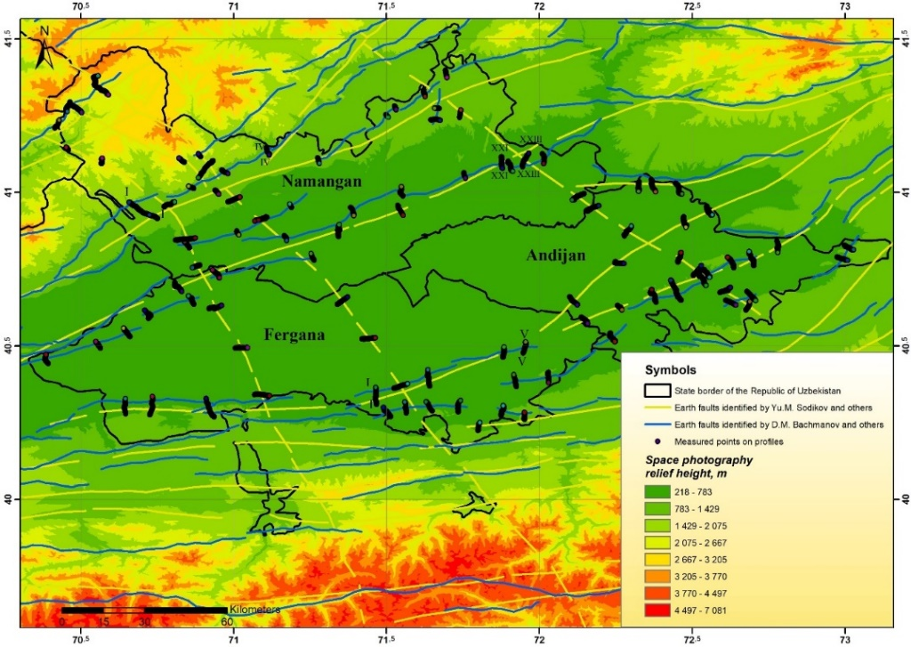
Figure 1. Geophysical surveys conducted in the Fergana Valley
Instrumental observations were carried out on 43 profiles in the territory of Namangan region, 29 profiles in the territory of Fergana region, 28 profiles in the territory of Andijan region, in total on 100 profiles, that is, at about 8000 points with a step of 50 m between points, that is, at a distance of 400 km. In order to determine the location and directions of the Earth's faults in space, magnetometric and radiometric observations were carried out on profiles crossing the fault zones in a perpendicular direction. Field measurements were carried out on profiles crossing the above-mentioned active earth faults perpendicularly. In total, field measurements were carried out on 100 profiles (Fig. 1).
To determine the location of the active fault running through the Fergana Valley, geophysical measurements were conducted on 100 profiles perpendicular to it. As a result, a database was created in Excel, and based on these, graphs of the occurrence of faults in geomagnetic and natural radioactive fields were drawn up for 100 profiles (Figs. 2-5).
In the graph shown in Figure 2-5 above, the blue line shows the current location on the map of the fault zone passing through the Fergana Valley, which was identified by V.G. Trifonov [11], and the yellow line by Ibragimov et al [1]. The purple line shows the anomalous variations that were revealed in instrumental measurements, that is, in geophysical fields. It can be seen from the graphs that the zone marked in purple is the boundary of the fault zone passing through the Fergana Valley, which is clearly distinguished in anomalous geomagnetic and radioactive fields.
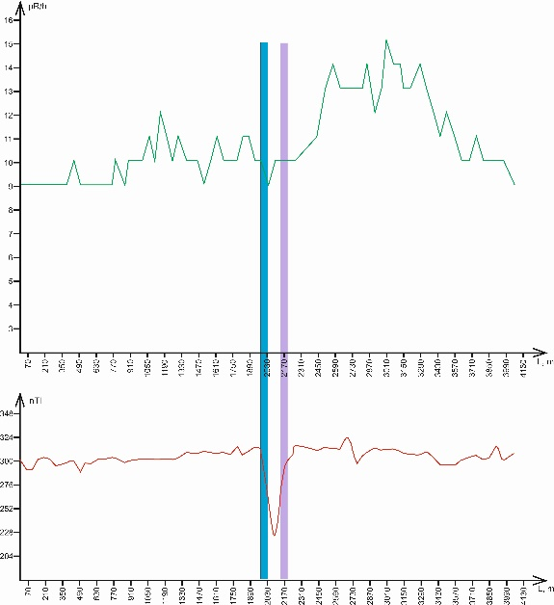
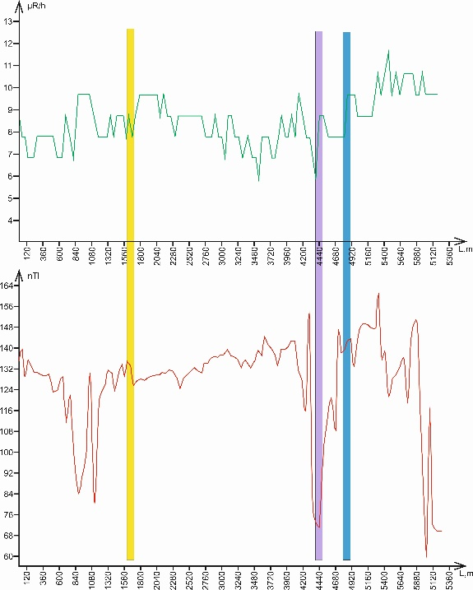
Figure 2. Graph of the Altiarik profile (I-I) Figure 3. Graph of the Mekhnatabad profile (V-V)
In the geophysical fields measured according to the Altiarik profile, the manifestation of the South Fergana flexure fault zone coincided with the radioactive field in the range of 4432 - 4874 meters, and in the geomagnetic field from 4432 to 4874 meters. In the geophysical fields measured according to the results of the Mekhnatabad profile, the manifestation of the active earth fault coincided with the radioactive field in the range of 2035 to 2314 meters, and in the geomagnetic field from 2035 to 2314 meters. In the physical fields observed in the Altiarik profile, the dynamic influence zone of the earth fault was invisible, and its width was on average 442 meters, and in the Mekhnatabad profile, 279 m.
In the geophysical fields measured according to the Uychi 1 profile, the manifestation of the North Fergana flexure fault zone coincided with the radioactive field in the range of 2200-2600 meters, and in the geomagnetic field of 2200-2600 meters. To the Uychi 2 profile, the manifestation of the active fault coincided with the radioactive field in the range of 570-1113 meters, and in the geomagnetic field of 570-1113 meters. The physical fields observed on the Uychi 1 profile showed that the zone of influence of the dynamic fault was prominent, with an average width of 400 m, and 543 m on the Uychi 2 profile. 543 m on the Uychi 2 profile.
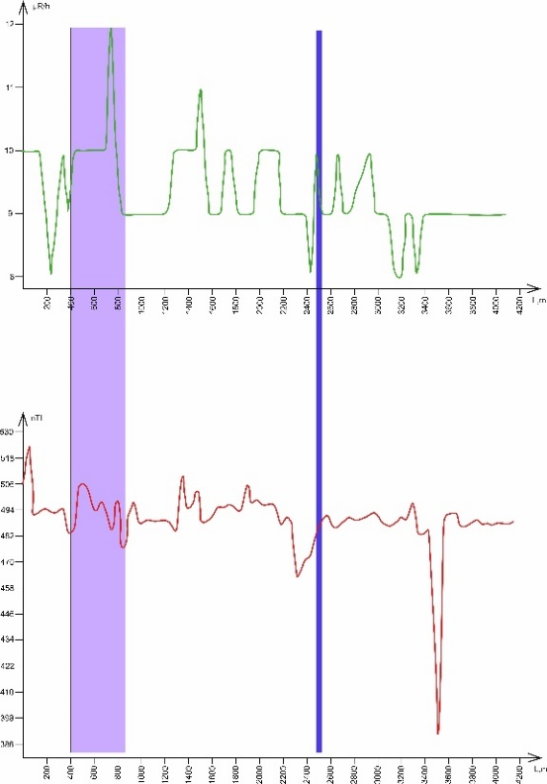 | 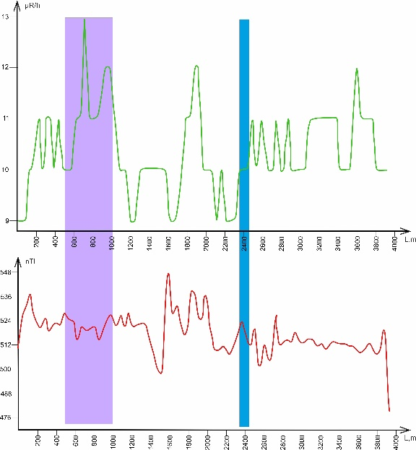
Figure 4. Graph of the profile of Uychi 1 | Figure 5. Graph of the profile of Uychi 2
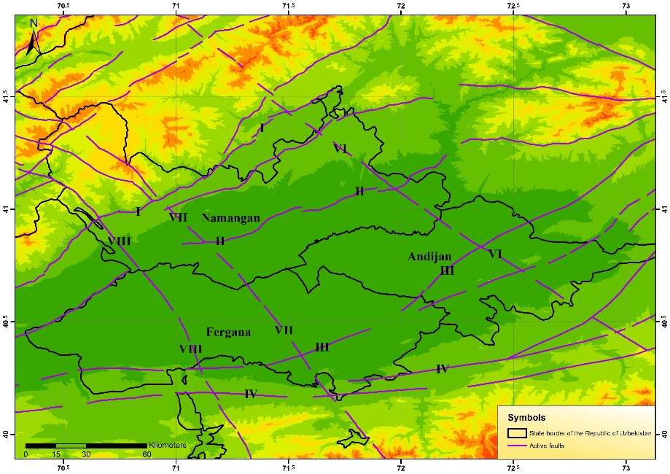
1 - North Fergana fault, 2 - North Fergana flexure fault, 3 - South Fergana flexure fault, 4 - South Fergana fault, 5 - East Fergana fault, 6 - Arashan-Pop-Chimyon fault, 7 - Kumbel-Kokan-Khaidarkan fault
FIGURE 6. Map of active faults in Eastern Uzbekistan and surrounding areas

CONCLUSION
As a result of the conducted observation work, the location and directions of 7 active fault zones passing through the Fergana Valley, as well as the width of the fault for the first time, were determined. It should be noted that the practical achievements obtained based on the results of instrumental geophysical observations conducted in the Fergana Valley are recommended for widespread use in determining the boundaries of tectonic faults passing through other regions of our Republic, compiling their passports, studying their extent by size, assessing the seismic potential of fault zones, assessing their seismic activity in the past and today, creating seismotectonic foundations for seismic zoning maps of various scales being conducted in the republic, and organizing seismic and seismological research at a high level.

References
- R. N. Ibragimov, Seismogenic zones of the Middle Tien Shan (Fan, Tashkent, 1978), pp.144.
- V. A. Ismailov, A. S. Khusomiddinov, Sh. I. Yodgorov, E. M. Yadigarov and B. U. Aktamov, Seismic microzonation map of the territory of Yangi–Andijan: methodology and results 464, 114–130 (2024).
- V. A. Ismailov, A. R. Rakhmatov, A. S. Khusomidinov, E. M. Yadigarov, J. Bozorov, News of National academy of sciences of the Republic of Kazakhstan geology series and technical sciences 5, 131–145 (2025).
- V. A. Ismailov, Sh. I. Yodgorov, A. S. Khusomiddinov, E. M. Yadigarov, Sh. B. Allayev and B. U. Aktamov, Geomechanics and Geoengineering 18, 1–21 (2023).
- A. Khusomiddinov, J. Bozorov, E. Yadigarov, Sh. Allaev and A. Mansurov, Seismic Instruments 11, 1-7 (2025).
- F. Shukurov, International Journal of Geology, Earth & Environmental Sciences 8 (2), 68-75 (2018).
- Z. F. Shukurov, International Journal of Geology, Earth & Environmental Sciences 10(3), 83-92 (2020).
- U. A. Nurmatov, Z. F.Shukurov, V. R. Yusupov, S. K. Kultaev and Sh. E. Ismatov, Reports of the University of Geological Sciences 5, 74-78 (2024).
- U. A. Nurmatov, V. R. Yusupov and Z. F. Shukurov, Journal of geosciences insights 2, 1-6 (2024).
- Y. V. Rustamovich, S. Z. Fazliddinovich and Y. E. Makhmadiyorovich, Geodesy and Geodynamics 12 (2), 102–109 (2021).
- E. A. Zelenin, D. M. Bachmanov, S. T. Garipova, V. G. Trifonov and A. I. Kozhurin, Earth System Science 14, 4489-4503 (2022).

