Probabilistic Methods of Reliability Analysis of Low-Rise Residential Buildings Constructed From Local Materials
Zhanybek Mamatov^{1, a)}
¹Kyrgyz State Technical University named after I.Razzakov, Kyrgyz Republic
^{a)} Corresponding author: janybek@mail.ru
Abstract. In the article deals with general principle issues of application of probabilistic methods to reliability analysis of low-rise clay houses constructed from local materials, as well as compliance of the constructed object with the design characteristics and the degree of violation of such compliance. The article analyses deformation and fracture of semi-brittle materials, which belong to initial inhomogeneous materials and beyond elasticity limit can be interpreted as dissipative structures, and also, the results of a series of experiments on models of low-rise buildings according to classifications of individual dwelling houses are given. Beyond the limit of elasticity in such materials, local areas of sliding surfaces appear, in which macroscopic fractures are gradually prepared in the process of further deformation. In accordance with this we will associate plastic deformation with the formation of sliding surfaces, close to the action of maximum tangential stresses. Therefore, diagrams of the dependence of the maximum tangential stress T on the maximum deformation shear G contain information that takes into account the main stages of elastic-plastic deformation and fracture. When constructing the defining relations, one cannot ignore the effect of plastic loosening characteristic of such materials, which is characterised by the dependence of the relative change of the volume θ on the shear strain G. Based on the results of experimental studies, the seismic resistance of low-rise clay houses, constructed from local materials, has been determined, taking into account economic efficiency and construction technology.

INTRODUCTION
Clay dwellings are one of the most famous and extensive architectural forms in the world. According to the United Nations, one third of the world's population lives in adobe buildings. Earthen material buildings have the advantages of local materials, low raw material cost, good thermal performance, good living comfort and sustainability, so they are widely used in Asian, African and South American countries. However, due to the low strength of the material, the earthquake resistance of earthen buildings is rather poor, as shown by severe damage from previous earthquakes [1].
The walls of dwellings and other buildings have been constructed from soil since long before Christ, Pliny the Elder (23-79). In some countries and cultures, clay is still the main building material in demand. As we know, mankind built not only low-rise huts, but also grandiose constructions out of clay. Suffice it to say that the Great Wall of China, the Thesiphon Arch, the pyramids of Sakkara (Egypt) and Chang-Chan (Peru) were built of clay. In general, clay was used everywhere, even there are multi-storey houses built of clay [2, 3].
In particular, more than half of the population of the Kyrgyz Republic live in rural areas, mainly in mountainous regions. Residential houses and buildings of the population are mostly constructed of clay materials without observing the rules and norms of earthquake resistance, as a result of which they are subject to complete destruction in case of strong earthquakes. Kyrgyzstan is a seismically active mountainous region located on many tectonic faults. Therefore, the presence of the threat of destructive earthquakes is quite understandable. As research results show, the overwhelming part of Kyrgyzstan is prone to 8-9-point earthquakes [4]. At the same time, the traditional types of individual housing construction made of soil blocks and raw adobe have been formed in the territory of Kyrgyzstan so far. In this regard, the need to develop earthquake-resistant structural and planning solutions for residential buildings using local building materials is urgent.
It is well known that the formulation and solution of safety problems of building structures are based on the theory of limit states. The study of structural safety processes in the traditional form can be considered as not meeting modern challenges. The lack of relevant normative documents leads to the fact that the developed innovations can be referred to beyond-design impacts. Such impacts often lead to unexpected failures of structures, which results in economic damage and, as a rule, in loss of life. Analysis of the cause of failures, the consequence of which can be considered as progressive collapses of buildings and structures, determines the relevance and practical applicability of setting structural safety problems in more detailed representations than in the assessment for the first and second groups of limit states.
Recently, in the design of multi-element systems, the countermeasures against cascading failure development and prevention of progressive failure have been solved. The US and Canadian standards introduced the concept of ‘integrity’ of a structure [5]. It is noted in [6] that it seems appropriate, along with the concepts of ‘bearing capacity’ and “serviceability”, to introduce the concept of ‘survivability’ [7, 8]. [7, 8] and it is proposed to define one more group of limit states. The third group of limit states (on survivability) proposed [6] includes limit states characterised by avalanche-like development of failures leading to complete failure of the system elements.
The main objective of this study is to ensure earthquake resistance of low-rise individual residential buildings in compliance with volume planning and structural solutions based on the requirements of design standards, taking into account the achievements of structural mechanics for the entire life cycle of buildings.

MATERIALS, METHODS, AND OBJECT OF STUDY
Basically, a structure is designed so that certain performance parameters are ensured. However, the real situation does not provide an opportunity to guarantee full compliance of the constructed object to the designed characteristics, it is clear that nothing can be said in advance about the degree of violation of such compliance, however, to a certain extent it is possible to provide for the sensitivity of the structure to defects, both initial state and those accumulated in the process of operation. The modern notion of acceptable risk of destruction of construction objects under unusual beyond-design impacts [9], since building structures and materials are semi-brittle (having the properties of brittleness and plasticity), allows us to involve for analytical modelling the theory of damageability of structures and the previously known apparatus of the ‘Theory of Plastic Flow’. In the process of operation, synergetic effects arise in objects [10], and at slow nature of external influence they can be attributed to self-organisation through control parameters. This indicates the usefulness of using methods of the mathematical theory of catastrophes in deterministic modelling [11]. For probabilistic calculations, it is first of all necessary to have a deterministic relationship between the characteristics of a structure and its load-bearing capacity [6]. In our research a measure of damageability (scalar function) was introduced and the developed concept of progressive failure can be applied to other objects [12].
The analysis of deformation and fracture of semi-brittle materials shows the necessity to take into account the cooperative (cumulative) interaction of various processes realised in a dissipative structure. In the study of the behaviour of these materials, several stages can be distinguished, at the first of which the deformations are assumed to be elastic, and are modelled as an elastic-orthotropic medium. In this case, in conditions of axial compression, the volume strain, remaining negative, grows in modulus, and loosening occurs. In the hardening region, which corresponds to a small part of the strain accumulated at the time of fracture, the volume change (compaction) in modulus is decreasing, and the time resistance corresponds to the zero value of the volume strain, which is characteristic of plastic materials, as can be seen from Fig. 1 [13].
Testing of house models was carried out on a seismic platform manufactured and mounted by the employees of the Kyrgyz Engineering and Construction Institute named after N. Isanov (Kyrgyz Republic, Bishkek), which reproduces horizontal vibrations according to a certain law, sufficiently satisfying the requirements of the experimental study of earthquake resistance. Taking this into account, the seismic platform, the general view of which is shown in Figure 2, is made one-component with the following technical characteristics:
- power supply source - AC voltage - 380 V;
- power consumption - 50 kW;
- frequency of oscillation (with protective blocking device) -1 -7,3 Hz;
- amplitude of oscillations - 0,14 - 2,1 cm;
- load capacity - 15 tonnes;
- overall dimensions of the table, mm: - 4200x4200x800.

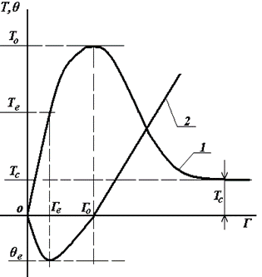 | 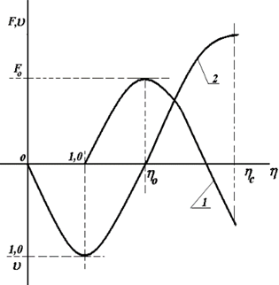
(a) | (b)
FIGURE 1. Qualitative behaviour of passport relationships (curve 1) and (curve 2) and normalisation coordinates F(ƞ) and ϑ(ƞ): where, (a) T - tangential stress, G - shear strain, -volumetric strain, (b) F - normalised stresses, ƞ - normalised shear strains
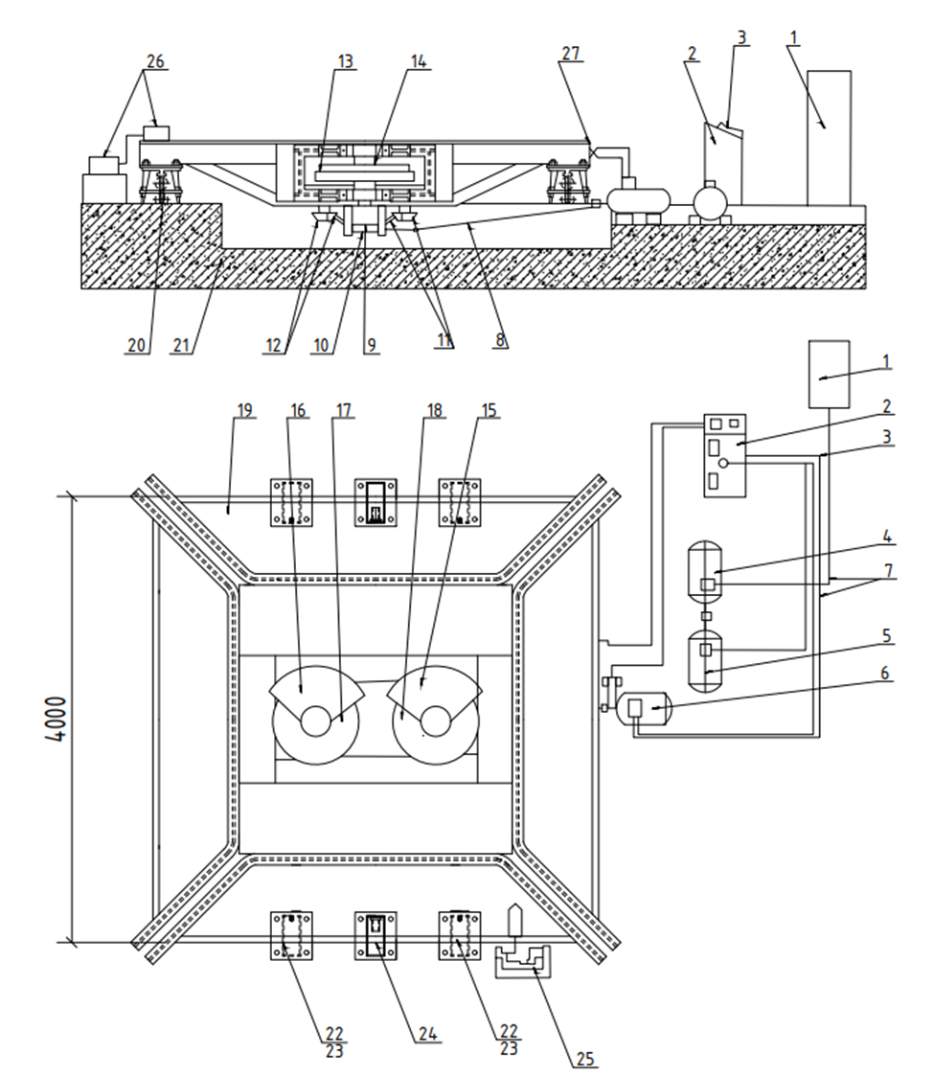
FIGURE 2. Schematic diagram of the test platform: 1-power cabinet, 2-control panel, 3-handle lator, 4-electric motor of three-phase current, 5-generator of direct current, 6-electric motor of direct current, 7-power cables, 8-cardan shaft, 9-reducer of unbalances, 10-reducer shaft, 11-12-conical gears, 13-14-shafts of unbalances, 15-16- main unbalances, 17-18- auxiliary unbalances, 19- seismic platform, 20-support, 21-foundation, 22-pneumatic shock absorber, 23-shock absorber support, 24-safety support, 25-registration of visible record, 26-accelerometer of GeoSIC type, 27-visual indicator-frequency meter.

RESULTS
Theories based on the concept of internal parameters assume that elastic and inelastic deformations take place at each stage of loading, unloading and reloading. Such features of the deformation process as strain rate sensitivity, hardening, the Bauschinger effect, dependence on loading history, reverse creep, unstrengthening, etc., encountered in semi-brittle materials, when deforming metals at elevated temperatures, etc., can be taken into account. At the same time, this theory is applicable only to hardening and elastic-ideal-plastic materials and, first of all, because of the acceptance of the Drucker postulate. In building structures, some nodal joints, depending on the stress-strain state, behave like a semi-brittle material. The behaviour of semi-brittle materials, metals at elevated temperatures and the vast majority of geomaterials (under load) may not conform to this postulate. Therefore, such materials cannot be satisfactorily described by the theory of plastic flow.
Academician M. Y. Leonov studied the stress-strain relations for semibrittle bodies [14] and the phenomena of jump-like transition of materials from elastic to plastic states. Brittle and semibrittle building materials are known to be initial inhomogeneous materials and can be interpreted as dissipative structures beyond the elastic limit. Insufficient knowledge of the physical nature of ongoing processes, random distribution of defects in the material, as well as the uncertain nature of external influences, as a rule, do not allow describing nonlinear deformation processes of semibrittle materials by direct analytical methods.
A peculiarity in the behaviour of semibrittle materials should be considered the presence of a limit region, in which stresses decrease with continued strain growth. At this last stage, the volume strain becomes positive and tends to increase. Beyond the elastic limit in semi-brittle materials, as in other materials, there appear local areas of sliding surfaces, based on the development of the concept of sliding in the interpretation of M.Y. Leonov, in which in the process of further deformation macroscopic fractures are gradually prepared. Professor B.A. Rychkov [15] noted that in a special case full plasticity is achieved when two slip sites become active, this is confirmed by the experimental work of V.A. Panyaev [16]. And in semi-brittle materials plastic deformation is accompanied by loosening, which can also be modelled by visual mechanical representations. The inner essence of such a phenomenon can be modelled using an idealized scheme-mechanism of plastic deformation implementation, which goes back to the ideas of S.A. Khristianovich and E.I. Shemyakin [17-19].
The theory of damageability of structures can qualitatively and quantitatively assess the indestructibility of a structure during the entire design operational time interval, including sudden beyond-design impacts.
On the basis of practical examination of obtained damage to building structures, low-rise buildings built of local materials and analysis of statistical data on buildings of individual residential buildings in the Kyrgyz Republic, we have made a classification of individual residential buildings by types of load-bearing structural systems into 4 types. Taking into account the peculiarities of our country, such as seismicity, highlands and climatic conditions, and according to the mentioned classification in the works [4, 12], about 40% of buildings are built of raw brick or blocks of regular shape; about 15% of buildings have a wooden frame with filling from clay materials or houses built according to the technology ‘Syntch’; about 25% of buildings are ginobitic according to the technology “Sokmo” and ‘Pahsa’; about 20% of buildings have a reinforced concrete frame with filling from clay materials. A number of experimental works on models of houses of the above classification for all four types of load-bearing structural systems have been carried out.
The nature of damage for each of the 4 types of houses made of local materials and the reasons that cause them have been identified. The structural deficiencies of such houses that aggravate the risk of earthquake damage include: weak fastening of the above-ground part of the houses to the foundations; insufficient rigidity of load-bearing structures, leading to cracks, distortions and destruction of walls; attic floors, openings and corner connections also have low rigidity. Frequent collapse of wall infill material is associated with the consequence of their unreliable fixing with the frame elements. There are also horizontal displacements of walls relative to foundations caused by insufficient fixing of lower straps.
Features of individual types of houses were considered in the works [4, 12, 20, 21], below we will dwell in detail on the analysis of each type:
1. A model of a house whose walls are built of earthenite (‘Sokmo’) of regular shape (Fig. 3). For the construction of this model, conventional formworks made of wooden planks 60 cm high were used, which were filled with clay mortar without aggregates, aged until the desired consistency was reached.
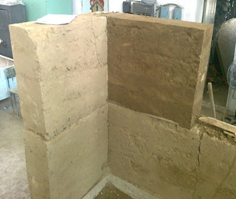 | 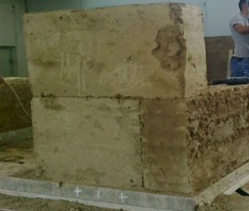
FIGURE 3. Fragment of the wall of the Sokmo house model
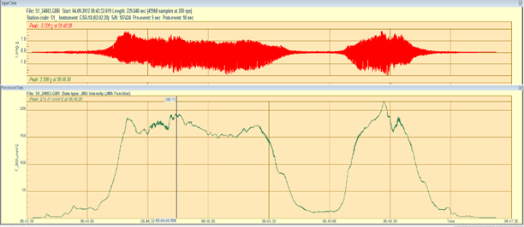
FIGURE 4. Record of intensity (score) of vibrations at the cover level of the ‘Sokmo’ model, which destruction corresponds to the acceleration value of 188 cm/s²
The intensity of seismic impact during the destruction corresponds to J=8 points on the MSK-64 scale. The results of the experiment proved that the models of houses built according to the ‘Sokmo’ method completely collapse at 5-6-point (in terms of acceleration) earthquake (Fig. 5).
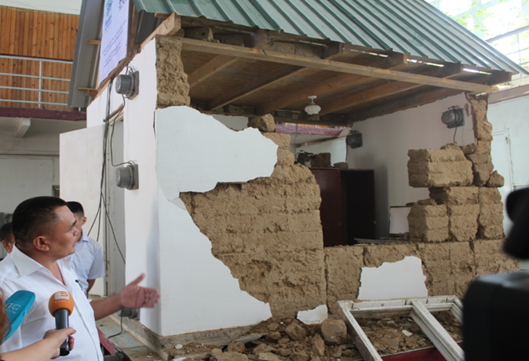
FIGURE 5. General view of the juqmo house model after the experiment (photo by Zhanybek Mamatov)
2. Model of the house whose walls are built with raw bricks or blocks of regular shape. The wall material for the construction of this house model was a raw brick with three hollow holes, measuring 0.085×0.12×0.25 m, weighing more than 4 kg, made in a local brick factory and prepared for subsequent firing (Fig. 6).
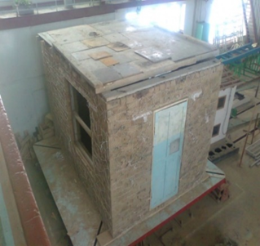 | 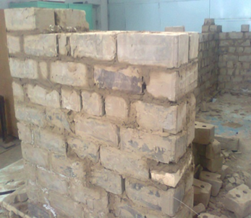
(a) | (b)
FIGURE 6. View of the raw brick house model: (a) - completed view; (b) - wall fragment
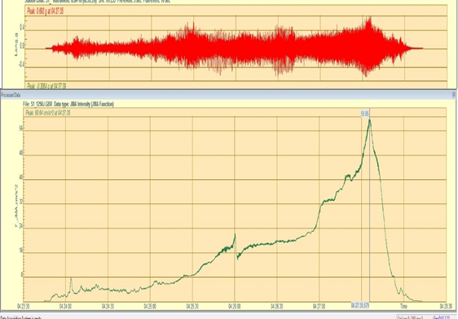
FIGURE 7. Recording of the seismic platform vibration intensity on the model of a house made of ‘raw brick’, acceleration -
60 cm/s²
The masonry is almost the same as that made of burnt bricks. The thickness of walls made of raw brick can be taken as 1; 1.5 or 2 bricks, and of blocks of regular shape - 1 or 1.5 blocks. This type of walls is erected without appropriate reinforcement, also, is not earthquake resistant. In order to demonstrate a simple method of reinforcing such walls, a scale model of a house was built on a seismic platform, and a relatively inexpensive reinforcement was made in advance. Its main feature consists in reinforcing from inside and outside of the wall with nets of cords (Fig. 8) with surface shotcreting with sand-cement mixture. According to the results of the conducted experiment, it is obtained that the model house built of raw brick with simple reinforcement has noticeably higher earthquake resistance compared to the house made of simple ‘Sokmo’.
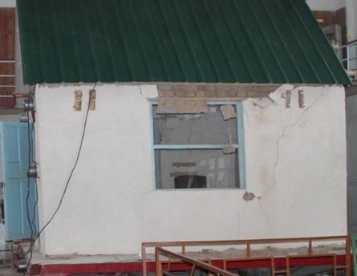
FIGURE 8. Models of the house, made of raw brick, after the experiment
It should be noted that since the seismic platform is an artificial source of forced vibrations, it implies the presence of certain limitations, i.e. the acceleration of vibrations of the vibration platform is in inverse dependence on the mass of the tested model: the smaller the load on the seismic platform, the greater the acceleration and displacement values created by it. In the tests, due to the large weight of the house model, more than 14.5 tons, reproducing seismic vibrations of the seismic platform, it could not lead to destruction. Fig. 7 shows the correspondence of these values of accelerations in points intensity of seismic impact of the seismic platform is only 6.0 points on the scale of MSK-64 and at the same time, it receives significant damage, Figure 8 shows the appearance of the house model after the experiment.
3. Wood frame house model filled with clay material (‘Synch’). The Synch house is a timber frame (Fig. 9) consisting of lower and upper joist beams, post beams, struts and has clay material infill.
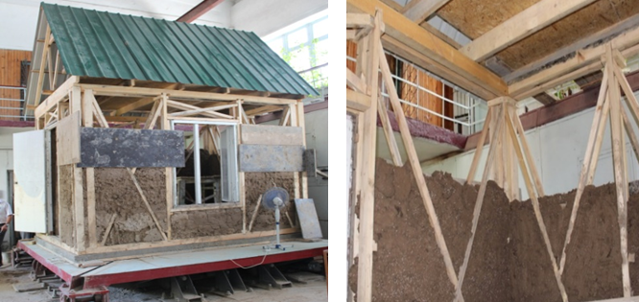
FIGURE 9. Model of the house ‘Syntch’ and a fragment of its construction
As a material for filling the space inside the frame we used clay with the addition of foam balls (polystyrene foam) with a density of 15-20 kg/m3 to reduce the weight of the wall filling. During the research we obtained a patent for the modified clay material with polystyrene foam [22].
The amplitude-frequency vibration spectra of the ‘Syntch’ house model at the pavement level are shown in Figure 10. The predominant frequency for 1 segment is f=7.5 Hz or period T=0.133 sec. According to the record (Figure 10) of the intensity of vibrations at the level of coverage of the model of the house ‘Syntch’, the destruction corresponds to the value of acceleration 142cm/s2.
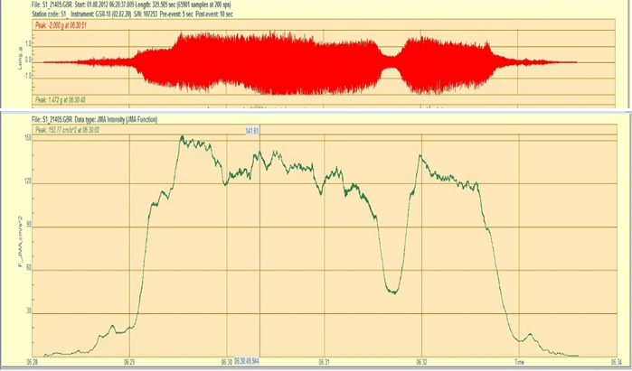
FIGURE 10. Record of vibration intensity at the coverage level of the ‘Syntch’ model
Figure 11 shows that the seismic intensity is 7-8 points on the MSK-64 scale. ‘Syntch’ type houses can be used as a model dwelling house in seismically hazardous areas and also as housing for disaster victims. Cross-sections of support posts made of sawn timber, according to structural requirements should have the following dimensions: - 100×50 mm, 50×50 mm, struts - 50×30 mm (Fig. 11), and timbers - 150×150 mm; 150×100 mm. Instead of timbers for supporting posts can be taken logs of circular cross-section with a diameter of 60-80 mm, which after appropriate treatment are fixed to the foundation.
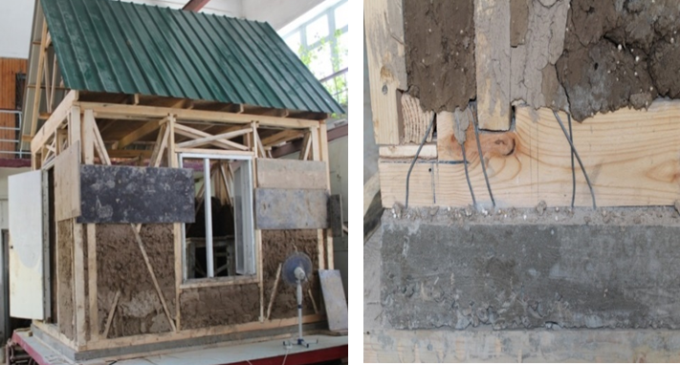
FIGURE 11. The process of erecting a wooden frame house model ‘Syntch’
When filling the frame, it is necessary to leaven (infuse) clay, prepare a regular formwork of the required size, add various additives (e.g. straw) to the clay, and then pour the thick mass all around the perimeter and tamp it tightly. When pouring the wall, it is necessary to withstand technological breaks to allow the clay mortar to dry and harden to a certain degree. Houses of this design are considered to be earthquake-resistant structures in comparison with other buildings. The results of the experiments showed that in a 7, 8-point (in terms of acceleration) earthquake, the infill collapsed, but the wooden frame remained strong and stable (Fig. 12). It should be emphasised that in case of powerful earthquakes, tragic consequences are excluded for such houses, and the collapsed infill can be easily restored in the future. One more thing that should be recalled is that the parts of such houses, for example, the foundation and wooden supports or wooden supports and roof should be connected and work as a whole.
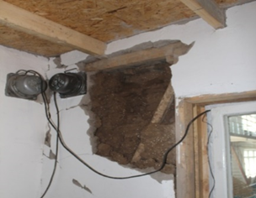 | 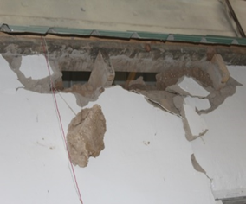
FIGURE 12. General view of a model of a house type ‘Syntch’, after the experiment
Houses of this type are usually built on poor foundations, because the stones are laid on clay mortar, and there is no bond between the foundation and the frame filling. Therefore, concrete should be poured between the stones instead of clay, and the foundation should be bonded to the timber frame. Thus, a wire with a 0.5 meter long outlet should be placed inside the foundation. The step of the wire should be no more than 1 meter, the more frequent, the better. The scaffolding installed on the foundation should also be fixed with wire (Fig. 11) of 6 mm diameter, or with anchor bolts M 10-12 mm.
1. Model house with reinforced concrete frame and earthen infill. This model house is a reinforced concrete frame (Fig. 13), consists of columns and cores at the edges of door and window openings, an upper strapping belt around the perimeter of the walls and is filled with clay materials.
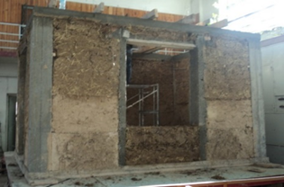 | 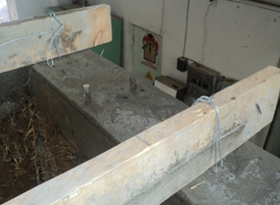
FIGURE 13. Reinforced concrete frame house models with clay infill
An experiment was conducted on a reinforced concrete frame house model filled with clay material. The vibration recordings are shown in Figure 14. The amplitude-frequency spectra of vibrations of the house model at the seismic platform level within the three selected sites, the predominant frequencies along the B-W direction are: 7.6 Hz; 15.3 Hz; 22.3 Hz; 30.0 Hz.
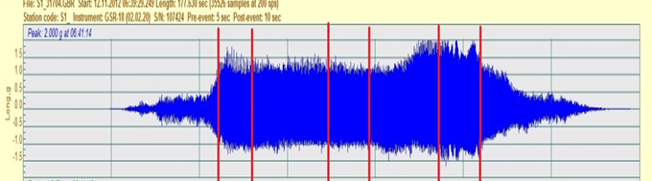
FIGURE 14. Vibration recordings at the coverage level of the house model
Analysis of the amplitude-frequency spectra of the house model vibrations within the three selected sites showed the following: the predominant frequencies along the B-W direction of motion of the seismic platform are from 7.4 to 76 Hz. Then the natural period of the model will be T0 = 0.13 sec. At the same time, the maximum value of the acceleration amplitude at the level of the seismic platform was established: B-Z - 1.755g. This acceleration corresponds to more than 9 points on the MSK-64 seismic intensity scale (Fig. 15). At such values, such buildings are not destroyed.
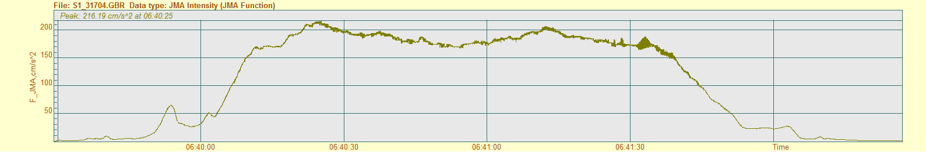
FIGURE 15. Maximum intensity values at the pavement level expressed in accelerations
When building houses of this design, firstly, when pouring the foundation, it is necessary to lay the reinforcement of vertical columns at the corners (four rods in each corner), in the openings of windows and doors (two rods each) together with the concrete. Secondly, at wall intersections where there are reinforced concrete inclusions, reinforcement should be continued up to the level of the transom. At the same time, at least two rods should protrude every 60 cm in height at the joints between the supports and the wall. Thirdly, straw should be added to the soaked clay, a formwork should be installed, with the help of which one row of the wall should be made 60 cm high. They should be connected to the rods left in the supports with the help of cross nets. Subsequent rows are laid in the same way up to the level of the transom. A reinforced concrete ring belt (seismic belt) is built on top of the reinforced concrete supports and the erected wall. Then two reinforcing bars protruding from the foundation are inserted into the ring belt at the edges of doors and windows, formwork is set up and concrete is poured (Fig. 16). This element is called monolithic or reinforced concrete core [4,12, 21, 22].
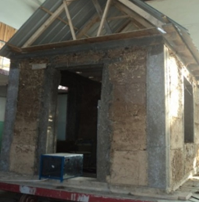 | 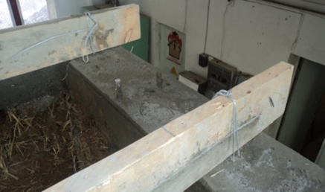
FIGURE 16. The process of erecting a model house from a “reinforced concrete frame”
According to the results of experiments, it can be seen that in case of a 7, 8-point (according to the acceleration index) earthquake, in a house built in compliance with all construction technologies and methods, only cracks appeared in the plaster of the house and in the places of connection of clay walls with concrete elements at the level of window sills and lintels (Fig. 17). It is obvious that houses of such construction are resistant to earthquake compared to other listed three types of buildings.
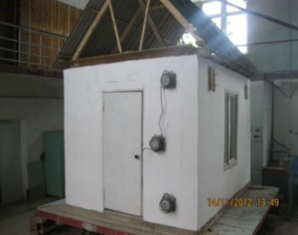 | 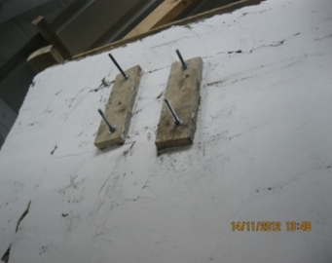
FIGURE 17. General view of the ‘reinforced concrete frame’ house model, after the experiment
Thus, a series of experiments were conducted to test 4 house models on the seismic platform and compare them for earthquake resistance.

CONCLUSION
1. Synergistic effects occur in objects during operation, and with the slow nature of external influence, they can be attributed to self-organization through control parameters. This indicates the usefulness of attracting methods of the mathematical theory of catastrophes in deterministic modelling. For probabilistic calculations it is necessary to have a deterministic dependence between the characteristics of the structure and its bearing capacity. The integral characteristic of the damage accumulation process is named damageability parameter and a measure of damageability (scalar function) is introduced.
2. In building structures some nodal joints, depending on the stress-strain state, behave like a semi-brittle material and belong to initial inhomogeneous materials and beyond the elasticity limit can be interpreted as dissipative structures. A peculiarity in the behaviour of such materials should be considered as the presence of a limit region in which stresses decrease with continued strain growth. At this, the last stage, the volume strain becomes positive and tends to increase. Beyond the elastic limit in these materials, localized areas of sliding surfaces appear, in which macroscopic fractures are gradually prepared in the process of further deformation. At the same time, plastic deformation is accompanied by loosening, which can also be modelled by illustrative mechanical representations.
3. Based on the analysis of statistical data on individual residential buildings in the Kyrgyz Republic, the classification of individual residential buildings by types of load-bearing structural systems into 4 types was made. According to this classification, about 40 per cent of buildings are built of raw brick or blocks of regular shape; about 15 per cent of buildings have a wooden frame with filling of clay materials or houses built according to the technology ‘Syntch’; about 25 per cent of buildings are built of clay concrete according to the technology “Sokmo” and ‘Pahsa’; about 20 per cent of buildings have a reinforced concrete frame with filling of clay materials.
4. Based on the results of experimental studies, the earthquake resistance of the house model is determined, taking into account economic efficiency and construction technologies. From them the houses of ‘Syntch’ type can be used as a model dwelling house in seismically dangerous zones, and also as housing for victims of natural disasters, it is expedient to build them in villages where it is difficult to deliver building materials.
5. The conducted research shows that the dwellings built without sufficient observance of the technology of construction of dwellings made of clay in various forms (sokmo, adobe and pahsa) are not resistant to earthquake and are prone to destruction.

References
- H. Chen, K. Yuan, L. Guo and S. Zhang, “Study on seismic failure mechanism and damage model of unconstrained adobe block walls,” Structures 68, 107107 (2024).
- J.Evans, M.J.Smith and L.Smiley, The adobe house. Philosophy and Practice (Kiev: Ridna Zemlya, 2004).
- B.A.Krylova nd Yu.V.Pazyuk, Application of ground-cement concrete in rural construction. Review (Moscow: VNIIIS, 1986), 60p.
- Zh.Y Mamatov, Y. Sydykov and S. Mamatov, “Classification of residential buildings made of local materials in the Kyrgyz Republic and the results of experiments on them,” in XXVI International Scientific Conference “Construction the Formation of Living Environment”, E3S Web of Conferences 410, edited by A. Ter-Martirosyan et al. ( 2023), pp. 03026.
- Design of Buildings to Resist Progressive Collapse (2005) United Facilities Criteria (UFC)-4-023-03,
pp. 139 – 170.
- O.V. Mkrtychev and V.D. Reiser, Theory of Reliability in Design of Building Structures (Monograph. ASV, Moskow, 2016), 908p.
- A.V. Perelmuter, Selected problems of reliability and safety of building structures (ASB, Moscow, 2007),
256 p.
- V.D. Raiser, Risk estimation at designing of constructions (Seismic construction. Safety of constructions. 2007), pp. 15-18.
- V.M. Bondarenko, N.V. Klyueva and A.V. Piskunov, “Applied dissipative theory of structural safety of reinforced concrete,” Izvestiya Orel GTU. Series ‘Construction, transport’ 1(21), 8–18(2009). (in Russian)
- G. Haken, Information and Self-Organisation. Macroscopic approach to complex systems (Springer Berlin, Heidelberg, 2006), p. 258.
- R. Gilmore, Applied theory of catastrophes (Mir, Moscow, 1984), p. 285.
- Z.Y.Mamatov, A.A Abdykalykov and N.U. Shamshiev, “Analysis of Structural Safety of Structures when Accounting Processes of Progressive Destruction,” Mech. Solids 59, 1226-1236(2024).
- Zh.Y. Mamatov. “Investigation of dilatancy of materials with account of unstrengthening,” Ph.D. thesis, Kyrgyz State University of Construction, Transport and Architecture, 2004.
- M.Ya. Leonov, Mechanics of deformations and fracture (Ilim, Frunze, 1981), 237p.
- B.A.Rychkov, I.V.Goncharova and A.V.Volkov, “About strain hardening of cast iron under proportional and complex loading,” Vestnik PNIPU. Mechanics 1, 113 –127 (2016).
- V.A. Panyaev, Experimental study of grey cast iron deformation (Sb. Complex deformation of a solid body. – Ilim, Frunze, 1969), pp.126-135.
- S.A. Khristianovich, “Deformation of hardening plastic material,” Mekh. Tverd. Tela 2, 148 –174 (1974).
- S.A.Khristianovich and E.I.Shemyakin, “To the question of ideal plasticity,” Mekh. Tverd. Tela 4, 87 – 97 (1967).
- Zh.Y. Mamatov. “About irreversible deformation of rocks,” Problems of natural-technical sciences, information technologies and management at the present stage, 222–232 (2003).
- Zh.Y.Mamatov, S. Orunbaev, Y. Sydykov and N. Shamshiev, “Residential buildings made with local materials and their classification on the basis of a field experiment,” In book: Recent Research on Geotechnical Engineering, Remote Sensing, Geophysics and Earthquake Seismology, pp. 309-313(2024).
- Zh.Y. Mamatov, Zh. Kozhobaev, N. Shamshiev and Y. Sydykov, “Some features of the structural systems of houses built from materials,” in XXVI International Scientific Conference “Construction the Formation of Living Environment”, E3S Web of Conferences 410, edited by A. Ter-Martirosyan et al. (2023.), pp. 03032
- Patent No. 1593 Modified clay material with polystrol foam. KR, Bishkek, 31.10.2013.

