The Experimental Studies of Reinforced Concrete Beams Reinforced with Composite Materials Based on Carbon and Basalt Fibers
Mirzakhid Miralimov^{1, a)}, Sherzod Akhmedov^{1, b)}, Shahzod Safarov^{1, c)}
and Ruslan Ospanov^{1, d)}
¹Tashkent State Transport University, Adilkhodjaev 1, Tashkent, Uzbekistan
^{a)} Corresponding author: mirzakhid_miralimov@yahoo.com
^{b)} axmedov_sh@tstu.uz
^{c)} safarov_shaxzod@tstu.uz
^{d)} jandos_chingis@mail.ru
Abstract. This article presents the results of experimental studies of bending resistance of reinforced concrete model beams with various external reinforcement options with composite materials (fabrics based on carbon and basalt fibers) in a stretched zone. A methodology for conducting experimental studies was developed, and prototypes of bent reinforced concrete beams were manufactured and tested under static load. Laboratory tests were also carried out to determine the physicomechanical properties of the above-mentioned fabrics with the preparation of standard samples in accordance with GOST25.601. The studies carried out can be used to improve the design provisions of domestic regulatory documents on strengthening reinforced concrete structures of buildings and structures with composite materials.

INTRODUCTION
Recently, reinforcement of structures of buildings and structures with composite materials has become widespread and is rightfully the most promising method [1,2]. The method of reinforcement with composite materials is essentially very similar to the method of reinforcing structures with surface reinforcement stickers, with the only difference being that composite materials (CM) are used instead of metal profiles or reinforcement strips (sheets).
They are flexible fabrics with a unidirectional or bidirectional arrangement of fibers, consisting of a variety of high-strength thin carbon, glass, polyester, aramid and other fibers enclosed in a polymer resin [3]. Carbon fibers are most widely used in the creation of composite materials for the repair and reinforcement of building structures [4].
In some cases, when providing scientific support for the repair (reinforcement) of reinforced concrete structures, it is allowed to use composite materials based on other types of fibers: boron, basalt, ceramic [5]. It should be noted that the reserves of raw materials for the production of basalt fibers are practically unlimited. The BASALT UZBEKISTAN company was founded in 2015 in the Jizzakh region, Farish district of the Republic of Uzbekistan is a manufacturer of composite materials based on basalt rocks: basalt roving, fiber, canvases, construction and road geogrids, composite pipe, crushed stone, reinforcement and fabric [6].
Currently, basalt fibers are an alternative to glass fibers. In some cases, based on economic considerations, it is much more efficient to reinforce structures with basalt fibers than glass fibers. Basalt fibers are considered to be chemically more resistant than glass fibers.To achieve certain properties, when producing basalt fibers, it is not necessary, as in the case of glass, to introduce special additives that affect their final properties during processing [7].

METHODOLOGY
In order to experimentally substantiate the use of external reinforcement made of composite materials to strengthen structures and structures, experimental studies were conducted on the strength of reinforced concrete beams reinforced with carbon and basalt tapes under static load.
For the experiments, reinforced concrete beam-type models were made with a length of 160 sm, a height of 24 cm and a width of 13 sm, in the amount of 5 pieces (Fig.1). Flat welded frames with class A400 working fittings with a diameter of 12 mm and A240 with a diameter of 6 mm, respectively, were used as reinforcement of the beams. The beams were made of concrete of compressive strength class B35, which were planned to be reinforced with polymer composite materials at the next stage. All beams passed a 28-day period before the composite tapes were glued by fibers (Fig.2).
The model beams were divided into three groups:
- group "a" - 1 free sample (beam B1);
- group "b" - 2 samples (beams B2 and B3), reinforced in an unloaded state with a longitudinal canvas 30 cm wide without and anchored with U-shaped clamps 15 cm wide (Fig.2). An external reinforcement system consisting of a carbon composite tape based on high-strength carbon fiber was used as reinforcement material. Carbon Fiber Tape grades are 530/300 with a tensile strength (fiber) of 3500 MPa and a modulus of elasticity of 250 GPa.
- group "c" - 2 samples (beams B4 and B5), reinforced in an unloaded state with a longitudinal canvas 30 cm wide without and with U-shaped clamps 15 cm wide, an external reinforcement system consisting of basalt composite tape TPR 720 PRo 2 based on basalt fiber from BASALT company was used as reinforcement material. UZBEKISTAN”, where, according to the technical data sheet, the specific tensile strength of the fiber is 650-750 mN/tex, and according to the mechanical property with a tensile strength (fiber) of 2600 MPa with an average modulus of elasticity of at least 80 GPa.
Two-component epoxy resin FibARM 530+ was used for the adhesive, with components: A (resin): FibARM 2-062A and B (fixative): FibARM 2-062B. To determine the physical and mechanical properties during stretching of the above-mentioned fabrics based on carbon and basalt fibers, laboratory tests were carried out with the preparation of standard samples of composite materials (Fig.3). The equipment of the Scientific Research Institute of Technical Standardization under the Ministry of Construction and Housing and Communal Services of the Republic of Uzbekistan was used. Composite samples were prepared in accordance with GOST 25.601. Certain physical and mechanical properties during stretching of three samples for each composite fabric based on carbon and basalt fibers are given in the table. 1 and 2.
Further, a reinforced concrete beam without glued composite fabrics, as the sample without fiber was tested (beam B1). In order to isolate the zone of pure bending, the load on the beam model was applied in the form of two concentrated forces applied at the same distance from the ends of the beam (Fig.4). To load the model samples, a LINE ELPress stand with phased loading was used.
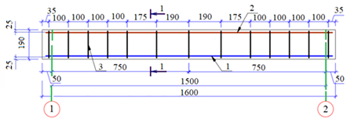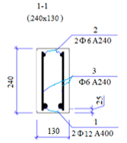
FIGURE 1. Tthe model of beam

Experimental studies
In order to isolate a clean bending zone, the load on the beam model was applied in the form of two concentrated forces, which were transmitted through a specially made metal traverse. At the same time, it was first necessary to determine the destructive value of the Pn load according to the well-known formulas given in [8]. Further, the destructive load obtained from the calculation was applied in steps, depending on the expected destructive load of 0.5 tons each, until transverse cracks with an opening width of up to 0.3 mm appeared in the stretched concrete zone.
During loading, deflections were measured using an ICH-50 type deflection meter with a division price of 0.01 mm installed in the middle of the beam. The obtained parameter values: maximum load and deflection for beam B1 are shown in the table 3. Theoretical data with experimental data, when compared, is approximately 8-12%, which is satisfactory [9].
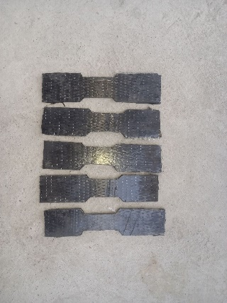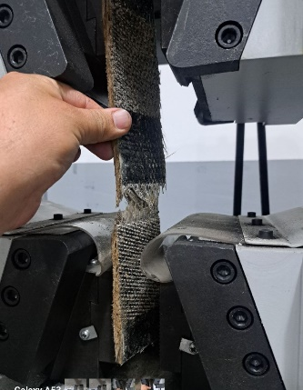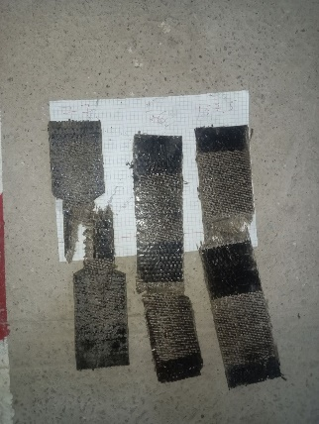
FIGURE 2. The samples of carbon and basalt tapes before and after testing
TABLE 1. Physical and mechanical properties of carbon fabric
Carbon fiber sample No. | Cross-sectional area, m² | Breaking load, kN | Relative elongation, % | Tensile strength, MPa | Modulus of elasticity, GPa
Sample 1 | 0,000156 | 95 | 1,5 | 608,97 | 40,59
Sample 2 | 0,000156 | 89 | 1,53 | 570,51 | 39,89
Sample 3 | 0,000156 | 103 | 1,6 | 660,25 | 41,26
TABLE 2. Physical and mechanical properties of basalt fabric
Basalt fiber sample No. | Cross-sectional area, m² | Breaking load, kN | Relative elongation, % | Tensile strength, MPa | Modulus of elasticity, GPa
Sample 1 | 0,00018 | 81 | 2,8 | 450,00 | 16,07
Sample 2 | 0,00018 | 89 | 3,5 | 494,44 | 14,12
Sample 3 | 0,00018 | 82 | 2,6 | 455,56 | 17,52

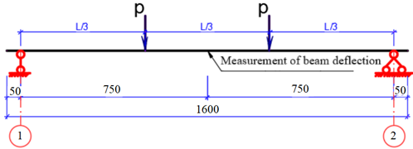
FIGURE 3. Calculation scheme for loading beams

TABLE 3. The obtained parameter values: maximum load and deflection for beam B1
Beam number | Calculation according to standard |  | Experimental data
Beam number | Рn, t | fn, mm | Рn, t | fn, mm
B1 | 3,00 | 0,56 | 3,17 | 0,72
A further increase in the load Pn = 3.41 t led to cracking of the concrete in the inclined part of the reference point and complete destruction of the sample. The test results for reinforced concrete model beams are shown in table 4. Reinforced concrete model samples made of concrete B35 reinforced with carbon strips for the second group "b" collapsed under loads of 12,54 ton without clamps and 12,95 ton with U-shaped clamps.
Reinforced concrete model samples made of concrete B35 reinforced with basalt tapes for the third "c" group collapsed at loads of 9,21 ton without clamps and 9,72 ton with clamps.
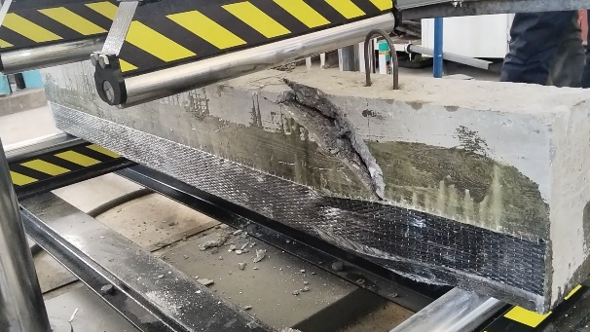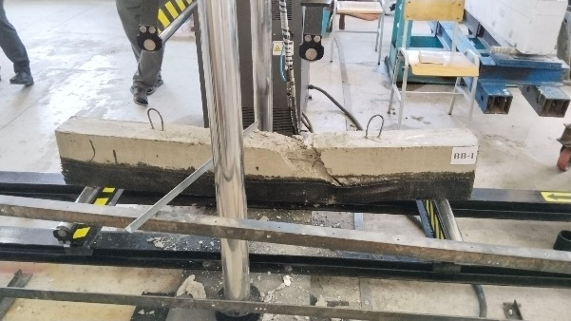
а) b)
FIGURE 4. Destruction of samples reinforced without clamps: a) carbon tape, b) basalt tape
During the tests, all reinforced samples collapsed almost in the middle of the span along the inclined section in the zone of maximum bending moment from the compressed part of the section. In this case, the destruction was accompanied by the detachment of the reinforcement composite material and the destruction of the protective layer of concrete. The results of the experimental studies are shown in the table 4. In experiments, it was found that reinforcement of reinforced concrete beams with woven polymer composite materials according to the proposed scheme can significantly increase their load capacity.
Tests have also shown that reinforcement with composites does not begin to work immediately, but only after the reinforced concrete section has exhausted its ability to work elastically. Up to this level, the effect of reinforcement by composites has virtually no effect on the operation of the bent beam. According to the results of experimental studies, it was possible to establish that non-reinforced samples were destroyed by compressed concrete from the action of a bending moment. The destruction patterns of reinforced beams differ significantly from each other. The beams of the series, reinforced with a U–shaped clip sticker with vertical clamps, were destroyed during static tests by tearing and peeling the reinforcement material in the middle of the span.
TABLE 4. The results of the experimental studies
Beam number | Experimental data
Beam number | The load at which the initial cracks occurred Pn, t | The load at which complete destruction occurred Pn, t | Increased load-bearing capacity, times
B1 | 3,17 | 3,41 | -
B2 | 10,18 | 12,14 | 3,21
B3 | 10,75 | 12,94 | 3,39
B4 | 6,94 | 8,20 | 2,19
B5 | 7,65 | 9,71 | 2,41

Conclusion
Based on the experiments reviewed, it can be concluded that composite fabrics significantly increase the overall strength of the structure due to excellent adhesion to reinforced concrete and high mechanical properties of the materials. It can be concluded that when deformed as part of a reinforced structure, composite tapes withstand the structure until their tensile strength properties are completely exhausted: the destruction of the structure occurs due to the rupture of the carbon fiber tape, and not due to its detachment from the concrete surface, which is already observed at high deformations, however, the rupture of basalt tapes does not occur. In experiments, the question of the presence of a dynamic effect on the reinforced structure and the effect on deformability were not considered. In this regard, additional research is required.
Further development of the experimental methodology can serve to improve external reinforcement systems and clarify the design provisions of domestic regulatory documents when designing structures reinforced with composite materials.
It is important to note that basalt composite material has a number of advantages over carbon composite materials: it is cheaper, resistant to high temperatures and chemical corrosion, environmentally friendly and requires less energy consumption during production. In this regard, basalt composites can be widely used in the future as an economical and effective external reinforcing material for reinforced concrete structures.

References
- O. I.Trufanova and L. V.Feskova, “Analysis of factors influencing the reliability and technical characteristics of reinforced concrete overpasses,” Bridges and tunnels: theory, research, practice 7, 81-89, (2015) (in Russian)
- F. Adilov, F. Yuldoshev, R. A. Abirov and M. Miralimov, “Numerical approach for estimation of stress strain state of deep tunnels” in FORM-2019, E3S Web of Conferences 97 (EDP Sciences, Tashkent, Uzbekistan, 2019), 04064. https://doi.org/10.1051/e3sconf/20199704064
- V.I. Shesterikov, “Ultimate damages rating on the basis of the research results of performance and repair capability of reinforced concrete span beams of bridge structures,” ROSDORNII, 170-185, (2009).
- S.V. Bokhanova, “Standardization of temporary vertical loads on bridges from motor vehicles taking into account the prospects of their development,” Ph.D. Moscow, 2002.
- V.P. Kozhushko, S.M. Krasnov, “Change in reactive pressures and bending moments under the action of various external loads on the strip,” Bulletin of Kharkov National Automobile and Highway University 1(102), 63–72 (2023), DOI:10.30977/BUL.2219-5548.2023.102.1.63
- G.N. Azizov, “Spatial calculation of reinforced concrete superstructures of bridges,” Roads and bridges 1(7), 8–21 (2007)
- Y. L. Cheung, “Finite strip analysis of slab and box girder bridges,” Hong-Kong Eng. 19, 31–41 (1985)
- J. Hołowaty, “Numerical method for live load distribution in road bridges,” in Advances and Trends in Structural Engineering, Mechanics and Computation - Proceedings of the 4th International Conference on Structural Engineering, Mechanics and Computation, SEMC 2010, edited by M. A. Glinicki et al. (2010). pp. 425–428
- J. Hołowaty, “Live Load Distribution for Assessment of Highway Bridges in American and European Codes,” Structural Engineering International 22(4), 574–578 (2012)
- M. Miralimov and D. Nosirov, “Stress-deformed state and stability of railway structures at high speeds of movement of passenger trains,” in The 4th International Conference of EACEF (European Asian Civil Engineering Forum), pp.25–30 (2013)
- C. Y. Ong, J. B. Yeo, K. K. Choong and M. Miralimov Int. J. of Struct. and civil eng. res. (2015)
- M. M. Miralimov Eur. J. Tech. Nat. Sci. (2019)
- R. A. Abirov “The seismic risk mitigation problems in urban areas of Central Asia,” in International Disaster Reduction Conference-2016, IDRC Conference Proceeding, edited by W. J. Ammann et al. (Global Risk Forum Davos, 2016), pp. 129-130

