On Strengthening of Slopes by Gabion Structures
Rustam Abirov^{1, a)}
¹Institute of Mechanics and Seismic Stability of Structures named after M.T. Urazbaev, Uzbekistan Academy of Sciences, Tashkent, Uzbekistan
^{a)}Corresponding author: rustam.abirov@gmail.com
Abstract. Without a high-quality roadbed, it is impossible to construct a modern highway that can maintain the road surface's bearing capacity and evenness over the long term, particularly on weak soils and under varying hydrological and climatic conditions. A notable characteristic of long-distance transport structures, such as highways, is that they traverse areas with different geotectonic formations. For these structures, ensuring their viability (functionality) during operation, maintenance, and resistance to geological influences is a particularly pressing concern. These factors highlight the necessity of developing measures and technologies aimed at constructing roads that boast improved strength characteristics and extended service life, in alignment with international norms and standards. In this issue case study for strengthening are proposed

INTRODUCTION
A significant portion of the routes for roads, bridges, and overpasses is laid in areas susceptible to hazardous natural phenomena and processes, with seismic impacts being among the most dangerous. Much of the territory in the Republic of Uzbekistan consists of loess and fill soils that are 5 to 25 meters thick, which can become unstable under various external influences. Over time, after the construction of engineering structures and facilities, loess soils typically become saturated and lose their strength properties. If the loss in stability of soil foundations is due to natural factors, it can lead to a reduction in the capacity of motorways, resulting inevitably in economic costs.
In seismic prone areas, in mountain zone the risk due earthquakes can lead to significant losses. And mitigation of so risk due slope stability meets several troubles at applying the structural measures [1]. One of effective solution is the implementation of gabion structures or geotextile [2]. These structures help prevent the mixing of waterlogged clay soil with road pavement materials, distribute vehicle wheel loads over a larger area of the subsurface soil, and reduce uneven pavement deformations caused by dynamic and seismic impacts. Besides, they ensure efficient strength of soils and road construction materials, ultimately decreasing material consumption and the effort required for transporting, laying, and compacting imported materials. By shifting some work from the construction site to industrial production, we can enhance labor productivity, lower costs, and accelerate the pace of road construction.
Therefore, enhancing current standards for reinforcing roadbeds, drainage systems, and other road and bridge structures using gabion structures, along with developing design and technological solutions for weak soil foundations, is an urgent matter.

Statement of problem
Existing experience with road surveys confirms that specific problematic sections of roads often incur significant additional operating costs or needs new technical solutions [3-8].
The primary cause of these additional costs is the instability of road structures, which arises from the migration of pressurized groundwater from the excavation into the embankment (fig.1). Depending on the soil and hydrogeological conditions, this can lead to rutting in the excavation area, while landslide deformations and soil subsidence may occur in the embankment. The situation becomes even more complicated if the road section is low-lying, such as crossing a ravine or shallow gully, and features a high embankment, with depressions along both upstream sides of the longitudinal profile. In such areas, groundwater can migrate in both directions into the foundation of the road structure built atop the high embankment [9-11].
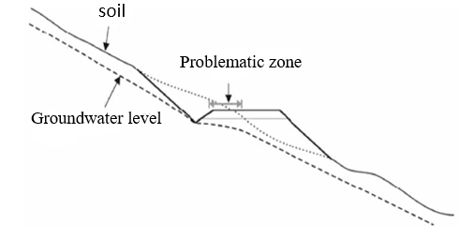
Figure 1. Cross-section of a problematic road section
Road operation in seismic zones has revealed numerous failures of road structures during strong and catastrophic earthquakes. These failures cause disruptions in economic connections and result in significant material damage [3].

METHODS
Analysis of road structure damage shows that the extent of the damage is influenced by various factors, including the engineering and geological characteristics of the terrain, the properties of the soil, roadbeds, and foundations, the structural features of the roads, the seismic environment, the quality of construction, and other elements.
Subgrades are particularly vulnerable to unfavorable seismic conditions when they are flooded or have a high groundwater level. Subgrades located in river floodplains with alluvial soils, especially near bridge approaches, are particularly at risk of damage. In mountainous areas, landslides pose a significant threat to roads during earthquakes, especially when the earthquake reaches a magnitude of 5.
Subgrades in excavations and at ground level are less susceptible to earthquakes than those in embankments. As the height (or depth) of the subgrade increases, the level of potential damage escalates. Furthermore, increasing the steepness of the slope—particularly in the case of an oblique slope—significantly reduces the seismic resistance of the subgrade, as illustrated in Figures 2.
The primary cause of localized shear deformations on subgrade slopes is the soil moisture content reaching a liquefied state, combined with water flow along the sloped surfaces of a temporary aquiclude. A temporary aquiclude forms as a layer of frozen soil at the surface, which prevents water from infiltrating into the body of the embankment.
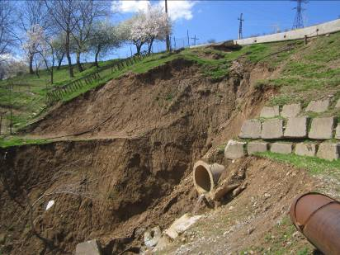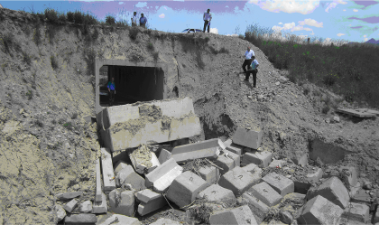
Figure 2. Road sections damaged due to loss of foundation bearing capacity, Uzbekistan (Photo by Abirov R.)
A notable characteristic of localized deformations is that if they continue to develop, they can lead to significant damage (fig. 3).
The bridge approach refers to the section of the roadbed embankment that is adjacent to the bridge and is used for vehicles entering and exiting. The design of the approach roadbed is fundamentally similar to that of the main roadbed, but it has stricter requirements concerning the physical and mechanical properties of the soil, as well as its compaction. Additionally, the approach cone and slopes are reinforced to enhance stability.
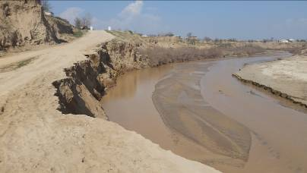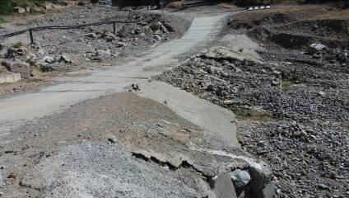
Figure 3. Washed out roads (Photo by Abirov R.)
Soil subsidence and inadequate compaction have led to damage in the approach roadbed and roadway thresholds around the transition slabs. This damage is primarily caused by soil subsidence as a result of insufficient compaction and soil erosion occurring beneath the transition slabs and cross beams due to poor drainage (fig. 4).
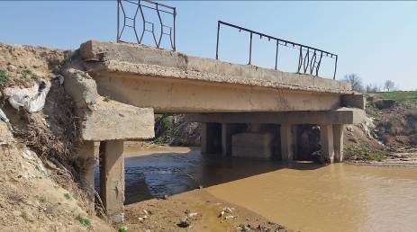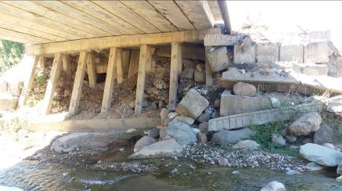
Figure 4. Soil subsidence due to insufficient compaction and soil washout from under transition slabs (Photo by Abirov R.)
From the analysis conducted, it can be concluded that the observed defects in the road structure and soil foundations are quite varied and stem from several hazards. These hazards can generally be classified into three groups:
I - increase in useful loads, weight of the active soil pressure prism due to its additional moistening; additional loading or cutting of landslide slopes, scree slopes; hydrodynamic pressure of water flowing out of the body of floodplain embankments after the flood waters recede; and washing out and erosion of slopes;
II - hazards associated with a decrease in resistive forces within the soil mass: deterioration of the physical and mechanical properties of the subgrade, foundation, or surrounding soil. This includes phenomena such as suffusion, soil weathering, and other related factors;
II - natural hazards, their impact is largely influenced by the geographical conditions along the road's route. They can occur suddenly and are associated with natural disasters, potentially resulting in complete or partial destruction of the subgrade. Examples include earthquakes, mudflows, avalanches, floods, and tectonic movements at fault lines.

APPROACH
Below proposed approach for installation of gabion structures in the working design for the bridge across the Pskem River at the exit to the settlement of "Ispai" from the 4K795 "Chorbog Suv Ombori Aylanma Yuli - Korabulok Village - Pskom Village" highway (fig. 5).
The existing bridge across the Pskem River at the exit to the village of Ispai was built by residents using the “hashar” method. In 2014, due to high water flow and long-term deformation of the riverbank slopes, the foundations of the bridge's bank piers were washed away.
The existing bridge piers are made of shallow rubble concrete. The bridge superstructure is built of composite materials, consisting of I-beams. The main beams, which are located at the bottom, measure 23 meters in length.
Two composite I-beams are installed parallel to the metal beams and connected by transverse braces made from metal I-beams.
The bridge roadway is made of wooden crossbars and a deck 5 cm thick from edged wooden boards. The overall width of the bridge roadway is 3.0 m, with guardrails made of metal corners.
Following a survey, the bridge was deemed unsafe, and it was proposed to replace the roadway and begin construction of reinforcement structures on the bridge banks (fig. 6).
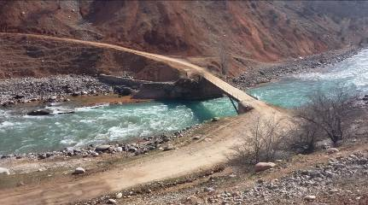
Figure 5. General view of the investigated site (Photo by Abirov R.)
The design was based on topographic and geodetic data compiled by the survey department of Loyikha Sifat LLC in March 2015. The design envisages the preservation and use of the existing superstructure, with the reinforcement of the bridge banks using gabion boxes. The piers are massive, cantilevered. The existing superstructure consists of composite I-beams with a total height of 77 cm. The distance between the beams is 232.5 cm. The main beams are connected by cross bracing made of corners of varying profiles and horizontal strip plates at the joints.
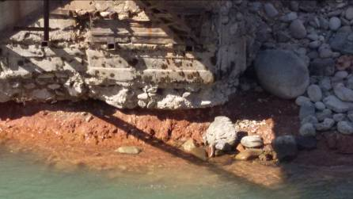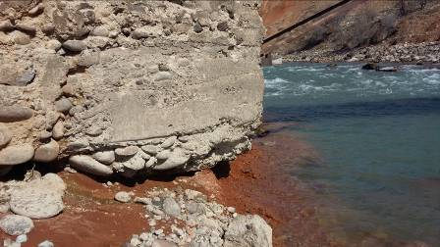
Figure 6. General view of the locations and conditions of bridge supports (Photo by Abirov R.)
The ends of the metal bridge superstructure are fixed (embedded in concrete). The roadway of the bridge is made of wood. Crossbars constructed from 20x20 cm wooden beams, each 3.0 m long, are installed along the top of the main beams.
Wooden wheel stops, measuring 25x25 cm in cross-section, are placed along both sides of the roadway and secured with bolts that are welded to the cantilevered extensions of the railing. Between these wheel stops, a single-layer decking of longitudinal boards, 5 cm thick, is laid on the crossbars.
The metal railing posts are attached from below to the structure using cantilevers that are welded to the top of the main beams. Additionally, they are bolted to the wheel stops from above.
At the junction of the bridge with the approaches above the massive piers, a transition section of monolithic concrete is being constructed to ensure a smooth transition for vehicle traffic onto the wooden bridge roadway. Based on the profiles of the adjacent roads, the approaches are backfilled with a gravel-sand mixture of the necessary thickness.
To ensure traffic safety on the approaches to the bridge from the bank, protective parapets made of monolithic rubble concrete are being installed. Each parapet measures 5 meters in length, 0.4 meters in width, and 1.2 meters in height, with 0.4 meters embedded into the ground. The design specifies that four parapets are to be installed per bridge, and their locations will be determined on-site.
Additionally, to protect the bank slopes and the bridge's piers, the design includes reinforcing the bridge banks with gabion boxes, each measuring 3 meters long, 1-meter-wide, and 1-meter high. When filling the gabions with stones, the stones should have a minimum diameter equal to the cell diameter and should not exceed 30 centimeters in diameter. The appendix contains a draft solution and structural diagrams for reinforcement using the gabion boxes, which have been submitted to the responsible design office.

ANALYSIS AND DISCUSSION
An analysis of the influence of the main design parameters of gabion structures on the strengthening, stability, and deformability of the roadbed was validated by numerical methods. The effectiveness of erected gabions in the Parkent district of the Tashkent region was tested in laboratory and field conditions.
Based on the analysis of geodetic data, soil conditions, and topography, standard solutions for slope and roadbed reinforcement will be developed and proposed here. Based on the experimental results, new, improved, and expanded standard solutions for strengthening roadbeds, drainage systems, water outlet systems were applied.
The proposed approach for strengthening of bridge’s slopes was installed on considered site. This method was the first time applied in our region. The advantages and disadvantages of this approach can be determined after an earthquake or the exhaustion of the life cycle of the proposed design.

CONCLUSION
By the using this approach initially was proposed numerical modelling. By this theoretical investigation at numerical modeling was conducted taking into account the interaction of the structure with the foundation under seismic impacts. A test methodology was developed to study the interaction of various types of gabion structures and cohesionless soils. Further, the structural and technological solutions for the individual design of road and bridge structures using gabion structures on weak soil foundations were developed.
Regulatory and working documentation was developed for the widespread use of proposals and technical solutions in the reconstruction of existing and newly constructed highways. Technical Regulations for "Mesh Products for Gabion Structures for Strengthening Weak Foundations of Highway and Urban Road Structures" and "Instructions for the Design and Construction of Gabion Structures on Highways and Bridges" were developed jointly with local responsible for bridges and highway operation office.

Acknowledgments
This investigation provided on the base of budget funding of the Institute of Mechanics and Seismic Stability of Structures named after M.T. Urazbaev, Uzbekistan Academy of Sciences.

References
- R. A. Abirov “The seismic risk mitigation problems in urban areas of Central Asia,” in International Disaster Reduction Conference-2016, IDRC Conference Proceeding, edited by W. J. Ammann et al. (Global Risk Forum Davos, 2016), pp. 129-130
- A. I. Comer, M. Kube and M. Sayer, J. Geotextiles and Geomembranes, 14, 313–326 (1996).
- A. Dawson, Water in Road Structures: Movement, Drainage & Effects (Springer, Nottingham, 2008).
- S. R. Meschyan, Experimental rheology of clay soils (Nedra, Moscow, 1985).
- H. I. Mohamed, J. Irrig. Drain. Eng. 136(8), 573-577 (2010).
- B. Toprak, O. Sevim O and I. Kalkan, Int. J. Adv. Mech. Civ. Eng. 3(4), 56-58 (2016).
- M. Duncan, S. Wright and T. Brandon, Soils Strength and Slope Stability (Wiley, 2014).
- L. W. Abramson, S. L. Thomas, Sunil Sharma and M. Glenn Boyce, Slope Stability and Stabilization Methods (Wiley, 2001).
- F. Adilov, M. Miralimov, R. Abirov, “To the stability of the roadbed reinforced with gabions” in CATPID-2020, IOP Conf. Ser.: Mater. Sci. Eng. 913, edited by Batyr Yazyev et.al. (IOP Publishing Ltd., Nalchik, Russia, 2020), https://doi:10.1088/1757-899X/913/4/042066
- F. Adilov, R. Abirov, “On numerical investigation of stability of roadbeds reinforced by gabion structures” in CONMECHYDRO–2021, E3S Web Conf., 264 edited by D. Bazarov (EDP Sciences, Tashkent, Uzbekistan, 2021) https://doi.org/10.1051/e3sconf/202126402004
- D.A. Sagdullayeva, Sh.A.Maxmudova, F.F.Adilov, R.A.Abirov, I.O. Khazratkulov and I.A. Nasirov On stability of slopes in mountain zones. Case study. in J. Phys.: Conf. Ser. 1425 edited by A. Volkov et al. (IOP Publishing Ltd., Moscow, Russia, 2019) https://doi:10.1088/1742-6596/1425/1/012016

