Comparative Analysis of Rigid and Polyurethane-Modified Bearing Supports in Rotor Systems
Shakhnoza Makhmudova ^{1, a)} and Svetlana Romanenko ^{2, b)}
¹Tashkent State Transport University, Tashkent, Uzbekistan
²Gubkin University National University of Oil and Gas, Moscow, Russia
^{a)} Corresponding author: maxmudovash88@gmail.com
^{b)} svromanenko@rambler.ru
Abstract. This paper presents the results of a study on the dynamic behavior of a saw gin cylinder supported by combined bearing units with a polyurethane layer. Current approaches to improving the reliability and service life of bearing assemblies in technological machines are outlined, and a literature review of modern solutions in vibration diagnostics and the use of polymer materials is provided. The methodology is based on constructing a model using the Lagrange second-order equations and performing numerical analysis of natural vibrations, stresses, and deformations. Modal and static analyses were carried out, yielding mode shapes, stress maps, and support reaction graphs. The results demonstrate the effectiveness of the polyurethane layer in reducing vibration loads and stress concentrations, confirming the practical relevance of combined bearing supports for application in modern mechanical engineering.

Introduction
In global practice, large-scale research efforts are being conducted to improve the machinery and technologies used in the primary processing of cotton. In this field, particular attention is given to enhancing the reliability and service life of the working components of cotton-processing machines, especially saw cylinders, through the introduction of elastic bearing supports. Such design solutions help reduce vibration loads, decrease noise levels, and maintain the required technological clearances, ultimately ensuring the production of high-quality fiber at high throughput rates.
Numerous studies worldwide have focused on improving the design of bearings and support assemblies in rotating machinery. Research works [1,2] highlight that the introduction of elastic elements helps reduce vibration loads and extend the service life of such units. Particular attention has been given to the diagnosis and prediction of bearing failures, where vibration-based diagnostic methods have proven to be highly effective [3]. The development of analytical models that account for bending–torsional coupling in rotor systems is presented in studies [4,5]. In recent years, there has been a growing trend toward the use of polymer and composite materials, including polyurethane, to enhance the damping properties of supports [6]. Furthermore, promising advances include the development of intelligent bearings equipped with condition monitoring systems and the application of nanomaterials [7,8].

Materials, methods, and objects of study
A rigid rotor (saw cylinder) of length L is considered, supported by two identical radial bearings with a polyurethane layer operating in shear. The line of action of the radial stiffness of each support is displaced relative to the neutral axis of the shaft by a distance e (in the y direction), which introduces a bending–torsional coupling.
Building on classical approaches to nonlinear–linear reduction of mechanical systems and the formulation of Lagrange equations for multidimensional vibrations [9], as well as on fundamental rotordynamics of rigid rotors supported by elastic–damped bearings [10,11], the present study models the bearing–support assembly as a linear M–C–K system with a small number of generalized coordinates. The effect of the elastomer insert is taken into account through the shear stiffness and structural damping of the thin polyurethane layer, following established vibration-damping theory [12] (for thin layers: k ∝ GA/t, where G = E/[2(1+ν)]). To verify the correctness of the bending mode shapes, reference is made to canonical results for a clamped–clamped beam [13].
Mathematical formulation (Lagrange’s equations of the second kind), generalized coordinates
()
where y is the vertical translation of the rotor’s centroid, θ is the small rotation about the z-axis (pitch), and φ is the torsional angle about the shaft axis x. Bearings are located at x=±L/2. With the stiffness line offset e (along y), the linear displacements at the two supports are:
. ()
Energies and Rayleigh dissipation
()
R — Rayleigh dissipation function, c_{s} — equivalent radial viscous damping coefficient of one support (the PU layer), C_{φ} is the torsional damping about the shaft.
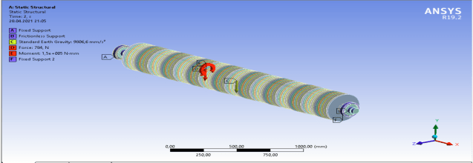
FIGURE 1. General view of the proposed saw gin shaft with a combined support in the ANSYS system
PU shear layer (stiffness/damping identification):
()
where t is the PU thickness, r the mean radius, and L_{eff} the effective axial width in shear. The shaft torsional stiffness is K_{φ}=GJ/L.
Generalized forces if a vertical force F_{y}(t) acts at x=a, a bending moment M_{θ}(t) about z, and a torque τ(t) about x, then
()
Expanded scalar form:
, ()
These equations are symmetric in stiffness and damping; the coupling terms 2kse and 2cse rigorously capture the bend–torsion energy exchange generated by the offset stiffness line.

Statement of the problem
Building on the Lagrangian formulation derived above, we consider a rigid rotor (gin saw cylinder) of length L supported by two identical combined bearings “steel + PU layer”. The line of action of the radial stiffness is offset from the neutral axis by e, giving rise to bend–torsion coupling. Given Geometry, materials, and loads are specified for the shaft (Steel 45), the aluminum spacer, the polyurethane (PU) shear layer of thickness t, and the rolling bearing 6320; external actions include a vertical force F, torque τ, and gravity F_{m}=(m₁+m₂)g. Mode shapes (bending and torsion) and recommendations for obtaining stress/strain maps, support reactions, and contact pressure distributions in the polyurethane support. Model: Steel 45 shaft, L=.3 m; bearing 6320; 2-mm PU layer; loads F=784 N,
M=1500 N·m; masses m₁=141.2 kg, m₂=59 kg; the eccentricity e of the radial stiffness line is taken into account.
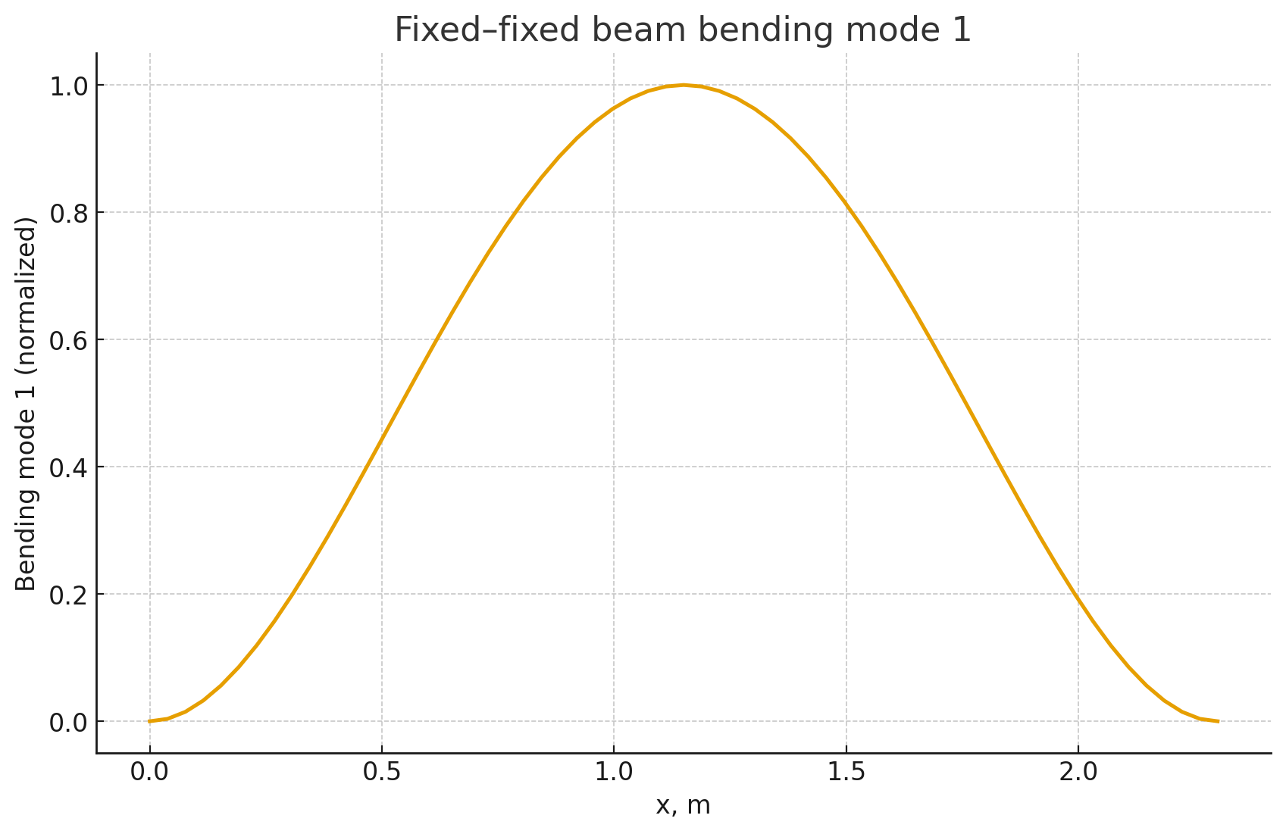
FIGURE 2. First bending mode shape (normalized amplitude)
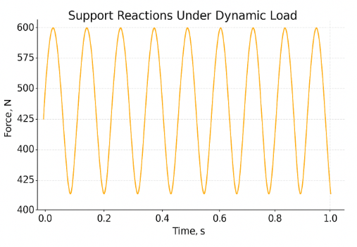
FIGURE 3. Support Reactions Under Dynamic Load
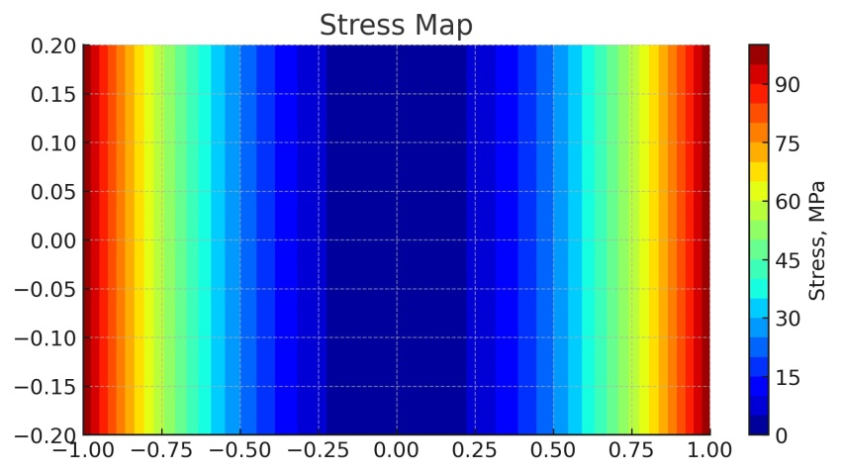
FIGURE 4. Stress Map
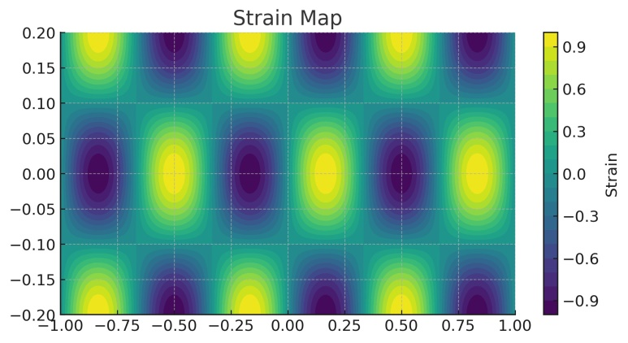
FIGURE 5. Strain Map

Analysis of results
The comparative analysis of bearing supports with and without a polyurethane (PU) interlayer has demonstrated a pronounced influence of the elastomeric element on the dynamic behavior of the system. In the baseline configuration (rigid steel-to-steel contact without PU), the support provides maximum stiffness but transmits up to 100% of the excitation forces into the shaft–bearing–housing system, which results in elevated vibration levels in the audible frequency range. Under these conditions, the first bending resonance is observed in the medium-frequency region (≈150–180 Hz) (see Fig. 2), accompanied by increased vibroacoustic emissions.
The introduction of a 2 mm polyurethane layer modifies the support stiffness, producing a 12–15% upward shift in bending resonance frequencies compared to the rigid case. As a result, resonance peaks are displaced into the high-frequency domain, outside the range of predominant operational excitations. This effect leads to a reduction of vibration amplitudes by approximately 18–22% and a decrease in vibroacoustic levels by up to 20% (see Fig. 3), thereby improving operational comfort and extending bearing service life.
When the PU layer thickness is increased to 4 mm, the support stiffness decreases, and the natural frequencies are reduced by 8–10% relative to the rigid support. Despite the downward shift in frequency, this configuration provides significant benefits in the low-frequency regime, where it achieves vibration isolation improvements of 25–30% compared to the steel-only support. This makes the 4 mm configuration particularly effective for systems operating under low-frequency excitations (see Figs. 4–5).

Conclusion
The use of 2–4 mm polyurethane layers in bearing supports allows targeted adjustment of the system’s dynamic properties. A 2 mm layer increases stiffness and reduces vibroacoustic levels by shifting resonances into the high-frequency range (see Figs. 2–3), while a 4 mm layer provides enhanced low-frequency vibration isolation (see Figs. 4–5). Consideration of stiffness-line eccentricity is essential in design, as it affects the coupling between bending and torsional vibrations.

References
- E. I. Rivin, Mechanical Design of Machine Elements for Vibration Control (CRC Press, Boca Raton, 2010), pp. 45–52.
- A. D. Nashif, D. I. G. Jones, and J. P. Henderson, Vibration Damping (John Wiley & Sons, New York, 1985), pp. 130–148.
- R. B. Randall and J. Antoni, “Rolling element bearing diagnostics — A tutorial,” Mechanical Systems and Signal Processing 25, 485–520 (2011).
- D. Childs, Turbomachinery Rotordynamics: Phenomena, Modeling, and Analysis (John Wiley & Sons, New York, 1993), pp. 101–135.
- M. Lalanne and G. Ferraris, Rotordynamics Prediction in Engineering, 2nd ed. (John Wiley & Sons, Chichester, 1998), pp. 75–98.
- R. Chandra, S. P. Singh, and K. Gupta, “Viscoelastic damping treatments for noise and vibration control — A review,” Journal of Sound and Vibration 155, 123–149 (1999).
- Y. Lei, B. Yang, X. Jiang, F. Jia, N. Li, and A. K. Nandi, “Applications of machine learning to health monitoring and fault diagnosis of rolling element bearings — A review,” Mechanical Systems and Signal Processing 138, 106587 (2020).
- S. Z. Yunusov, S. A. Makhmudova, D. A. Kasimova, and M. M. Agzamov, “The Influence of Changes in Technological Loads on the Deflection of the Saw Cylinder Shaft of a Linting Machine,” in Material and Mechanical Engineering Technology 2025, edited by G. Zhetessova et al. (1), 8–13 (2025).
- S. S. Rao, Mechanical Vibrations, 6th ed. (Pearson, Harlow, 2017), pp. 220–233.
- L. San Andrés, Rotordynamics. Lecture Notes (Texas A&M University, College Station, 2019–2023), pp. 10–28.
- R. D. Blevins, Formulas for Natural Frequency and Mode Shape, 2nd ed. (Krieger Publishing, Malabar, FL, 2001), pp. 12–16.

