Seismic Longitudinal Waves as Indicators of Ongoing Earthquakes
Viktor Galiaskarov^{1, a)}
¹Institute of Mechanics and Seismic Stability of Structures named after M.T.Urazbaev, Uzbekistan Academy of Sciences, 100125, Tashkent, Dormon yuli, 40, Uzbekistan
^{a)} Corresponding author: victor.galiaskarov@gmail.com
Abstract. The document determines the frequency characteristics of longitudinal seismic waves based on seismograms from an engineering seismometric observation station, with the aim of creating early earthquake warning equipment to send a signal to the emergency power and gas supply shutdown system to prevent fire and other dangerous consequences in the event of a building collapse.

Introduction
Uzbekistan is located in seismic prone area and mitigation of consequences of earthquakes are vital for our region [1]. One of so approach in earthquake prediction and implementation of early alarm systems. Currently, science cannot predict a future earthquake, or accurately indicate the location and time of the beginning of this process, but it can notify about an earthquake that has begun or is currently occurring based on seismic waves. In recent decades, earthquake early warning systems (EEWS) have been industrially produced: Palert, ShakeAlert, secty lifePatronm, EEWS-Earthquake Early Warning System and other systems. EEWS have begun to be used in many countries: Japan, USA, Taiwan, Turkey, Mexico, Greece, Romania, New Zealand [2-4]. An assessment of the effectiveness of various EEWS, as well as the development of an early warning system for the territory of Uzbekistan is presented in the work of Ibragimov A.Kh. [5].
The principle of operation of the earthquake early warning system (EEWS) is based on the difference in the speed of seismic longitudinal P-waves and transverse S-waves. The speed of longitudinal P-waves is greater than the speed of transverse S-waves and longitudinal waves arrive at the observation point earlier than transverse waves. Therefore, longitudinal waves can be used in various early warning systems to prevent strong earthquakes [6, 7]. EEWSs warn people a few seconds before the shock wave reaches the building where they are located, which can save lives and preserve health. In addition, they can automatically activate emergency procedures, such as disconnecting electricity and gas supply systems in the event of an impending tremor.
To date, a reliable earthquake early warning system has not yet been created; this problem is being solved in many countries located in seismically active areas of the globe. Employees of the Institute of Mechanics and Earthquake Resistance of the Academy of Sciences of Uzbekistan propose as an option for solving this problem, the creation of equipment for recording and processing longitudinal P-waves as EEWSs. This opportunity appeared after the commissioning of the engineering and seismometric observation station (ESOS).

Object of the study
The Institute of Mechanics and Earthquake Resistance of Structures of the Academy of Sciences of Uzbekistan has developed a multichannel recording device equipped with analog-to-digital converters for recording electrical signals from various sensors on a personal computer. Based on this recording device, measurement systems have been created for various experimental studies [6-9]. A 12-channel Engineering Seismometric Observation Station (ESOS) has also been created [10]. ESOS is used to observe vibrations of buildings and their soil foundations during earthquakes.
The seismometric station includes a recording system and seismometric sensors installed at different levels: in the ground on which the building is located; on the floor of the basement of the building; on the floor located at half the height of the building; on the attic floor. During an earthquake, vibrations of the building are recorded by seismometric sensors, the signals from which are fed to the recording device, where each seismometer is recorded. The recording device consists of a computer with software that operates around the clock and records even very weak earthquakes. ESOS operates continuously and records the earthquake process from the very beginning, records and saves it as a separate file in the archive. The view of the 12-channel ESOS with six seismometers on the floor, located in the basement of the institute building is shown in Figure 1. Three SM-3 seismometers for recording displacements of the building foundation in the longitudinal, transverse and vertical directions and three OSP-2 seismometers for recording accelerations of the building foundation in the longitudinal, transverse and vertical directions. In the attic of the institute building there are three SM-3 for recording displacements and three OSP-2 for recording accelerations.
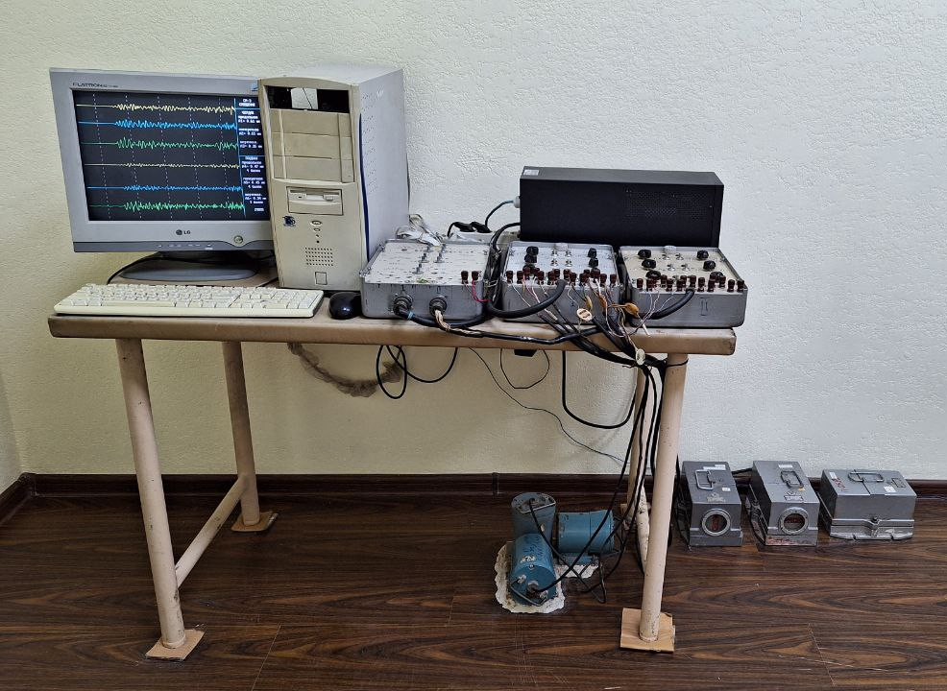
FIGURE 1. 12-channel engineering seismometric observation station and seismometers located on the basement floor
This article analyzes ESOS seismograms recorded by SM-3 displacement seismometers located on the basement floor of the institute building in order to study the frequency characteristics of the longitudinal P-wave and transverse S-wave. Perhaps the research will help to determine some patterns that can be taken into account when creating earthquake early warning equipment.

Statement of the problem
Determination of the frequency characteristics of the longitudinal P-wave and transverse S-wave of a 4-point earthquake that occurred in on 2020 March 26 at 9:45 Tashkent time on the border of Uzbekistan and Tajikistan, registered by the ESOS. The seismogram of this earthquake is shown in Figure 2.
According to the Republican Center for Seismic Forecasting Monitoring of the Ministry of Emergency Situations, the magnitude of the earthquake at the epicenter was 5.4, depth h = 10 km. The distance from the epicenter to Tashkent was 122.5 km.
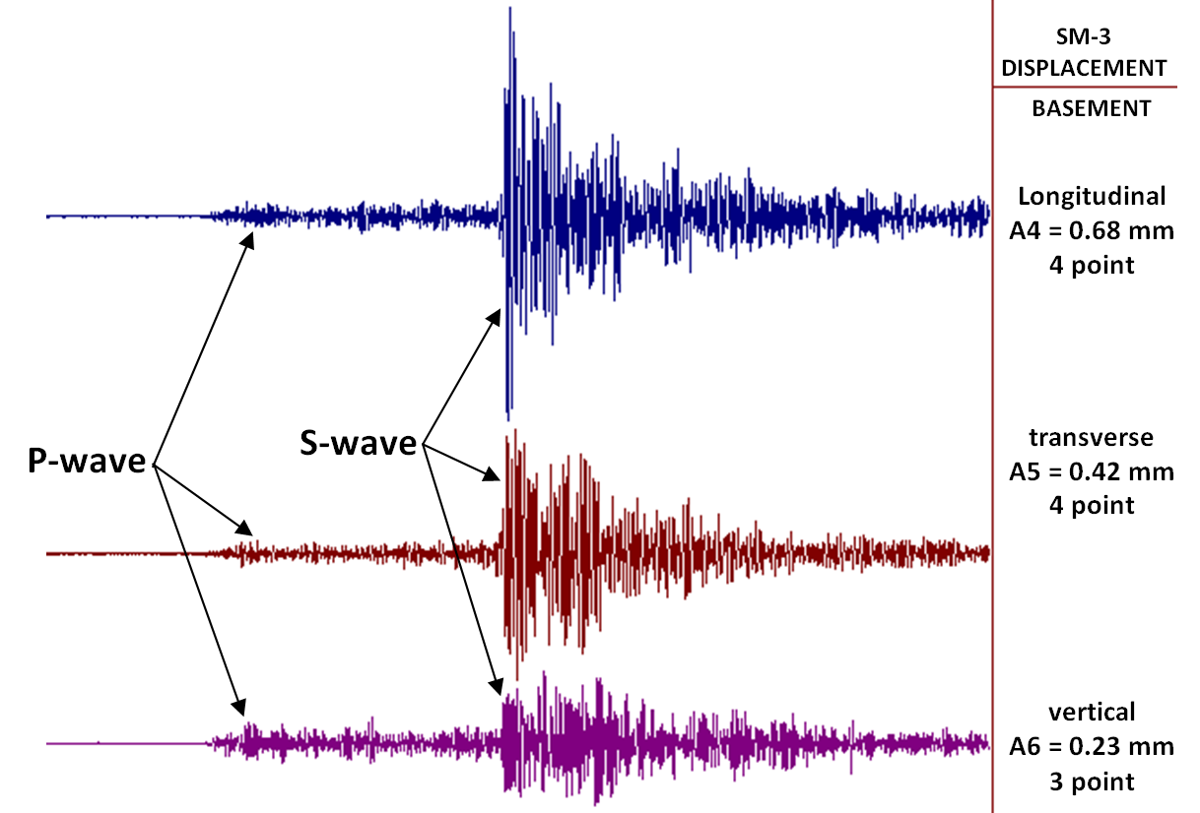
FIGURE 2. Seismogram of the earthquake that occurred on the Uzbekistan-Tajikistan border on March 26, 2020 at 9:45. Recording duration is 50 seconds
The strength of the tremors in the city of Tashkent in the area of the ESOS Institute of Mechanics and Seismic Resistance of Structures reached 4 points in the horizontal plane and 3 points in the vertical direction. Figure 2 shows a seismogram of this earthquake, recorded by the ESOS for 50 seconds, where seismic longitudinal P-waves and transverse S-waves are clearly distinguished [11]. To determine the amplitude-frequency characteristic of oscillations, the computer has the ability to stretch the seismogram to a size convenient for viewing. Figure 3 shows a fragment of this seismogram with a total duration of 12 seconds and 9 seconds with transverse S-waves. The interval between the vertical dotted lines is 1 second. On the seismogram fragment, based on the maximum amplitudes of the S-waves, we calculate the number of oscillations and periods per second:
Longitudinal direction - 4.5 - 5 Hz, Tlong ≈ 0.2 – 0.22 s;
Transverse direction - 5 Hz, Ttran = 0.2 s;
Vertical direction - 6 Hz, Tvert ≈ 0.17 s;
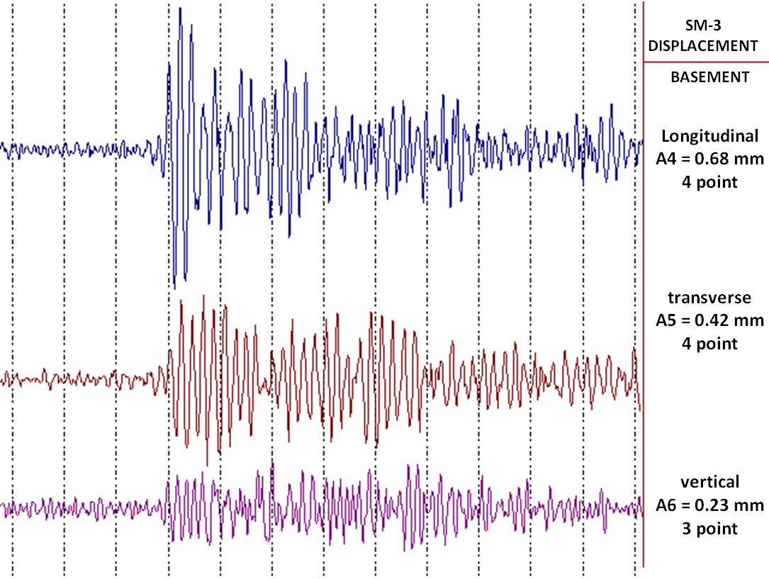
FIGURE 3. A fragment of the seismogram of Figure 2, the recording duration is 12 seconds
Figure 4 shows a part of the seismogram of the earthquake with a duration of 30 seconds. The duration of the recording of the seismic longitudinal P-wave is Δt = 15 seconds before the arrival of the transverse seismic wave front. It is difficult to calculate the number of oscillations of the longitudinal seismic wave in one second due to the small amplitude of the signal and the presence of seismic background.
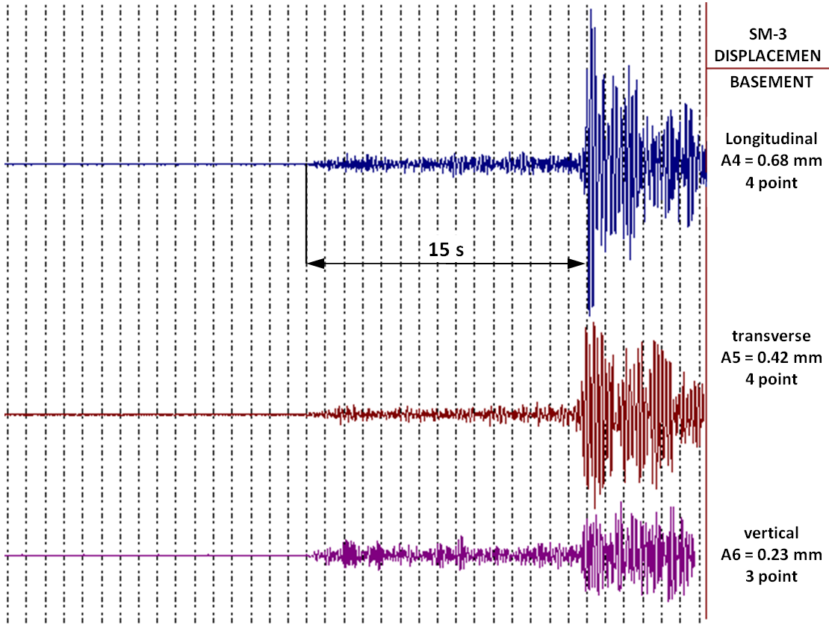
FIGURE 4. Presence of 15-second seismic P-wave oscillations preceding shear S-waves (tremors)
The “moving average” method was used to determine the frequency of longitudinal seismic P-wave oscillations.
To calculate the average value of data for a certain period, which "slides" forward as new values are added, with old data excluded from the calculation and new ones included in the average [12]. Each point of the output signal is replaced by the arithmetic mean of several adjacent points of the input signal:
(1)
where N - is the window size (amount of data); n is the serial number in the sequential receipt of signal data.
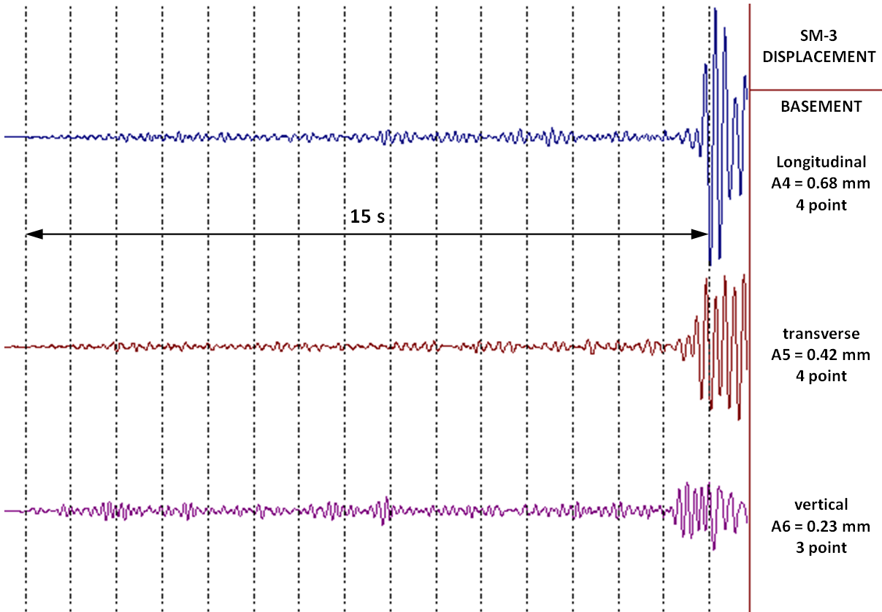
FIGURE 5. Type of oscillations of longitudinal P-waves after computer processing
In this work, N = 10 was used. The seismogram of longitudinal P-waves processed by this method is shown in
Fig. 5. After processing, the number of oscillations and periods per second can be calculated:
Longitudinal direction - 5 Hz, Tlong = 0.2 s;
Transverse direction - 4.5 – 5 Hz, Ttran ≈ 0.2 – 0.22 s;
Vertical direction - 6 Hz, Tvert ≈ 0.17 s;
By comparing the number of oscillations of S-waves and P-waves, it can be seen that the oscillations of longitudinal and transverse seismic waves differ insignificantly by 0.5 Hz (table 1).
TABLE 1. Wave oscillation frequencies
Direction of waves according to seismometers | P-wave  F, [Hz] | S-wave  F, [Hz]
Longitudinal direction | 5 | 4.5-5
Transverse direction | 4.5-5 | 5
Vertical direction | 6 | 6
This document presents the oscillation frequencies determined from earthquake seismograms recorded by the ESOS for 2020-2021. Earthquakes with a magnitude greater than two were considered, while seismic longitudinal P-waves were processed on a computer to accurately calculate the number of oscillations, the results are placed in Table 2. The table also includes oscillations for one second of transverse S-waves, the time duration Δt of longitudinal P-waves before the arrival of the transverse wave front determined from seismograms, and the earthquake strength in points determined by the ESOS. The table also contains the Ministry of Emergency Situations data on the location of the epicenter and the time of the earthquake, the magnitude at the epicenter M, the depth of the source h and the distance L from the epicenter to Tashkent (ESOS).
TABLE 2. Characteristics of earthquakes
Date,  time | Location of  the epicenter | Magnitude at the epicenter, M | Depth  h, km | Distance  to Tashkent  (ESOS)  L, km | ESOS indications, points | Δt, sec. | P-wave oscillation frequency,  Hz | S-wave oscillation frequency, Hz
24.01.2020  12:10 | Tajikistan | 5,5 | 10 | 317 | 3 | 38 | 5,0 | 4,5
26.03.2020  09:45 | Uzbekistan - Tajikistan | 5,4 | 10 | 122,5 | 4 | 15 | 5,0 | 4,5
04.07.2020 14:52 | Tajikistan | 5,5 | 10 | 301 | 3 | 36 | 5,0 | 4,0
09.07.2020  11:40 | Tajikistan | 4.7 | 10 | 145 | 3 | 21 | 6,0 | 5,5
06.11.2020  12:38 | Kyrgyzstan | 4,9 | 10 | 244 | 2 | 28 | 6,5 | 6,0
10.07.2021  07:37 | Tajikistan | 6,0 | 15 | 307 | 3 | 35 | 5,5 | 5,0
29.01.2020  14:10 | Tajikistan - Afghanistan | 5,3 | 60 | 344 | 2 | 45 | 5,0 | 4,5
16.06.2020  06:30 | Tajikistan | 5,5 | 112 | 457 | 2 | 45 | 6,0 | 4,0
Data from the Republican Center for Seismic Prognostic Monitoring |  |  |  |  | Data registered by ESOS

Analysis of results
From Table 2 it follows that in this region the oscillation range is from 4 to 6.5 Hz for seismic longitudinal P-waves and transverse S-waves. With these data, it is possible to build equipment that signals about an earthquake occurring at the moment and about the fact that an earthquake will begin in a few seconds at the place where the equipment is installed.
The developed equipment should consist of a seismometer 1, an amplifier 2, a low-pass filter 3 (LPF), an analog-to-digital converter (ADC) 4, a computer 5, and an emergency unit 6 (Fig. 6).
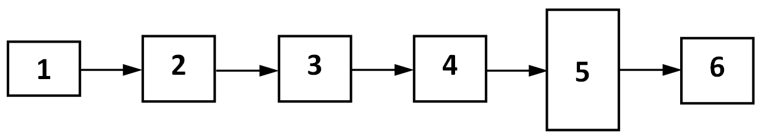
FIGURE 6. Equipment for recording seismic longitudinal P-waves
The equipment operates as follows: during an earthquake, seismometer 1 records seismic longitudinal P-waves, amplifier 2 amplifies them and feeds them to low-pass filter 3. Filter 3 with a passband from 0 to 15 Hz does not pass signals with a frequency higher than 15 Hz, related to seismic background and man-made noise. From the filter output, the signal goes to ADC 4, where it is converted into a digital code for feeding to computer 5. Amplifier 2 amplifies the amplitude of P-waves to a value necessary for accurate signal processing by a personal computer, while the amplitudes of transverse S-waves exceeding the dynamic range of ADC 4 are limited (cut off) (Fig. 7).
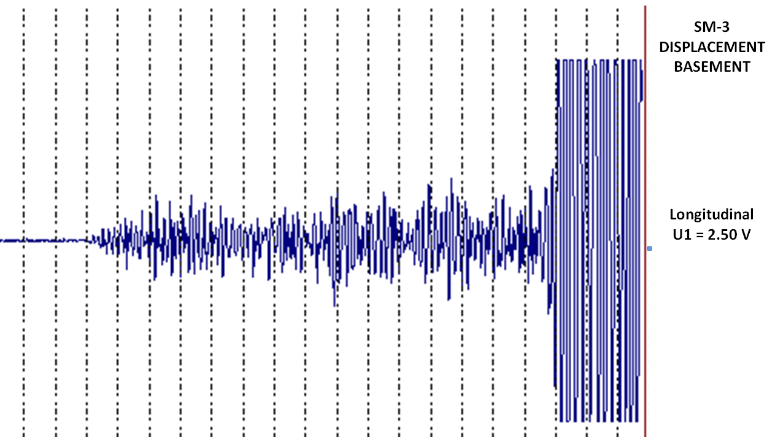
FIGURE 7. Longitudinal P-waves entering the computer
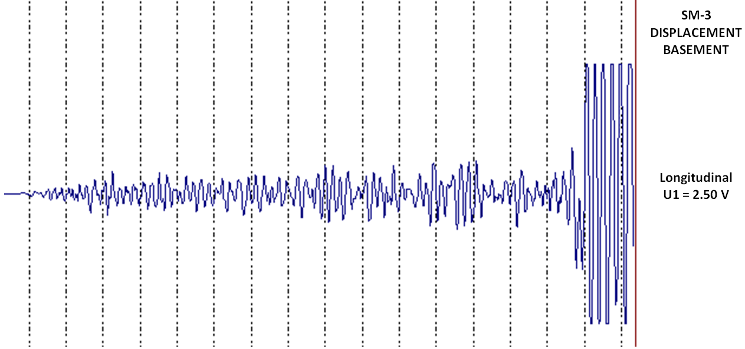
FIGURE 8. Computer processed longitudinal P-waves
The computer processes and analyzes the received signal, consisting of amplified longitudinal P-waves and limited transverse S-waves (Fig. 8). If the signal has frequencies from 3 to 7 Hz, the computer sends a signal about an impending earthquake to the dispatcher, and depending on the level of longitudinal P-waves, sends a command to emergency unit 6 to turn off the power supply and gas supply at the facility.

Conclusion
The analysis of seismograms showed that oscillations of seismic longitudinal P-waves preceding tremors - transverse shear waves S-waves are present in the seismograms of all earthquakes, the epicenters of which are located both far and close to the ESOS.
The study of the oscillation periods of seismic longitudinal waves for the region where the Engineering Seismometric Observation Station is located showed that they are in the range of 4 to 6 oscillation periods per second. Such stability of frequency characteristics of seismic longitudinal waves provides an opportunity to develop equipment for early warning of ongoing earthquakes. This will give people in the danger zone valuable seconds to save themselves, while cutting off electricity and gas supplies to the facility to prevent a fire.

Acknowledgments
This study was made possible thanks to budgetary funding from the M.T. Urazbaev Institute of Mechanics and Earthquake Resistance of Structures of the Academy of Sciences of the Republic of Uzbekistan. We express our sincere gratitude to the Academy for its ongoing support and contribution to the advancement of scientific research.

References
- R. A. Abirov “The seismic risk mitigation problems in urban areas of Central Asia,” in International Disaster Reduction Conference-2016, IDRC Conference Proceeding, edited by W. J. Ammann et al. (Global Risk Forum Davos, 2016), pp. 129-130
- M. A. Richard, P. Gasparini, O. Kamigaichi and M. Böse, Seismological Research Letters 80(5), 682–693 (2009) https://doi.org/10.1785/gssrl.80.5.682
- YM. Wu, NC. Hsiao, TL. Chin, DY. Chen, YT. Chan and KS. Wang, “Earthquake Early Warning System in Taiwan,” in Encyclopedia of Earthquake Engineering, edited by M.Beer et al. (Springer, Berlin, Heidelberg, 2013), 1–12.
- https://www.earthquakeearlywarning.systems/palert.html
- A. Kh. Ibragimov, Journal of Civil Protection 4(3), 280–286 (2020) https://doi.org/10.33408/2519-237X.2020.4-3.280.
- Kh.S.Sagdiev, V.A.Galiaskarov and Z.R.Teshabayev, UZ Patent No. DGU 20150124 (16 June 2015).
- V.A.Galiaskarov, Central Asia: International scientific and practical journal, Series: Technical Sciences 2(3), 415-419 (2019).
- Kh.S. Sagdiev, Z.R. Teshabayev, V.A. Galiaskarov and A.S. Yuvmitov, Magazine of Civil Engineering 6(98), 9801-9802 (2020).
- V. A. Galiaskarov, F. F. Adilov and R. A. Abirov, Industrial Laboratory. Materials Diagnostics 87(2), 65–71 (2021). https://doi.org/10.26896/1028-6861-2021-87-2-65-71
- V.Galiaskarov and Z.Teshabaev, “Modernization of Engineering Seismometric Observation StationUsing Computer Technologies,” in International conference: “Ensuring seismic safety and seismic stability of buildings and structures, applied problems of mechanics”, AIP Conference Proceedings 3265, edited by R. A. Abirov (AIP Publishing, Melville, NY, 2025), https://doi.org/10.1063/5.0265615
- V.A. Galiaskarov and Sh.A. Makhmudova, “Determining the distance from the earthquake epicenter to the seismic station,” in Proceedings of the international scientific and technical conference "Innovative activities in science and education", Innovations in the oil and gas industry 3(3) (2022), pp. 22–28
- Steven W. Smith, The Scientist and Engineers Guide to Digital Signal Processing, (California Technical Publishing, 2006), 277-284.

