Structural Assessment of Ully Hovli in Uzbekistan by Laser Scanning: Preliminary Results
Shakhzod Takhirov^{1, a)}, Bakhodir Rakhmonov^{2, b)}, Mirzokhid Akhmedov^{3, c)}, Ravshan Shamansurov^{4, d)}, Ravshan Nafasov^{2, b)}, Ravshan Savutov^{2, b)}
and Shukhrat Khasanov^{5, e)}
¹University of California - Berkeley, Berkeley, California, United States of America.
²Urgench State University, Urgench, Uzbekistan.
³Miyamoto International - Silk Road, Tashkent, Uzbekistan.
⁴Sigma Innovative Tech, Tashkent, Uzbekistan.
⁵BNZ Industrial Support, Tashkent, Uzbekistan.
^{a)} Corresponding author: takhirov@berkeley.edu
^{b)} Rah-Bahodir@yandex.ru
^{c)} m.akhmedov@miyamotointernational.com
^{d)} shamansurov@rambler.ru
^{e)} xasanovshuxrat999@gmail.com
Abstract. The paper is focused on the structural assessment of the ancient monument in the Khorezm region of Uzbekistan. A historic fortress, "Ully Hovli," was studied. A terrestrial laser scanner was used to collect information about it. The laser scanner produced the so-called point cloud containing detailed information about its current geometry, including all imperfections and possible structural anomalies. The point cloud was investigated for two walls. One of the walls—the front wall on the right side of the main entrance—was fully reconstructed during the recent restoration effort. The analysis conducted during this study showed that this wall mimics the taper common to this type of construction from untreated earthen materials, called pakhsa. It was shown that this wall has a much more regular structure than the inner wall, which was preserved with very limited alterations. It was shown that this inner wall has an irregular structure, with large indentations that reduce its thickness. This paper discusses the preliminary results of the analysis. The research team plans to conduct a new expedition to collect additional point clouds with a laser scanner, and future work will yield more results.

Introduction
"Ully Hovli" (also known as Ulli Hovli, Uly Howly, or Ulli-Huli) is a historical fortress-settlement and cultural complex in the Khorezm region of Uzbekistan. The word-by-word translation of the name stands for "big yard" or "large house" in the local language. It was originally constructed in the 17th century and has recently been restored as a heritage and cultural space for the Turkmen people. The entrance walls and plaque of the monument is presented in fug. 1.
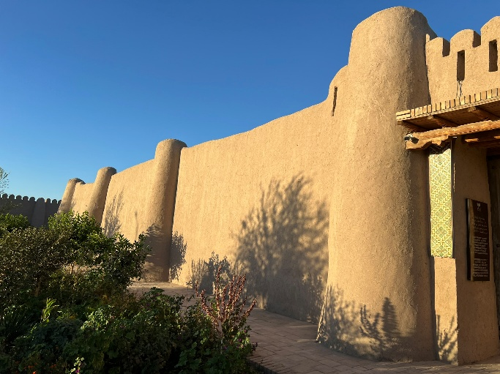 | 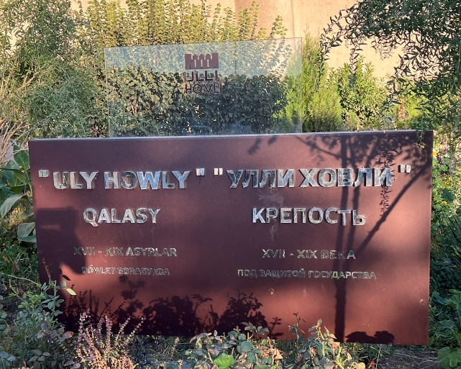
(a) | (b)
Figure 1. The monument’s front wall on the left side of the main entrance (a) and its name plaque (b).
The monument’s history and its invaluable place in Turkmen history in Central Asia are discussed in detail in [1]. The monument underwent reconstruction, which was completed in the fall of 2014. The work was conducted under multiyear state funding [2] from the program aiming at tourism development in the Khorezm region. One of the festive grand openings happened during the President of Turkmenistan's visit in April 2018 [3].

Laser SCAnning
A laser scanning project was conducted on October 8, 2024, to acquire with high accuracy the current geometry of the object. A terrestrial laser scanner, C10, from Leica Geosystems was used. The laser scanning was conducted from 14 positions (the so-called stations), and all were stitched into a single point cloud in the Cyclone Register 360, also from Leica Geosystems [4]. A plan view of the final point cloud is presented in FIGURE 2.
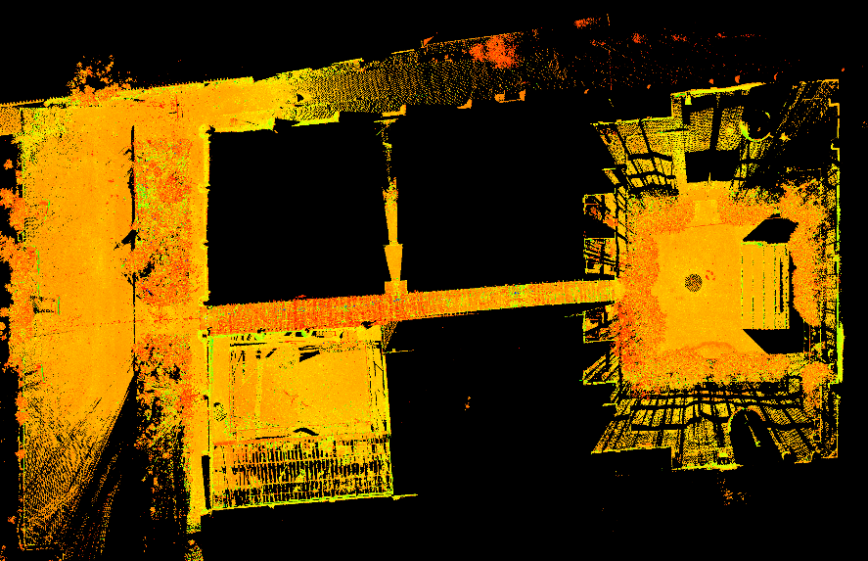
Figure 2. The plan view of the monument’s point cloud
The monument is constructed of uncured earthen material, or adobe. This type of construction is commonly called “pakhsa” in the region of Central Asia. This type of construction is quite common in the region because of its low cost and wide availability of this construction material [5-7]. Although it appears to be a simple construction technique, when the earthen material is properly prepared, placed, and cured, it can yield a material with adequate structural properties [8].
The monument consists of a long corridor that leads from the main entrance to the inner courtyard at its end. Based on the current arrangement, the left side of the corridor is occupied by a hotel and a few community rooms. On the right side of the corridor, a few museums are located after a large open space (smaller courtyard) allocated to a stable with traditional animals.
The monument’s overall dimensions in a plan view are close to a rectangle with a length of close to 107.3 meters and a width of 64.3 meters, as presented in FIGURE 3.
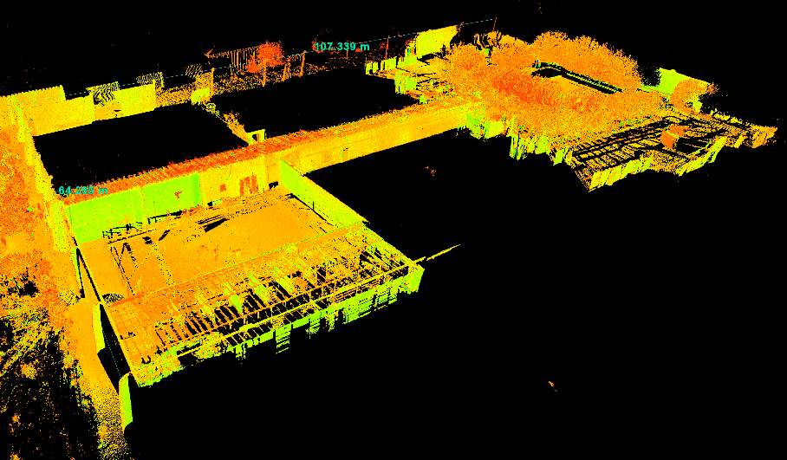
Figure 3. The overall dimensions of the monument
An elevation view of the front wall is presented in fig. 4. As shown in the image, the front wall has two main towers right next to the entrance and three secondary towers on the left and right sides.
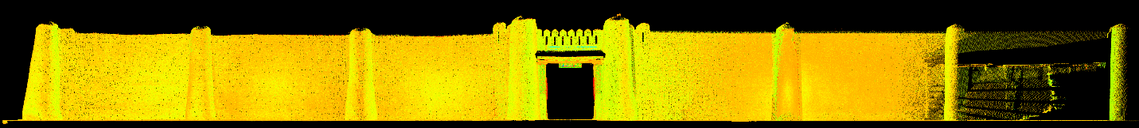
Figure 4. The elevation view of the front wall
As mentioned earlier, the monument underwent a recent restoration. During the laser-scanning project, it was observed that a small courtyard that is dedicated as a stable for traditional animals has walls with limited restoration signs, as presented in FIGURE 5.
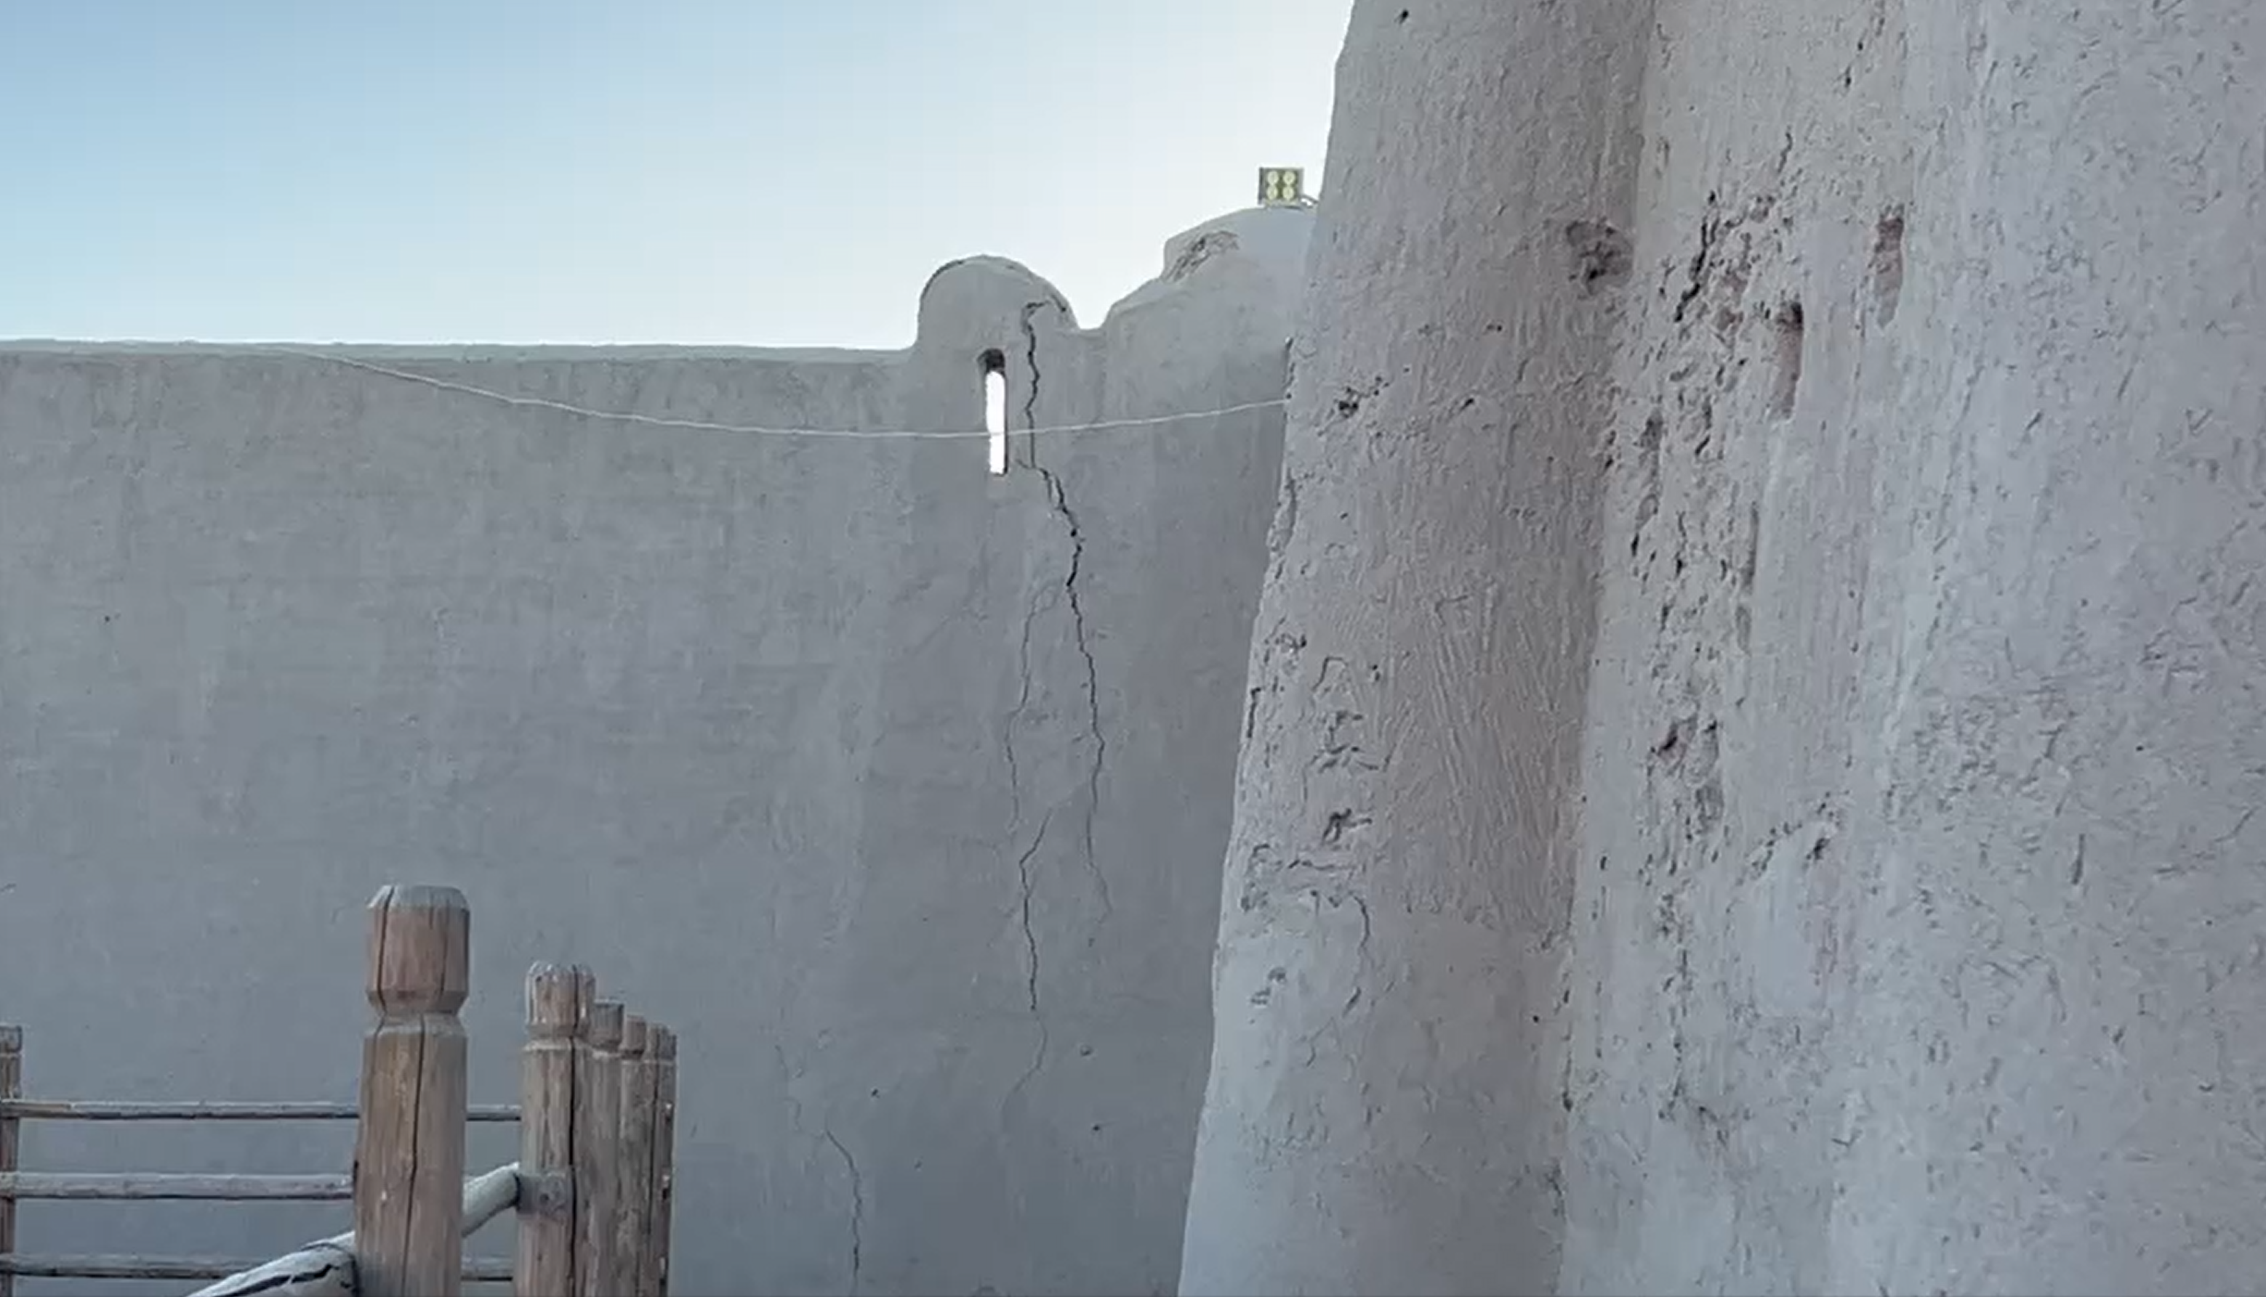
Figure 5. The wall of a small courtyard with limited restoration signs (on the right side of the image)
Since this courtyard had exposed walls from the outside and inside, its walls were scanned from both sides to estimate the thickness of the walls and their taper. The rest of the analysis of the monument’s point cloud was conducted in the MATLAB environment [9].

Front WALL: Fully Restored from both sides
Based on the condition of the monument before reconstruction [10], the front wall on the right side of the main entrance was fully rebuilt. This wall is investigated in more detail in this section of the paper. A few horizontal slices of the wall’s point cloud were investigated as presented in FIGURE 6a. The plan views of the respective sections are presented in FIGURE 6b. As shown in the latter image, the wall width increases gradually with elevation. It is quite common in pakhsa construction. The wall’s taper on the inside of the monument is larger than that on the front side. This conclusion is more visible in the vertical sections of the wall, which are shown in fig. 7.

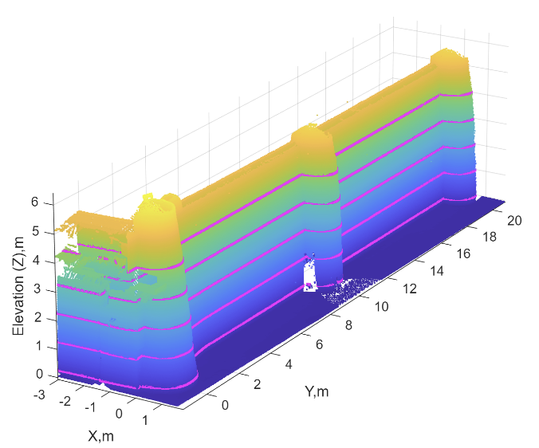
(a) | (b)
Figure 6. The horizontal sections of the monument’s front wall on the right side of the main entrance (a), and plan views of the sections (b)
Fig. 7a shows an isometric view of the wall with two vertical slices marked by red and green. The elevation views are presented in fig. 7b. It shows that the wall thickness varies from 1.33 m at the bottom to 0.46 m at the very top. The thickness of the tower (shown in red) is much larger than that. It varies from 2.24 m at the bottom of the tower to 1.27 m at its top. Since it is a modern construction, the wall thickness is very consistent along its length, as shown in the plan view sections of fig. 6b. That is why only vertical sections are shown in fig. 7 as representative examples. The exterior walls are about 5.5 m tall.
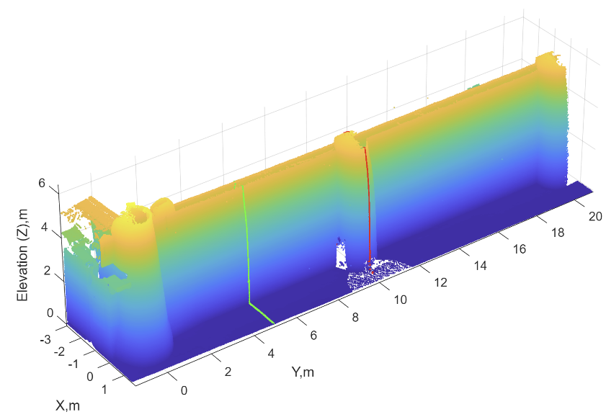
(a) | (b)
Figure 7. Two vertical sections of the monument’s front wall on the right side of the main entrance (a), and elevation views of the sections (b)

Inner WALL: Restored from one side only
The inner wall on the right side of the corridor still has some signs of wear and tear, as discussed (see discussion related to fig. 5). This wall was also investigated by analyzing its horizontal and vertical slices. The results for horizontal sections are presented in fig. 8. The image on the right shows an isometric 3D view of the wall, with the horizontal sections shown in magenta. The image on the right shows the plan views of these sections. As shown in fig. 8b, the plan view changes significantly along the X axis. In addition, the least restored side of the wall (right side of the plot) has several deep indentations.

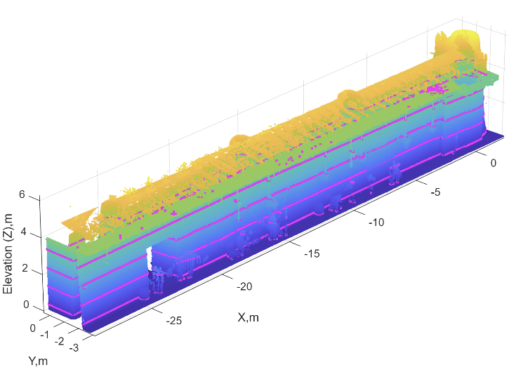
(a) | (b)
Figure 8. The horizontal sections of the monument’s inner wall on the right side of the corridor (a), and plan views of the sections (b)
Similar to the outer wall, which was fully reconstructed, the wall has a taper on both sides. It has a smaller taper on the corridor side (the left side of the plot in fig. 9b) but a larger taper on the side of the stables (the right side of the plot in fig. 9b). As shown, the wall thickness varies from about 1.46 m at the bottom of the wall to 0.75 m at its top. The indentations in the wall are quite deep, and in some cases, they reduce the thickness of the wall to 0.65 m as shown in fig. 9b.
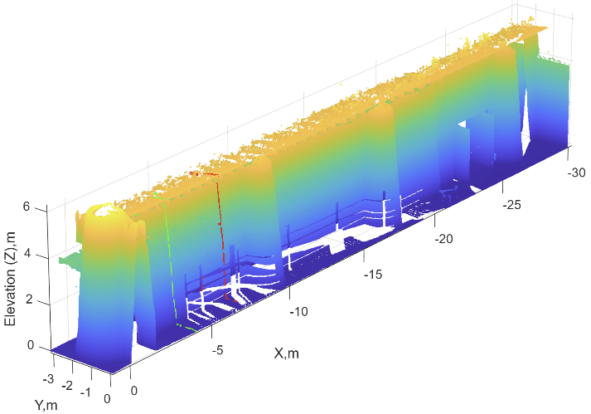
(a) | (b)
Figure 9. Two vertical sections of the monument’s inner wall on the right side of the corridor (a), and elevation views of the sections (b)

CONCLUSIONs
The paper is focused on the structural assessment of the ancient monument in the Khorezm region of Uzbekistan. A historic fortress, "Ully Hovli," was studied. A terrestrial laser scanner was used to collect information about it. The laser scanner produced the so-called point cloud containing detailed information about its current geometry, including all imperfections and possible structural anomalies. The point cloud was investigated for two walls. One of the walls—the front wall on the right side of the main entrance—was fully reconstructed during the recent restoration effort. The analysis conducted during this study showed that this wall mimics the taper common to this type of construction from untreated earthen materials, called pakhsa. It was shown that this wall has a much more regular structure than the inner wall, which was preserved with very limited alterations. It was shown that this inner wall has an irregular structure, with large indentations that reduce its thickness. The wall thickness varies with elevation, ranging from about 1.5 m at the very bottom to about 0.5 m at the top. The thickness of towers in the exterior wall varies from about 2.2 m at the bottom to about 1.3 m at the top. The exterior walls are about 5.5 m tall. This paper discusses the preliminary results of the analysis. The research team plans to conduct a new expedition to collect additional point clouds with a laser scanner, and future work will yield more results.

References
- M. Egamberganova, Journal of Critical Reviews 7(04), (2020).
- https://www.uzdaily.uz/en/reconstruction-of-ulli-hovli-fortress-completed/ last accessed 11/04/2025.
- https://www.uzdaily.uz/en/president-of-turkmenistan-arrives-in-khorezm/ last accessed 11/04/2025.
- Leica Geosystems. https://rcdocs.leica-geosystems.com/cyclone-register-360/latest/help-cyclone-register-360. Last retrieved on 07/25/2025.
- ADB (2025). Tajikistan: Case Study Report on Resilient Community Housing. Consultant’s report (TA 6929-REG).
- S. Takhirov, B. Rakhmonov, M. Akhmedov and M. Blondet, “Structural health monitoring of chadra hauly (Khorezm, Uzbekistan) by means of laser scanning,” in International conference: “Ensuring seismic safety and seismic stability of buildings and structures, applied problems of mechanics”, AIP Conference Proceedings 3265, edited by R. A. Abirov (AIP Publishing, Melville, NY, 2025), 030017.
- S. Takhirov, B.S. Rakhmonov, R. Nafasov, A. Samandarov, S. Sultanova, M.M. Akhmedov and
R.A. Shamansurov, “First Step Toward Preservation of Ancient Toprak Qala in Uzbekistan: Estimation of Erosion and Deterioration Rates by Laser Scanning,” in RILEM Bookseries, (2024), 581–590.
- S. Takhirov, Z. Ergashev, B. Rakhmonov, A. Gilani, M. Akhmedov and R. Shamansurov, “Detailed material testing of adobe structures to complete a comprehensive SHM approach that includes laser scanning and ambient vibration studies,” in 13th International Conference on Structural Health Monitoring of Intelligent Infrastructure, edited by Dr. W. Lienhart et al. (Graz, Austria, 2025), pp. 1000–1007.
- MathWorks (2020) Matlab Version R2020a Update 6.
- https://centralasia-adventures.com/en/uzbekistan/khorezm_and_karakalpakstan/ulli-hovli.html last accessed 11/04/2025.

