Determine of the Seismic Impacts for the Specific Construction Site
Anatoly Ischuk^{1, a)}
¹Institute of Geology, Earthquake Engineering and Seismology of the National Academy of Sciences of Tajikistan
^{a)} Corresponding author: anatoly.ischuk@gmail.com
Abstract. Generally, the seismic microzoning use for define the seismic impact on the construction site based on the General Seismic Zoning map in terms of MSK-64 scale consider the local soil conditions and provide the results in terms of plus or minus 1 unit of MSK-64 scale for current construction site. Consider up-to-date methodology and approaches, the modern approach is suggested based on the so-called site-specific seismic hazard analysis instead of traditional microzoning. The up-to-date ground motion prediction models (GMPM) and special software for calculation of the spectral accelerations consider the local soil conditions in terms of Vs30 value are used. As seismic sources the zonation of earthquake epicenters location as well as the active faults that capable to produce the strong earthquakes are defined. Finally, PSHA and DSHA use for estimation of the seismic impact on the specific construction site. Results are presented in terms of uniform hazard spectra and synthesized accelerograms

Introduction
Previously, and even till now in some countries, two regulating documents used for estimation of the design seismic impacts and selection of the dynamic loads on the structures on the construction site:
1 - the map of the General Seismic Zonation in terms of MSK-64 scale;
2 – results of the seismic microzoning of the construction site in terms of increment or reduction of the basis MSK-64 units depending of the local soil conditions.
However, a more modern and accurate assessment of seismic impacts on a specific construction site has long been widely used throughout the world. It is so called “site-specific seismic hazard analysis”.
Classical probabilistic seismic hazard analysis (PSHA) [1,2,3], deterministic seismic hazard analysis (DSHA) and ground motion models (GMM) are usually used, and consider the local soil conditions on the construction site.
Special software for seismic hazard calculation generally used. The most popular are R-CRISIS [4] and Open Quake [5], when seismic impacts are calculated for given points grid for the specific area.
Spectral accelerations with given oscillation periods (spectral ordinates) for given probability of exceedance for specified period of years (or return periods) are calculated. The hazard curves and uniform hazard spectra are obtained for every grid point on the specific construction site.

Methodology
We already used site-specific seismic hazard analysis for some construction sites in Tajikistan consider both PSHA and DSHA. The methodology is described shortly below.
First of all, the seismic sources are defined, and generally there are two common types:
A – based on the earthquake epicenters distribution generally, and the earthquake catalogues are the basis for this;
B – based on the definition of the active faults or their segments that capable to generate the earthquakes with M ≥ 6.
The example of the site-specific seismic hazard analysis is given below for the dam of tailing pit in some of the mine in Tajikistan.
The earthquake catalogue for the area with 200-300 km radius from the dam site location is analyzed (Fig. 1). This territory is further divided into sections (zones) based on the distribution (Fig. 2) of the earthquakes and tectonics futures.
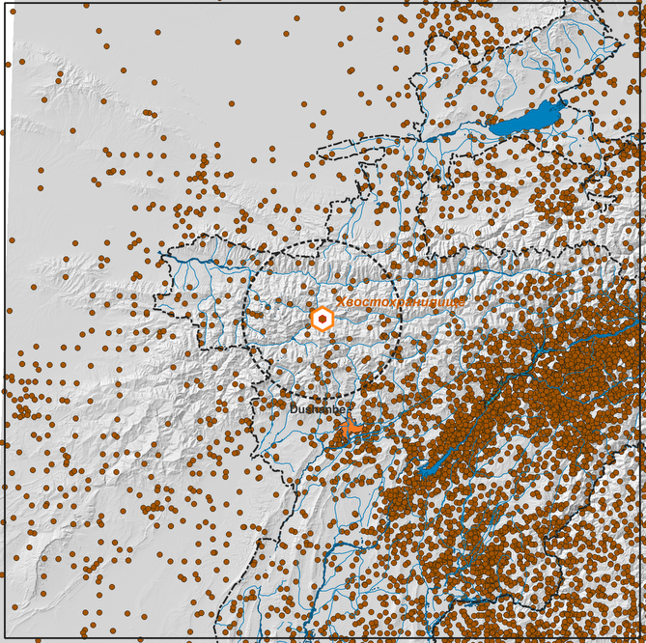
FIGURE 1. Earthquake epicenters distribution in the given area
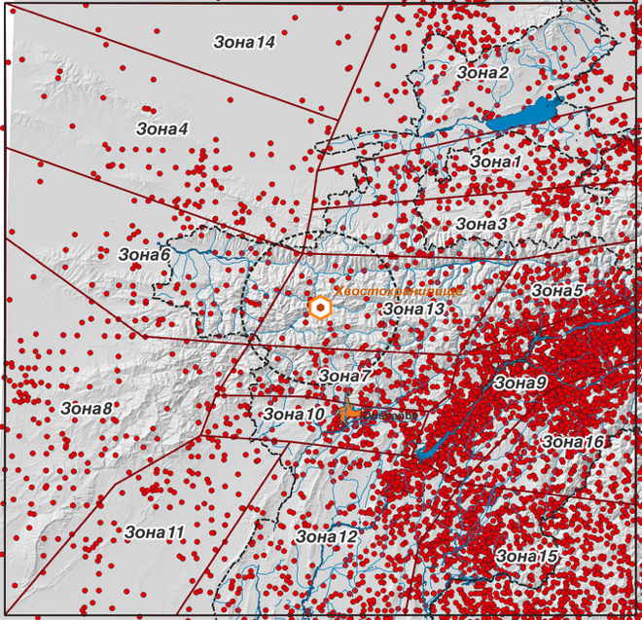
FIGURE 2. Selected zones as the seismic sources
It is so-called areal model of seismic sources with equal Gutenberg-Richter parameters and Mmax, and consequently, seismic impacts for every zone.
Additionally, the fault model based of the active faults distribution that capable to generate the strong earthquakes (with M ≥ 6 as a rule) in the area with 50 km radius from the site is created. Active faults refer to faults that show signs of active movement in the late Pleistocene–Holocene period in general.
All identified active faults for the study area are shown in Figure 3. Selected active faults as seismic sources and their segments with rupture plane projection on the surface are shown in Figure 4.
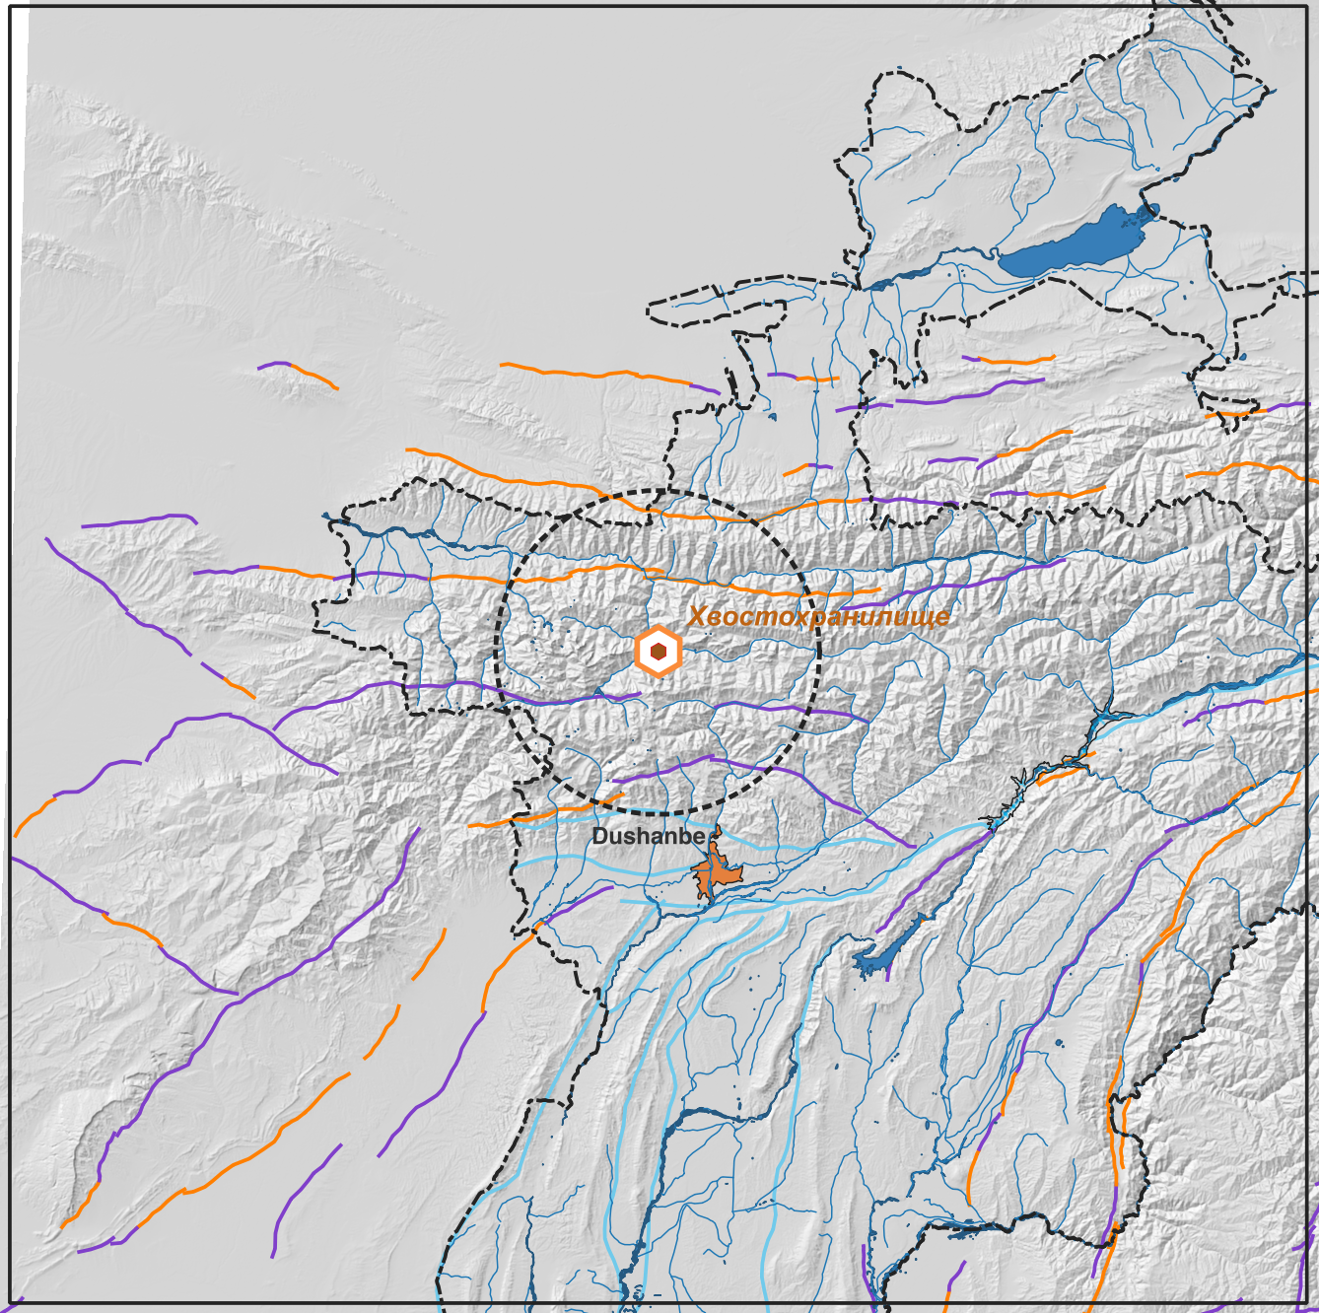
FIGURE 3. Active faults identified in the study area (the color indicate the different confidence of their activity)
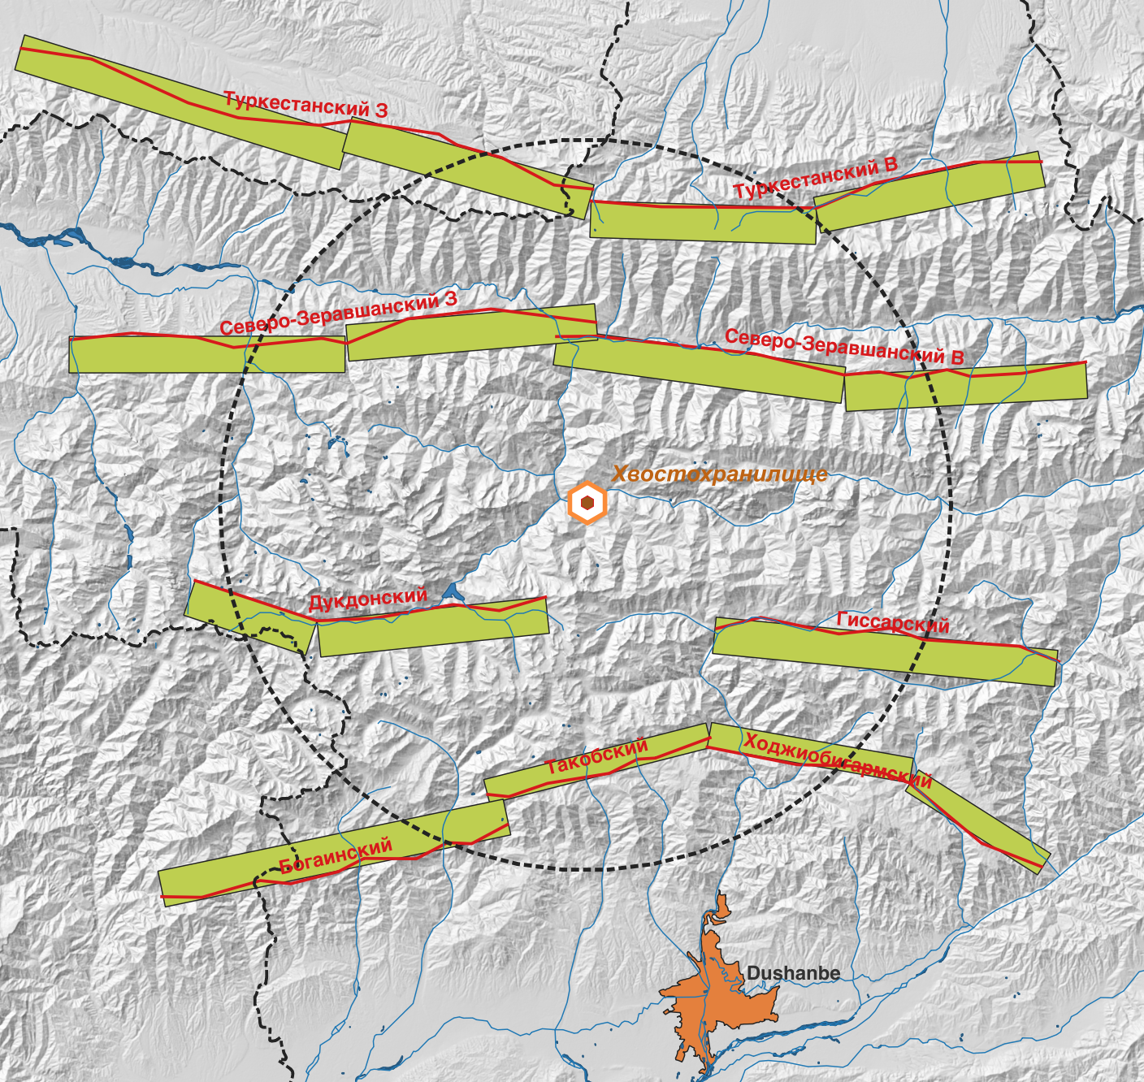
FIGURE 4. Active faults and their segments with rupture plane projection on the surface selected as seismic sources

At the same time, the type of fault (thrust, normal fault, or strike-slip), the dip angle of the rupture plane, and the maximum possible magnitude are taken into account. The most important factor here is determining the displacement velocity (slip rate) along a specific fault or its segment.
A specialized program is typically used to calculate seismic impacts, usually in units of seismic acceleration. We use R-CRISIS software [4]. This program allows us to obtain unified hazard spectra for selected probabilities of exceedance design values (or return period) and hazard curves for specific sites, taking into account local soil conditions (through the value of the Vs30 parameter – the velocity of shear-waves in the upper 30 m of soil).
Ground motion models (GMM) are using to calculate the spectral acceleration for needed spectral ordinates consider the type of focal mechanism and Vs30 for prevalent type of the soil in the site [3]. As a rule, several models are used. If they are not available for the territory under consideration, models with similar geological conditions and soils are taken from global databases.

RESULTS
As the result of computer calculations, the matrices with calculated spectral accelerations for given specified spectral ordinates and return periods will be done. The example of such matrix is given in Figure 5.
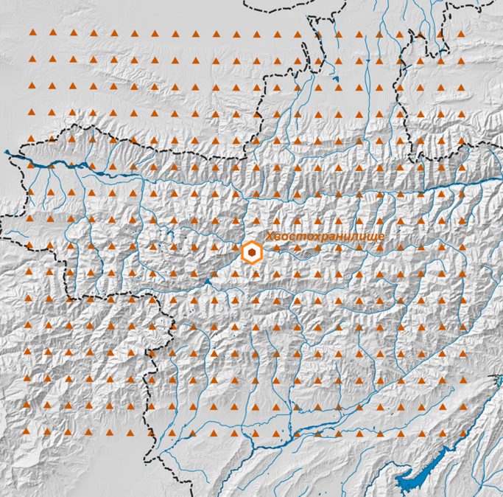
FIGURE 5. The matrix of the calculated spectral accelerations (points grid)
For each point of such matrix, hazard curves are calculated for specified oscillation periods, on the basis of which uniform hazard spectra are constructed for specified return periods (or probability of exceedance in given years). Usually, the horizontal and vertical components of oscillations are considered. Example of such matrix is given in Figure 6 where the PGA values for 10% probability of exceedance in 50 years (or 475 years return period) are shown.
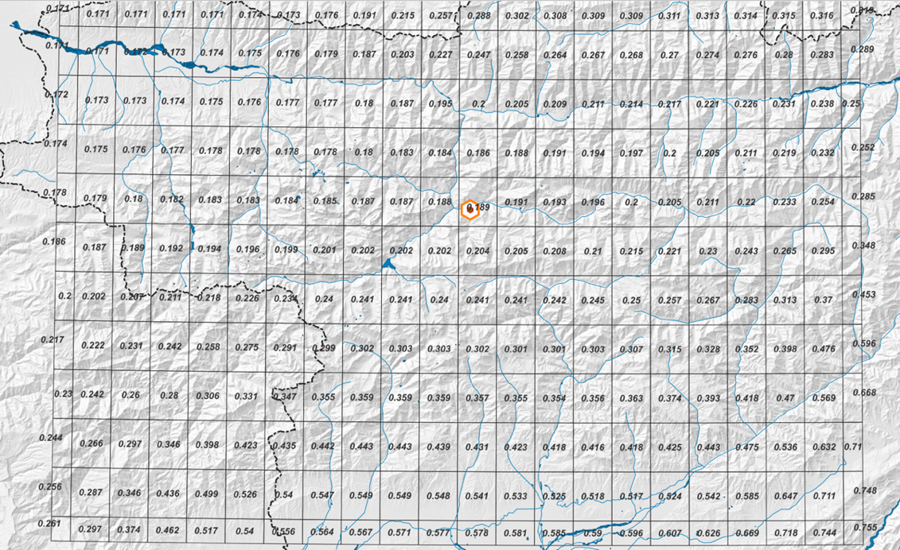
FIGURE 6. Peak ground acceleration (PGA) for 10% probability of exceedance in 50 years (475 years return period) for every cell of the matrix
The examples of hazard curves for selected periods of oscillation are shown in Figure 7, and uniform hazard spectra for given return periods and for horizontal and vertical components are shown in Figure 8.
Since potentially active faults have been identified near the site under consideration, which may produce a significant impact for the seismic action on the site, a deterministic method (deterministic seismic hazard analysis – DSHA) is also applied, which considers the most unfavorable scenario of seismic impacts from possible earthquakes.
Usually, several scenarios are considered when there are several active faults, and the worst-case scenario is selected, i.e., the combination of “magnitude-distance” that contributes most to the seismic impact.
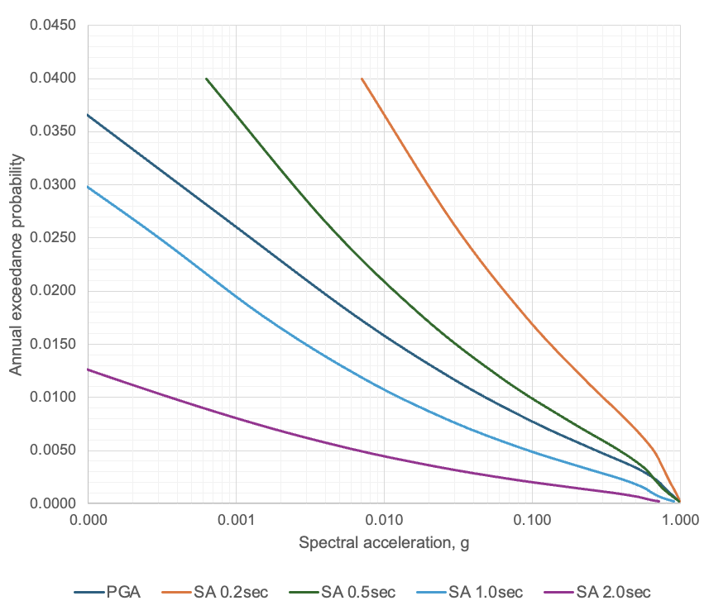
FIGURE 7. Hazard curves for selected periods of oscillation.
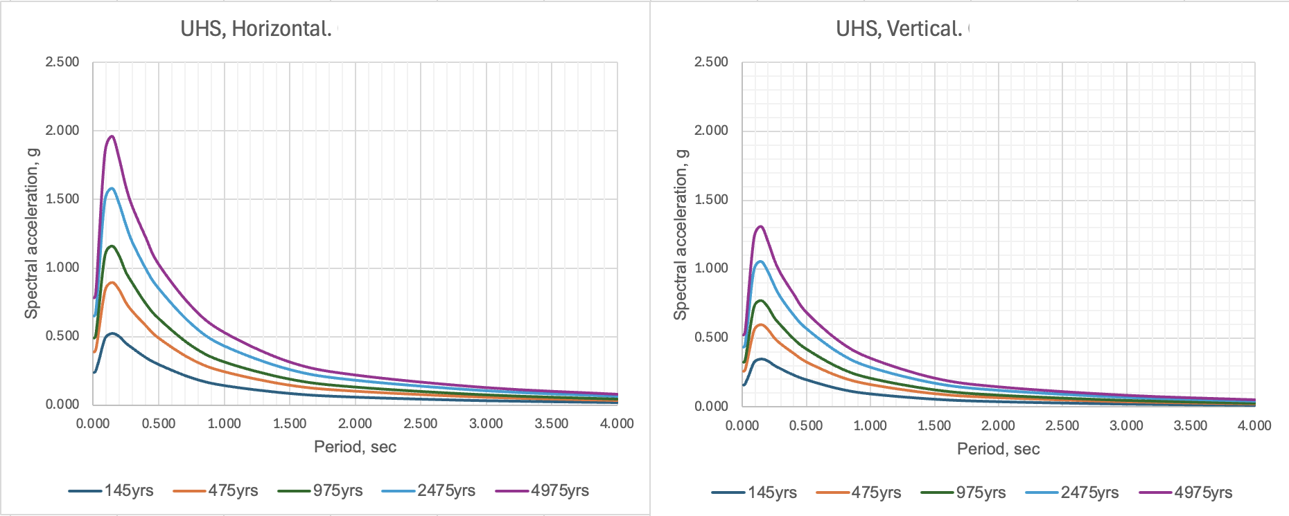
FIGURE 8. Uniform hazard spectra for given return periods
The results of DSHA correspond to so-called maximum considered earthquake (MCE). The worst-case scenario, i.e. worst combination of “magnitude – distance” for consider site is given in Figure 9.
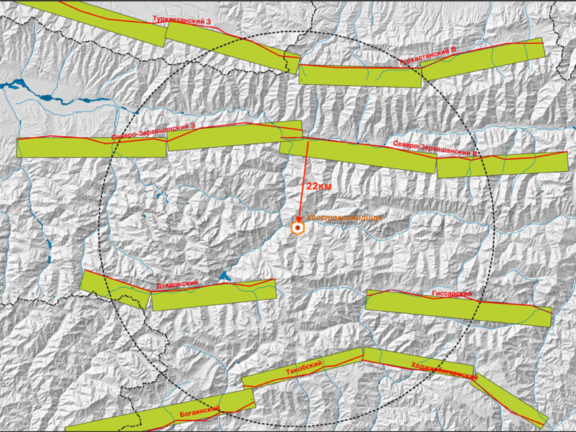
FIGURE 9. The worst-case scenario for DSHA
Usually, calculations are based on the median value of the DSHA results plus 1 sigma (or 84th percentile).
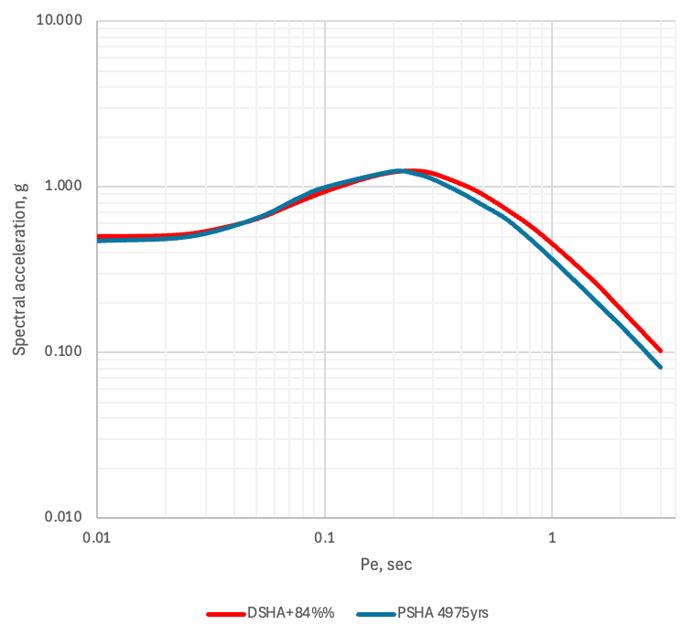
FIGURE 10. Comparing of the uniform hazard spectra from PSHA and DSHA
Next, the spectra obtained using PSHA for a recurrence period of 4975 years (2475 years or another value determined by the type and importance of the facility) and using DSHA are compared. If there is a large difference, the Customer decides, which value to use for calculations that provide the safety of the structure. Comparing of the UHS from PSHA and DSHA is given in Figure 10.

DISCUSSION
As a rule, spectra are used to calculate the linear deformations of structures under seismic loads. However, accelerograms, either real or synthesized, must be used to calculate nonlinear deformations.
Based on the results of the PSHA, the so-called deaggregation of results by magnitude and distance is also carried out. In other words, pairs of “magnitude-distance” ratios are identified that determine the greatest contribution to seismic impact on the site for a given recurrence period and spectral ordinate (frequency of vibrations). An example of such assessment is shown in Figure 11.
Based on the analysis, earthquake parameters are selected that are necessary for selecting accelerogram records of real earthquakes and further processing them in order to obtain calculated synthesized accelerograms. From global databases of accelerograms of real earthquakes, earthquake records are selected with a close combination of magnitude, distance, and Vs30 velocity values, and those that most closely match the calculated hazard spectrum for the required recurrence period. The calculated spectrum is taken from the results of the PSHA or DSHA for the recurrence period specified by the Customer.
Special software performs a procedure called “adjust process” of the actual spectrum to the calculated spectrum (spectral matching). The result is a synthesized accelerogram with a response spectrum similar to the calculated one (Figure 12). As a rule, of 3-component accelerograms are used: two horizontal and one vertical. Usually, 3 (sometimes more) sets of 3-component entries are prepared.
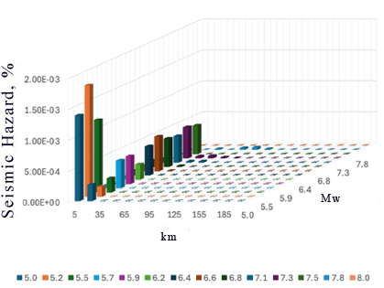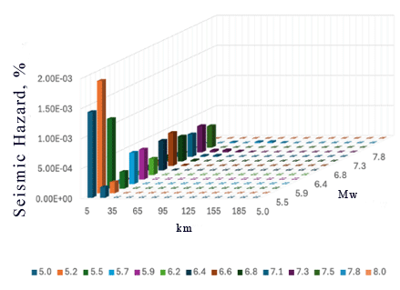
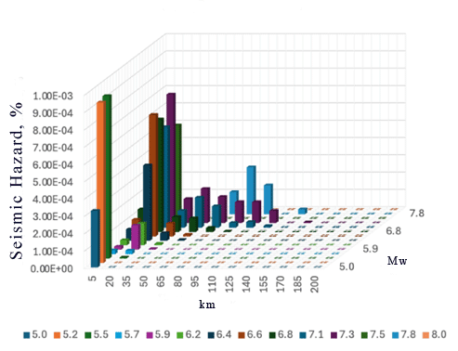
FIGURE 11. Deaggregation for three spectral ordinates for 4975 years return period
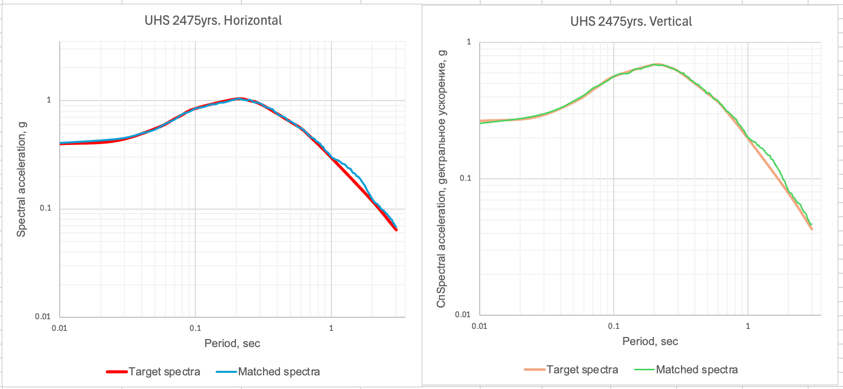
FIGURE 12. Comparison of the target spectra and spectra after spectral matching procedure

CONCLUSION
Finally, the numerical results of spectral matching are proposed in Figure 13.
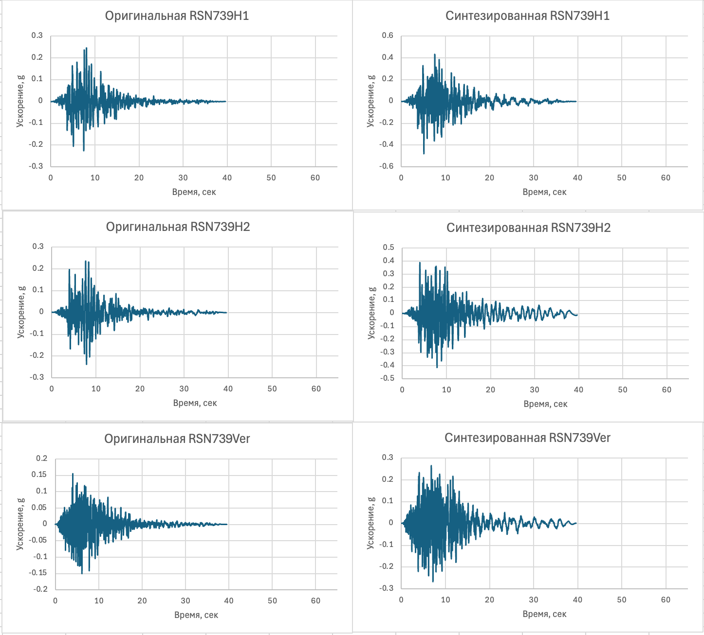
FIGURE 13. Example of results of spectral matching. Target spectra on the left, and after spectral matching are on the right
The seismic hazard assessment method used allows the use of hazard spectra with a given probability of exceedance the calculated values (return period), as well as synthesized accelerograms for calculating the dynamic seismic loads of earthquakes for a specific construction site, taking into account the local soil conditions at the site.
This approach can significantly refine and improve calculations for the seismic safety of structures at a specific construction site.

References
- C. A. Cornell, Bull. Seism. Soc. Am. 58, 1583-1606 (1968)
- L. Esteva, “Criteria for the construction of spectra for seismic design”, in Third Panamerican Symposium on Structures, (Caracas, Venezuela, 1967).
- R. K. McGuire, Bull. Seism. Soc. Am. 85, 1275–1284 (1995).
- M. Ordaz, F. Martinelli, V. D’Amico and C. Meletti, Seismological Research Letters 84 (3), 240-245 (2013).
- M. Pagani, D. Monelli, G. Weatherill, L. Danciu, H. Crowley, V. Silva, P. Henshaw, L. Butler, M. Nastasi, Seismological Research Letters 85(3), 692-702 (2014) https://doi.org/10.1785/0220130087

