Spectral Method in Seismic Dynamic Problems of Tall Earth Dams
Klara Salyamova^{1, a)} and Ekaterina An^{1, b)}
¹ Institute of Mechanics and Seismic Stability of Structures named after M.T. Urazbaev, Uzbekistan Academy of Sciences, Tashkent, Uzbekistan
^{a)} Corresponding author: klara_51@mail.ru
^{b)} ekaterinaan1986@gmail.com
Abstract. Design standards for structures in seismic regions do not require consideration of the multidimensional configuration or the stress-strain state study of the structure. A methodology and algorithm for solving a two-dimensional problem are proposed to determine the seismic stress state of an earth dam under primary loads using the spectral method. Problems are solved to determine the dynamic characteristics of the dam-foundation system under consideration. A stress-strain state analysis based on these characteristics is performed using the first mode of natural vibrations. The most vulnerable sections of the dam, potentially leading to adverse consequences, are identified.

Introduction
Tall earth dams are critical hydraulic structures susceptible to seismic damage, which can lead to catastrophic consequences such as dam failure and flooding. Studying the seismic stress state of such structures is a key aspect of ensuring their safety in seismically active regions. The spectral method, based on the analysis of the structure's dynamic characteristics (frequencies and modes of natural vibrations), allows for the effective modeling of seismic loads and assessment of stresses in the earth structure. Research in this area has evolved from simple linear models to complex nonlinear analyses that consider the interaction of the dam with the foundation and reservoir, as well as the impact of pore pressure.
The spectral method used to analyze the seismic response of the dam-foundation system is described in reference [1]. Seismic analysis of a dam with a foundation is a complex task due to the uncertainty in the material properties. In [1], the effect of randomness and material heterogeneity on the seismic response of gravity dams and their foundations was investigated using a stochastic spectral finite element method based on the Karhunen-Loève expansion. The Pine Plane Dam was considered a case study. First, the Karhunen-Loève expansion modes were determined, and then, the seismic response of the dam was analyzed. Foundation heterogeneities affect the dam response in the high-frequency range, highlighting the need to consider the uncertainty of material properties in design assessment and risk analysis.
Application of the spectral method shows that, under horizontal seismic loading, tall earth dams experience transverse vibrations, with maximum vertical stresses at the base of the windward slope and shear stresses at the base and on the leeward slope, where the risk of bearing capacity loss is higher. The safety factor remains above 1, indicating adequate safety, but with recommendations for strengthening.
In [2], it is noted that when dynamically analyzing dams subject to spatially heterogeneous loading, the use of foundation models with viscous properties should be avoided, as this can significantly underestimate crest displacements and the overall level of dam damage.
In reference [3], a new methodology for modeling damage to tall concrete dams during earthquakes is proposed. To test this approach, the seismic behavior of the Koyna gravity dam in India and the Shapai reinforced concrete arch dam in China was studied under strong earthquakes. The results showed that the proposed method reliably describes the damage process of concrete dams under significant seismic loading.
Quantifying uncertainty plays a key role in the design, monitoring, and risk analysis of embankment dams. In [4], a combination of finite difference and soft computing methods was used to reduce the computational burden on embankment dam materials during the initial filling stage. Research has shown that material parameters such as dry density, elastic modulus, friction angle, and Poisson's ratio significantly influence the calculation of displacements and stresses.
Geotechnical and hydrological studies are critical before dam construction. The presence of gypsum and anhydrite in dam foundations and piers can lead to the risk of uneven settlement and structural instability. In [5], the solubility of four types of solutions in municipal water and water of the Marash Dam was experimentally determined and calculated, revealing differences in the solubility of gypsum in these solutions.
An analysis of factors influencing the stress-strain state of rockfill dams with clay-cement concrete diaphragms was conducted in [6], using PLAXIS software. The stress-strain state of dams with diaphragms of varying compositions was studied, and it was concluded that a rock-concrete belt on the downstream face of the diaphragm is necessary for dams over 100 m high.
In [7], simplified and calibrated methods for assessing the seismic behavior of earth structures are described. First, a linearization method is presented that accounts for the effect of pore pressure on the equivalent linear shear modulus, applied to the Aratozawa Dam. Then, a graded approach, including static, simplified dynamic, and nonlinear time-domain analyses, is implemented for an embankment dam similar in height to the Aratozawa Dam and subjected to severe seismic loading. A new simplified method for assessing the seismic behavior of dams, embankments, and medium-sized dams is also proposed, taking into account the geometric features and foundation properties of these structures when analyzing their response to seismic loading. The spectral element method demonstrates high accuracy in analyzing dam-reservoir interactions, with diagonal mass matrices and reduced computation time (several times faster than the FEM), especially for large structures.
The interaction between a dam and its reservoir significantly affects the behavior of the dam during earthquakes. This interaction should be accurately considered in seismic design using a rational and reliable dynamic analysis method. In [8], the Legendre spectral element method is used for wave propagation in a dam-reservoir system, ensuring spectral convergence with increasing polynomial degree.
This review of literature sources demonstrates the effectiveness of the spectral method in predicting the seismic stress state of tall gravity earth dams, especially in combination with finite element methods and stochastic models, which allow for the consideration of nonlinearities and interactions.
Continuous improvement of strength analysis methods for various types of loads, such as gravity, hydrostatics, and dynamic loads, including seismic loads, is required to ensure the safe and reliable operation of tall earth dams in seismic zones [9-10]. Current regulatory calculation methods for these structures [11] are based on one-dimensional theory and fail to account for the geometry of the structure itself, the piecewise heterogeneous physical and mechanical properties of both the structure and its foundation, and, especially, the stress-strain state, which allows for identifying the most vulnerable areas in terms of stability loss. The proposed methodology for solving the stress-strain state problem allows for a two-dimensional approach and addresses the aforementioned shortcomings.

Materials and methods
During the design of the Pskem Dam, several configuration options for the dam were considered. Gidroproekt JSC presented us with one of the dam designs with a core for strength and stability calculations. To calculate the stress-strain state of an earth dam operating under complex conditions and various loads, a plane calculation model was selected, being the central cross-section of the dam, subject to plane strain conditions (Fig. 1). The model includes not only the dam body with its core but also the siltstone foundation. Two options of foundation depth were considered: 35 m (Fig. 2) and 200 m (Figs. 3, 4).
The geometric parameters of the dam model under consideration are: height H = 200 m; crest width 10 m; slope ratios of upstream slope m₁= 2.55, of downstream slope m₂= 2.25, and symmetrical core m_{c}= 0.2.
The physical and mechanical properties of the materials for each section of the dam are taken from the design documentation presented by Hydroproject OJSC and given in the table.
TABLE 1. Soil properties in the body and foundation of the earth dam.
Layer No | Soil type | γ_{nat}, t/m³ | γ_{hum}, t/m³ | ϕ | С, t/m²
1 | Siltstone | 2.37 | 2.42 | 31 | 5.00
2 | Alluvium | 2.15 | 2.20 | 39 | -«-
3 | Large block stones | 1.95 | 2.23 | 42 | -«-
4 | Resistant stone prisms | 1.95 | 2.23 | 39 | -«-
5 | Loam | 1.72 | 2.11 | 24 | 2.00

Other parameters required for the calculation, such as Young's modulus, shear wave propagation velocity, and Poisson's ratio, are taken from soil mechanics formulas in accordance with the dam soil category [12].
The spectral method is primarily implemented within the framework of modal analysis, where the seismic load is represented through a response spectrum that takes into account the dynamic properties of the dam. Both domestic and foreign standards for the design of structures in seismic areas, when calculating seismic loads [11], include formulas with dynamic coefficient βi, weight Qk, and vibration modes nik.
The first step in calculating seismic impact is determining the dynamic characteristics of the structure (frequencies and modes of natural vibrations). To determine the dynamic characteristics of a two-dimensional model of the "dam-foundation" system, the numerical finite element method is used. According to the developed methodology [13], the resolving system of equations includes the stiffness and mass matrices constructed in solving the problem, as well as the sought-for eigenfrequencies and natural mode vectors, determined during the solution to the eigenvalue problem. After finding these values, we determine the seismic load Si, which depends on the vibration modes, using the corresponding formulas from state standards SHNK 2.06.11-04 [11]. Thus, the problem of determining the structure's stress-strain state under seismic impact is reduced to solving a static problem with respect to the sought-for displacements at the nodes. Next, the normal and principal stresses are determined using formulas from elasticity theory [14].

Results of the study
Below are the results of the dam's seismic analysis, taking into account the first vibration mode. Solving the eigenvalue problem yielded the first frequency of ω₁=0.728 Hz, with a corresponding period of T=1.37 sec. The fundamental mode of the dam's natural vibrations is shown in Fig. 1 and represents a dam shear in the transverse direction.
FIGURE 1. The first mode of natural vibrations of the Pskem Dam with a frequency of ω=0.728 Hz and a period of T=1.37 sec
By substituting the mode vector η₁ and the dynamic coefficient β₁~1/Т into the seismic load formula S₁ [11], the stress state of the dam caused by a given seismic load is determined.
It should be noted that, in addition to the specified parameters, the seismic load formula [11] includes other coefficients as well. However, since the problem was solved in an elastic linear formulation, changing these coefficients, while causing a proportional change in the components of the stress-strain state of the system, does not affect the value of the safety factor K. This coefficient is expressed as a fraction, and a proportional increase in the numerator and denominator does not change the final value of the fraction.
The results of calculating the dam's displacements and stresses under seismic action are presented in Fig. 2. The hydrostatic load on the upstream slope was also taken into account here.
The results show that under horizontal seismic action, the dam undergoes transverse oscillations (Fig. 1). Moreover, horizontal stresses σх (Fig. 2c) reach values of ±1.6 MPa on slopes where a positive sign indicates tension of the upstream slope, and a negative sign indicates compression of the downstream slope. Maximum vertical stresses σ_{у} are observed at the bottom of the upstream slope (-1.5 MPa) (Fig. 2d), where the maximum hydrostatic pressure is reached. Maximum shear stresses (approximately 3 MPa) (Fig. 2e) occur at the dam base and on the downstream slope surface, where the risk of shear strength loss is greatest.
Thus, it was demonstrated that the developed method is quite suitable for assessing the strength of soil structures under seismic loads. This method takes into account the dam's structural features and soil moisture content.

а) horizontal displacements, m
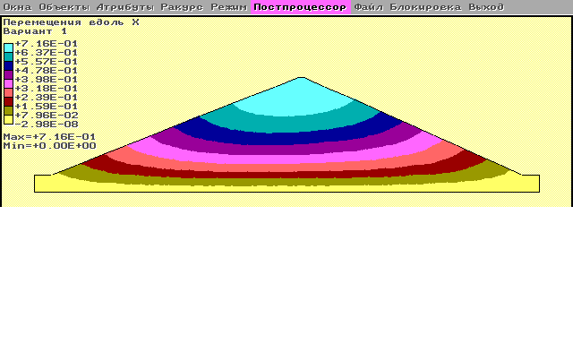

b) vertical displacements, m
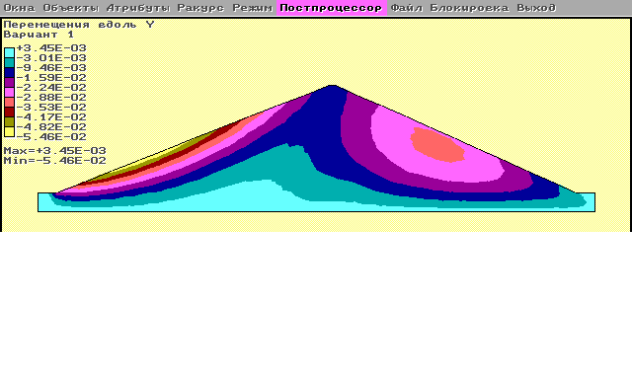

c) normal horizontal stresses σ_{х}, МPа
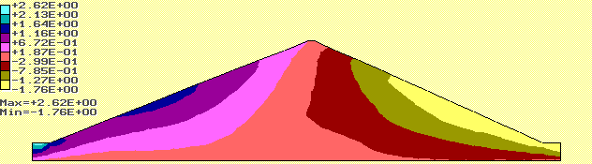

d) normal vertical stresses σ_{у}, МPа
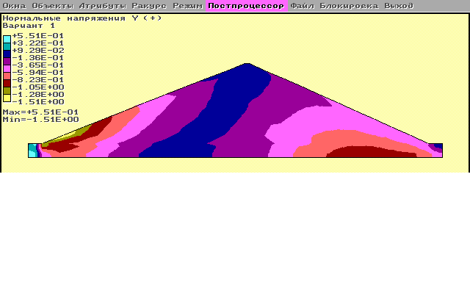

e) shear stresses, МPа
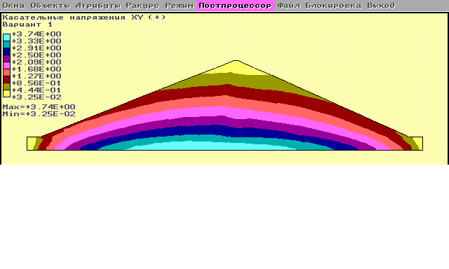

f) principal stresses σ1, МPа
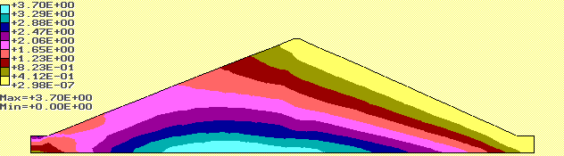
g) principal stresses σ3, МPа
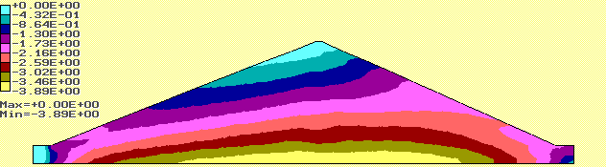
h) equivalent stresses σequ=2τmах, МPа
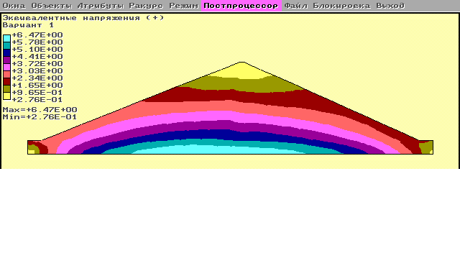
FIGURE 2. Components of the stress-strain state in a dam under seismic impact and hydrostatic pressure on the upstream slope
Below, we present the results of solving the stress-strain state problem for the same earth dam, subject to its weight and hydrostatic pressure on the upstream slope. Unlike the previous calculations, where the foundation layer was only 35 m thick, the foundation thickness in this case is 200 m. The calculation results, presented in Figures 3 and 4, show that the gravitational load (the weight of the dam) and the hydrostatic load are distributed onto the compliant foundation, increasing its deformation and, accordingly, the dam displacement.

a) Horizontal dam displacement (m), considering a foundation thickness of 200 m
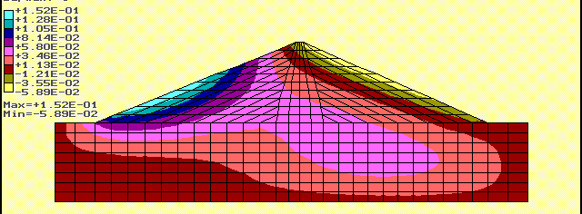

b) Vertical dam displacement (m), considering a foundation thickness of 200 m
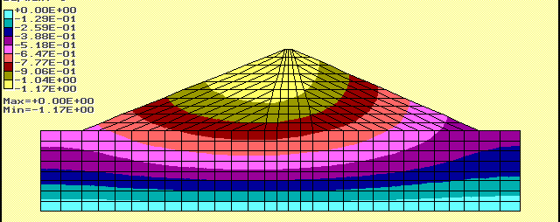
c) Horizontal dam stresses (MPa), considering a foundation thickness of 200 m
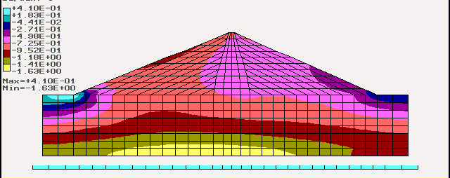
d) Vertical dam stresses (MPa), considering a foundation thickness of 200 m
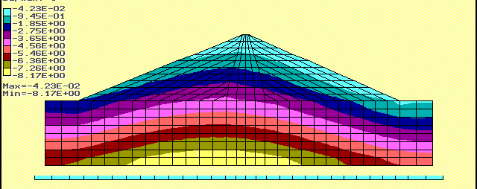
e) Shear dam stresses (MPa), considering a foundation thickness of 200 m
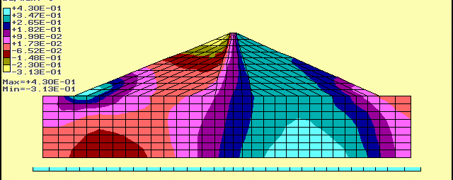
FIGURE 3. Displacement and stress distribution fields in a dam on a 200 m thick foundation, considering its weight and hydrostatic pressure
The horizontal displacement of the upstream slope under the hydrostatic pressure of a dam on a shallow foundation, i.e., with a practically rigid foundation, is slightly more than 5 cm (Fig. 2a), and for a 200 m thick (practically compliant) foundation, it is three times greater, i.e., 15 cm (Fig. 3a). The vertical settlement of the dam crest on a compliant foundation is almost 1.2 m (Fig. 2b), compared to 30 cm on a rigid foundation (Fig. 3b).
Comparing the stresses along the dam contour vs the foundation depth, it can be noted that with increasing compliance depending on the foundation depth, the deformation of the dam toe increases, and the magnitude of horizontal and shear stresses in the dam body changes, which is particularly manifested in its upstream slope, subject to hydrostatic pressure. In the central part, stresses σ_{х} increase to 1 MPa, whereas in Fig. 3 they were only 0.7 MPa; the shear stresses in the crest zone increased to 0.31 MPa versus 0.15 MPa in Fig. 3. The principal stresses obtained under the main loads, which include the dead weight and hydrostatic pressure on the upstream slope, are shown in Fig. 4.
a) Principal stresses of the dam σ₁ (MPa), considering a foundation thickness of 200 m
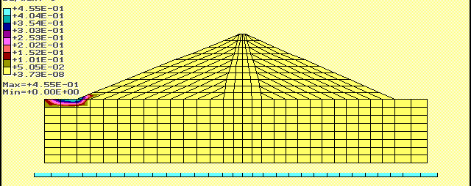
b) Principal stresses of the dam σ₃ (МПа), considering a foundation thickness of 200 m
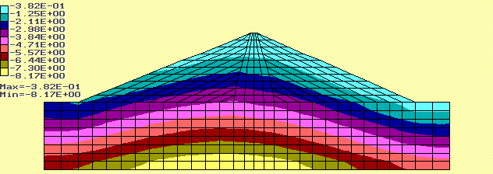
c) Dam stresses σ_{equ} (МPа), considering a foundation thickness of 200 m
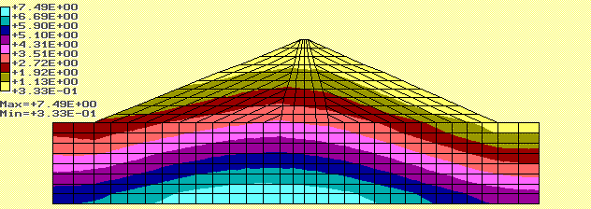
FIGURE 4. Distribution of principal stresses in the dam considering its weight and hydrostatic pressure
It was found that the principal loads are compressive, so the principal positive (tensile) stresses are small (Fig. 4a) and manifest themselves only in a small area at the foot of the upstream slope.

Conclusions
The stress-strain state of a dam with its foundation was analyzed under gravitational and hydrostatic loads. The two-dimensional calculation model includes the dam body with its core and a siltstone foundation. Foundation depths of 35 meters and 200 meters were considered. The dynamic characteristics of the dam were determined, as well as its first frequency and the fundamental mode of natural vibrations, in the form of lateral shear.
The most vulnerable sections of the dam, potentially leading to adverse consequences, were identified. Maximum vertical stresses were observed at the bottom of the upstream slope, where maximum hydrostatic pressure is achieved. Maximum shear stresses occur at the dam base and on the downstream slope surface, where the risk of shear strength loss is greatest.
It was found that with increasing compliance related to the choice of foundation depth, deformation of the dam toe increases, and the magnitude of horizontal and shear stresses in the dam body changes, which is particularly reflected in its upstream slope subject to hydrostatic pressure. The developed methodology is suitable for assessing the strength of earth structures under seismic loads. This takes into account the dam's structural features and soil moisture content. The developed methodology can be extended with a spectral approach to other tall earth dams, integrating modern tools to improve calculation accuracy. Future work should focus on probabilistic assessments, taking into account the uncertainties of soil properties.

ACKNOWLEDGMENTS
This investigation was conducted under Contract No.18/2018 between Hydroproject JSC and the Institute of Mechanics and Seismic Stability of Structures named after M.T. Urazbaev, Uzbekistan Academy of Sciences.

References
- Q.P. Zeng, J.T. Wang, M.Z. Zhang, X.C. Wang, H.L. Huang and J.W. Pan, Soil Dynamics and Earthquake Engineering 182, 108723 (2024).
- M.K. Poul and A. Zerva, Engineering structures 200, 109725 (2019).
- H.Q. Chen, D.Y. Li and S.S. Guo, International Journal of Structural Stability and Dynamics 14(07), 1450021 (2014).
- B. Shakouri, M. Mohammadi, M.J.S. Safari and M.A. Hariri-Ardebili, Computers and Geotechnics 164, 105814 (2023).
- A. Moazzami and S.M. Hosseini, Turkish Online Journal of Qualitative Inquiry 12(8), (2021).
- A.S. Bestugeva and A.A. Tarasov, Power Technology and Engineering 57(1), 1-9 (2023).
- C. Masson, S. Demars, F. Brousset, F. Andrian, P. Labbe, Z. Kteich,... and J.J. Fry, “Evaluation of Embankment Dam Seismic Response by a New Generation of Simplified and Graded Methods,” in Twenty-Eighth International Congress on Large Dams/ Vingt-Huitième Congrès International des Grands Barrages, edited by ICOLD / CIGB (CRC Press., London, 2025), pp. 2611-2640.
- R. Tarinejad and S. Pirboudaghi, International Journal of Civil Engineering 13(4), 372-381 (2015).
- K. Salyamova, K. Toshmatov Alimjon Ogli, N. Nishonov and E. An, “Seismic stress state of a high earth dam using the spectroscopic method,” in XI International Scientific and Practical Conference Innovative Technologies in Environmental Science and Education, E3S Web of Conference 431, edited by D.V. Rudoy et al. (EDP sciences, Divnomorskoe village, Russia, 2023), 03008.
- K. Salyamova, N. Nishonov and E. An, “Study of resonant oscillations of an earth dam under seismic impacts considering dissipation in soil” in International Scientific Conference “Energy Management of Municipal Facilities and Environmental Technologies”, E3S Web of Conferences 592, edited by I. Onyusheva et al. (EDP sciences, Astana, Kazakhstan, 2024), 05003.
- ShNK 2.06.11-04 Construction in seismic areas. Hydraulic structures – Part 2: Dam made from soil materials (2006)
- L. Tanchev, Dams and appurtenant hydraulic structures (CRC Press, Boca Raton, 2014), pp. 1-1073.
- О.C. Zienkiewicz and R.L. Taylor, The finite element (Butterworth-Heinemann, UK, 2000), pp. 1– 690.
- L.D. Landau, L.P. Pitaevskii, A.M. Kosevich and E.M. Lifshitz, Theory of elasticity: (Butterworth-Heinemann, UK, 2012), pp. 1– 195.

