Stress-Strain State Evaluation of Earth Dams Under the First Mode of Natural Vibrations
Klara Salyamova^{1, a)} and Ekaterina An^{1, b)}
¹ Institute of Mechanics and Seismic Stability of Structures named after M.T. Urazbaev, Uzbekistan Academy of Sciences, Tashkent, Uzbekistan
^{a)} Corresponding author: klara_51@mail.ru
^{b)} ekaterinaan1986@gmail.com
Abstract. This article presents a developed methodology and algorithm for solving problems related to determining the dynamic characteristics of earth dams within a plane elastic formulation. This formulation takes into account the design features and the piecewise non-homogeneous physical and mechanical properties of soils that comprise the structure. The natural frequencies and vibration modes obtained using the finite element method are analyzed. The stress-strain state (SSS) of two earth dams (high and medium-high) is determined for the first three modes of natural vibrations. The most vulnerable zones of the considered structures in terms of loss of stability are identified.

Introduction
Dams are built around the world to manage water and energy resources. Because the Republic of Uzbekistan is located in a seismic zone, the primary task in designing dams is ensuring their seismic resistance. Studying how dams behave under various loading conditions, including seismic ones is crucial to ensuring their safety and reliability. Due to growing environmental problems, population growth, and urbanization, the study of the stress-strain state of dams has attracted considerable attention.
Seismic analysis of earth dams is crucial in regions repeatedly affected by earthquakes. Calculating the dam's natural frequency is integral to analyzing its seismic behavior. Therefore, providing a suitable method for calculating natural frequencies is essential to eliminating the resonance phenomenon. In [1], the natural frequencies of earth dams are determined using an analytical method. This method uses shear wave velocity and dam height to obtain the natural frequency. The dam's geometry, foundation rigidity, and the soil's physical and mechanical properties (elastic modulus and Poisson's ratio) play an important role in strength calculations.
According to current design standards, studying the stress-strain state of earth dams helps solve seismic resistance problems and predict the state of the most vulnerable sections of the structure.
Reference [2] presents a study of the seismic behavior of large arch dams during strong earthquakes. A 3D finite element program developed for the dynamic analysis of concrete dams was used for numerical modeling. This program includes calculation moduli for linear and nonlinear seismic analysis that consider the effects of joint displacement, as well as tension and compression in concrete. Results of the seismic response calculated using linear and nonlinear models are compared to investigate the influence of joint displacement on structural response and analyze resulting concrete damage under strong seismic loading.
The study in reference [3] is devoted to analyzing the dynamic response of an earth dam under free and forced vibrations (initiated by an earthquake) using the finite element method. This analysis was conducted after the construction of the dam. The behavior of the dam and foundation materials is considered linear elastic. In the study of free vibrations, various conditions are considered, and their influence on the dam's free vibration characteristics is demonstrated. To study the dam's seismic response under forced vibrations, the system is subjected to the Boumerdes earthquake acceleration of May 21, 2003, recorded at Station No. 2 at the Kaddara Dam's base. A parametric study takes into account the influence of basic parameters, such as soil stiffness and density.
Reference [4] studies the seismic response of earth dams and shows that plasticity should be considered in seismic analyses because it decreases natural frequencies and dissipates energy, which can significantly affect a dam's seismic response.
The study in reference [5] presents an equation for calculating the natural frequency of an earth dam using analytical methods. Advantages of this method include a more accurate estimation of seismic parameters and consideration of the flexibility of the earth dam foundation. In reference [6], a method is proposed to estimate the degradation of the first natural frequency of vibration of earth dams with increasing strain levels induced by seismic events. The natural frequency is determined by studying the response of the structure in the frequency domain. For this study, four dams with varying degrees of geometric complexity, material properties, and known natural frequencies were selected. Plane strain models of these structures were constructed and analyzed. Numerical analysis shows that the strain-dependent variation of the first natural frequency follows the same trend as the one obtained using the “sum of sine” excitation when the dam is subjected to very different seismic conditions.
Many studies have examined ways to improve dam designs using advanced computational tools, such as finite element analysis. In [7], a numerical simulation based on a finite element model was used to study the behavior of a very high dam made of non-homogeneous rock during the early stages of filling the reservoir for the first time. When studying the stress-strain state of a concrete arch dam, the researchers chose a linear elastic material model for the dam and its foundation. They modeled localized nonlinearities by including elements. The study showed that the finite element model accurately predicts the behavior of the prototype structure. Considering the levels of accuracy inherent in the survey measurements and total measured displacements, this tool can model expected displacements and other behaviors at each stage of the first filling. In [8], the stresses and deflections of an arch dam were studied using the FEM ANSYS, that allows for the analysis of complex structures with minimal error.
Reference [9] describes a procedure for numerically analyzing the stability of a concrete arch dam using the finite element method. Based on the dam's geometry and the surrounding rock mass, an optimal finite element mesh was created for the model. The boundary conditions and loads correspond to the dam's actual operating conditions. In accordance with the geological maps obtained in field studies, the rock mass was divided into five quasi-homogeneous zones. The PAK software was used to perform numerical modeling of filtration, thermal, and stress-strain processes on the dam. The presented analysis controls allowable compressive and tensile stresses in accordance with USBR recommendations, indicating the distance between actual and allowable stresses in concrete. The global safety factor of the dam was determined using the shear strength reduction method.
In [10], a mathematical model was developed to assess the stress-strain state of earth dams. This model is spatial and is based on the Lagrange variational equation. It takes into account the actual geometry, material properties, and inhomogeneous design features of the structures. A technique was also developed to solve spatial problems in assessing the stress-strain state of earth dams using the finite element method. The mathematical model's adequacy and the results' accuracy were verified by solving test problems. The stress-strain state of the Gissarak, Sokh, and Pachkamar earth dams was investigated under the action of volumetric forces and hydrostatic water pressure. The greatest displacements were observed on the crest and in the core zone of the dam. Accounting for inhomogeneous design features significantly affected the resulting displacement field in the core zone. A spatially deformed state of the structure occurred near the banks. A small area in the upper part of the core near the crest exhibited positive stresses, caused by the indentation of the crest due to side surcharge loading.
In [11], the seismic resistance problem of homogeneous earth dams in complex geohydrodynamic regions is solved. The calculations are performed using the finite element method. Due to the dams' large size, the general equation of their motion is solved using the well-known "traveling wave" method. The shift of viscoplastic soils within the dam results in residual deformations, even from a single strong seismic impact. These deformations could subsequently be initiated even during weak earthquakes. This circumstance must be considered when designing this type of dam.
In [12], the dynamic behavior of an earth dam is analyzed, considering the interaction effects between the dam, its foundation, and the reservoir. A parametric study of the geometric parameters of a non-homogeneous earth dam made of sandy soil and an impermeable core material is performed. The numerical models were subjected to four known ground motions. A comparative analysis of linear and nonlinear models revealed similar responses to moderate-intensity earthquakes.
A dynamic analysis of the Makhool Dam was presented in [13] using GeoStudio software to study the seismic behavior of earth dams. The study's results showed that horizontal displacement and shear deformation increased with dam height, reaching a maximum displacement of 94 cm after the earthquake. In addition to the dam's physical and mechanical properties, the dam acceleration also affects the soil strength, as weaker soil reduces the seismic acceleration of the dam. Pore water pressure was highest at the foot of the dam, and horizontal motion increased with depth.
In [14], the nonlinear behavior of an earth dam with a pliable soil layer is investigated. This study aims to (1) examine how the pliable foundation affects the dynamic response of the earth dam and (2) investigate the impact of a large earth dam on the dynamic response characteristics of the foundation soil layer. The researchers used a nonlinear static and dynamic finite element model to analyze the behavior of a dam under different input acceleration records and two scenarios: (1) when the dam is built on soft foundation soil and (2) when the dam is built on rigid rock. The study found that the presence of the dam significantly affects the amplification and frequency content of the underlying soil accelerations. The study also showed that the foundation soil layer must be considered in seismic analyses of large earth dams because it can significantly amplify seismic motion at the dam base.
In [15], a three-dimensional model of an earth dam with a liquefiable foundation was developed to study its seismic behavior, the liquefaction process, and the reinforcement mechanism. Three typical models were examined: unreinforced, slab reinforced and gravel pile reinforced models were investigated using 1-G shake table testing and numerical simulation. The experimental and simulation results showed that the uneven settlement and cracks that appeared in the UR model were primarily caused by liquefaction of the foundation rather than seismic residual deformation. Foundation slabs and gravel piles significantly reduce uneven settlement and crack formation due to multiple reinforcement mechanisms.
Numerical studies considering the seismic behavior of earth dams were conducted in [16]. A parametric study was performed to identify the effects of dam height and input motion characteristics on the seismic response of earth dams. To this end, three real earthquake records with varying intensities and peak ground acceleration were used as input motions.
In [17], a numerical method for determining the settlement and stress-strain state of the high earth dam of the Charvak HPP was developed based on the finite element method. A static problem was solved to study displacements, normal and shear stresses within the framework of a plane problem of elasticity theory. The results of calculating vertical displacements, normal stresses, and pore pressure were compared with in-kind observation data. A cause-and-effect relationship was revealed between the water level in the reservoir and the dam deformation.
In [18], the stress-strain state of the dam under basic loads was studied using the finite element method, taking into account the actual geometry and design features of the object. The results were presented in the form of graphs of the distribution of vertical displacements and normal vertical stresses of the dam. It follows from the results that the area of the upstream slope, where hydrostatic pressure acts, is subject to large subsidence.
Seismic effects are resonant. The magnitude of seismic impact on a structure at a given earthquake intensity is determined by the structure's dynamic characteristics (frequencies and modes of natural vibrations), which present a "passport" for the structure. These characteristics are determined by the design (configuration, dimensions, mass, and physical and mechanical properties of the structure's materials) and the rigidity or compliance of the foundation. The seismic resistance and strength of a structure are tested using various calculation methods (static, linear-spectral, and dynamic analysis) and experimental methods.
The objective of this study is to determine the dynamic characteristics of two earth dams with different design features and physical and mechanical characteristics of soils using a numerical method based on the developed methodology.

Materials and methods
An earth structure under plane deformation conditions is considered as a calculation scheme (Fig. 1).
FIGURE 1. Calculation scheme of the earth dam: 1 - the area of wetted soil below the depression curve; 2 – the areas of dry soil; 3 - the dam core

The scheme in Fig. 1 presents the model of a high earth dam. A similar model applies to the second earth dam under consideration, with a concrete transition zone in the body of the structure cut into the foundation soil to a depth of 10 m (Fig. 2).
FIGURE 2. Earth dam: 1 – retaining prism; 2 – concrete transition zone; 3 – loamy diaphragm (a mixture of loam and sandy loam); 4 – upstream wedge of gravel-pebble soil with sand filling
The problems are solved using the numerical finite element method and triangular discretization of the considered domain. Using the developed FEM technique [19], the problem is reduced to solving second-order ordinary differential equations:
()
In addressing the problem of natural oscillations, when external forces are zero (, equation (1) takes the following form:
()
and the solution to system (2) is sought in the form:
()
As a result of substituting solution (3) into equation (2), we obtain a homogeneous system of algebraic equations that has a unique solution only if the determinant of the system is zero
()
where [K], [M] – are the stiffness and mass matrices of the structure; ω² – is the eigenvalue (the square of the natural frequency of oscillations); {q} is the mode of natural oscillations (the vector of displacements of the grid nodes) corresponding to the frequency.
The natural frequencies ω and the modes of natural oscillations {q}, representing the two-component displacements of the grid nodes, corresponding to a certain oscillation frequency, are determined using the numerical Muller method [20].
The reliability of the obtained results was verified by solving a test problem, i.e., by comparing them with the results obtained by the Hydroproject Research Institute (Moscow).
According to the developed methodology and algorithm, the stress-strain state of the high (H=135 m) earth dam P was studied. The following design characteristics of the dam soils were taken : a core of loam and sandy loam, a density of 1.7 t/m³, and Poisson's ratio ν=0.3. Young's modulus was determined from the known value of the longitudinal wave velocity for low-moisture soils of natural structure (sandy loam, loam, loess), approximately equal to с=1 km/sec. Using formula, we obtain E=1700MPa. The above characteristics were provided by the relevant design organizations.
The second dam under consideration is an earth-fill dam made of gravel and pebble soil with a loamy diaphragm serving as an anti-seepage element. The following parameters were used to obtain the dynamic characteristics: the dam height is 39 m and the length along the crest is 1700 m. The anti-seepage element is cut into the base of the dam foundation to a depth of 10-12 m (Fig. 3) and overlaps the boulder and pebble deposits. To maintain the slope stability along the entire height of the upper slope, a 0.2 m thick concrete lining was made. Structural features of the dam are: the height in the channel part is 39 m; average slope laying coefficients: upstream m_{1dam}=3,4; downstream - m_{2dam}=2.6m; diaphragm (loam) – average slope laying coefficients: upstream m_{1diaf}=2.6; downstream - m_{2diaf}=2.0; the concrete transition zone between the loamy diaphragm and the retaining prism of the dam has a thickness of normals 3.0 m. Piecewise non-homogeneous characteristics of the dam soils are: the upstream wedge of the dam is made of gravel-pebble soils with sand filling and compaction at a density of ρ=2.0 t/m³; the diaphragm is a mixture of loam and sandy loam with a density of ρ=1.65t/m³; the soil of the retaining prism has a density of ρ=1.95t/m³; the transition zone is concrete with a density of ρ=2.6t/m³. The above characteristics were provided by the relevant design organizations.

Results of the study
Figure 3 (a-d) shows the first natural frequencies (ω), periods (T), and oscillation modes of the high dam P.

a) the initial unstrained state

b) the first mode of vibration ω₁=3.1 Hz, Т₁=0.32 s

c) the second mode of vibration ω₂=4.6 Hz; Т₂=0.22 s

d) the third mode of vibration ω₃=5.4 Hz; Т₃=0.18 s
FIGURE 3. Natural modes of vibration of the dam P
The obtained modes (Fig. 3) indicate a complex deformation of the structure, where horizontal and vertical displacements of the nodal points take place. The first mode is a shift of the structure in the horizontal direction; in the second mode, vertical displacements predominate; the third mode is a complex deformation of the slopes.
Figure 4 shows the frequencies and modes of vibration of the second dam under consideration against the background of the unstrained state.

a) the first mode of natural vibrations (ω₁=7.3 Hz; Т₁=0.136 s)

b) the second mode of natural vibrations (ω₂=9.26 Hz; Т₂=0.1 s)
c) the third mode of natural vibrations (ω₃=11.83 Hz; Т₃=0.084 s)
FIGURE 4. Modes, frequencies, and periods of natural vibrations of a dam with a loamy diaphragm
Here, too, the first mode represents a shift in horizontal section, the second one represents a vertical settlement accompanied by slope deformation and in the third mode, deformations of the lower slope of the structure mainly predominate, while the upper slope is deformed to a lesser extent.
Knowing the dynamic characteristics (modes and frequencies of natural vibrations), it is possible to predict the structure’s behavior under a particular dynamic impact.
The spectral method for calculating structures for seismic impacts [21], which is widely used in accordance with current design standards, is applied to conditional seismic loads, assuming elastic deformation of the system. The seismic load at the k-th level is determined by the corresponding i-mode of vibrations η_{ik} [21]:
S_{ik}=Ak₁k₂k_{ψ}β_{i}η_{ik}Q_{k} ()
where A is the maximum acceleration of the foundation, taken depending on the estimated earthquake intensity; k₁, k₂, k_{ψ} are the coefficients of the permissible level of damage, design solutions, and dissipative properties, respectively; β_{i} is the dynamic coefficient that accounts for the spectral composition (spectral content) of the structure; η_{ik} are the coefficients of the modes of vibration normalized by mass; Q_{k} is the weight of the structure at the k-th level.
In the calculation, it is assumed that under seismic impact, the horizontal component of earthquakes predominates with distance from the epicenter, causing oscillations of the structure according to the fundamental (first) mode. Therefore, the conducted studies are limited to determining the stress state of dam sections deformed according to the first mode. The remaining coefficients, included as linear factors in the expression for seismic load (5), are conventionally taken equal to 1.
Thus, only the role of the fundamental mode of vibrations in the formation of the SSS under horizontal impact is assessed. It follows that when determining the stress state of the dams under seismic impact, we will use the first three vibration modes, which represent the displacements of the nodes of the finite element discretization of the plane models of the dams under study, according to which the principal normal (σ₁, σ₂) and shear stresses (τ_{max}) are determined along the cross-section of the dams (Figs. 5-6).
The isolines of the fields of principal stresses of the high dam P are shown in Fig. 5.

a) principal horizontal stresses σ₁, MPa
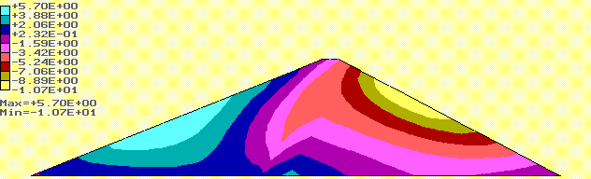
b) principal vertical stresses σ₂, МPа
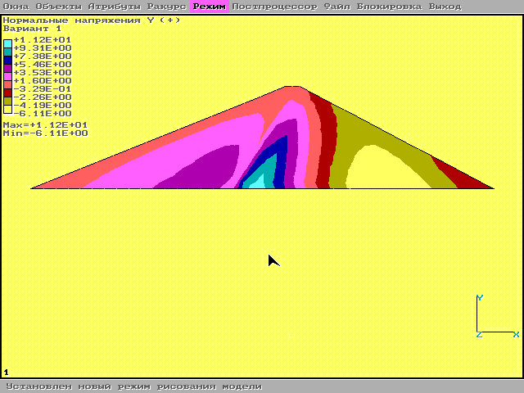
c) maximum shear stresses (τ_{мах}), МPа
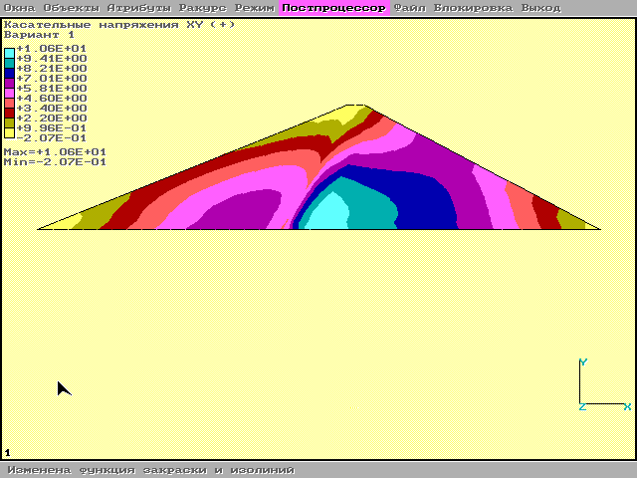
FIGURE 5. Isolines of principal stresses in the first high earth dam according to the first mode of vibrations
Isolines of distribution of components of principal stresses along the channel section of the high earth dam P, according to the first mode of vibrations, correspond to the deviation (deformation) towards the lower slope. The highest values of horizontal tensile stresses (positive in sign) fall on the middle part of the surface of the upper slope (Fig. 5a), where the stresses vary from 3.6 MPa to 5.7MPa. At a 7-point shock (with seismicity coefficient of 0.12), the stresses vary from 0.432 to 0.684MPa. On the lower slope, the stresses vary from -2.5 to -10 MPa. Hence, normal stresses reflect the extension of the upper and compression of the lower slopes. The maximum values of shear stresses fall on the area of the lower retaining prism, on the zone adjoining the lower part of the core (up to 1.0 MPa). The values of shear stresses on the surface of the lower slope (0.725 MPa) significantly exceed the values on the upstream slope (0.215 MPa) (Fig. 5c). This can lead to the possibility of a landslide occurring on the lower slope.
Figure 6 shows the isolines of the principal stresses in the section of the earth dam under consideration during its shift according to the first mode of vibration.

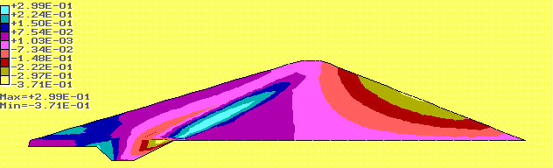
FIGURE 6. Isolines of the principal normal stresses of the earth dam according to the first mode of vibration
The results obtained for the stress state of the dam show that the presence of a rigid concrete transition zone creates stress concentration zones around it (Fig. 6). Here, the normal stress reaches its maximum value σ₁, МPа:
σ_{1max}=-0.37МPа.

Conclusions
A horizontal shift on the surface of the upper slope of both dams (see Figures 5 and 6) results in tensile stresses (positive stress values in Figure 6a) on the upper slope and compressive stresses (negative stress values in Figure 5a) on the lower slope.
The obtained stress fields cannot be considered actual stresses under seismic action since the seismic coefficients, which depend on the foundation's acceleration, soil type, and other parameters, were not considered here. Accounting for these parameters does not alter the qualitative pattern of stress distribution, and when solving a linear problem, it is reduced to a proportional change in all stresses obtained.

ACKNOWLEDGMENTS
This investigation provided on the base of budget funding of the Institute of Mechanics and Seismic Stability of Structures named after M.T. Urazbaev, Uzbekistan Academy of Sciences.

References
- M. Mahdizadeh and A. Ghanbari, “Calculation of Natural Frequency of Earth Dams by Means of Analytical Solution,” in Geotechnical Engineering, 7th International Conference on Case Histories, edited by Shamsher Prakash. (Missouri University of Science and Technology, Chicago, Illinois, 2013), 3.13a.
- A. Alegre, “Numerical models for seismic analysis of arch dams” in Congress on Numerical Methods in Engineering, edited by David Greiner et al. (Las Palmas de Gran Canaria, Spain, 2022), pp. 1-20.
- B. Malika and M. Sadika, “Analysis the dynamic response of earth dam in free vibration and forced by introducing the effect of the interaction dam foundation” in MATEC Web of Conferences 149, edited by A. Diouri et al. (EDP Sciences, Rabat, Morocco, 2018), 02066.
- Y. Parish, M. Sadek and I. Shahrour, Natural Hazards and Earth System Sciences 9(2), 451–458 (2009).
- N. Hasani, A. Ghanbari and S. Hosseini, Numerical Methods in Civil Engineering 1(1), 7-13 (2014).
- S. Chakraborty, J. T. Das, A. J. Puppala and A. Banerjee, Engineering geology 248, 330-345 (2019).
- R. O. Cassells and Q. H. W. Shaw, “Validated numerical modelling of the stress-strain response of a super high concrete arch dam during early stages of first filling,” in Dams – A critical resource in present time, SANCOLD conference 2023, edited by Michelle Blaeser. (Johannesburg, Pretoria, South Africa, 2023), pp.237 – 248.
- V. Binol, S. Arya and J. Simi, International Journal of Research in Engineering and Technology 03(07), 180 –193 (2014)
- D. Rakić, M. Zivkovic, M. Bojović, S. Radovanović, A. Bodić, N. Milivojevic and D. Divac, “Stability analysis of concrete arch dam using finite element method,” in 6th International Scientific Conference on Mechanical Engineering Technologies and Applications, edited by Taurista Perdana Syawitri et al. (Atlantis Press, Dordrecht, Netherlands 2022), pp. 301 – 308.
- D. J. Jurayev, N. Vatin, T. Z. Sultanov and M. M. Mirsaidov, Magazine of Civil Engineering 118(1), 11810 (2023).
- A. Gevorgyan and R. Minasyan, World Science 9(49), 23-27 (2019).
- G. Gazetas and P. Dakoulas, Soil Dynamics and Earthquake Engineering 11(1), 27–61 (1992).
- M. H. Ali and A. H. K. Al-Shukur, Mathematical Modelling of Engineering Problems 11(6). 1655-1662 (2024).
- L. Pelecanos, S. Kontoe and L. Zdravkovic, “The effects of nonlinear dam-foundation interaction on the seismic response of earth dams,” in Recent Advances in Earthquake Engineering in Europe, 16th European Conference on Earthquake Engineering-Thessaloniki 2018, edited by Kyriazis Pitilakis (Springer, Cham, Switzerland, 2018), pp. 1-10.
- C. Y. Cui, Soil Dynamics and Earthquake Engineering 173, 108083. (2023).
- B. Ebrahimian and A. Noorzad, Long-Term Behaviour and Environmentally Friendly Rehabilitation Technologies of Dams, 805-817 (2017).
- K. Salyamova, E. An, N. Nishonov, K. Toshmatov and K. Turdikulov, “Long-term monitoring of earth dam of the Charvak hydroelectric power plant (HPP) considering the water level of the reservoir,” in International Scientific Conference “Fundamental and Applied Scientific Research in the Development of Agriculture in the Far East”, E3S Web of Conference 462, edited by A. Muratov et al. (EDP sciences, Blagoveshchensk, Russia, 2023), 02050.
- K. Salyamova, K. Tashmatov, N. Nishonov, E. An, “Monitoring the State of Dams Through Satellite and in Situ Observations and Conducting Theoretical Studies,” in International Conference: “Ensuring Seismic Safety and Seismic Stability of Buildings and Structures, Applied Problems of Mechanics”, AIP Conference Proceedings 3265, edited by R.A. Abirov (AIP Publishing, Melville, NY, 2025), 030008.
- О.C. Zienkiewicz and R.L. Taylor, The finite element (Butterworth-Heinemann, UK, 2000), pp. 1– 690.
- I. F. Obraztsov, L. M. Savelyev and H. S. Khazanov, Finite Element Method in Problems of Structural Mechanics of Aircraft (Vysshaya shkola, Moscow, Russia, 1985), pp. 1 – 392.
- ShNK 2.06.11-04: Construction in seismic areas. Hydraulic structures – Part 2: Dam made from soil materials, (2006).

