LSTM Model Based on TF-IDF and GloVe Word Embedding for Sentiment Analysis
Andien Dwi Novika^{1, a)}, Jeffrey Junior Tedjasulaksana^{1, b)}, and Abba Suganda Girsang^{1, c)}
Author Affiliations
¹Binus Graduate Program, Bina Nusantara University, Jakarta 11480, Indonesia
Author Emails
^{a)} andien.novika@binus.ac.id
^{b)} jeffrey.tedjasulaksana@binus.ac.id
^{c)} agirsang@binus.edu
Abstract. Natural Language Processing (NLP) and machine learning has a crucial field and that is sentiment analysis. It involves extracting and recognizing subjective information (opinions) within a given text. In this study, sentiment analysis will be carried out using English movie review data of 50,000 data. Pre-trained GloVe word embeddings transform each word within the document into a compact vector, where the vector symbolizes the word's projection within the vector space. Long short-term memory (LSTM) is a type of recurrent neural network (RNN) variation that employs a set of gates to manage the flow of learning during each time step, aiming to capture extended relationships within lengthy sentences. So in this study, the LSTM-GloVe will be compared with other model methods such as Term Frequency Inverse Document Frequency (TF-IDF) as text embedding and Multi-Layer Preceptron (MLP) as classifier. The best results were obtained by LSTM-GloVe with an accuracy value of 84.5%.

introduction
The inherent conceptual and psychological aspects of natural language add to the challenges of text processing. Sentiment analysis is a crucial area within Natural Language Processing (NLP) and machine learning, focusing on extracting and identifying subjective content, such as opinions, within textual data. The primary goal of sentiment analysis is to classify the author's perspective toward a particular entity as positive, negative, or neutral.
Sentiment analysis or also called opinion mining, involves assessing opinions, emotions, and sentiments of an user regarding various entities. The widespread use of social media has led to the generation of vast amounts of data containing user reviews, brand perceptions, emotional expressions, political views, and other forms of public opinion. This sentiment-based information available online serves as a valuable resource for readers, policymakers, businesses, and other stakeholders.
The field of sentiment analysis is gaining increasing attention due to its ability to convert unstructured user reviews into usable information. This technique serves as a text organization method to express sentiments in various forms, such as positive, negative, like, dislike, thumbs up, thumbs down, and others. Therefore, it is important to use various machine learning techniques to get valuable knowledge from large-scale data [1]. In the business world, sentiment analysis is about classifying and recognizing parts of text according to the company's needs.

TF-IDF is a commonly utilized technique for feature extraction in natural language processing. This approach effectively minimizes the significance of frequently occurring words across multiple documents that provide limited information, such as conjunctions while enhancing the weight of distinctive words within individual documents. As a result, these unique terms more accurately represent the key characteristics and primary topics of the analyzed text [2]. On the other hand, the GloVe algorithm incorporates both word occurrence frequencies and global statistical patterns to identify semantic relationships between words within a corpus. It employs a method for factorization of a global matrix. The matrix signifies the presence of specific words in a given document [3].
A multi-layer perceptron (MLP) represents a form of neural network used to analyze and solve various complex tasks, including prediction models. MLPs are capable of forming effective algorithms in handling challenging problems [4]. This​ study applied MLP due to its capability to acquire representations from training data produced by the neural network. Moreover, the MLP utilized relies on a word vector representation that has been pre-trained.
Meanwhile, Recurrent Neural Network (RNN) is an advanced algorithm for handling sequential data. RNN can process variable-length inputs, improve the feature representation, as well as convert them into text vectors. This process allows the formation of a matrix of feature vectors along with their sequence dimensions [5]. Recurrent Neural Networks (RNNs) face significant large-scale challenges in parallel computing [6]. An improved variant, Long Short-Term Memory (LSTM), utilizes a set of gating mechanisms to regulate the flow of information at each step. This allows LSTM to effectively capture dependencies that are long-range within lengthy text sequences [7].
This study used term frequency-inverse document frequency (TF-IDF) for text vectorization. Pre-trained GloVe also used for word embeddings. MLP and LSTM will be compared to see which one is the best combination of vectorization techniques and classifiers is used using movie review data as much as 50,000 data that have been labeled sentiment.
TF-IDF is a method that quantifies the importance of words in a document, helping to highlight key terms for categorization and identification [8]. TF-IDF is based on statistic. Meanwhile, GloVe converts words into dense vector representations. Each vector reflects the word’s contextual meaning in a high-dimensional space. By analyzing word co-occurrence probabilities, GloVe effectively captures both semantic and syntactic relationships between words [9].

Related Work
A number of studies have examined the process of sentence vectorization in the context of sentiment analysis.
Abid et al. in 2019 proposed the combination of Glove with RNN and CNN for weighting, which allows the utilization of subjectivity knowledge in sentiment analysis. In their approach, CNN is used to extract global features before proceeding with traditional aggregation methods. Their proposed model, Glove-Bi-GRU-CNN, achieved the best accuracy rate of 87.18% on the STSC-1.5k dataset.
On the other hand, [11] studied about the training and predicting using GloVe that is combined with DCNN method for classifying sentiment with an unsupervised learning approach using a large Twitter dataset. This method integrates the polarity of sentiment from each word scores and feature n-grams to make the feature of the set of tweets, which are further processed through the CNN layer. The evaluation of this method was tested on five Twitter datasets, and the results obtained showed significant improvement compared to previous approaches.
However, it should be noted that most of the aforementioned techniques still face challenges, such as the lack of semantic representation, high dimensionality and sparsity issues, and the tendency to ignore sentiment information in the text.
[12] conducted an analysis of 32 recent studies that applied deep learning techniques to sentiment classification tasks. Their research examined the architectures of deep neural network, recurrent neural network, and convolutional neural network, integrating them with TF-IDF and word embedding methods to transform data input for sentiment prediction using DL models. Multiple experiments were performed across various datasets, including those from Twitter, to assess the effectiveness of RNN, CNN, and DNN models. Findings from the study indicate that deep learning approaches combined with word embeddings demonstrate greater reliability compared to those incorporating TF-IDF.
Meanwhile, [13] ​introduced a method called Improved Word Vector (IWV), which integrates part-of-speech (POS) analysis, a lexicon-based strategy, pre-trained word embeddings, and CNN. Their experimental findings revealed that utilizing pre-trained word representations substantially enhances accuracy in contrast to the standard model.
[14] studied Sentiment and Semantic-Based Emotion Detector (SS-BED). SS-BED is a deep learning model that employs two LSTM layers along with two distinct word embedding matrices to capture both sentiment and semantic features, facilitating emotion recognition. While each approach possesses its own strengths and weaknesses, a common limitation observed among them is their inability to assess the varying degrees of importance between sentences in sentiment analysis.

Methodology
This paper used LSTM for sentiment analysis. LSTM is compared with MLP as the classifier. This paper also compares GloVe and TF-IDF as word representations of text. IMDB Movie Review Dataset is used to observe the model’s classification result. The overall flow chart can be seen in Fig 1.
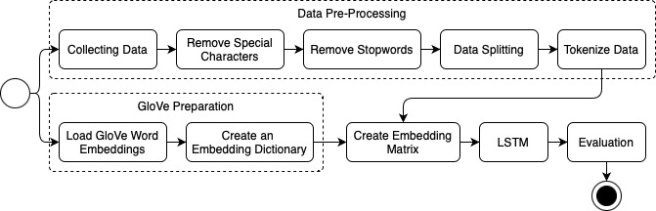
FIGURE 1. GloVe-LSTM Flow

Data Preprocessing
The model is applied to IMDB Movie Review Dataset from Kaggle. This dataset has 50000 samples with 25000 positive samples and 25000 negative samples. This dataset is taken from the Internet Movie Database (IMDB), an online database that has information related to movies, television shows, and video games.
Creating a textual representation using a word vector model constitutes a crucial phase within this experiment. Our research employed the GloVe model, which relies on statistical insights and involves extensive pretraining on a sizable corpus. The GloVe model takes into account both broad and specific word information, aiming to assimilate the strengths of neural network language models and Word2Vec [15]. The dataset's text utilized for training and testing must undergo preprocessing steps like eliminating stop words, removing special characters, and tokenizing the text before being transformed into input for the word embedding layer.
For model training and testing, the dataset is divided into two sets, and that are: a training set and a testing set. The split follows an 80:20 ratio, signifying that the initial 80% of the dataset becomes the training set, and the remaining 20% becomes the testing set. The training set is feed to train the model, while the testing set serves the purpose of appraising its performance. The training set is divided into training set and validation set with 80:20 ratio, signifying that the initial 80% of the training set constitutes the training set, and the remaining 20% becomes the validation set. Representation of IMDB Movie Review Dataset shown on Table 1.
TABLE 1. Representation of IMDB Movie Review Dataset
Review | Sentiment
Like the previous poster, I am from northern Vermont, and I was inclined to like this film. However, not since "Red Zone Cuba" have I seen such a confusing plot… | negative

GloVe Model
The GloVe model proves to be a potent technique for leveraging overarching corpus statistics and refining the learning model using contextual windows. Its primary aim revolves around converting words into vectors and generating word vectors through inputted corpora. The procedure involves these steps: initially, forming a matrix indicating word co-occurrences across the entire corpus; subsequently, processing the learning word vector in accordance with the co-occurrence matrix and the GloVe model. In this study, 100-dimension GloVe is used. Fig. 2 shown GloVe word representation for ‘Film’.
GloVe is a computation-based model that utilizes a log-bilinear approach to understand word relationships. This model works by analyzing how frequently words appear together in a given corpus, allowing it to identify patterns in word associations. The ratio of word co-occurrence probabilities is leveraged to capture word meanings and improve accuracy in solving word analogy tasks. During the training process, GloVe is designed to generate word vectors that reflect statistical relationships between words, where the vectors have some dots that represents the logarithm of the words' co-occurrence probability within the text. The GloVe model's depiction can be articulated through equation 1.
$J=\sum_{i,j}^{N}{f\left(X_{ij}\right)}{(V_{i}^{T}V_{j}+b_{i}+b_{j}-\ln\left(X_{ij}\right))}^{2}$ (1)
In this equation, $X$ denotes the co-occurrence matrix, with the count of occurrences where words $i$ and $j$ appear within a specific window captured by the element $X_{ij}$. Typically, the window size falls between 5 to 10, while $V_{i}$and $V_{j}$ symbolize the word vectors for word $i$ and word $j$. The terms $b_{i}$ and $b_{j}$signify the bias factors, N corresponds to the dimension of the cooccurrence matrix $\left(N×N\right)$, and $f$ serves as the weighting function.
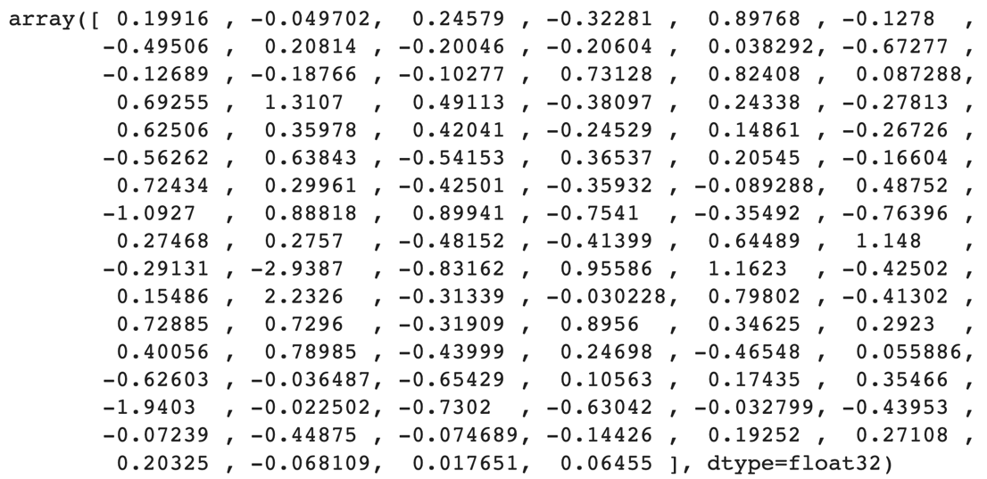
FIGURE 2. GloVe Word Representation for ‘Film’

Long Short-Term Memory
Long Short-Term Memory (LSTM) is one of a type of Recurrent Neural Networks (RNNs). It finds frequent applications in handling sequential data like text, speech, and time series information. Within LSTM, hidden layers function as memory cells that store and retrieve data across time. The architecture of LSTM incorporates distinct components: an input gate, output gate, forget gate, and memory cell [16]. These three gates have an important role in governing the passage of information within LSTM [17]. LSTM architecture can be seen in Fig. 3.
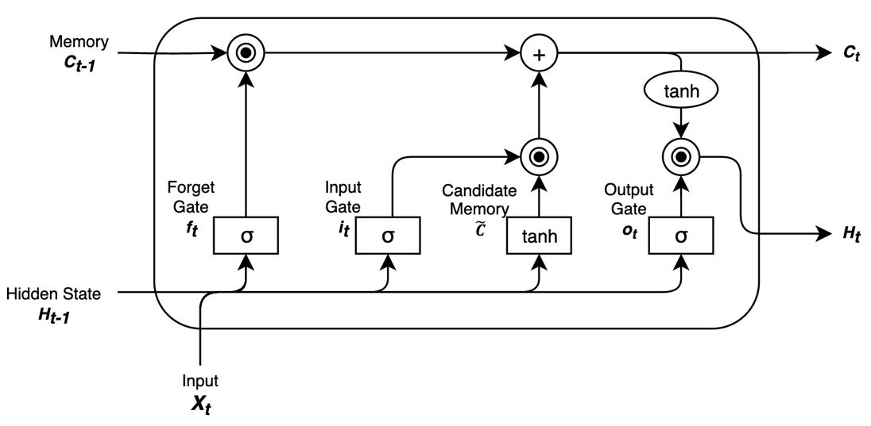
FIGURE 3. LSTM Architecture
In mathematical terms, the LSTM unit is formulated as shown in Eq. 2 until Eq. 6 [18]:
- Forget Gate
$f_{t}= σ(W_{f}.\left[h_{\left(t-1\right)}, x_{t}\right]+b_{f})$ (2)
- Input Gate
$i_{t}= σ(W_{i}.\left[h_{\left(t-1\right)}, x_{t}\right]+b_{i})$ (3)
- Cell Gate
$C_{t}= f_{t}.C_{\left(t-1\right)}+i_{t}×tanh(W_{c}.\left[h_{\left(t-1\right)}, x_{t}\right]+b_{c})$ (4)
- Output Gate
$o_{t}= σ(W_{o}.\left[h_{\left(t-1\right)}, x_{t}\right]+b_{o})$ (5)
- Hidden State
$h_{t}= o_{t}×tanh(C_{t})$ (6)
In this context, σ represents the sigmoid function, signifies the dot product, $×$ denotes element-wise multiplication, $\left[h_{\left(t-1\right)}, x_{t}\right]$ combines the prior hidden state with the present input, while W and b stand for the weight and bias parameters.

Result
Multiple outcomes were collected to determine the model that produces the optimal outcome while assessing with accuracy and undergoing a training period of 10 epochs. The model combinations are GloVe + LSTM, GloVe + MLP, TF-IDF + LSTM, and TF-IDF + MLP. Every model undergoes training using the batch training approach, employing a batch size of 128. The outcomes of all the specified algorithm combinations will also be elaborated upon in Table 2.
TABLE 2. Testing Result
Model | Accuracy
GloVe + LSTM | 84.5%
GloVe + MLP | 79.7%
TF-IDF + LSTM | 50.3%
TF-IDF + MLP | 84.4%
Table 2 shows that the combination of vectorization with GloVe and classifier with LSTM produces the highest accuracy when compared to other models. When GloVe vectorization is combined with the MLP model classifier, the accuracy drops significantly. When vectorization using the TF-IDF is combined with the MLP classifier, the accuracy results are fairly high, but when combined with the LSTM classifier, the accuracy results immediately decrease. According to the results of the testing, the best model for performing sentiment analysis was GloVe + LSTM with an accuracy of 84.5%, followed by the TF-IDF + MLP model with an accuracy of 84.4%, GloVe + MLP with an accuracy of 79.7%, and the TF-IDF + LSTM model with an accuracy of 50.3%.

GloVe + LSTM gains the best result because two of them could comprehend the contextual meaning from a text. Unlike TF-IDF, GloVe creates a vector representation based on matrix co-occurrence. GloVe can thus capture the structure of word meanings and the relationships between words in their representations. LSTM has a recurring structure that helps it to recognise sentence word order and context. It aids in language processing, which necessitates an awareness of the sequence and interrelation of words. MLP is a feedforward network that can form non-linear relationships between input and output properties. MLP, on the other hand, lacks the natural ability of iterative models such as LSTM to deal with order and context in text.

Conclusion
In this study, the combination of GloVe and LSTM for sentiment analysis of 50,000 movie review data. LSTM-GloVe compared to several other models such as TF-IDF vectorization and MLP classification algorithm. Pre-trained GloVe word embeddings are used to vectorize text and LSTM is used as a model to classify sentiment from the previous vectorized input. we use pre-trained 100-dimension GloVe embedding initialization for embedding layer weight initialization. The best results were obtained using the LSTM-GloVe compared to other models, this is because GloVe can articulate semantic similarities, such as synonyms of the word.

References
[1] Q. T. Ain et al., “Sentiment Analysis Using Deep Learning Techniques: A Review,” 2017. [Online]. Available: www.ijacsa.thesai.org
[2] D. E. Cahyani and I. Patasik, “Performance comparison of tf-idf and word2vec models for emotion text classification,” Bulletin of Electrical Engineering and Informatics, vol. 10, no. 5, pp. 2780–2788, Oct. 2021, doi: 10.11591/eei.v10i5.3157.
[3] J. Pennington, R. Socher, and C. D. Manning, “GloVe: Global Vectors for Word Representation,” Proceedings of the 2014 conference on empirical methods in natural language processing (EMNLP), pp. 1532–1543, 2014, [Online]. Available: http://nlp.
[4] M. Almaghrabi and G. Chetty, “Improving sentiment analysis in arabic and english languages by using multi-layer perceptron model (MLP),” in Proceedings - 2020 IEEE 7th International Conference on Data Science and Advanced Analytics, DSAA 2020, Institute of Electrical and Electronics Engineers Inc., Oct. 2020, pp. 745–746. doi: 10.1109/DSAA49011.2020.00095.
[5] F. Liu, J. Zheng, L. Zheng, and C. Chen, “Combining attention-based bidirectional gated recurrent neural network and two-dimensional convolutional neural network for document-level sentiment classification,” Neurocomputing, vol. 371, pp. 39–50, Jan. 2020, doi: 10.1016/j.neucom.2019.09.012.
[6] M. Xuanyuan, L. Xiao, and M. Duan, “Sentiment Classification Algorithm Based on Multi-Modal Social Media Text Information,” IEEE Access, vol. 9, pp. 33410–33418, 2021, doi: 10.1109/ACCESS.2021.3061450.
[7] X. Wang, Y. Liu, C. Sun, B. Wang, and X. Wang, “Predicting Polarities of Tweets by Composing Word Embeddings with Long Short-Term Memory,” pp. 1343–1353, 2015.
[8] S. Qaiser and R. Ali, “Text Mining: Use of TF-IDF to Examine the Relevance of Words to Documents,” Int J Comput Appl, vol. 181, no. 1, pp. 25–29, Jul. 2018, doi: 10.5120/ijca2018917395.
[9] M. Kamyab, G. Liu, and M. Adjeisah, “Attention-Based CNN and Bi-LSTM Model Based on TF-IDF and GloVe Word Embedding for Sentiment Analysis,” Applied Sciences (Switzerland), vol. 11, no. 23, Dec. 2021, doi: 10.3390/app112311255.
[10] F. Abid, M. Alam, M. Yasir, and C. Li, “Sentiment analysis through recurrent variants latterly on convolutional neural network of Twitter,” Future Generation Computer Systems, vol. 95, pp. 292–308, Jun. 2019, doi: 10.1016/j.future.2018.12.018.
[11] Z. Jianqiang, G. Xiaolin, and Z. Xuejun, “Deep Convolution Neural Networks for Twitter Sentiment Analysis,” IEEE Access, vol. 6, pp. 23253–23260, Jan. 2018, doi: 10.1109/ACCESS.2017.2776930.
[12] N. C. Dang, M. N. Moreno-García, and F. De la Prieta, “Sentiment analysis based on deep learning: A comparative study,” Electronics (Switzerland), vol. 9, no. 3, Mar. 2020, doi: 10.3390/electronics9030483.
[13] S. M. Rezaeinia, R. Rahmani, A. Ghodsi, and H. Veisi, “Sentiment analysis based on improved pre-trained word embeddings,” Expert Syst Appl, vol. 117, pp. 139–147, Mar. 2019, doi: 10.1016/j.eswa.2018.08.044.
[14] A. Chatterjee, U. Gupta, M. K. Chinnakotla, R. Srikanth, M. Galley, and P. Agrawal, “Understanding Emotions in Text Using Deep Learning and Big Data,” Comput Human Behav, vol. 93, pp. 309–317, Apr. 2019, doi: 10.1016/j.chb.2018.12.029.
[15] R. Ni and H. Cao, “Sentiment Analysis based on GloVe and LSTM-GRU,” 2020.
[16] Z. Zhao, W. Chen, X. Wu, P. C. Y. Chen, and J. Liu, “LSTM network: A deep learning approach for Short-term traffic forecast,” IET Intelligent Transport Systems, vol. 11, no. 2, pp. 68–75, Mar. 2017, doi: 10.1049/iet-its.2016.0208.
[17] Venkatesh, S. U. Hegde, A. S. Zaiba, and Y. Nagaraju, “Hybrid CNN-LSTM model with glove word vector for sentiment analysis on football specific tweets,” in Proceedings of the 2021 1st International Conference on Advances in Electrical, Computing, Communications and Sustainable Technologies, ICAECT 2021, Institute of Electrical and Electronics Engineers Inc., 2021. doi: 10.1109/ICAECT49130.2021.9392516.
[18] W. K. Sari, D. P. Rini, and R. F. Malik, “Text Classification Using Long Short-Term Memory With GloVe Features,” Jurnal Ilmiah Teknik Elektro Komputer dan Informatika, vol. 5, no. 2, p. 85, Feb. 2020, doi: 10.26555/jiteki.v5i2.15021.

