Explore Simpler Eigenmarking:
Quantum Entailment Model Checking
Tatpong Katanyukul^{1, a)}
¹Department of Computer Engineering, Khon Kaen University, Khon Kaen, Thailand 40002
^{a)} Corresponding author: tatpong@kku.ac.th
Abstract. Targeting entailment model checking, a recent study has pioneered an idea of Eigenmarking search, an improvement over Grover search using extra qubits. The extra qubits condition the quantum state evolution such that the answer states (if exist) are always in the minority. The minority criterion is essential to Grover probability-amplitude amplification and consequently the effectiveness of Grover search. In addition to enforce the minority criterion, Eigenmarking also employs complementary states (through well-orchestrated phase rotation) for easy identification of a no-answer case (related to a no-violation case in the context of model checking). Eigenmarking search has been shown effective in a two-qubit simulation. Three Eigenmarking schemes have been previously proposed. Two schemes require two extra qubits. One scheme (called “subtle marking”) requires one extra qubit with a multiple-qubit-controlled phase rotation. Our study refines the mechanism using only one extra qubit with only two-qubit-controlled phase rotation, commonly known as ccz, regardless of how many qubits the input has. Using a multiple-qubit-controlled phase rotation (as in subtle marking) associates with highly entangled states. Highly entangled states in a real quantum hardware are difficult (or in some cases may even be unachievable) particularly in a scaled-up scenario involving many qubits. Our proposed new Eigenmarking scheme has lightened the burden for the hardware requirement. The new Eigenmarking search has been experimented in two-qubit-system simulations and shown viable, achieving the minimal relative local winning margin of W=3.17 and the worst-case distinguishability of D=0.769 (cf. W=0.67; D=0.19 from conventional marking and W=0.28; D=0.55 from subtle marking).

INTRODUCTION
Logical reasoning is one of the most notable functions in computational intelligence. Entailment — truth inference of an under-questioned sentence based on an accepted knowledge — is central to resolve logical reasoning. Entailment can be verified using model checking: checking every combination of truth values for all logical symbols involved (the input) and their resultant truth values if the resultant values of the sentence agrees with ones of the knowledge. However, computation cost of model checking may be exponential of the number of possible input values [1].
The advent of rapid development in quantum computing [2] has offered a great opportunity for computationally intensive tasks. A previous study [3] has proposed Eigenmarking schemes to enhance Grover search [4] in the context of entailment model checking. Original Grover search assumes a single-answer scenario and exploit the minority condition in one of its key mechanism, i.e., probability-amplitude amplification. The context of entailment model checking requires a huge relaxation on this minority constraint. The key idea of Eigenmarking is to add extra qubits such that regardless of a proportion of answer states in all possible input states, these answer states remain minorities in a total number of all states. Another word, extra qubits create many dummy states such that even all input states are answers, they still remain minorities in this extended state space: one extra qubit allows double the number of states; two extra qubits allow quadruple the number of states.
While the extra qubits have extended the state space, the extra qubits also act as a tag for the input states: the first previously proposed scheme [3] (called “conventional marking”) uses tag 01 to mark the answer states (target group) and tag 10 for the complementary states; the last previously proposed scheme [3] (called “subtle marking”) uses tag 0 for the answers and tag 1 for the complementaries. The complementary states are selected to represent a no-answer scenario: their probability amplitudes are considerably amplified when there is no answer.
Conventional marking schemes uses two extra qubits and π/2-phase rotations. Subtle marking uses one extra qubit and multiple-qubit-controlled phase rotation. Conventional marking is reported to have a good global winning margin, i.e., the answer states have remarkably larger chances to be measured (regardless of a tag value), but when there is no answer, it has to rely on the difference between measurements in the target states and ones in complementary states to decide if it is a no-answer scenario.
Subtle marking is reported to have a good local winning margin — when considered among the target states (with target tag, i.e., tag qubit is 0) the answer states have also substantially larger chances to be measured — and a large contrast between measurements in the target states (very low chance) and ones in complementary states (very high chance) when there is no answer. Its second reported property makes determining if there is any answer easier when using subtle marking. However, a main disadvantage of subtle marking is architectural: it uses multiple-qubit-controlled phase rotation. This puts considerable stress on the hardware requirement and for a large-input problem, e.g., 1000-qubit input, this may not even be possible.
Our work proposed a more refined scheme to reduce stress on hardware requirement and evaluate the quality of its deliverables conferring to conventional and subtle Eigenmarking schemes. Specifically, this study aims to design a simpler Eigenmarking scheme using only one extra qubit and a two-qubit-controlled phase rotation (CCZ) to improve scalability and hardware feasibility.

Background
Entailment. When an accepted knowledge α entails a sentence β, it means that what sentence β says agrees with what knowledge α has said. This is written with notation α⊨β. It means that for every combination of input truth values when the entailer α is true, the entailee β is also true.
There are two main approaches for entailment checking [1]: theorem proving and model checking. Theorem proving applies rules of inference to the entailer to eventually derive the entailee. Model checking checks all input truth values to validate the resultant truth values.
E.g., suppose knowledge α={A⇒B,B⇒C} ( “Monthong is a variety of durian.”, “Durian is prickly.”); β₁={A⇒C} (“Monthong is prickly.”); β₂={A⇒ ¬ C} (“Monthong is not prickly.”); β₃={D⇒E} (“There is life on Mars.”); and β₄={D⇒ ¬ E} (“There is no life on Mars.”), this can be reasoned: α ⊨ β₁; α ⊭ β₂; α ⊭ β₃ and α ⊭ β₄ for violations as shown in Table 1 (violation is emphasized in italic). For entailment model checking, entailment is equivalent to no violation: for all x’s, no logical false of ¬ α(x) ∨ β(x) (≡ no logical true of α(x) ∧ ¬ β(x)).

TABLE 1. Example of entailment model checking: α ⊨ β if and only if ¬ α (x) ∨ β (x) for all x’s.
A | B | C | D | E | $$α$$ | $$β_{1}$$ | $$β_{2}$$ | $$β_{3}$$ | $$β_{4}$$
F | F | F | F | F | T | T | T | T | T
$$⋮$$ | $$⋮$$ | $$⋮$$ | $$⋮$$ | $$⋮$$ | $$⋮$$ | $$⋮$$ | $$⋮$$ | $$⋮$$ | $$⋮$$
T | T | T | F | F | T | T | F | T | T
T | T | T | F | T | T | T | F | T | T
T | T | T | T | F | T | T | F | F | T
T | T | T | T | T | T | T | F | T | F

Quantum computation. Quantum properties, such as superposition and entanglement, can be exploited for computation. Superposition is a quantum state that is a linear combination of eigenstates, e.g., state $|ψ⟩=a_{i}|+⟩+b_{i}|-⟩$ where $|+⟩$ and $|-⟩$ are the eigenstates (depending on the measurement operator) and $a_{i}$ and $b_{i}$ are probability amplitudes of the corresponding eigentstates. For a given basis (a set of eigenstates), a state can be written in a vector form $|ψ⟩=[a_{i},b_{i}]^{T}$, where the eigenstates $|+⟩$ and $|-⟩$ are implicit.
A state can evolve in two distinct modes [5]. (1) In quantum evolution mode, state $|ψ⟩$ evolves according to Schrödinger equation (SE) based on Hamiltonian $\hat{H}$ (energy operator) of the system. I.e., $iℏ\frac{∂|ψ⟩}{∂t}=\hat{H}|ψ⟩$ where $i=\sqrt{-1}$ and $ℏ$ is a reduced Planck constant. The solution to SE, $|ψ⟩=|ψ_{0}⟩exp(-\frac{i}{ℏ}\hat{H}t)$ where $|ψ_{0}⟩$ is an initial state.
For a specific period of time $t$, this is equivalent to unitary transformation whose unitary operator corresponds to the Hamiltonian: $U≡exp(-\frac{i}{ℏ}\hat{H}t)$, hence $|ψ⟩=U|ψ_{0}⟩$ or a state is a unitary transformation from its previous state: $|ψ^{'}⟩=U|ψ⟩$. A control on system energy dictates the Hamiltonian and equivalently manipulates a unitary operator. Some common unitary operators are not operator $X=\left[\begin{matrix}0 & 1 \\ 1 & 0\end{matrix}\right]$, Hadamard operator $H=\frac{1}{\sqrt{2}}\left[\begin{matrix}1 & 1 \\ 1 & -1\end{matrix}\right]$, and one-qubit-controlled-phase $CZ=\left[\begin{matrix}1 & 0 & 0 & 0 \\ 0 & 1 & 0 & 0 \\ 0 & 0 & 1 & 0 \\ 0 & 0 & 0 & -1\end{matrix}\right]$ for a two-qubit system.
(2) In measurement mode, state collapses to one of its eigenstates upon measurement. The eigenstates correspond to the measurement operator, which is applied to measure the system. A probability of an eigenstate to which the state collapses is a squared modulus of the amplitude of that eigenstate in the state before the measurement. E.g., given a state $|ψ⟩=a_{i}|+⟩+b_{i}|-⟩=[a_{i},b_{i}]^{T}$ prior to the measurement in a basic of $|+⟩$ and $|-⟩$, after the measurement the state will collapse to either $|+⟩$ (with probability $|a_{i}|^{2}$), i.e., $|ψ^{'}⟩=|+⟩=[1,0]^{T}$, or $|-⟩$ (with probability $|b_{i}|^{2}$), i.e., $|ψ^{'}⟩=|-⟩=[0,1]^{T}$.
A hardware of a quantum computer can be implemented using many technologies, e.g., superconducting circuit [6], and to control qubits can be done by changing the system energy, e.g., through microwave pulses.

Classical logic from quantum gates. Any classical logic can be derived from a proper application of quantum gates. Figure 1 shows equivalent functions to logical AND and OR.

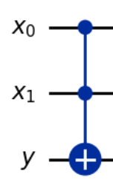 | 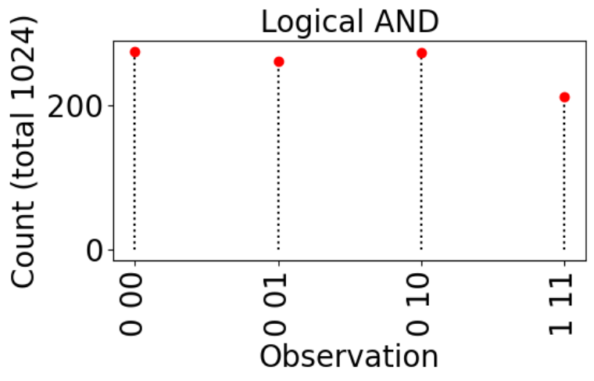 | 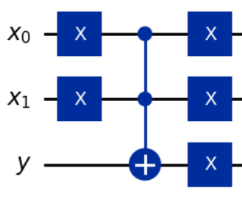 | 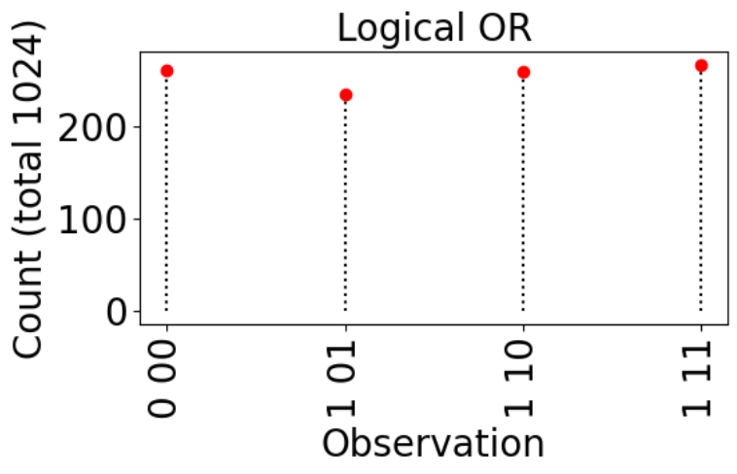
(a) | (b) | (c) | (d)
Figure 1. Quantum gate applications: (a) logical AND, (b) its simulated result, (c) logical OR, and (d) its simulated result.

Grover search. Grover algorithm [4] addresses a search problem: given a function $f:\{0,1\}^{n}→\{0,1\}$ with a promise that there is exactly one answer $x^{'}$ such that $f(x)=1$ if $x=x^{'}$ and $f(x)=0$ otherwise. A binary input $x$ has $n$ qubits. Thus, there are $N=2^{n}$ possible combinations to search.
Suppose the underlying function is given as a corresponding unitary operator $U_{f}$ (often called “oracle”), which takes $n+1$ qubits ($n$ for input $x$ and $1$ for ancillary $y$) and rotates $y$ by $π$ (phase inversion) only when $f(x)=1$. That is, the unknown function operator Uf≡|x'⟩⟨x'|⊗Rz(π)+x∈X​|x⟩⟨x|⊗I where $\tilde{X}$ is a set of non-winning states; identity $I=\left[\begin{matrix}1 & 0 \\ 0 & 1\end{matrix}\right]$ and rotation $R_{z}(θ)=\left[\begin{matrix}1 & 0 \\ 0 & e^{iθ}\end{matrix}\right]$.
Grover algorithm is as follows: (1) Prepare $|x⟩$ in a ground state, i.e., $|x_{0}⟩=|0⟩≡|\underset{n}{\underbrace{00…0}}⟩$. (2) Apply $H^{⊗n}$, where $H^{⊗n}=\underset{n}{\underbrace{H⊗H⊗…⊗H}}$ is a tensor product of $H$. It is equivalent to apply $H$ independently to each qubit of $|x_{0}⟩$, i.e., $|x_{1}⟩=H^{⊗n}|x_{0}⟩$. (3) Apply the phase inversion, i.e., $|ψ_{2}⟩=U_{f}|x_{1},1⟩$. (4) Apply the inversion about the mean to the input part, i.e., segment $|x_{2}⟩|y⟩=|ψ_{2}⟩$ and have $|x_{3}⟩=(2A-I)|x_{2}⟩$, where $I$ is an identity matrix and an average matrix $A=\frac{1}{N}\left[\begin{matrix}1 & 1 & … & 1 \\ 1 & 1 & … & 1 \\ ⋮ & ⋮ & ⋱ & ⋮ \\ 1 & 1 & … & 1\end{matrix}\right]$. (5) Grover operation (steps 3 and 4) should be applied for $J$ times (Derived from [7]), $J=arg\min_{j}\frac{1}{N-1}\cos^{2}\left(\left(2j+1\right) \sin^{-1}\sqrt{\frac{1}{N}}\right)$ or simply $J=round\left(\frac{π}{4}\sqrt{N}-\frac{1}{2}\right)$ when $N$ is large. (6) Measure the qubits. An eigenstate observed in the measurement is very likely to be the answer.

Eigenmarking. Conventional Eigenmarking [3] (1) adds two additional qubits $|t_{1}t_{0}⟩$ each controls phase rotation on the ancillary $|y⟩$ and (2) has $U_{f}$ shift phase by only $π/2$ (instead of full phase inversion, equivalent to $π$), and (3) extends the inversion about the mean to average over all qubits (not just the input qubits). Table 2 shows the algorithm.
TABLE 2. Conventional marking.
(1) Have $U_{f}≡\left|x^{'}\right\rangle \left\langle x^{'}\right| ⊗R_{z}\left(\frac{π}{2}\right)+\sum_{x∈\tilde{X} }{|x⟩⟨x|⊗I}$.
(2) Prepare $|ψ_{0}⟩=|x,y⟩=|0,0⟩$.
(3) Do $|ψ_{1}⟩=H^{⊗(n+1)}|ψ_{0}⟩$.
(4) Apply Grover selection $|ψ_{2}⟩=U_{f}|ψ_{1}⟩$.
(5) Apply marking: let $|t_{1},t_{0}⟩=H^{⊗2}|0,0⟩$ and segment $|x_{2}⟩|y_{2}⟩=|ψ_{2}⟩$,
then $|t_{0}^{'},y_{3}⟩=CR(π/2)|t_{0},y_{2}⟩$ and $|t_{1}^{'},y_{4}⟩=CR(-π/2)|t_{1},y_{3}⟩$
where $CR(θ)=I⊗|0⟩⟨0|+R_{z}(θ)⊗|1⟩⟨1|$.
(6) Apply inversion about the mean to all qubits: aggregate $|ψ_{4}⟩≡|t_{1}^{'},t_{0}^{'},x_{2},y_{4}⟩$
and $|ψ_{5}⟩=(2A-I)|ψ_{4}⟩$.
(7) Measure the qubits.

Subtle marking [3] employs only one extra qubit, but resorts to multiple-qubit-controlled phase rotation. Table 3 shows subtle marking algorithm. It is worth noting that an alternative to Eigenmarking for addressing entailment model checking could be an application of quantum counting [8]. Quantum counting usually employs quantum phase estimation [5]. However, quantum phase estimation requires a large number of coherent qubits as well as deep circuits. [9] Such requirement poses critical difficulties for the current technology — Noisy Intermediate Scale Quantum (NISQ [10]) computers. Quantum phase estimation is also actively investigated [9, 11]. Therefore, it is too soon to reach consensus on these alternatives.
TABLE 3. Subtle marking.
(1) Prepare system in the ground state: $|ψ_{0}⟩=|0⟩$, where $|ψ_{0}⟩=|t_{0},x,y⟩$.
(2) Apply Hadamard: $|ψ_{1}⟩=H^{⊗n+2}|ψ_{0}⟩$.
(3) Apply Grover selection: $|ψ_{2}⟩=(I⊗U_{f})|ψ_{1}⟩$.
(4) Apply marking: $|ψ_{3}⟩=MCR(π)|ψ_{2}⟩$,
where MCR(θ)=|1,1⟩⟨1,1|⊗Rz(θ)+x≠|1,1⟩​|x⟩⟨x|⊗I.
(5) Do inversion about the mean: $|ψ_{4}⟩=(2A-I)|ψ_{3}⟩$.
(6) Measure the qubits.

simpler eigenmarking
Our work refines subtle marking to use only two-qubit controlled phase rotation, significantly reduce stress on the hardware requirement. Specifically, step (4) in Table 3 is changed to: $|ψ_{3}⟩=CCZ|t,x_{\text{msq}},y⟩$, where $t$ is a tag qubit; $x_{\text{msq}}$ is the most significant qubit of the input; $y$ is an ancillary; and
CCZ&=|1,1⟩⟨1,1|⊗Rz(π)+x≠|1,1⟩​|x⟩⟨x|⊗I=100000000100000000100000000100000000100000000100000000100000000-1.
Since the ancillary $y$ is put through Hadamard gate and it is eventually averaged over, this qubit also acts as an extra tag (and plays a role in extending a state space). Therefore, this qubit is also measured at the end of the algorithm (step 6).

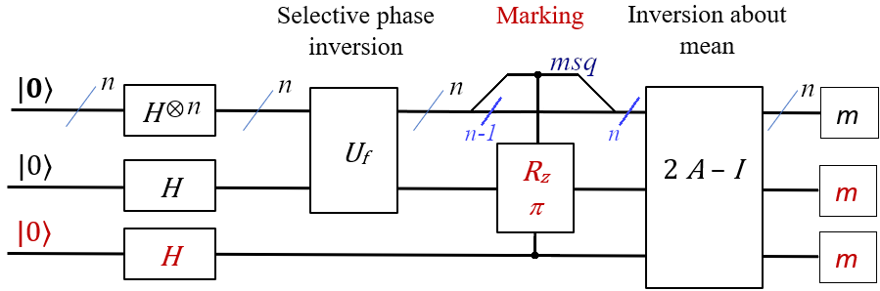 | 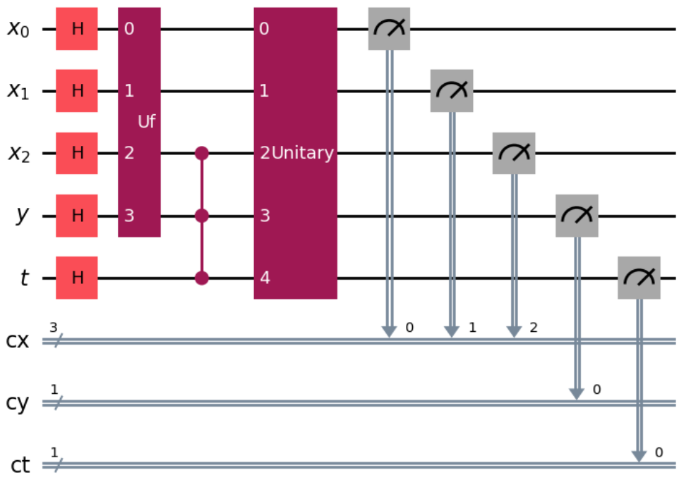
(a) | (b)
Figure 2. Simpler Eigenmarking. (a) Generic diagram and (b) Qiskit graphic draw of a three-qubit system: $x_{2}$ is the most significant qubit (msq).

methodology
Our proposed new Eigenmarking scheme is tested on all possible scenarios of a two-qubit system using Qiskit (version 1.1.1) and Qiskit Aer Simulator (version 0.15.1). Each treatment is repeated for 40 times, while each time the simulator simulates it for 1024 runs. The winning margins $W$ and distinguishabilities $D$ are presented in Table 4. Both performance indices are introduced in the previous study [3]. The winning margin measures how clearly answer states dominate non-answer states. It is a relative difference between the minimal count of the answer states and the maximal count of the non-answer states. Relative winning margin $W=\frac{c-c^{'}}{c^{'}}$ where $c$ is a minimal number of observed answer states (winning count), i.e., $c=\min_{k∈\{n(s)\}}k$ for $n(s)$ is a number of observed answer states, and $c^{'}$ is a maximal number of observed non-answer states (non-winning count), i.e., $c^{'}=\max_{k∈\{n(s^{'})\}}k$ for $n(s^{'})$ is a number of observed non-answer states. A larger $W$ means the difference between a number of observed answer states and a number of observed non-answer states. E.g., given answer states $|01⟩$ and $|10⟩$ with 1024 runs and suppose that observables are 0000 (200 counts), 0101 (320 counts), 0110 (380 counts), 0111 (64 counts), and 1110 (60 counts). Then we have $W=(320-200)/200=0.6$ when observables are shown in format ppxx; pp and xx represent prefix and original state, respectively. Local relative winning margin only counts non-answer states with target prefix, i.e., 01 for this simpler Eigenmarking. Hence, local relative winning margin $w=(320-64)/64=4$.
Winning margin measures quality of results in case-by-case basis. Providing a bigger picture across scenarios, distinguishability quantifies how clearly non-answer case can be distinguished from cases with some answers. Distinguishability measures the worst-case difference between the minimal score in scenarios with at least some answer(s) and the maximal score in a no-answer scenario: $D=min\{min(M_{i})\}_{i>0}-max(M_{0})$ where $M_{i}$ is a marking factor of the scenario with $i$-answer(s) and $M_{i}=\frac{c_{t}-c_{n}}{c_{t}+c_{n}}$; $c_{t}$ is a maximum count of states with target tag (simpler marking: prefix 01), $c_{n}$ is a maximum count of complementary states (simpler marking: starting with 111). A large value of $D$ indicates the ease of differentiate a no-answer case from any some-answer one. E.g., given the previous example (answers $|01⟩$ and $|10⟩$), $M_{2}=\frac{380-60}{380+60}=0.72$. Suppose we have $M_{i}$ for all cases: $M_{0}=-1$, $M_{1}=\{0.3,0.7,0.65,0.73\}$, $M_{2}=\{0.72,⋯\}$, $…$ and suppose the worst marking score from some-answer cases, $min\{min(M_{i})\}_{i>0}=0.3$. We will have $D=0.3-(-1)=1.3$.

TABLE 4. Winning margin [min., mean, max.](std. dev.) and distinguishability.
Scheme | Relative winning margin |  | Distinguishability
 | Global | Local | $$D$$
Convention. | [0.57, 1.10, 1.76](0.2) | [0.67, 1.49, 2.60](0.3) | 0.190
Subtle. | [-0.37, 0.31, 6.12](1.4) | [0.28, 25.72, 197.00](15.8) | 0.550
Simpler. | [-0.29, 1.06, 19.95](4.1) | [3.17, Large, Large](Large) | 0.769

conclusion and discussion
A new eigenmarking scheme is proposed. It requires only one extra qubit and a common ccz gate. Its performance has been shown to be viable in a two-qubit simulation.
Regarding practical implementation, our novel eigenmarking scheme requires less resources than previously proposed eigenmarking. It requires only one extra qubit and two-qubit-control phase rotation. Using two-qubit controlled phase rotation leads to entanglement of only three qubits regardless of search space. This could be conferred to multiple-qubit controlled phase rotation in subtle eigenmarking, which leads to entanglement of $n+2$ qubits for $n$-qubit search space. Maintaining coherence of highly entangled states poses critical challenges on practical hardware, particularly on superconducting circuits. In addition, as all eigenmarking schemes relying on Grover search, implementing oracle $U_{f}$, especially a complex one, remains one of the major practical challenges.
To further advance the development of the eigenmarking approach, its scalability (scaling up to a large number of qubits), robustness (accounting for noise and testing on a real quantum machine), theoretical analysis (examining its potentials and limits), further exploration on applications along with other related algorithms (synergizing its applicability) have to be adequately investigated.

References
- S. Russell and P. Norvig, Artificial intelligence: a modern approach (Pearson, 2022).
- Y. Kim, A. Eddins, S. Anand, and et al., “Evidence for the utility of quantum computing before fault tolerance,” Nature 618, 500–505 (2023).
- T. Katanyukul, “Toward entailment checking: explore eigenmarking search,” in InCACCT (2025).
- L. Grover, “Quantum mechanics helps in searching for a needle in a haystack,” Phys. Rev. Lett. 79(325) (1997).
- M. A. Nielsen and I. L. Chuang, Quantum computation and quantum information (CUP, 2016).
- P. Krantz, M. Kjaergaard, F. Yan, and et al., “A quantum engineer’s guide to superconducting qubits,” Appl. Phys. Rev. 6 (2019).
- M. Boyer, G. Brassard, P. Høyer, and A. Tapp, “Tight bounds on quantum search,” Fortschritte der Physik 46 (1998).
- G. Brassard, P. Høyer, and A. Tapp, “Quantum counting,” in ICALP (1998).
- A. Shukla and P. Vedula, “Toward practical quantum phase estimation: a modular, scalable, and adaptive approach,” arXiv preprint arXiv:2507.22460 (2025).
- K. Bharti, A. Cervera-Lierta, T. Kyaw, and et al., “Noisy intermediate-scale quantum algorithms,” Rev. Mod. Phys. 94 (2022).
- Y. Dong, J. Gross, and M. Niu, “Optimal low-depth quantum signal-processing phase estimation,” Nat. Commun. 16 (2025).

Count of any non-answer state with a target tag is zero.

