Polynomial Regression Analysis of the Three-year Trend of Weekly Dengue Cases in Baguio City
Joseph Ludwin DC. Marigmen^{a)} and Rizavel C. Addawe ^{b)}
¹Department of Mathematics and Computer Science, College of Science
University of the Philippines Baguio
Governor Pack Road, Baguio City 2600, Philippines
^{a)} Corresponding author: jdmarigmen@up.edu.ph
^{b)}rcaddawe@up.edu.ph
Abstract. Polynomial regression offers a flexible basis for characterizing cyclic behavior and persistent trends in infectious diseases data. While annual seasonality is evident, Baguio City's weekly dengue totals display a recurring three-year periodicity with rising peak amplitude. Hence, this paper aims to fit a polynomial regression model to study the trend and behavior of weekly reported dengue cases throughout the three-year period. A best-fitting polynomial model is achieved through data transformations and outlier treatment procedures. The implementation of a more sustainable solution in controlling the spread of disease must be implemented to avoid the recurring and increasing cycle.

INTRODUCTION
Dengue fever or dengue, a vector-borne viral disease transmitted through bites of dengue-carrying female Aedes aegypti mosquitoes, has become a global issue. According to the World Health Organization (WHO), reported dengue cases worldwide increased ten times from 500 thousand to 5.2 million from 2010 to 2019, respectively. Even with a decline of cases during the COVID-19 pandemic, reported dengue cases continue to surge worldwide, with others exceeding expectations [1].
According to WHO, dengue transmission is cyclic with large outbreaks, and is recorded every three to four years. The cyclic trend may have originated from the changed distribution of vectors in the area, effects of the El Niño phenomenon and climate change, fragile healthcare system, or from the political or financial instabilities [2]. As defined by WHO, an outbreak refers to the occurrence of disease cases that are beyond the expected range of values under a certain geographic location or climate [3].
Several regions have reported increasing dengue cases in certain periods. In the American region, dengue cases were reported to be cyclic, recurring every three to five years [1]. Keating [4] utilized a second-order multiple linear regression model to describe the relationship between seasonal temperature fluctuations and cyclical dengue fever incidence in Puerto Rico. Kim et al. [5] remarked that the optimal patch-specific control strategies of the two-patch dengue transmission dynamics were sensitive to seasonality and residence-time scenarios in the Peruvian jungles. On the other hand, Stoddard et al. [6] showed that annual and three-year peaks of dengue incidence were observed from 2000 to 2010 in Iquitos, Peru. Lastly, Fernández - Niño et al. [7] remarked that through exploratory wavelet analysis on the dengue incidence data in Colombia from 1978 to 2013, two- to five-year cycles were observed at the national level since 2004.
In the Western Pacific region, one of the countries that are mostly affected by the disease is the Philippines [1]. Seposo et al. [8] remarked that temperature, along with the geographical and socioeconomic factors such as highly dense areas, areas in lower latitudes, high poverty incidence, less people in urban areas with larger household size, and higher health spending per capita, contribute to the increasing trend of dengue cases. Undurraga et al. [9] remarked that dengue cases were ten times higher than rabies cases, twice compared to fluke cases, and 10% of tuberculosis cases, thus posing a substantial burden in the country. Looking at the specific regions, Xu et al. [10] remarked the predominance of cases in the southern region during the months of August, and on the National Capital Region during the months of September.
Baguio City, a highly-urbanized area in the northern region of the Philippines, have recorded high dengue cases throughout each year. In 2016, the country's DOH - Epidemiology Bureau reported less than 71 thousand cases in the country as of Morbidity Week (MW) 29. Among the 17 regions, the Cordillera Administrative Region (CAR), where Baguio City is part of, had the 9th most recorded dengue cases. In response, the City Local Government of Baguio City implemented Ordinance No. 66 series 2016, or the "Anti-Dengue Ordinance of the City of Baguio", which aims to reduce the occurrence of dengue cases by implementing control and prevention measures, integrated vector management, and strengthened actions against the disease [11]. However, in 2019, dengue cases from January 1 to July 29 increased by 24 percent compared to the same period last 2018. The Baguio City Health Services Office (BCHSO) recommended suspending the use of skirts in student uniforms and requiring long pants instead [12]. Still in 2022, less than 3000 dengue cases were recorded throughout the year, 121 percent increase compared to 2021 [13]. In response, the City Local Government implemented Resolution No. 255, series of 2023, authorizing the City Government of Baguio to have a Memorandum of Agreement with DOH Center for Health Development-CAR in constituting an anti-dengue program for the city [13].
Providing a solution on yearly basis would not be enough to attain the goal of controlling and preventing the spread of disease in an area. Hence, it is important to understand the trend of reported dengue cases to aid the local government policymakers at a longer time span. Thus, this paper aims to conduct a polynomial regression analysis to model and analyze cyclic trend of weekly dengue cases in Baguio City from 2005 to 2022. The research study is part of Goal 3 (Good Health and Well-being) of the Sustainable Development Goals (SDGs).

METHODOLOGY
Polynomial regression analysis is a statistical modeling method used when there is a nonlinear relationship between the independent and dependent variables [14]. The statistical model, called the polynomial regression model, has the polynomial equation

$$\begin{aligned}E\left(Y | X\right)=a_{0}+ a_{1}X+ a_{2}X^{2}+ ⋯+ a_{n-2}X^{n-2}+ a_{n-1}X^{n-1}+ a_{n}X^{n},\#\left(1\right)\end{aligned}$$

where ${\left\{a_{k}\right\}}_{k=0}^{n}$ are coefficients, $X$ is the independent variable, $Y$ is the dependent variable, and $E(Y|X)$ is the expectation of $Y$ given $X$ [15]. Using the method of undetermined coefficients, we acquire the equation

$$\begin{aligned}E\left(Y | X\right)=Aβ\#\left(2\right)\end{aligned}$$

where $E\left(Y | X\right)={\left[E\left(Y_{1} | X_{1}\right) E\left(Y_{2} | X_{2}\right) ⋯ E\left(Y_{m} | X_{m}\right)\right]}^{T}$ is the transposed row vector containing values of $E\left(Y | X\right)$, $A=\left[1 X X^{2} ⋯ X^{n}\right]$ is the matrix containing values of $X$ with $X^{k}={\left[X_{1}^{k} X_{2}^{k} ⋯ X_{m}^{k}\right]}^{T}$ for $k=0,1,2,⋯,n$, and $β={\left[a_{0} a_{1} a_{2} ⋯ a_{n-1} a_{n}\right]}^{T}$ is the transposed row coefficient vector. However, $E\left(Y | X\right)$ is not necessarily equal to $Y={\left[Y_{1} Y_{2} ⋯ Y_{m}\right]}^{T}$. Thus, we take the error term $ε={\left[ε_{0} ε_{1} ε_{2} ⋯ ε_{n-1} ε_{n}\right]}^{T}$ such that

$$\begin{aligned}Y=E\left(Y | X\right)+ε=Aβ+ε.\#\left(3\right)\end{aligned}$$

The error term $ε$ can be minimized by using the Ordinary Least Squared (OLS) method using the following formula for $β$:

$$\begin{aligned}β={\left({\left(A^{T}A\right)}^{-1}\right)}^{T}A^{T}Y\#\left(4\right)\end{aligned}$$

where $A^{T}$ represents the transpose of matrix $A$ and ${\left(A^{T}A\right)}^{-1}$ represents the inverse matrix of $A^{T}A$ [15]. As part of minimizing $ε$, we need to satisfy three main Gauss-Markov conditions - namely, normality with true zero mean (i.e. $ε∼N\left(0,σ^{2}\right)$ with $E\left(ε\right)=0$), homoscedasticity (i.e. $E\left(ε^{2}\right)=σ^{2}$), and independence (i.e. $E\left(ε_{i}ε_{j}\right)=0$ for $i≠j$) [16]. When all three conditions are satisfied, we say that the OLS method is the best linear unbiased estimator (BLUE).
Now that we established our main model and its conditions for the error terms, we proceed with model fitting on the given data. In this study, we utilized the reported weekly dengue cases data from 2005 to 2022, acquired from the BCHSO, as our sample data. For each year, tallies of reported dengue cases were acquired according to morbidity week. Barplots and line plots were used to identify the trend of dengue cases. Once a cyclic trend is identified, we then computed the average reported dengue cases per week in a cyclic period. The resulting data were utilized in generating a polynomial regression model using R statistical software along its packages and functions.
Using the sample data, we estimated the coefficient vector $\hat{β}$ using Equation (4) to arrive at our main model $Y=X\hat{β}+\hat{ε}$, where $\hat{ε}$ is the vector containing the estimated error components (or residuals). To achieve the Gauss-Markov conditions, we conducted four statistical tests as summarized in Table 1 along with their corresponding R packages and functions. Each test takes the null hypothesis $H_{0}$ as the main assumption to satisfy the Gauss-Markov condition. To achieve $H_{0}$, we need to have a p-value greater than 0.05.
TABLE 1. Summary table of the hypothesis tests used to satisfy the Gauss-Markov conditions for the model residuals
Condition | Statistical Test | Source | R function | R package | Source
True zero mean | one-sample t test | [17] | test.t | (built-in)
Normality | Kolmogorov-Smirnov Test | [18] | ols_test_normality | olsrr | [19]
Homoscedasticity | Breusch-Pagan Test | [20] | ols_test_breusch-pagan | olsrr | [19]
Independence | Breusch-Godfrey Test | [21] | bgtest | lmtest | [22]

When homoscedasticity and independence are not satisfied, it is possible that outliers may have affected the model. Thus, we construct boxplots of reported weekly dengue cases to identify these outliers. In treating these outliers, two methods are considered. One method is winsorization, where we replace the largest or smallest outlier on that week with its second largest or second smallest data point, respectively [23]. An alternative method used in this study is the mean imputation, where we replace the outliers with the original weekly average dengue case [23].
In addition to outlier identification, data transformations such as the Logarithmic transformation and Box-Cox transformation are utilized. The Logarithmic transformation is performed by taking the logarithmic value, on base 10, of the components of $Y$. Since the weekly reported dengue cases consist of nonnegative values and the logarithmic expression is only applicable to positive numbers, we consider adding 1 to each component. The Logarithmic transformation can be applied using the built-in log function in R.
The Box-Cox transformation, on the other hand, is a generalization of the traditional transformations like the Logarithmic, Square Root, Arcsine, and Inverse transformations. It is performed using the formula

$$\begin{aligned}Y_{i}^{'}=\left\{\begin{aligned}\frac{{\left(Y_{i}+1\right)}^{λ}-1}{λ}, & if λ≠0 &&& \\ \log\left(Y_{i}+1\right), if λ=0\end{aligned}\right.\#\left(5\right)\end{aligned}$$

for each component $Y_{i}∈Y$ and $λ$ is the transformation parameter [24]. Since the Box-Cox transformation only works for positive values, we added 1 in each component. The transformation parameter is estimated by maximizing the log-likelihood of the equation

$$\begin{aligned}\log{L}=-\frac{1}{2σ_{Y}^{'2}}\sum_{i=1}^{k}{{\left[Y_{i}^{'λ}-\left(β_{0}+β_{iX_{i}}\right)\right]}^{2}}+\left(λ-1\right)\sum_{i=1}^{k}{\log\left(Y_{i}^{'}\right)}\#\left(6\right)\end{aligned}$$

where $σ_{Y}^{'2}$ is the variance of $Y^{'}={\left[Y_{1}^{'} Y_{2}^{'} ⋯ Y_{m}^{'}\right]}^{T}$ [25]. The transformed value can be returned to its original form by applying the formula

$$\begin{aligned}Y_{i}=\left\{\begin{aligned}{\left(λY_{i}^{'}+1\right)}^{\frac{1}{λ}}-1, if λ≠0 \\ {10}^{Y_{i}^{'}}-1, if λ=0.\end{aligned}\right. \#\left(7\right)\end{aligned}$$

The Box-Cox transformation can be applied using the boxcox function in the MASS package. Similarly, outlier determination and treatment methods are conducted after data transformation to identify a better fitting polynomial model. Thus, we have thirteen types of data for model-fitting. Table 2 summarizes the process. Each model corresponds to the type of data used. For example, in Model 4, after winsorizing outliers, the new original data were then transformed through logarithmic transformation to arrive at the new set of data.
TABLE 2. Summary table of the types of data used for model-fitting
Model | Data used | Outlier Treatment Method | Data Transformation (if needed)
1 | Original data
2 | Original data | Winsorization
3 | Original data | Mean imputation
4 | Original data | Winsorization | Logarithmic transformation
5 | Original data | Winsorization | Box-Cox transformation
6 | Original data | Mean imputation | Logarithmic transformation
7 | Original data | Mean imputation | Box-Cox transformation
8 | Logarithmic data
9 | Logarithmic data | Winsorization
10 | Logarithmic data | Mean imputation
11 | Box-Cox data
12 | Box-Cox data | Winsorization
13 | Box-Cox data | Mean imputation

Once we acquire the best-fitting polynomial regression models in these methods, we identify the best-fitting polynomial regression model by utilizing the adjusted coefficient of determination (adjusted $R^{2}$), the root mean squared error (RMSE), the Akaike Information Criterion (AIC), and the Bayesian Information Criterion (BIC). Compared to other models, we say that the selected model is best when the model has the highest adjusted $R^{2}$ value and the lowest RMSE, AIC, and BIC values. In case that not all conditions are satisfied, we say that the selected model is the best when at least three of the four conditions are satisfied. Lastly, we conduct a cross validation to validate the robustness of the generated polynomial regression model with polynomial models of different order. For the cross validation, we compute the respective model Mean Squared Error (MSE) and model variance. We say that the selected model is a robust polynomial regression model when it has the lowest MSE and variance values.

RESULTS AND DISCUSSION
In preparation for polynomial regression modeling, we first provide data visualizations and preliminary analysis. Figure 1 (a) shows the weekly reported dengue cases in Baguio City from 2005 to 2022. Except for the period 2005-2007, reported weekly dengue cases follow a three-year cyclic pattern with the third year having most number of reported dengue cases in the period. These cyclic patterns are shown to be more evident in Fig. 1 (b) and (c). Using the reported average weekly dengue cases in Fig. 1 (c), we then construct our polynomial regression model. Having three relative maximum points and three relative minimum points, we consider the polynomial model of at least order seven.
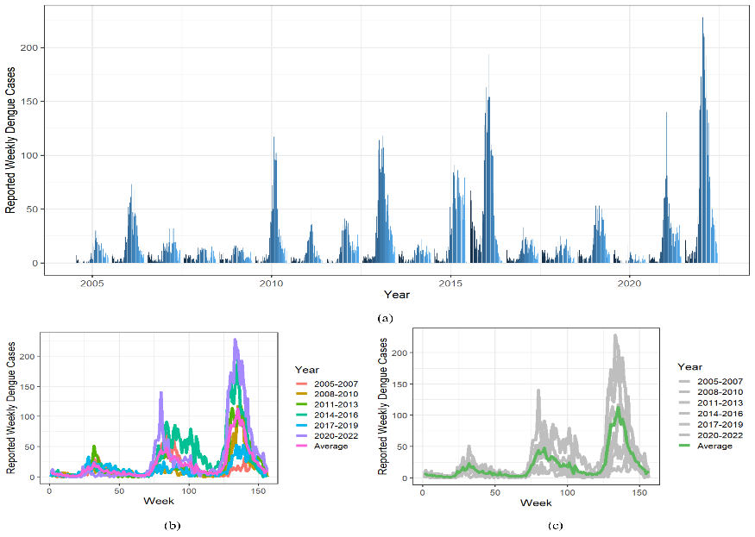
FIGURE 1. Reported weekly (a) dengue cases, (b) dengue cases in a three-year cycle, and (c) average dengue cases in Baguio City from 2005 to 2022
Now that we establish our order of polynomial, we then determine the outliers. Figure 2 shows the weekly boxplots of reported dengue cases in Baguio City using the original and transformed data. Circles above or below each boxplot were identified as outliers. There are 39 identified outliers from the original data, 28 from the logarithmic transformed data, and 30 from the Box-Cox transformed data.

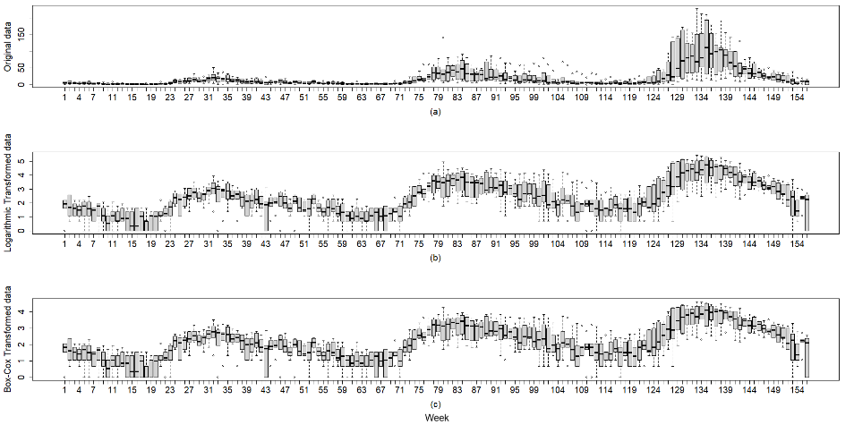
FIGURE 2. Boxplots of reported weekly dengue cases in Baguio City from 2005 to 2022 using the (a) original, (b) logarithmic transformed, and (c) Box-Cox transformed data

Given these preliminary results, we then perform polynomial regression modeling based from the summary table provided in Table 2. As a result, nineteen polynomial equations were generated. Among these equations per model, we choose the best-performing that have satisfied the Gauss-Markov conditions with the highest adjusted $R^{2}$ and lowest RMSE, AIC, and BIC values. This best-performing equation will represent the corresponding model. Note that Models 1, 2, 3, 5, 7, and 11 did not satisfy one of the Gauss-Markov conditions. Thus, we have generated seven models for comparison. Table 3 summarizes the result.
TABLE 3. Summary table of best-fitting polynomial regression model per data type
Model | Order | RMSE | Adjusted $R^{2}$ | AIC | BIC
4 | 20 | 0.1972 | 0.9569 | -19.8752 | 47.2216
6 | 20 | 0.1983 | 0.9563 | -18.0702 | 49.0267
8 | 20 | 0.1767 | 0.9643 | -54.0919 | 13.0049
9 | 21 | 0.0836 | 0.9549 | -285.5011 | -215.3544
10 | 21 | 0.0846 | 0.9540 | -281.9462 | -211.7995
12 | 21 | 0.1726 | 0.9519 | -59.4832 | 10.6635
13 | 21 | 0.1740 | 0.9514 | -56.9135 | 13.2332

Among the seven models, Model 9 had the lowest RMSE, AIC, and BIC values. While Model 4 had the larger adjusted $R^{2}$, Model 9 met the remaining conditions; hence, the polynomial model based on log-transformed data with winsorized outliers is selected as the best - fitting specification. Model 9 is

$$\begin{aligned}Y^{'}=0.9989 + 2.9987X - 0.7278X^{4}- 0.9803X^{5}- 1.1607X^{6}- 2.4400X^{7} \\ +1.6070X^{8}+ 2.1086X^{9}- 0.6334X^{10}- 0.3705X^{11}- 0.1977X^{12} \\ -0.3645X^{15} + {0.8314}^{16} + 0.4432X^{17} - 0.6355X^{18} - 0.2249X^{21}. \#\left(8\right)\end{aligned}$$

The computed estimated coefficients for $X^{2},X^{3},X^{13}, X^{14},X^{19},$ and $X^{20}$ were not statistically significant (p-value > 0.05) and were therefore removed from the model.
As we acquire our best-fitting polynomial, we then conduct our cross-validation to determine robustness. As shown in Fig. 3, the estimated squared error decreases as the polynomial order increases, implying that the polynomial equation of order 21 is the robust polynomial regression model in the study.

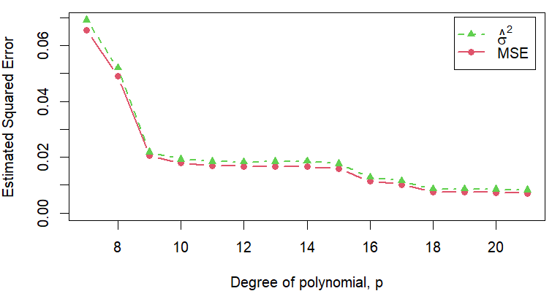
FIGURE 3. Estimated squared error of the polynomial regression models

Henceforth, we say that Equation (8) is the best polynomial regression equation. Returning to the original data, we have the regression model

$$\begin{aligned}Y={10}^{Y^{'}}-1.\#\left(9\right)\end{aligned}$$

Lastly, we generate the predictive analysis for dengue cases in Baguio City. Figure 4 shows the graph of Equation (9) along with the 95% confidence bands and 95% prediction bands. The resulting maximum prediction values in the band serves as the weekly threshold value.

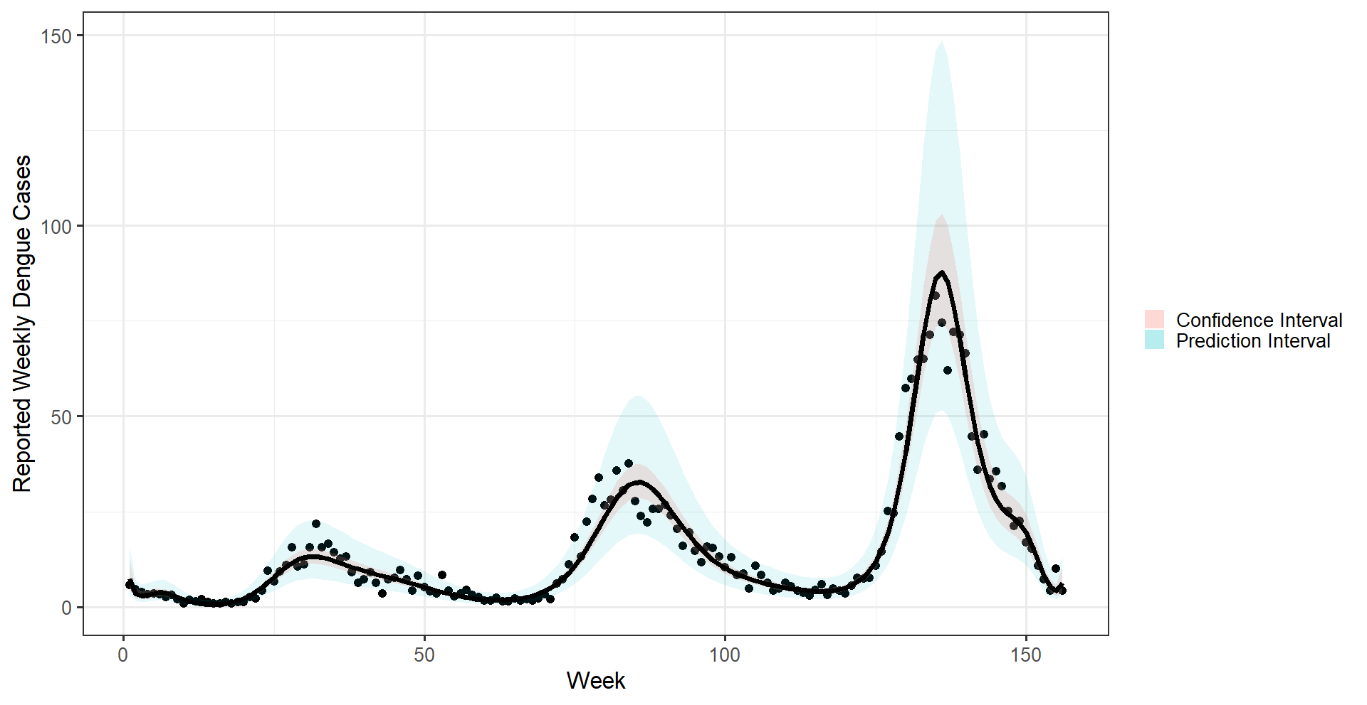
FIGURE 4. Graph of Equation (9) with 95% confidence bands and 95% prediction bands

In the three-year cycle, reported weekly dengue cases are expected to reach its maximum peak between Weeks 135 and 136, or particularly, between MWs 31 (second week of August) and 32 (third week of August) of the third year. During this week, it is predicted that the expected highest reported weekly dengue cases is 150 cases. Going beyond the prediction value will imply a local outbreak. Historically, local outbreaks are observed in 2016 with 154 to 194 reported cases and 2022 with 179 to 210 reported cases. Furthermore, local outbreaks were observed in 2015 from MW 31 to MW 51, as reported dengue cases were 12 to 48 cases higher than its respective maximum predicted value of weekly cases. Also, local outbreaks were present in 2021 from MW 24 to MW30, with 11 to 93 reported cases higher than its respective maximum predicted value of weekly cases.
Considering the three-week gap from the time of infection to the time of report, it is noted that infection through dengue-carrying mosquitoes is very abundant on the third to fourth week of July. To avoid recurrence of these outbreaks, the community, along with the city local government, should prepare for this period and must conduct further actions to control and prevent the spread of dengue, especially on the third year.

CONCLUSION
Through the implementation of logarithmic transformation and winsorization of 28 outliers on the transformed data, we acquired a polynomial regression model of order 21 that can explain the three-year cyclic pattern of weekly total dengue cases in Baguio City. Using weekly data from 2005 - 2022, we estimate that dengue cases peak in the second and third weeks of August in the third year of the three-year cycle (particularly in the years 2007, 2010, 2013, 2016, 2019, and 2022). Considering the three-week gap from infection to reporting, we see that the abundance of dengue-carrying mosquitoes is observed between the third and fourth weeks of July.
The identification of these peak periods, most especially on the third year of the three-year cycle, can guide the policymakers in implementing policies and leading the community to achieve the goal of controlling and preventing the spread of the disease. However, some challenges are also noted due to the continuing effects of climate change along with the changing socioeconomic status of individuals in the city. Thus, to further understand the dynamics of dengue cases in the city, we recommend identifying the climatic and socioeconomic factors, especially on the third year, that provide the significant factor on the trend.
In terms of the acquired polynomial regression model, having a polynomial equation of order 21 does not present a parsimonious model. Thus, we recommend utilizing a more robust regression method that can properly model the data well at a lower polynomial order. Alongside the utilization of a more robust regression method is the recommendation of conducting a more robust estimation method for the coefficients of the polynomial model to boost the ability of the model to explain the data well.

Acknowledgments
We acknowledge the Baguio City Epidemiology and Surveillance Unit for the raw data on reported dengue cases in Baguio City from 2005 to 2022, and the University of the Philippines Baguio - Research Dissemination Grant for the funding support.

References
- W. H. Organization, Dengue- Global Situation, WWW document,
(https://www.who.int/ emergencies/disease-outbreak-news/item/2023-DON498).
- J. Cogan, Dengue,WWW document, (https://www.who.int/news-room/fact-sheets/detail/dengue-and-severe-dengue).
- W. H. Organization, Environment, Climate Change and Health, WWW document, (https://www.who.int/teams/environment-climate-change-and-health/emergencies/disease-outbreaks).
- J. Keating, Soc. Sci. Med. 53 (2001), https://doi.org/10.1016/S0277-9536(00)00443-3.
- J. E. Kim et al., PLoS ONE 12 (2017), https://doi.org/10.1371/ journal.pone.0173673.
- S. T. Stoddard et al., PLoS Negl. Trop. Dis. 8 (2014), https://doi.org/10.1371/journal.pntd.0003003.
- J. A. Fernández-Niño et al., Biomédica 36 (2016), https://doi.org/10.7705/biomedica.v36i0.2869.
- X. Seposo, S. Valenzuela, and G. L. Apostol, PLoS Negl. Trop. Dis. 17 (2023), 10.1371/journal.pntd.0011700.
- E. A. Undurraga et al., Am. J. Trop. Med. Hyg. 96 (2017), 10.4269/ajtmh.16-0488.
- Z. Xu et al., Sci. Total. Environ. 708 (2020), 10.1016/j.scitotenv.2019.134849.
- A. Refuerzo, WWW document, (https://www.sunstar.com.ph/more-articles/anti-dengue-ordinance-now-in-effect)
- A. Dumlao, Due to dengue epidemic, Baguio may relax school dress code, WWW document, (https://www.
philstar.com/nation/2019/08/12/1942755/due-dengue-epidemic-baguio-may-relax-school-dress-code).
- G. Keith, WWW document, (https://new.baguio.gov.ph/news/mayor-given-go-signal-to-enter-into-anti-dengue-agreement-with-doh).
- E. Ostertagová, Procedia Eng. 48, 500 (2012).
- D. G. Kleinbaum et al., Applied Regression Analysis and Other Multivariable Methods, 5th ed. (Cengage Learning, Boston, MA, 2013).
- A. Sen and M. Srivastava, Regression Analysis: Theory, Methods, and Applications (Springer Verlag, NY, 1990).
- R. E. Walpole et al., Probability & Statistics for Scientists & Engineers, 9th ed. (Pearson Education Limited, Essex, England, 2016).
- V. W. Berger and Y. Zhou, Encyclopedia of Statistics in Behavioral Science (John Wiley & Sons, NJ, 2005).
- A. Hebbali, olsrr: Tools for Building OLS Regression Models (Vienna, 2024).
- T. S. Breusch and A. R. Pagan, Econometrica 47, 1287 (1979).
- R. Rois et al., Int. J. Bus. Manag. 7, 88 (2012).
- A. Zeileis and T. Hothorn, R J. 2, 7 (2002).
- R. Chambers and R. Ren, “Outlier robust imputation of survey data,” in JSM Proceedings (American Statistical Association, Alexandria, VA, 2004) p. 3336.
- G. E. P. Box and D. R. Cox, J. R. Stat. Soc. Ser. B. Methodol. 26, 211 (1964).
- N. A. M. Ishak and S. Ahmad, “Estimating Optimal Parameter of Box-Cox Transformation in Multiple Regression with Non-normal Data,” in Regional Conference on Science, Technology and Social Sciences (RCSTSS 2016), Pahang, Malaysia, December 2016, edited by N. Y. et al. (Springer, Singapore, 2018) p. 1039.

