Exponential B-Spline Alternating Group Explicit Method in
Solving Parabolic Differential Equation
Nur Aliah Izzati Binti Rosman^{1, a)}
¹School of American Education, Sunway University, 47500 Bandar Sunway, Selangor, Malaysia.
^{a)} Corresponding author: aliahr@sunway.edu.my
Abstract. Exponential B-Spline Alternating Group Explicit (ExpBSPAGE) iterative method is proposed to solve a linear first order differential equation which is the heat conduction equation and is derived from the cubic Exponential B-Spline collocation technique. The stationary case with odd number of points with even number of intervals for both time and space dimension is considered in this study. The performance of ExpBSPAGE is compared to AGE and Cubic B-Spline Group Explicit (BSPAGE) in terms of accuracy based on the numerical results.

INTRODUCTION

The general form of one-dimensional heat equation is given by
$$U_{t}=ωU_{xx}+ξ\left(x,t\right), 0≤x≤1, 0≤t≤T$$ | (1)

for temperature $U$, generated heat energy$x$, time $t$, space$x$ and total time $T$ with initial-boundary conditions

$$\begin{matrix}U\left(x,0\right)=f\left(x\right), 0≤x≤1 \\ U\left(x,t\right)=g\left(t\right), U\left(1,t\right)=h(t), 0≤t≤T\end{matrix}$$ | (2)

where $f$ is the initial temperature, $g$ is the first wall temperature, $h$ is the end wall temperature and $w$ represents the thermal diffusivity coefficient. The heat equation originates from Fourier’s Law and the conservation of energy which is applicable to chemical diffusion and other similar mechanisms [1-2].
In 1986, Sahimi introduced a finite difference approach known as the Alternating Group Explicit (AGE) iterative method for solving parabolic Partial Differential Equations (PDEs) numerically. This method is derived from Alternating Direction Implicit (ADI) iterative method, with results that are both analogous and comparable [3]. The AGE was further enhanced by incorporating spline functions. Kadhum implemented cubic splines into the AGE to obtain the numerical solutions for parabolic PDEs in 1988 [4]. A comparative analysis was conducted involving numerical results and computational complexity with other established methods, including ADI, Group Explicit (GE),
Crank-Nicolson (C-N), and Successive Over-Relaxation (SOR).
Evans and Kadhum found that the spline-based AGE method offers improved stability and high numerical accuracy. They applied the AGE to solve linear three-term recurrence equations derived from the cubic spline approximations to the one-dimensional diffusion equations and obtained the convergence and stability of the method in 1997 [5]. The derivation and existence of the optimal acceleration parameters for the stationary and non-stationary forms were established. In 1999, they extended their past research for two-dimensional diffusion equations [6].
In 2009, Mohanty and Jain proposed high-accuracy cubic Spline Alternating Group Explicit (SPAGE) iterative methods for one-dimensional quasi-linear parabolic equations. They studied the application of AGE and Newton- AGE iterative methods on a two-level implicit cubic spline formula for the solution of one-dimensional quasi-linear parabolic equations. The proposed ideas require three spatial grid points and are applicable for both rectangular and polar coordinate problems. The convergence analysis at higher time level was discussed and compared with the corresponding SOR and Newton-SOR iterative methods both in terms of accuracy and performance [7]. These SPAGE differ in terms of the type of splines and its properties of the basis together with the value of acceleration parameter that relates to the eigenvalues of the block matrices. This support that the combination of AGE and spline method improves the variation of technique in solving the heat equation.
In solving PDEs, various B-spline methods have been developed. In 2011, Goh et al. proposed Cubic B-Spline (CuBS) method for solving one-dimensional heat, wave, and advection-diffusion equations with promising results and discussed the accuracy and efficiency of the method [8]. They continue their collaboration in 2012 to solve one dimensional heat and advection-diffusion equations using B-Spline collocation method and analysed the numerical solutions, stability and efficiency of their method [9]. For further exploring the spline and AGE, B-Spline Alternating
Group Explicit (BSPAGE) iterative method is proposed by Rosman et al. in 2019 to solve one-dimensional diffusion equation where the AGE iterative method is derived from the CuBS collocation technique [10]. They found that BSPAGE is more accurate and converges faster than AGE and SPAGE. Then, they continue their study and proposed Extended B-Spline Alternating Group Explicit (ExtBSPAGE) iterative method in solving the heat equation by the derivation of extended CuBS collocation on the AGE iterative method. The numerical result of ExtBSPAGE is more accurate and converges faster compared to AGE and BSPAGE [11].
Furthermore, there have been various application of Exponential cubic B-Spline collocation technique in solving PDEs [12-14]. Thus, the idea of merging the Exponential CuBS and AGE is proposed. The objectives of this study are to develop ExpBSPAGE iterative scheme, to solve heat equations using ExpBSPAGE, to analyse and compare the numerical results between AGE, BSPAGE and ExpBSPAGE iterative methods with the exact solution.

STATIONARY ALTERNATING GROUP EXPLICIT ITERATIVE METHOD
The main idea of AGE is the fractional splitting strategy which is applied alternately at each half time step on large tri-diagonal linear systems of difference schemes and the accuracy is better compared to the existing finite difference schemes [3], [15], [16]. From Eq. (1) and Eq. (2), consider a uniformly spaced network whose mesh points are $x_{i}=i∆x$ and $t_{j}=j∆t$ for $i=0,1,…,m,m+1$ and $j=0,1,…,n,n+1$ with $∆x=\frac{1}{m+1}, ∆t=\frac{T}{n+1}$ and constant $λ=\frac{∆t}{{\left(∆x\right)}^{2}}$ where $m$ and $n$ are odd integers. The heat equation is discretized using theta-weighted approximation at the point $\left(x_{i},t_{j+\frac{1}{2}}\right)$ as follows [3], [15], [16]:

$$\left(1+2ωλθ\right)u_{i,j+1}-ωλθ(u_{i-1,j+1}+u_{i+1,j+1})=ωλ\left(1-θ\right)(u_{i-1,j}+u_{i+1,j})+\left(1-2ωλ(1-θ)\right)u_{i,j}$$ | (3)

where $ω$ is the thermal diffusivity coefficient and $u_{i,j}$ is the approximation solution of the internal points at $j+1$ time level. We note that when $θ$ takes the values $1, \frac{1}{2}, \frac{1}{2}-\frac{1}{12λ}$ and $0$ represents the fully implicit, the Crank-Nicolson, the
Douglas and the classical explicit finite-difference schemes respectively. Once $θ=\frac{1}{2}$, Eq. (3) can be written in matrix form as

$$Au=F$$ | (4)

where $A={\left[\begin{matrix}\begin{matrix}\begin{matrix}a & b & 0\end{matrix} \\ \begin{matrix}b & a & b\end{matrix}\end{matrix} & \begin{matrix}\begin{matrix}0 & 0 & 0\end{matrix} \\ \begin{matrix}0 & 0 & 0\end{matrix}\end{matrix} & \begin{matrix}0 \\ 0\end{matrix} \\ \begin{matrix}\begin{matrix}0 & b & a\end{matrix} \\ \begin{matrix}0 & 0 & ⋱\end{matrix}\end{matrix} & \begin{matrix}\begin{matrix}b & 0 & 0\end{matrix} \\ \begin{matrix}⋱ & ⋱ & 0\end{matrix}\end{matrix} & \begin{matrix}0 \\ 0\end{matrix} \\ \begin{matrix}\begin{matrix}0 & 0 & 0\end{matrix} \\ \begin{matrix}0 & 0 & 0\end{matrix}\end{matrix} & \begin{matrix}\begin{matrix}0 & b & a\end{matrix} \\ \begin{matrix}0 & 0 & b\end{matrix}\end{matrix} & \begin{matrix}b \\ a\end{matrix}\end{matrix}\right]}_{m×m}, u={\left[\begin{matrix}\begin{matrix}u_{1} \\ u_{2}\end{matrix} \\ \begin{matrix}⋮ \\ u_{m-1}\end{matrix} \\ u_{m}\end{matrix}\right]}_{m×1}$ and $F={\left[\begin{matrix}\begin{matrix}f_{1} \\ f_{2}\end{matrix} \\ \begin{matrix}⋮ \\ f_{m-1}\end{matrix} \\ f_{m}\end{matrix}\right]}_{m×1}$ with $a=1+2ωλθ, b=-ωλθ$

such that $F=\left\{\begin{matrix}f_{1}=ωλ\left(1-θ\right)\left(u_{0,j}+u_{2,j}\right)+ωλθu_{0,j+1}+\left(1-2ωλ\left(1-θ\right)\right)u_{1,j}, \\ f_{i}=ωλ\left(1-θ\right)\left(u_{i-1,j}+u_{i+1,j}\right)+\left(1-2ωλ\left(1-θ\right)\right)u_{1,j},i=2,3,…,m-2,m-1, \\ f_{m}=ωλ\left(1-θ\right)\left(u_{m-1,j}+u_{m+1,j}\right)+\left(1-2ωλ\left(1-θ\right)\right)u_{m,j}+ωλ\left(1-θ\right)u_{m+1,j}+ωλθu_{m+1,j+1}.\end{matrix}\right.$

According to the AGE theory [4], $A$ can be split into two matrices as follows:

$$A=G_{1}+G_{2}$$ | (5)

where $G_{1}=\left[\begin{matrix}\frac{a}{2} & ⋮ & 0 & 0 & ⋮ & 0 & ⋮ & 0 & 0 \\ ⋯ & ⋯ & ⋯ & ⋯ & ⋯ & ⋯ & ⋯ & ⋯ & ⋯ \\ 0 & ⋮ & \frac{a}{2} & b & ⋮ & 0 & ⋮ & 0 & 0 \\ 0 & ⋮ & b & \frac{a}{2} & ⋮ & 0 & ⋮ & 0 & 0 \\ ⋯ & ⋯ & ⋯ & ⋯ & ⋯ & ⋯ & ⋯ & ⋯ & ⋯ \\ 0 & ⋮ & 0 & 0 & ⋮ & ⋱ & ⋮ & 0 & 0 \\ ⋯ & ⋯ & ⋯ & ⋯ & ⋯ & ⋯ & ⋯ & ⋯ & ⋯ \\ 0 & ⋮ & 0 & 0 & ⋮ & 0 & ⋮ & \frac{a}{2} & b \\ 0 & ⋮ & 0 & 0 & ⋮ & 0 & ⋮ & b & \frac{a}{2}\end{matrix}\right]$ and $G_{2}=\left[\begin{matrix}\frac{a}{2} & b & ⋮ & 0 & 0 & ⋮ & 0 & ⋮ & 0 \\ b & \frac{a}{2} & ⋮ & 0 & 0 & ⋮ & 0 & ⋮ & 0 \\ ⋯ & ⋯ & ⋯ & ⋯ & ⋯ & ⋯ & ⋯ & ⋯ & ⋯ \\ 0 & 0 & ⋮ & \frac{a}{2} & b & ⋮ & 0 & ⋮ & 0 \\ 0 & 0 & ⋮ & b & \frac{a}{2} & ⋮ & 0 & ⋮ & 0 \\ ⋯ & ⋯ & ⋯ & ⋯ & ⋯ & ⋯ & ⋯ & ⋯ & ⋯ \\ 0 & 0 & ⋮ & 0 & 0 & ⋮ & ⋱ & ⋮ & 0 \\ ⋯ & ⋯ & ⋯ & ⋯ & ⋯ & ⋯ & ⋯ & ⋯ & ⋯ \\ 0 & 0 & ⋮ & 0 & 0 & ⋮ & 0 & ⋮ & \frac{a}{2}\end{matrix}\right]$. The matrices $A, G_{1}$ and $G_{2}$ are of the same dimension, square, tri-diagonal and non-singular [3], [15], [16]. Thus, Eq. (4) becomes

$$\left(G_{1}+G_{2}\right)u=F$$ | (6)

Therefore, the AGE iteration is given by

$$\begin{matrix}\left(G_{1}+rI\right)u^{\left(p+\frac{1}{2}\right)}=\left(rI-G_{2}\right)u^{\left(p\right)}+F^{\left(p\right)}, \\ \left(G_{2}+rI\right)u^{\left(p+1\right)}=\left(rI-G_{1}\right)u^{\left(p+\frac{1}{2}\right)}+F^{\left(p\right)},\end{matrix}$$ | (7)

for acceleration parameter, $r>0$ and iteration number, $p$ [3, 15]. The linear system in Eq. (7) is solved for the approximate solution, $u^{j}$. The stability and its rate of convergence is governed by the acceleration parameter, $r$ [3, 15,
16].

EXPONENTIAL CUBIC B-SPLINE METHOD

Suppose that ${\left\{x_{i}\right\}}_{i=0}^{k}$ is a uniform partition of a finite interval $[p,q]$ with $k∈Z^{+}$ such that $p=x_{0}<x_{i}<…<x_{k}<q$ and $x_{i}=x_{0}+ih$ where $h=\frac{q-p}{k}$ and $i∈Z$. The basis function for Exponential CuBS [12, 13, 14] is
$$B_{i}^{4}\left(x\right)=\left\{\begin{matrix}\begin{matrix}\left(\frac{ρ}{2\left(φ_{2}ρh-φ_{1}\right)}\right)\left(\left(x_{i}-x\right)-\frac{1}{ρ}\left(\sinh\left(ρ\left(x_{i}-x\right)\right)\right)\right), x∈[x_{i},x_{i+1}] \\ \begin{matrix}\frac{φ_{2}ρh}{φ_{2}ρh-φ_{1}}+\frac{ρ}{2}\left(\frac{φ_{2}\left(φ_{2}-1\right)+φ_{1}^{2}}{\left(φ_{2}ρh-φ_{1}\right)\left(1-φ_{2}\right)}\right)\left(x_{i+2}-x\right) \\ +\frac{1}{4}\left(\frac{\left(1-φ_{2}\right)e^{-ρh}+φ_{1}\left(e^{-ρh}-1\right)}{\left(φ_{2}ρh-φ_{1}\right)\left(1-φ_{2}\right)}\right)e^{ρ\left(x_{i+2}-x\right)}\end{matrix} \\ +\frac{1}{4}\left(\frac{\left(φ_{2}-1\right)e^{ρh}+φ_{1}\left(e^{ρh}-1\right)}{\left(φ_{2}ρh-φ_{1}\right)\left(1-φ_{2}\right)}\right)e^{-ρ\left(x_{i+2}-x\right)}, x∈[x_{i+1},x_{i+2}]\end{matrix} \\ \begin{matrix}\begin{matrix}\frac{φ_{2}ρh}{φ_{2}ρh-φ_{1}}+\frac{ρ}{2}\left(\frac{φ_{2}\left(φ_{2}-1\right)+φ_{1}^{2}}{\left(φ_{2}ρh-φ_{1}\right)\left(1-φ_{2}\right)}\right)\left(x-x_{i+2}\right) \\ +\frac{1}{4}\left(\frac{\left(1-φ_{2}\right)e^{-ρh}+φ_{1}\left(e^{-ρh}-1\right)}{\left(φ_{2}ρh-φ_{1}\right)\left(1-φ_{2}\right)}\right)e^{ρ\left(x-x_{i+2}\right)}\end{matrix} \\ +\frac{1}{4}\left(\frac{\left(φ_{2}-1\right)e^{ρh}+φ_{1}\left(e^{ρh}-1\right)}{\left(φ_{2}ρh-φ_{1}\right)\left(1-φ_{2}\right)}\right)e^{-ρ\left(x-x_{i+2}\right)}, x∈[x_{i+2},x_{i+3}] \\ \end{matrix} \\ 0, otherwise.\end{matrix}\right.$$ | (8)

where $φ_{1}=\sinh{ρh},φ_{2}=\cosh{ρh}$ and $ρ$ is a free parameter.

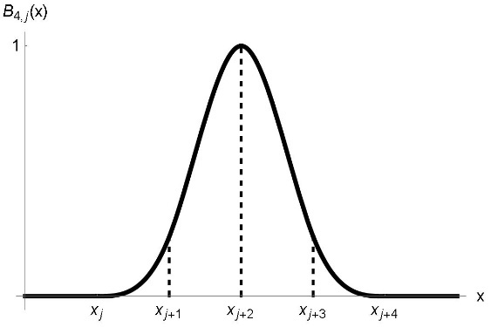
Figure 1. Basis function for cubic Exponential B-Spline for $ρ=1$ and $h=1$.

Fig 1 illustrates the basis function of Exponential CuBS. An arbitrary Exponential CuBS curve can be generated by the following formula [12-14]:

$$S(x,t)=\sum_{i=-3}^{n-1}{C_{i}B_{i}^{4}\left(x\right)}$$ | (9)

TABLE 1. Values of $B_{i}, B_{i}'$ and $B_{i}''$.
$$x$$ | $$x_{i}$$ | $$x_{i+1}$$ | $$x_{i+2}$$ | $$x_{i+3}$$ | $$x_{i+4}$$
$$B_{i}$$ | $$0$$ | $$\frac{φ_{1}-ρh}{2\left(φ_{2}ρh-φ_{1}\right)}$$ | $$1$$ | $$\frac{φ_{1}-ρh}{2\left(φ_{2}ρh-φ_{1}\right)}$$ | $$0$$
$$B_{i}'$$ | $$0$$ | $$\frac{ρ(1-φ_{2})}{2\left(φ_{2}ρh-φ_{1}\right)}$$ | $$0$$ | $$\frac{ρ(1-φ_{2})}{2\left(φ_{2}ρh-φ_{1}\right)}$$ | $$0$$
$$B_{i}''$$ | $$0$$ | $$\frac{φ_{1}ρ^{2}}{2\left(φ_{2}ρh-φ_{1}\right)}$$ | $$-\frac{φ_{1}ρ^{2}}{φ_{2}ρh-φ_{1}}$$ | $$\frac{φ_{1}ρ^{2}}{2\left(φ_{2}ρh-φ_{1}\right)}$$ | $$0$$

The value of $B_{i}$ and its derivatives $B_{i}'$ and $B_{i}''$ at the nodal points are tabulated in Table 1. Suppose that the spline curve, $u(x,t)$ is the approximation to the exact solutions, $U(x,t)$. Thus, the values of $u(x,t)$, $u'(x,t)$ and $u''(x,t)$ at the point $x_{i}$ can be simplified into

$$\left\{\begin{matrix}S\left(x,t\right)=\frac{φ_{1}-ρh}{2\left(φ_{2}ρh-φ_{1}\right)}C_{i-3}+C_{i-2}+\frac{φ_{1}-ρh}{2\left(φ_{2}ρh-φ_{1}\right)}C_{i-1} \\ S^{'}\left(x,t\right)=\frac{ρ(1-φ_{2})}{2\left(φ_{2}ρh-φ_{1}\right)}C_{i-3}+\frac{ρ(1-φ_{2})}{2\left(φ_{2}ρh-φ_{1}\right)}C_{i-1} \\ S^{''}\left(x,t\right)=\frac{φ_{1}ρ^{2}}{2\left(φ_{2}ρh-φ_{1}\right)}C_{i-3}-\frac{φ_{1}ρ^{2}}{φ_{2}ρh-φ_{1}}C_{i-2}+\frac{φ_{1}ρ^{2}}{2\left(φ_{2}ρh-φ_{1}\right)}C_{i-1}\end{matrix}\right.$$ | (10)

EXPONENTIAL B-SPLINE ALTERNATING GROUP EXPLICIT ITERATIVE METHOD
The ExpBSPAGE scheme is defined by

$$\left(\frac{φ_{1}-ρh-kωθφ_{1}ρ^{2}}{2\left(φ_{2}ρh-φ_{1}\right)}\right)\left(C_{i-3,j+1}+C_{i-1,j+1}\right)+\left(1+\frac{kωθφ_{1}ρ^{2}}{φ_{2}ρh-φ_{1}}\right)C_{i-2,j+1}=\left(\frac{φ_{1}-ρh-kω\left(1-θ\right)φ_{1}ρ^{2}}{2\left(φ_{2}ρh-φ_{1}\right)}\right)\left(C_{i-3,j}+C_{i-1,j}\right)+\left(1+\frac{kω\left(1-θ\right)φ_{1}ρ^{2}}{φ_{2}ρh-φ_{1}}\right)C_{i-2,j}$$ | (11)

where Eq. (1) is discretized using theta-weighted approximation at the point $\left(x_{i},t_{j+\frac{1}{2}}\right)$ and Eq. (10) is substituted into
Eq. (1). The B-Spline and boundary conditions are reduced at both time and space dimensions resulting in Eq. (11) to become

$$\left\{\begin{matrix}\left(a_{1}-\frac{2b_{1}\left(φ_{2}ρh-φ_{1}\right)}{φ_{1}-ρh}\right)C_{i-2,j+1}=\left(d_{1}-\frac{2c_{1}\left(φ_{2}ρh-φ_{1}\right)}{φ_{1}-ρh}\right)C_{i-2,j}+\left(\frac{2\left(c_{1}-b_{1}\right)\left(φ_{2}ρh-φ_{1}\right)}{φ_{1}-ρh}\right)u_{0,j} \\ a_{1}C_{i,j+1}+b_{1}\left(C_{i-1,j+1}+C_{i+1,j+1}\right)=c_{1}\left(C_{i-1,j}+C_{i+1,j}\right)+d_{1}C_{i,j}, i=1,2,…,m-1,m \\ \left(a_{1}-\frac{2b_{1}\left(φ_{2}ρh-φ_{1}\right)}{φ_{1}-ρh}\right)C_{i+2,j+1}=\left(d_{1}-\frac{2c_{1}\left(φ_{2}ρh-φ_{1}\right)}{φ_{1}-ρh}\right)C_{i+2,j}+\left(\frac{2\left(c_{1}-b_{1}\right)\left(φ_{2}ρh-φ_{1}\right)}{φ_{1}-ρh}\right)u_{m+1,j}\end{matrix}\right.$$ | (12)

where $a_{1}=1+\frac{kωθφ_{1}ρ^{2}}{φ_{2}ρh-φ_{1}}, b_{1}=\frac{φ_{1}-ρh-kωθφ_{1}ρ^{2}}{2\left(φ_{2}ρh-φ_{1}\right)},c_{1}= \frac{φ_{1}-ρh-kω\left(1-θ\right)φ_{1}ρ^{2}}{2\left(φ_{2}ρh-φ_{1}\right)}$ and $d_{1}=1+\frac{kω\left(1-θ\right)φ_{1}ρ^{2}}{φ_{2}ρh-φ_{1}}$. Thus, the linear system is

$$\overline{A}C=\overline{F}$$ | (13)

where $\overline{A}={\left[\begin{matrix}a_{1}-\frac{2b_{1}\left(φ_{2}ρh-φ_{1}\right)}{φ_{1}-ρh} & 0 & 0 & 0 & 0 & 0 \\ b_{1} & a_{1} & b_{1} & 0 & 0 & 0 \\ 0 & b_{1} & a_{1} & b_{1} & 0 & 0 \\ 0 & 0 & ⋱ & ⋱ & ⋱ & 0 \\ 0 & 0 & 0 & b_{1} & a_{1} & b_{1} \\ 0 & 0 & 0 & 0 & 0 & a_{1}-\frac{2b_{1}\left(φ_{2}ρh-φ_{1}\right)}{φ_{1}-ρh}\end{matrix}\right]}_{\left(m+2)×(m+2\right)}, C={\left[\begin{matrix}\begin{matrix}C_{-1} \\ C_{0}\end{matrix} \\ \begin{matrix}⋮ \\ C_{m-1}\end{matrix} \\ C_{m}\end{matrix}\right]}_{\left(m+2\right)×1}$ and
$\overline{F}={\left[\begin{matrix}\begin{matrix}{\overline{f}}_{0} \\ {\overline{f}}_{1}\end{matrix} \\ \begin{matrix}⋮ \\ {\overline{f}}_{m}\end{matrix} \\ {\overline{f}}_{m+1}\end{matrix}\right]}_{\left(m+2\right)×1}$ with $F=\left\{\begin{matrix}{\overline{f}}_{0}=U_{0}, \\ {\overline{f}}_{i}=c_{1}\left(C_{i-2}+C_{i}\right)+d_{1}C_{i-1},i=1,2,…,m-1,m, \\ {\overline{f}}_{m+1}=U_{m+1}.\end{matrix}\right.$

Then, $\overline{A}$ can be split into two matrices as follows:

$$\overline{A}={\overline{G}}_{1}+{\overline{G}}_{2}$$ | (14)

where ${\overline{G}}_{1}=\left[\begin{matrix}z & ⋮ & 0 & 0 & ⋮ & 0 & ⋮ & 0 & 0 \\ ⋯ & ⋯ & ⋯ & ⋯ & ⋯ & ⋯ & ⋯ & ⋯ & ⋯ \\ 0 & ⋮ & \frac{a_{1}}{2} & b_{1} & ⋮ & 0 & ⋮ & 0 & 0 \\ 0 & ⋮ & b_{1} & \frac{a_{1}}{2} & ⋮ & 0 & ⋮ & 0 & 0 \\ ⋯ & ⋯ & ⋯ & ⋯ & ⋯ & ⋯ & ⋯ & ⋯ & ⋯ \\ 0 & ⋮ & 0 & 0 & ⋮ & ⋱ & ⋮ & 0 & 0 \\ ⋯ & ⋯ & ⋯ & ⋯ & ⋯ & ⋯ & ⋯ & ⋯ & ⋯ \\ 0 & ⋮ & 0 & 0 & ⋮ & 0 & ⋮ & \frac{a_{1}}{2} & b_{1} \\ 0 & ⋮ & 0 & 0 & ⋮ & 0 & ⋮ & 0 & z\end{matrix}\right]$ and ${\overline{G}}_{2}=\left[\begin{matrix}z & 0 & ⋮ & 0 & 0 & ⋮ & 0 & ⋮ & 0 \\ b_{1} & \frac{a_{1}}{2} & ⋮ & 0 & 0 & ⋮ & 0 & ⋮ & 0 \\ ⋯ & ⋯ & ⋯ & ⋯ & ⋯ & ⋯ & ⋯ & ⋯ & ⋯ \\ 0 & 0 & ⋮ & \frac{a_{1}}{2} & b_{1} & ⋮ & 0 & ⋮ & 0 \\ 0 & 0 & ⋮ & b_{1} & \frac{a_{1}}{2} & ⋮ & 0 & ⋮ & 0 \\ ⋯ & ⋯ & ⋯ & ⋯ & ⋯ & ⋯ & ⋯ & ⋯ & ⋯ \\ 0 & 0 & ⋮ & 0 & 0 & ⋮ & ⋱ & ⋮ & 0 \\ ⋯ & ⋯ & ⋯ & ⋯ & ⋯ & ⋯ & ⋯ & ⋯ & ⋯ \\ 0 & 0 & ⋮ & 0 & 0 & ⋮ & 0 & ⋮ & z\end{matrix}\right]$ with
$z=\frac{a_{1}}{2}-b_{1}\left(φ_{2}ρh-φ_{1}\right)$. The dimension of matrix ${\overline{G}}_{1}$ and ${\overline{G}}_{2}$ is $\left(m+2)×(m+2\right)$. Therefore, the ExpBSPAGE iteration is

$$\begin{matrix}\left({\overline{G}}_{1}+rI\right)u^{\left(p+\frac{1}{2}\right)}=\left(rI-{\overline{G}}_{2}\right)u^{\left(p\right)}+F^{\left(p\right)}, \\ \left({\overline{G}}_{2}+rI\right)u^{\left(p+1\right)}=\left(rI-{\overline{G}}_{1}\right)u^{\left(p+\frac{1}{2}\right)}+F^{\left(p\right)},\end{matrix}$$ | (15)

for acceleration parameter, $r>0$ and iteration number, $p$. The linear system in Eq. (15) is solved for the unknowns $C_{j}$ and substituted in $S(x_{i},t)$ to obtain the approximate solution.

NUMERICAL RESULTS
Numerical solutions were generated using BSPAGE iteration method on two problems. For both problems, the following values are used: $θ=0.5, ∆t=0.001, r<0$ and $U\left(0,t\right)=U\left(1,t\right)=0$.

Problem 1: The highest time level at $t=0.017$ the total number of intervals of time and space dimensions is $m=17$ where $∆x=\frac{1}{18}$. The initial condition is taken to be $U\left(x,0\right)=4x(1-x)$ and the exact solution is $U\left(x,t\right)=\frac{32}{π^{3}}\sum_{n=1,(2)}^{∞}{\frac{1}{n^{3}}e^{-π^{2}n^{2}t}\sin\left(nπx\right)}$ [3]. The free parameter for ExpBSPAGE is $ρ=12.67$.

Problem 2: The highest time level at $t=0.019$ the total number of intervals of time and space dimensions is $m=19$ where $∆x=\frac{1}{20}$. The initial condition is taken to be $U\left(x,0\right)=\sin\left(πx\right)\left(1+6\cos\left(πx\right)\right)$ and the exact solution is $U\left(x,t\right)=e^{-π^{2}t}\sin\left(πx\right)+3e^{-4π^{2}t}\sin\left(2πx\right)$ [3]. The free parameter for ExpBSPAGE is $ρ=13.54$.

Discussion
The numerical absolute errors and norms at the highest time level for Problem 1 and Problem 2 are shown in Table 2. From the table, ExpBSPAGE scheme is observed to produce more accurate results compared to AGE and BSPAGE schemes. The graphs of absolute errors for Problem 1 at $t=0.017$ and for Problem 2 at $t=0.019$ are shown in Fig 2 and Fig 3. The value of $L_{2}norm$ and $Maxnorm$ of ExpBSPAGE scheme is the smallest compared to AGE and BSPAGE schemes. The value of acceleration parameter of ExpBSPAGE is slightly lower than AGE and slightly higher than BSPAGE. However, this situation still sustains the accuracy of ExpBSPAGE scheme since the $r$ value is real, small and positive. Fig 4 and Fig 5 shows that ExpBSPAGE scheme converges much faster compared to AGE and BSPAGE. ExpBSPAGE converges with a small value of the acceleration parameter, this implies that ExpBSPAGE converges faster with small rate of convergence.

TABLE 2. Absolute errors and norms for Problem 1 for $ρ=12.67$ at $t=0.017$and Problem 2 for $ρ=13.54$ at $t=0.019$.
Problem 1 |  |  |  | Problem 2
$$x$$ | $$AGE$$ | $$BSPAGE$$ | $$ExpBSPAGE$$ | $$x$$ | $$AGE$$ | $$BSPAGE$$ | $$ExpBSPAGE$$
$$0.27778$$ | $$2.71×{10}^{-4}$$ | $$2.02×{10}^{-4}$$ | $$8.21×{10}^{-5}$$ | $$0.05$$ | $$1.44×{10}^{-3}$$ | $$4.13×{10}^{-4}$$ | $$4.17×{10}^{-4}$$
$$0.33333$$ | $$2.28×{10}^{-4}$$ | $$1.45×{10}^{-4}$$ | $$3.55×{10}^{-5}$$ | $$0.15$$ | $$3.86×{10}^{-3}$$ | $$9.00×{10}^{-4}$$ | $$8.18×{10}^{-4}$$
$$0.38889$$ | $$1.32×{10}^{-4}$$ | $$9.43×{10}^{-5}$$ | $$4.38×{10}^{-6}$$ | $$0.20$$ | $$5.28×{10}^{-3}$$ | $$9.58×{10}^{-4}$$ | $$8.29×{10}^{-4}$$
$$0.44444$$ | $$9.70×{10}^{-5}$$ | $$6.05×{10}^{-5}$$ | $$3.02×{10}^{-5}$$ | $$0.45$$ | $$2.45×{10}^{-3}$$ | $$8.20×{10}^{-4}$$ | $$6.26×{10}^{-4}$$
$$0.55556$$ | $$8.75×{10}^{-5}$$ | $$6.06×{10}^{-5}$$ | $$3.02×{10}^{-5}$$ | $$0.50$$ | $$6.94×{10}^{-4}$$ | $$8.94×{10}^{-4}$$ | $$7.34×{10}^{-4}$$
$$0.61111$$ | $$1.44×{10}^{-4}$$ | $$9.43×{10}^{-5}$$ | $$4.33×{10}^{-6}$$ | $$0.55$$ | $$4.57×{10}^{-4}$$ | $$9.23×{10}^{-4}$$ | $$7.56×{10}^{-4}$$
$$0.66667$$ | $$1.89×{10}^{-4}$$ | $$1.45×{10}^{-4}$$ | $$3.56×{10}^{-5}$$ | $$0.75$$ | $$4.74×{10}^{-3}$$ | $$5.66×{10}^{-4}$$ | $$4.80×{10}^{-4}$$
$$0.72222$$ | $$3.10×{10}^{-4}$$ | $$2.03×{10}^{-4}$$ | $$8.21×{10}^{-5}$$ | $$0.85$$ | $$4.64×{10}^{-3}$$ | $$2.00×{10}^{-4}$$ | $$1.45×{10}^{-4}$$
$$0.83333$$ | $$4.32×{10}^{-4}$$ | $$2.57×{10}^{-4}$$ | $$1.41×{10}^{-4}$$ | $$0.90$$ | $$2.68×{10}^{-3}$$ | $$6.38×{10}^{-5}$$ | $$3.99×{10}^{-6}$$
$$0.94444$$ | $$3.07×{10}^{-4}$$ | $$1.24×{10}^{-4}$$ | $$7.37×{10}^{-5}$$ | $$0.95$$ | $$2.92×{10}^{-3}$$ | $$2.15×{10}^{-5}$$ | $$1.85×{10}^{-7}$$
$$r$$ | $$0.49970$$ | $$0.49295$$ | $$0.49620$$ | $$r$$ | $$0.49931$$ | $$0.42120$$ | $$0.49080$$
$$L_{2}norm$$ | $$1.12×{10}^{-3}$$ | $$1.44×{10}^{-3}$$ | $$3.62×{10}^{-4}$$ | $$L_{2}norm$$ | $$1.63×{10}^{-2}$$ | $$3.22×{10}^{-3}$$ | $$2.71×{10}^{-3}$$
$$Maxnorm$$ | $$4.32×{10}^{-4}$$ | $$5.03×{10}^{-4}$$ | $$1.41×{10}^{-4}$$ | $$Maxnorm$$ | $$5.28×{10}^{-3}$$ | $$9.58×{10}^{-4}$$ | $$8.29×{10}^{-4}$$

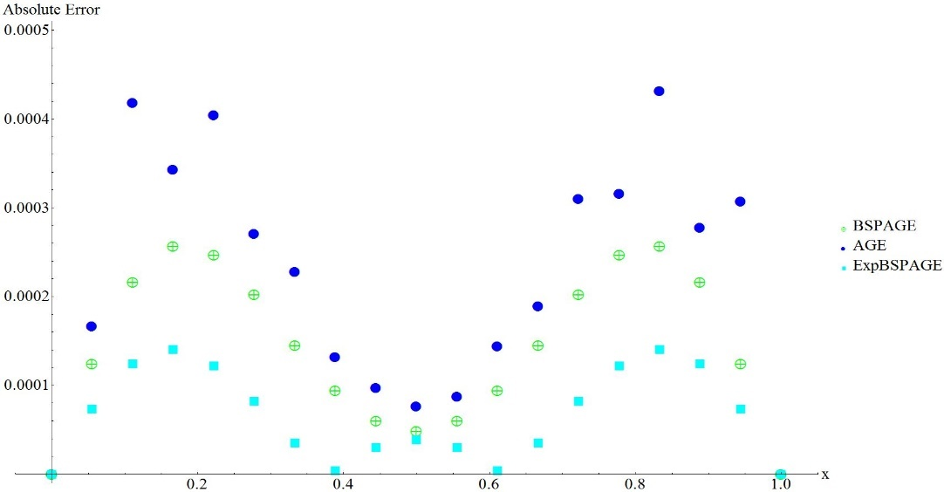
Figure 2. Absolute Error for Problem 1 for $m=17$.

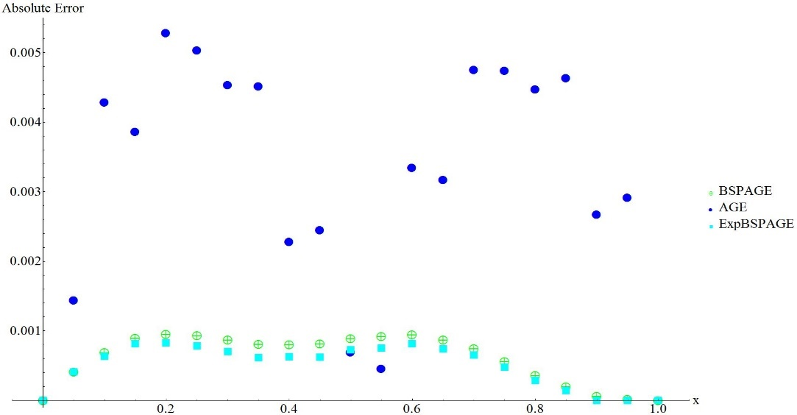
Figure 3. Absolute Error for Problem 1 for $m=19$.

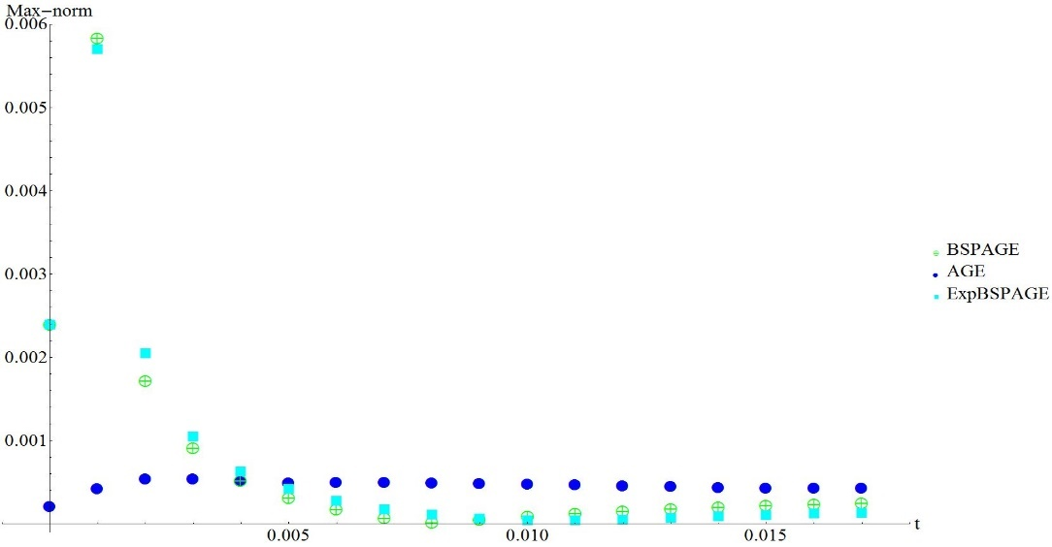
Figure 4. $Maxnorm$ for Problem 1.

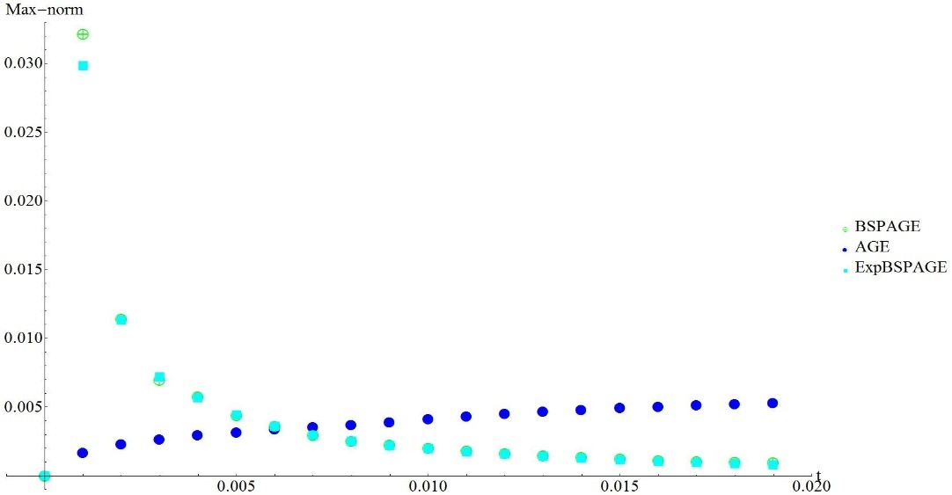
Figure 5. $Maxnorm$ for Problem 2.

CONCLUSION
In this study, ExpBSPAGE is formulated to solve heat equations. The ExpBSPAGE scheme was applied to two problems and the numerical results were found to be more accurate than those of AGE and BSPAGE in terms of $Maxnorm$ and $L_{2}norm$. Following these results, further studies will be made on the stability and error analyses of ExpBSPAGE.

References
- S. K. Njogu, “Heat Equations And Their Applications I," M. Sc. thesis, University of Nairobi 2009.
- D. W. Hahn, and M. N. Özisik, Heat conduction (John Wiley & Sons, 2012).
- M. S. Sahimi, “Numerical methods for solving hyperbolic and parabolic partial differential equations," Ph. D. thesis, Loughborough University 1986.
- N. I. Khadum, “The spline approach to the numerical solution of parabolic partial differential equations," Ph. D. thesis, Loughborough University 1988.
- D. J. Evans and N. I. Kadhum, International Journal of Computer Mathematics 63, 245–263 (1997).
- D. J. Evans and N. I. Kadhum, International Journal of Computer Mathematics 70, 751–771 (1999).
- R. K. Mohanty and M. K. Jain, International Journal of Computer Mathematics 86, 1556–1571 (2009).
- G. Joan, A. M. Ahmad, and M. I. A. Izani, Computers & Mathematics with Applications 62, 4492–4498 (2011).
- G. Joan, A. M. Ahmad, and M. I. A. Izani, Journal of Applied Mathematics 2012, (2012).
- N. A. I. Rosman, et. al, “B-spline alternating group explicit (BSPAGE) in solving heat equation", AIP Conference Proceedings 2184, 2019, pp. 060011.
- N. A. I. Rosman, et. al, “Solving heat equations using extended B-spline alternating group explicit", AIP Conference Proceedings 2138, 2019, pp. 030033.
- F. E. Merga and G. F. Duressa, Journal of Numerical Analysis and Approximation Theory 53, 279–297 (2024).
- S. Mangal and G. Vikas, Journal of Applied Mathematics and Computing 71, 3965–3995 (2025).
- U. M. Yusuf, et. al, Lafia Journal of Scientific and Industrial Research 3, 14–20 (2025).
- A. R. B. Abdullah, “The study of some numerical methods for solving partial differential equations," Ph. D. thesis, Loughborough University 1983.
- D. M. Young, (2014). Iterative solution of large linear systems. Elsevier.

