Keropok Lekor in the Digital Age: ERP Systems for Agile and Efficient Production Management
Faizah Aplop,^{1, a)} Nasyrul Adly Afandy,^{1, b)} Wan Ikhwan Wan Mohammad,^{2, c)}
and Izzat Roslan^{1, d)}
¹Institute of Oceanography and Environment, Universiti Malaysia Terengganu, Kuala Nerus, Terengganu, Malaysia. ²College of Computing, Informatics and Mathematics, UiTM, Kuala Terengganu, Terengganu, Malaysia
^{a)}Corresponding author: faizah_aplop@umt.edu.my
^{b)}Corresponding author: p5751@pps.umt.edu.my
^{c)}wanikhwan@uitm.edu.my
^{d)}haqimi150@gmail.com
Abstract. The surging demand for keropok lekor these days presents both immense opportunity and significant challenges for producers in Terengganu. To truly capitalize on this growing market and enable sustainable business expansion, an automated approach to operations and management is essential. Scaling up to meet increased production volumes while simultaneously upholding the cherished quality and efficiency standards becomes an uphill battle. ROMAns, and ERP-based system is developed to optimize keropok lekor business processes from end to end. It acts as the central nervous system of the entire operation, facilitating a seamless and instantaneous flow of critical information across all departments for keropok lekor company. From raw material procurement and inventory management to production scheduling, quality control, financial management, sales, and distribution, every single function is interconnected. This eliminates the silos that often plague traditional, manual processes, where data can be fragmented, inconsistent, and slow to disseminate. By integrating data and streamlining operations, a keropok lekor business can achieve remarkable efficiency. Real-time insights from production lines enable proactive adjustments, which helps to minimize waste and maximize output. Automated tracking of ingredients and finished products ensures optimal stock levels, preventing both shortages and overstocking. This comprehensive data analysis empowers management to make informed decisions, identify bottlenecks, and continuously refine their processes. In this paper, we will focus on production management, as it’s where an Enterprise Resource Planning (ERP) system has its most transformative impact. Specifically, we’ll examine how the ROMAns production module measures daily performance, calculates waste, and assesses the quality of both raw materials and finished products.

INTRODUCTION
Keropok lekor, a traditional Terengganu fish-based snack, holds cultural significance as both a local staple and tourist attraction, reflecting the state’s culinary identity. Made primarily from a blend of fish and sago flour, its unique chewy texture and crispy exterior have made it a favorite throughout Malaysia and in neighboring countries like Singapore, Indonesia, Brunei, and Thailand. Although traditionally sold at local markets and food stalls, the snack is now widely available in hypermarkets and online. The online marketplace and social media offer substantial opportunities for business growth for many and it has contributed greatly to the increase demand of keropok lekor from Terengganu throughout Malaysia as the market reach is increasing. Positive effects of these online platforms as significant digital marketing tools encourage keropok lekor business owners in Terengganu to invent and diversify their products with the goal to market and increase the sale of keropok lekor in a larger scale. Some of the innovations are selling keropok lekor in pre-packaged form and introduce different versions of keropok lekor by adding more flavors, textures and shapes to meet broader range of customers’ preferences.
A 2019 inspection report [1] by the Terengganu state government emphasized the importance of rural economic development by identifying key rural and agro-based industries with potential for growth and reinforcement. Among these, keropok lekor was singled out as the most promising fish-based product for commercialization. The report explicitly recommended aggressive marketing and promotion initiatives by local authorities to capitalize on its unique cultural value, growing domestic demand, and untapped export potential in regional markets. This strategic focus aligns with broader efforts to modernize traditional food industries while preserving artisanal production methods that contribute to rural employment and value-chain development. Since 2020, these efforts have contributed positively to Terengganu’s socioeconomic progress. According to [2], Terengganu’s GDP is primarily supported by three key sectors: agriculture (including fisheries), manufacturing, and services. Manufacturing represents the largest contributor, with oil and gas accounting for 40% of this sector’s output. Notably, the keropok lekor industry has emerged as another significant growth driver within manufacturing. Figure 1 has shown consistent growth of Terengganu’s GDP,
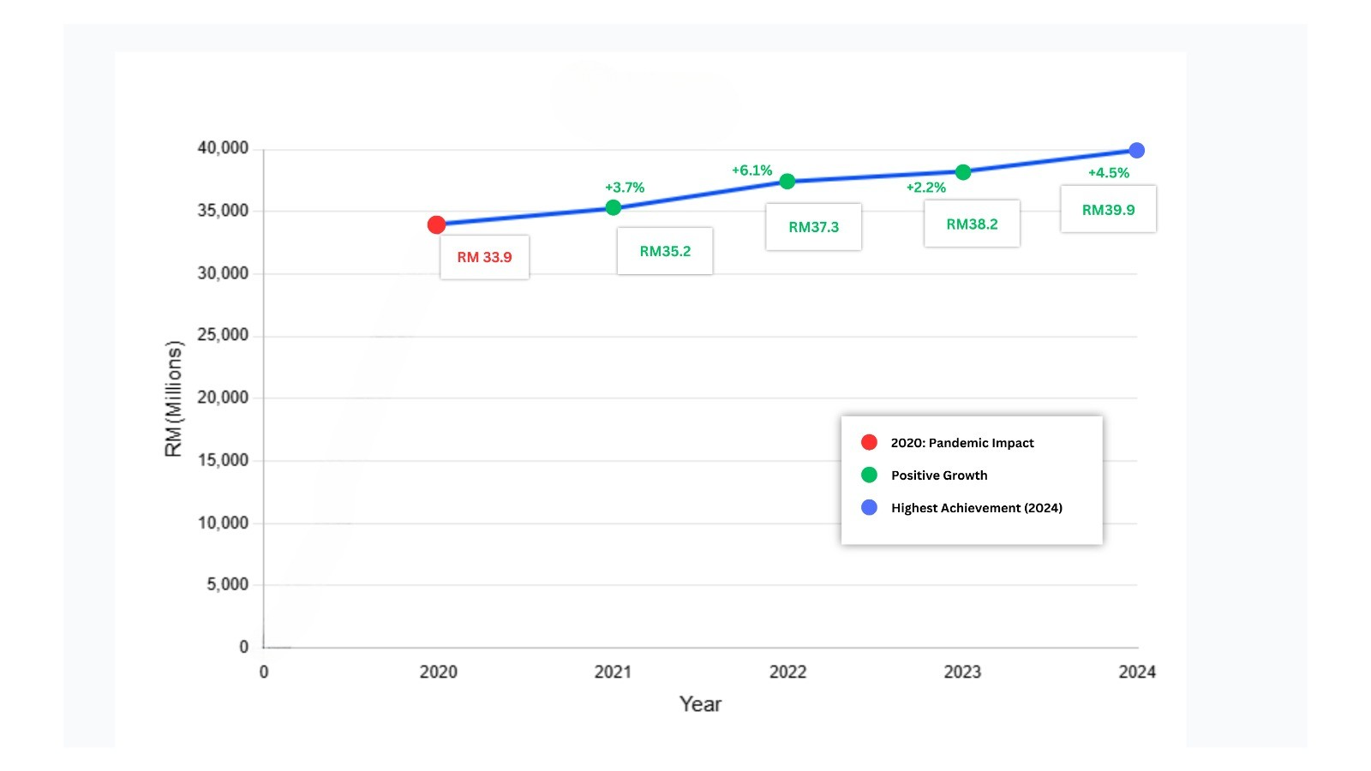
FIGURE 1. Terengganu’s GDP trend from 2020 – 2024.
rising by 4.5% in 2024 compared to the previous year and accumulating a total increase of 17.4% from 2020 to 2024.

Problem statement
As stated by [3], product innovation plays a crucial role in enhancing yield and expanding market reach, both domestically and globally. Like many other industries, the keropok lekor sector faces cyclical business conditions, compelling producers to continuously innovate in order to stay competitive. These innovations may involve improvements in taste, design, manufacturing processes, and equipment. By fostering comparative differentiation through unique features and exclusivity, innovation not only strengthens product sustainability but also captures customer interest. However, scaling production to meet rising demand, particularly through online platforms, presents challenges. Many keropok lekor producers still rely on traditional methods, which, as reported by [4], suffer from low efficiency and competitiveness. This persistence stems from the belief that manual processes preserve the snack’s authentic taste and cultural significance [5]. Consequently, production remains highly labor-intensive, with a hands-on approach to both manufacturing and distribution [6].
Herein lies the critical role of production management in balancing tradition with modernization. Strategic upgrades in equipment and processes, when implemented without compromising product quality, can simultaneously improve efficiency, reduce costs, and satisfy growing market demand. By thoughtfully integrating innovation with cultural authenticity, such production management approaches not only foster sustainable industry growth but also strengthen keropok lekor’s market competitiveness. To achieve operational stability and improved scalability, keropok lekor producers require targeted automated solutions that can streamline operations while preserving artisanal values, systematically enhance workforce skills and enterprise management, simplify production processes without sacrificing traditional characteristics, and enable smarter product marketing. Fundamental to this transition is the implementation of standardized processing protocols that ensure consistent quality while meeting evolving consumer expectations for food safety, nutritional value, and product authenticity, which are critical factors in maintaining keropok lekor’s cultural significance amid commercial expansion. To operationalize these standards, an Enterprise Resource Planning (ERP) system emerges as an optimal solution. As an integrated information management platform, ERP systems provide unified coordination of core business processes, real-time data integration across operational functions, and industry-agnostic adaptability for diverse manufacturing environments. This technological infrastructure enables producers to maintain traditional production values while achieving the efficiency and traceability required for market expansion.

Research Objective
An ERP system functions as a unified information platform, essentially an integrated software suite designed to seamlessly connect all core business operations across various departments, regardless of the industry sector [7]. According to [8], while ERP systems are widely adopted for document processing in business operations, their true value lies in optimizing enterprise-wide information management. Organizations implement these systems because their modular architecture provides function-specific solutions that enable efficient data centralization and cross-functional integration. To develop a tailored ERP system for the keropok lekor industry, a research collaboration was established with ROMA Food Industries Sdn. Bhd. (RFI), an SME specializing in keropok lekor manufacturing. This partnership enabled an in-depth understanding of operational challenges, current practices, production workflows, and business management needs. This comprehensive research led to the development of ROMAns, the first-ever ERP system specifically designed for keropok lekor manufacturers in Terengganu. ROMAns represents a significant leap forward, as it is the first system of its kind designed to address the unique operational challenges, production workflows, and business management needs of this industry in Terengganu. This marks a pivotal moment, providing local producers with a powerful digital tool to streamline operations, optimize production, and enhance overall business efficiency.

CHALLENGES IN KEROPOK LEKOR PRODUCTION
Similar to other food manufacturing enterprises, Terengganu’s keropok lekor producers encounter significant production challenges that require strategic solutions. These operational hurdles present themselves through several critical aspects of the manufacturing process. As fish flesh serves as the primary ingredient for keropok lekor production, supply shortages frequently occur, particularly during monsoon seasons and perennial floods that regularly affect Malaysia’s east coast states like Terengganu. The severe weather conditions prevent fishing activities, reducing catches by up to 50%. During these periods, producers are often forced to source fish from wholesalers, typically resulting in compromised quality [3]. Customer preferences present an additional operational challenge. As evidenced by [9] in their qualitative study of Terengganu keropok lekor producers, raw material selection critically influences consumer demand patterns. Their findings specifically highlight how sardine varieties (tamban and selayang) yield the most preferred sensory characteristics, establishing fish quality as a key determinant in market acceptance. However, shortages of these species have driven up their prices, which in turn has increased the cost of keropok lekor and other essential ingredients.
Another crucial challenges to the producers of keropok lekor is the very high turnover rate of production workers [10] [3], which are largely attributable to the volatile and unpredictable nature of market demand. These erratic consumption patterns create significant fluctuations in production workloads, directly affecting operational rhythms within manufacturing facilities. Peak demand periods subject production staff to significant operational stresses, including mandatory overtime and accelerated work paces to accommodate abrupt order surges [9]. This cyclical pressure contrasts sharply with demand troughs, where diminished production activity fosters workforce anxieties over job security and underutilization of skills, a duality that exacerbates employee turnover in the keropok lekor sector.
To maximize profitability amid rising market demand, keropok lekor producers must optimize their production capacity utilization. A case study by [11] on Maja Baroh Enterprise, a prominent SME in the keropok lekor industry demonstrates how strategic capacity expansion can enhance output. The study recommends modernizing production infrastructure, particularly replacing outdated equipment like boiling stoves, to implement lean manufacturing principles. Besides that, technological innovations like keropok lekor drying machines can help in enhancing business performance and reducing maintenance costs. Ultimately, this can minimize the production cost of keropok keping [12]. As for RFI, they leverage both traditional sun drying techniques and a custom-designed drying machine to optimize keropok keping production. In contrast to [12], their machine utilizes gas cylinder as its primary energy source, thereby minimizing operational expenses. Aligning with this approach, RFI has set an ambitious production target of 6-10 tons daily, requiring both equipment upgrades and process optimization to achieve scalable growth. However, all these machinery innovations to increase production yield does not have accurate data driven assessment on the production performance especially on the consumption of raw materials and supplies, labor allocation and quality control.

ROMAns: DATA-DRIVEN APPROACH TO PRODUCTION PLANNING AND SCHEDULING
The ROMAns ERP system architecture integrates five critical modules specifically engineered for end-to-end keropok lekor enterprise management: Human Resources (HR), Production, Finance, Sales, and Inventory. As depicted in Figure 2, this represents the refined framework developed through an iterative 24-month collaboration with RFI, incorporating four structured requirement gathering session with department executives and the CEO of RFI and four testing phases involving five hired programmers and RFI top management and executives. This paper specifically focuses on the Production module of the ROMAns system, as it serves as the operational nexus that critically governs three key determinants of keropok lekor business success, which are product quality consistency, manufacturing efficiency, and cost optimization. As the central driver of both profitability and customer satisfaction, this module’s performance directly impacts the entire value chain, from raw material processing to final product output.
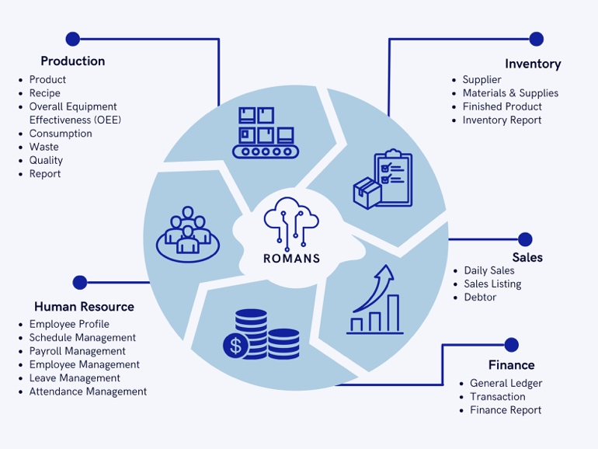

FIGURE 2. Refined version of ROMAns modules.

Production submodules

Our preliminary investigation identified seven critical submodules for Production Management in keropok lekor manufacturing, which are Product Profile, Recipe Management, Overall Equipment Effectiveness (OEE), Consumption Tracking, Waste Management, Quality Management, and Production Reporting. The workflow follows a logical hierarchy, beginning with product registration in the product profile. Users first input the finished product specifications and target pricing before documenting the associated recipe. ROMAns’ Recipe Management submodule serves as the foundation for RFI’s operations by standardizing production formulas for consistent product quality, enabling precise ingredient costing through accurate quantification, reducing material waste through optimized measurements, and synchronizing with inventory systems for real-time stock updates. This systematic approach to recipe documentation directly enhances cost control, operational efficiency, and ultimately, profitability across RFI’s keropok lekor production lines. Figure 3 presents the process flow for the Production module.
Production performance can be quantitatively measured using Overall Equipment Effectiveness (OEE), an industry-standard metric developed by Seiichi Nakajima in the 1960s. This powerful tool enables daily monitoring of manufacturing efficiency by tracking three critical factors: availability, performance, and quality. ROMAns will automatically calculate overall OEE percentage for keropok lekor production on daily basis using the following formula:

$\text{OEE\% = Actual}\frac{\text{Output}}{\text{Target}}\text{Output × 100\%}$ (1)
To determine the Target Output(TO), ROMAns will first calculates the Actual Hour (AH) using this equation:
$AH = PH - IH - RH - DT$ (2)
Where
PH= Production Hour, IH = Idle Hour, RH = Rest Hour, DT = Down Time
The Target Output (TO) is then calculated by multiplying the Actual Hour (AH) by the Total Manpower (TM) and the Rate Besen Per Hour (RBHR):
$$TO = AH x TM x RBHR$$  Therefore, the final equation to measure the OEE percentage using ROMAns is: | (3)
$$\text{OEE =}\frac{\text{AO}}{\text{AH × TM × RBHR}}\text{× 100\%}$$ | (4)

RFI’s production standards require each worker to process 1.8 besen (approximately 16 kg) of keropok lekor dough per hour. For instance, for a typical 8-hour shift accounting for rest periods, idle time, and equipment downtime across 12 production workers, the daily target output is calculated as follows:
8 productive hours x 12 workers x 16 kilogram/hour = 1536 kilogram of keropok lekor dough (5)
To calculate the OEE% for that day, let’s assume the actual output is 1,300 kilograms of keropok lekor dough. Based on this, the OEE% for that particular day is 84.5%, as shown in the equation below:
$\frac{\text{1500}}{\text{1536}}\text{× 100\% = 84.5\%}$ (6)

ROMAns will automatically calculate actual hour, target output and OEE based on the above formulae. Production manager can instantly see how efficient a production line is with automated tracking, which also gets rid of manual calculation errors. This benchmark enables RFI to monitor individual and team productivity, identify bottlenecks when targets are unmet, calculate raw material requirements precisely and schedule production to meet daily demand.
The consumption tracking submodule closely monitors the usage of raw materials, particularly perishable ingredients such as fish and tapioca flour, to optimize resource allocation and minimize waste. By analyzing real-time consumption patterns, the system enables precise cost calculations, dynamic pricing adjustments, and accurate profit–loss assessments. It also records waste for both raw materials and finished products, including defective items, by weight and percentage. Identifying and analyzing these waste patterns enhances inventory accuracy and overall production efficiency.
A dedicated quality management submodule establishes and documents product standards for keropok lekor. ROMAns automatically sends a warning message to management when high levels of material or product waste/defects occur. Customer feedback is regularly analyzed to drive product improvements. In the event of a quality issue, detailed records are maintained and investigated by the production manager. Corrective actions are then taken and reviewed by top management to ensure consistent product quality, which is vital for maintaining customer trust and loyalty.
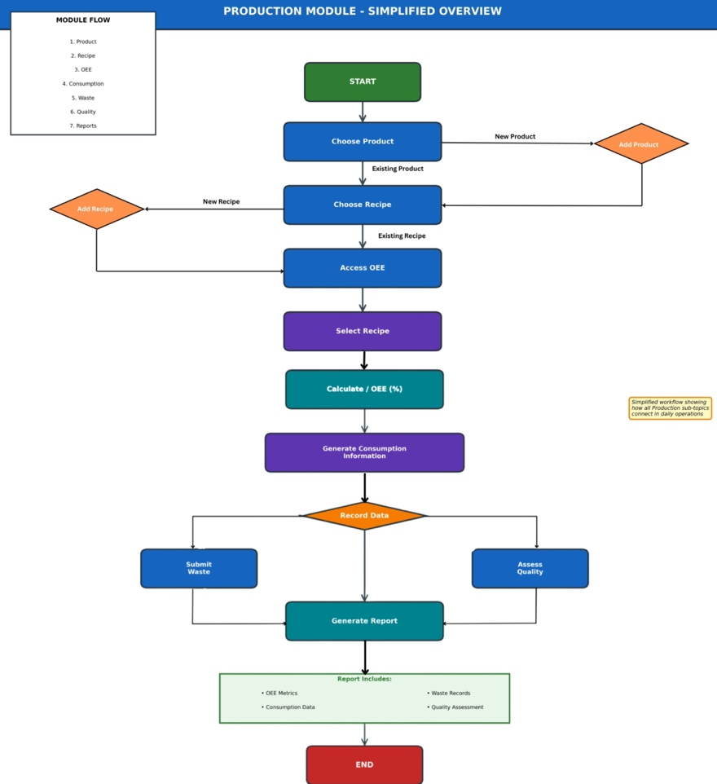

FIGURE 3. Production module simplified overview.

CONCLUSION
The Terengganu keropok lekor industry is at a pivotal point, balancing its rich cultural heritage with the demands of a rapidly modernizing market. This traditional snack, a cornerstone of Terengganu’s identity and economy, has seen its demand soar, thanks to online platforms and innovative product diversification. However, this growth has exposed significant challenges within the industry, primarily stemming from its reliance on traditional, labor-intensive production methods. While these artisanal processes are valued for preserving the snack’s authentic taste, they often lead to inefficiencies and hinder the scalability required to meet broader market demands. To navigate this duality, a strategic shift toward modernization without sacrificing authenticity is essential. The development and implementation of an Enterprise Resource Planning (ERP) system, such as ROMAns, represents a critical step in this direction. This custom-built system for keropok lekor manufacturers is designed to streamline operations, optimize production workflows, and centralize data management. By enhancing production management and operational stability, the ROMAns system enables producers to scale their businesses effectively, capitalize on growing domestic and international markets, and contribute more significantly to Terengganu’s socioeconomic progress. This approach aligns with government initiatives to commercialize and promote rural industries, transforming keropok lekor from a regional delicacy into a globally competitive product. However, there remains room for improvement within ROMAns, particularly in automating business analytics, an area where Artificial Intelligence technologies can play a crucial role. Our next goal is to integrate AI-driven analytics into the system, enabling ROMAns to become a smarter, more adaptive platform that continuously supports data-driven decision-making and sustainable business growth. Ultimately, by thoughtfully blending tradition with modern technology, the keropok lekor industry can continue to thrive, preserving its cultural significance while achieving new levels of commercial success.

ACKNOWLEDGMENTS
This work is funded by Universiti Malaysia Terengganu (UMT) and ROMA Food Industry Sdn Bhd (RFI) under the Private Partnership Research Grant (PPRG), Vot no. 55443.

REFERENCES
- Kerajaan Negeri Terengganu, “Kajian rancangan struktur negeri Terengganu 2050 (kajian semula): Laporan pemeriksaan,” Tech. Rep. (Kerajaan Negeri Terengganu, 2024).
- Jabatan Perangkaan Malaysia, “State socioeconomic report Terengganu,” Tech. Rep. (Jabatan Perangkaan Malaysia, Kementerian Ekonomi Malaysia, 2024).
- N. Mansor, Keropok Lekor Terengganu. Terengganu-Fischwürste (Penerbit UMT, Kuala Nerus, 2019).
- M. Omar, N. M. Adzahan, H. M. Ghazali, R. Karim, and M. S. B. Karim, International Food Research Journal 18, 117–124 (2011).
- W. N. N. Wan Md. Hatta, Art and Design Studies 27, 1–6 (2015).
- M. R. Abu Bakar and M. G. Hanafiah, Jurnal Wacana Sarjana 2, 1–7 (2018).
- U. Rahardja, APTISI Transactions on Management 7, 152–159 (2022).
- L. E. L. Barna and V. A. Enachescu, “ERP system application in the education environmental,” in European Proceedings of Educational Sciences, Vol. 5 (2023) pp. 537–542.
- A. S. Suhaimi, W. I. M. Wan Lokman, W. A. M. Wan Abdullah, and N. A. Nik Ariffin, Jurnal Sejarah Lisan Malaysia 5, 280–300 (2021).
- F. Aplop, “Issue and challenges in manufacturing keropok lekor post pandemic,” Personal interview with Mohd Ismail Abu Bakar (2023), ROMA Food Industries Sdn. Bhd.
- F. Ayob, M. K. A. M. Ariffin, and S. Sulaiman, “Development of boiling stove for lekor ball’s production: Local industries (SME),” in Proceeding International Multidisciplinary Conference (IMC 2022) (2022) pp. 239–250.
- M. S. Z. M. Suffian, S. Mohamaddan, A. M. A. Abang Mohamad Mohtar, and M. N. Leman, “Modal analysis of keropok keping drying machine,” in IOP Conference Series: Materials Science and Engineering, Vol. 1062 (2021) p. 012004.

