Framework of Academic Analytic Dashboard For Higher Education Decision Making
Robiah Arifin^{1, a),} Mohd Nordin Abdul Rahman^{2,} and Zarina Mohamad ^{3, b)}
¹Infostructure and Network Management Centre, Universiti Sultan Zainal Abidin, 21030 Kuala Nerus, Terengganu, Malaysia.
^{2,3}Faculty of Informatics and Computing, Universiti Sultan Zainal Abidin, 22200 Besut Campus, Besut, Terengganu, Malaysia.

^{a)} Corresponding author: robiah@unisza.edu.my
^{b)}mohdnabd@unisza.edu.my, zarina@unisza.edu.my
Abstract. Higher education institutions play a crucial role in producing competitive and talented graduates who contribute to the well-being, development, and prosperity of the nation. Therefore, it is essential for these institutions to place strong emphasis on ensuring governance efficiency. Efficient governance encompasses various aspects, including management, financial administration, and the provision of facilities. To ensure that these elements contribute effectively to the overall management of higher education institutions, the optimal use of data must be prioritized and implemented. This research aims to develop an academic analytics dashboard designed to forecast student and staff intake based on various data domains, including student information, staff records, publications, research output, and financial data. The result from the analytic process is presented in a visualization using a dashboard and a business intelligence tool. To achieve these objectives, the study incorporates several tools and technologies, including business intelligence tools, application programming interfaces (APIs), single linear regression, and forecasting techniques.

INTRODUCTION
Higher education institutions play a pivotal role in producing competitive graduates who are capable of contributing to the development and advancement of the nation. Therefore, it is imperative for these institutions to possess efficient and effective governance systems.
However, despite having large volumes of institutional data including student information, staff records, financial data, research outputs, publications, and teaching and learning data. These data assets are often not fully utilised in a structured, timely and meaningful manner. The problem is that decisions in many universities are still made based on assumptions, ad-hoc reports, fragmented spreadsheets, and siloed systems. This leads to delayed insights, reactive decisions, and difficulty in supporting strategic planning.
The efficiency of governance within higher education institutions can be significantly enhanced through the systematic utilization of data and information. When institutional data is integrated, analysed, and presented effectively, it can support administrators in making informed decisions, formulating policies, planning strategically, and generating accurate forecasts. Various approaches have been adopted internationally to harness the potential of data in university management, for example academic analytics, interactive dashboards, and modern visualization tools.
Therefore, there is a need to develop a centralized and intelligent analytical solution that can transform raw data into actionable insights for decision makers.
Thus, this research aims to develop an academic analytic dashboard to support decision-making processes and strategic planning. To achieve this, the research applies machine learning algorithms and visualizes the results using business intelligence tools. The research places strong emphasis on data quality and data utilization, because data plays the primary role in enabling accurate, transparent and evidence-based decision-making within universities.

LITERATURE REVIEW
In the education domain, the analytics can be divided into three categories, including Learning analytics, Education Data Mining, and Academic Analytics [1]. Learning Analytics (LA) focuses on enhancing teaching and learning processes. It involves the collection, analysis, and reporting of student data about learners and their contexts, with the primary aim of understanding and optimizing both learning and the environments in which it occurs [2].
Then, Educational Data Mining (EDM) is centered on the use of educational data to gain deeper insights into student behavior and learning patterns. EDM is a technique to develop an algorithm using the mining of a dataset from the education environment [3]. EDM seeks to extract meaningful patterns from large datasets in order to better understand how students learn and to inform the development of personalized educational interventions
Also, the Academic Analytics (AA), on the other hand, emphasizes the use of educational data to support strategic decision-making at the institutional level. AA aims to improve the educational academic management by using various data, including students, staff, and finance [4]. It is employed to address academic challenges such as student retention, improve marketing strategies, and enhance overall institutional effectiveness.

Academic Analytic
Academic analytics is a process that collects, analyses, and visualizes educational data, including student, staff, financial, research, and management data to generate institutional insights and improve decision-making for management in an academic institution environment [5]. Academic analytics aims to benefit educational stakeholders and students. However, many obstacles exist, including the data, technology usage, and expertise.

The main obstacle is the data. To execute the academic analysis, the data must be clean and valid because the quality of data impacts the result and decision-making process [6]. Additionally, the quality of data is an essential fundamental to achieving the conclusion and result [7]. The data must be trustworthy and meaningful. To ensure the quality of data is perfect, the data cleaning process is needed.

Data Visualization
The result of academic analysis is perfect for presentation in a visualization style, because the visualization capable to present in various style. Visualization is a tool that provides the interface to present information from the dataset through the analysis process [8]. The data visualization is a powerful tool to support the analysis of data and financial decision-making [9]. Data visualization allows the user to manipulate and transform the data into information. Then the information can be used in the decision-making process and strategic planning.

Manipulating data and analytics is able to aid management in making decisions and in strategic planning [10]. The result from the analytic process able to present used business intelligence tools. Business intelligence is a technology that is able to store, analyze, and provide access to manipulate the data for decision-making purposes [11].

IMPLEMENTATION of Academic Analytics
To realize the effectiveness and efficiency of higher education institution management, the implementation of academic analytics is able to support and realize it. This research conducted a few steps and processes to implement the academic analytics, including data integration, cleaning, and visualization. Figure 1 depicts the framework for implementing the academic analysis dashboard.

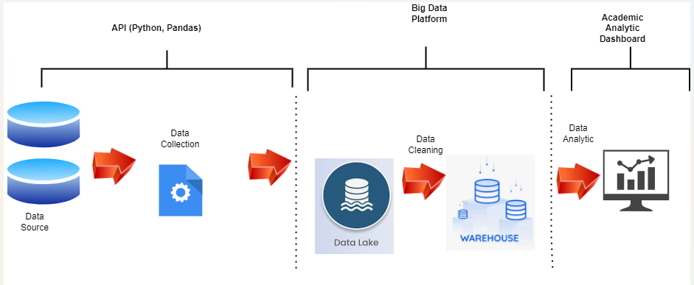
Figure 1. Framework to develop the academic analytics dashboard

Regarding Figure 1, the framework to develop the academic analytic dashboard consists of three phases, including data collection, data cleaning, and data analytics. Each phases implement the various methods to support the process of the phase. Data collection focused on collecting and integrating data from any resources. Then, data cleaning focused on cleaning the data from the data lake. Lastly, data analytics focuses on using the data to create data analysis, forecasting, and visualization.

Data Integration and Collection
This phase aims to collect the data from any resources and databases. These data will be stored in the data lake. Data collection includes students, staff, research, publication, and finance data. The process of collecting this data uses the application programming interface (API) technique. The API that developers use is Python. Python is a programming language that can support the API function.

Before the API was developed, the target of the data had to be identified, to ensure the transaction of the API runs smoothly without any interruption. This phase collects the data directly from the production database, without considering the data cleaning, data emptiness, or data validity. Additionally, the integration and collection of data into a data lake process running on a schedule that is set up. This framework allows setting up the schedule based on the situation and is able to change the schedule at any time.

Data Cleaning and Verification
The second phase of this framework is data cleaning and data verification. This phase focused on cleaning the data before moving to the data warehouse. Before the data cleaning process is implemented, the requirements must be identified, and the definition of operational data (OD) must be clearly decided. After the requirement data was identified, the data cleaning process can proceed.

To execute the data cleaning process, a smart algorithm will be developed using Python as a programming language. The smart algorithm consists of the requirements, conditions, and rules of OD. Then the smart algorithm will filter the data, only data that fulfills the requirement, condition, and OD is able to move to the data warehouse.

Academic Analytic Dashboard
The last phase in this framework is to develop the data analytics dashboard. Data from the data warehouse will be implemented in the analytic process. A single regression technique was used to implement an analytic dashboard. The result is visualized using business intelligence tools. This research executes the forecasting for staff intake, student intake, budget for staff salary, and publication. Table 1 shows the data used to execute the academic analysis.

Table 1. Data for academic analytic dashboard
Academic analytic | Data | Field
Staff intake | Staff | Start date, position, status, department, keyid
Student intake | Student | Registration date, department/faculty, program/course, semester, keyid
Salary | Salary, staff | Staf position, staf start date, staf salary increament, keyed, department, staf status

Regarding Table 1, these data were used to run and execute the academic analytic. Then the result is visualized in the dashboard. Figures 2,3, and 4 showed a few results based on academic analytic using the data at Table 1.

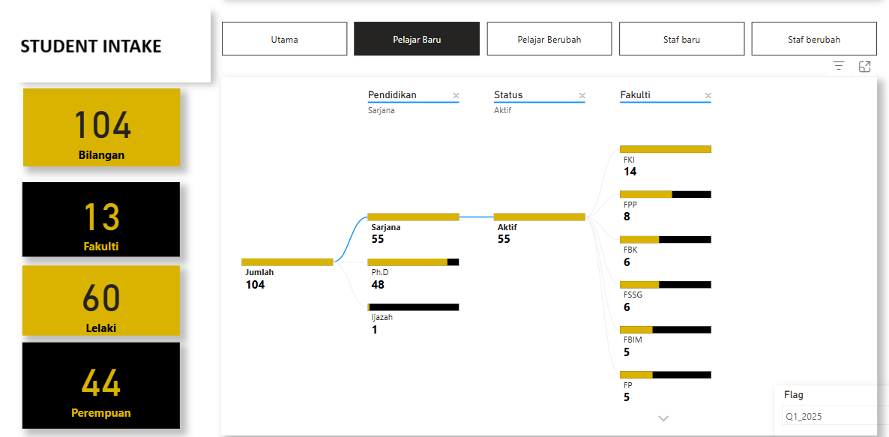
FIGURE 2. Dashboard for student intake

Referring to Figure 2, a total of 104 students were registered, representing 13 faculties. Of this total, 60 were male students, while 44 were female students. At the education level, the student intake comprised 55 Master’s students, 48 PhD students, and 1 Bachelor’s degree student.

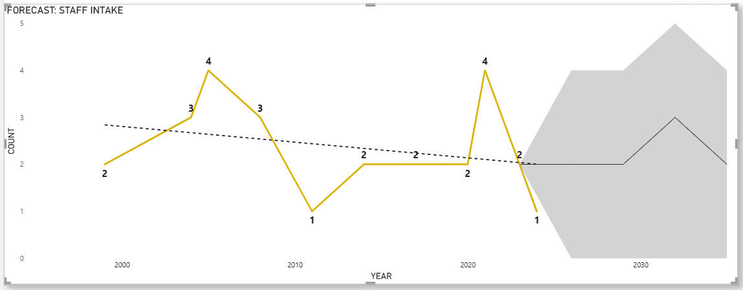

Figure 3. Forecasting staff intake dashboard

Meanwhile, Figure 3, depicted the forecasting results for future staff intake. The forecasting projection was performed up to the year 2035. Based on the forecasting results, the staff intake is expected to continue increasing due to several contributing factors, including the need to reduce the student and staff ratio gap, as well as to account for staff attrition.

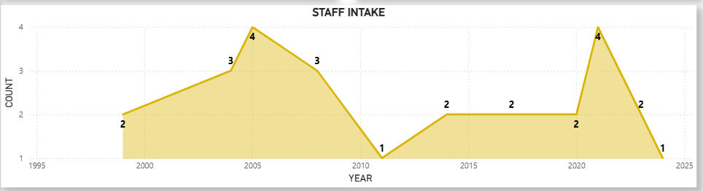
Figure 4. Staff Intake Dashboard

Finally, Figure 4, illustrates the trend of staff intake from the year 2000 to 2025. The staff recruitment pattern appears inconsistent, as it is influenced by various factors, including financial resources allocated for salary expenditure. As shown in Figure 4, the years 2005 and 2023 recorded the highest staff intake, with four new staff members each year. In contrast, the lowest intake was observed in 2011, with only one new staff member recruited.

Regarding these results at Figure 2, 3 and 4, the bursary department is able to forecast the budget it will spend to hire the staff for five years. Then the higher education institution can also predict the publications that will be published for five years. Also, can estimate the intake of students for five years, considering the total academic staff.

CONCLUSION
Academic analytics are able to support higher education management. The data, including staff, students, research, and finance, is important to execute the academic analytics. To execute the academic analytics, it needed to implement a few tools and methods. This research implements the API to collect the data, then a smart algorithm to execute the data cleaning. After that, the single regression technique was implemented to create the prediction model for staff intake and student intake.

However, this study faced several challenges, primarily related to data cleanliness and data quality. The quality and accuracy of data are largely dependent on the end-users who input the data into the system. Thus, cultivating awareness of the importance of data quality and data hygiene among users is crucial to ensure that academic analytics outcomes can be reliably used by the university for decision-making purposes.

Lastly, the business intelligence tools were implemented to visualize the result. In future planning, we plan to implement the multiple linear regression. Then the result will be compared between single linear regression and multiple linear regression.

ACKNOWLEDGEMENTS

We wish to extend our sincere gratitude to the Center of Research and Innovation Management (CREIM) at UniSZA for their invaluable financial support towards the publication. Our heartfelt appreciation also goes to all team members from UniSZA, including Pn. Robiah Arifin, the staf at Infostructure and network management center for the idea and technical development behind the project, and Prof. Dr. Mohd Nordin bin Abdul Rahman and Dr. zarina binti Mohamad as her supervisor for the conceptual and technical writing,

References
- T. Susnjak, G.S. Ramaswami, and A. Mathrani, International Journal of Educational Technology in Higher Education. 19(1), (2022).
- G. Ramaswami, T. Susnjak, A. Mathrani, and R. Umer, Technology, Knowledge and Learning. 28(3), (2022).
- S. Batool, J. Rashid, M.W. Nisar, J. Kim, H.-Y. Kwon, and A. Hussain, Education and Information Technologies. 28(1), (2022).
- A. Llauró, D. Fonseca, E. Villegas, M. Aláez, and S. Romero, International Journal of Interactive Multimedia and Artificial Intelligence. (2023).
- Tsai, Y. S., Singh, S., Rakovic, M., Lim, L. A., Roychoudhury, A., & Gasevic, D, Charting design needs and strategic approaches for academic analytics systems through co-design. In: 12th international learning analytics and knowledge conference. (2022), 381-391.
- S. Iqbal, S. Moniz, F. Bennin, G.A. Garavito, R. de Koning, R. Yu, and C. Vindrola-Padros, Research Involvement and Engagement. 11(1), (2025).
- I. Finocchi, A. Martino, F. Ranjbar, and Blerina Sinaimeri, Scientific Data. 12(1), 311–311 (2025).
- D. Streeb, M. El-Assady, D.A. Keim, and M. Chen, IEEE Computer Graphics and Applications. 41(2), 17–22 (2021).
- Patel, N., Shah, H., & Mewada, K, (2023), arXiv:2403.18822.
- M.M. de Medeiros, and A.C.G. Maçada, Management Decision. 60(4), 953–975 (2021).
- J Mark Munoz, in Global Business Intelligence, (New York Routledge, 2017), p. 67-81.

