Leveraging Big Data Analytics to Advance Business Intelligence: An Innovative Direction

Mohamed Elhoseny^{1,a)}, Noura Metawa^{1,b)}, Adam Marks^{1,c)} and Yousef Damra^{1,d)}
¹University of Sharjah, UAE

^{a)}Corresponding author: melhoseny@sharjah.ac.ae
^{b)} nmetawa@sharjah.ac.ae
^{c)} amarks@sharjah.ac.ae
^{d)} ydamra@outlook.com
Abstract. In recent years, data growth has changed how organizations operate. Incorporating big data analytics (BDA) into business intelligence (BI) is now essential to improving strategic decision-making. Hence, this study aims to conduct a review of the existing literature on big data analytics for business intelligence. In addition, it provides a synthesis of the challenges organizations face using BDA with BI and provides possible solutions. A qualitative approach is employed, based on a review of academic articles published. This study contributes to the literature by providing an overview of BDA applications in BI. It offers practical insights for organizations and improves our understanding of the role of data analytics in business intelligence. It also addresses a gap in the literature by linking challenges to actionable solutions.

INTRODUCTION
Since the advent of the Fourth Industrial Revolution (4.0), a wide range of disruptive technologies has transformed traditional systems, and new business models have emerged across all sectors [1]. Business Intelligence (BI) and Big Data Analytics (BDA) have contributed directly to the decentralization of data-based decisions [2]. Business Intelligence refers to the process of extracting insights from information about businesses and marketing, and using this information to make strategic decisions that enhance firm development and marketing [3]. Academics and businesses have become increasingly interested in business intelligence. It has become a marketing strategy to enhance e-commerce, business performance, and information quality [4], [5].
BI is primarily intended to help managers make informed and intelligent decisions, which creates a powerful competitive advantage for a company. Furthermore, sustainable and socially responsible business practices can be established and observed through business intelligence [6]. Yet, as big data technologies develop rapidly, BI faces new challenges and opportunities. The Internet and advancements in computing enable the collection of structured, unstructured, and complex data, creating new opportunities for business intelligence [7]. Data of this magnitude and complexity has given rise to the concept of big data analytics. Big data analytics refers to the collection, organization, and analysis of large amounts of data to identify patterns and provide insights [8].
Big data analytics has become a crucial technique for companies looking to gain a competitive advantage by uncovering hidden information [9]. The use of big data analytics for data-driven decision-making is increasing across industries to achieve desired business results. The integration of big data analytics into business intelligence has become increasingly popular in recent years, as it offers tremendous business opportunities. In the era of big data analytics, business intelligence will play an increasingly crucial role in strategic decision-making, enabling organizations to make informed decisions and gain a competitive advantage over their competitors. The use of big data analytics has become increasingly relevant for businesses to make strategic decisions in real-time, manage supply chain risk, and enhance customer satisfaction [7]. This study aims to contribute to the literature by providing a structured overview of how big data analytics can be used to enhance business intelligence.

LITERATURE REVIEW
Big data analytics and business intelligence research have experienced rapid growth over the past few years. Recently, big data has become popular, but business intelligence has been around for decades. Business intelligence refers to the integration and analysis of data resources that support decision-making within an organization [10]. It is the process of collecting raw data from various sources, analyzing it, transforming the data into valuable information, providing the information in a timely and expected manner to users, regulating the flow and sharing of information, and enforcing access, authorization, and authentication controls to ensure security [11]. BI has proven essential for organizations to gain a competitive advantage in the global marketplace. It has been recognized as an essential method for enhancing their performance. Consumers expect businesses to provide faster, more efficient services as the world changes rapidly. Keeping up with consumer expectations is crucial for a company's competitiveness. Staying up to date with trends and developing technologies will increase the need for business intelligence systems.
Moreover, data generation is increasing, and processing it in a timely and resource-sufficient manner has become increasingly challenging. The data are not currently well-structured to be processed with traditional data processing tools. It is essential that organizations find methods and tools specifically designed for processing big data, enabling them to maximize their value. Hence, big data analytics has become a key competitive advantage tool for organizations [12]. Big data analytics (BDA) refers to the application of various analytics methods to derive descriptive, predictive, and prescriptive insights from diverse big data sources [13]. It involves statistical analysis, visualization, and data management tools for uncovering hidden trends, correlations, and valuable insights from big data. By utilizing BDA, organizations can enhance operational performance, broaden revenue streams, and gain a competitive edge. Aligning big data analytics with business intelligence provides a new avenue to businesses.
When organizations collect unprecedented amounts of data and information, their ability to analyze and utilize big data is vital in today's marketplace [14]. Big Data Analytics plays a crucial role in transforming business intelligence, which contributes to informed organizational decision-making. For instance, Sun et al. (2018) examined how big data analytics services can enhance and improve business intelligence by proposing a Big Data Analytics Service-Oriented Architecture (BASOA) [5]. The authors advanced their prior terminology of big data analytics to develop another layer of technology that included data warehouse, data mining, machine learning, visualization, and optimization. Moreover, the article examined temporality, expectability, and relativity as characteristics of intelligence in BI. In support of the BASOA model, a survey of 71 IT managers reveals that structured analytics services can enhance organizational intelligence and facilitate informed decision-making. Their research also emphasized that big data analytics as a service (BAaaS) is an increasing area of attention in the modern era's data-rich environment.
Similarly, Niu et al. (2021) developed an Optimized Data Management using Big Data Analytics (ODM-BDA) framework to improve organizational business intelligence and decision-making [3]. The authors highlighted the need for a cloud-based analytics infrastructure. They proposed a model that encompasses customer behavior prediction, correlation-based clustering, and simulation analysis to measure its accuracy and efficiency. Using actual positive rates, delays, and error rates, and evaluating the framework's performance, they discovered that ODM-BDA performed substantially better in terms of accuracy and efficiency than traditional BI systems. They reported accuracy rates of 96% and strong predictive capabilities, reinforcing the role of big data analytics in improving business operations and strategic-level decisions.
Furthermore, Ram et al. (2016) examine the impact of big data analytics on business intelligence in China using data from social media platforms [7]. They employ semi-structured interviews involving IT and business personnel. The authors identify key findings: Big data analytics enhances business intelligence by utilizing real-time data to enable companies to make informed decisions; data analysis helps identify customer sentiment, which can inform pricing or customizable product offerings, identify market opportunities, and establish a basis for personalization. However, the authors also highlight significant challenges, including the privacy and security of the data, as well as the need for an appropriate analytics infrastructure that can be developed to address analytics securely.

Challenges of Big Data Analytics in Business Intelligence
In today's competitive and dynamic business environment, leveraging big data analytics is crucial for gaining a competitive edge and making informed decisions. Organizations are beginning to realize that the information extracted from Big Data analytics can improve the quality of their business intelligence. However, utilizing the power of big data can be challenging due to several obstacles. Understanding and addressing these challenges is crucial for organizations that utilize big data analytics. Due to the rapid growth of big data technologies, business intelligence faces new challenges [15].
One of the significant challenges related to big data analytics for business intelligence is the security and privacy concerns associated with the sensitive nature of the information [16]. The use of big data, which encompasses heterogeneous data collected from various sources, remains a target for hackers [7]. Secure business intelligence implementations are highly critical in industries such as finance, where transactional data is analyzed for business insights [17]. Moreover, there are no clear regulations protecting privacy, as big data analytics is still a relatively new and developing field. As a result, the public may lose trust in big data analytics [3]. Effective data visualization remains a significant challenge in big data analytics and business intelligence. Visualization involves communicating analytical findings clearly and intelligibly to facilitate effective decision-making [18]. As big data continues to grow in volume, drawing insights becomes increasingly challenging, primarily due to the lack of scalable visualizations. As the Big Data landscape expands in volume, velocity, and variety, the quality of data remains a concern for business intelligence [19]. Due to the diversity of data sources, conventional data quality assessment methods may be insufficient. The validity of business intelligence insights can be significantly affected by inaccurate, inconsistent, and incomplete data [20]. Business intelligence systems rely heavily on data. High-quality data is crucial for gaining valuable and accurate insights into a company's business. A comprehensive approach is required to address data quality concerns.
Moreover, given the pace of advancements in big data technology and business intelligence, there is a shortage of skilled professionals [17]. It is challenging to find skilled analytics professionals. The demand for hiring qualified analytics professionals has increased, and the talent competition is intensifying. It becomes challenging to leverage a company's business intelligence when there is no team of qualified individuals capable of handling the complexity of big data analytics. In business intelligence, adequately storing large amounts of data is challenging. Experts have stated that a large percentage of global information lies within vast, unstructured big data sets [21]. Although big data is generally considered valuable to growing organizations, current technologies focused on storage cannot keep up with the rapid volume of big data due to the limited number of storage devices. Conventional storage holds around four terabytes of data per disk, while big data can reach Exabytes, requiring thousands of disks to store [22].

METHODOLOGY
The integration of big data analytics and business intelligence was examined through a structured review of peer-reviewed literature published between 2019 and 2024. A comprehensive search was performed in the Scopus database using keyword combinations related to big data analytics, business intelligence, and studies that addressed both topics jointly. The search was limited to final-stage publications, written in English, and classified as journal articles, review papers, book chapters, or conference papers. These criteria ensured the inclusion of recent and relevant academic contributions to the field.

Proposed Solutions to Overcome Big Data Analytics Challenges in Business Intelligence
To mitigate any security and privacy concerns associated with big data analytics, organizations should develop a solid data governance framework that ensures sensitive data is protected, improves compliance with regulations, and enhances security [17]. Organizations must implement proper security protocols to minimize data breaches and unauthorized access by applying end-to-end encryption [23]. When addressing visualization issues, organizations should assess the use of specialized visualization tools such as Tableau, Power BI, and QlikView. These visualization technologies enable the organization to present complex data sets in a way that stakeholders can easily conceptualize [18]. Regarding challenges associated with data quality, organizations should adopt holistic approaches that incorporate advanced data validation strategies, continuous monitoring, and integration strategies to enhance data accuracy, consistency, and completeness [19]. It is essential that quality checks are incorporated into the business intelligence workflow to ensure data integrity.
These approaches can ensure that enterprises can improve decision-making based on the validity, accuracy, and consistency of their business intelligence insights. Given the shortage of skilled workers to work with big data, it is vital that organizations continue to invest in talent development and training opportunities that enhance analytics skills and capabilities to oversee a large and complex big data ecosystem [17]. This could include the establishment of data forces that would have formally recognized and product-driven training that guarantees employees will have the capabilities to use analytics and knowledge management. In relation to storage problems, organizations need to consider feasible storage solutions that allow them to scale using cloud computing, distributed file systems, or NoSQL databases, which can be used to expand and remain flexible in storing massive amounts of big data [22]. These solutions can help to make data more readily accessible while still allowing organizations to grow their storage over time as their data grows.

Proposed Framework
To strengthen the conceptual foundation of the proposed framework, this study incorporates the Resource-Based View (RBV), which posits that organizational performance is contingent upon an organization's ability to exploit valuable, rare, inimitable, and non-substitutable (VRIN) resources [24]. RBV has been applied in the context of big data analytics, as evidenced by research that demonstrates data quality, analytic tools, BI systems, and human capabilities constitute strategic resources that support decision-making and competitive advantage [25]. Integrating RBV into the framework supports our findings on how BI solutions serve as capability-enhancing resources that mitigate the respective challenges of BDA, such as privacy, visualization, and data governance, thereby improving business intelligence outcomes. Based on a comprehensive review of the challenges and solutions in big data analytics for business intelligence, this paper proposes the framework presented in Fig. 1.

Big Data Sources
(Structured, Semi-Structured, Unstructured)
Challenges

Privacy Concerns
Visualization Issues Challenges

Data Quality Issues
Skilled Professionals
Storage Limitations
Solutions

End-to-end encryption
Power BI and Tableau

Advanced data validation strategies
Talent development programs
cloud computing and NoSQL databases
Outcomes & Benefits

Enhanced decision-making
Sustainable competitive advantage
Improved organizational performance
Figure 1. Proposed Framework.

ANALYSIS

Time Trend of Publications
Figure 2 shows the publications from 2020 to 2024. The data show that both BDA and BI have seen a steady increase in publications for the last five years. Further, BDA publications have always outnumbered BI publications in all measured years, suggesting that BDA is a larger area focusing on data-driven research. BDA and BI publications are not much larger, suggesting that we are still seeing the emergence of integrated studies, and the studies are gaining relative momentum.
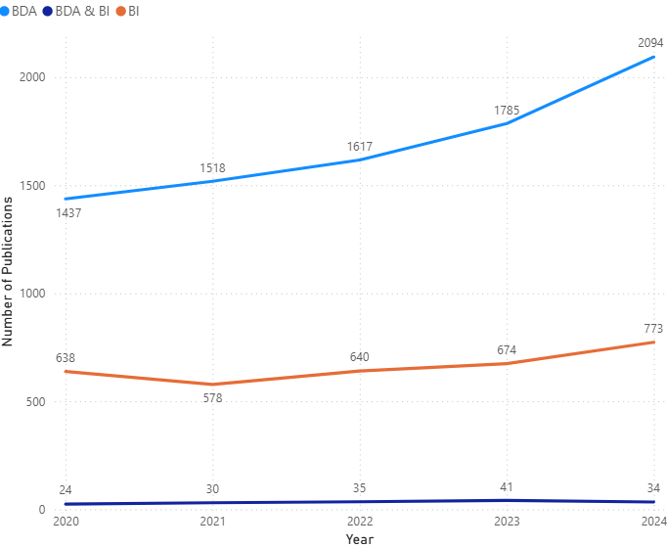
Figure 2. Time Trend of BDA and BI.

Publication Type
Table 1 presents the number and type of documents reviewed. The three types of documents and their respective characteristics relate to BDA, BI, and BDA & BI. In the BDA documents reviewed, journal articles represent the largest number of documents reviewed (43.20%), followed by conference papers (32.68%) and book chapters (15.71%). Conference papers are the largest share of BI documents (42.96%) and journal articles (40.21%). The BDA & BI documents reviewed relied almost entirely on conference papers as the largest type of document (43.90%), followed by journal articles (31.10%).
TABLE 1. Publication Type.
Document type | BDA |  | BI |  | BDA&BI
 | Number | % | Number | % | Number | %
Article | 3651 | 43.20% | 1328 | 40.21% | 51 | 31.10%
Conference Paper | 2762 | 32.68% | 1419 | 42.96% | 72 | 43.90%
Book Chapter | 1328 | 15.71% | 394 | 11.93% | 26 | 15.85%
Review | 506 | 5.99% | 67 | 2.03% | 5 | 3.05%
Book | 204 | 2.41% | 95 | 2.88% | 10 | 6.10%

Country and Subject Category
According to Table 2, India has the highest publication output for BDA, BI, and BDA & BI, with the US, China, and the UK following. These numbers indicate a wide engagement in research from both emerging and developed economies. Figure 3 shows that most studies for BDA & BI were in Computer Science and Engineering. This shows how BDA and BI cover a wide area of research and are thus relevant to both technical and managerial domains.
TABLE 2. Country.
Country | BDA |  | Country | BI |  | Country | BDA & BI
 | Number | % |  | Number | % |  | Number | %
India | 2475 | 33.95% | India | 595 | 28.12% | India | 54 | 46.15%
US | 1128 | 15.47% | US | 360 | 17.01% | China | 12 | 10.26%
China | 1049 | 14.39% | China | 231 | 10.92% | UK | 12 | 10.26%
UK | 646 | 8.86% | Indonesia | 174 | 8.22% | Germany | 7 | 5.98%
Italy | 389 | 5.34% | UK | 145 | 6.85% | US | 7 | 5.98%
Malaysia | 369 | 5.06% | Portugal | 143 | 6.76% | Saudi Arabia | 6 | 5.13%
Saudi Arabia | 346 | 4.75% | Malaysia | 127 | 6.00% | Jordan | 5 | 4.27%
Australia | 339 | 4.65% | Jordan | 125 | 5.91% | Norway | 5 | 4.27%
Canada | 296 | 4.06% | Italy | 115 | 5.43% | South Africa | 5 | 4.27%
France | 254 | 3.48% | Saudi Arabia | 101 | 4.77% | Australia | 4 | 3.42%
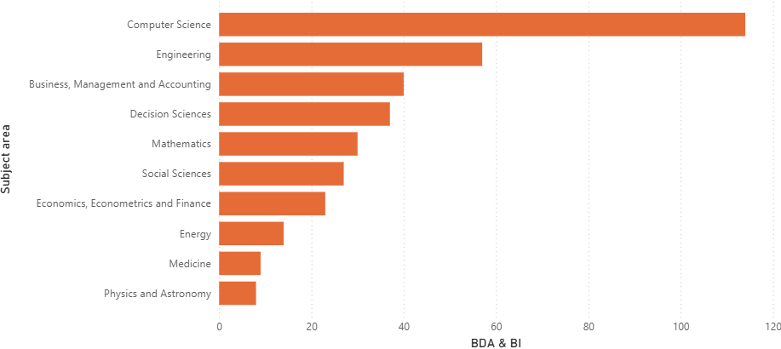
Figure 3. Subject Category for Both BDA & BI.

Keyword Analysis
Figure 4 shows the visualization of keyword co-occurrences based on the BDA and BI literature represented in VOSviewer. The most frequently recurring keywords included "big data analytics", "business intelligence", "decision-making", "machine learning", and "data mining". The keywords suggested some thematic clustering into themes like predictive modeling, real-time analytics, support of strategic decision making, and data visualization, representing the multifaceted research paths of the field, including extensive overlap with the developments of AI techniques.
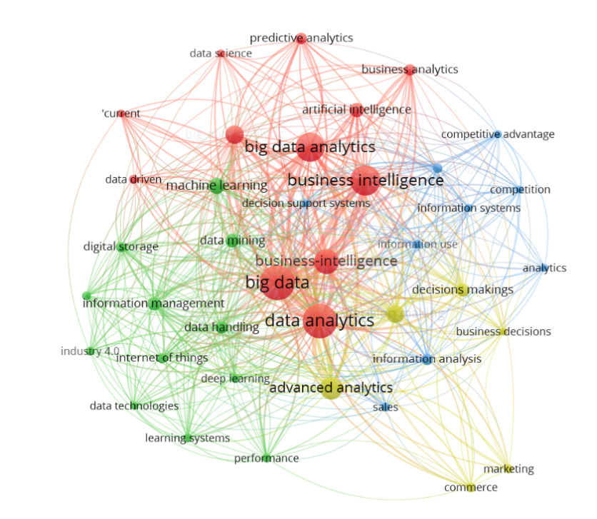
Figure 4. Visualization of Major Keywords in BDA and BI using VOSviewer.

CONCLUSION
This research aimed to review the literature on BDA and its role in BI, identifying the challenges organizations face and the solutions to those challenges. A qualitative approach was used, based on a review of articles published in academic journals. The research revealed that BDA plays a crucial role in enhancing BI activities, primarily by improving the efficacy of decision-making and operational procedures, and increasing responsiveness to competitive pressures. Despite this, challenges such as data privacy, visualization, data quality, professional skills shortages, and storage capacity persisted. Literature provides various options to address these challenges, such as end-to-end encryption, visualization tools like Power BI and Tableau, data validation techniques, professional training programs, and scalable storage capacity through solutions like cloud computing or NoSQL databases.
REFERENCES
- P. V. Thayyib et al., Sustainability 15, 4026 (2023).
- H. Chen, R. H. Chiang, and V. C. Storey, MIS Q. 36, 1165–1188 (2012).
- Y. Niu et al., Inf. Process. Manag. 58, 102725 (2021).
- L. Fink, N. Yogev, and A. Even, Inf. Manage. 54, 38–56 (2017).
- Z. Sun, L. Sun, and K. Strang, J. Comput. Inf. Syst. 58, 162–169 (2018).
- M. Petrini and M. Pozzebon, J. Strateg. Inf. Syst. 18, 178–191 (2009).
- J. Ram, C. Zhang, and A. Koronios, Procedia Comput. Sci. 87, 221–226 (2016).
- A. Gandomi and M. Haider, Int. J. Inf. Manage. 35, 137–144 (2015).
- D. Chong and H. Shi, J. Manag. Anal. 2, 175–201 (2015).
- C. A. Tavera Romero et al., Sustainability 13, 10026 (2021).
- E. Sirin and H. Karacan, Int. J. Intell. Syst. Appl. Eng. 4, 206–215 (2017).
- J. Zakir, T. Seymour, and K. Berg, Issues Inf. Syst. 16, 81–90 (2015).
- P. Mikalef et al., Inf. Syst. E-Bus. Manage. 16, 547–578 (2018).
- A. M. Komolafe et al., Int. J. Manag. Entrep. Res. 6, 838–862 (2024).
- S. Fan, R. Y. Lau, and J. L. Zhao, Big Data Res. 2, 28–32 (2015).
- J. Chen, L. Ramanathan, and M. Alazab, Microprocess. Microsyst. 81, 103722 (2021).
- A. O. Adewusi et al. , Comput. Sci. IT Res. J. 5, 415–431 (2024).
- M. A. Wani and S. Jabin, “A Fuzzy Logic Based Load Balancing Algorithm in Cloud Computing Environment”, in Big Data Analytics: Proceedings of CSI 2015, edited by V. B. Aggarwal et al. (Springer, Singapore, 2018), pp. 613–628.
- A. Rehman, S. Naz, and I. Razzak, Multimed. Syst. 28, 1339–1371 (2022).
- R. R. Pansara, (2023), TechRxiv: 10.36227.
- D. Che, M. Safran, and Z. Peng, “From Big Data to Big Data Mining: Challenges, Issues, and Opportunities”, in Database Systems for Advanced Applications, edited by B. Hong et al. (Springer, Berlin, 2013), pp. 1–15.
- S. Kaisler et al., Big Data: Issues and Challenges Moving Forward. In: 2013 46th Hawaii International Conference on System Sciences, Grand Wailea, Maui, Hawaii, January 2013, (IEEE, 2013), pp. 995-1004 .
- L. Burkhalter et al., Zepth: Cryptographic Enforcement of End-to-end Data Privacy. In: Proceeding 15th USENIX Symposium on Operating Systems Design and Implement, Santa Clara, CA, USA, February 25-27 2020, (2021), pp. 384-404.
- J. Barney, J. Manag. 17, 99–120 (1991).
- M. Gupta and J. F. George, Inf. Manage. 53, 1049–1064 (2016).

