Sustainable Development in Malaysia’s Cattle Farming: A System Dynamics Analysis
Nurul Nazihah Hawari^{1, a)} and Aisyah Nadhirah Zuraimi^{1, b)}
¹Institute of Strategic Industrial Decision Making, School of Quantitative Sciences, Universiti Utara Malaysia, 06010 Sintok, Kedah, Malaysia.
^{a)} Corresponding author: nnazihah@uum.edu.my
^{b)}aisyahnadhirah1506@gmail.com
Abstract. Malaysia’s ruminant livestock sector faces persistent sustainability challenges, including limited local breeds, high dependence on imported feed, inadequate grazing land, and a shortage of skilled personnel. This study adopts a system dynamics modeling approach to investigate the sector’s structural issues and simulate long-term strategies for sustainable development. The model integrates key variables such as breed quality, feed costs, land availability, climate impacts, and workforce capacity. Through scenario analysis, the study evaluates the effects of genetic enhancement, local feed cultivation, workforce training, and policy interventions on production efficiency and food security. The results offer actionable insights for policymakers such as Department of Veterinary Services and Ministry of Agriculture to design effective, data-driven strategies that support resilient and sustainable cattle farming, while advancing Malaysia’s economic and environmental objectives. By modeling long-term scenarios (2019–2030), the study finds that the Mechanization & Training scenario provides the highest gain in production and self-sufficiency.

INTRODUCTION
Malaysia’s ruminant livestock sector plays a crucial role in ensuring national food security, rural employment, and economic resilience. However, the sector faces significant sustainability challenges, including low meat yields from traditional breeds, high dependence on imported feed, limited grazing land, and a shortage of skilled personnel. These structural issues contribute to declining self-sufficiency levels and rising reliance on imports, undermining Malaysia’s goal of achieving a more resilient agrifood system. In response, the National Agrofood Policy 2021–2030 (NAP 2.0) emphasizes the modernization of agriculture through sustainable practices, innovation, and productivity improvements to ensure long-term food availability and affordability. As of 2023, Malaysia’s beef self-sufficiency was only 22%, showing a downward trend [1]. Malaysia continues to rely on imports, particularly from Australia and India [2].
Malaysia’s cattle farming sector continues to face structural weaknesses that constrain its ability to meet national food security goals. Local beef production remains low due to traditional breeds with limited productivity, high feed costs, land scarcity, and a persistent shortage of skilled labor. These constraints have contributed to declining beef self-sufficiency, which fell to 22% in 2023, despite rising domestic demand. The heavy reliance on imports exposes Malaysia to global market uncertainties, price volatility, and supply disruptions. These issues highlight the need for a systems-based analysis capable of capturing the interconnected biological, economic, and operational factors influencing long-term sector performance. To address the complexity of these challenges, this study adopts a System Dynamics (SD) modeling approach. SD offers a holistic framework to simulate the dynamic interactions between critical variables such as breed quality, feed cost, land use, climate pressures, and workforce capacity. Through feedback loop analysis and scenario-based simulation, this method supports the evaluation of strategic policy options that could enhance the sector’s efficiency and long-term sustainability.
This study investigates the sustainability of the cattle farming sub-sector in Malaysia. It focuses on modeling production trends, feed dependency, and the effects of selected policy interventions. The model is built using primary data collected from key institutional stakeholders and secondary data from agencies such as the Department of Veterinary Services (DVS), Department of Statistics Malaysia (DOSM), and the Malaysian Green Technology and Climate Change Centre (MGTC). These data sources ensure the model reflects actual operational conditions and national targets for livestock development. The aim of this study is to develop a decision-support tool grounded in validated system behavior, historical data from 2019–2022, and scenario-based simulations. By allowing policymakers to examine the long-term impacts of interventions such as local feed development, farmer training, mechanization, and farm expansion before implementation, the model serves as a practical platform for identifying strategies that can improve self-sufficiency, strengthen food security, and promote sustainable rural development.

LITERATURE REVIEW
Ruminant livestock systems face growing pressures from rising global food demand, environmental limits, and economic constraints. Scholars have emphasized the need for a systems perspective that integrates technological, economic, and environmental dimensions to address these challenges [3; 4]. Key themes emerging from past studies include production efficiency, technological adoption, feeding practices, health management, and the use of modeling tools to inform sustainable strategies. Livestock productivity challenges in other regions, such as South Africa, reveal similar structural gaps [5].
Production inefficiencies, such as limited breed productivity and low adoption of advanced practices, have been widely reported. Local studies have also highlighted constraints in Malaysia’s cattle farming such as breed performance and grazing limitations [6]. [7] highlighted Indonesia’s dependence on beef imports due to slow domestic growth, while [8] noted the long-term benefits of reproductive technologies in dairy production despite initial costs. Other studies emphasized optimizing herd structures and resources used to boost performance [9; 10].
Technology has shown promise in improving productivity and lowering prices, but access remains uneven, especially among smallholders [3]. Similarly, feed management directly affects costs, emissions, and nutritional outcomes. [11; 12; 13] demonstrated how optimized rations, and planning can improve efficiency while addressing sustainability goals.
Health interventions also play a vital role. [14] found that vaccinating against PPR in Senegal improved both profitability and food security. These findings support integrating animal health as a component of sustainable livestock policy. Understanding ruminant digestion is vital for improving feed efficiency [15].
Various modeling methods have been used to understand the complexity of livestock systems. SD modeling has gained attention for its ability to capture feedback loops and simulate long-term policy effects. Studies by [16; 17] demonstrated the effectiveness of SD in forecasting production trends and evaluating intervention scenarios. This study complements earlier works applying SD to domestic sectors such as tourism and housing stock [18; 19]. In comparison, linear programming models have been used to optimize feed costs [13], while data mining approaches like k-means clustering have supported location-specific decision-making [20]. Predictive models such as CART have also been used to forecast livestock traits [21].
In summary, sustainability in ruminant livestock production is shaped by interconnected biological, economic, and environmental variables [22]. Among the tools available, SD offers the most comprehensive approach for simulating dynamic behavior and informing long-term strategies, making it particularly suited to the context of Malaysia’s cattle industry. While techniques such as linear programming, econometric forecasting, and data mining offer valuable insights, each has limitations when applied to complex livestock systems. Linear programming focuses on optimization but cannot represent time delays or feedback effects. Econometric models capture correlations but struggle with non-linear interactions. Machine learning methods identify patterns but generally lack interpretability and causal structure. In contrast, SD explicitly models stocks, flows, delays, and feedback loops, making it more suitable for evaluating long-term intervention impacts in Malaysia’s cattle industry.

METHODOLOGY
This study employs a SD modelling approach to analyze the sustainability of Malaysia’s ruminant livestock sector. This section outlines the research framework, data sources, model development process, simulation design, validation procedure, and policy scenario formulation. The goal is to construct a structured and operational system dynamics model that simulates the key dynamic behaviors of the ruminant sector and provides insights into effective, long-term policy interventions.
SD is a simulation-based methodology used to model and analyze complex systems with feedback loops and time delays. It facilitates the understanding of interdependencies among variables, enabling the prediction of long-term trends and the evaluation of strategic interventions. In the context of Malaysian cattle farming, SD allows for the simulation of key factors such as herd dynamics, resource availability, environmental impact, and economic constraints. This study utilizes Vensim software to develop and simulate the model.
The research process follows five core steps: problem identification, formulation of the dynamic hypothesis, development of the simulation model, model testing and validation, and policy design with scenario evaluation. These steps follow the standard SD methodology widely applied in policy-oriented modelling (Sterman, 2000). Together, they align with the study’s objectives and provide a structured framework for analyzing system behavior and designing effective sustainable development strategies.
The first step, problem identification, focuses on defining the challenges faced by Malaysia’s ruminant livestock sector, particularly the decline in local beef production and increasing reliance on imports. The second step involves constructing a Causal Loop Diagram (CLD) to represent the relationships between key variables, such as cattle population, birth and death rates, feed availability, climate change, and labor capacity. This step helps articulate the feedback structures and interactions within the system.
Next, a Stock and Flow Diagram (SFD) is formulated to represent the system quantitatively. Stocks include cattle population, beef production, beef stock, and Malaysian population, while flows represent the birth, death, slaughter, and consumption rates (FIGURE 1). This simulation model enables the projection of system behavior from 2019 to 2030, with historical data from 2019–2022 used for model calibration and validation. The model incorporates core variables to calculate the Self-Sufficiency Level (SSL), an indicator of Malaysia’s reliance on local versus imported beef.

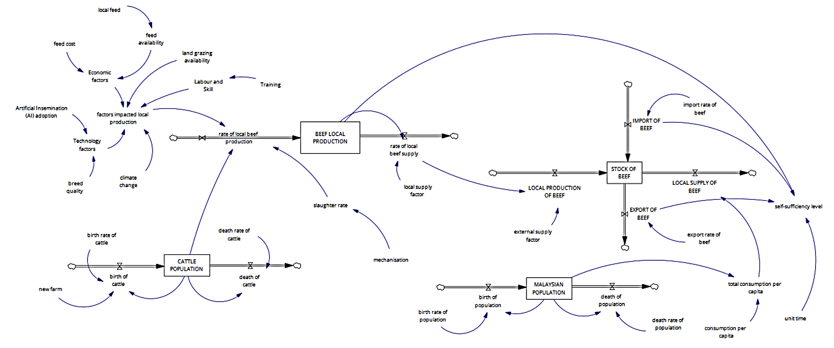
Figure 1. Stock Flow Diagram of Cattle Farming

Data for the model were sourced from both primary and secondary sources. Primary data were collected via interviews with a senior officer from the Malaysian Agricultural Research and Development Institute (MARDI), providing expert insights into policy, technical challenges, and the current state of cattle farming. Secondary data were obtained from the Department of Veterinary Services (DVS) and the DOSM for cattle population, beef production, birth and death rates, and self-sufficiency ratios from 2019–2022. Additional sustainability benchmarks were drawn from the Green Practice Guidelines for the Livestock Sector, issued by the Ministry of Environment and Water (KASA) and the Malaysian Green Technology and Climate Change Centre (MGTC). The stock–flow structure is governed by the following core equations. These equations clarify how herd growth, production flows, and consumption interact to produce long-term system behavior.

Cattle Population Dynamics:
$$\text{Cattle Population}(t)=\text{Cattle Population}(t-1)+(\text{Birth Rate}-\text{Death Rate}-\text{Slaughter Rate})$$
Beef Production:
$$\text{Beef Production}=\text{Slaughter Rate}×\text{Average Carcass Weight}$$
Self-Sufficiency Level (SSL):
$$\text{SSL}=\frac{\text{Local Beef Production}}{\text{Local Beef Consumption}}×100$$
Beef Stock Accumulation:
$$\text{Beef Stock}(t)=\text{Beef Stock}(t-1)+(\text{Production}-\text{Consumption})$$
The model development process involved identifying endogenous, exogenous, and excluded variables. Endogenous variables, such as cattle population and local beef production, are determined by internal SD. Exogenous variables, including birth and death rates or beef imports, act as external influences. Some variables like land availability, AI adoption, and feed cost were excluded to maintain model focus and clarity, though they are acknowledged as important in broader discussions.
After model construction, validation was conducted using unit consistency checks and by comparing the simulated reference mode to actual historical trends. Validation graphs for cattle and population data confirmed the model’s accuracy in replicating real-world behavior, lending confidence to the reliability of future scenario simulations. Behavioral validation was conducted by comparing the simulated outputs with historical data from 2019–2022. The model demonstrated strong agreement with observed trends, supported by three error metrics: a Mean Absolute Percentage Error (MAPE) of 7.4%, a normalized Root Mean Square Error (RMSE) of 0.039.
The final stage of the methodology involves designing and evaluating four policy interventions:
- Local Feed & New Farm – a strategy targeting large-scale farmers with government support to improve feed accessibility and increase cattle farm development.
- Local Feed & Training – a program for smallholders focused on technical training and the adoption of local feed practices.
- Mechanization & New Farm – a government-driven initiative for large-scale farms to reduce labour costs and enhance productivity through automation; and
- Mechanization & Training – a hybrid intervention targeting both farm sizes by combining mechanization support with farmer training programs.
Each intervention was simulated and compared to a baseline scenario to evaluate impacts on cattle population, self-sufficiency, production efficiency, and economic viability. Results from these scenarios offer actionable insights for decision-makers aiming to reduce import dependency and foster a more resilient and sustainable cattle farming industry in Malaysia.

Results and Analysis
This section presents the outcomes of the system dynamics (SD) simulations designed to evaluate the sustainability of Malaysia’s ruminant livestock sector. The model assesses system behavior over the 2019–2030 period under a baseline scenario and four policy interventions. Three key performance indicators are used to evaluate sectoral sustainability: local beef production, beef stock, and self-sufficiency level (SSL). The scenarios represent distinct policy directions involving feed development, farm expansion, farmer training, and mechanization support. FIGURE 2 displays simulated behavior across all scenarios.
Local beef production declines significantly under the baseline scenario, falling from 44,024 MT in 2019 to approximately 25,041 MT in 2030. This demonstrates that without intervention, Malaysia’s production capacity weakens due to existing structural constraints. Among the policy scenarios, Mechanization & Training delivers the strongest improvement, raising production to approximately 54,902 MT by 2030, more than double the baseline projection. This scenario combines productivity-enhancing mechanization with farmer training, enabling better utilization of farm resources. The Mechanization & New Farm scenario yields only marginal gains (25,685 MT by 2030), indicating that expanding farm capacity without corresponding efficiency enhancements has limited impact. Similarly, Local Feed & Training and Local Feed & New Farm slow the production decline but generate only modest improvements, reinforcing that feed-related interventions alone cannot shift long-term production trends.

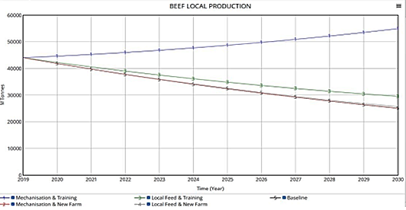 | 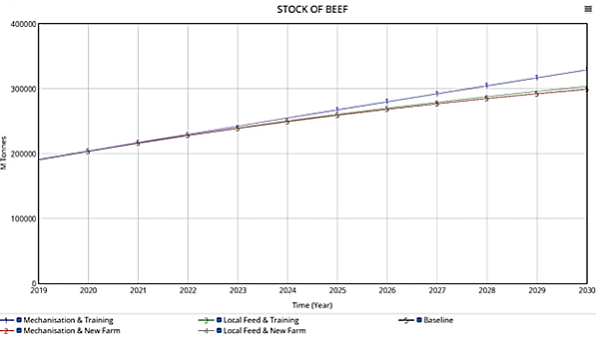
- Beef Local Production trend | - Stock of Beef trend
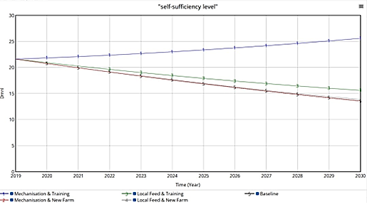
- Self-Sufficiency Level trend

Figure 2. Trends of Cattle Farming
The baseline scenario shows a slow and steady rise in beef stock, reflecting ongoing market trends but insufficiently induced to reduce import dependence. Mechanization & Training again produces the most significant improvement, increasing beef stock to nearly 330,000 MT by 2030. The strong performance reflects the synergistic effect of efficiency gains from mechanization and improved farm management through training. Mechanization & New Farm and Local Feed & Training show moderate stock increases after 2025 but remain far below the Mechanization & Training scenario. Local Feed & New Farm provides the smallest improvement, suggesting that expanding farm numbers without parallel capacity-building does little to enhance national stock levels.
SSL declines from 21.60% in 2019 to 13.55% under the baseline scenario by 2030, highlighting increasing reliance on imports. Mechanization & Training markedly reverses this trend, raising SSL to 25.58% by 2030, an outcome driven by higher production volumes and improved retention of local beef into the supply chain. Meanwhile, Mechanization & New Farm (13.57%), Local Feed & Training (15.60%), and Local Feed & New Farm (13.85%) offer modest improvements but fail to meaningfully shift Malaysia’s SSL trajectory.
Across all three performance indicators, Mechanization & Training consistently emerges as the most impactful policy lever. Its dual focus technology adoption and human capital development produces strong reinforcing effects on productivity, stock growth, and import substitution. In contrast, interventions that focus solely on increasing farm numbers or improving feed access yield limited gains. These findings underscore that Malaysia’s ruminant sector requires integrated, capability-driven interventions, not isolated structural expansion. A strategy combining mechanization, skills development, and technical support offers the best pathway toward improved production efficiency, higher SSL, and long-term sector resilience.

CONCLUSION
This study examined the sustainability challenges facing Malaysia’s ruminant livestock sector and proposed strategic solutions using a SD modeling approach. Through simulation of key variables, such as cattle population, feed availability, breed quality, and land use, the model provided insights into how different policy interventions could influence beef production and self-sufficiency over time. Among the scenarios tested, the combination of mechanization and farmer training emerged as the most effective strategy, resulting in the highest gains in productivity and sustainability.
The research makes several contributions. It enhances understanding of the dynamic interactions within the livestock system by integrating key variables into a holistic model. The findings support evidence-based policymaking, particularly in highlighting the value of combining technological support with capacity building. The study also introduces new considerations, such as localized feed development and overseas farm establishment, as potential solutions to structural constraints like import dependency and land scarcity. Methodologically, it advances the use of SD modeling as a tool for long-term agricultural planning.
Despite its strengths, the study has limitations. It does not include detailed cost analyses of interventions or account for environmental externalities such as greenhouse gas emissions. These exclusions were intended to maintain model simplicity but may limit the comprehensiveness of the sustainability assessment. Furthermore, the model is based on fixed historical assumptions and requires ongoing updates to reflect changing policy, market, and climate conditions.
Future research should expand the model to incorporate agent-based dynamics, allowing for more detailed representation of individual farmer behavior and regional differences. The scope can also be broadened to include dairy and small ruminant systems to better represent Malaysia’s overall livestock landscape. Environmental indicators such as emissions and water usage should be included to align with global sustainability benchmarks. Additionally, future simulations should be supported by financial analyses to evaluate the feasibility and cost-effectiveness of proposed interventions. Exploring the potential of international land acquisition strategies may also yield new opportunities, though such approaches must be assessed for geopolitical and ethical implications.
Overall, this study provides a valuable framework for understanding and improving the sustainability of Malaysia’s cattle farming sector. The findings can support the design of integrated, long-term strategies to enhance food security, rural livelihoods, and agricultural resilience. The results highlight the importance of strategic planning support for agencies such as DVS and MOA, reinforcing the value of SD modeling in national agricultural policy design.

References
- Statista, “Malaysia: beef self-sufficiency ratio 2023,” https://doi.org/1080000/1081195-blank-355.
- MLA, Beef and Sheepmeat Malaysia, MLA Industry Insights (2024).
- C.F. Nicholson, A.R.P. Simões, P.A. LaPierre, and M.E. Van Amburgh, J. Anim. Sci. 97, 1903 (2019).
- A.R.P. Simões, C.F. Nicholson, A.M. Novakovic, and R.M. Protil, Int. Food Agribus. Manag. Rev. 23, 71 (2020).
- K. Mokoena, K.M. Molabe, M.C. Sekgota, and T.L. Tyasi, Vet. World 15, 1719 (2022).
- O. Ariff, N. Sharifah, and J. Malaysia, J. Anim. Sci. 18, 1 (2015).
- J. Lusk, et al., IOP Conf. Ser.: Earth Environ. Sci. 1341, 012085 (2024).
- K. Dizyee, D. Baker, and A. Omore, J. Dairy Res. 86, 440 (2019).
- N. Shahsavari-Pour, S. Rahimi-Ashjerdi, A. Heydari, and A. Fekih, Appl. Sci. 13, 1662 (2023).
- F. Wanyoike, K.M. Rich, N. Mtimet, S. Bahta, and L. Godiah, Small Rumin. Res. 218, 106882 (2023).
- S. Irawan, S.T. Risyahadi, and H. Wijaya, Proceedings 83, 15 (2022).
- O. Alqaisi and E. Schlecht, Sustainability 13, 215 (2020).
- Z. Alwadood, A.M.D. Yati, and N. Mohd Noor, J. Sci. Math. Lett. 11, 19 (2023).
- J. Aboah, A. Apolloni, R. Duboz, B. Wieland, P. Kotchofa, E. Okoth, and M. Dione, PLoS One 18, e0287386 (2023).
- J. Parish, “Understanding the Ruminant Animal Digestive System,” Mississippi State University Extension Service (2022), http://extension.msstate.edu/publications/understanding-the-ruminant-animal-digestive-system.
- K.G. Odoemena, J.P. Walters, and H.M. Kleemann, Sustainability 12, 3241 (2020).
- N.N. Hawari, D.I. Abdullah, and N.A. Zainuddin, AIP Conf. Proc. 2896, 040023 (2023).
- I.F. Mustafa and N.N. Hawari, AIP Conf. Proc. 2472, 040016 (2022).
- N.N. Hawari and N.N.B. Rozari, AIP Conf. Proc. 2472, 020002 (2022).
- Y. Ma, C. Chu, and H. Lee, Comput. Oper. Res. 136, 105467 (2022).
- M.O. Oyebanjo, O.M. Coker, and O.H. Osaiyuwu, Biotechnol. Anim. Husb. 39, 33 (2023).
- P.A. Samsudin, et al., Green Practices Guideline for Livestock Sector, Malaysian Green Technology and Climate Change Corporation (2023).

