System Dynamics Analysis of Digital Transformation for Malaysian SMEs
Nurul Nazihah Hawari^{1, a)}, Nur Fathihah Salmizi^{1, b)}, Mohammad Khairul Hakimin Zainoor^{2, c)} and Aiman Zakwan Zahari^{2, d)}
¹Institute of Strategic Industrial Decision Making, School of Quantitative Sciences, Universiti Utara Malaysia, 06010 Sintok, Kedah, Malaysia.
²Malaysia Productivity Corporation (MPC), Lorong Produktiviti, Jalan Sultan, 46200 Petaling Jaya, Selangor, Malaysia.
^{a)}Corresponding author: nnazihah@uum.edu.my
^{b)}nurfathihahsalmizi@gmail.com
^{c)}MKhairul@mpc.gov.my
^{d)}Aiman@mpc.gov.my

Abstract. Digital transformation is essential for strengthening the resilience and sustainability of Small and Medium Enterprises (SMEs), particularly during periods of disruption such as the COVID-19 crisis. In Malaysia, where SMEs form a critical economic pillar, the pandemic highlighted structural weaknesses while accelerating digital adoption. This study applies a system dynamics (SD) model to examine the long-term impacts of digitalization on SME sustainability by integrating key drivers such as digital awareness, government incentives, workforce skills, training, and technology uptake. Two intervention strategies are evaluated: (1) a targeted approach focused on awareness and technology adoption, and (2) a comprehensive approach combining digital literacy, incentives, and training. Results show that while both strategies enhance performance and adaptability, the comprehensive intervention produces significantly higher adoption rates and stronger long-term resilience. Reinforcing feedback loops reveal how improvements in skills and performance stimulate further digital investment. The study offers practical insights for policymakers and supports the design of inclusive and sustainable digitalization strategies aligned with Malaysia’s MyDIGITAL initiative and the Sustainable Development Goals (SDGs).

introduction
The rapid advancement of digital technologies has reshaped industries and intensified global business competition. For Small and Medium Enterprises (SMEs), which account for over 90% of businesses and more than 60% of global employment [1], digitalization is now a strategic necessity. In Malaysia, SMEs form 98.5% of registered firms, contribute 38.3% to GDP, employ 48% of the workforce, and generate 17.8% of exports [2;3], making them central to national economic development. Digitalization offers clear benefits including greater efficiency, wider market reach, and enhanced innovation capacity [4] yet many SMEs, particularly in rural or traditional sectors, face persistent barriers such as limited finances, inadequate digital skills, and resistance to organizational change [5;6]. The COVID-19 crisis further widened the digital divide, with digitally mature SMEs adapting successfully while others experienced severe disruptions [7].
To accelerate digital adoption, Malaysia introduced initiatives such as MyDIGITAL and Industry4WRD, supporting more than 30,000 SMEs through grants and digital-skills programs [8]. E-commerce, cloud services, and digital payments increased significantly between 2020 and 2022 [9]. However, existing studies often analyze enablers and barriers in isolation, offering limited insight into how these factors interact dynamically over time. This study addresses that gap by focusing on SMEs across three major sectors services, retail, and light manufacturing and across both urban and semi-urban/rural regions, acknowledging variation in digital readiness and structural challenges.
Using a System Dynamics (SD) modelling approach, this research evaluates the long-term effects of digital transformation on SME sustainability in Malaysia. The model incorporates key drivers such as digital awareness, government incentives, workforce skills, and technology uptake, and tests two policy interventions: a focused strategy on awareness and adoption, and a comprehensive strategy combining digital training, financial support, and literacy development. Simulations over the 2019–2025 period reveal critical feedback loops and leverage points that shape SME resilience. The findings provide evidence-based insights for designing adaptive and inclusive digitalization policies aligned with Malaysia’s national priorities and the Sustainable Development Goals (SDGs), particularly SDG 8 and SDG 9.

literature review
Small and Medium Enterprises (SMEs) play a critical role in global and national economies, accounting for 90% of businesses worldwide and over 60% of employment [1]. In Malaysia, SMEs comprise 98.5% of firms, contribute 38.3% to GDP, and employ 48% of the workforce [3], making them central to socio-economic progress. Digitalization has become a key driver of SME productivity, cost reduction, and resilience, supported by technologies such as e-commerce, cloud computing, and digital financial tools [4]. National initiatives including Industry4WRD and MyDIGITAL aim to accelerate this transition through infrastructure upgrades, digital talent development, and technology incentives [2]. Empirical studies consistently show that digital adoption improves operational efficiency, customer engagement, and adaptability, especially under market volatility [10].
Despite this momentum, digital transformation remains uneven, particularly among micro-enterprises and rural SMEs. Financial constraints, limited credit access, low digital literacy, cybersecurity concerns, and cultural resistance continue to hinder adoption [6;11]. Recent data indicate that although over 30,000 SMEs received digital grants and digital payments rose by 35% between 2020 and 2022 [8], significant regional disparities persist. Participation in digitalization programs remains substantially lower in East Malaysia compared to Peninsular Malaysia [9], highlighting the need for more inclusive and geographically targeted interventions.
Prior research uses both quantitative and qualitative approaches to examine SME digitalization. Econometric studies link digital adoption to higher revenue and market responsiveness [12], while qualitative studies reveal regional variations in incentive uptake [13]. However, these approaches often fail to capture the dynamic interactions, feedback loops, and time delays that shape long-term digital transformation. System dynamics modeling addresses this gap by enabling the simulation of interdependent variables and policy impacts within a feedback-rich environment. SD has been applied in Malaysia across domains such as housing and environmental planning [14;15], demonstrating its suitability for complex policy analysis.
Government support continues to be essential for enabling SME digital growth through initiatives such as the SME Digitalization Grant Scheme, Go-eCommerce, and the MyDIGITAL Workforce Movement [16]. Yet, structural and regional disparities remain barriers to equitable progress. Overall, the literature underscores the transformative potential of digitalization while highlighting persistent financial, skill-based, and cultural challenges. To address these complexities, this study employs a system dynamics model to simulate SME digital transformation between 2019 and 2021, offering insights that support Malaysia’s digital economy agenda and the Sustainable Development Goals.

methodology
This study adopts a mixed-methods approach, combining semi-structured interviews with SMEs and secondary data from government reports, academic literature, and the Department of Statistics Malaysia. The interviews provide qualitative insights into digitalization challenges, while secondary data supplies the quantitative basis for model parameterization. A system dynamics modelling framework is then used to simulate the long-term impacts of digitalization on SME sustainability, capturing feedback loops, time delays, and non-linear interactions. The model was developed through five iterative stages: problem articulation, dynamic hypothesis formulation, model construction, validation, and policy testing.
The first stage, problem articulation, defines the model’s purpose: to understand how digitalization affects the sustainability of Malaysian SMEs. Key variables such as digital adoption, revenue growth, operational efficiency, government incentives, and workforce training are identified. A reference mode is then established to capture historical system behavior without digitalization interventions, reflecting Malaysia’s relatively stable SME contribution to GDP with disruptions during events such as the COVID-19 pandemic (refer Fig. 1). The simulation spans 2016–2025 to enable both retrospective analysis and forward-looking projections.

FIGURE 1. The reference mode of contribution of SMEs to Malaysia's GDP from 2016 to 2023

Following problem articulation, a dynamic hypothesis is formulated to explain how digitalization affects SME sustainability. It posits that greater digital adoption improves profitability, reduces operating costs, and enhances market responsiveness. A causal loop diagram (refer Fig.2) illustrates these interactions, highlighting reinforcing loops such as awareness driving adoption, which then increases awareness and balancing loops that limit progress due to high costs or external shocks like the COVID-19 pandemic. A key balancing structure, the Cost–Adoption Constraint, shows that as digitalization rises, operational and investment costs increase, reducing SMEs’ capacity or willingness to adopt further technologies. These feedback mechanisms capture how digital tools can boost performance and encourage reinvestment, while financial and environmental pressures may slow adoption and weaken resilience.

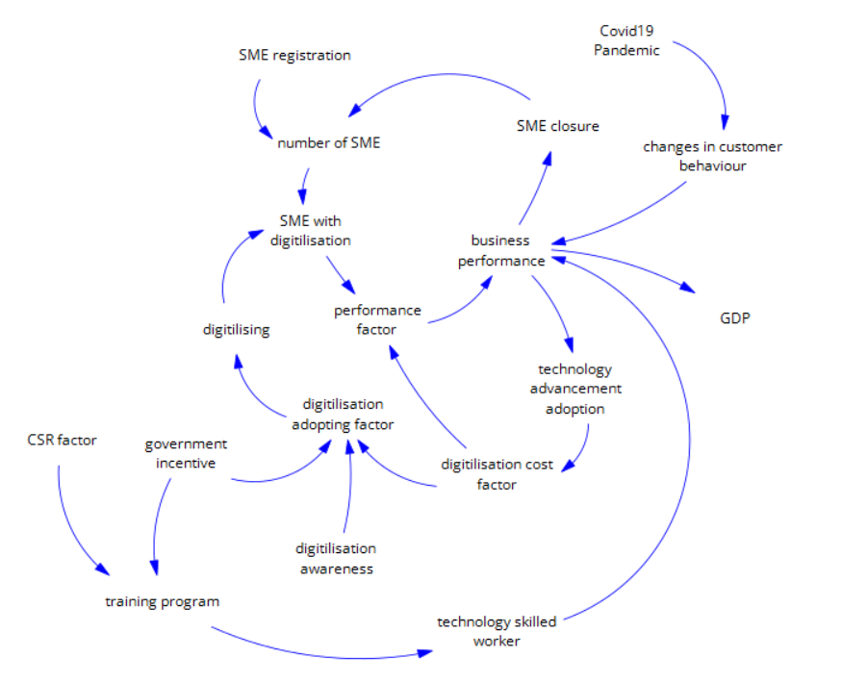

FIGURE 2. The causal loop diagram of digitalization towards SMEs sustainability

In the third stage, the dynamic hypothesis is translated into a simulation model using Vensim. The model incorporates stock–flow structures to represent how resources accumulate and change over time (refer Fig. 3). Stocks capture system conditions such as the number of digitalized SMEs or business performance while flows represent transition rates, including digital adoption and business exits. Auxiliary variables account for productivity, marketing costs, and external shocks. Together, these components simulate how shifts in digitalization inputs influence SME sustainability across the model’s time horizon. Several variables in the model represent intangible constructs such as digital awareness, technology-adoption readiness, training effectiveness, and government incentive intensity and were operationalized using proxy indicators and normalization techniques. Digital awareness was captured through a 0–1 Digital Awareness Index based on SME participation in digital training, social media usage, and national digitalization programs [8]. Technology-adoption readiness was quantified using ICT expenditure, cloud-service subscription rates, and digital-payment usage, all normalized to a 0–1 scale. Training effectiveness was proxied by the number of employees completing accredited digital-skills programs and competency-improvement scores from SME Corp. Government incentive intensity was measured by the annual value of digital-related grants disbursed per SME.

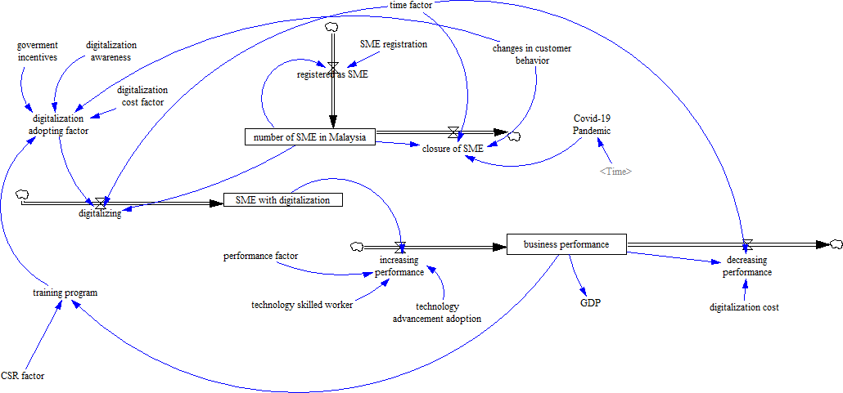

FIGURE 3. The stock and flow diagram of digitalization towards SMEs sustainability

Model validation was then conducted to ensure the simulation accurately reflects real-world dynamics. Structural validation assessed model logic, feedback loops, and variable interactions, while behavioral validation compared simulated results with historical data. Unit consistency checks in Vensim confirmed dimensional correctness, and the model closely reproduced observed trends from 2016 to 2023. Goodness-of-fit metrics further supported model reliability, with a Mean Absolute Percentage Error (MAPE) of 6.8%, indicating low deviation between simulated and actual SME performance.

results and findings
This section presents the simulation outcomes based on the developed SD model and evaluates how different digitalization strategies influence SME performance and sustainability. By adjusting key variables, the simulations reveal system-wide effects on technology adoption, business growth, and overall resilience. The base case simulates SME digitalization without additional interventions from 2019–2025. Digital adoption rises gradually due to market forces and post-pandemic recovery but plateaus after 2022 as operational costs, regional disparities, and skill shortages persist. Business performance shows only modest post-COVID recovery, and the simulated trend aligns closely with historical SME GDP contributions, confirming the model’s structural validity. This scenario serves as the benchmark for comparing the interventions.
Intervention 1 increases digital awareness by 10% and adoption rate by 0.5%. The strategy produces a 6% increase in digitalized SMEs by 2025 (refer Fig. 4(a)). Reinforcing loops shows awareness driving adoption and modest improvements in performance, but the overall impact remains limited due to the small scale of technological uptake and the absence of broader structural support. Intervention 2 applies a comprehensive approach to raising awareness by 10%, incentives by 20%, and training by 5% (refer Fig. 4(b)). This combination addresses key barriers related to cost, capability, and awareness. By 2025, digital adoption increases by more than 18% relative to the baseline, and business performance improves by 15%. Strong reinforcing loops emerge incentives and training accelerate adoption, improved performance encourages reinvestment, and the cycle continues to strengthen outcomes.

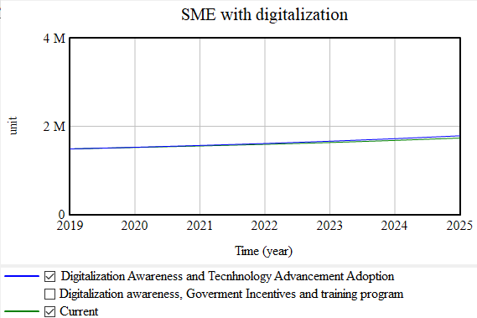 | 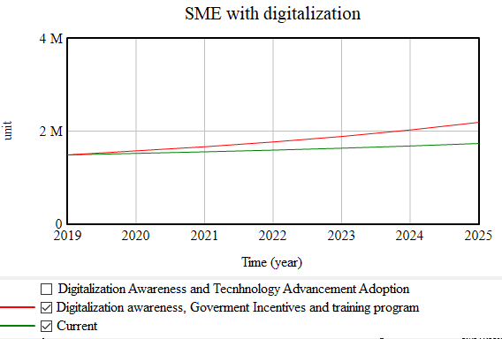
- Intervention of digitalization awareness and technology advancement adoption | - Intervention of digitalization awareness, government incentives, and training programs implementation

FIGURE 4. Simulated behaviour for the number of SMEs with digitilisation under current scenario and intervention

Comparative analysis shows that Intervention 2 consistently outperforms Intervention 1 across all indicators. While Intervention 1 yields incremental gains, its narrow focus limits systemic transformation. Intervention 2 leverages synergistic effects by simultaneously strengthening skills, affordability, and awareness producing higher adoption and more resilient long-term performance (refer Fig. 5).
Overall, the results demonstrate that integrated, multi-dimensional strategies are far more effective than awareness-led approaches alone. Structural support through funding, capability development, and training is essential for accelerating SME digital transformation. These findings highlight the value of system dynamics modelling for identifying leverage points, anticipating delayed impacts, and informing inclusive, evidence-based digitalization policies for national economic planning.

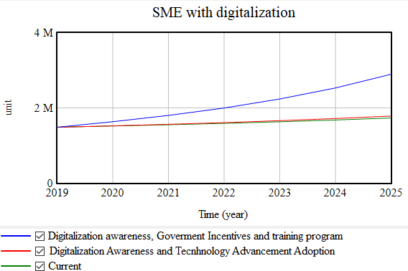 | 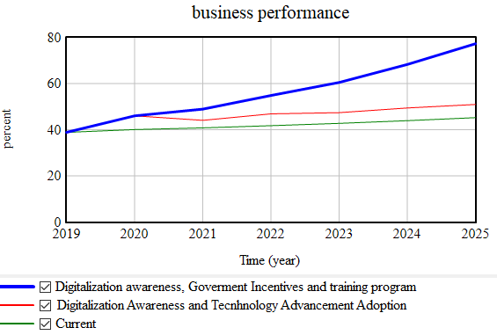
- The total number of digitalized SMEs in Malaysia | - The business performance of SMEs

FIGURE 5. Results of scenario analysis

conclusion
This study developed a system dynamics model to assess the digital transformation of Malaysian SMEs, integrating interview insights with national data to capture interactions among digital awareness, incentives, training, business strategy, and performance within a feedback-rich system. Among the tested scenarios, the comprehensive intervention combining increased awareness, expanded incentives, and broader training proved most effective in strengthening SME sustainability. The results show that generic digital training is insufficient; programs must be tailored to SME size, sector, regional context, and digital readiness to ensure relevance, uptake, and policy effectiveness.
The findings offer important guidance for policymakers. Effective strategies should extend beyond awareness campaigns and subsidies to include inclusive, accessible, and sector-specific digital literacy initiatives, complemented by grants or tax relief aligned with business maturity. Efforts must also target rural and underserved regions through mobile training units or localized digital hubs. System dynamics provides a valuable tool for evaluating such strategies in advance, allowing policymakers to test interventions, anticipate delayed effects, and optimize resource allocation.
Methodologically, this research reinforces the usefulness of simulation-based modelling for analyzing socio-economic systems, demonstrating how digitalization outcomes emerge from reinforcing and balancing feedback loops. Future work should extend the simulation horizon, incorporate additional performance indicators, and validate assumptions through pilot studies. Comparative modelling with other developing economies may also yield transferable policy insights.
In conclusion, this study provides an evidence-based framework to support Malaysia’s SME digitalization agenda. Aligning model insights with national development priorities and the SDGs highlights the need for targeted, adaptive, and context-sensitive interventions. Integrating system dynamics into digitalization policy planning represents a significant step toward building a resilient, innovative, and digitally empowered SME ecosystem.

Acknowledgments
The authors would like to express their sincere appreciation to the Malaysia Productivity Corporation (MPC), Lorong Produktiviti, Jalan Sultan, Petaling Jaya, Selangor, for their valuable support in this research. MPC generously provided relevant data and contributed to the model validation process, enhancing the accuracy and practical relevance of the system dynamics model developed in this study.

References
- OECD, Enhancing the Contributions of SMEs in a Global and Digitalised Economy (OECD Publishing, 2017).
- Ministry of International Trade and Industry, National Policy on Industry 4.0 (Industry4WRD) (MITI, 2021).
- Department of Statistics Malaysia, Business Statistics (DOSM, 2024).
- J. M. Müller, O. Buliga, and K. I. Voigt, Technol. Forecast. Soc. Change 132, 2–17 (2018).
- OECD, The Digital Transformation of SMEs (OECD Publishing, 2021).
- M. Michela, P. Lara, P. Giorgia, and Q. Roberto, J. Bus. Res. 123, 642–656 (2021).
- D. Vrontis, R. Chaudhuri, and S. Chatterjee, Sustainability 14, 7949 (2022).
- Malaysian Digital Economy Corporation, Digital Economy Report (MDEC, 2023).
- Deloitte, The State of Digital Transformation in Malaysia (Deloitte, 2022).
- S. Marinko, M. M. O., and R. Samuel, Int. J. Inf. Manage. 68, 102594 (2023).
- K. G. Khai, Y. W. Onn, Z. Rozitaayu, K. Shamini, and A. Ahmad, J. Educ. Soc. Sci. 16, 73–81 (2020).
- T. Kollmann, C. Stöckmann, and J. M. Kensbock, Technol. Forecast. Soc. Change 164, 120442 (2021).
- H. Chen, Front. Psychol. 13, 951696 (2022).
- N. N. Hawari and N. N. B. Rozari, The 5th Innovation and Analytics Conference & Exhibition (IACE 2021), Kedah, Malaysia, November 23-24 2021 (AIP Publishing, 2021).
- F. F. Haron and N. N. Hawari, J. Technol. Manage. Bus. 5, 3 (2018).
- SME Corporation Malaysia, SME Statistics and Reports (SME Corp, 2023).

