A Data Analytics Approach to Examining Board Gender Diversity, ESG Scores, and Carbon Emissions: The Moderating Role of Women Directors in Malaysia and Indonesia

Nurul Nazlia Jamil^{1, a)} , Ersa Tri Wahyuni^{2,b)} and Peni Nugraheni ^{3, c)}
¹Faculty of Economics and Muamalat, Universiti Sains Islam Malaysia,71800 Nilai, Negeri Sembilan, Malaysia
² Department of Accounting, Faculty of Economics and Business, Universitas Padjajaran,Bandung, 40132, Indonesia
³Department of Accounting,Universitas Muhammadiyah Yogyakarta,JL. Brawijaya, Kasihan, Bantul,
Yogyakarta 55183, Indonesia

^{a)} Corresponding author: nurulnazlia@usim.edu.my
^{b)}ersa@unpad.ac.id
^{c)} peninugraheni@umy.ac.id

Abstract. With an emphasis on the moderating influence of women in the boardroom, such research observes properties of carbon emissions or ESG scores in corporations listed onto the Malaysian and Indonesian stock exchanges. This study looks at how ESG scores, carbon emissions and gender diversity on boards relate to each other by using information from non-financial corporations. Using a data analytics approach, we analyze panel data from publicly listed firms in Malaysia and Indonesia between 2018 and 2023. According to the results, reduced carbon emissions in relation to revenue are linked to higher ESG rankings. Furthermore, here is negative connection among quantity of women on rations and carbon emissions as well as ESG scores, indicating that gender-diverse boards may promote better environmental policies. The study also emphasizes how well Malaysian and Indonesian ESG reporting and disclosure laws work to cut carbon emissions. Although the study makes the case that gender quotas in boardrooms could improve the adoption of ESG even further, it is only applicable to Malaysia and Indonesia and might not accurately represent patterns in other developing countries.

Introduction
The whole volume of greenhouse gases, especially carbon dioxide (CO₂), emissions that are either directly or indirectly caused by human actions are known as the "carbon footprint" [1]. Assuring that economic growth does not negatively impact the environment or future generations, lowering carbon footprints is consistent with sustainable development goals [2]. Carbon neutrality has emerged as a key objective as the need to combat climate change grows, with the drive for lower emissions being driven by ethical, financial, and environmental considerations.

The Environmental, Social, and Governance (ESG) framework is critical aimed at businesses seeking or enhancing their impact and value. A key aspect of Corporate Social Responsibility (CSR) is minimizing carbon footprints, which can improve brand image and meet consumer expectations for sustainability [3]. Carbon emissions are not only an environmental issue but also an ethical and financial one, as reducing them can mitigate the risks of carbon taxes and penalties [4]. Despite the challenges, the road to sustainability presents significant opportunities for companies to improve stakeholder relations and strengthen their corporate image.

Recent studies have also explored connection among gender assortment on commercial boards or ESG enactment, particularly regarding carbon discharges [5,6]. Research indicates that female on boards tend to improve ESG scores, as diverse teams often make more balanced and informed decisions [7]. Companies with greater gender diversity have been found to implement more proactive environmental policies, reducing carbon emissions [8]. Furthermore, firms having great ESG scores attract more investor attention or benefit from enhanced reputations [9].

By investigating consequence of feminine managements on carbon emissions and other ESG aspects in Malaysian and Indonesian enterprises, such research seeks for closing this fissure. According to study's hypothesis, connotation amongst carbon emanations and ESG scores may be qualified via existence of females on boards. The study have goals for adding to continuing discussion onto how gender assortment might improve company sustainability and governance by examining this link.
LITERATURE REVIEW

The study on correlation between ESG scores as well as cumulative carbon discharges is pertinent to scholars or practitioners because of increasing demand on businesses to show that they are involved in environmentally friendly procedures [10]. Among numerous CSR metrics which are employed in conjunction with an ESG score for assessing a business's administration, cultural and ecological sustainability is its handling of carbon [11]. Additionally, data shows that a company's ESG scores are positively correlated with its exceptionally large actions to address ecological problems, such as lowering greenhouse gas emissions or engaging in sustainable practices. It appears that establishing strong ESG rules in place encourages businesses to use improved carbon management strategies, which lowers overall discharges [12, 13, 14]. This connection is not so straightforward, though, which is an important point: while numerous enterprises succeed in this industry, several also face difficulties. Numerous factors, including the company's dedication to environmentally friendly goals and accessibility of tangible assets, might be blamed for this discrepancy.

ESG Scores and Corporate Sustainability
The connection amongst commercial sustainability or ESG enactment, particularly into relation to carbon emissions became topic of various recent articles. Better environmental performance, especially in lowering carbon footprints, has been associated with ESG scores that evaluate firm's ecological, communal, and supremacy standards. Businesses with higher ESG scores exhibit more operative tactics for reducing greenhouse gas emanations, rendering to [15]. This research indicates that gains in environmental outcomes are positively correlated with corporate governance that prioritizes sustainability.

The idea that companies with better ESG scores typically have fewer carbon emissions is supported by a number of research. In line with investor expectations for ecologically conscious enterprises, these firms generally implement more comprehensive and successful sustainability initiatives [16]. But there are still certain difficulties. According to [17], disparities in ESG score amongst agencies can damage the legitimacy of ESG scores and make meaningful comparisons more difficult. The phenomenon of “greenwashing,” where companies mislead stakeholders about their environmental impact, also complicates the picture [18]. These issues underscore the need for standardized reporting frameworks and better measurement systems to assess ESG and carbon emission performance. The literature recommends robust connection amongst higher ESG scores and reduced carbon emissions. However, challenges related to measurement inconsistency and greenwashing highlight the complexity of this relationship. It tends forward for formulation of the first hypothesis:

Hypothesis 1: Higher ESG scores are linked with a markdown in carbon emissions.

Gender Assortment on Boards and ESG Enactment
Various researchers found that boards with more women tend to make better decisions regarding environmental sustainability. [7] shows that companies with more female representation on boards achieve better ESG scores, particularly in environmental dimensions. This can be attributed to women’s leadership styles, which often prioritize long-term sustainability goals or moral decision-making, including reducing carbon emissions. Moreover, [16] argues that firms with female board members going for implementing practical ecological policies which lessen carbon footprints. It aligns with broader trend that gender-diverse rations have a tendency to to foster more responsible environmental practices. The existence of females onto commercial rations is also connected with a more robust commitment to sustainability, as women are going to challenge traditional decision-making patterns and push for policies that align with sustainable business practices.

The literature designates that gender assortment on rations can positively impact ESG scores and environmental outcomes, particularly carbon emissions. However, the strength of this relationship is influenced by appropriate features including industry standards or regional guidelines. Based on such findings, the second theory is projected:

Hypothesis 2: A larger negative association among ESG performance or carbon emissions results from the inclusion of females onto corporate panels, which moderates association among ESG score or carbon emissions.

Data Analytics in ESG Research
Recent advances in data analytics particularly in the domains of machine knowledge (ML), normal linguistic processing (NLP), and prognostic demonstrating have significantly expanded capabilities of ESG (Environmental, Social, and Governance) research. These advanced techniques enable researchers and analysts for processing high dimensions of structured and unstructured ESG-related records, such as sustainability reports, social media content, and financial disclosures, to uncover latent patterns, trends, and correlations that were previously difficult to detect using traditional statistical approaches.

Machine learning prototypes, including arbitrary forests, sustenance trajectory apparatuses, and deep learning neural setups, are now being utilized for classify ESG performance, predict ESG scores, or flag potential instances of greenwashing. Predictive modeling, in particular, enables the forecasting of ESG risks or performance outcomes based on historical and real-time indicators, facilitating forward-looking investment strategies and risk management [19]. Furthermore, NLP techniques are being used to extract sentiment and evaluate the transparency and tone of sustainability disclosures, offering qualitative depth to ESG assessments [20]. These analytical tools provide a more granular and dynamic understanding of ESG factors, especially when dealing with complex, high-dimensional, or time-variant datasets, as commonly encountered in ESG reporting across different sectors and regions. In summary, the integration of advanced data analytics into ESG research has shifted the paradigm from static, backward-looking evaluations to dynamic, real-time, and predictive analytics, thereby enhancing the decision-making capacity of investors, regulators, and corporate strategists.

RESEARCH DESIGN
Data was collected from 150 publicly listed companies in Malaysia and Indonesia (75 from each) over a five-year period (2018–2023). Non-financial firms are more relevant for this investigation because they engage in carbon-intensive activities, allowing purer analysis of associations among ESG scores, carbon emissions, or women’s moderating role on boards.

Analytical Technique

To explore association amongst gender diversity, ESG notches, or carbon productions, a range of analytical techniques are employed to derive both descriptive and inferential insights. Descriptive analytics, such as the calculation of mean, median, and normal eccentricity, are used to recapitulate the essential propensities and erraticism of important numbers, counting ESG scores, board gender composition, and carbon emissions across the sample. To complement traditional regression techniques, predictive modeling approaches such as Random Forest is employed to forecast carbon emission levels based on a range of ESG indicators and board composition metrics. These ensemble methods are well-suited for handling complex, non-linear relationships and large datasets. Additionally, clustering techniques, particularly K-means clustering, are used to segment companies into distinct groups based on their ESG performance and gender diversity profiles, facilitating a deeper understanding of underlying patterns. The analyses were conducted using advanced statistical and data visualization tools, including Python, R, and Tableau, which provide robust support for machine learning, regression modeling, and interactive dashboards, respectively.

Model Measurement
The purpose of this study is to examine how ESG scores affect corporate carbon emissions. Following the procedures used in similar studies [21], we developed the following basic regression model:
CARBONi,t = α𝑖 + β1ESGSCOREi,t + β2SIZE i,t + β3LEVERAGEi,t + 𝜀𝑖,t (1)

Where the amount of carbon output is indicated by CARBONi,t. According to personal information in communal, economical, and governance pillars, company's overall score is known as ESGSCOREi (Refinitiv Eikon database). LEVERAGEi,t represents total debt divided by sum of all assets, and SIZEi,t is business size as determined by logarithmic conversion of total assets. However, the error term is 𝜀𝑖.

To test second hypothesis (H2), this study employs a moderation effect of women on board. The model to test H2 is as follows:

CARBONi,t = α𝑖 + β1ESGSCOREi,t + β2ESGSCOREi,t x WOMENei,t + β3SIZEi,t + β4LEVERAGEi,t + 𝜀𝑖,𝑡 (2)

ESGSCOREi,t x WOMEN i,t is connection factor between ESG score or proportion of females onto same plane, where ESGSCOREi,t is general business score calculated using personal information in ecological, economical, and governance component (Refinitiv Eikon database). The other components are identical to those in formula itself (1).

Variable Dimension

In reference to earlier research, the present research includes two factors: pressure and company size (SIZE). Table 1 presents the variable definitions and measurements. The ESG score, sourced from Refinitiv Eikon, aggregates environmental, social, and governance performance on a 0–100 scale, normalized using Refinitiv’s methodologies. Carbon emissions are reported as total CO₂ equivalent emissions to revenues (USD in millions), allowing for size-adjusted comparisons across firms. The proportion of female on boards reflects the ratio of female board members to total board members. While the data rely on company disclosures, Refinitiv Eikon’s verification processes ensure a consistent and standardized dataset for analysis.

Table 1. Variable Measurement
Variables | Symbol | Measurement
Carbon Emission | CARBON | Log Total CO₂ Equivalent Emissions to Revenues USD in million (Refinitiv Eikon database)
ESG Score | ESGSCORE | Total business grade derived from personal information in the management, cultural and ecological pillars (Refinitiv Eikon database)
Women | WOMEN | The proportion of female executives
Firm size | SIZE | The entire resources log
Leverage | LEVERAGE | The overall assets divided by total debt

ANALYSIS AND RESULTS

Descriptive Analysis
The statistical results for each of investigation's parameters are displayed in Table 2. The slight difference among organizations is indicated by average carbon discharge per unit of 8.34 tons per million dollars of sales (log) typical variance of 1.12 tons per million dollars of sales (log). Considering an expected variation of 16.824 and an average ESG score of 51.271, business’s sustainability initiatives exhibit notable variance.

Table 2. Descriptive Statistics
Variable | Minimum | Maximum | Mean | Standard Deviation
Carbon (log) | 5.20 | 10.80 | 8.34 | 1.12
ESG Score | 11.205 | 90.277 | 51.271 | 16.824
Women | 0.000 | 84.278 | 46.286 | 31.005
Firm Size | 7.717 | 15.337 | 11.332 | 1.433
Leverage | -0.7605 | 117.383 | 0.346 | 3.387

Regression Analyses
The findings of H1 tests for this research are shown in Table 3. The ESG SCORE factor, that is minus or significantly different at the 10% level (Coeff. = -1.695 p-value = 0.090), indicates substantial correlation between lower carbon emanations or greater ESG scores. Because companies who prioritize responsibility for society and environment are more inclined to take action to lower their ecological impact in order to satisfy demands of multiple participants, this outcome is to be expected. The findings are consistent with studies by [5] and [12], that similarly discovered a negative relationship amongst ESG performance and carbon emission magnitude. Thus, hypothesis 1 is validated. The carbon emission (-8.480, coefficient) is negative and significant, or p-value for female is 0.000.

Table 3. Regression Analysis
Variable | Coefficient | p-value
Constant | 7.556 | 0.000
ESG Score | -1.695 | 0.090*
Women | -8.480 | 0.000***
Firm Size | -4.019 | 0.000***
Leverage | -1.382 | 0.167
F-stats | 12.011
Adjusted R-square | 0.260

Moderation Effect

Table 4 estimates reducing impact of female on board upon relationship among carbon discharge or ESG score. According to results, female significantly lessen relationship among carbon discharge or ESG score. With a negative coefficient (-1.464) and a p-value of 0.003, result shows a highly meaningful regulating connection. Table 4 supports hypothesis H2, it states that association among carbon emissions and ESG score for Malaysian and Indonesian businesses has gradually lessened with presence of women. These findings are in line with those of [5], who demonstrated that an important rise in proportion of female on boards can enhance businesses' accessibility or adherence to ethical standards, as demonstrated by quantity of carbon discharge they generate.

Table 4. Moderating Regression Analyses
Variable | Coefficient | p-value
Constant | 6.813 | 0.000
ESG Score | -2.204 | 0.028
ESG score*Women | -1.464 | 0.003
Firm Size | -4.376 | 0.000***
Leverage | -1.527 | 0.127
F-stats | 17.056
Adjusted R-square | 0.115

Predictive Modeling
The Random Forest model used for predicting carbon emissions achieved an accuracy of 86% as shown in Figure 1, indicating a strong predictive performance and reliable classification capability. Among the input variables, the most influential predictors identified by the model were the ESG score, firm size, and the percentage of women on the board. These variables contributed significantly to the model’s ability to distinguish between high and low emission firms, suggesting that sustainability practices, corporate scale, and board gender diversity play critical roles in determining a company’s environmental impact.

FIGURE 1. ESG X % Women Directors Interaction
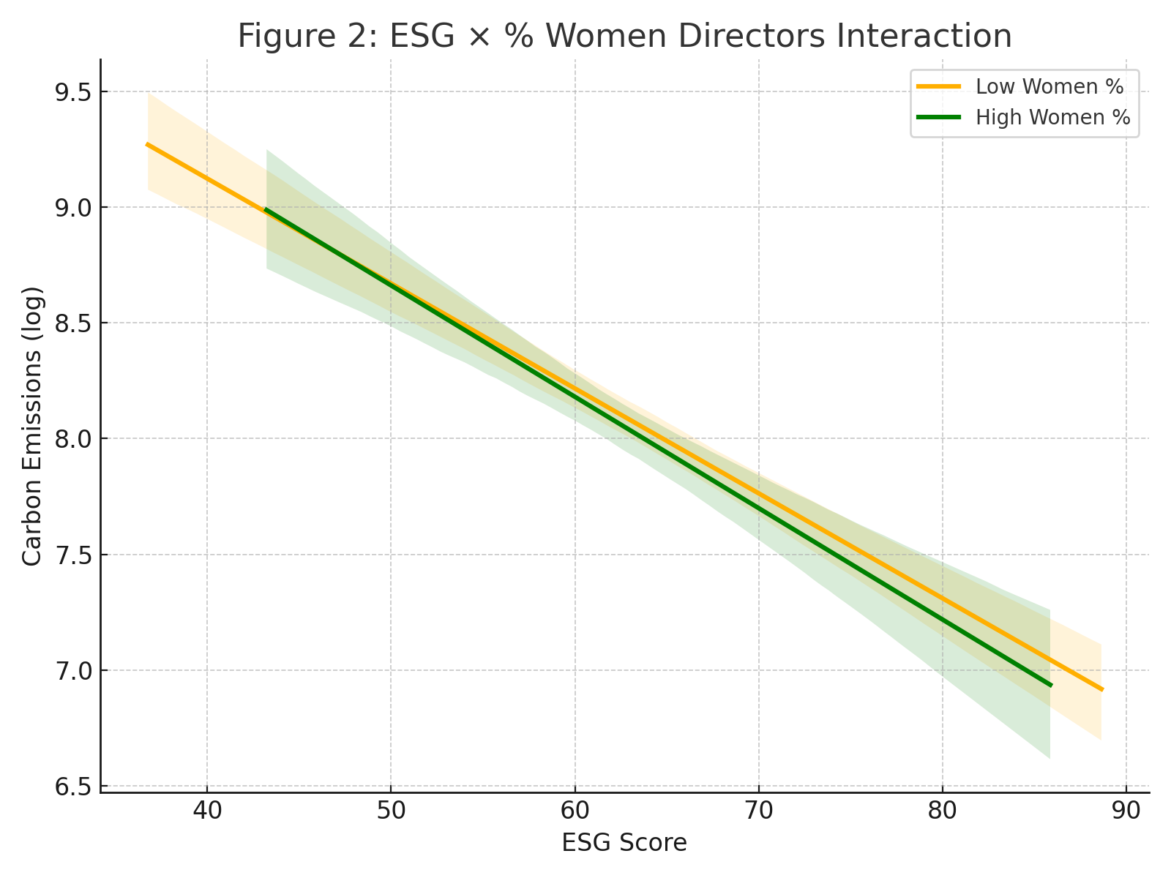
Figure 2 shows the relative importance of input variables in predicting corporate carbon emissions using a Random Forest model, a type of machine learning algorithm that is especially effective for regression and classification tasks. The ESG Score has the highest feature importance, meaning it's the most powerful predictor of a firm’s carbon emissions among the variables considered.

FIGURE 2. Feature Importance from Random Forest
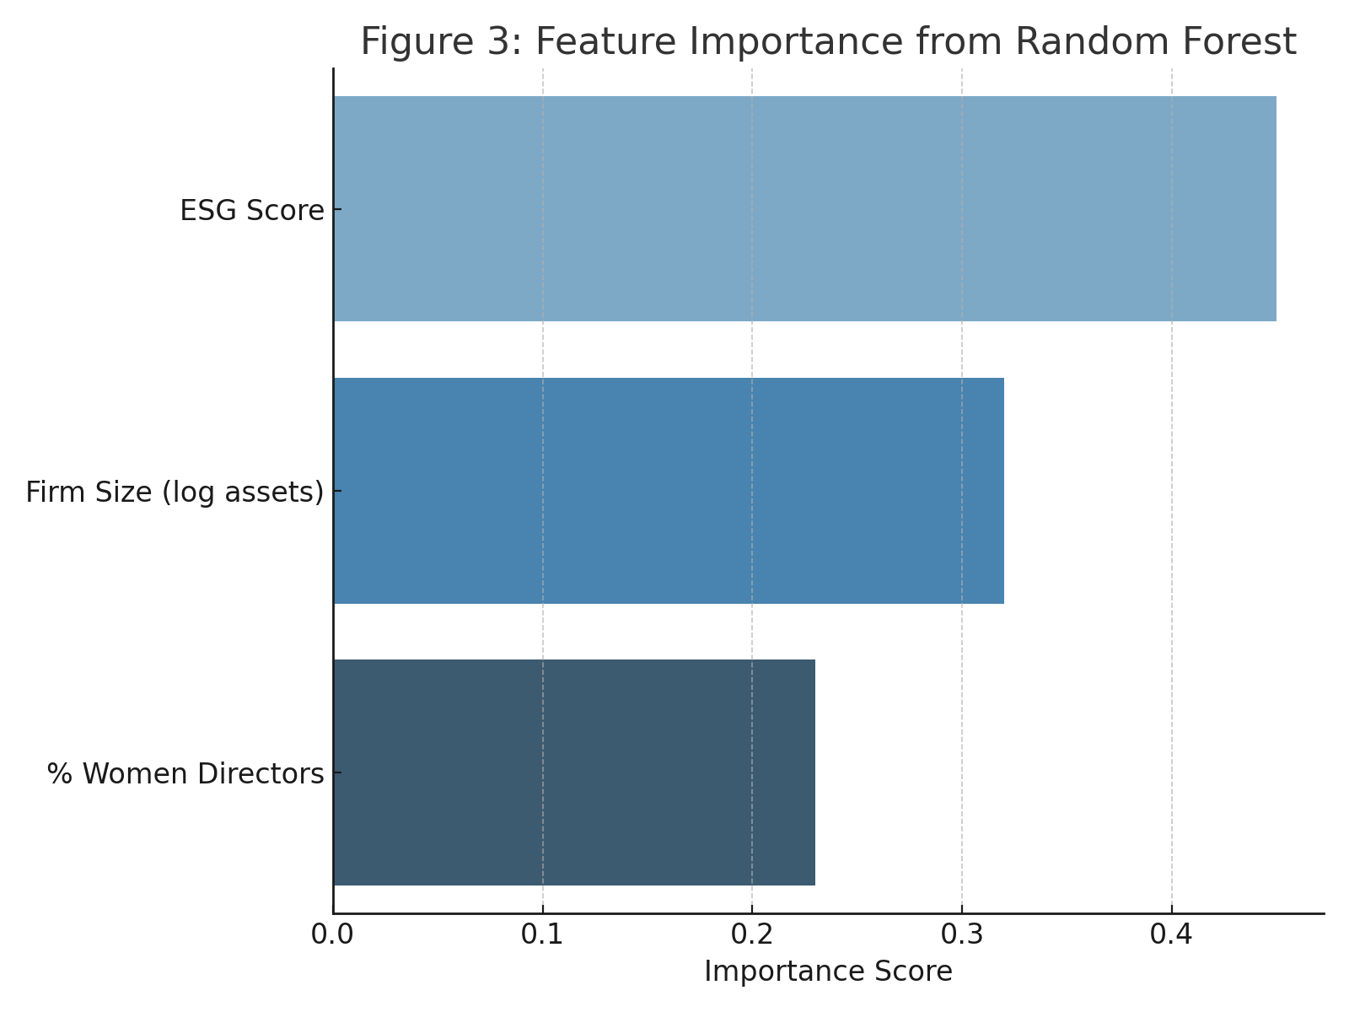

Figure 3 uses K-Means clustering to group companies based on their ESG scores and board gender diversity levels. Clustering is an unsupervised learning technique used to identify natural groupings or patterns in data.

FIGURE 3. K-Means Clusters by ESG Score X % Women Directors

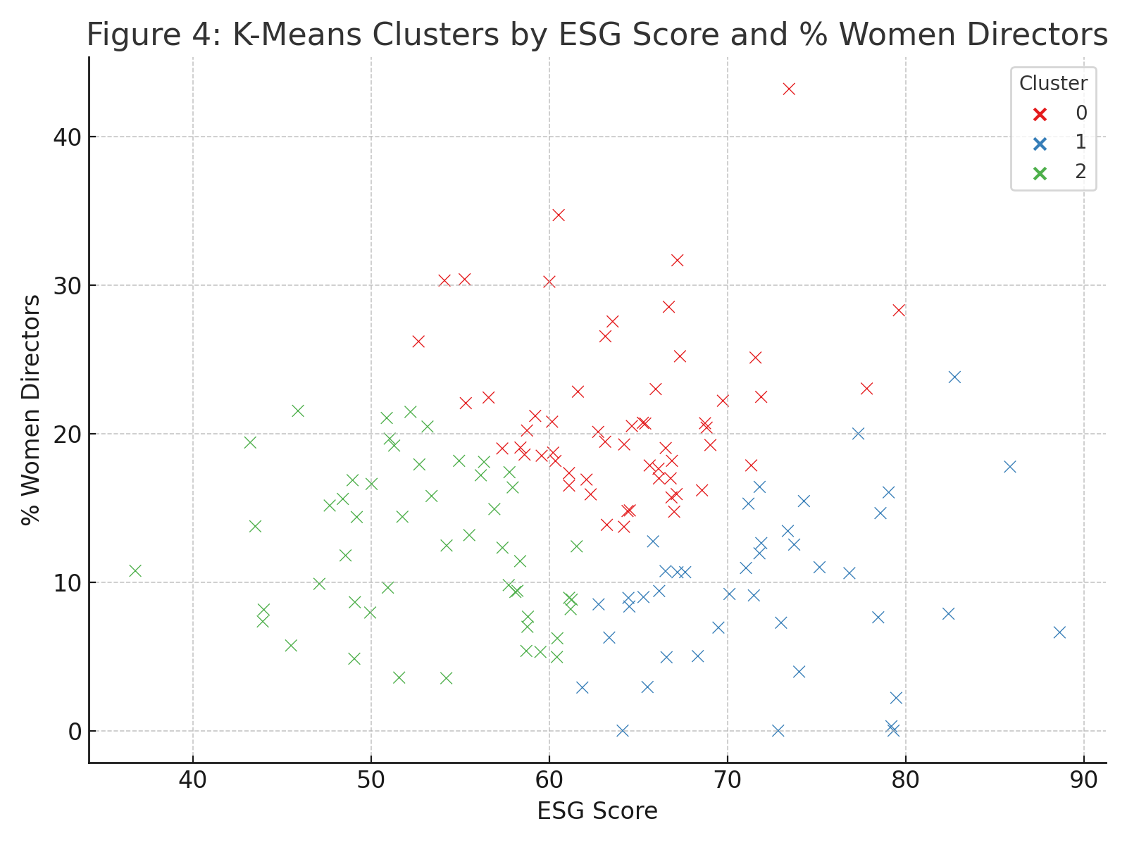

CONCLUSION
The presence of such inquiry emerges pertinent since it makes particular presumption: assuming the carbon discharges of public firms in Malaysia and Indonesia are reflected in their ESG scores from 2018 to 2023. Additionally, study illustrates significance of female representation on boards in relationship among an organization's carbon emissions and ESG score. By validating these trends, forecasting provides participants with a data-driven method for evaluating sustainability efficiency or vulnerability. The findings indicated significant inverse relationship among the ESG score as well as carbon emanations. Additionally, results indicated that female significantly lessen connections among carbon gases releases and ESG score in terms of softening action. Data analytics methods such as regression modeling, machine learning, and clustering enabled a deeper understanding of these complex relationships. Such conclusions have insinuations for politicians, investors, and corporate boards seeking to align authority structures with sustainability goals.

ACKNOWLEDGEMENTS

We would like to thank Universiti Sains Islam Malaysia,Universitas Padjajaran, Bandung, Indonesia and Universitas Muhammadiyah Yogyakarta, Indonesia (UMY Research Fellow Program 2025) for their helpful feedback and support.

References
1. H. Song, H. Wu, and H. Zhang, Int. J. Contemp. Hosp. Manag. 36, 1534–1556 (2024).
2. A. G. Olabi, K. Obaideen, K. Elsaid, T. Wilberforce, E. T. Sayed, H. M. Maghrabie, and M. A. , Renew. Sustain.
Energy Rev. 153, 111710 (2022).
3. Y. Qian and Y. Liu, J. Environ. Manage. 367, 122016 (2024).
4. Y. Chan, K. Hogan, K. Schwaiger, and A. Ang, J. Impact ESG Invest., 1, 26–45 (2020).
5. R. Manita, M. G. Bruna, R. Dang, and L. H. Houanti, J. Appl. Account. Res. 19, 206–224 (2018).
6. F. Paolone, M. Pozzoli, M. Chhabra, and A. Di Vaio, J. Knowl. Manag. 28, 106–131 (2024).
7. P. G. Thirumagal, A. Tirkey, and S. Suresh, “Moderating effect of board size and board independence between
women on board and ESG,” in International Conference on Economics, Business and Sustainability (Springer
Nature Singapore, Singapore, 2023), pp. 16–25.
8. A. Issa and J. R. Hanaysha, Int. J. Account. Inf. Manag. 31, 623–646 (2023).
9. H. Yahya, Corporate Governance: The International Journal of Business in Society (2023).
10. A. Baratta, A. Cimino, F. Longo, V. Solina, and S. Verteramo, Sustainability 15, 6685 (2023).
11. R. Benkraiem, M. Qureshi, A. Saeed, and C. Zopounidis, Financ. Mark. Inst. Instrum. (2024).
12. Y. Cong, C. Zhu, Y. Hou, S. Tian, and X. Cai, Front. Environ. Sci. 10, 977049 (2022).
13. Y. Jiang and Q. Tang, Pac. Account. Rev. 35, 534–561 (2023).
14. S. Treepongkaruna, H. H. Au Yong, S. Thomsen, and K. Kyaw, Bus. Strategy Environ. (2024).
15. Y. Zhao, Y. Gao, and D. Hong, J. Knowl. Econ., 1–35 (2024).
16. P. Hardiningsih, I. Januarti, E. N. A. Yuyetta, C. Srimindarti, and U. Udin, Int. J. Energy Econ. Policy 10, 18–25
(2020).
17. M. Jeriji, W. Louhichi, and Z. Ftiti, Br. J. Manag. 34, 555–575 (2023).
18. J. L. Robertson, A. W. Montgomery, and T. Ozbilir, Bus. Strategy Environ. 32, 4015–4027 (2023).
19. J. Cao, J. Li, and G. Wang, Finance Res. Lett. 40, 101729 (2021).
20. F. Li, Y. Wang, and Y. Zhang, Technol. Forecast. Soc. Change 186, 122165 (2023).

