A Regression-Based Analysis of Economic Factors Influencing Fertility Trends in Malaysia
Nur Azulia Kamarudin^{1, a)} and Nur Farzana Sukhami^{2, b)}
^{1,2} School of Quantitative Sciences, Universiti Utara Malaysia, 06010 UUM Sintok, Kedah, Malaysia.
¹Institute of Strategic Industrial Decision Modelling, Universiti Utara Malaysia, 06010 UUM Sintok, Kedah, Malaysia.
^{a)} Corresponding author: nurazulia@uum.edu.my
^{b)} nur_farzana3@sqs.uum.edu.my
Abstract. Over the past four decades, Malaysia’s fertility rate has fallen sharply and has remained below the replacement level of 2.1 births per woman since 2013. This persistent decline raises concerns about population ageing and its long-term impact on the economy and society. This study examines how key economic factors, namely inflation, GDP per capita, female unemployment, and male unemployment, affect the fertility rate in Malaysia. Secondary time-series data from 1982 to 2022 were obtained from the Department of Statistics Malaysia (DOSM) and the World Bank. Multiple linear regression analysis was used after cleaning the data and checking for assumptions such as linearity, normality, homoscedasticity, and multicollinearity. Male unemployment was excluded from the final model due to high multicollinearity. The results show that log GDP per capita has a strong and statistically significant negative relationship with fertility, supporting the quantity–quality trade-off theory, which suggests that higher household income leads to fewer children but greater investment per child. In contrast, inflation and female unemployment have weak and statistically non-significant effects. Nevertheless, the negative trend in female unemployment suggests that job insecurity may discourage childbearing. The model explains 95.9% of the variation in fertility rate, but the presence of positive autocorrelation in residuals indicates that results should be interpreted with caution. Overall, the findings highlight the importance of economic stability in shaping fertility decisions. Future research should consider social and cultural factors and use time-series techniques that account for autocorrelation.

Introduction
Over the past 50 years, the global total fertility rate has steadily declined from 5 to 2.3 births per woman [1]. Similarly, Malaysia reflects this trend, recording its lowest fertility rate in 2022. According to the [2], the fertility rate represents the average number of children a woman between ages 15 and 49 is likely to have. Since 2013, Malaysia's fertility rate has consistently remained below the replacement level of 2.1, the rate necessary for a stable population. [1] highlights three main reasons for this decline: women’s empowerment, reduced child mortality, and rising child-rearing costs.
Moreover, raising a child in Malaysia poses significant financial challenges, costing approximately RM400,000 to RM1.1 million per child. Furthermore, inflation, measured by the Consumer Price Index (CPI), increases these expenses by rising living costs. As inflation rises, consequently, so do the costs related to child-rearing, disproportionately impacting lower-income households [3].
Additionally, economic conditions, often evaluated through Gross Domestic Product (GDP) per capita, strongly influence fertility decisions. Generally, an increase in GDP per capita signals improved economic circumstances. However, research by [4] indicates that higher GDP per capita typically associates with lower fertility rates. This observation aligns with [5] who explain this through the quantity-quality trade-off theory: higher-income families choose fewer children but invest more heavily in each child's education and healthcare, enhancing human capital and productivity [6].
Employment status also significantly affects fertility decisions, although its effects vary between genders. Typically, unemployment generates financial instability, leading to lower fertility rates. In particular, studies by [7] and [8] suggest male unemployment negatively affects fertility due to societal expectations that men are the primary providers. Consequently, unemployed men often experience greater financial and emotional distress, discouraging larger families. On the other hand, unemployed women may have more time for family caregiving, which can sometimes positively affect fertility despite reduced household income.
In the meantime, Malaysia's economy still faces considerable uncertainty regarding future economic growth and inflation [9]. These ongoing uncertainties greatly influence family planning decisions, often prompting families to remain smaller. Despite the declining fertility rate, Malaysia's overall population remains stable, mainly due to increased life expectancy [10]. Nevertheless, the demographic structure is shifting and rapidly ageing, creating economic challenges such as higher healthcare costs [11] and reduced workforce productivity [12]. Therefore, addressing the declining fertility rate and its demographic implications is critical for Malaysia’s long-term economic and social sustainability.

Methodology

Data Collection
Secondary data from 1982 to 2022 has been retrieved from DOSM and the World Bank, covering fertility rate, unemployment (male and female), inflation, and GDP per capita. Missing unemployment data for 1991 and 1994 have been imputed using the mean of adjacent years to avoid bias. GDP per capita is transformed into its natural logarithm to linearise its exponential growth pattern and align its scale with percentage-based variables. This log transformation also aids in improving model fit and normalising residuals. The fertility rate serves as the dependent variable, while the four economic indicators are the independent variables.

Assumption Checks before Multiple Linear Regression
Several assumptions of the multiple linear regression model are checked to achieve a reliable result. The first assumption is checking the linearity between the independent and dependent variables, while the second assumption is that multicollinearity must not exist in the data. Multicollinearity exists when the independent variables are highly correlated. The existence of multicollinearity is checked using the Pearson correlation coefficient and Variance Inflation Factor (VIF) value. The Pearson correlation coefficient is calculated to test the strength of the linear correlation between two variables. The value that is greater than 0.5 indicates a strong relationship, while the value that is lower than 0.5 indicates a weak relationship. A correlation matrix is then generated to assess the relationships among the variables and to provide a preliminary check for potential multicollinearity, particularly among the independent variables. Multicollinearity is said to exist when the VIF value exceeds 10. The variable with largest VIF value is removed from the model [13].

Multiple Linear Regression Modelling
An initial multiple linear regression is estimated with fertility rate as the dependent variable and all four economic indicators as predictors. The Ordinary Least Squares (OLS) method is employed for model estimation. The model fit is assessed using R² (proportion of variance explained) and Adjusted R² (variance explained adjusted for the number of predictors). The overall significance of the regression model is also evaluated using F-statistics, which tests whether the group of independent variables taken together explains a significant portion of the variation in the dependent variable.

Assumption Checks after Multiple Linear Regression
The assumptions of normality of residuals and homoscedasticity are checked through scatter plot, while independence of residuals is checked using the Durbin-Watson test. The Durbin-Watson values that are close to 2 indicate there is no autocorrelation among the residuals.

Model Interpretation
The multiple linear regression analysis is done to identify the effect of the inflation rate, log GDP, female unemployment, and male unemployment on the fertility rate.

Results and Discussion
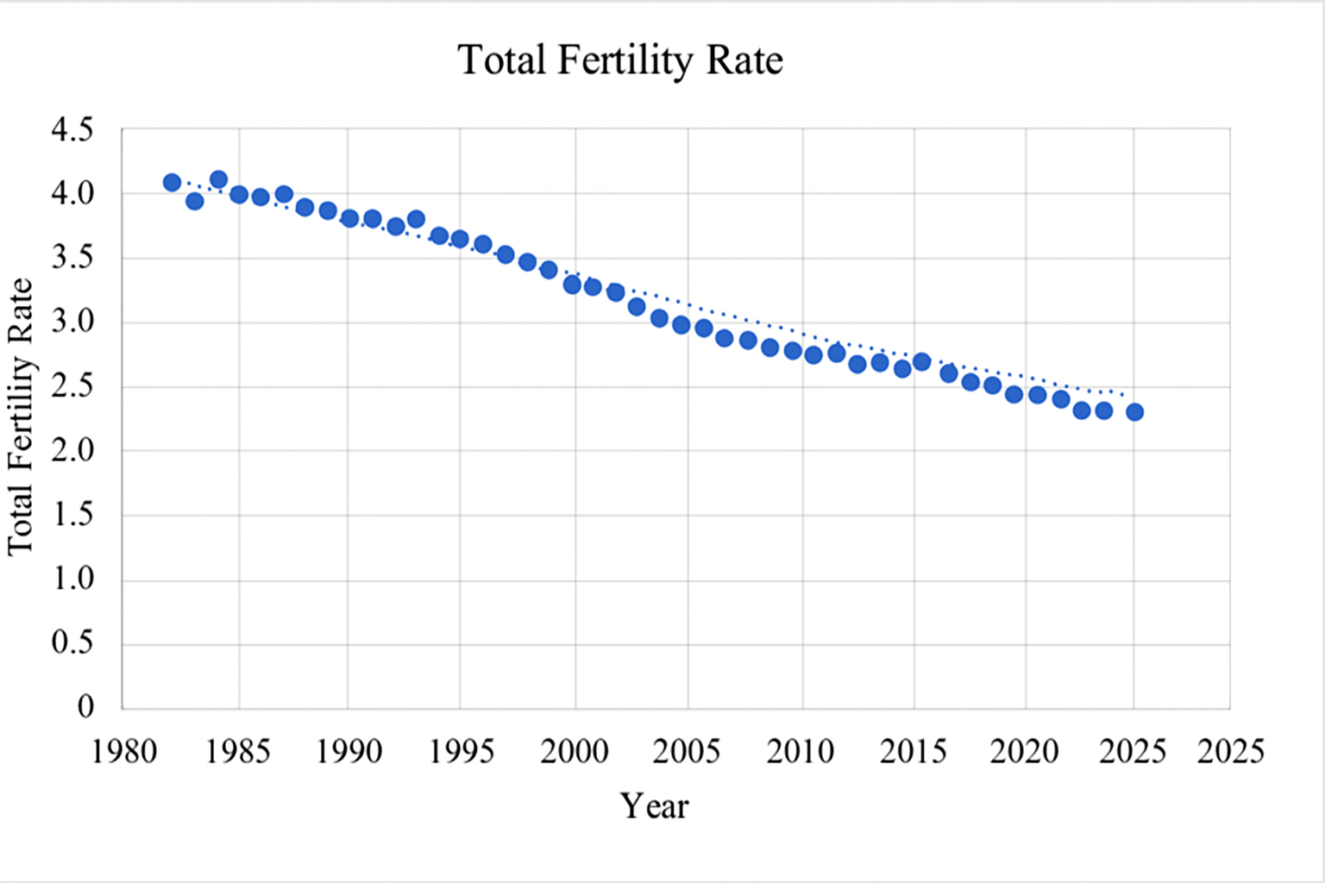
Figure 1 presents the fertility rate in Malaysia from 1982 until 2022. It has shown a continuously declining trend over time.
FIGURE 1: Total Fertility Rate in Malaysia from 1982 to 2022 (DOSM, 2022)
Table 1 shows the summary statistics for the study variables. The fertility rate averaged 2.76 children per woman, while inflation averaged 2.55%. Female unemployment averaged 4.31%, slightly higher than male unemployment at 3.65%. The log-transformed GDP per capita had a mean of 8.77, showing gradual economic changes across the study period.
TABLE 1. Summary Statistics
Variable | Mean | Std Dev
Fertility_Rate | 2.76 | 0.75
Inflation | 2.55 | 1.52
Female Unemployment | 4.31 | 1.43
Male Unemployment | 3.65 | 1.10
Log_GDP | 8.77 | 0.38

Assumption Checks before Multiple Linear Regression
Inflation rate, female unemployment, and male unemployment have showed a positive linear relationship with the total fertility rate, while only log GDP shows a negative linear relationship with the total fertility rate. All the independent variables have a linear relationship with the dependent variable. So, the linearity assumption is fulfilled.Table 2 shows the correlation of the fertility rate with each independent variable. The log GDP has the strongest negative correlation with the correlation coefficient value of -0.98 with the fertility rate. Meanwhile, the inflation rate shows the weakest positive correlation with the fertility rate, with the correlation value 0.27. Female and male unemployment are highly correlated (0.94), indicating potential multicollinearity concerns in regression modelling.
TABLE 2. Pearson Correlation Matrix
Variable | Fertility Rate | Inflation | Log GDP | Female Unemployment | Male Unemployment
Fertility Rate | 1.00 | 0.27 | –0.98 | 0.60 | 0.41
Inflation | 0.27 | 1.00 | –0.22 | –0.19 | –0.34
Log GDP | –0.98 | –0.22 | 1.00 | –0.68 | –0.51
Female Unemployment | 0.60 | –0.19 | –0.68 | 1.00 | 0.94
Male Unemployment | 0.41 | –0.34 | –0.51 | 0.94 | 1.00

Table 3 shows the VIF values for each variable. Among all the variables, female unemployment and male unemployment show a high VIF value of 18.264 and 14.363, respectively. While the VIF value for the inflation rate is 1.494 and 2.926 for log GDP. From the results, female unemployment and male unemployment have a VIF value that is greater than 10, indicating a strong correlation between the two variables. Thus, there is a multicollinearity problem with this data.
TABLE 3. VIF value
Variable | VIF value
Inflation Rate | 1.494
Log GDP | 2.926
Female Unemployment | 14.363
Male Unemployment | 18.264

To fix the multicollinearity problem in this data, the variable that has a higher VIF value is removed from the data. So, the male unemployment is removed from this data because the VIF value of the male unemployment is larger compared to the VIF value of the female unemployment. Then, the VIF values are computed again, and the results are shown in Table 4.

TABLE 4. VIF Value Output (without male unemployment)
Variable | VIF value
Inflation rate | 1.352
Log GDP | 2.427
Female unemployment | 2.400

The VIF value for the inflation rate, log GDP, and female unemployment is 1.352, 2.427, and 2.4 respectively, which are all lower than 10. This indicates that multicollinearity is now absent in the data. Since there is no longer a multicollinearity problem in the data, the second assumption has been fulfilled.

Multiple Linear Regression
TABLE 5. Estimated Model
Variable | Coefficient (β) | Std. Error | t-value | p-value
Constant | 21.005 | 1.03 | 20.57 | <0.001
Inflation Rate | 0.015 | 0.019 | 0.55 | 0.583
Log GDP per capita | -2.060 | 0.10 | –19.96 | <0.001
Female Unemployment | -0.050 | 0.027 | –1.90 | 0.066
R² = 0.959
Adjusted R² = 0.955
F (3,37) = 293.675, p < 0.001

Table 5 shows that the R² value for this model is 0.959 which indicates that 95.9% of the variation in the dependent variable can be explained by the independent variable. Meanwhile, the adjusted R² = 0.955 indicates 95.5% of the variation is explained by the independent variable that affects the dependent variable. This implied that the reduced model as an excellent model fit. The F-test indicates that the independent variables jointly explain a statistically significant proportion of variance in fertility rate (p < 0.001). Thus, the model is significant overall.

The final multiple linear regression model can be written as follows:

$$\hat{y }=21.005 + 0.0106IR - 2.0672LGDP -0.051FU$$
It can be interpreted that the fertility rate will increase by 0.0106 with a unit increase in the inflation rate when the log GDP and the female unemployment remain constant. Meanwhile, the fertility rate will decrease by 0.0516 with an increase in one unit of female unemployment when the inflation rate and log GDP remain constant. Finally, with a 1% increase in GDP it will decreases the fertility rate by 2.060/100 units if the inflation rate and female unemployment remain constant. Nevertheless, log GDP is the only statistically significant predictor (p-value <0.001), showing a strong negative relationship between economic output per person and fertility.

Assumption Checks after Multiple Linear Regression
The assumptions of normality of residuals and homoscedasticity are fulfilled. Meanwhile, the Durbin–Watson statistic for the model is 0.585 demonstrating strong positive autocorrelation in the residual. Values below 1.5 indicate problematic positive autocorrelation, which violates the classical assumption of independent errors in regression analysis [14]. This condition is common in time series data, where observations across years are not independent. The presence of autocorrelation may result in underestimated standard errors and unreliable significance tests for the model coefficients, thus affecting the robustness of inference [15]. While the model demonstrates strong explanatory power, standard OLS inference should be interpreted cautiously [16]. Nonetheless, the multiple linear regression model is retained for this analysis to provide an exploratory assessment of the relationships between fertility rate and the selected economic variables. The coefficient estimates remain unbiased under autocorrelation.

Conclusion
Malaysia’s fertility rate has dropped significantly over the past 40 years. The relationships found in this study between the economic factors and fertility rate align with both economic theory and previous international research.
Inflation showed a small positive link with fertility, but this relationship was not statistically significant. This may be because Malaysia’s inflation rates have generally been moderate, and families respond to price changes in different ways [17]. In contrast, log GDP per capita had a strong and significant negative effect on fertility. This supports the demographic transition theory and the quantity–quality trade-off proposed by [5] which suggests that as household income increases, families tend to have fewer children but spend more on each child’s health, education, and overall development. Female unemployment was also negatively related to fertility, though the effect was only marginally non-significant. This suggests that when women face job insecurity or reduced household income, they may delay or avoid having children. This finding aligns with previous studies showing that unstable employment conditions can reduce the likelihood of starting or growing a family [18, 19].
Nevertheless, the violation of the independence assumption means that standard errors and p-values may be underestimated, and statistical significance should be interpreted with caution. Thus, future analyses should consider autocorrelation-robust techniques for example ARIMA, Prais-Winsten and Cochrane-Orcutt to ensure reliable inference for fertility trends in longitudinal data [20].
Moreover, this study only looks at economic factors and does not include social, cultural, or policy influences. Future research should consider including more variables too. Overall, the results suggest that economic stability, both at the national and household level, plays a key role in shaping fertility decisions in Malaysia.

References
- P. Alvarez, What Does the Global Decline of the Fertility Rate Look Like? (World Economic Forum, Geneva, 2022).
- Department of Statistics Malaysia, Vital Statistics, Malaysia, 2022 (Department of Statistics Malaysia, Putrajaya, 2022).
- J. Y. Koyuncu and Y. Okşak, Balkan J. Soc. Sci. 21, 7 (2022).
- J. R. B. D. Cruz, M. C. M. Dequilla, and A. C. D. Pizarro-Uy, J. Econ. Finance Acc. Stud. 4, 259 (2022).
- G. S. Becker and R. J. Barro, Q. J. Econ. 103, 1 (1988).
- S. Ross, What Is Human Capital and How Is It Used? (Investopedia, New York, 2023).
- J. M. Fernandez-Crehuet, L. A. Gil-Alana, and C. M. Barco, Soc. Indic. Res. 152, 1177 (2020).
- G. Alderotti et al., Demography 58, 871 (2021).
- C. Lee, Uncertainties in Malaysia’s Economic Recovery (ISEAS–Yusof Ishak Institute, Singapore, 2022).
- T. N. Peng, Bracing for Low Fertility in Malaysia (ISEAS–Yusof Ishak Institute, Singapore, 2020).
- P. Rao, Visualizing the World’s Plummeting Fertility Rate (Visual Capitalist, Vancouver, 2023).
- S. N. A. Mohd, A. A. Ishak, and D. P. Selvaratnam, Front. Public Health 9, 731554 (2021).
- S. L. Turner et al., BMC Med. Res. Methodol. 21, 181 (2021).
- R. T. Baillie et al., Econometrics Journal 28(2), 131(2022).
- M. Petit-Bois, Behav. Res. Methods 48, 1475 (2016).
- N. S. M. Shuhaimy, J. Econ. Malaysia 59, 25 (2025).
- A. P. Kristensen and T. Lappegård, Demogr. Res. 46, 1037 (2022).
- D. D. K. Örsal and J. R. Goldstein, Vienna Yearb. Popul. Res. 12, 1 (2014).
- C. Bottomley et al., Stat. Med. 42, 1277 (2023).
- A. Bhandari, Multicollinearity: Causes, Effects and Detection Using VIF (Updated 2023) (Analytics Vidhya, Mumbai, 2020).

