Exploring the Moderating Impact of Online Users’ Demographic Characteristics
Zoha Rahman^{1, a)}, Lubaba Nawar^{2, b)}, Sharmin Akhter^{3, c)}, Sakib Hossain ^{2, d)}, Jubayer Asadullah^{4, e)} and Nashid Bintey Hayder ^{5, f)}
¹ UCSI University, 1, Jalan Menara Gading, 56000 Kuala Lumpur, Malaysia
²University of Liberal Arts Bangladesh, 688 Beribadh Road, Mohammadpur, Dhaka - 1207, Bangladesh
³Bangladesh University of Business and Technology, Mirpur-2, Dhaka-1216, Bangladesh
⁴Midland Bank, Dhaka-1212, Bangladesh
⁵BGMEA University of Fashion and Technology, Nishatnaga, Turag, Dhaka-1230, Bangladesh

^{a)} Corresponding author: joha_dusbe@iub.edu.bd
^{b)} lubaba.nawar@ulab.edu.bd
^{c)} sharmin.a@bubt.edu.bd
^{d)} sakib.hossain@ulab.edu.bd
^{e)} jubayer.asadullah@midlandbankbd.net
^{f)} nashidibaju@gmail.com

Abstract: Within the Social Media channels, fan-pages are now getting a widely recognized marketing platform, while their contribution towards increasing sales is significant. Now, online brand pages provide more selling opportunities for Business-to-Consumer (B2C) organizations by attracting traffic to their relevant websites. Hence, it will be suitable to clarify users’ online behavior concerning the marketer’s Facebook brand pages and their equivalent engagement and purchase goals. Thus, the current study tries to find out the impact of fan-page engagement activities on social media users’ purchase action. This study aims to examine the marketing outcome of users’ engagement in online brand pages embedded in fan-page to suggest an amalgamation of current conceptualizations. For this purpose, data were collected from social media activists on fan-pages. Also, it was previously found that the consumer engagement actions depend on the characteristics of users (i.e., who is engaged). Thus, we explored the moderating impact of social media users’ demographic profile (income, gender, and age) between the relationships of users’ online engagement actions and their purchase intention. The findings of this study will contribute to the knowledge relating to consumer behavior, which will help marketers in improving their sales-relevant actions. The study aims to provide an elementary guideline for academicians and marketers to infer the notion of fan-page engagement activities and their impact on online users’ purchase intention, as well as exploring the moderating role of the user’s characteristics.

INTRODUCTION
In today’s world, social media brand pages have become one of the most effective tools for Business to Consumer (B2C) marketing. These online platforms not only help brands connect with their consumers but also boost sales and pushes website traffic. However, while the popularity of the fan pages grows, it is still not clarified how engagement actions on these pages actually translate into consumer’s purchase intention. Previous research highlights that demographic factors like gender, age, and income play an important role in shaping how people behave online and how they make buying decisions [1]. Yet, there is still little evidence on how these demographics might influence or moderate the link between users’ engagement activities and their purchase intentions. Understanding these distinctions is essential for marketers who want to design content strategies that truly resonate with different consumer groups. This study therefore examines the extent to which fan-page users’ engagement activities (like, comments, shares) influence their purchase intention and determines how demographic characteristics (gender, age, and income) moderate the strength and direction of this relationship. The study will provide the guidelines to the academicians and marketers to interpret the perception of fan-page engagement actions and its impact on consumer’s purchase intention, as well as opening a vast area of unexplored researches on the subject of social media.

LITERATURE REVIEW

Previous research conducted by [1, 2] shows that fun interactions, a communal feeling, solid content form trust and loyalty, making people come back for the product. On social media, interactions like this nature peoples’ feelings about the particular brand and inspires them to have stronger purchase intention [3]. An idea called Stimulus – Organism – Response (S - O - R) confirms: Entertaining posts (the stimulus) ignites feelings and thoughts (the organism), which ultimately leading to purchasing action (the response) [4]. These findings support the observation that interaction is a crucial precursor of purchase intention through different nations and circumstances [5]. Income, age and gender may determine how interaction in social media shapes consumer’s purchase intention. Gender often influences this relationship as women are more sensitive and respond more to influencer validation compared to men [6]. The effects of age ranges are mixed. Although younger consumers are more active interacting, but transition from interaction to purchase intention shows insignificant variation across different age groups [7]. Regarding employment and income variation, consumers of higher income range effectively convert interaction into purchase and confide more in transaction online [8]. Most studies use PLS-SEM or SEM frameworks, frequently conducting moderation analysis or using multiple groups to test the demographic effects on these relationships [9]. Regardless of this progress, very few models assemble all these three moderators- income, age and gender within a combined brand-page engagement – purchase intention framework. The present study addresses this gap and applies SEM to test the three moderators, proposing a more all-inclusive understanding of the influences of demographics on social media brand engagement.

METHODOLOGY and Hypothesis Development
This study analyzed how Malaysian consumers use Facebook fan-pages. An online survey was conducted to test the proposed hypotheses, focusing on twelve active B2C fan-pages with strong user growth and engagement. A self-administered questionnaire, developed from previous studies, was shared with followers of these pages. It measured sixteen key factors related to content, social and cultural values, emotions, engagement, and purchase intention using a 5-point Likert scale [10, 11]. Before conducting the main survey, a pilot test was run to ensure the questions were clear and reliable. In total, responses from 307 followers of diverse backgrounds were analyzed using Structural Equation Modeling (SEM) to assess the research model and test the hypotheses.

Relationship between online user engagement and Purchase Intention:

User engagement is a relationship between consumers and brands that initiates a two direction connectivity [12]. Brand engagement usually involves emotional, cognitive and different stages of behavior while interacting with the brand [13]. Customers’ engagement in online fan-pages shows to directly affect purchasing intention [1, 2, 3]. The Stimulus–Organism–Response (S–O–R) framework suggests that engaging or entertaining content (stimulus) triggers consumers’ internal emotions and cognitions (organism), which in turn drive their purchasing behavior (response) [14]. Based on this insight we propose:

H1: Fan-page interaction positively impacts purchase intention

Moderating impact of online user demographic characteristics:

Gender. Gender frequently moderates this relationship, as women tend to be more responsive and sensitive to influencer endorsements than men [6, 15]. According to [16] women tend to see themselves as more alike the female influencer than the male influencer, which fosters stronger interactions and, consequently, enhances both brand attitude and engagement with posts. For men, however, there was no significant difference between male and female influencers in terms of brand attitude or post engagement via perceived similarity and interaction. Thus:

H2: Variations in gender affect how fan-page engagement influences buying intentions

Age. The influence of age appears inconsistent. While younger consumers tend to engage more actively online, the shift from engagement to purchase intention does not differ significantly across age groups [7]. A study conducted on Australian context reveals, that the factors influencing consumers’ intentions to book travel online vary between different generations [17]. Thus:

H3: Variations in age influence how fan-page engagement affects buying intentions.

Income. Consumers with higher income levels are generally more successful in translating online interactions into actual purchases and tend to exhibit greater confidence in conducting online transactions [8]. On the other hand, consumers of low income only engage in online activities which they perceive as risk free and will not affect their security, so they have lower tendency to purchase products from online [18]. Thus:

H4: Differences in income affect how fan-page engagement influences buying intentions

THE STRUCTURAL MODEL ANALYSIS
The structural model was evaluated by analyzing path coefficients (beta weights), which reflect the strength of relationships between independent and dependent variables. Of the seven proposed paths, six demonstrated statistical significance and a positive effect on the predicted constructs.

The effect of engagement on purchase intent was significant, showing a strong positive relationship (β = 0.71, p < 0.001, t-value = 3.69), supporting the acceptance of H1.

We analyze the following key considerations to understand how demographic characteristics moderate the effect of fan-page engagement on purchase intention:
Multi-group Moderation Analyses: A moderator is a variable, either qualitative or quantitative, that alters the strength or direction of the relationship between an independent and dependent variable. It influences the correlation between two variables, affecting the relationship’s intensity [19].
Establishing an Analytic Framework for Testing Moderator Effect: Using a path diagram as both a descriptive and analytical tool enables the creation of a framework to assess the correlational and experimental aspects of a moderator variable [9]. The key elements of a moderator are outlined in a model with three causal paths: the effect of the predictor on the dependent variable (Path IV to DV), the effect of the moderator on the dependent variable (Path M to DV), and the interaction between these two (Path IVM to DV). The moderator hypothesis is supported if the interaction path (IVM to DV) is significant. Main effects for the predictor or moderator may exist, but they are not directly relevant to testing the moderator hypothesis.
In this study, we outline the analytical procedures for testing moderation hypotheses appropriately. Moderation implies that the moderator variable modifies the causal relationship between two variables. The differential effect of the independent variable on the dependent variable must be assessed statistically as a function of the moderator. The method for testing these effects depends on the measurement level of the moderator and independent variables. In this analysis, we consider cases where the moderator is categorical (e.g., gender, age, income) and the independent variable is continuous. The standard approach involves correlating engagement with purchase intent separately for each group (e.g., gender, age, income) and then comparing the differences. However, correlations can be affected by variance changes [20]. Regression coefficients, which are less sensitive to measurement error in the dependent variable or variance differences in the independent variable, should be tested first before evaluating the slopes individually [21].
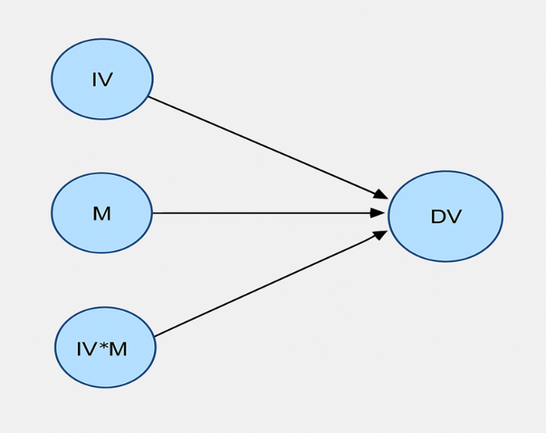 | 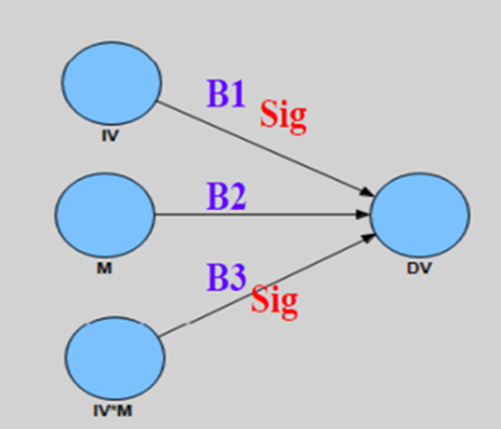
(a) | (b) | (c)
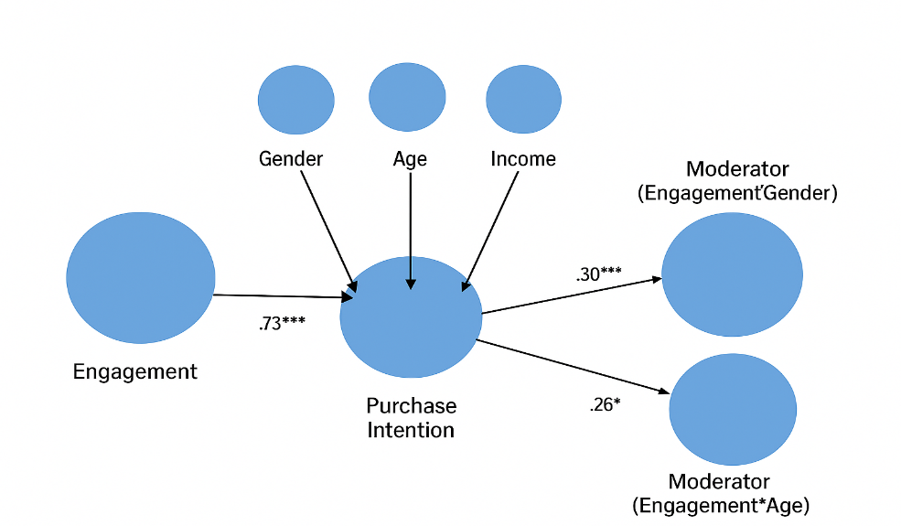
(d)

Figure 1. Schematic Diagram displays moderation analysis executed by SMART PLS in section - (a). When path “B3” is found significant, the moderation ensues is displayed in section (b) and (c). The Model of Moderation Analysis in SMART-PLS is shown in section (d).

Moderation ensues when the path “B3” is found significant in the model of moderator analysis. This is shown in the section (b) and (c) of Figure1.The software that is used for the execution of the analysis is SMRT_PLS. The output that is obtained and the analytical model of our moderation - both is exhibited in section (d).

TABLE 1. Result of moderation output based on hypothesis engagement impacts purchase intention considering moderator gender
Gender category | Estimation | P-value | Moderator Estimate
Female participants | .14 | 3 | .73**
Male participants | .55 | 0 | .73**

TABLE 2. Result of moderation output based on hypothesis engagement impacts purchase intention considering moderator age
Age category | Estimation | P-value | Moderator Estimate
Young | .57 | 2 | .25
Middle | .69 | 0 | .25
Adults | .55 | 1 | .25

TABLE 3. Result of moderation output based on hypothesis engagement impacts purchase intention considering moderator income
Employment Status | Estimation | P-value | Moderator Estimate
Employed Follower | .76 | 0 | .84***
Unemployed Follower | .37 | 2 | .84***

Moderation analysis was mainly executed on multiple groups in order to identify effect in results due to variations in income, trust and gender group. As a measure of the projected structural model this analysis is based on hypothesized relationships. The moderating effects that are significant are confirmed by statistics of hypothesized Z-score. The result of moderation output based on hypothesis engagement impacts purchase intention considering moderator gender, age and income, obtained in the analysis can be observed in the Tables1, Table2 and Table3 respectively.

The result of moderation analysis confirms the validation that, variations in gender type affect fan-page engagement transitioning into buying intentions. It implies that the relation between intention of purchase and engagement varies significantly across male, female gender groups. Percentage of respondents that consist of females are 61%, and remaining 39% consist of males. Association between intention of purchase and engagement, the male followers exhibited (β=.34, p<.05)) minor impact, on the other hand, females displayed medium (β=.56, p<.01) impact. Hence, the outcomes imply that female participants show greater tendency to exhibit purchasing intention in comparison to male participants.

In moderation analysis of age group where three categories (below 20-young; 20-24 as middle aged; above 40 as adults) are considered, the outcomes obtained shows no moderating effect that can be significant. This ensures that hypothesis stating that, variations in age influence fan-page engagement transitioning into buying intentions can be rejected. The portion of young, middle aged and adult respondents are 36%, 43% and 21% respectively. Of these three age categories, the strongest intention of purchasing (β=.62, p<.01) is shown by the middle-aged group category, trailed by the group that consists of young age followers (β =.51, p<.05), and then comes the adult group (β=.47, p<.05). The outcomes finalizes that followers of all three categories show intention of purchasing.

When two groups of income are considered: employed and unemployed, the outcomes confirm the validation of hypothesis stating that, differences in income affect fan-page engagement transitioning into buying intentions. Here significant difference is seen in hypothesized relation of purchase intention and engagement. Proportion of employed respondents are 46%, whereas 54% were unemployed. The outcomes demonstrate followers who are employed are more probable to have intention of purchasing (β=.71, p<.01) when matched to their counterpart who are unemployed (β=.27, p<.05). Hence, the outcomes imply income status of employment or income to be vital moderating factors between purchasing intention and engagement.

Conclusion
The study examined the influence of fan page engagement activities (like, comments, shares) on users’ purchase intentions and assessed the moderating role of demographic characteristics (gender, age, and income) in moderating this relationship. Engagement was found to positively influence purchase intention. Gender significantly moderated this link, with the female followers showing a stronger effect, while age had no significant moderating effect. Income, represented by employment status, strengthened the engagement purchase relationship. Overall, engagement is a key driver of purchase intention, particularly among female and higher-income users. This suggests marketers should focus on creating interactive contents that encourage engagement, with products and strategies aimed at female and employed users. The study supports the Stimulus–Organism–Response (S–O–R) framework and integrates multiple demographic moderators into a single model, offering a comprehensive view of social media consumer behavior. Future research could extend this model to other platforms (e.g – TikTok, Reddit, Instagram, Snapchat, YouTube etc) product categories, and cultural contexts.

REFERENCES

- L. Ao, R. Bansal, N. Pruthi, and M. B. Khaskheli, Sustainability, 15, 2744 (2023).
- M. Behnam, L. D. Hollebeek, M. K. Clark, and R. Farabi, J. Retail. Consum. Serv., 60, 102456 (2021).
- N. A. Obeido and S. Teker, Pressacademia, (2025).
- U. Saleem, S. Yi, M. Bilal, D. I. Topor, and S. Căpuşneanu, Front. Psychol.,13, (2022).
- D. U. R. Ningsih and D. Mulia, Indonesian J. Bus. Anal., 5, 3197 (2025).
- Y. Zhao and F. Bacao, Int. J. Environ. Res. Public Health, 18, 13004 (2021).
- N. L. Indiani, I. M. Amerta, and I. Sentosa, Cogent Bus. Manag.,11, (2024).
- A. A. Sani, S. I. Kassim, and B. B. Mahmoud, Eurasian J. Manag. Soc. Sci., 5, (2024).
- D. T. Cuong, Sage Open, 14, (2024).
- G. Onofrei, R. Filieri, and L. Kennedy, J. Bus. Res., 142, 100 (2022).
- L. D. Hollebeek, T. G. Sharma, R. Pandey, P. Sanyal, and M. K. Clark, J. Prod. Brand Manag.,(2014)
- W. Ozuem and M. Willis, Digital Marketing Strategies for Value Co-Creation., 163–188 (2025)
- D. Pereira, J. Silva and B. Casais, J. Nonprofit Public Sect. Mark. 36, 685–712 (2024).
- Jornales, D. C. G., IOP Conf. Ser.: Earth Environ. Sci. 1199, 012029 (2023)
- Lady, S. Shevia, F. Melsen, L. Purwianti, and C. Liu, J. Manaj. Bisnis, 16, 372 (2025).
- L. Hudders and S. De Jans, Int. J. Advert. 41, 1–22 (2022).
- S. Sharma, G. Singh, and S. Pratt, Austral. J. Inf. Syst. 24, (2020)
- L. G. J. Bender and C. L. Q. Mattoso, Consumer Behavior Review 6, e-251162 (2022).
- S. Rijal, R. Rahmatullah, S. Sriwahyuni, N. Arisah, and A. C. T. Tadampali, Int. J. Bus., Law Edu. 6, 568–597
- K. Kapanski and D. Pavlov, Energy Market & Pol. J. 27, 23–37 (2025)
- N. Mustaq and A.S. Butt, J. Appl. Stat. Res. 1, 29, (2025)

