Modeling the Operations of Convenience Store at Varsity Mall using Discrete Event Simulation
Nur Anis Hannan Md Shahid^{1, a)}, Wan Laailatul Hanim Mat Desa^{1, b)} and Ruzanita Mat Rani^{2, c)}
¹ School of Quantitative Sciences, Universiti Utara Malaysia, 06010 Sintok, Kedah, Malaysia
³ Centre for Mathematical Sciences, Faculty of Computer and Mathematical Sciences, Universiti Teknologi MARA, 40450 Shah Alam, Selangor, Malaysia

^{b)}Corresponding author: laailatul@uum.edu.my
^{a)} hannan.anis23@gmail.com
^{c)} ruzanita@tmsk.uitm.edu.my
Abstract. The purpose of this study is to model and simulate the operations at one of the convenience stores at Varsity Mall using the Discrete Event Simulation (DES) approach. When customers arrive, they queue to receive services such as order and pay for their purchases, using a self-service area for meal preparation or dine-in where they can eat at the provided space by the store. Observations indicate that waiting occurs during the order and pay process. To evaluate the current system performance, a simulation model is developed using the customer arrival time, the customer departure time, the service time at each process and the number of workers. The simulation model is built using Arena Software version 15.1, helps identify bottlenecks in the current system and several alternative scenarios are tested to improve the performance of the current system. Based on the simulation results from the three scenarios, Scenario 2 is identified as the most effective alternative with 35% reduction of waiting time. It proposes adding one more cashier at the payment counter. Implementing this change would increase the number of customers served, reduce the average waiting time for the order and pay process, and achieve a more balanced level of resource utilization. Therefore, customer satisfaction will improve through shorter waiting periods and reduced the total time in system.
INTRODUCTION
The convenience store is a retail store that is open for long hours for the convenience of customers and stocks a small range of necessities, such as packaged foods and drugstore items. Convenience stores are mostly in convenient places such as neighborhoods, petrol stations and shopping centers, so it is easy for customers to get the item. Malaysia provides an attractive and expanding retail store that supplies domestic and imported goods in various formats, distributed by numerous retailers [1, 2]. In Malaysia, new convenience store chains are popping up including myNews, Family Mart, and CU Mart to compete with established ones like 7-Eleven and those that have merged with gas stations. 7-Eleven is the largest convenience store chain in Malaysia that serves more than 900,000 customers daily with more than 2,400 locations.

Long waiting times and inefficient service processes in convenience stores can negatively affect customer satisfaction and overall operational performance. While DES has been applied in various industries to analyse system dynamics, its use in Malaysian convenience stores remains limited. This study addresses this gap by modelling customer flow and service processes using DES, assessing current system performance, and recommending improvements to enhance service efficiency.

Convenience stores are widely recognized for their accessibility, extended operating hours, and provision of essential items, which influence customer satisfaction and purchasing behaviour [1, 2]. Previous studies have shown that waiting time and service efficiency are critical factors affecting customer experience, with longer waits often leading to negative emotions and lower service evaluations [2]. Discrete event simulation (DES) has been successfully applied in various fields, including healthcare [3], campus dining [4], traffic management [5], service industries [6,7,8], and manufacturing [9], to model complex systems and evaluate performance under different scenarios. Despite the widespread application of DES, limited research has focused specifically on its use in Malaysian convenience stores to optimize queue management and service efficiency. This gap highlights the relevance of the current study, which aims to develop a DES model for convenience store operations, assess system performance, and propose improvements to enhance customer satisfaction.

SYSTEM DESCRIPTION AND PROCESS FLOW OF THE CASE STUDY

In this convenience store, most of the customers tend to get their items in a short time and can easily eat anywhere. To maintain customer satisfaction, the convenience store needs to provide efficient service, especially during peak hours. There are two types of customers that have been considered during this study, which are single customers and group customers. Customers' arrivals are more frequent during peak hours compared to non-peak hours. Upon arrival, customers decide whether to join the queue or not. If they join the queue, they will proceed to order and pay, use the self-service counter and then decide whether to dine-in or leave the store. The process flow chart of the convenience store at Varsity Mall is illustrated in Fig.1.

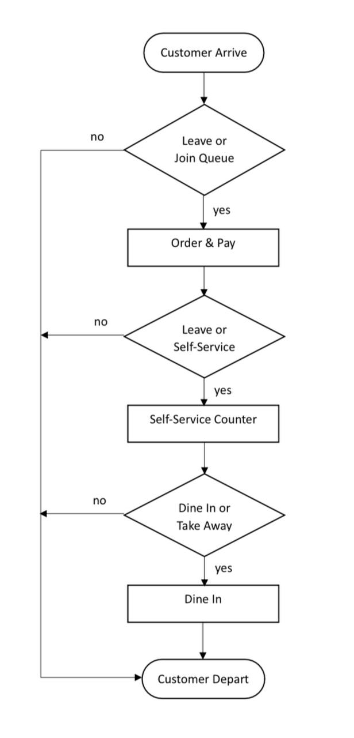

FIGURE 1. Process Flow Chart of a Convenience Store at Varsity Mall.

MODEL DEVELOPMENT

The primary goal is to evaluate the performance metrics of the convenience store system and recommend improvements to enhance its overall efficiency. DES provides a visual representation of the system's operations, facilitating an in-depth analysis of crucial metrics like waiting times and resource utilization. Data for this simulation model were obtained through both primary and secondary sources. Primary data involved observation and interview sessions with the manager of the convenience store, while secondary data gathered from websites, journals and articles. The data collection of customer arrival times, service times at the payment counter, service times at the self-service counter, number of workers and customer departure time are observed and recorded. Data collection was carried out during peak hours from 5.00 p.m. until 7.00 p.m. for a month. In order to process raw data and fit it into appropriate statistical distributions, the Arena Input Analyzer which is a tool integrated in Arena software was used. Table 1 shows the expression value for each process. The simulation model was developed based on several assumptions which were i) no water dispensers or microwave breakdown during the observation, and ii) each process consists of full attendance of workers. The model logic of the DES model at the convenience store is shown in Fig. 2, while Fig. 3 presents the animation of the convenience store at Varsity Mall.

TABLE 1. Expression Value for each process.
Process Name | Distribution Types | Values
Arrival Time (Single) | Exponential | EXPO (2.66)
Arrival Time (Group)  Order and Pay Time (Single)  Order and Pay Time (Group)  Water Dispenser Time (Single)  Water Dispenser Time (Group)  Microwave Time (Single)  Microwave Time (Group)  Dine In Time (Single)  Dine In Time (Group) | Exponential  Lognormal  Beta  Beta  Beta  Beta  Lognormal  Beta  Beta | EXPO (2.86)  LOGN (2.49, 2.48)  13 * BETA (0.6, 2.35)  1 + 6.6 * BETA (0.0324, 0.0208)  2 + 11 * BETA (0.479, 0.554)  0.73 + 2.84 * BETA (0.62, 0.599)  0.14 + LOGN (2.39, 1.78)  36 + 20 * BETA (0.227, 0.301)  43.1 + 2.83 * BETA (0.621, 0.6)

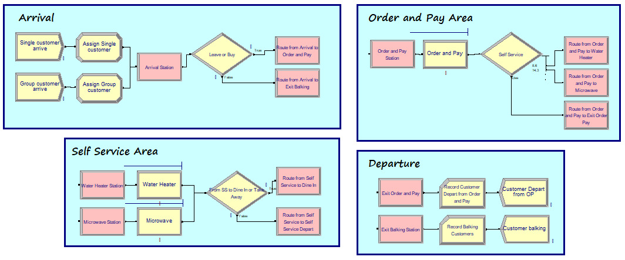
FIGURE 2. A part of the DES Model logic at the Convenience Store at Varsity Mall.

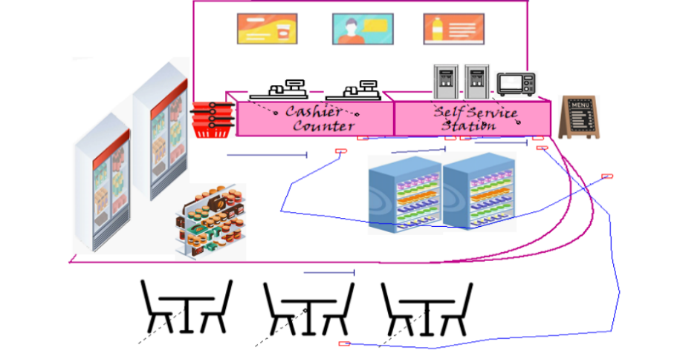
FIGURE 3. Animation of the convenience store at Varsity Mall.

MODEL VERIFICATION AND VALIDATION

The process of verification ensures that the model works as intended, often through analysis or animation. It determines whether the model complies with the requirements and conceptual design. Validation ensures that the model accurately represents the actual system and that there are no significant variations between it and the actual system. One of the validation processes is checking validity level which involves comparing any key performance metrics from developed model with actual data [10, 7].

Validity Level = $\frac{Actual data-Simulation Output}{Actual Data} x 100$ (1)

MODEL EXPERIMENTATION

The simulation's outcomes showed that the convenience store system is performing as intended. However, three alternative scenarios were proposed, evaluated and taking into account their possible impact on the system in order to maximize its performance. These scenarios were analysed to identify the best course of action for improving the system's efficiency.
- Scenario 1: Increase the customer arrival rate by 10% compared to the basic model.
- Scenario 2: Add one additional cashier at the payment counter to see the impact of waiting time.
- Scenario 3: Remove one water dispenser from the self-service counter to assess its effect on resource utilization.
Each scenario was systematically evaluated to determine the optimal approach for improving service efficiency and resource management within the convenience store.

SIMULATION RESULT AND DISCUSSION

The average number of customers who were successfully served, the average waiting time for each process and the average resource utilization were the performance metrics gathered from the DES model. According to [11], running the simulation model five times helps produce more accurate result. The most common number of replications used in Arena Simulation is three to five replications to ensure that the study does not rely on a single run and achieves more reliable outcome.

Number of customers served

Table 2 shows the actual number of customers who get served is 83 customers and the simulated number of customers get served is 86 customers. The difference between actual and simulated value on the number of customers served is 3.61%. Hence, the simulation model is valid since the value is less than 10%. The average number of customers served in the basic model (simulation output), and in the three different scenarios are presented in Table 3. The results show an increase in the number of customers served across all three scenarios and the highest number of customers served refers to scenario 1.

TABLE 2. Validity level of the Average Number of Customers Served.
Performance Measure | Actual Data | Simulation Output | Validity Level (%)
Number of customers successfully get served | 83 | 86 | 3.61

TABLE 3. Average Number of Customers Served based on Simulation Results of Five Replications.
Performance Measure | Basic Model | Scenario 1 | Scenario 2 | Scenario 3
Number of customers successfully get served | 86 | 96 | 91 | 89

Customer waiting time for services

The average waiting time for each process in a convenience store refers to the duration customers spend waiting before receiving a service. In this case, the customers need to wait for few processes such as order and pay, microwave, water dispenser and dine in.

TABLE 4. Average Waiting Time (in Minutes) for each Process.
Process | Basic Model | Scenario 1 | Scenario 2 | Scenario 3
Order and pay | 5.7107 | 6.1815 | 0.3279 | 4.7523
Microwave use | 0.1715 | 0.31 | 0.3694 | 0.2138
Water dispenser use | 0.0993 | 0.1737 | 0.2383 | 1.8378
Dine In | 1.4475 | 3.7757 | 1.657 | 5.0016

From five replications, the basic model showed the average waiting time was 5.7107 minutes for the order and pay process, 0.1715 minutes for the microwave use process, 0.0993 minutes for the water dispenser use process and 1.4475 minutes for the dine-in process. Based on Scenario 1, if the number of customers increases by 10%, the average waiting time for all the processes increases. The average waiting time for the order and pay process is 6.1815 minutes, the average waiting time for the microwave use process is 0.3100 minutes, the average waiting time for the water dispenser use process is 0.1737 minutes and the average waiting time for the dine-in process is 3.7757 minutes. Increasing the number of cashiers in Scenario 2 can reduce the waiting time for the order and pay process by 0.3279 minutes. Moreover, if Scenario 3 is applied, the waiting time for the microwave use, the water dispenser use, and dine-in process were increased.

Resource Utilization

In many systems, resource utilization is a common measure used to determine how effectively resources are being used. The management can assess how much of the resources is. In this study, the measures of resource utilization were focus on the available resources such as three cashiers, three dine-in tables, two water dispensers and one microwave. Table 5 shows the output of the basic model and three scenarios of resource utilization in percentage.

TABLE 5. Average Utilization in Percentage (%) for each resource
Resources | Basic Model | Scenario 1 | Scenario 2 | Scenario 3
Cashier 1 | 85.45 | 86.75 | 47.01 | 81.84
Cashier 2 | 87.14 | 88.54 | 54.47 | 83.53
Cashier 3 | - | - | 48.72 | -
Table Dine In 1 | 38.86 | 66.34 | 52.52 | 37.63
Table Dine In 2 | 54.04 | 61.94 | 65.15 | 62.26
Table Dine In 3 | 49.89 | 44.19 | 47.79 | 47.29
Water Dispenser 1 | 13.03 | 18.05 | 14.93 | 31.35
Water Dispenser 2 | 14.07 | 12.57 | 15.12 | -
Microwave | 24.72 | 21.71 | 18.84 | 15.89

According to resource utilization analysis, Cashier 1 and Cashier 2 frequently display high usage levels which are 85.45% and 87.14% in many periods. This shows that these resources are highly active and fully engaged and with operations. However, Cashier 3 usage rate is below 70% which indicates underutilized. The usage of the dine-in tables is 38.86%, 54.04% and 49.89%, which shows that the tables are underutilized. This indicates that, they may have excess capacity or low customer occupancy during certain periods. Similarly, the water dispensers very low usage rates, which range from 13.03% to 14.07%, implying that they remain mostly idle. Microwave usage is also low at around 25%, indicating underutilization. Overall, only the cashier counters, especially Cashier 1 and Cashier 2 are operating at high capacity while the tables, water dispensers and microwave are underutilized, highlighting opportunities for better task distribution and resource optimization.

CONCLUSION
In conclusion, this study applied a discrete event simulation (DES) approach to analyze the operations of a convenience store at Varsity Mall, UUM. The findings indicate that increasing the number of cashiers (part-time) can effectively reduce queue waiting times. Based on the simulation results from the three scenarios, Scenario 2 is the best alternative. The alternative suggests adding one more cashier at the payment counter. If this alternative is implemented, the number of customers served will increase, minimize the average waiting time for the order and pay process and one of the most balanced of resource utilization. Future researchers may consider observing the entire operational period to provide a more comprehensive picture, rather than focusing solely on peak hours.

Acknowledgments
We would like to sincerely thank Universiti Utara Malaysia for providing the resources and help needed to conduct this study. Besides that, we would like to express our gratitude to the lecturers, colleagues and family for their helpful criticism and support, which significantly raised the standard of this work. Finally, we are pleased to express our gratitude to everyone who helped to successfully complete this study, whether directly or indirectly.

REfERENCES
- M. Caballero, G. Quesada, M. F. Ruiz-Ruiz, and V. Mar. Discrete Event Modeling for Operational Management of Restaurants. In 3rd South American International Conference on Industrial Engineering and Operations Management, May 10-12 2022, (IEOM Society International, 2022).
- B. Tasar, K. Ventura, and U. G. Cicekli, Br. Food J 122(9), 2881–2894 (2020).
- A. Z. Abideen, and F. Mohamad, J. Model. Manag. 16, 70–102 (2021).
- A. Kambli, A. A. Sinha, and S. Srinivas, J. Hosp. Tour. Manag. 43, 62–70 (2020).
- M. Z. H. Abd Jalal, M. K. M. Nawawi, W. L. H. M. Desa, R. Khalid, W. K. Abduljabbar, and R. Ramli, J. Phys.: Conf. Ser. 890, 012111 (2017).
- N. N. Hawari, L. L. Chen, and N. S. Nizad, Appl. Math. Comput. Intell. 10, 87–100 (2021).
- N. N. Hawari, W. L. H. M. Desa, N. Nordin, and N. H. M. Zaki, ASM Sci. J. 20, 1–11 (2025).
- W. L. H. M. Desa, S. J. Wei, and N. Rohani, Proceedings of the 8th International Conference on Quantitative Sciences and Its Applications, September 17-19 2024, (AIP Publishing, 2024).
- K. T. Wai, W. L. H. M. Desa et al., Int. J. Bus. Technol. Manag. 6 (3), 537–544, (2024).
- W. D. Kelton, N. B. Zupick, and N. J. Ivey, Simulation with Arena 7th ed. (McGraw Hill, New York, 2024).
- A. H. Kamali, M. Moradi, F. Goodarzian, and P. Ghasemi, Int. J. Adv. Manuf. Technol. 118, 2949–2979 (2021).

