Forecasting Performance of Stock Prices using ANFIS Optimized by Genetic Algorithm
Nurul Syifa Mahamad Zuki^{1,} ^{a)}, Ros Idayuwati Alaudin^{1,} ^{b)} and Fazillah Mohmad Kamal^{1,} ^{c)}

¹School of Quantitative Sciences,
Universiti Utara Malaysia, 06010 UUM Sintok, Kedah, Malaysia.

^{b)} Corresponding author: idayuwati@uum.edu.my
^{a)} nurulsyifamz090295@gmail.com
^{c)} fazillah@uum.edu.my

Abstract. Accurate stock price forecasting is essential for informed investment decisions and effective risk management. This study compares two neuro-fuzzy models, namely a standard Adaptive Neuro-Fuzzy Inference System (ANFIS) using Subtractive Clustering (SC) and an enhanced ANFIS model optimized with a Genetic Algorithm (ANFIS-GA). Both models were trained and tested on weekly stock price data from four Bursa Malaysia companies covering January 2010 to December 2023. Forecasting performance was evaluated using Root Mean Square Error (RMSE), Mean Absolute Error (MAE), Mean Absolute Percentage Error (MAPE), and R-squared, together with computational efficiency and model interpretability. Results show that both models successfully capture underlying stock price dynamics, while ANFIS-GA consistently yields slightly higher forecasting accuracy and markedly faster inference time, although with significantly longer training durations due to GA optimization. ANFIS-GA also exhibits smoother convergence and greater adaptability to volatile market conditions. These findings demonstrate that integrating Genetic Algorithm optimization into ANFIS improves robustness, convergence behaviour, forecasting performance and reduces inference time, making it more suitable for practical financial forecasting applications.

INTRODUCTION
Forecasting stock prices is a critical but challenging task because of the highly nonlinear and dynamic nature of financial markets. Traditional statistical models often fail to capture the complex patterns and volatility inherent in stock price movements. As a result, soft computing techniques such as the Adaptive Neuro-Fuzzy Inference System (ANFIS) have gained prominence for their ability to model nonlinear relationships while maintaining interpretability [1]. ANFIS combines the learning capabilities of neural networks with the transparency of fuzzy logic, making it particularly suitable for forecasting financial time series data.

In this study, the standard ANFIS model using subtractive clustering (SC) to generate its fuzzy rule base by grouping input data into clusters is employed as the standard. SC is a clustering method that identifies cluster centres in the data space but does not perform parameter optimization [2]. To improve forecasting performance, a Genetic Algorithm (GA) is integrated with ANFIS to optimize parameters such as membership functions and rule consequences. This hybrid model is referred to as ANFIS-GA. The use of GA aims to enhance accuracy, convergence behaviour, interpretability, and computational efficiency [3, 4].

Although the application of ANFIS-GA in financial forecasting is increasing, comprehensive studies that evaluate its performance against the standard ANFIS model remain limited, particularly in relation to forecasting accuracy, convergence behaviour, computational efficiency, and model interpretability. Model interpretability is especially critical in financial contexts, where transparency and explainability support informed decision-making [5]. Therefore, this study aims to compare the forecasting performance of ANFIS and ANFIS-GA models in stock price forecasting. To achieve this aim, the study evaluates forecasting accuracy using multiple error metrics, analyses convergence behaviour and computational efficiency during training, evaluates model interpretability, and examines robustness across different datasets.

LITERATURE REVIEW
Forecasting of stock prices using intelligent systems has been widely studied, reflecting the increasing demand for robust and accurate predictive models in financial markets. Numerous studies have demonstrated that soft computing approaches outperform traditional statistical methods when dealing with nonlinear, nonstationary time

series data. For example, Svalina et al. [5] developed an ANFIS model for stock price prediction on the Zagreb Stock Exchange, highlighting its ability to capture complex patterns. ANFIS-based modelling and control have been reviewed, highlighting their flexibility across diverse application domains [6]. Several studies have focused on enhancing ANFIS performance using optimization techniques. A hybrid neuro-fuzzy and GA approach has been applied for flood forecasting, reporting improved accuracy and convergence [7]. This concept has also been extended for stock price forecasting, where GA-optimized ANFIS models achieved better generalization than standard ANFIS [8]. A comparative analysis on vehicle flow prediction further showed that GA optimization improved model fitting and interpretability [9].
Beyond GA optimization, researchers have explored alternative hybrid or deep learning frameworks. Neural network models have been compared for foreign exchange rate prediction [1], while artificial neural networks and long short-term memory networks have been evaluated for foreign currency forecasting [4]. Previous research highlighted the role of advanced deep learning architectures in improving univariate and multivariate financial forecasts [10, 11]. These studies reinforce the trend toward hybrid, learning-driven approaches for financial time series prediction. Despite these advances, few studies have simultaneously examined forecasting accuracy, convergence behaviour, computational efficiency, and interpretability of ANFIS-GA compared with the standard ANFIS model across multiple datasets. Addressing this gap, the present study evaluates both models under a common framework, drawing on insights from previous research to clarify how evolutionary optimization can enhance neuro-fuzzy models for stock price forecasting.

METHODOLOGY
This study compares the performance of ANFIS and ANFIS-GA models for weekly stock price forecasting. The workflow comprises data acquisition, preprocessing, ANFIS construction, GA optimization, and performance evaluation.

Data Collection and Preprocessing
Weekly closing prices from January 2010 to December 2023 for four Bursa Malaysia companies, including Telekom Malaysia Berhad (TM), MISC Berhad (MISC), Tenaga Nasional Berhad (TNB), and Petronas Gas Berhad (Petronas), were obtained from Yahoo Finance. Six consecutive weeks were used as model inputs, and the seventh week as the target output:
Inputs: [𝑃𝑡−6,𝑃𝑡−5,𝑃𝑡−4,𝑃𝑡−3,𝑃𝑡−2,𝑃𝑡−1], Output: 𝑃𝑡
Data were normalized via min–max scaling and split 70% for training and 30% for testing. In this study, the testing dataset represents unseen data that was not used during training, thereby allowing evaluation of each model’s ability to generalize to future stock prices.
TABLE 1. Summary statistics of Bursa Malaysia stock data (January 2010– December 2023).
Dataset (Company) | Min | Max | Mean | Std. Dev.
Data 1 (TM) | 2.19 | 7.50 | 5.17 | 1.22
Data 2 (MISC) | 3.91 | 9.37 | 7.03 | 1.16
Data 3 (TNB) | 5.00 | 16.16 | 10.70 | 3.04
Data 4 (Petronas) | 9.65 | 24.88 | 17.81 | 3.54

Table 1 presents the summary statistics of the four Bursa Malaysia datasets from 2010–2023. TM (Data 1) and MISC (Data 2) display relatively narrow ranges and lower standard deviations, indicating more stable weekly closing prices. In contrast, TNB (Data 3) and Petronas (Data 4) show wider ranges and higher standard deviations, reflecting greater volatility. This variation is expected to affect model performance, with GA optimization likely providing more benefit for the more volatile series.

ANFIS Model Construction
A first-order Takagi–Sugeno fuzzy inference system was generated by subtractive clustering with radius, 𝑟𝑎 =
0.5. Membership functions used Gaussian shapes,
𝑥 − 𝑝𝑖 2  𝜇𝐴𝑖(𝑥) = exp [− ( 𝑞 ) ] , 𝑖 = 1,2  𝑖 | (1)

and the firing strength of the i-th rule was
𝑤𝑖 = ∏^{𝑛} 𝜇 𝐴𝑖𝑗(𝑥𝑗),  𝑗=1 | (2)
normalized as
𝑤𝑖  𝑤̅̅̅𝜄 = ∑𝑀 𝑤 .  𝑘=1 𝑘 | (3)
Each rule output was
𝑤̅̅𝜄̅𝑓𝑖 = 𝑤̅^{𝑙}(𝑎1 + 𝑏1𝑥 + 𝑐1𝑦), | (4)

and the network output combined all rules by weighted average
𝑦(𝑥) = ∑^{𝑀} 𝑤̅̅̅_{𝑖̅}𝑓 .  𝑖=1 𝑖 | (5)

Genetic Algorithm Optimization
To enhance forecasting accuracy, GA evolved the ANFIS membership function parameters over 30 generations with a population size of 20 and parameter bounds [–2, 2].

Performance Evaluation
Forecasting performance was assessed using RMSE, MAE, MAPE, and R-squared. Model interpretability was measured by the total number of fuzzy rules, and computational efficiency by total training time using MATLAB’s tic–toc. The key configuration parameters for both the standard ANFIS and ANFIS-GA models are summarized in Table 2.
TABLE 2. Parameters and Configurations of the standard ANFIS and ANFIS-GA Models
Parameter | Setting
Input features | 6 consecutive weekly closing prices (Weeks 1–6)
Output | Predicted closing price (Week 7)
Normalization | Min–max scaling
Training / Testing split | 70% training, 30% testing
Subtractive clustering radius | 0.5
ANFIS training | 30 epochs; parameters [30 0 0.01 0.9 1.1]
GA optimization | 30 generations, population size 20, bounds [–2,2]
Interpretability measure | Number of fuzzy rules generated
Efficiency measure | Training time using MATLAB tic–toc

RESULTS AND DISCUSSION
The performance of the standard ANFIS and ANFIS-GA models was evaluated using the four Bursa Malaysia datasets. As shown in Table 1 (Methodology), Data 1 and Data 2 display relatively stable price behaviour, whereas Data 3 and Data 4 are more volatile with wider ranges and larger standard deviations. This variation provides a useful test for comparing model robustness under different market conditions.

The forecasting results are detailed in Table 3, which reports RMSE, MAE, and MAPE for training and testing. Across all datasets, both models captured the main price dynamics effectively. ANFIS-GA achieved slightly lower testing errors than the standard ANFIS, demonstrating improved generalization. For instance, in Data 1, the testing RMSE decreased from 0.1374 (ANFIS) to 0.1331 (ANFIS-GA), while MAPE fell from 2.02% to 1.94%. Similar marginal gains were observed across the other datasets, especially in the more volatile Data 3 and Data 4, indicating that GA optimization is particularly beneficial where data variability is higher. Furthermore, Table 4 shows that both models achieved very high R-squared values on the training sets (>0.97) and acceptable values on the test sets (0.71–0.88). ANFIS-GA consistently outperformed ANFIS on test sets, again with the largest improvements occurring for Data 3 and Data 4. This pattern reflects the advantage of GA in tuning parameters to handle nonlinearity and volatility.

TABLE 3. Forecasting accuracy metrics (training/testing RMSE, MAE, and MAPE) for the standard ANFIS and ANFIS- GA models across four datasets.
Dataset | Phase | RMSE ANFIS | RMSE ANFIS- GA | MAE ANFIS | MAE ANFIS- GA | MAPE ANFIS (%) | MAPE ANFIS-GA (%)
Data 1 | Train | 0.1382 | 0.1422 | 0.0967 | 0.0980 | 2.05 | 2.09
 | Test | 0.1374 | 0.1331 | 0.1082 | 0.1044 | 2.02 | 1.94
Data 2 | Train | 0.2030 | 0.2022 | 0.1450 | 0.1443 | 2.18 | 2.17
 | Test | 0.1193 | 0.1187 | 0.0884 | 0.0887 | 1.24 | 1.25
Data 3 | Train | 0.2665 | 0.2707 | 0.1836 | 0.1830 | 1.71 | 1.71
 | Test | 0.2331 | 0.2284 | 0.1818 | 0.1792 | 1.97 | 1.93
Data 4 | Train | 0.4167 | 0.4167 | 0.2960 | 0.2960 | 1.63 | 1.63
 | Test | 0.2510 | 0.2509 | 0.1947 | 0.1947 | 1.16 | 1.16

TABLE 4. Model fit (R-squared) for the standard ANFIS and ANFIS-GA models across four datasets.
Dataset | Phase | R-squared ANFIS | R-squared ANFIS-GA
Data 1 | Train | 0.9892 | 0.9886
 | Test | 0.8701 | 0.8782
Data 2 | Train | 0.9752 | 0.9754
 | Test | 0.7360 | 0.7388
Data 3 | Train | 0.9934 | 0.9932
 | Test | 0.8371 | 0.8436
Data 4 | Train | 0.9882 | 0.9882
 | Test | 0.7101 | 0.7102

TABLE 5. Computational efficiency and interpretability of the standard ANFIS and ANFIS-GA models.
Dataset | Training Time (s) ANFIS | Training Time (s) ANFIS-  GA | Forecast Time (s) ANFIS | Forecast Time (s) ANFIS-  GA | Rules ANFIS | Rules ANFIS- GA | Interpretability Index ANFIS | Interpretability Index ANFIS-GA
Data 1 | 1.4900 | 1345.87 | 0.0534 | 0.0023 | 4 | 2 | 0.0625 | 0.2500
Data 2 | 1.7800 | 2500.95 | 0.0534 | 0.0043 | 5 | 6 | 0.0400 | 0.0278
Data 3 | 1.8500 | 1612.94 | 0.0620 | 0.0021 | 5 | 3 | 0.0400 | 0.1111
Data 4 | 1.3800 | 1922.63 | 0.0538 | 0.024 | 4 | 4 | 0.0625 | 0.0625

Meanwhile, Table 5 summarizes training time, forecasting time, and interpretability indices. As expected, ANFIS-GA required substantially longer training times (over 1000 s compared to ~1.5 s for ANFIS) due to the iterative search of the Genetic Algorithm. However, inference time for ANFIS-GA was an order of magnitude faster (0.002–0.004 s versus 0.05–0.06 s for ANFIS), which is advantageous for real-time forecasting applications. The impact on interpretability was mixed. For example, in Data 1, the rule count dropped from four to two, increasing the interpretability index, while in Data 2, the rule count increased from five to six, reducing interpretability. This highlights the need to balance transparency and accuracy when applying evolutionary optimization. To visualise these outcomes, Fig. 1 plots actual versus forecasted stock prices. Both models tracked the underlying trends and turning points closely, with ANFIS-GA generally closer to the true values during volatile periods. In addition, Fig. 2 displays training error convergence, where ANFIS-GA shows smoother and faster convergence, implying effective parameter tuning by the GA. Slightly higher training error in ANFIS-GA was offset by lower testing error, suggesting that GA helped avoid overfitting and improved generalization.

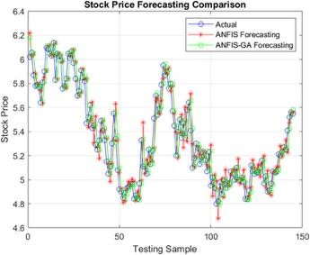  (a) Data 1 | 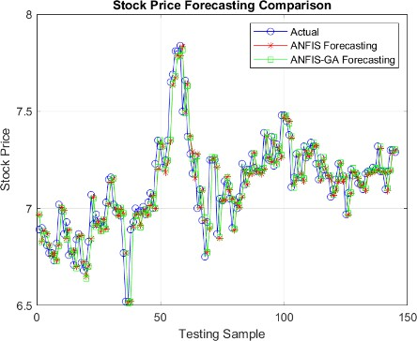  (b) Data 2
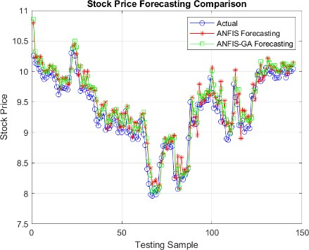  (c) Data 3 | 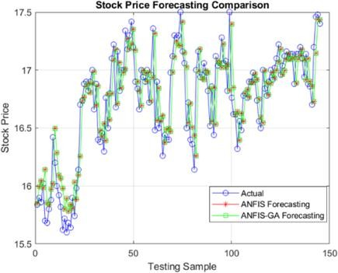  (d) Data 4
FIGURE 1. Actual versus predicted stock prices for ANFIS and ANFIS-GA across all datasets.

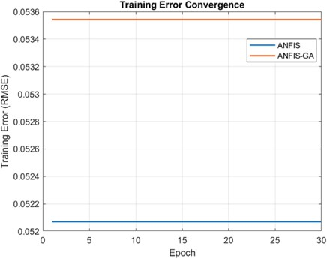  (a) Data 1 | 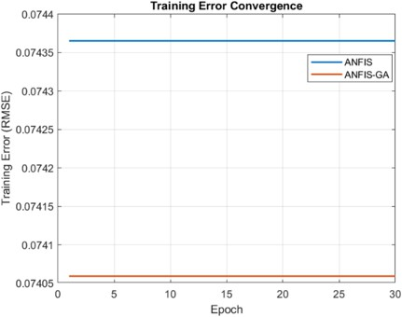  (b) Data 2
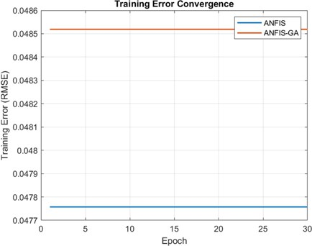  (c) Data 3 | 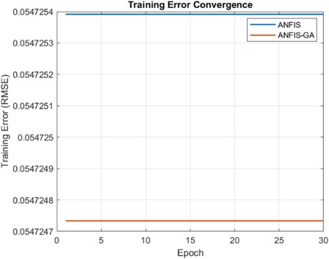  (d) Data 4
FIGURE 2. Training error convergence of ANFIS and ANFIS-GA across all datasets.

CONCLUSION
This study compared the forecasting performance of a standard ANFIS model and a GA-optimized ANFIS (ANFIS-GA) across four Bursa Malaysia stock datasets spanning January 2010 to December 2023. Both models successfully captured nonlinear stock price dynamics, but ANFIS-GA achieved slightly higher forecasting accuracy, faster inference, and greater robustness, particularly for the more volatile datasets, than the standard ANFIS. The training error convergence plots indicated stable learning and low RMSE throughout all epochs, indicating effective model training. Although GA optimization markedly increased training time, ANFIS-GA provided improved generalization and adaptability, demonstrating the value of evolutionary optimization for enhancing neuro-fuzzy forecasting systems. These results show that ANFIS-GA offers a practical and generalizable approach for financial time series forecasting where accuracy and rapid inference are priorities. Future work could extend this framework to larger or multivariate datasets, explore alternative hybrid optimization techniques, and further balance accuracy with interpretability to meet the transparency needs of financial decision- making.

ACKNOWLEDGMENTS
The authors declare that no funding was received for this research.

REFERENCES

- P. Aggarwal and A. K. Sahani, Comparison of Neural Networks for Foreign Exchange Rate Prediction, Proceedings of the 15th IEEE International Conference on Industrial and Information Systems (ICIIS), Rupnagar, India, 26-28 November 2020, (IEEE, Piscataway, NJ, 2020), pp. 415–419, doi:10.1109/ICIIS51140.2020.9342733.
- S. L. Chiu, J. Intell. Fuzzy Syst. 2(3), 267–278 (1994), doi:10.3233/IFS-1994-2304.
- K. S. Adewole et al., Theories and Applications, Cham: Springer International Publishing, 177-196 (2021).
- A. Alamsyah and W. H. Aprillia, Comparison of predictions foreign currency exchange rates (USD, JPY, EUR, GBP, CHF, CAD) to Rupiah (IDR) using Artificial Neural Network and Long Short-Term Memory, Proceedings of the 6th International Conference on Information Technology, Information Systems and Electrical Engineering (ICITISEE), Yogyakarta, Indonesia 13-14 December 2022, Ed. by A. Setyanto,
A. Sunyoto, and F. W. Wibowo, (IEEE, Piscataway, NJ, 2022), pp. 585-590, doi: 10.1109/ICITISEE57756.2022.10057683.
- T. Svalina, M. Galzina, M. Lujić, and D. Šimunović, ANFIS model for stock price prediction, Zagreb Stock Exchange, WWW document, (https://github.com/aylint/stock-price-anfis).
- C. R. Rejeesh, Int. J. Electr. Comput. Eng. 9(2), 1157–1168 (2019), doi:10.11591/ijece.v9i2.pp1157-1168.
- A. Mukerji, C. Chatterjee, and N. S. Raghuwanshi, J. Hydrol. Eng. 14(6), (2009), doi:10.1061/(ASCE)HE.1943- 5584.0000040.
- D. Nopianti, A. Panudju, and F. Permana, Int. J. Adv. Comput. Sci. Appl. 12(6), 123–130 (2021).
- I. O. Olayode, L. K. Tartibu, and F. J. Alex, Appl. Sci.13(2), 744 (2023).
- M. R. A. Khalil and A. A. Bakar, Int. J. Adv. Comput. Sci. Appl. 14(3), 122–131 (2023).
- H. Wu, Improving Stock Price Prediction using Linear Regression and Long Short-Term Memory Model (LR-LSTM), Proceeding of the 2023 4th International Conference on Big Data Economy and Information Management (BDEIM ’23), (ACM, New York, NY, 2024), pp. 767-771, doi:10.1145/3659211.3659343.

