THE 6TH INNOVATION AND ANALYTICS CONFERENCE & EXHIBITION

proceedingS of THE 6TH INNOVATION AND ANALYTICS CONFERENCE & EXHIBITION (iACE 2025)

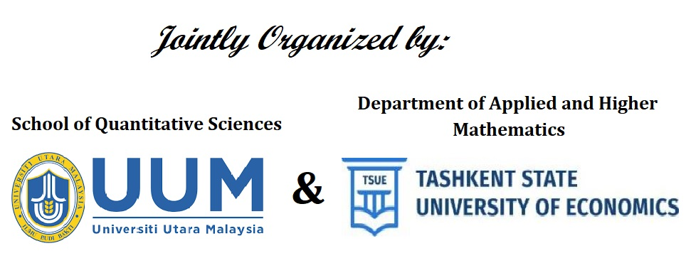

HYBRID CONFERENCE
20-22 OCTOBER 2025

EDITORS

HASLINDA IBRAHIM
NURUL NAZIHAH HAWARI
SHUKHRAT ALLADUSTOV
JAFRI ZULKEPLI
NAZRINA AZIZ

