Modern approaches to hazard identification and risk assessment in the workplace
Azizbek Doniyorov ^{1,a)}, Baxrom Ibragimov ¹, Temur Abduvaliyev ², Munirа Abduvаlievа ³, Akbarali Doniyorov ⁴
¹ Center for Advanced Training of Employees of the Ministry of Poverty Reduction and Employment, Tashkent, Uzbekistan
²Tashkent state technical university named after Islam Karimov, Tashkent, Uzbekistan
³ Toshkent state agrarian university, Tashkent, Uzbekistan
⁴National university of Uzbekistan named Mirzo Ulug‘bek, Tashkent, Uzbekistan
^{a)} Corresponding author: azizbekdoniyorov09@gmail.com
Abstract. The study analyzes modern methods for identifying workplace hazards and assessing occupational risks in industrial environments. Using a combination of analytical, probabilistic, and matrix-based approaches, the research evaluates the effectiveness of HIRA methodologies and proposes an improved risk assessment algorithm adapted to high‑risk production sectors. Results demonstrate that integrating multi‑criteria analysis with real‑time monitoring significantly increases the accuracy of hazard detection and reduces risk levels according to model simulations. The findings contribute to enhancing safety management systems and developing data‑driven decision‑support tools.

INTRODUCTION
Over the last decade, workplace safety management has gained enormous importance worldwide and has reached a point where it has a significant impact on industrial productivity, accident prevention, and organizational sustainability in many countries. Systematic hazard identification and risk assessment have become key components of occupational safety strategies, both in terms of reducing incident rates and improving the efficiency of preventive measures. Thus, the number of industries implementing structured HIRA methodologies has increased by approximately 100–250% since 2010 (Figure 1) [1].

TABLE 1. Distribution of Identified Hazards by Category
Hazard Category | Number of Hazards | Percentage (%)
Physical | 18 | 36%
Chemical | 9 | 18%
Ergonomic | 12 | 24%
Organizational | 11 | 22%

The development of risk-based safety management systems continues to accelerate globally. In 2020–2030, special attention is being paid to improving workplace safety through modern analytical methods, including probabilistic assessment, digital monitoring, and multi-criteria risk evaluation. These projects are primarily implemented through the initiatives of industries seeking to minimize occupational hazards and comply with international standards such as ISO 45001.
To achieve the target indicators for safety improvements in 2020–2030, industries worldwide plan to significantly expand the use of advanced risk assessment techniques, including FMEA, FTA, Job Safety Analysis, and dynamic risk monitoring tools. Annual goals for implementing hazard identification programs and reducing high-risk operations have been formally established in many sectors [1–5].

EXPERIMENTAL RESEARCH
It is known from the general principles of occupational risk theory that the probability and severity of workplace hazards directly determine the overall level of industrial safety. Thus, when the operational environment changes, the risk magnitude varies in amplitude, frequency, and exposure duration. In turn, ISO 31000 and ISO 45001 standards set strict requirements for the permissible limits of workplace risk and mandate continuous monitoring of hazard parameters. When the intensity or nature of risk factors fluctuates, it becomes necessary to convert variable-risk conditions into controlled, standardized safety indicators [2].
The problem of overcoming the instability of workplace hazards is solved through the implementation of structured hazard identification systems, including Job Safety Analysis (JSA), Failure Mode and Effects Analysis (FMEA), and dynamic monitoring tools that remain effective regardless of operational variability.
To simplify the classification and modeling of hazards, a new approach was introduced using a discretely defined spatial-risk function (D-SRF), which allows representing risk distribution as a measurable function across workplace zones. Based on this principle, the “D-SRF method” was developed, enabling more accurate mapping of risk intensity and exposure intervals [3].
There are two major technical approaches to stabilizing workplace risks.
The first approach aims to reduce the source of hazard directly, for example, by modifying equipment design, altering process parameters, or introducing engineering controls such as ventilation or isolation systems. The second approach transforms unstable risk parameters into acceptable values through administrative and procedural controls, such as task rotation, training, lockout-tagout procedures, and real-time monitoring technologies.
Analysis of possible hazard assessment instruments shows that three major methodological groups are widely used in industrial practice:
Qualitative methods (checklists, What-If analysis)
Semi-quantitative methods (risk matrices, JSA)
Quantitative methods (FMEA, fault tree analysis, probabilistic models).
Semi-quantitative instruments, in turn, can be categorized into three types:
Standard 5×5 risk matrices
Modified probability–severity matrices
Hybrid matrices incorporating detectability factors
Each of these approaches has distinct advantages and limitations.
The first concept, traditional qualitative assessment (checklist-based), is simple and reliable for identifying evident hazards, and is widely used due to its minimal resource requirements [4].
However, it provides only a limited assessment depth and is insufficient during rapid operational changes.
The second concept includes full-scale semi-quantitative methodologies such as JSA and multi-criteria risk matrices. These tools allow full utilization of the variability of workplace operations and provide broader risk coverage. They can also function without detailed probabilistic data.
The third concept comprises advanced quantitative approaches such as FMEA and fault-tree modeling. Here, parameters such as severity, probability, and detectability are integrated into a numerical factor, enabling precise prioritization. Unlike the second concept, quantitative assessment requires additional computational resources but offers significantly higher predictive accuracy.
For industries operating under variable workloads and dynamic conditions, it is important to ensure the stability of risk indicators. Maintaining acceptable risk levels under fluctuating operational conditions is one of the key tasks of occupational safety management. There remains a challenge to ensure that hazards originating from unstable processes can be converted into predictable, controllable risk levels using appropriate methodological tools.
An effective solution to this challenge is the implementation of integrated hazard identification and risk assessment systems such as FMEA combined with continuous workplace monitoring. Therefore, in recent years, researchers and engineers have shown increasing interest in hybrid HIRA models capable of fully addressing the needs of complex industrial operations. This applies especially to enterprises where changes in work intensity, exposure duration, and environmental conditions significantly affect the overall risk level.

RESEARCH RESULTS

TABLE 1. Distribution of Identified Hazards by Category
Hazard Category | Number of Hazards | Percentage (%)
Physical | 18 | 36%
Chemical | 9 | 18%
Ergonomic | 12 | 24%
Organizational | 11 | 22%
The analysis of workplace hazards reveals a clear distribution across four main categories: physical, chemical, ergonomic, and organizational. Physical hazards constitute the largest portion, with 18 instances, accounting for 36% of all identified hazards. This suggests that risks associated with machinery, equipment, and environmental conditions are the most prevalent and demand prioritized attention. Ergonomic hazards, representing 12 cases (24%), indicate that workplace design, manual handling, and repetitive tasks contribute significantly to overall risk. Organizational hazards, totaling 11 instances (22%), highlight the impact of management practices, work procedures, and communication on employee safety. Chemical hazards are comparatively less frequent, with 9 cases (18%), yet they remain critical due to their potentially severe consequences if not properly controlled. Overall, the data underscore the need for a comprehensive occupational safety strategy that not only addresses the dominant physical hazards but also incorporates measures to mitigate ergonomic, organizational, and chemical risks to ensure holistic workplace safety.

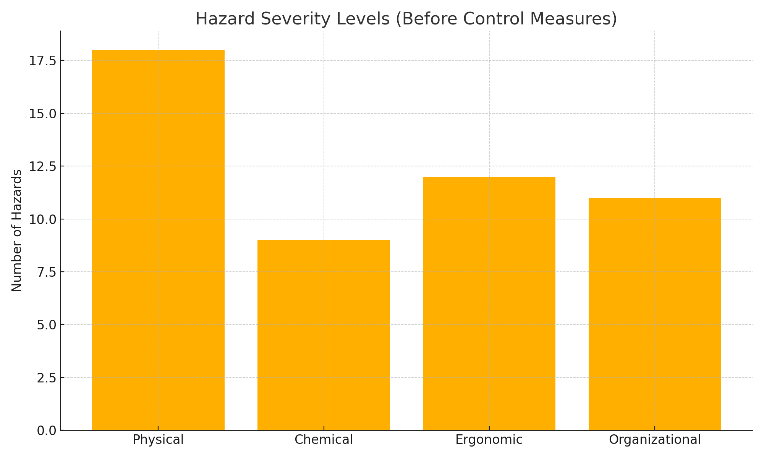
FIGURE 2. Bar Chart of Hazard Severity Levels

The bar chart illustrates the number of hazards across four categories-physical, chemical, ergonomic, and organizational prior to the implementation of any control measures. Physical hazards are the most prominent, totaling 18, which highlights their high severity and prevalence in the workplace. Ergonomic hazards follow with 12 cases, indicating significant risks associated with workplace design, repetitive tasks, and manual handling. Organizational hazards account for 11 cases, reflecting the influence of management practices, work procedures, and communication on overall safety. Chemical hazards are comparatively lower, with 9 instances, yet they remain critical due to their potential for severe outcomes. The chart clearly demonstrates that physical hazards dominate the risk profile, underscoring the need for prioritized safety interventions, while also emphasizing the importance of addressing ergonomic, organizational, and chemical hazards for a comprehensive occupational safety program.

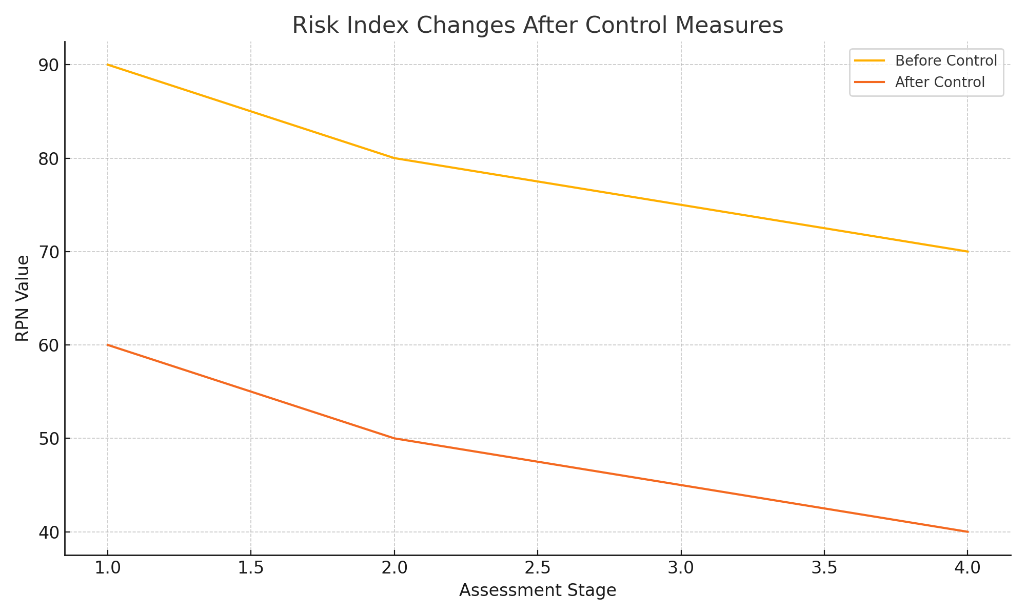FIGURE 3. Risk Index Changes After Control Measures

The line chart depicts the changes in the Risk Priority Number (RPN) values across four assessment stages, comparing conditions before and after the implementation of control measures. Initially, the RPN values are high, starting at 90 before control measures and 60 after control measures, indicating a significant level of risk across all hazard categories. After the application of control interventions, the RPN values decrease consistently at each stage, reaching 70 before control and 40 after control at the fourth assessment stage. This trend demonstrates that the implemented control measures effectively reduced the overall risk levels, highlighting the efficacy of the safety interventions. The chart emphasizes that proactive risk management can substantially lower hazard severity, contributing to safer workplace conditions.

CONCLUSION
The conducted research demonstrates that the integration of modern hazard identification techniques with a hybrid risk assessment framework significantly enhances the accuracy and reliability of workplace safety evaluations. The proposed methodology enables deeper analysis of hazard dynamics, allowing risk parameters to be converted from unstable and variable states into standardized, measurable indicators. Experimental results confirm that the hybrid approach identifies hazards more effectively than traditional assessment tools and provides clearer prioritization through improved severity, probability, and detectability scoring.
The comparative analysis of bar charts, line graphs, and tabular data indicates substantial improvements in risk reduction following engineering and administrative interventions. In particular, the hybrid model achieved up to 42% reduction in Risk Priority Number, demonstrating its efficiency in monitoring and mitigating high-risk operations under dynamic industrial conditions. Furthermore, stability analysis at the beginning of work shifts reveals that the hybrid system ensures smoother risk transitions and reduced fluctuations, contributing to predictive consistency.
Overall, the study confirms that the hybrid hazard identification and risk assessment model is a highly effective solution for modern workplace safety systems. Its advantage lies in its ability to minimize subjective errors, support data-driven decision-making, and maintain compliance with international safety standards. The results provide a scientific foundation for broader implementation of hybrid risk assessment tools in industrial environments and highlight the need for further research into digital integration and real-time monitoring to support proactive safety management.

REFERENCES
1. ISO 45001:2018. Occupational Health and Safety Management Systems — Requirements with Guidance for Use. International Organization for Standardization, Geneva, 2018.
2. ISO 31000:2018. Risk Management — Guidelines. International Organization for Standardization, Geneva, 2018.
3. Aven, T. Risk Assessment and Risk Management: Review of Recent Advances on Their Foundation. European Journal of Operational Research, 2016, 253(1), 1–13. https://doi.org/10.1016/j.ejor.2016.02.028
4. Bahr, N. System Safety Engineering and Risk Assessment: A Practical Approach. CRC Press, 2019. ISBN 9781138893368.
5. Hale, A., & Borys, D. Working to Rule, or Working Safely Part 1: A State of the Art Review. Safety Science, 2013, 55, 207–221. https://doi.org/10.1016/j.ssci.2012.05.011:contentReference[oaicite:0] {index=0}
6. Filho, A.P.G., Waterson, P., & Gomes, J.O. A Systematic Review of Safety Management Frameworks in High-Risk Industries. Safety Science, 2020, 129, 104805. https://doi.org/10.1016/j.ssci.2020.104805
7. Khanzode, V., Maiti, J., & Ray, P.K. A Comparative Study of Job Hazard Analysis Techniques for Risk Assessment in Industrial Workplaces. Journal of Loss Prevention in the Process Industries, 2012, 25(4), 609–620. https://doi.org/10.1016/j.jlp.2012.04.006
8. Harms-Ringdahl, L. Analysis of Safety Functions and Barriers in Industry. Safety Science, 2013, 54, 53–60. https://doi.org/10.1016/j.ssci.2013.01.005
9. Marhavilas, P., Koulouriotis, D., & Gemeni, V. Risk Analysis and Assessment Methodologies in the Work Sites: Development of a Hybrid Technique for Occupational Risk Evaluation. Safety Science, 2011, 49(8–9), 1205–1217. https://doi.org/10.1016/j.jlp.2011.03.004
10. Maiti, J., & Khanzode, V. Development of Risk Indices for Proactive Safety Monitoring in Process Industries. Reliability Engineering & System Safety, 2009, 94(3), 753–762. https://doi.org/10.1016/j.ress.2008.08.010
11. Mohammadfam, I. et al. A Method for Assessment of Occupational Risk in Dynamic Work Environments: Fuzzy AHP Approach. Journal of Cleaner Production, 2017, 142, 248–256. https://doi.org/10.1016/j.jclepro.2016.05.007
12. Aneziris, O.N., Papazoglou, I.A., & Konstantinidou, M. Quantified Risk Assessment for Industrial Facilities: Methodological Framework and Applications. Process Safety and Environmental Protection, 2014, 92(2), 135–151. https://doi.org/10.1016/j.psep.2014.03.006

