Analysis of the Efficiency of a Static, Single-Axis and Double-Axis PV Systems
Kamal Reymov^{1, 2 a)}, Shirin Esemuratova¹, Quwat Uzaqbaev¹, Sarvar Rustamov², Akram Tovbaev³
¹Karakalpak State University named after Berdakh, Nukus, Uzbekistan
² Urgench state university, Urgench, Uzbekistan
² Navoi State University of Mining and Technologies, Navoiy, Uzbekistan
^{a)} Corresponding author: kamalreymov@gmail.com
Abstract. This study investigates the performance of fixed and tracking photovoltaic (PV) systems for maximizing solar energy utilization in regions with high solar potential, with a case study based on a 100 MW PV plant in Urgench, Uzbekistan. The research compares fixed-tilt PV panels, single-axis trackers (SAT), and dual-axis trackers (DAT) using PVsyst simulations to evaluate annual electricity production, efficiency, and seasonal performance. The results demonstrate that fixed PV panels, while simple and cost-effective, are limited in energy capture, producing approximately 15-25% less energy than SATs and 30-40% less than DATs. Single-axis trackers achieve moderate improvements, increasing annual electricity output by around 9% over fixed systems. Dual-axis tracking systems provide the highest energy yield, with up to 34% more electricity than fixed panels and 23% more than SATs, and seasonal gains ranging from 28,8% to 43,6%. The study highlights the critical role of PV orientation and tracking strategies in optimizing solar energy harvest. It concludes that, from a net energy efficiency perspective, dual-axis tracking systems offer the most effective solution for enhancing renewable energy production and supporting sustainable energy development in solar-rich regions such as Uzbekistan.
INTRODUCTION
Global energy-related constraints, particularly in developing countries, have encouraged researchers to investigate alternative energy sources that can potentially replace conventional fossil fuels [1–2]. These alternative energy sources mainly include solar, hydropower, and wind energy technologies [3]. Among them, solar energy, which is generated through the capture of solar radiation, is considered one of the cleanest energy sources, as it has a minimal impact on environmental pollution. It has been reported that the total amount of solar energy reaching the Earth is approximately 1,8 × 10¹¹ MW [4]. Due to its equatorial location, Indonesia possesses significant solar energy potential, with an average daily solar radiation intensity of about 4,8 kWh/m² across the country [3].
In Uzbekistan, the observed Global Horizontal Irradiation (GHI) typically ranges from approximately 4,0 to 5,0 kWh/m²·day, with a median value of around 4,52 kWh/m²·day. This level is comparable to that of European countries with favorable solar conditions, such as Spain, making Uzbekistan a highly suitable region for the development and deployment of solar energy systems.
Solar energy, when utilized through photovoltaic (PV) systems, has the potential to make a significant contribution to global energy demand [5]. However, the energy efficiency of PV systems is strongly influenced by environmental factors such as temperature, wind speed, ambient humidity, and the intensity of solar radiation. To achieve maximum efficiency, PV panels should receive solar radiation at an angle as close as possible to perpendicular during operation. This condition can be effectively achieved by employing solar tracking systems that follow the apparent trajectory of the sun throughout the day.
Numerous studies have been conducted to enhance the efficiency of solar panels through the implementation of solar tracking systems [6]. Given the relatively high costs and practical challenges associated with the procurement of solar panels, it is essential to utilize this technology as efficiently as possible.
This can be achieved by developing advanced solar tracking systems, accurately optimizing the tilt angle, and selecting appropriate installation sites. Such measures ensure that each panel operates close to its maximum potential, thereby significantly improving the return on investment associated with solar panel deployment.
In recent years, researchers have proposed various designs of solar tracking systems aimed at maximizing the energy output of solar panels [7]. Numerous studies have also focused on improving the performance of these tracking systems through the use of efficient mechanical actuation mechanisms and optimized control strategies.
The primary objective of this study is to compare the energy efficiency achieved by different types of solar trackers. Economic aspects, such as installation and maintenance costs, are considered outside the scope of this work, and the analysis is focused solely on the energy efficiency of PV panels.
Further advancements in solar tracking and solar energy optimization technologies play a crucial role in enhancing the utilization of solar energy and supporting a sustainable energy future. However, large-scale energy harvesting remains challenging due to the intermittent nature of solar radiation and the inherent power losses associated with current photovoltaic technologies.
EXPERIMENTAL RESEARCH
Fixed PV panels are widely used in residential and commercial applications due to their relatively low installation and maintenance costs. However, such systems have inherent limitations, as they are unable to adapt to the apparent movement of the sun across the sky, resulting in suboptimal solar energy capture.
Solar tracking systems (STS) address this inefficiency by dynamically adjusting the panel orientation to follow the sun’s position, thereby enhancing overall energy yield. Despite the additional challenges related to higher costs and maintenance requirements, recent advances in intelligent tracking methods offer promising solutions for improving system efficiency and enabling broader adoption of solar tracking technologies.
Various strategies have been proposed to maximize the utilization of solar energy, including improvements in PV system components, enhancements in cooling system materials, and the development of maximum power point tracking (MPPT) algorithms [8]. However, among these approaches, dynamically adjusting the orientation of PV panels relative to incoming solar radiation-compared to fixed photovoltaic configurations-remains one of the most effective methods for improving energy conversion efficiency.
Fixed photovoltaic panels offer several advantages that make them a practical option for solar energy applications. Owing to their low installation and maintenance costs, these systems are particularly suitable for users who prioritize cost effectiveness. Their simple design, which does not involve moving components, enhances structural durability and contributes to stable long-term operation while simplifying maintenance requirements.
Although fixed solar panels cannot optimize energy capture to the same extent as solar tracking systems, they are still capable of harvesting solar radiation effectively through appropriate tilt angle adjustment. This approach is especially effective in regions where solar irradiance remains relatively stable throughout the year.
Despite being simpler and requiring less maintenance than solar tracking systems, fixed solar panels exhibit certain limitations, primarily due to their inability to capture solar radiation at its maximum level throughout the day. As the sun’s position varies both daily and seasonally, fixed photovoltaic panels are generally less effective in harvesting solar energy compared to panels equipped with solar tracking systems that can adapt to changes in solar orientation (Table 1).
In contrast, fixed panel systems remain attractive because of their lower installation costs, structural simplicity, and operational stability.
TABLE 1. Advantages and limitations of fixed photovoltaic panels
Advantages | Simple construction | Disadvantages | Lower solar use
Advantages | The cheapest option | Disadvantages | ~15-25% less than single-axis
Advantages | Low maintenance requirements | Disadvantages | ~30-40% less than double -axis
Advantages | Reliable and durable | Disadvantages | ~30-40% less than double -axis

A fixed PV system is permanently installed and does not incorporate any mechanism for tracking the movement of the sun. As illustrated in Figure 1, this type of panel is mounted at a predefined tilt angle, optimized according to the geographical location, in order to receive the maximum possible solar radiation throughout the day.

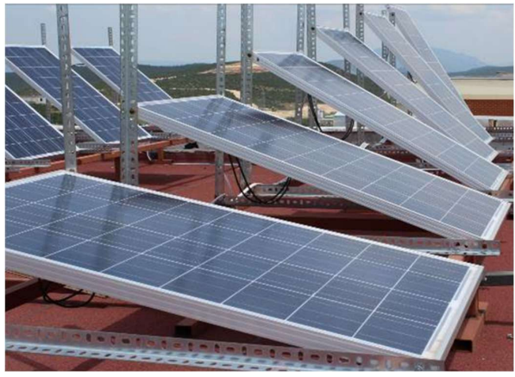
FIGURE 1. Fixed PV panels

Although fixed solar panels are simpler and require less maintenance than solar tracking systems, they do have certain limitations, primarily because they cannot capture the maximum amount of solar radiation throughout the day. Due to the daily and seasonal variation of the sun’s position, fixed photovoltaic panels are generally less efficient in harvesting solar energy compared to panels equipped with solar trackers that can adjust their orientation to follow the sun. On the other hand, fixed panels are well-regarded for their lower installation costs, structural simplicity, and operational stability.
Several studies on fixed photovoltaic panels have investigated various aspects, including the optimization of installation tilt angles, material selection, and comparative performance with other technologies. The impact of optimal tilt angles is closely related to changes in geographic latitude, which allows for periodic adjustments throughout the year and can significantly improve the energy efficiency of solar panels.
Solar tracking systems have the potential to generate significantly more renewable energy compared to fixed systems, as they follow the movement of the sun throughout the day.
- The addition of a single-axis tracker can increase solar energy production by approximately 25-35% compared to a fixed photovoltaic system.
- Dual-axis solar trackers can further enhance energy output, achieving a 30-45% increase over fixed systems.
Solar radiation can be quantified by measuring the light intensity or the power of the incoming light flux. The tilt angle of a surface is closely related to the solar elevation angle (α) and the zenith angle (θz). The tilt angle is defined as the angle between the line connecting the centers of the Earth and the Sun and the horizontal plane at a given location. The elevation angle is the angle formed between the solar rays and the horizon.
The solar azimuth angle, which represents the direction of the sun relative to true north following the clockwise rotation of the Earth, is an important parameter [9]. Conversely, the surface azimuth angle indicates how far a surface deviates from the local meridian. The angle of incidence (β) between the surface and the incoming solar rays is considered positive for surfaces facing the equator. A graphical representation of these solar angles can be found in Figure 2 [10].
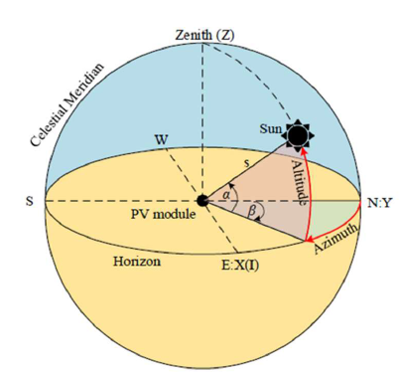 | 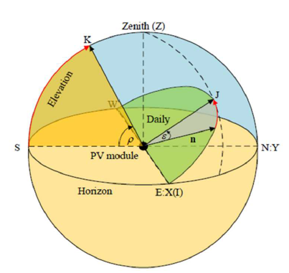
(a) ( b)
FIGURE 2. View of the Solar Corner System (a) the position of the sun in the horizontal coordinate system and (b) the observation system
Single-axis trackers (SATs) rotate around a single axis, aiming to maintain the photovoltaic panel surface perpendicular to incoming solar radiation. Compared to fixed-tilt photovoltaic systems, SATs can increase energy production by approximately 34,6%. Of the total energy produced, around 7,8% is consumed by the tracker itself, while the electrical control system accounts for approximately 3,9% of the total energy output.
There are several types of SATs, each with distinct characteristics:
- Horizontal Single-Axis Tracker (HSAT): The rotation axis is oriented horizontally relative to the ground [11].
- Vertical Single-Axis Tracker (VSAT): Mechanically simpler than dual-axis systems, VSATs can capture up to 96% of the annual solar irradiation. Their performance varies by about 16% between high and low irradiance regions, making them an effective option for non-concentrating PV systems [12].
In general, a north-south orientation of the horizontal axis is preferred over an east-west orientation. For vertical single-axis trackers, the rotation axis is vertical relative to the ground and is usually aligned in the east-west direction (Figure 3).
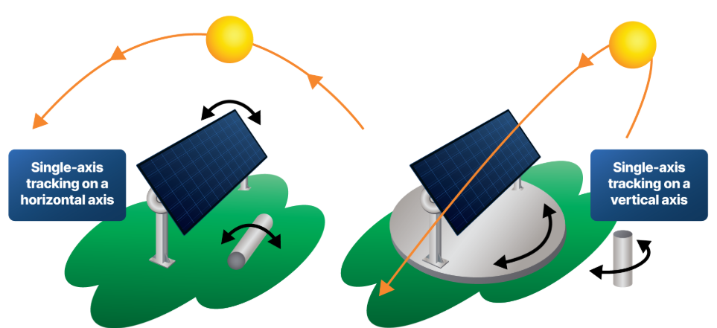
FIGURE 3. Single-Axis Solar Trackers

Dual-axis solar tracking systems (DAT) move photovoltaic panels simultaneously along both the azimuth (east-west) and elevation (zenith) axes, maintaining an almost constant perpendicular orientation relative to incoming solar radiation (Figure 4). These systems can fully replicate the sun’s movement across the sky throughout the day and across seasons.
Compared to fixed-tilt photovoltaic systems, DATs can increase energy production by 35-45%, and in some cases, they provide an additional 5-10% energy gain over single-axis tracking systems [13]. This makes them particularly suitable for projects where high energy efficiency is required.
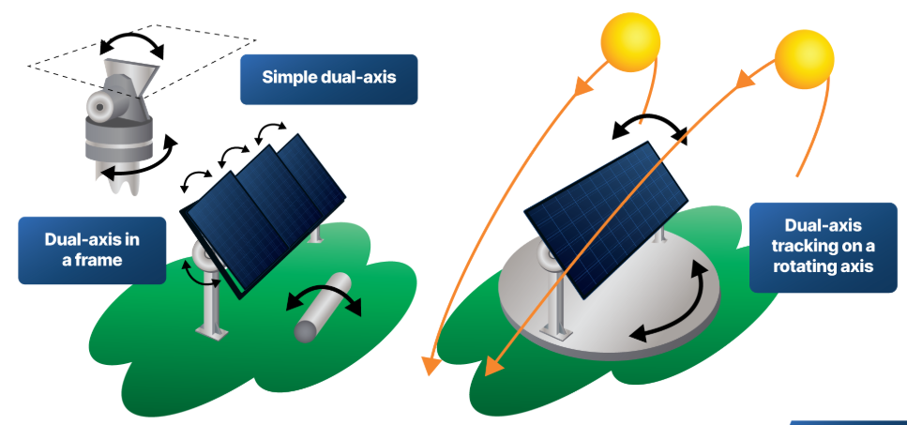
FIGURE 4. Types of dual-axis tracking systems
However, dual-axis tracking systems are associated with higher energy consumption and mechanical complexity:
- Approximately 8-10% of the total generated energy is consumed by mechanical movement and position control.
- The electrical control and sensor systems consume around 4-6% of the total energy output [14].
The main limitations of DAT systems include:
- High capital costs,
- Increased maintenance requirements,
- Sensitivity to wind loads.
For these reasons, DAT systems are primarily deployed in areas with limited land availability or where maximizing energy output is a priority.
RESEARCH RESULTS
The research results are illustrated using a 100 MW fixed photovoltaic (PV) power plant located in Urgench, Uzbekistan. During the project design in PVsyst software, the first step involves entering the system location data and a brief project overview. This includes the geographical coordinates, site parameters, project settings, and relevant meteorological information.
The initial input data are presented in Figure 5.
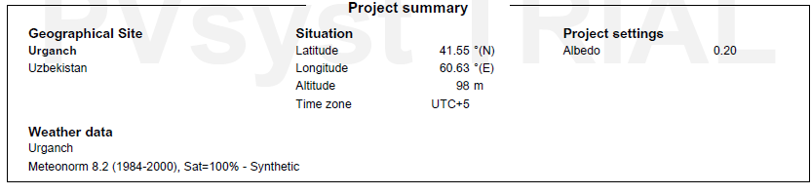
FIGURE 5. Initial data for the object of research

Using the specified location, all three systems were simulated in PVsyst. The annual electricity production (broken down by month) is summarized in Tables 2, 3, and 4. During the same experimental period, the total electricity generated by the fixed PV system on August 7, 2025, was 156,27 GWh. For the single-axis tracking system, the total annual electricity production increased to 169,98 GWh, representing an approximate 9% improvement.
For the dual-axis tracking system, the electricity fed into the grid reached 209,87 GWh, which corresponds to an increase of about 34,3% compared to the fixed system and approximately 23,5% compared to the single-axis tracker.

TABLE 2. Fixed PV system
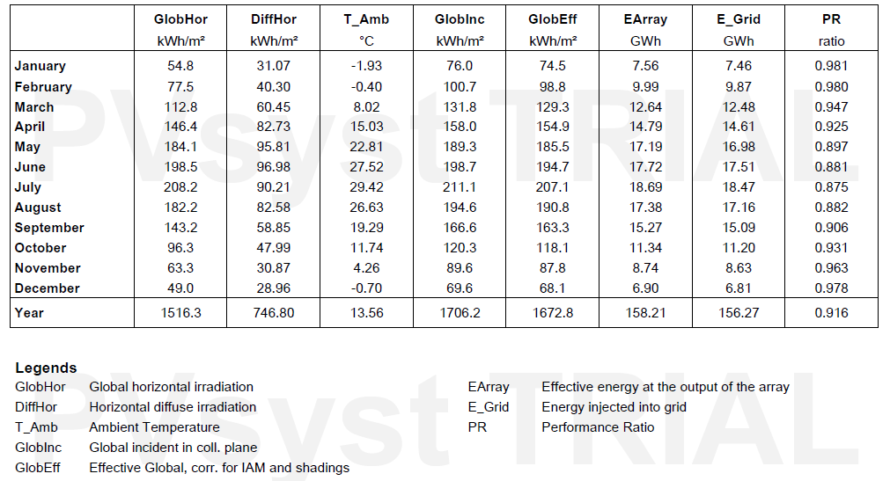
TABLE 3. Single-Axis Tracker System
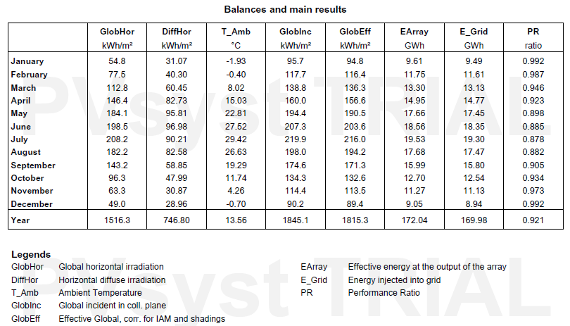

TABLE 4. Dual Axes Tracking System
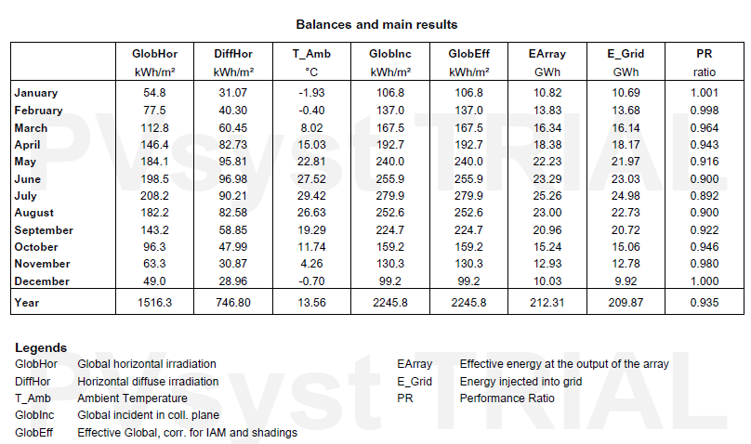
CONCLUSIONS
The results indicate that the effectiveness of solar energy utilization depends not only on geographical location and solar radiation potential but also significantly on the orientation of PV panels and the employed tracking strategy. Fixed PV panels are characterized by low installation and maintenance costs as well as structural simplicity. However, their inability to adjust to daily and seasonal variations in solar position limits their efficiency, resulting in approximately 15-25% lower energy production compared to single-axis systems and 30-40% lower compared to dual-axis systems.
Single-axis solar tracking systems allow panels to maintain a near-perpendicular orientation to the sun throughout the day, resulting in an average energy increase of 25-35% over fixed systems. According to simulation results, implementing a single-axis tracker increased the electricity fed into the grid by about 9% compared to the fixed system. Despite the energy consumed by mechanical and electrical control components, these systems provide an effective solution from a net energy yield perspective.
Dual-axis solar tracking systems demonstrated the highest efficiency. Experimental and simulation analyses indicate that these systems can generate 30-45% more electricity than fixed panels and achieve a more than 20% gain compared to single-axis systems. Specifically, PVsyst simulations show that the electricity injected into the grid by a dual-axis system reached 209,87 GWh, representing a 34,3% increase over the fixed system and a 23,5% increase over the single-axis system. Seasonal analysis further revealed efficiency gains ranging from 28,8% to 43,6% from winter to summer.
Overall, the findings confirm that employing solar tracking systems significantly enhances PV panel energy efficiency. From a pure energy efficiency standpoint-excluding economic considerations-dual-axis tracking systems represent the most optimal solution. In regions with high solar radiation potential, such as Uzbekistan, these systems are particularly valuable for increasing the share of renewable energy and supporting a sustainable energy future.
REFERENCES
- Rakhmonov I.U., Reymov K.M. “Statistical models of renewable energy intermittency”. E3S Web of Conferences, 2020, 216, 01167. https://doi.org/10.1051/e3sconf/202021601167.
- Rakhmonov I.U., Reymov K.M., Shayumova Z.M, “The role of information in power management tasks”, E3S Web of Conferences 139, 01080 (2019). Pp. 1-3. https://doi.org/10.1051/e3sconf/20191390.
- Shakhnoza Kuldasheva, Abdikamalova Aziza, Rashid Kulmatov, Gulirano Karimova, Raushana Dauletbayeva, Gulbahor Nortojiyeva, Akhmed Reymov. “Study and assessment of mineralogical, chemical and granulometric composition of volatile soil-sand aerosols from the dried-out part of the Aral Sea”. E3S Web of Conferences 575, 04007 (2024). https://doi.org/10.1051/e3sconf/202457504007. CADUC-2 2024.
- Axmed Reymov, Izimbet Turdimambetov, Nurnazar Pirnazarov, Shakhimardan Shaniyazov, Durdana Absametova, Azamat Baymurzaev, Arislanbay Orazbaev, Azamat Usnatdinov, Salamat Tajetdinov. “Exploring novel techniques for measuring and identifying minuscule dust particles in the atmosphere”. E3S Web of Conferences 575, 03006 (2024). https://doi.org/10.1051/e3sconf/202457503006. CADUC-2 20245. 6 Factors Affecting Solar Energy Production.
5. Reymov, K.M., Esemuratova, S.M., Khusanov, B.M., Mytnikov, A.V. “A study of a hybrid type stand-alone 3 kW photovoltaic system of Karakalpak state university”. E3S Web of Conferences 384, 01047 (2023). https://doi.org/10.1051/e3sconf/202338401047.
6. R. Vinodhkumar and S. John, “IoT based dual-axis solar tracking system”, in IOP Conf. Series: Materials Science and Engineering, vol. 913, 2020, doi: 10.1088/1757-899X/912/3/032024.
7. F. J. Gómez-uceda, J. Ramirez-faz, M. Varo-martinez, and L. M. Fernández-ahumada, “New omnidirectional sensor based on open-source software and hardware for tracking and backtracking of dual-axis solar trackers in photovoltaic plants”, Sensors, vol. 21, no. 3, p. 726, 2021, doi: 10.3390/s21030726
8. Y. Zhu, J. Liu, and X. Yang, “Design and performance analysis of a solar tracking system with a novel single-axis tracking structure to maximize energy collection”, Appl. Energy, vol. 264, 2020, doi: 10.1016/j.apenergy. 2020.114647.
9. A. Marcu, C. Alexandru, and I. Barbu, “Modeling and simulation of a dual-axis solar tracker for PV
Modules”, in IOP Conf. Series: Materials Science and Engineering, vol. 514, p. 012036, 2019, doi:
10.1088/1757-899X/514/1/012036.
10. H. Shang and W. Shen, “Design and implementation of a dual-axis solar tracking system”, Energies, vol. 16, no. 17, p. 2023, doi: 10.3390/en16176330.
11. B. A. Hamad and A. M. T. Ibraheem, “Design and implementation of a dual-axis solar tracking system STS”, NTU-JET, vol. 1, no. 1, pp. 35-43, 2021.
12. B. A. Hamad, A. M. T. Ibraheem, and A. G. Abdullah, “Design and practical implementation of dual-axis solar tracking system with smart monitoring system”, Przeglad Elektrotechniczny, vol. 96, no. 10, pp. 151–155, 2020, doi: 10.15199/48.2020.10.28.
13.Luque, A., Hegedus, S. Handbook of Photovoltaic Science and Engineering. Wiley, 2nd Edition, 2011.
14. International Energy Agency (IEA). Technology Roadmap: Solar Photovoltaic Energy. IEA Publications, 2020.
15. M. N. A. Mohd Said, S. A. Jumaat, and C. R. A. Jawa, “Dual axis solar tracker with IOT monitoring
system using Arduino”, IJPEDS, vol. 11, no. 1, pp. 451–458, 2020, doi:10.11591/ijpeds.v11.i1.pp451-458.

