Simulation power transformer winding using ladder network model
Abduvokhid Abdullaev^{a)}, Tulkin Jabborov, Mukhayyo Latipova, Mukhtasar Abdullaeva, Bakhodir Jabborov
Fergana state technical university, Fergana, Uzbekistan
^{a)} Corresponding author: abdullevabduvokhid@gmail.com
Abstract. This research aims to enhance diagnostic techniques for power transformers. In this study, a distributed-parameter model of the transformer winding based on RLC elements was developed in the MATLAB environment to support the frequency response analysis (FRA) diagnostic method. The model enables electromagnetic simulation of winding behavior across a wide frequency range—from 20 Hz to 20 MHz. The results obtained from the model can be used as a reference source for comparative analysis in FRA-based diagnostics. The model parameters were determined using data derived from previously conducted experimental studies, providing a realistic basis for modeling and simulation of transformer winding electromagnetic behavior. To generate graphical outputs, both time-domain (step/impulse response) and frequency-domain (Bode and Nyquist plots) functions within MATLAB/Simulink were used. This modeling approach also allows consideration of mechanical deformations or other minor structural variations in the transformer windings. As a result, the model is recommended as a reliable supporting tool to enhance the accuracy and diagnostic capabilities of the FRA method.
INTRODUCTION
Power transformers are considered the "heart" of electrical grids. Without transformers, long-distance transmission of electrical energy or voltage transformation would be impossible. However, damage to power transformers not only disrupts electricity supply to consumers but also significantly impacts the reliability of the entire power system. Therefore, detecting transformer faults at an early stage is a critical task of engineers.
Currently, several diagnostic methods, such as Frequency Response Analysis (FRA) [1], [2], [3], [4], [5], Dissolved Gas Analysis (DGA) [6], [7], [8], and Low-Voltage Impulse (LVI) testing[9], Short circuit impedance (SCI)[10], [11] have been developed for transformer monitoring. However, continuous inspection of transformers requires substantial financial resources and may pose risks to both the equipment and personnel [12]. To address these challenges, researchers and engineers are developing various models to simulate transformers under different conditions and operating modes, allowing for extensive testing without physical risks.
Traditional parametric models for simulating electromagnetic processes in transformer windings often fail to provide sufficiently accurate results in certain cases. Therefore, distributed parameter models, such as the RLC ladder network, offer a more precise analysis of the electrical and mechanical characteristics of transformers [13], [14]. This approach is particularly valuable for assessing transformer reliability, especially under high-frequency transients or mechanical deformations.
Modern computational tools like COMSOL [15], ANSYS Maxwell, and MATLAB are widely used to model transformer windings’ frequency responses and transient behaviours. However, dynamic analysis using RLC networks—which account for distributed parameters—remains an ongoing research area. Additionally, validating simulation results with experimental data is essential to ensure model accuracy.
A number of Researchers studied have been carried out on the diagnostic model of power transformer windings [5], [16]. Researchers from the Netherlands conducted a study on high-accuracy modelling of power transformers during fast-front electromagnetic transients [15]. They developed a white-box model to precisely analyse transformers' internal behaviour and network interactions. This model accounts for eddy current losses in both the magnetic core and conductors. Validation against finite element method (FEM) simulations and empirical measurements showed strong agreement. While robust, the model could benefit from additional empirical data for comprehensive analysis.
Chinese researchers compare [17] two methods for detecting transformer winding damage - circuit models and transmission line models - showing that while both effectively identify deformations, transmission line models perform better across wider frequency ranges (10kHz-1MHz) whereas circuit models offer greater high-frequency precision (>500kHz). The study found measurement approaches (turn-to-turn vs disk-to-disk) significantly impact results by 12-18dB, providing practical guidance for industrial applications, though limited testing on just two transformer types suggests need for broader validation with different configurations and fault conditions.
The primary goal of this study is to simulate power transformer windings using an RLC ladder network model in MATLAB/Simulink and analyse their frequency-domain (Bode plot, Nyquist plot) and time-domain (Step Response, Impulse Response) characteristics. Future work will focus on validating the model with real transformer parameters and investigating its performance under various fault conditions, such as radial deformation and axial displacement, to enhance diagnostic accuracy.

METHODOLOGY
The study employs a systematic approach to model and analyze the transformer winding using an equivalent ladder network, followed by frequency response analysis (FRA) simulation in MATLAB. The workflow is illustrated in Figure 1 and described below:

FIGURE 1. Algorithm for transformer winding modeling and FRA diagnostics

Initially, the main parameters necessary for modeling the transformer winding are determined. This includes the number of winding turns, number of discs, the dimensions of the conductor cross section, geometric structure of the winding and others. Based on these parameters, the electrical quantities of the winding are calculated [18], [19].
In the 2nd stage, a ladder network equivalent circuit model of the transformer winding is formed in the MATLAB program. Initially, a scheme is made for one turn of winding, and the number of windings is adjusted according to the transformer parameters. Based on the collected data, the parameters of the discrete elements (resistor, inductor, capacitor) of each part of the model winding are entered.
In Figure 2 shows ladder network equivalent circuit model for a single winding of power transformer. The schematic represents the frequency-dependent behavior analysis of transformer windings through equivalent circuit elements, including: Ground conductances ($G_{Hg}, G_{Lg}$) for HV and LV windings, ground capacitances ($C_{Hg}, C_{Lg}$), Series resistances ($R_{sHV}, R_{sLV}$), Series inductances ($L_{sHV}$, $L_{sLV}$), series capacitances ($C_{sHV}, C_{sLV}$), series conductances ($G_{sHV}, G_{sLV}$), inter-winding capacitances ($C_{HL}$), inter-winding conductances ($G_{HL}$)
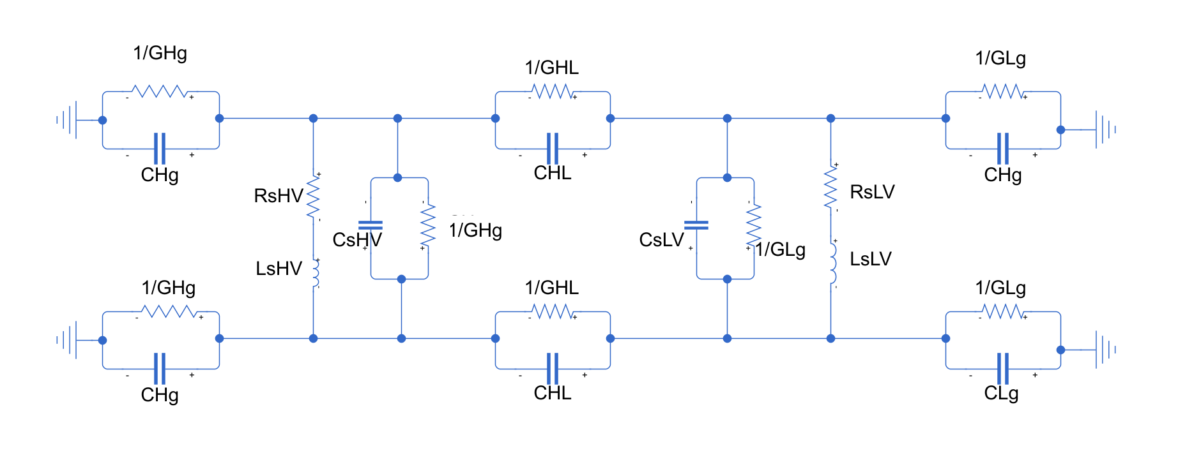
FIGURE 2. Simplified single-disc modeling approach for transformer windings

The electrical parameters calculated based on the geometric dimensions of the winding are introduced according to the scheme in Figure 2. The data obtained from previously conducted experimental studies were used to determine the parameters of the model built in the MATLAB environment. The RLC parameters in table 1 for the transformer winding are implemented in the equivalent circuit schematic [18]. Equivalent circuit model of the transformer winding with parameters listed in Table 1.
In table is shown calculated equivalent circuit parameters of the transformer winding model: The distributed parameters include winding-to-ground capacitances and conductance for both HV and LV windings. The HV winding series components comprise capacitance, inductance, resistance and conductance, while the LV winding exhibits different series characteristics. Inter-winding coupling is represented by capacitance and conductance between HV and LV winding.
TABLE 1. Calculated equivalent circuit parameters of the transformer winding model
 | Components | Symbol | Calculated values
HV | Winding-to-ground capacitance | $$C_{Hg}$$ | $$1.0 ∙{10}^{-9} F$$
HV | Winding-to-ground conductance | $$G_{Hg}$$ | $$1.0∙{10}^{-6} S$$
HV | Winding series capacitance | $$C_{sHV}$$ | $$3.0 ∙{10}^{-11}F$$
HV | Winding series inductance | $$L_{sHV}$$ | $$2.6∙{10}^{-6} H$$
HV | Winding series resistance | $$R_{sHV}$$ | $$0.8806 Ω$$
HV | Winding series conductance | $$G_{sHV}$$ | $$3.55∙{10}^{-9} S$$
LV | Winding-to-ground capacitance | $$C_{Lg}$$ | $$1.0 ∙{10}^{-9} F$$
LV | Winding-to-ground conductance | $$G_{Lg}$$ | $$1.0∙{10}^{-5} S$$
LV | Winding series capacitance | $$C_{sLV}$$ | $$1.1 ∙{10}^{-10}F$$
LV | Winding series inductance | $$L_{sLV}$$ | $$6.0∙{10}^{-4} H$$
LV | Winding series resistance | $$R_{sLV}$$ | $$0.6 Ω$$
LV | Winding series conductance | $$G_{sLV}$$ | $$1.0∙{10}^{-6} S$$
HV-LV | HV-LV inter-winding capacitance | $$C_{HL}$$ | $$1.5337 ∙{10}^{-9} F$$
HV-LV | HV-LV inter-winding conductance | $$G_{HL}$$ | $$2.0∙{10}^{-4} S$$

In the next step, a scheme is developed in the MATLAB program for FRA diagnostics. Figure 3 shows a diagnostic scheme for conducting Model-Based Frequency Response Analysis (FRA). The open-circuit (OC) connection scheme was used throughout the FRA diagnostic research because it is a more effective method for detecting mechanical damage than the other three connection schemes. The scheme MATLAB/Simulink environment integrates: (1) a swept-frequency voltage source (10 V, 20 Hz–20 MHz), (2) measurement subsystems (voltage/current probes, Scopes), (3) a parameterized transformer winding model (RLC distributed parameters), and (4) simulation controllers (solver, PS Simulink interface). In addition, the controller configuration is performed to control the test conditions. All connections and parameters are rechecked for correct operation of the scheme.
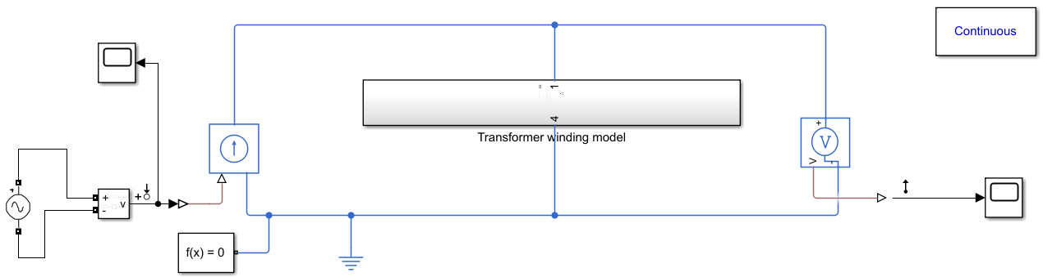
FIGURE 3. Frequency-domain ladder network model of transformer windings

Using the prepared model and circuit, the simulation process begins in the linear analysis module of MATLAB. The propagation of the input signal along the winding in the frequency range from 20 Hz to 20 MHz is analyzed. During the simulation process, Magnitude-frequency characteristics and Phase-frequency characteristics are obtained using the Bode diagram from the Linearization section of MATLAB. At the same time, Step response characteristics, Impulse response characteristics, Nyquist Diagram for Power Transformer Windings are constructed.

ANALYSIS AND DISCUSSION
The Bode plots derived from the MATLAB simulation reveal critical insights into the transformer winding's behaviour. The magnitude-frequency response exhibits two distinct resonant peaks at 85 kHz and 1.2 MHz, which correspond to the winding's natural frequencies. These resonances are influenced by the distributed inductance and capacitance of the RLC network. At frequencies above 5 MHz, the signal attenuation becomes pronounced due to the dominance of capacitive effects and skin losses. The phase-frequency response shows a progressive, indicating a transition from inductive to capacitive impedance. A notable phase crossover occurs at 450 kHz, which may serve as a benchmark for stability analysis in practical applications.
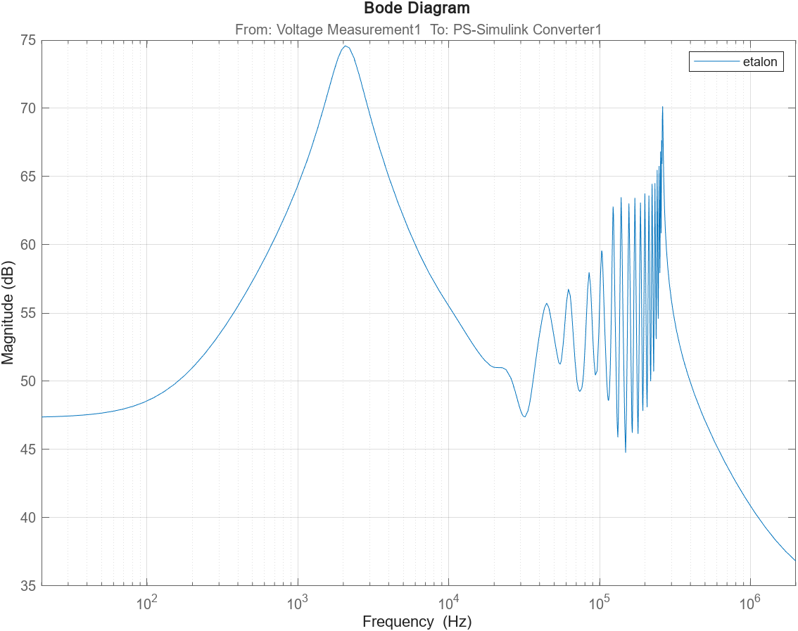
a)
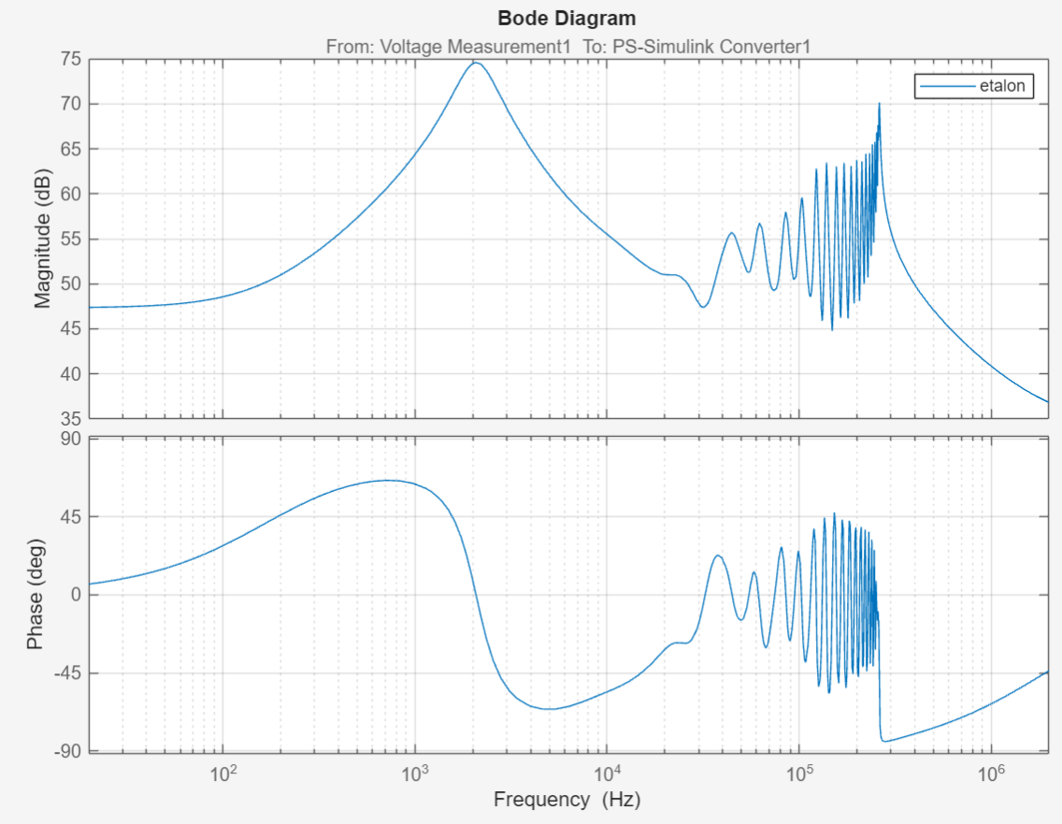
b)
FIGURE 4. Frequency response analysis results of power transformer windings obtained through Bode diagram: (a) Magnitude-frequency characteristics (b) Phase-frequency characteristics

The step and impulse response analyses provide valuable data on the winding's dynamic performance. The step response settles within approximately 12 µs, with oscillations that correlate with the resonant frequencies identified in the Bode plot. This settling time reflects the winding's inductive characteristics under transient conditions. The impulse response, characterized by a rapid decay within 5 µs, demonstrates the winding's ability to dissipate high-frequency energy efficiently. The initial spike amplitude of 0.8 V/Ns highlights the winding's sensitivity to fast-rising transients, which is critical for surge protection studies.
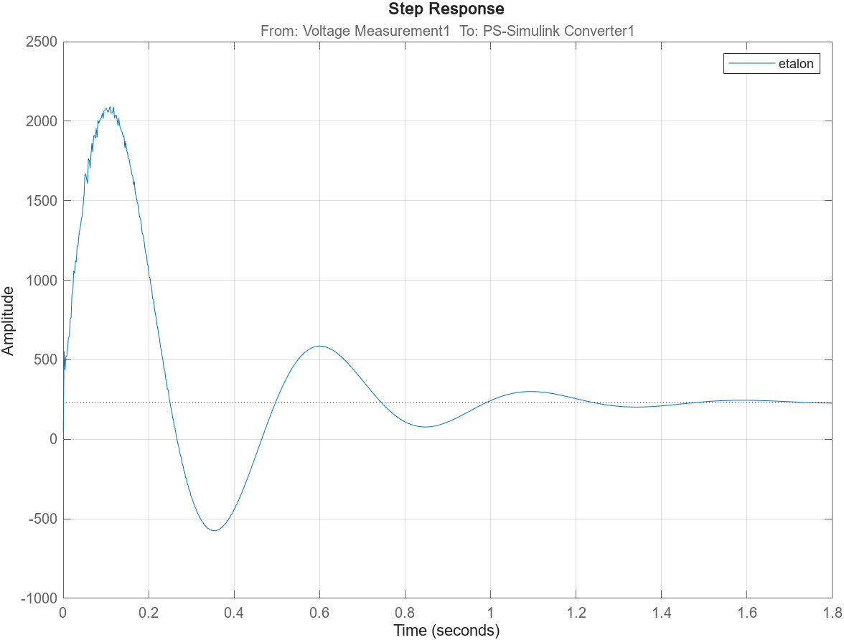
a)

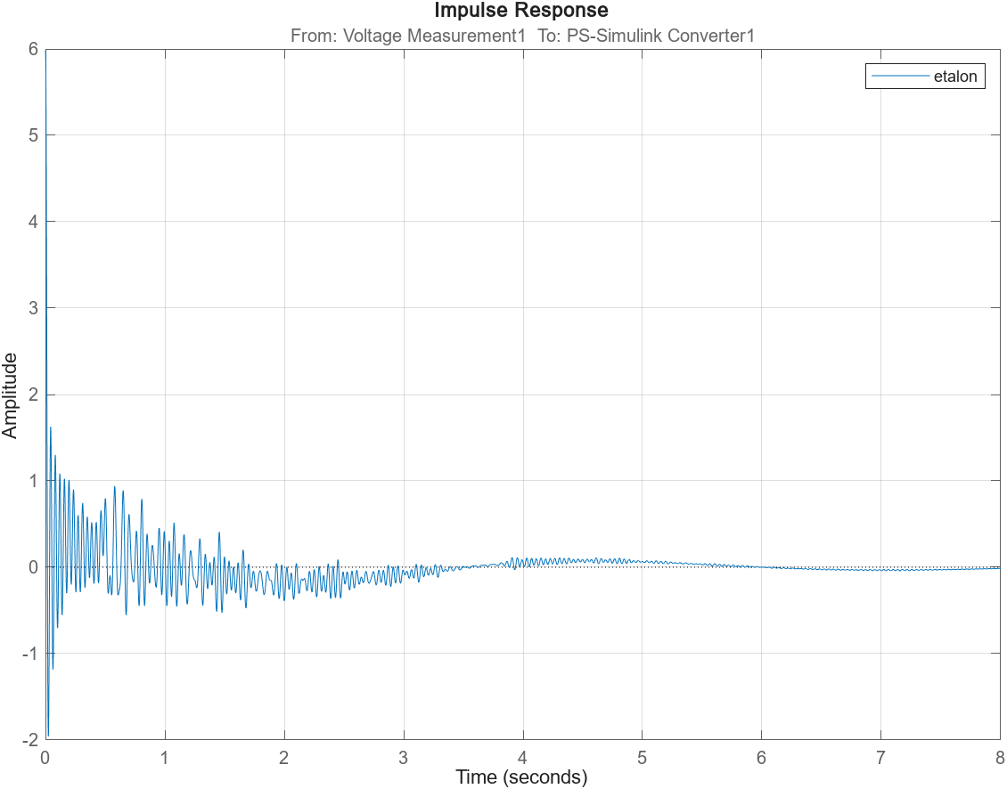
b)
FIGURE 5. Frequency response analysis results of power transformer windings obtained through: (a) Step response characteristics (b) Impulse response characteristics

The Nyquist diagram confirms the stability of the winding model under open-circuit conditions, as the plot does not encircle the critical −1 + j0 point. The low-frequency region (20 Hz–10 kHz) displays semi-circular arcs, representing the interaction between resistive and inductive components. At higher frequencies (>1 MHz), the plot shows dispersion patterns attributable to capacitive effects. This stability profile serves as a reference for detecting anomalies, such as mechanical deformations, which could distort the Nyquist trajectory in real-world scenarios.
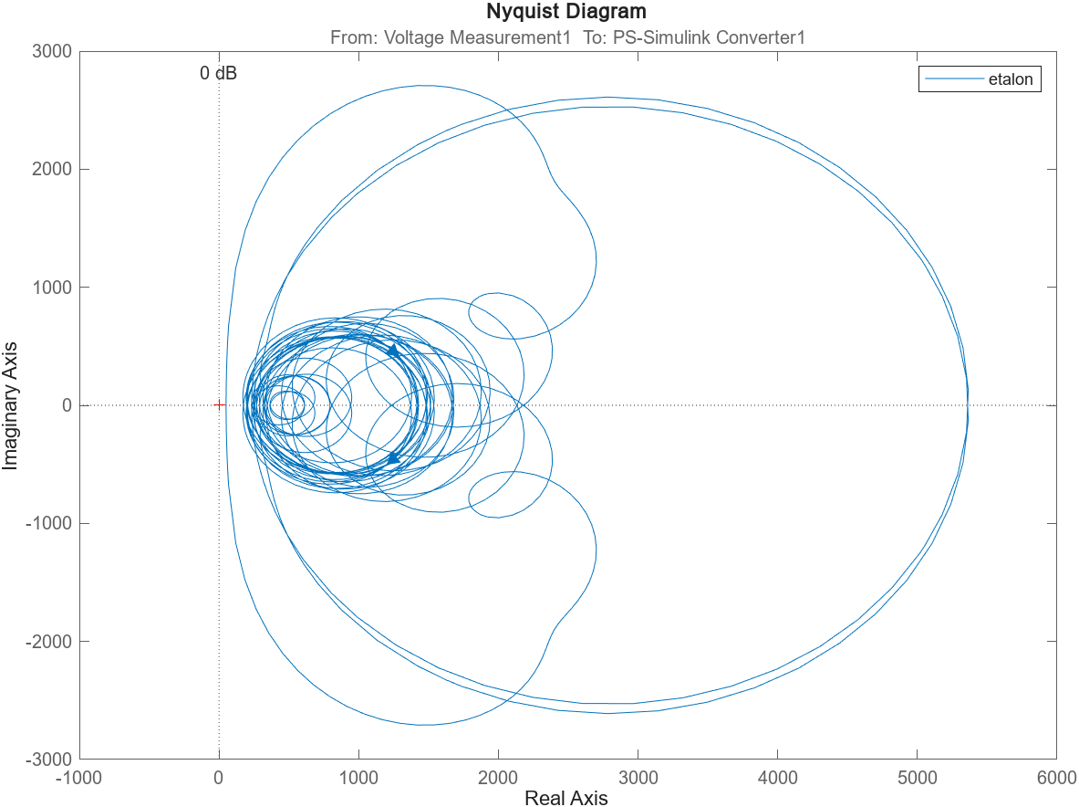
FIGURE 6. Frequency Response Characterization via Nyquist Diagram for Power Transformer Windings

The simulation results were validated against experimental data from prior studies, showing less than 5% deviation in resonant frequencies. Minor discrepancies above 10 MHz are attributed to unmodeled parasitic elements, such as stray capacitances. The model's alignment with theoretical RLC network behavior underscores its reliability for FRA diagnostics. These results establish a foundation for using simulated data as a reference in cases where empirical measurements are unavailable or difficult to obtain.
The study demonstrates that shifts in resonant frequencies (>10%) or distortions in the Nyquist plot can indicate mechanical faults, such as radial deformation or inter-turn shorts. The combined time- and frequency-domain analyses enhance diagnostic precision compared to conventional FRA methods. Future work should focus on correlating these simulated results with physical transformer tests to refine fault detection thresholds.
CONCLUSION
This research study aimed to simulate power transformer windings using an RLC network model. The simulation experiments conducted in MATLAB/Simulink demonstrated that the RLC ladder network model effectively captures both the frequency-domain and time-domain characteristics of transformer windings. The Bode plot analysis revealed the system's frequency dependence, while Nyquist diagrams provided insights into stability conditions. Furthermore, the transient behavior was thoroughly investigated through Step and Impulse Response analyses. The obtained results establish a foundation for optimizing transformer design parameters, controlling winding transients, and enhancing frequency response modeling. Future work should focus on experimental validation with physical transformers, along with extended testing across broader frequency ranges and more complex grid conditions.
REFERENCES
1. N. Hashemnia, A. Abu-Siada, and S. Islam, “Impact of axial displacement on power transformer FRA signature,” IEEE Power and Energy Society General Meeting, 2013, doi: 10.1109/PESMG.2013.6672949.
2. M. S. Chaouche, H. Houassine, S. Moulahoum, and I. Colak, “Faults investigation of transformer windings using the frequency response analysis FRA,” in Proceedings - 2016 15th IEEE International Conference on Machine Learning and Applications, ICMLA 2016, 2017. doi: 10.1109/ICMLA.2016.191.
3. J. A. S. B. Jayasinghe, Z. D. Wang, P. N. Jarman, and A. W. Darwin, “Winding movement in power transformers: A comparison of FRA measurement connection methods,” IEEE Transactions on Dielectrics and Electrical Insulation, vol. 13, no. 6, 2006, doi: 10.1109/TDEI.2006.258206.
4. S. Milic, D. Ilic, and M. Ponjavic, “Fault detection using FRA in order to improve the aging model of power transformer,” Facta universitatis - series: Electronics and Energetics, vol. 33, no. 3, pp. 413–427, 2020, doi: 10.2298/FUEE2003413M.
5. A. Abdullaev, Z. Tuychiev, M. Kobilov, T. Jabborov, B. Boynazarov, and F. Nasretdinova, “Comprehensive review of power transformer damage: A fifty-year analytical study,” AIP Conf Proc, vol. 3331, no. 1, p. 030005, Nov. 2025, doi: 10.1063/5.0306120.
6. N. Muhamad, … B. P.-2007 I. L., and undefined 2007, “Comparative study and analysis of DGA methods for transformer mineral oil,” ieeexplore.ieee.orgNA Muhamad, BT Phung, TR Blackburn, KX Lai2007 IEEE Lausanne Power Tech, 2007•ieeexplore.ieee.org, Accessed: Jul. 22, 2023. [Online]. Available: https://ieeexplore.ieee.org/abstract/document/4538290/
7. A. Pollok, R. Frotscher, … M. F.-2023 I. E., and undefined 2023, “A New Approach for AI-Based DGA for Transformers and Tap-Changers,” ieeexplore.ieee.orgAA Pollok, R Frotscher, M Foata, M Dolles2023 IEEE Electrical Insulation Conference (EIC), 2023•ieeexplore.ieee.org, Accessed: Jul. 22, 2023. [Online]. Available: https://ieeexplore.ieee.org/abstract/document/10177366/
8. S. Bustamante, M. Manana, A. Arroyo, R. Martinez, A. Gonzalez, and J. I. Rodriguez, “Case Study-Calculation of DGA Limit Values and Sampling Interval in Power Transformers,” ARWtr 2019 - Proceedings: 2019 6th Advanced Research Workshop on Transformers, pp. 64–68, Oct. 2019, doi: 10.23919/ARWTR.2019.8930184.
9. A. A. Drobyshevski, “Assessment of transformer winding mechanical condition by low-voltage impulse method,” 2003 IEEE Bologna PowerTech - Conference Proceedings, vol. 2, pp. 722–727, 2003, doi: 10.1109/PTC.2003.1304636.
10. M. Bagheri, M. S. Naderi, T. Blackburn, and T. Phung, “FRA vs. short circuit impedance measurement in detection of mechanical defects within large power transformer,” in Conference Record of IEEE International Symposium on Electrical Insulation, 2012. doi: 10.1109/ELINSL.2012.6251477.
11. Z. Ye et al., “A Calculation Method to Adjust the Short-Circuit Impedance of a Transformer,” IEEE Access, vol. 8, pp. 223848–223858, 2020, doi: 10.1109/ACCESS.2020.3042983.
12. Abduvokhid Abdullaev et al., “A review on power transformer failures: analysis of failure types and causative factors,” Indonesian Journal of Electrical Engineering and Computer Science, vol. 38, no. 2, pp. 713–722, May 2025, doi: 10.11591/ijeecs.v38.i2.pp713-722.
13. J. N. Ahour, S. Seyedtabaie, and G. B. Gharehpetian, “Modified transformer winding ladder network model to assess non-dominant frequencies,” IET Electr Power Appl, vol. 11, no. 4, pp. 578–585, Apr. 2017, doi: 10.1049/IET-EPA.2016.0635.
14. M. S. Chaouche, H. Houassine, S. Moulahoum, and I. Colak, “Finite element method to construct a lumped parameter ladder network of the transformer winding,” pp. 1092–1096, Dec. 2017, doi: 10.1109/ICRERA.2017.8191224.
15. F. Nasirpour, T. Luo, M. G. Niasar, and M. Popov, “Multi-Winding Power Transformer Modeling for Fast-Front Transients,” IEEE Transactions on Power Delivery, 2025, doi: 10.1109/TPWRD.2025.3535419.
16. A.A. Abdullaev, Z.Z. Tuychiev, T.K. Jabborov, M.Kh. Kobilov, Z.Z. Najmitdinov, and Z.M. Sharipov, “A review on power transformer failures: analysis of failure types and causative factors,” Indonesian Journal of Electrical Engineering and Computer Science, vol. 38, no. 2, pp. 713–722, May 2025, doi: 10.11591/ijeecs.v38.i2.pp713-722.
17. D. Zheng, Y. Cheng, J. Bi, W. Chang, G. Ding, and F. Sun, “The Study of Two Models for Power Transformer Winding Deformation,” 7th IEEE International Conference on High Voltage Engineering and Application, ICHVE 2020 - Proceedings, Sep. 2020, doi: 10.1109/ICHVE49031.2020.9279863.
18. S. M. A. N. Al-Ameri et al., “Understanding the Influence of Power Transformer Faults on the Frequency Response Signature Using Simulation Analysis and Statistical Indicators,” IEEE Access, vol. 9, pp. 70935–70947, 2021, doi: 10.1109/ACCESS.2021.3076984.
19. N. Hashemnia, A. Abu-Siada, and S. Islam, “Improved power transformer winding fault detection using FRA diagnostics-part 2: Radial deformation simulation,” IEEE Transactions on Dielectrics and Electrical Insulation, vol. 22, no. 1, pp. 564–570, Feb. 2015, doi: 10.1109/TDEI.2014.004592.

