Comparative analysis of an experiment with simulation modeling of perimeter protection of objects based on
Fiber-Optic technology
Abdurazak Kasimov¹, Mukhabbat Khizirova¹, Muratbek Yermekbayev¹ Utkir Khusenov^{2,a)}, Shinpolat Suyunbaev²
¹ University of Power Engineering and Telecommunications named after Gumarbek Daukeev, Almaty, Kazakhstan
² Tashkent State Transport University, Tashkent, Uzbekistan
^{a)} Corresponding author: otkirxusenov@mail.ru
Abstract. Fiber-optic technologies are a method of transmitting information over long distances using light signals through optical fibers. The main advantages include high bandwidth, low signal loss, resistance to electromagnetic interference, and enhanced security. This paper examines the research on the concept, implementation, and monitoring of a system that enables continuous perimeter surveillance of facilities using optical technologies, ensuring data transmission quality control during perimeter observation. An analysis was conducted on the effectiveness of fiber-optic sensors, including Bragg gratings, for monitoring changes associated with physical impacts on the secured area. During the experiment, measurements were conducted on real-world objects to assess the sensitivity and reliability of the system under various conditions. For result comparison, a simulation model was developed to replicate the system's responses to mechanical deformations and vibrations under various external influences. The results showed that, in real-world conditions, fiber-optic systems can effectively detect minor environmental parameter changes, such as vibrations and mechanical deformations, with high sensitivity and accuracy. However, simulation modeling made it possible to identify potential limitations and optimize system parameters, such as sensor distribution and signal processing algorithms. The comparison of experimental and simulation results confirmed the high reliability of the simulated data and the feasibility of using modeling for preliminary testing and configuration of security systems. The proposed methods can significantly enhance the accuracy and reliability of perimeter security systems, providing a more flexible approach to the design and integration of fiber-optic technologies into existing security systems.
INTRODUCTION
Ensuring reliable perimeter security of facilities is one of the most critical tasks in the field of safety. Traditional security methods such as video surveillance, security alarms and motion sensors are often limited by vulnerabilities to external influences, high installation and maintenance costs and limited range. In this regard, there has been a strong interest in recent years to new technologies that can improve the effectiveness of security [1-3], especially in the context of increased safety requirements.
One such technology is the Bragg Grid fiber optic system, which is an innovative way to monitor and detect changes in physical parameters of the environment such as vibration, deformation, temperature and other impacts
[4]. These systems are highly sensitive, can cover long distances, and are resistant to external influences, making them promising for use in perimeter security systems [5].
Despite the obvious advantages of fiber optic technologies, the question of their optimization and integration into existing security systems remains open. The effectiveness of such systems depends not only on the accuracy of the sensors but also on their proper placement, configuration, and the selection of data processing methods [6]. In this regard, it is important to conduct a comparative analysis of experimental data and simulation modeling to identify key factors influencing the effectiveness of perimeter security using fiber-optic technology.
Consider the following theoretical principles of work of Bragg gratings in fiber-optic systems:
- assess the advantages and limitations of experimental methods and simulation modeling for evaluating the effectiveness of perimeter security;
- conduct experimental research and simulate the system’s behavior under various intrusion scenarios;
- analyze the obtained data and compare the experimental results with the results of simulation.

RESEARCH METHODOLOGY
The article aims to improve the accuracy and reliability of fiber-optic security systems, which is crucial for developing effective security solutions, including the protection of high-risk facilities and in difficult operating conditions.
Fiber-optic perimeter security systems are based on the use of Bragg gratings, which enable the detection of mechanical deformations, vibrations, temperature changes, and other physical impacts [7]. Bragg gratings create periodic variations in the refractive index within the fiber, leading to the reflection of light at a specific wavelength [8]. These systems have high sensitivity and can effectively respond to even minor changes in the state of the protected area [9].
The key parameters influencing the performance of Bragg gratings include:
- Fiber parameters, such as diameter and material type;
- Bragg grating characteristics, including grating length and period;
- The influence of external factors, such as temperature and mechanical impact, on measurement accuracy;
- Experimental methodology.
An experiment was conducted on real objects simulating a secured perimeter to test the security system using Bragg gratings. As part of the experiment, fiber-optic sensors were installed along the perimeter of the object. The main stages of the experiment include:
- Influence of Physical Factors: During the experiment, various factors were applied, including vibrations (e.g., from impacts), deformations, temperature changes, and others.
The monitoring system recorded changes in the reflected light spectrum, allowing for the identification of the location and nature of the impact.
The results of the experiment demonstrated the system’s high sensitivity, its ability to detect minor changes, and its capacity to differentiate between various types of impacts.
- Simulation Modeling Methodology.
A specialized software environment was used to create the simulation model, enabling the replication of the fiber-optic system’s behavior in various scenarios. The main stages of the simulation include:
- Security system modelling. Models were built to account for different intervention scenarios such as fence break-up attempts, physical impact on the fiber, and other external impacts.
- Simulation of various parameters such as sensor distance, sensitivity and data processing algorithms.
- Impact analysis. The system’s reactions to various impacts (vibrations, mechanical deformations, temperature, etc.) were evaluated during the simulation.
The simulation demonstrated that the system could accurately track changes in the secured area and allowed for the optimization of sensor placement parameters to enhance sensitivity and reliability.
Comparing the data obtained from the experiment and the simulation allows for identifying the key features and limitations of each approach.
The experimental data demonstrated high accuracy in real-world conditions, confirming the high sensitivity of the fiber-optic system. However, simulation modeling enabled more precise adjustment of sensor parameters, such as their placement and data processing algorithms, to improve accuracy.
Limitations of External Factors: In real-world conditions, external factors such as weather conditions or electromagnetic interference can negatively affect the system’s accuracy. Simulation modeling allows for these influences to be considered in advance and enables adjustments to the model accordingly.
System Optimization: The simulation results made it possible to optimize sensor placement and system parameters, reducing installation and maintenance costs while maintaining high efficiency.
Fiber-optic communication lines (FOCL) play a key role in the development of modern communication technologies, providing high-speed and reliable data transmission over long distances [10].
The operation of optical fiber networks is based on the principle of light wave propagation through optical waveguides over long distances [11-12]. At the same time, electrical signals carrying information are converted into light pulses, which are transmitted through fiber-optic communication lines with minimal distortion [13]. Such systems have become widely used due to a number of advantages that FOCL have over transmission systems using copper cables or radio waves as the transmission medium.
Such a bandwidth makes it possible to transmit data streams at several terabits per second. Key advantages of FOCL include low signal attenuation, which, with modern technologies, allows optical system segments to span 100 kilometers or more without retransmission, high interference immunity due to the low susceptibility of optical fiber to electromagnetic interference, and many others.
Fiber-optic cables used for data transmission can also serve as sensors for measuring deformations, vibrations, and other mechanical impacts [14]. Such sensors are increasingly used in modern security systems, particularly for creating signal barriers to protect perimeter fences. The attractiveness of fiber optics is determined by several factors. These sensors are resistant to electromagnetic radiation and electrically hazardous. In addition, industrial communication cables can be used as sensors in most cases, which are produced in a wide range and their cost is lower than the cost of specially developed cable sensors.
One of the most commonly used fiber-optic sensors is the sensor based on fiber Bragg gratings (FBG) [15-16]. A fiber Bragg grating (FBG) is a sensitive sensor embedded directly within an optical fiber [17]. An FBG is a periodic structure in the core of the optical fiber that functions as a spectrally selective mirror [18-19]. It reflects only a specific narrow part of the spectrum, while the rest of the spectrum passes through the FBG without significant changes. The reflection wavelength is determined by the FBG’s period (Figure 1). Deformation of the fiber section with the FBG leads to a change in its period and, consequently, a shift in the reflection wavelength [20].
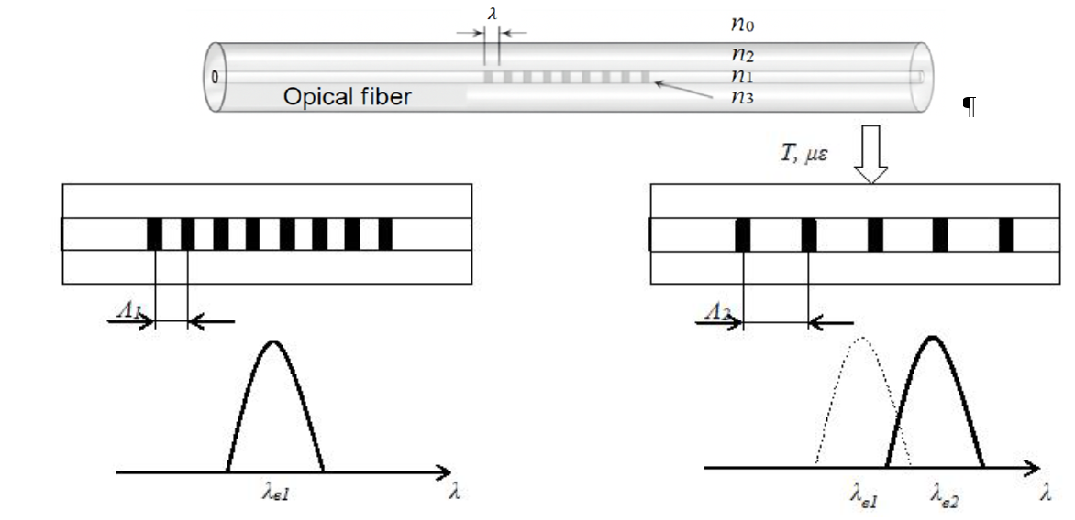
FIGURE 1. Fiber Bragg Grating

In this paper, various mathematical formulas were used to illustrate the physical principles of fiber-optic sensor operation, signal processing, and data analysis.
1. Bragg Shift Formula
The fundamental mathematical description of a Bragg grating in a fiber-optic system is associated with the shift in the reflected light wavelength due to changes in mechanical strain, temperature, or other external influences. The Bragg shift can be described by the formula:
Δ𝜆_{𝐵} = 2𝑛ΔΛ (1)
where: Δ𝜆_{𝐵} – | change in the reflected signal wavelength;
𝑛 – | refractive index of the fiber material;
ΔΛ – | change in the periodicity of the Bragg grating.
This expression will calculate the changes in wavelength that can be used to analyze changes in mechanical and temperature parameters.
2. Response of a Fiber-Optic Sensor to mechanical deformations
Mechanical deformations (such as fiber stretching or compression) cause changes in the wavelength of the reflected signal. This can be expressed by the following equation:
Δ𝐿 =$\frac{FLo}{EA}$ (2)
where: Δ𝐿 – | change in fiber length (stretching or compression);
𝐹 – | force applied to the fiber;
𝐿₀ – | initial fiber length;
𝐸 – | elastic modulus of the fiber material;
A – | cross-sectional area of the fiber.
This expression is used to model deformations that affect the optical characteristics of the fiber.
3. Formula for calculating system sensitivity
To determine the sensitivity of a security system based on fiber-optic sensors, an equation can be used to describe the ratio of signal change (e.g., reflected light intensity) to the magnitude of the applied impact:
$s= \frac{ΔP}{Δx}$ (3)
where: 𝑆 – | system sensitivity (signal change per unit of impact);
Δ𝑃 – | change in signal parameter (e.g., reflected light intensity);
Δ𝑥 – | magnitude of impact (e.g., temperature change or vibration).
This expression allows for assessing the effectiveness of sensors in detecting small changes.
4. Formula for analyzing system accuracy
To evaluate the accuracy of a fiber-optic security system, the accuracy parameter 𝜎 can be used, which is related to system noise and other sources of error.
𝜎 =$\sqrt{\frac{1}{N}}\sum_{i=1}^{N}{{\left(x_{i}- \overline{x}\right)}^{2}}$ (4)
where: 𝜎 – | standard deviation (measurement accuracy);
𝑥_{𝑖} – | measured signal values;
$\overline{x}$ – | mean signal value;
𝑁 – | number of measurements.
This expression allows for assessing the statistical accuracy of the system’s operation and its resistance to interference.
Experimental Part. A multimode fiber, due to its large core diameter, has a relatively high number of modes propagating through the fiber simultaneously. This section explores the application of fiber-optic sensors based on fiber Bragg gratings in various sensor networks. To analyze the use of these sensors, we calculate the impact of external factors on the secured perimeter (Figure 2 and Figure 3).
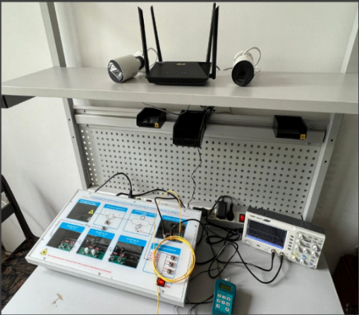 | 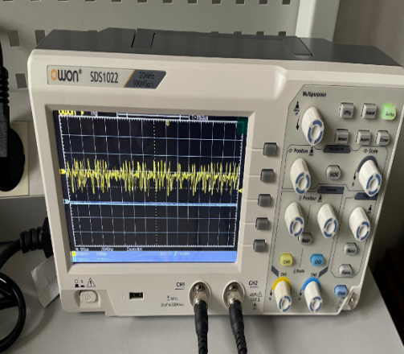
FIGURE 2. Laboratory Setup for Perimeter Protection

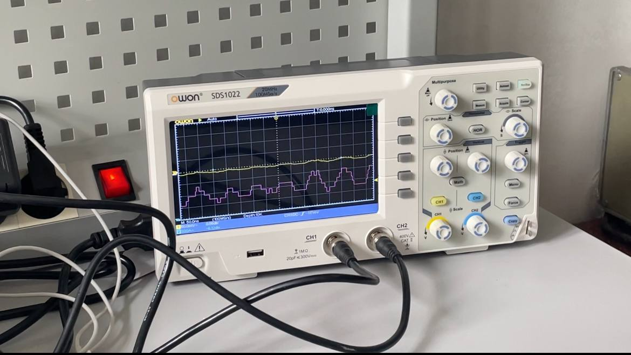 | 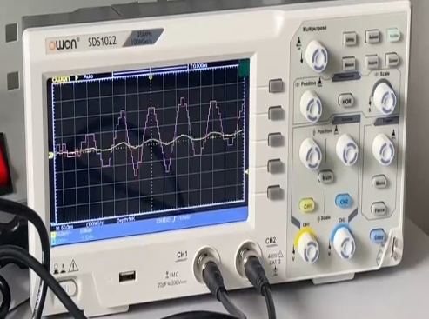
FIGURE 3. Results of pulse signals and mechanical impacts using the OWON SDS1022 Oscilloscope; a) gerghrhrhrhr; b)gbrhrhrhhrjhrhjr

Modeling of Mechanical Impact Model in Matlab. Generation of an optical sensor image under vibration impact using Matlab. We simulate the rotational vibration of the tracking device according to the experiment, which is modeled by using a Simulink model. The data required for modeling the vibration of the tracking device is generated by running the Simulink model (Figure 4). The result obtained from the model is shown in Figure 5.
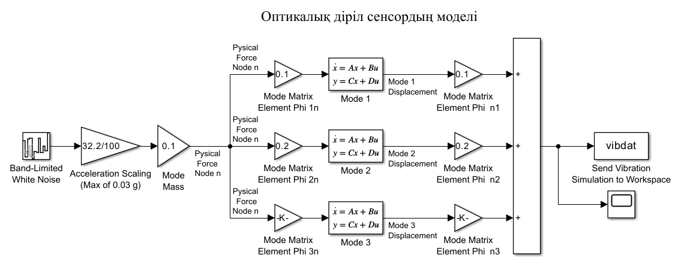
FIGURE 4. Simulink model

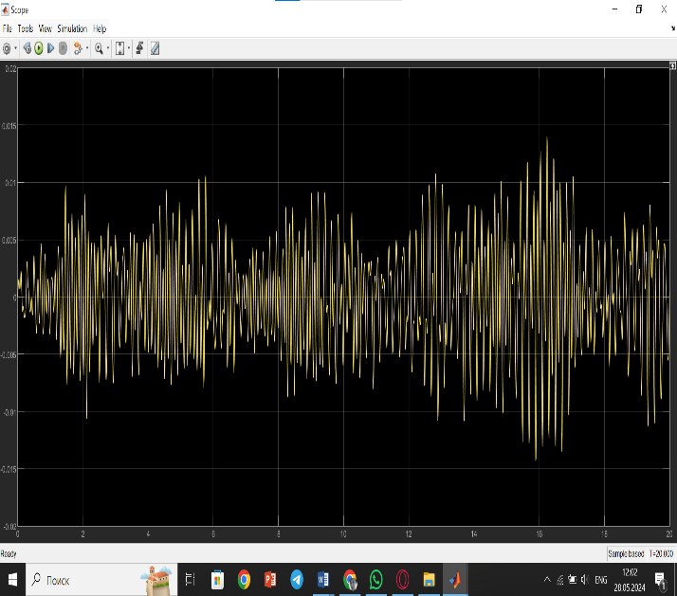 | 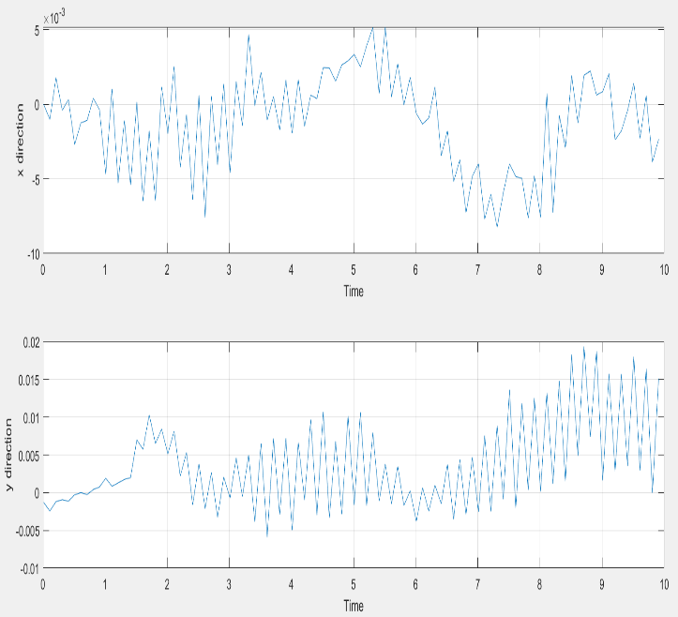
FIGURE 5. Simulation Results

Figure 6 shows the simulation results after mechanical impact on the fiber sensor with a Bragg grating in MATLAB.
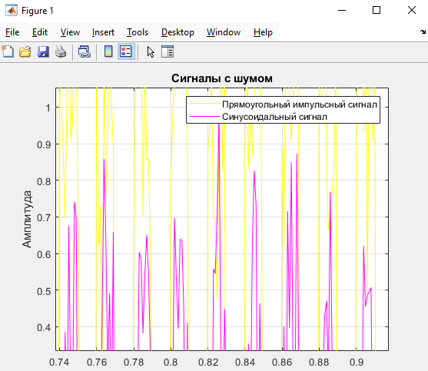 | 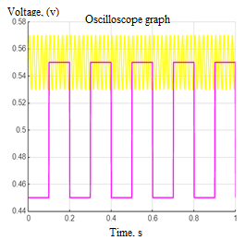
FIGURE 6. Simulation results of pulse and mechanical impact
RESEARCH RESULTS
Fiber Bragg gratings were used as the protection system, based on optical sensors commonly employed in modern networks. The operating principles and fundamental theoretical materials of fiber-optic sensors based on fiber Bragg gratings have been studied. The analysis of their usage revealed that such sensors are utilized in many facilities and defense networks and are among the most in-demand technologies today. This popularity is due to the high accuracy and reliability of measuring various parameters. Optical sensors based on Bragg gratings demonstrated a maximum error of about 0.5%, whereas other sensors can have an error of 10% or more. The experimental part of the study included a series of experiments using a bending strain sensor based on Bragg gratings. During the experiments, various mechanical impacts on the optical fiber were investigated, and changes in parameters such as the Bragg wavelength were measured. The experimental results confirmed the high sensitivity of the sensors to mechanical deformations and their ability to accurately measure curvatures [21].
The computational part of the paper focused on mathematical modeling and data analysis obtained from the experimental section. Calculations of Bragg wavelength shifts under various deformations were performed, confirming both theoretical predictions and experimental data.
CONCLUSIONS
Comparative Analysis of Experimental and Simulation Results: The comparison of data obtained from the experiment and simulation allows for identifying key features and limitations of each approach.
Data Accuracy: Experimental data demonstrated high accuracy under real-world conditions, confirming the high sensitivity of the fiber-optic system. However, simulation modeling allowed for more precise adjustment of sensor parameters, such as their placement and data processing algorithms, to further improve accuracy.
Limitations of External Factors: In real-world conditions, external factors such as weather conditions or electromagnetic interference can negatively impact the system’s accuracy. Simulation modeling allows for these effects to be accounted for in advance and the model to be adjusted accordingly.
System Optimization: The simulation results enabled the optimization of sensor placement and system parameters, which could help reduce installation and maintenance costs while maintaining high system efficiency.
The comparative analysis showed that the combination of experimental research and simulation modeling provides a powerful tool for the development and optimization of fiber-optic perimeter security systems. Experimental validation confirms the system's effectiveness in real-world conditions, while simulation allows for precise parameter adjustment and enhances system reliability.
To further improve security systems, it is recommended to continue working on:
- Optimizing signal processing algorithms to enhance the system’s resilience to external interference.
- Developing more accurate models of external factors affecting the system.
- Integrating fiber-optic technologies with other security systems to create comprehensive solutions.
The article was prepared as part of the grant from the Science Committee of the Ministry of Science and Higher Education of the Republic of Kazakhstan for the project AP19675982: Development of a Wireless Object Security Monitoring System Based on Fiber-Optic Technologies.
REFERENCES
- Abdurakhmanov, A.Z., Khudayberganov, S., Khusenov, U., & Jumayev, S. Mathematical model of criteria for a comprehensive assessment of the state of railway transport infrastructure. In E3S Web of Conferences (Vol. 402, p. 06006). EDP Sciences. https://doi.org/10.1051/e3sconf/202340206006
- Dautbay Nazhenov, Utkir Khusenov, Azizjon Yusupov, Shinpolat Suyunbaev; Substantiation of the influence of the number of shunting locomotives on the working fleet of freight cars and other qualitative indices of railway transportation operations. AIP Conf. Proc. 4 November 2025; 3331 (1): 040002. https://doi.org/10.1063/5.0306962
- Khusenov, U., Suyunbaev, S., Umirzakov, D., Tokhtakhodjayeva, M., & Adizov, I. (2024). Assessment of the effect of train traction by locomotives of different types on the quality indicators of the train schedule. In E3S Web of Conferences (Vol. 583, p. 03018). EDP Sciences. https://doi.org/10.1051/e3sconf/202458303018
- Gordiyenko, V.N. Opticheskiye telekommunikatsionnyye sistemy: Uchebnik dlya vuzov / V.N. Gordiyenko. - M.: GLT, 2011. - 368 c.
- I.R. Gulakov, A.O. Zenevich, T. M. Mansurov. Komponenty volokonno-opticheskikh liniy svyazi. Minsk, 2020. 336 s.
- Kasimov A.O., Khizirova M. A., Yermekbayev M.M. K voprosu o primenenii volokonno-opticheskoy sistemy okhrany obektov. Nauchnyye trudy VIIREiS №3 (53), (june) 2023g. – S.168-176.
- Konnov K.A., Frolov Ye.A., Gribayev A.I., Zakharov V.V., Mikhneva A.A., Novikova V.A., Varzhel S.V. Zapis i vizualizatsiya volokonnykh reshetok pokazatelya prelomleniya s naklonnymi shtrikhami // Optika i spektroskopiya. 2018. T. 125. № 1. S. 51–56.
- Volokonno-opticheskiye sistemy peredachi: osnovnyye postroyeniya, kharakteristiki opticheskikh komponentov: uchebnoye posobiye / I.A. Saitov, K.I. Myasin, N.I. Myasin, V.YU. Golovachev, A.V. Yakovlev. – Orol: Akademiya FSO Rossii, 2015. – 352 s.
- Barbarin, Y.; Lefrancois, A.; Chuzeville, V.; Magne, S.; Jacquet, L.; Elia, T.; Woirin, K.; Collet, C.; Osmont, A.; Luc, J. Development of a Shock and Detonation Velocity Measurement System Using Chirped Fiber Bragg Gratings. Sensors 2020, 20, 1026.
- Kasimov A.O., Khizirova M.A., Yermekbayev M.M., Suyyeubayev O.B., Abdurazak K. Analiz metodov i sredstv volokonno-opticheskogo kontrolya datchik. «Vestnik Akademii Natsional'noy gvardii Respubliki Kazakhstan» № 1 (51), mart 2024 g. – S.264-274.
- Barbarin, Y.; Lefrancois, A.; Chuzeville, V.; Magne, S.; Jacquet, L.; Elia, T.; Woirin, K.; Collet, C.; Osmont, A.; Luc, J. Development of a Shock and Detonation Velocity Measurement System Using Chirped Fiber Bragg Gratings. Sensors 2020, 20, 1026.
- Kasimov A.O., Khizirova M.A., Yermekbayev M.M., Suyyeubayev O.B., Abdurazak K. Analiz metodov obrabotki signalov volokonno-opticheskoy sistemy monitoringa ob"yektov Nauchnyye trudy VIIREiS № 1 (5), (mart) 2024g. – p.109-118.
- Merkulov P.A., Semokhin A.A., Sergeyev M.V. Osnovnyye metody raboty volokonno-opticheskikh datchikov pri ikh funktsionirovanii v sistemakh okhrany perimetra // Sovremennyye nauchnyye issledovaniya i innovatsii. 2023. № 12.
- Mekhtiyev A.D., Neshina Ye.G., Al’kina A.D., Yugay V.V. Razrabotka skhem sistemy okhrany perimetrov raspredelonnogo tipa na osnove volokonno-opticheskikh tekhnologiy. Vestnik Universiteta Shakarima. Seriya tekhnicheskiye nauki. 2020;(4(92)). C. 18-24.
- Volokonno-opticheskiye datchiki / pod red. E. Udda. – M.: Tekhnosfera, 2015. – 520 s.
- Ivanchenko P., Krasovskiy V. Raspredelennyye volokonno-opticheskiye sistemy dlya okhrany perimetra: perspektivnyye tekhnologii // Algoritm bezopasnosti, № 4, 2003.
- Ivanov I.V. Okhrana perimetrov-2. – M.: Paritet Graf, 2000.
- Barbarin, Y.; Lefrancois, A.; Chuzeville, V.; Magne, S.; Jacquet, L.; Elia, T.; Woirin, K.; Collet, C.; Osmont, A.; Luc, J. Development of a Shock and Detonation Velocity Measurement System Using Chirped Fiber Bragg Gratings. Sensors 2020, 20, 1026.
- Zhunisov K.KH., Smaylov N.K., Zhetpisbayev K.U., Medetov B.ZH. (2016). Modelirovaniye volokonno-opticheskikh sensorov temperatury na osnove breggovskoy reshetki. Veles, 4-2, 71-76. URL: https://elibrary.ru/item.asp?id=27183919
- Kasimov A.O., Khizirova M.A., Yermekbayev M.M., Maksot M.Kˌ. Optikalykˌ talshykˌ parametrleríne mekhanikalykˌ əserlerdí zertteu N A U CH N Y Y T R U D Y Voyenno-inzhenernogo instituta radioelektroniki i svyazi Voyennyy nauchno-tekhnicheskiy zhurnal №1 (59), (yanvar-mart) 2025 g. Str 16-25.
- Kassimov A., Khizirova M., Yermekbayev M., Abdikhan D., Marxuly S. Mobile application for remote monitoring and control of lorawan networks. International Journal of Innovative Research and Scientific Studies. 2025-06-10 | Journal article. DOI: 10.53894/ijirss.v8i4.7948. URL http://www.ijirss.com/index.php/ijirss/article/view/7948/1748

