Algorithm for ensuring electromagnetic compatibility of traction transformers
Otabek Boltaev¹, Hainan Zhang², Firuza Akhmedova¹, Islomjon Ismoilov^{1,a)}
¹ Tashkent State Transport University, Tashkent, Uzbekistan
² University of Science and Technology Beijing, Beijing, China
^{a)} Corresponding author: islomjonismoilov777@gmail.com
Abstract. The article examines the maximum voltage pulses at the output of traction transformers, the degree of harmonic distortion, asymmetry of current and voltage, and the electric field in the insulation as the main factors leading to the disruption of electromagnetic compatibility in the transformer. Mathematical expressions were derived for each factor leading to deterioration of electromagnetic compatibility, taking into account system parameters, and 3D graphs were constructed that allow analyzing the dependence of electromagnetic compatibility on changes in various parameters. Also, a mathematical expression has been developed that allows simultaneously taking into account all the main factors leading to the disruption of electromagnetic compatibility, and based on this expression, an algorithm for ensuring electromagnetic compatibility of traction transformers has been developed, and the possibility of using intelligent control in reducing the electromagnetic effects of systems has been created.
INTRODUCTION
Traction transformers used in railway power supply systems are one of the main components of this system. Electromagnetic influences arising during the operation of these traction transformers in various modes negatively affect not only it itself, but also other electrical installations of the railway power supply system. The main reason for the violation of the state of electromagnetic compatibility in traction transformers can be various overvoltages arising in this system [2,3,4].
It is known that overvoltages arise from internal and external sources, and these overvoltages negatively affect the mechanical and electrical damage of the insulation in the system, as well as the operation of the transformer, leading to its failure. Therefore, in this article, we will consider the theoretical and practical aspects of the effectiveness of using overvoltage limiting and filter compensation devices in reducing electromagnetic effects in traction transformers [1,5,7].
According to the theory of electromagnetic compatibility, any electrical device interacts with external devices. Also, in traction transformers, under the influence of large currents and magnetic fields, electromagnetic waves arise, which affect the operating modes of overhead power lines and other adjacent electrical installations. According to research conducted in this area, relatively high efficiency can be achieved by reducing the electromagnetic interaction of various systems using overvoltage limiting devices [2,6,8].
It is possible to relatively improve the indicators of electromagnetic compatibility of systems using dischargers designed to protect insulation by passing atmospheric or internal overvoltages to the ground to limit overvoltages, devices for limiting overvoltages to effectively limit sudden impulse voltages, filter-compensation devices for filtering harmonic currents and compensating reactive power [9,10,11].
When reducing the electromagnetic effects of traction transformers, we carry out modeling processes, considering the maximum voltage pulses at the output of the traction transformer, the degree of harmonic distortion, asymmetry of current and voltage, and the electric field in the insulation as the main factors. For this, first of all, we propose the following expression for determining the maximum voltage pulses at the output of the traction transformer.
RESEARCH RESULTS
$E_{2imp}(Z_{s})=\frac{E_{1imp}}{k_{tr}(1+\frac{Z_{tr}}{Z_{s}})}$ , (1)
where $E_{1imp}$ – voltage pulse in the primary winding of the traction transformer; $Z_{s}$ – internal resistance of the source; $Z_{tr}={U_{k\%}∙U_{1}^{2}}/{100S_{tr}}$ – internal resistance of a traction transformer; $k_{tr}$ – Transformation factor of a traction transformer. According to the expression for determining the internal resistance of a traction transformer, expression (1) takes the following form:
$E_{2imp}(Z_{s})=\frac{E_{1}}{k_{tr}(1+\frac{U_{k\%}∙U_{1}^{2}}{100Z_{s}S_{tr}})}$ . (2)
Using the resulting expression (2) $Z_{s}$ and $U_{k\%}$ for different values of $E_{2}(Z_{s},U_{k\%})$ We construct the curves (Figure 1). According to the obtained graphs, the maximum impulse voltage at the output of the traction transformer has an increasing character with increasing source resistance and short-circuit voltage (Figure 1). When the short-circuit voltage changes from 8% to 12%, the maximum pulse voltage at the output of the traction transformer increases from approximately 154 kV to 175 kV, and also with an increase in the source resistance from 200 Ohm to 400 Ohm, the value of the maximum pulse voltage at the output of the traction transformer changes relatively linearly.
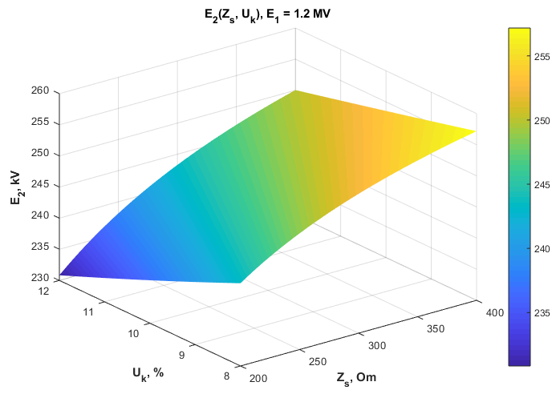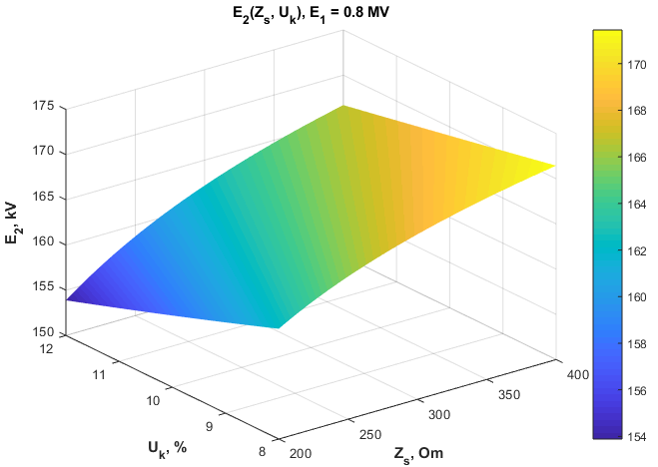
a) b)
FIGURE 1. $Z_{s}$ and $E_{2imp}(Z_{s},U_{k\%})$ for different values of $U_{k\%}$graphs: a) when $E_{1}=1.2 MV;$ b) when $E_{1}=0.8 MV$
As a result of the appearance of higher harmonics in the traction network, electromagnetic influences on the adjacent systems of the traction transformers increase. Harmonic distortions reduce the quality of electrical energy, lead to a violation of the sinusoidality of current and voltage, and as a result, deterioration of electromagnetic compatibility with adjacent systems occurs. In most cases, the degree of harmonic distortion in traction transformers is usually in the range of 5-12%, however, during the operation of a thyristor EMF, an increase in this indicator up to 20-30% can be observed.
For cases of harmonic distortion in traction transformers, the output voltage and current are determined using the following expressions.
$U_{ch}\left(t\right)=U_{1}\sin\left(ωt\right)+\sum_{n=3}^{∞}{U_{n}\sin\left(nωt+φ_{n}\right)},$ (3)
$I\left(t\right)=\frac{U_{1}}{Z_{1}}\sin\left(ωt\right)+\sum_{n=3}^{∞}{\frac{U_{n}}{Z_{n}}\sin\left(nωt+φ_{n}\right),}$ (4)
where $U_{1}$ – fundamental harmonic amplitude; $U_{n}$ – amplitude of an n-th harmonic; $ω$ – cyclic frequency; $φ_{n}$ - phase shift angle in an n-th harmonic; $Z_{n}=\sqrt{R^{2}+{(nωL)}^{2}}$ – Resistance of a traction transformer in an n-th harmonic. The degree of harmonic distortion in traction transformers is determined using the following expressions.
$k_{U}=\frac{\sqrt{\sum_{n=3}^{m}{U_{n}^{2}}}}{U_{1}}∙100\%$, $k_{I}=\frac{\sqrt{\sum_{n=3}^{m}{I_{n}^{2}}}}{I_{1}}∙100\%$, (5)
where $I_{1}$ – fundamental harmonic amplitude; m – highest harmonic.
When the active resistance and inductance of traction transformers are known, harmonic current distortions are
determined as follows.
$k_{I}=\frac{\sqrt{R^{2}+{(ωL)}^{2}}∙\sqrt{\sum_{n=3}^{m}{(\frac{U_{n}^{2}}{R^{2}+{(nωL)}^{2}}}})}{U_{1}}∙100\%$. (6)
Using the resulting expression (6) $R$, $L$ and $φ$ Let us construct curves that allow us to determine harmonic distortions for different values of (Figure 2).

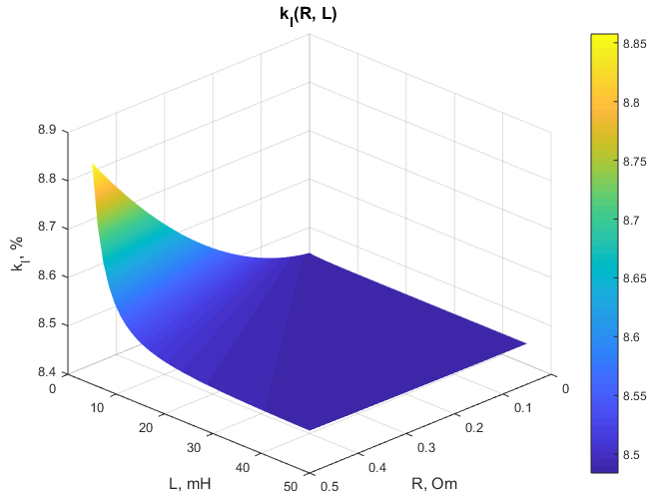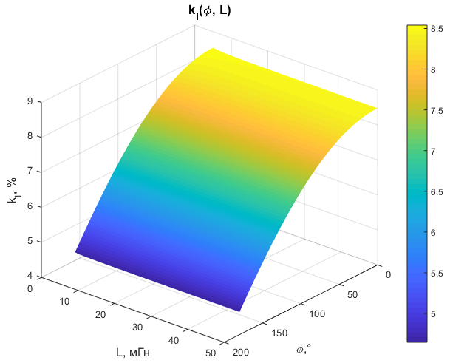
a) b)
FIGURE 2. 3D graphs enabling the identification of harmonic distortions for various values of chain parameters: a) harmonic distortion graphs for different values of R and L; b) harmonic distortion graphs for different values of φ and L
According to the analysis of the obtained 3D graphs, it was found that changes in resistance and inductance significantly affect the degree of harmonic distortion in traction transformers, that is, an increase in inductance from 5 mH to 50 mH leads to a decrease in the harmonic distortion coefficient from 8.85% to 8.5%, and an increase in the phase shift angle from 300 to 1800 leads to a sharp increase in the harmonic distortion coefficient from 4.8% to 8.5%.
As a result of the asymmetry of currents and voltages in the traction transformer, a violation of the degree of electromagnetic compatibility is also observed. For a more complete analysis of this process, we will develop an expression for determining the degree of electromagnetic compatibility in the case of asymmetric loading of traction transformers.
The degree of electromagnetic compatibility in traction transformers is a coefficient expressing the degree of symmetry and harmonic distortion, voltage and current compatibility, and is determined using the following expression.
$K_{EMC}=\frac{U_{t.k.}I_{t.k.}cos⁡(φ_{t.k.})}{U_{tes.k.}I_{tes.k.}cos⁡(φ_{tes.k.})},$ (7)
where $U_{t.k.},I_{t.k.}$ – amplitude of voltages and currents in the direct sequence; $U_{tes.k.},I_{tes.k.}$ – amplitude of voltages and currents in reverse order; $φ_{t.k.}$, $φ_{tes.k.}$ – phase shift angles.
The degree of electromagnetic compatibility in traction transformers is determined by the degree of asymmetry of currents and voltages as follows.
$K_{EMC}=\frac{1}{\sqrt{1+{\left(\frac{U_{tes.k.}}{U_{t.k.}}\right)}^{2}+{\left(\frac{I_{tes.k.}}{I_{t.k.}}\right)}^{2}}}.$ (8)
According to expression (8), if the traction transformer is symmetrically loaded, $U_{tes.k.}=0$, $I_{tes.k.}=0$ and in this case $K_{EMC}=1$, i.e., electromagnetic compatibility is fully ensured.
As the system's asymmetry increases, the degree of electromagnetic compatibility also deteriorates. For a more complete analysis of this situation, we will construct a graph of the dependence $K_{EMC}(K_{U_{nos}},K_{I_{nos}})$ (Figure 3).
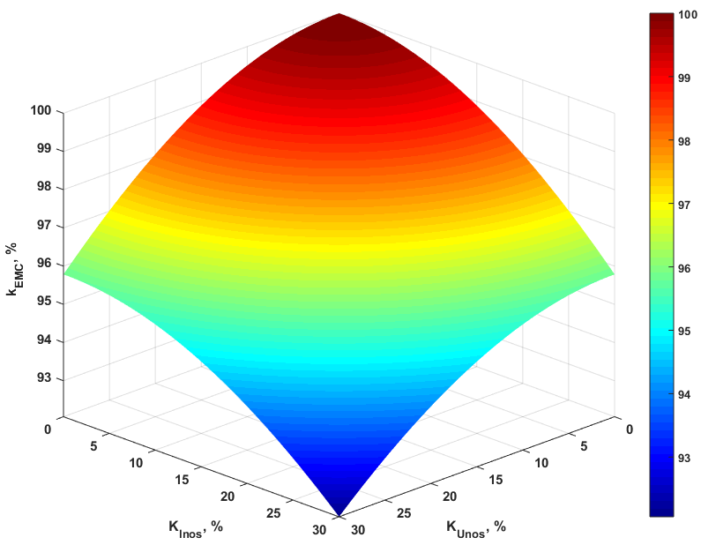
FIGURE 3. Dependence of electromagnetic compatibility in traction transformers on the degree of asymmetry

According to the analysis of the obtained graph, when the system is symmetrical, the degree of electromagnetic compatibility is ensured at 100%, an increase in the asymmetry of current and voltage in traction transformers reduces the degree of electromagnetic compatibility, and an increase in the coefficients of asymmetry of voltage and current up to 30% worsens the degree of electromagnetic compatibility up to 93-95%.
Disruption of the degree of electromagnetic compatibility in traction transformers also depends on the electric field in the insulation, and in this case, the degree of electromagnetic compatibility disruption is determined as follows.
$K_{EMCiz}=\frac{U_{iz}}{d_{iz}E_{iz}},$ (9)
where $U_{iz}$ – voltage drop in the insulator; $E_{iz}$ – electric field strength in an insulator; $d_{iz}$ – insulator length
Using expression (9), we construct its graph to assess the influence of the electric field in the insulator and its length on the degree of electromagnetic compatibility. (Figure 4).
According to the obtained graph, it was found that with an increase in the insulator length, the degree of electromagnetic compatibility of the system improves, and with an increase in the electric field strength, a deterioration in the degree of electromagnetic compatibility is observed.
Taking into account all the factors affecting the electromagnetic compatibility of the traction transformer, i.e., electromagnetic pulse, harmonic distortion, asymmetry, electric field strength, the expression that allows simultaneously taking into account the above expressions will be as follows.
$K_{EMC}=K_{0}e^{\left(-α_{1}\frac{E_{imp}K_{EMCiz}d_{iz}}{U_{iz}}-α_{2}k_{U,\left(I\right)}-α_{3}(K_{U_{nos}}^{2}+K_{I_{nos}}^{2})\right)},$ (10)
where $K_{0}$- ideal fitness level; $α_{1}$, $α_{2}$, $α_{3}$ – coefficients of influence of impulse voltage (about 0.1÷0.5), harmonic distortion (about 0.05÷0.3) and asymmetry (about 0.01÷0.1), respectively;
Using the obtained expression (10), we construct the following graphs to assess the electromagnetic compatibility of traction transformers, taking into account all their effects (Figure 5).
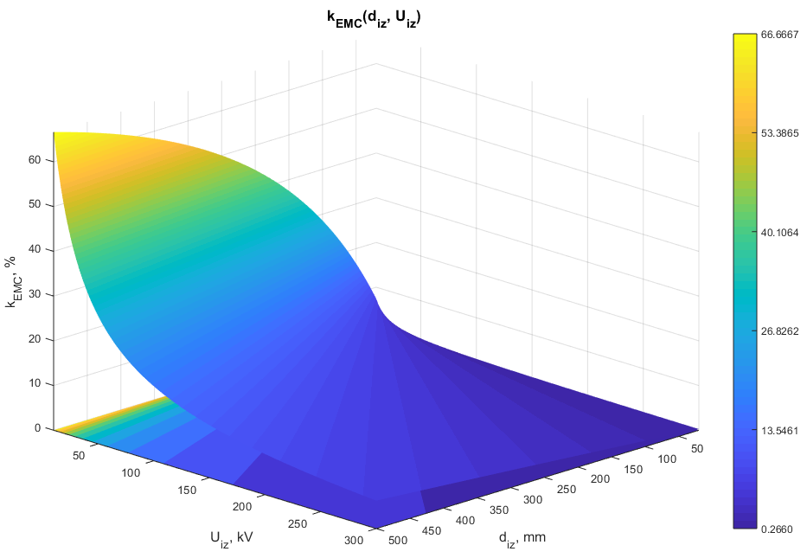
FIGURE 4. Dependence of the electric field in the insulator and its length on the degree of electromagnetic compatibility

According to the obtained graph, a sharp increase in pulse voltage, an increase in harmonic distortion and asymmetry in the system, and their simultaneous occurrence lead to a decrease in the electromagnetic compatibility of traction transformers by 30-40%, resulting in failures of isolators in traction transformers, increased energy losses, and a decrease in system stability.
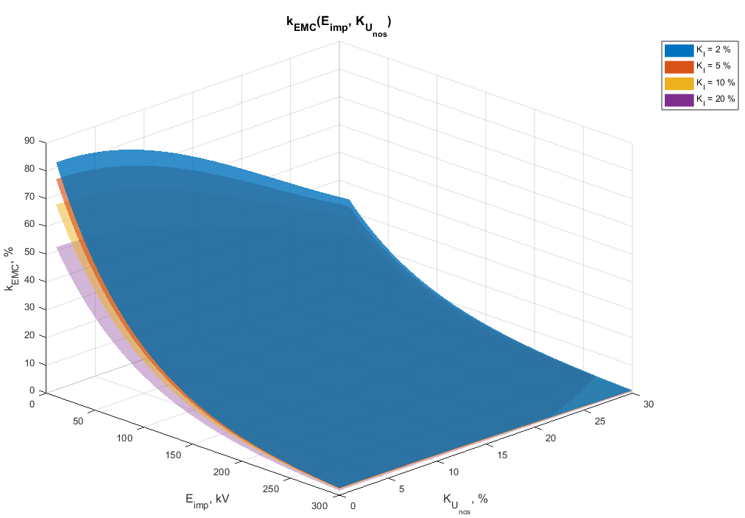
FIGURE 5. Dependence graphs $K_{EMC}(E_{imp}, K_{U_{nos}})$ for different values of the harmonic coefficient

The results obtained using the above-proposed expressions are important in the selection of overvoltage limiting devices for reducing electromagnetic pulses in traction transformers, harmonic distortions in the system, asymmetry of the system, and electric field strength in insulators. Also, the results show that by optimal selection of transformer parameters, it is possible to reduce pulse voltages at the output, which, in turn, serves to reduce electromagnetic influences in the railway power supply system and increase the reliability of electrical equipment.
To ensure electromagnetic compatibility in traction transformers, we will develop an algorithm for ensuring electromagnetic compatibility using the results of the above expressions (Figure 6).
Based on the developed algorithm, it is possible to determine the main factors influencing the electromagnetic compatibility of the traction transformer and the share of each of them, as well as to automatically select an overvoltage limiting device (OPN, RC filter, varistor, etc.) to eliminate this situation if the degree of electromagnetic compatibility is less than a certain threshold condition. With the help of the selected device, the pulse voltage and harmonic distortions are reduced, and the electromagnetic compatibility is brought to the optimal value. Through the control system, the process is controlled, and if necessary, electromagnetic adaptation is carried out again. Based on the application of this algorithm, the reliability of traction transformers in the railway power supply system is increased, the possibility of intelligent control is created to reduce the electromagnetic effects of the systems, and the service life of the insulation system is extended.
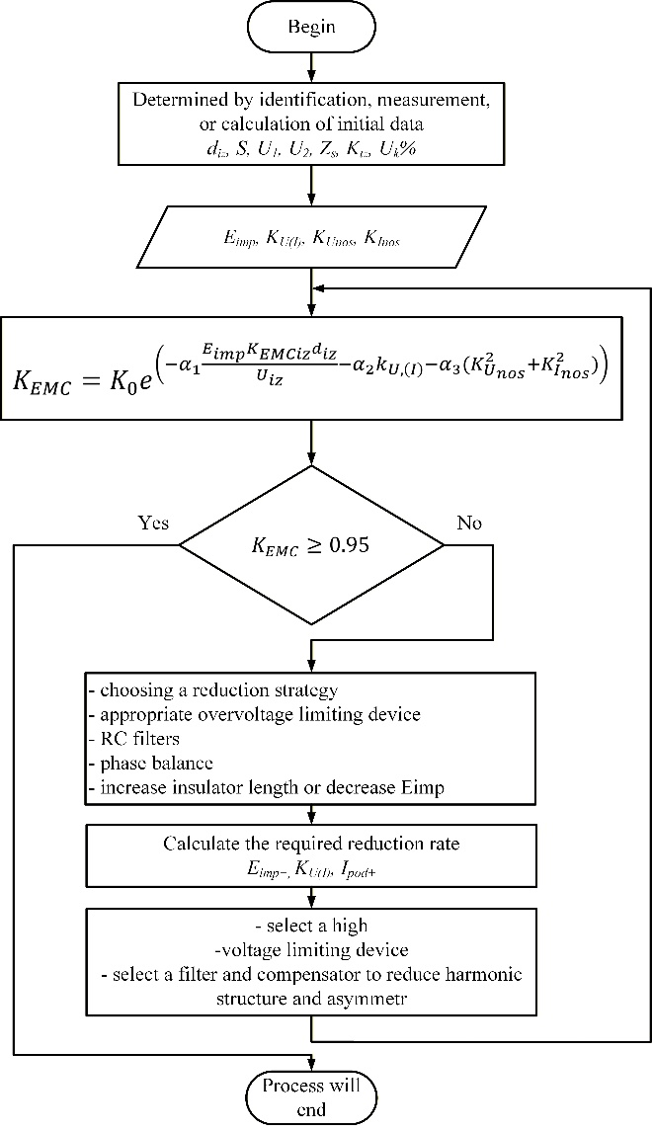
FIGURE 6. Algorithm for ensuring electromagnetic compatibility

According to the developed algorithm, it will be possible to determine the main factors influencing the electromagnetic compatibility of the traction transformer and the share of each of them, and to automatically choose an overvoltage limiting device (OPN, RC filter, varistor, etc.) in order to eliminate this situation if the degree of electromagnetic compatibility is less than some threshold condition. The pulse voltage and harmonic distortions are reduced with the help of a selected device, and electromagnetic compatibility is brought up to the optimal value. The process is controlled by the control system, and if necessary, electromagnetic adaptation is performed again. Increasing the reliability of traction transformers in the railway power supply system becomes possible based on the application of this algorithm, the possibility of intelligent control is created aiming at the reduction of electromagnetic effects of the systems, and the service life of the insulation system is extended.
CONCLUSIONS
According to the results of the calculation of electromagnetic compatibility using the developed expressions, it was established that in traction transformers without the use of protective equipment, voltage pulses increase by 2.5÷3 times, and the value of the electric field in the insulation exceeds the permissible limit. It has been established that when using overvoltage limiting devices, it is possible to reduce pulse voltages by 65÷70%, and when using them in combination with filter-compensation devices, it is possible to reduce the degree of harmonic distortion at the transformer output by 20÷25%.
Also, according to the conducted research, by limiting the electromagnetic compatibility of traction transformers from overvoltage and implementing them using filter-compensation devices, it is possible to extend the service life of the insulation system, increase the reliability of the transformer, and minimize electromagnetic impacts in railway power supply systems.
REFERENCES
- Berdiyev U.T., Vetcher A.K., Hasanov F.F., Avazov B.B. Soft magnetic materials for electric machine construction. AIP Conference Proceedings, 2612 (1), 050014, (2023).
- S.Amirov, O.Boltaev, K.Shakenov, F.Akhmedova, O.Kutbidinov. Determination of induced voltages on lines with complex approach trajectories. AIP Conf. Proc. 4 November 2025; 3331 (1): 030096. https://doi.org/10.1063/5.0305935
- D. Yusupov, B. Avazov. Theoretical solutions for cleaning transformer oils using an electric field taking into account the effects of environments. AIP Advances (2024). https://doi.org/10.1063/5.0306610
- Kolesnikov I.K., Abidova G.S., Khakimov S.H. The choice of a generalized criterion for the efficiency of an automated electric drive of a railway rolling stock. Lecture Notes in Networks and Systems, Vol. 912, (2024). https://doi.org/10.1007/978-3-031-53488-1_34
- Yusupov D.T., Muminov A.B., Nosirov A.I., Berdiev U.T., Kutbidinov O.M. Development of an algorithm of processes for cleaning power transformer oil in a circulatory way. Proceedings of the 15th International Conference on Thermal Engineering: Theory and Applications (ICTEA), Vol. 1, (2024).
- Berdiev U., Sulaymonov U., Abduvalieva D., Khasanov F., Berdiyorov U. Magnetic properties of soft magnetic composites used in electromechanical engineering. E3S Web of Conferences, 383, 04047, (2023). https://doi.org/10.1051/e3sconf/202338304047
- O.Boltaev, Sh.Sharapov, V.Mammadov, F.Akhmedova, S.Khakimov. Investigation of the modes of transducers with an exciting screen and scattering parameters. AIP Conf. Proc. 4 November 2025; 3331 (1): 040052. https://doi.org/10.1063/5.0305985
- IEC 61000-4-3. Electromagnetic Compatibility (EMC) – Part 4-3: Testing and Measurement Techniques – Radiated, Radio-Frequency, Electromagnetic Field Immunity Test. Tashkent, Uzbekistan, (2020).
- Otabek Boltaev, Gulbarshyn Tokpeissova, Firuza Axmedova, Odiljon Kutbidinov. Mathematical modeling of electromagnetic effects of the traction system on the side-off line. AIP Conf. Proc. 4 November 2025; 3331 (1): 040022. https://doi.org/10.1063/5.0305764
- Sauchuk H.K., Yurkevich N.P., Akhmedov A.P., Kolesnikov I.K., Berdiyev U.T., Khudoyberganov S.B., Khakimov S.H. Physical and thermal properties of binary (Bi-Ti-O)-TiO₂ UHF-ceramics. Proceedings of the International Conference on Thermal Engineering, Vol. 1 (1), (2024).
- Kolesnikov I.K., Abidova G.S., Karshiyev K.T., Hakimov S.H. Development of a mathematical model to determine the basic parameters of an induction motor. Advances in Science, Technology and Innovation, Part F764, pp. 265–269, (2025). https://doi.org/10.1007/978-3-031-82210-0_44

