The problem of electromagnetic compatibility in transformers and ways to solve it
Otabek Boltaev¹, Hainan Zhang², Islomjon Ismoilov^{1,a)}, Khasan Ostanaev¹
¹Tashkent State Transport University, Tashkent, Uzbekistan
² University of Science and Technology Beijing, Beijing, China
^{a)} Corresponding author: islomjonismoilov777@gmail.com
Abstract. Transformers are critical components in modern power supply systems, operating across voltage ranges from 0.4 to 110 kV in industrial, urban, transport, and agricultural applications. However, their operation generates electromagnetic interference (EMI), which can disrupt electronic devices, degrade data transmission, and compromise system reliability. This study investigates the sources and effects of electromagnetic compatibility (EMC) issues in transformers, including mechanical vibrations, high-frequency pulse voltages, resonance phenomena, electromagnetic noise, and grounding system defects. Mathematical models are developed to quantify acoustic waves, pulse voltages, ferroresonance, and electromagnetic field strengths in transformers of different voltage classes. Simulation results show that higher voltage transformers (35–110 kV) exhibit significant acoustic and electromagnetic emissions, which can adversely affect insulation, system components, and surrounding electronic equipment. Furthermore, grounding defects amplify electromagnetic disturbances, creating potential safety hazards. A comprehensive multicomponent mathematical model is proposed to assess total electromagnetic influence, integrating transformer-emitted electromagnetic waves, electrical noise, and grounding system deficiencies. The study highlights mitigation strategies, including electromagnetic shielding, low-resistance grounding, pulse voltage protection, EMC monitoring, and regular insulation control, to ensure reliable transformer operation and compliance with EMC standards. The findings provide a foundation for optimizing transformer design, operation, and protection against electromagnetic disturbances in power systems.
INTRODUCTION
Currently, transformers are one of the main devices of the power supply system. Transformers in the voltage range of 0.4-110 kV are widely used in power supply systems of small and large industrial enterprises, urban power grids, transport power supply, and agricultural facilities. During the operation of these devices, the problem of electromagnetic compatibility (EMM) arises, which negatively affects their reliable operation, the quality of data transmission or error transmission, as well as the performance of electronic devices. [1,3,4,9].
Scientific research aimed at solving the problem of electromagnetic compatibility in transformers has been sufficiently analyzed and implemented in practice by scientists of leading domestic and foreign scientific centers and higher educational institutions, namely N.M.Kuznetsov, I.F.Chumakov, W.Kalkner, Y.Zhang, F.Sabath, P.Ripka, A.Fujisaki, Y.Liu, P.Russer, G.Bucci, J.L.Drewniak, D.Pommerenke, O.T.Boltayev, Sh.R.Rakhmatov, B.A.Abdurasulov, K.A.Khalmatov, A.M.Yuldoshev, A.H.Sabirov, J.R.Tukhtayev, I.A., Kurbanov. Nevertheless, high errors in the mathematical model of electromagnetic compatibility of transformers, incomplete study of the sources of the EMF problem, or failure to take into account the change in EMF over time due to changes in the systems lead to the erroneous operation of electronic devices installed together with this system or around it. In this regard, scientific research aimed at reducing errors in the mathematical model of electromagnetic compatibility of transformers, a deeper study of the sources of the EMF problem, or solving problems related to taking into account changes in EMF due to changes in systems over time, is one of the urgent tasks. [5,7,10].
It has been known that, the capacity of electrical and electronic equipment to operate without electromagnetic interaction is referred to as their electromagnetic compatibility. The special focus should be drawn to the interference waves which the transformer produces and its susceptibility to external electromagnetic fields when evaluating EMF of a transformer. As the primary causes of the EMM problem, electromagnetic waves released by transformers (acoustic waves due to mechanical vibrations, high-frequency pulse voltages in the windings, resonant states within the power supply system), noise released by electrical systems (high-frequency pulses by other equipment, rectifiers, thyristor control systems, electrical discharge machines), and defects in grounding systems (high resistance of grounding points, incorrect connecting of equipment bodies and neutral points) are taken into consideration. Thanks to the existence of these issues in transformers, chains of disruptions in the work of automatic control systems, malfunctions of the computing devices, failures in the communication channels, and destruction of electronic boards or microprocessors. [2,6,8].
RESEARCH RESULTS
Mechanical resonance, electromagnetic core, and windings in transformers develop mechanical vibrations which are known as mechanical oscillations. These vibrations, further on, create sound vibrations i.e. sound and noise in the form of waves. An acoustic wave which is produced due to mechanical vibrations in transformers is equated as follows:
$\frac{∂^{2}λ}{∂t^{2}}={ϑ_{λ}}^{2}\frac{∂^{2}λ}{∂x^{2}}$ , (1)
where $λ\left(x,t\right)$ – wave amplitude; $ϑ_{λ}$ – wave velocity; $x$ – distance; $t$ – time.
By substituting the following boundary conditions into equation (1), using the Matlab program, we obtain curves of the distance dependence of the amplitude of acoustic waves (Figure 1).
$λ\left(x,0\right)=\sin\left(\frac{πx}{L_{λ}}\right), \frac{∂λ}{dt}\left(x,0\right)=0,$ (2)
where $L_{λ}=20∙\log_{10}(\frac{P_{tr}}{P_{0}})$ – the level of acoustic noise, depending on the type of transformer, can vary within 60-90 dB; $P_{tr}$ – measured acoustic pressure near the transformer; $P_{0}$ - The minimum acoustic pressure that the human ear can hear is assumed to be 20 μPa.
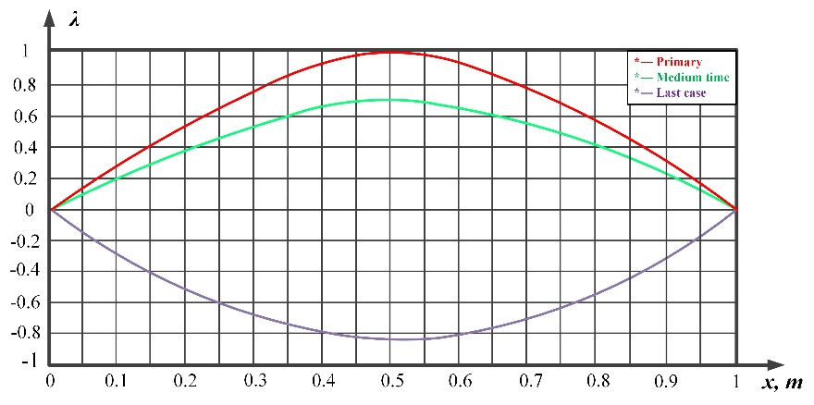
FIGURE 1. Acoustic wave level generated in a 35 kV transformer

The obtained graph shows different waveforms in three states (Figure.1). The red curve in it is the state when t=0, that is, the initial oscillations at the start of the transformer, in this case the acoustic wave propagates as a sinusoidal energy pulse, and we can see that the amplitude of the eacoustic wave is maximal, the energy of the wave is high, and the vibration is strong. The green curve represents the state with t=T/2, i.e., oscillations after a certain period of operation of the transformer, during which the wave propagates with a relatively lower amplitude than in its previous state. The blue curve represents the state of t=T, i.e., vibrations after the transformer is used for a specified period, in which the waveform is reversed, the amplitude of the acoustic wave is at the lowest level, most of the energy is dissipated into the medium.
To analyze acoustic waves in transformers of different voltages, using the above expression, we obtain curves that allow determining the level of acoustic waves in transformers with voltages of 10, 27.5, 35, and 110 kV.
According to the curves shown in Figure 2, the amplitude of the acoustic wave in 10 kV transformers is the lowest, at this voltage the noise level of the transformer is significant for humans, but not high enough to cause fatigue, the amplitude of the acoustic wave in 27.5 kV transformers is at an average level, at this voltage the energy of the wave spreads rapidly into the environment and the noise level is within the range of human hearing, the amplitude of the acoustic wave in 35 kV transformers is higher, at this voltage the propagation of vibrations and acoustic effects over a distance from the transformer is quite significant, and in 110 kV transformers the amplitude of the acoustic wave is very high, the main and harmonic components act together, and we can see that the amplitude value remains high even with increasing distance, the noise and vibration strength are high.
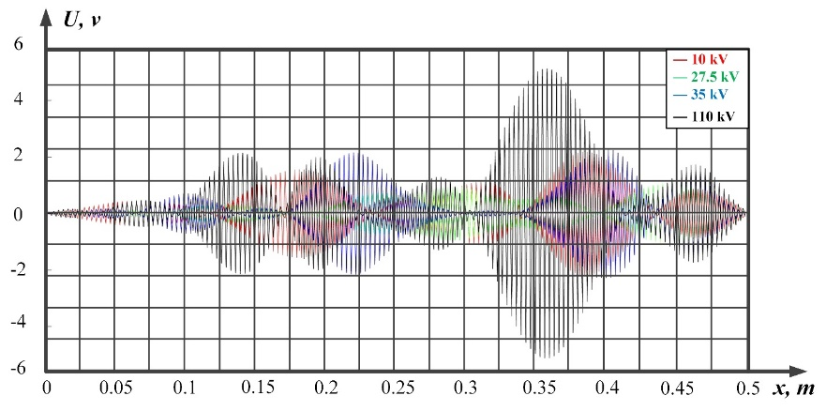
FIGURE 2. Comparison graph of acoustic waves in transformers of different voltages

High-frequency pulse voltages arise in the transformer windings due to switching processes, environmental influences, and internal resonances. Also, high-voltage pulse voltages arise in transformers due to the number of turns in the windings, the quality of insulation, capacitances, and the physical location of the systems.
The duration of high-frequency pulse voltages ranges from 10 ns to 10 μs, the voltage value is several kilovolts, the frequency is from 10 kHz to 10 MHz, and the propagation speed is approximately 300 m/μs.
The equation of high-frequency pulse voltages generated in transformers can be written as follows:
$U\left(t\right)=U_{0}∙e^{-αt}∙sin⁡(ωt+φ)$, (3)
where $ω=1/{\sqrt{LC}}$ – resonant frequency; $α$ – depping coefficient; $φ$ – initial phase.
Based on known values, we determine the high-frequency pulses that can occur in transformers with voltages of 10, 27.5, 35, and 110 kV and construct the curves of change of these values over time.
To perform calculations, the resonant frequency is first determined using the following expression:
$f=\frac{1}{2π\sqrt{LC}}$. (4)
If an impulse of resonant frequency, determined by expression (4), is applied to the LC circuit, an increase in amplitude is observed depending on the quality of the circuit.
$U_{out}=\frac{1}{R}\sqrt{\frac{L}{C}}∙U_{in}$, (5)
where $\frac{1}{R}\sqrt{\frac{L}{C}}=Q$ – contour authenticity.
Expression (5) theoretically allows us to determine the maximum value of the pulse voltage amplitude. Since the factors influencing the decrease in pulse voltage are not taken into account in expression (5), the maximum value in this form is taken. However, in practice, it is possible to achieve a reduction in the value of the pulse voltage up to 400 times due to screening the system, certain discharges arising in it, and insulation.
Depending on expression (4), the duration of the pulse voltage is determined as follows:
$T=\frac{1}{f}$. (6)
Using the above expressions (3) ÷ (6), we determine the high-frequency pulse voltages arising in systems with voltages of 10, 27.5, 35, and 110 kV and plot the obtained results on a single graph for comparison (Figure 3).
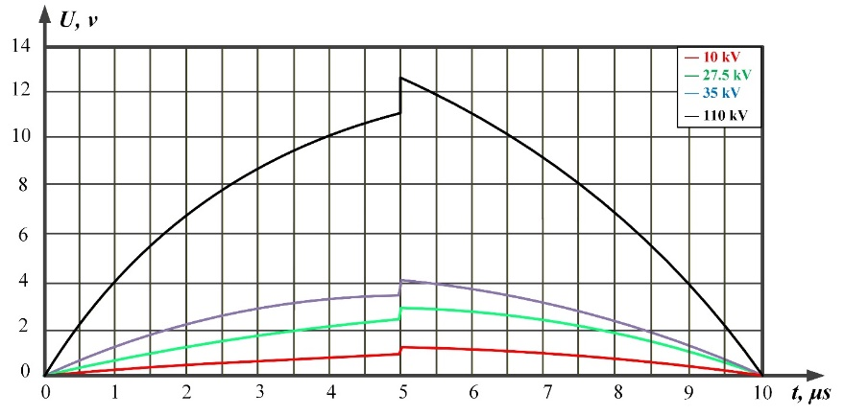
FIGURE 3. High-frequency pulse voltages occurring in transformers of different voltages

According to the analysis of the obtained graph, pulse voltages at all voltages begin at a time of 5 μs and have an exponential damping character, which corresponds to pulse voltages caused by discharges or insulation failures that occur in practice. We can also see on the graph that the pulse voltage increases several times compared to the nominal voltage. This, in turn, seriously affects the insulation, windings, and other elements of the transformer. Therefore, it is necessary to install pulse voltage protection devices in high-voltage devices. At the same time, depending on the level of high-frequency pulse voltages arising in the system, electromagnetic waves are also generated and negatively affect the operation of adjacent equipment.
Resonance, ferroresonance, and harmonic resonance states in the power supply system also generate electromagnetic waves. These resonance phenomena occur in transformers, cables, long wires when the load is low, in the presence of automatic switching and nonlinear elements (transformer, varistor). When the resonance phenomenon occurs, as a result of exceeding the system voltage limit, damage to insulation and the risk of equipment burning, overheating of cables and equipment, malfunction of electronic equipment, a decrease in system efficiency, and high vibrations in turbines, generators, and transformers are observed.
Determination of the frequency, energy, and amplitude of the electromagnetic wave caused by ferroresonance in the network is carried out in the following sequence. First of all, nonlinear inductance is determined by the following expression:
$L\left(i\right)=\frac{L_{0}}{1+αi^{2}}$ . (7)
The general differential equation for the system is as follows:
$U_{in}=Ri\left(t\right)+L\left(i\right)\frac{di\left(t\right)}{dt}+\frac{1}{C}\int{i\left(t\right)dt .}$ (8)
Using expression (8), we determine the possible ferroresonant voltage for systems with voltages of 10, 27.5, 35, and 110 kV and plot them on a single graph for comparison (Figure 4).
According to the curves obtained for comparing ferroresonant voltages occurring in systems of different voltages, an increase in the value of the ferroresonant voltage from the nominal value in the range of 1.4-1.5 is observed at all voltages. The duration of the ferroresistance voltage is also significant. In the obtained graphs, ferroresonance in 10 kV voltage systems is not so dangerous for this system, but for higher voltage systems, it poses a sufficient risk of insulation damage. Along with this, electromagnetic waves are also generated depending on the level of ferroresonance voltages arising in the system.
Noises emanating from transformers are also one of the main sources of EMM problems. Electromagnetic noise is harmful signals caused by changes in the electric current and magnetic field in a transformer, which propagate at different phases, frequencies, and amplitudes and interfere with the proper operation of other electronic devices.
To determine the level of electromagnetic noise in transformers, it is necessary to determine the energy density of the electromagnetic field, the electric and magnetic field strength.
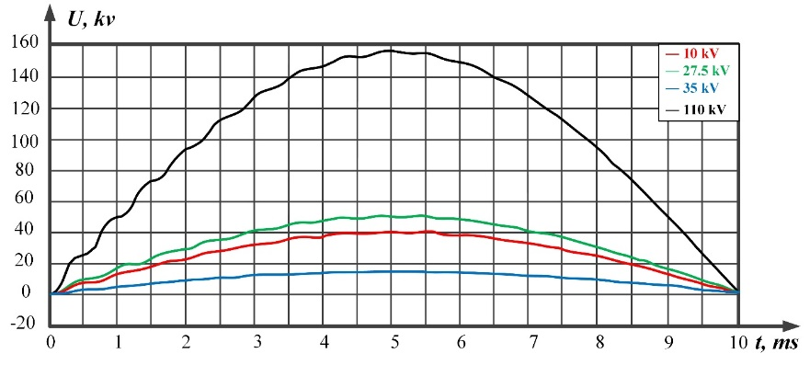
FIGURE 4. Ferroresonant voltages occurring in different voltage systems

The energy density of the electromagnetic field is determined by the following expression:
$W(t)=\frac{ε{E(t)}^{2}+μ{H(t)}^{2}}{2}$, (9)
where $ε$ – dielectric permittivity; $E(y)=\frac{U(t)}{d}$ – electric field strength; $μ$ – magnetic permeability; $H(t)=\frac{wI(t)}{l}$ – magnetic field strength; $w$ – number of turns; $l$ – magnetic core length.
Using the above expressions, we obtain a curve of the dependence of the electric and magnetic field strength and the electromagnetic field energy density on time (Figure 5).
a) | 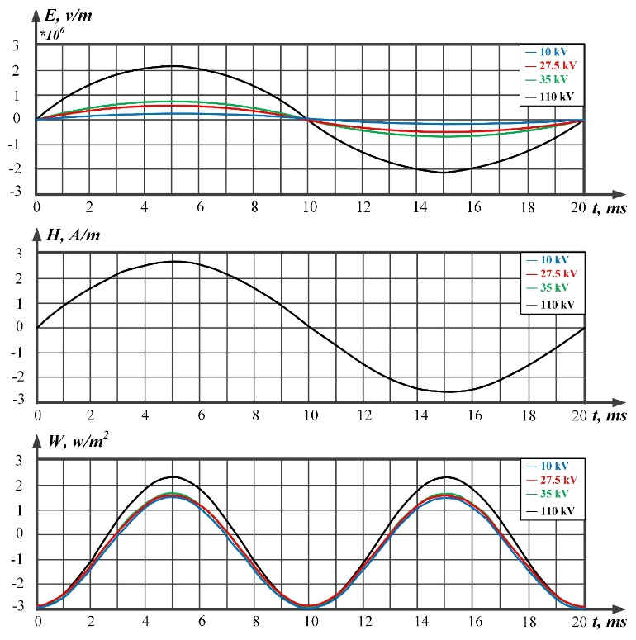
b)
c)
FIGURE 5. Curves of the dependence of electric and magnetic field strength and electromagnetic field energy density on time for systems of different voltages: a) Time-dependent curve of electric field strength; b) Time-dependent curves of magnetic field strength; c) Time-dependent curves of electromagnetic field energy density

According to the obtained graph, with an increase in the nominal voltage, the density of the electromagnetic field energy also increases, i.e., the value of the electromagnetic field energy density increases proportionally to the square of the voltage, as well as an increase in the electromagnetic energy density leads to a sharp increase in insulation requirements and special attention in calculating safety and energy losses at voltages of 110 kV and higher.
As a result of high resistance of grounding points, incorrect connection of equipment bodies and neutral points, the requirements of electromagnetic compatibility are violated, high-frequency interference does not pass through the grounding system completely, different potentials arise at different grounding points, mixing of different signals, the emergence of unexpected pulses, and high potentials in insulation are observed.
To fully assess the electromagnetic interference caused by defects in grounding systems, we will develop a mathematical model of this system. To do this, we can express the total resistance of the grounding point as follows:
$Z_{gnd}\left(f\right)=R_{gnd}+jX_{gnd}\left(f\right),$ (10)
where $R_{gnd}$ – active resistance of the grounding system; $X_{gnd}(f)$ – reactive resistance of the grounding system.
Considering that the current flowing from the grounding device changes according to the law $I\left(t\right)=I_{0}sinωt$, the potential at the grounding point is determined as follows:
$U_{gnd}\left(t\right)=\left[R_{gnd}+jX_{gnd}(f)\right]∙I_{0}sinωt.$ (11)
According to expression (11), if the value of $R_{yer}$ is high, the state $U_{yer}\left(t\right)≫0$ is observed, and in this case, a large potential difference arises in the shell of electrical devices.
When current flows through the grounding device, electrical and magnetic voltages arise depending on the current value, which are determined by the following expressions:
$E_{gnd}\left(l, t\right)=\frac{\left[R_{gnd}+jX_{gnd}(f)\right]∙I_{0}sinωt}{l},$ (12)
$H\left(l, t\right)=\frac{I_{0}sinωt}{2πl},$ (13)
where $l$ - measured distance from the grounding electrode or the point of impact.
The general form of the mathematical model obtained depending on the grounding system and the current flowing through it is as follows:
$W_{gnd}\left(t\right)=\frac{I_{0}^{2}\sin^{2}ωt}{2l^{2}}\left[ε_{0}{\left(R_{gnd}+jX_{gnd}\left(f\right)\right)}^{2}+\frac{μ_{0}}{4π^{2}}\right].$ (14)
In this case, the induced voltage is determined as follows:
$U_{ind}={MωI}_{0}cosωt$. (15)
Using the expressions obtained above, we obtain the curves of the dependence of the electric and magnetic field strength and the electromagnetic field energy on distance.
According to the obtained mathematical expressions and the curves constructed on their basis, with an increase in the resistance of the grounding system, the values of the electric and magnetic field strength increase, and in this case, the value of W (t) increases, the risk of electromagnetic influence arises, and the value of the induced voltage increases. Also, using the obtained mathematical expression, it is possible to assess the quality of the grounding system, conduct electromagnetic compatibility analysis of devices, and calculate their safety indicators. At the same time, by maintaining the resistance of the grounding system below the normative value, creating a symmetrical and equipotential grounding system, using additional tires for potential equalization, selecting corrosion-proof materials, and regularly conducting insulation control, it is possible to reduce the value of electromagnetic influences arising from this system.
Taking into account the above processes, we will develop a universal mathematical model that allows us to assess EMF, taking into account electromagnetic waves emanating from transformers, noise emanating from electrical systems, and shortcomings in grounding systems. For this purpose, we propose the following multicomponent expression for assessing the influence of EMF on devices in scientific and practical calculations:
$E_{total}\left(t,l\right)=E_{emw}\left(t,l\right)+E_{noise}\left(t,l\right)+E_{gnd}\left(t,l\right),$ (16)
where $E_{total}\left(t,l\right)$- total area of impact; $E_{emw}\left(t,l\right)$- an electric field created by electromagnetic waves propagating from transformers; $E_{noise}\left(t,l\right)$- electric field caused by noise from electrical systems; $E_{gnd}\left(t,l\right)$- electric field caused by defects in grounding systems.
$E_{emw}\left(t,l\right)=\frac{μ_{0}m^{''}(t-\frac{l}{ϑ_{λ}})∙\overline{l}}{4πl},$ (17)
$E_{noice}\left(t,l\right)=\sum_{k=1}^{N}{A_{k}\cos\left(ω_{k}t+φ_{k}\right)∙f_{k}\left(l\right),}$ (18)
$E_{gnd}\left(t,l\right)=\frac{ρ_{gnd}I_{gnd}(t-\frac{l}{ϑ_{imp}})}{2πl^{2}},$ (19)
where $m^{''}(t)$ – second derivative of magnetic moment with respect to time; $\overline{l}$ – unit vector value in the direction of wave propagation; $A_{k}$ – k-harmonic amplitude; $ω_{k}$ – angular frequency; $φ_{k}$ – phase shift angle; $f_{k}(l)$ – decreasing function with respect to distance; $ρ_{gnd}$ – specific earth resistance; $ϑ_{imp}$- speed of propagation of an electromagnetic pulse to the earth.
a) | 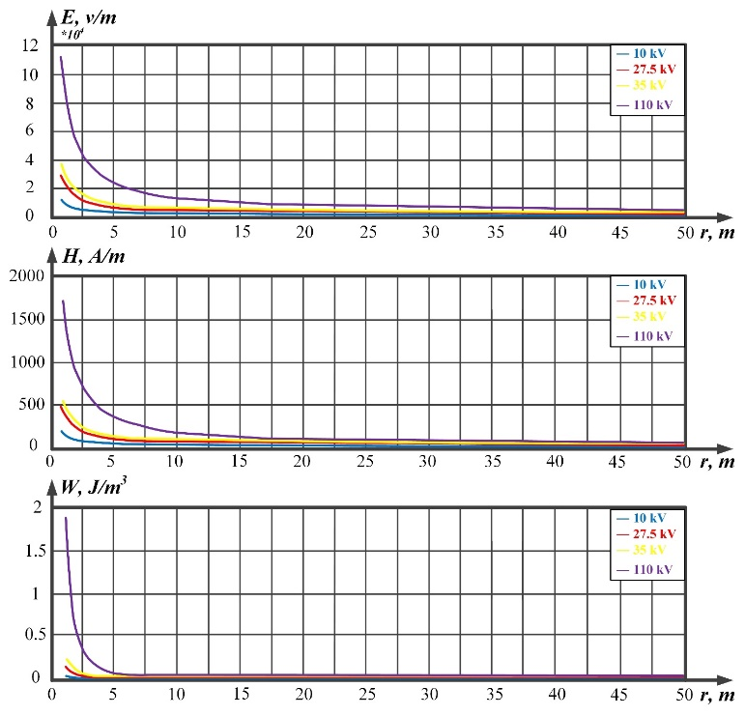
b)
c)
FIGURE 6. Curves of electric and magnetic field strength and electromagnetic field energy depending on distance for different voltages: a) Distance-dependent curve of electric field strength; b) Distance-dependent curves of magnetic field strength; c) Distance-dependent curves of electromagnetic field energy density

Substituting expressions (17), (18) and (19) into expression (16), we obtain the resulting mathematical expression of the following form:
$E_{total}\left(t,l\right)=\frac{μ_{0}m^{''}(t-\frac{l}{ϑ_{λ}})∙\overline{l}}{4πl}+\sum_{k=1}^{N}{A_{k}cos⁡(ω_{k}t+φ_{k})∙f_{k}(l)}+\frac{ρ_{gnd}I_{gnd}(t-\frac{l}{ϑ_{imp}})}{2πl^{2}}.$ (20)
The obtained general expression (20) takes the following form for transformers, taking into account the 3rd and 5th harmonics arising in the system, the magnetic core surface, the number of turns and the power of the winding:
$E_{total}\left(t,l\right)=\frac{μ_{0}wSω^{2}I_{o}cos⁡ωt}{4πl}+\frac{A_{1}\cos{ω_{1}t}+A_{2}\cos{ω_{2}t}}{l}+\frac{ρ_{gnd}I_{gnd}(t)}{2πl^{2}}.$ (21)
Using the obtained expression (21), we determine the total electromagnetic field arising in systems with voltages of 10, 27.5, 35, and 110 kV and compare these results.
In systems with a voltage of 10 kV, electromagnetic influences caused by various sources of influence change depending on the power of the transformers and the amount of load in which they operate. According to the obtained curves, we can see that the electric field caused by the action of electromagnetic waves is at a normal level. Effects caused by electromagnetic noise and grounding defects exceed the normative value. In this case, it is necessary to implement measures to reduce the electromagnetic effect (Figure 7).

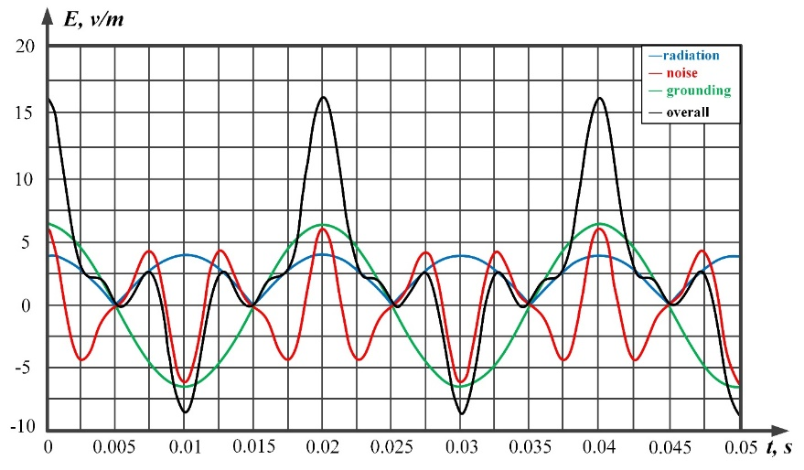
FIGURE 7. Electromagnetic effects occurring in 10 kV voltage systems
We also determine the electromagnetic effects arising in systems with voltages of 27.5, 35 and 110 kV and compare the general values obtained in them (Figure 8).
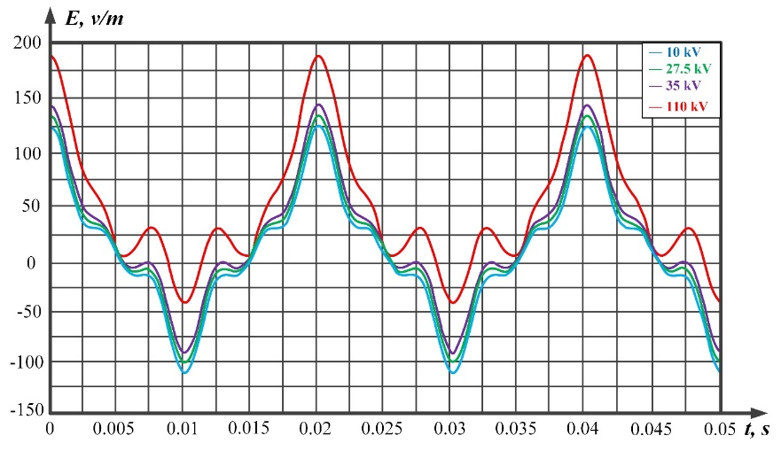
FIGURE 8. Electromagnetic effects arising in systems of different voltages

The obtained last expression and the curves constructed on its basis made it possible to check the electric field arising from the propagation of electromagnetic waves in the core and winding of the transformer, electromagnetic noise from electrical equipment and conductors, dangerous potentials and currents arising in grounding systems, as well as the compliance of the devices with EMF standards.
To eliminate the problem of electromagnetic compatibility in transformers, it is necessary to make the shell of electrical devices from metal or place the device on an electromagnetic screen, install filters on the input and output lines, use low-resistance grounding equipment, install EMC analyzers that detect EMF waves, monitor pulse voltages in transformers and regularly check the resistance of grounding systems, and check the EMF before using electrical devices.
CONCLUSIONS
Based on the conducted research and the developed mathematical model for solving the problem of electromagnetic compatibility in transformers, the following conclusions were made:
- by monitoring the level of acoustic waves arising as a result of mechanical vibrations in transformers, the possibility of timely development of diagnostic or protective measures is created.
- taking into account the fact that high-frequency pulse voltages increase proportionally with increasing nominal voltage of the transformer, the influence of pulse voltages on 110 kV transformers is significantly higher, and this situation negatively affects the insulation, it was determined that it is necessary to correctly choose the insulation gap, material quality, and degree of pulse resistance in the transformer design.
- according to the results of studies to determine the level of electromagnetic noise, it was found that the density of electromagnetic energy increases very rapidly with increasing voltage and periodically fluctuates between maximum and minimum values over time.
It has been established that defects in the grounding system lead to a sharp disruption of the electromagnetic compatibility of electrical devices, resulting in high-frequency and pulsed interference, the formation of various potentials in the shells of the devices, deterioration of signal quality, and a decrease in safety.
REFERENCES
- D.K. Karmokar and C.R. Paul, “Analytical model of conducted emission in power converters,” IEEE Transactions on Electromagnetic Compatibility, vol. 63, no. 2, pp. 390–398, 2021, https://doi.org/10.1109/TMC.2020.3017079
- O.T. Boltayev and I.N. Ismoilov, Comparative analysis of methods of reducing electromagnetic effects of power transformers. Railway Transport: Topical Issues and Innovations, no. 2, pp. 212–216, 2025.
- I.K. Kolesnikov, G.S. Abidova, K.T. Karshiyev, and S.H. Hakimov, "Development of a mathematical model to determine the basic parameters of an induction motor," in “Advances in Science, Technology and Innovation”, Part F764, 2025, pp. 265–269, doi: 10.1007/978-3-031-82210-0_44.
- I.K. Kolesnikov, G.S. Abidova, and S.H. Khakimov, "The choice of a generalized criterion for the efficiency of an automated electric drive of a railway rolling stock," in “Lecture Notes in Networks and Systems”, vol. 912, 2024. https://doi.org/10.1007/978-3-031-53488-1_34
- U. Berdiev, U. Sulaymonov, D. Abduvalieva, F. Khasanov, and U. Berdiyorov, "Magnetic properties of soft magnetic composites used in electromechanical engineering," *E3S Web of Conferences*, vol. 383, p. 04047, 2023. https://doi.org/10.1051/e3sconf/202338304047
- U.T. Berdiyev, A.K. Vetcher, F.F. Hasanov and B.B. Avazov, "Soft magnetic materials for electric machine construction," *AIP Conference Proceedings*, vol. 2612, no. 1, p. 050014, Mar. 2023, https://doi.org/10.1063/5.0117785
- D.T. Yusupov, M.Sh. Muxammadjonov, U.T. Berdiev, O. M. Kutbidinov, and D. R. Abdurakhimov, "Development of the algorithm of additional cooling process for oil power transformers with ONAN cooling system," in *Proc. 15th Int. Conf. on Thermal Engineering: Theory and Applications
- S.Amirov, O.Boltaev, K.Shakenov, F.Akhmedova, O.Kutbidinov. Determination of induced voltages on lines with complex approach trajectories. AIP Conf. Proc. 4 November 2025; 3331 (1): 030096. https://doi.org/10.1063/5.0305935
- S.Amirov, O.Boltaev, S.Minazhova, K.Kharshiyev, S.Khakimov; Mathematical model of an angular displacement transformer converter. AIP Conf. Proc. 4 November 2025; 3331 (1): 030095. https://doi.org/10.1063/5.0305983
- O.Boltaev, G.Tokpeissova, F.Axmedova, O.Kutbidinov. Mathematical modeling of electromagnetic effects of the traction system on the side-off line. AIP Conf. Proc. 4 November 2025; 3331 (1): 040022. https://doi.org/10.1063/5.0305764

