Method for energy-efficient organization of freight train operations with different mass standards
Utkir Khusenov^{1,a)}, Shinpolat Suyunbaev¹, Allanazar Ilyasov², Shokhrukh Kayumov¹
¹ Tashkent State Transport University, Tashkent, Uzbekistan
²Karakalpak State University name after Berdakh, Nukus, Uzbekistan
^{a)} Corresponding author: otkirxusenov@mail.ru
Abstract. The continuous expansion of railway networks leads to increased energy consumption and intensifies negative impacts on the environment. Analyses of scientific studies show that 60-70% of the total energy consumption in railways is attributable to train traction processes. As a result, the issue of energy-efficient control of train operations on railway sections has become a relevant and complex research area. It is well known that the mass standards and operating speeds specified in the train timetable are among the main factors determining fuel and energy consumption associated with traction. This paper clarifies the reserve running time that arises as a result of operating trains on railway sections that are not formed according to the maximum mass standard. It is substantiated that this leads to an increase in station dwell time during train crossings on single-track railway sections. A method for achieving energy savings by utilizing the resulting reserve time for train running on line sections has been investigated, and its effectiveness has been analyzed. The proposed method consists in increasing fuel and energy efficiency by reducing excessive station waiting times through lowering the locomotive control (power) settings of trains with reduced normative mass and available reserve time, while maintaining compliance with the scheduled running time.
INTRODUCTION
Railway transport provides significant convenience in our daily lives due to its safety, comfort, punctuality, and high efficiency. As economic development accelerates worldwide, the strategic importance of railway transport is further increasing, which in turn creates conditions for the expansion of railway networks. The expansion of railway networks increases energy consumption and intensifies negative impacts on the environment. Therefore, the issue of saving energy while ensuring trains reach their destinations on time and providing comfort during travel has become a relevant and complex research area. Energy consumption of railway networks accounts for more than 80% of the total energy used by railways. Of this, 60–70% corresponds to the energy required for train traction [1], meaning that the main energy consumption in railway systems is directly related to the traction process. For this reason, organizing train operations in an energy-efficient manner is a relevant issue of both theoretical and practical significance.
Saving fuel and energy resources through the efficient use of the kinetic energy of train movement is of great importance. Traction, coasting, and braking are the main modes of train operation. If reserve time is available during the inter-station movement of trains, it is possible to reduce fuel and energy consumption in traction by utilizing the kinetic energy of the train consist. Energy consumption should be minimized by optimally selecting the operating modes of train movement. Currently, 87.8% of the railway network of “Uzbekistan Railways” JSC consists of single-track railway sections. The normative train timetables for single-track sections of “Uzbekistan Railways” JSC for the years 2015-2025 have been analyzed. The analysis results showed that, when freight trains traveling in opposite directions cross each other, the trains have on average 40% of excess reserve time. This resulting reserve time increases the duration of unnecessary stops at stations and the occupation of station tracks. This indicates the importance of increasing fuel and energy efficiency by making effective use of the reserve time through reducing the locomotive control (power) settings, without deviating from the scheduled train running time.

RESEARCH METHODOLOGY
Currently, there are a number of scientific studies focused on organizing transportation in an energy-efficient manner based on the optimization of train operating modes. One of the earliest and most notable works on energy-efficient control of train operations was carried out by the Scheduling and Control Group (SCG) research team in Northern Australia. SCG researchers developed a model for energy-efficient train operation control and created the Metromiser system for suburban trains and the Freightmiser system for long-haul freight trains, aiming to minimize energy consumption by determining the optimal operating mode. Currently, these systems are produced by Siemens in Germany and can reduce energy consumption by up to 15% [2]. According to [3], on straight or gradient-free tracks, energy-saving control in short-distance train operations is divided into three modes: traction, coasting, and braking. In long-distance operations, an additional constant-speed mode (cruising) is also present. This process is illustrated in Figure 1.
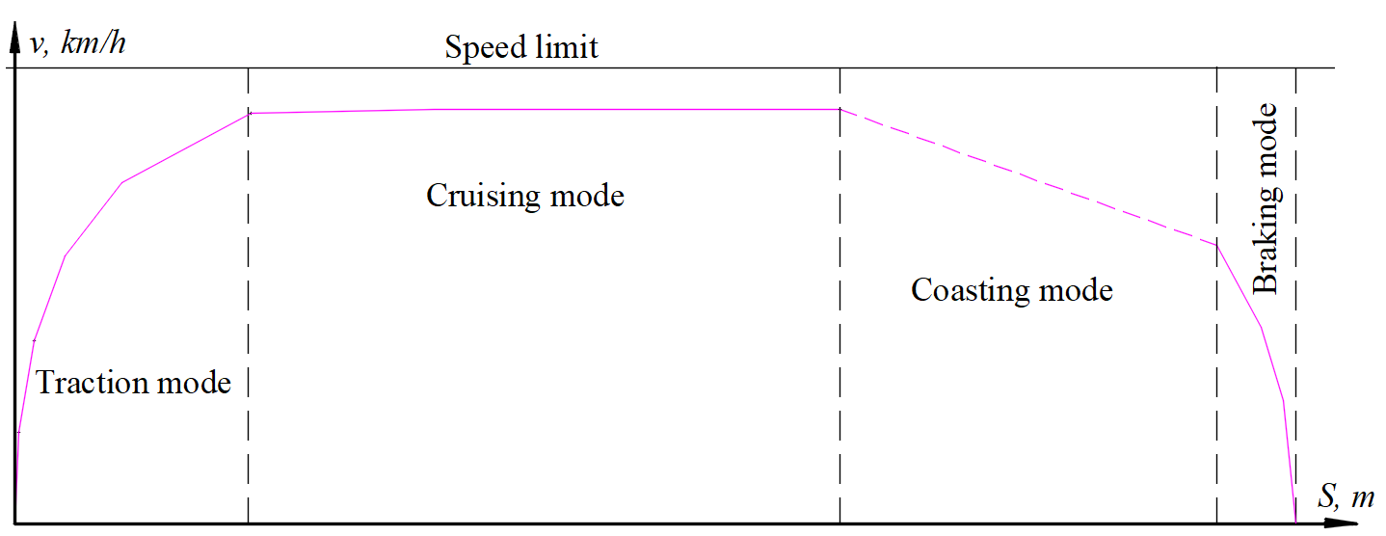
FIGURE 1. Energy-efficient control modes for long-distance train operations

In a scientific article on Belarusian Railways aimed at improving the energy efficiency of transportation [4], several key directions for increasing fuel efficiency in railway transport were discussed, including optimizing train operations, implementing intelligent technologies in practice, improving the fuel consumption standardization system, and developing and carrying out technical measures to modernize the rolling stock.
In the scientific article by Liu et al. [5] on improving the energy efficiency of railway vehicles, an analytical method based on the maximum principle was used to develop energy-saving strategies for trains operating on long-distance railway sections, taking into account speed limits and gradients. To reduce algorithmic complexity, continuous control variables were introduced. As a result, the theoretical model based on the maximum principle demonstrated how to minimize energy consumption by maximizing the use of the train’s kinetic and potential energy and reducing unnecessary braking.
Determining optimal control strategies for freight trains is a complex task, as it requires simultaneously considering numerous variables such as train speed, track gradient, distance, and energy consumption. In the scientific article by Howlett et al. [6], a globally optimal control strategy was developed for trains operating on steep-gradient tracks. The critical switching points for the optimal control strategy were calculated based on a new local energy minimization principle. This method was successfully applied in Australia for long-haul freight trains, allowing precise determination of optimal switching points and thereby achieving improved energy efficiency for long-distance freight operations.
The scientific article by Qing Gu et al. [7] is dedicated to studying the improvement of railway transport performance and the implementation of energy-saving measures. Research on reducing energy consumption in railway systems has been carried out along two main directions. The first direction focuses on reducing energy consumption by optimizing train acceleration, braking, and coasting modes based on energy-saving driving strategies. The second direction examines improving energy efficiency through regenerative braking and energy storage and reuse systems (ESS), allowing recovered electrical energy to be stored and reused when needed.
A number of scientific studies have been conducted by researchers in our country [8-16] on saving energy by organizing train operations rationally based on traction calculations. In particular, in the scientific article [8], the impact of the difference between the average specific comparative resistance, calculated based on the number and weight of wagon groups in a freight train, on electrical energy consumption was determined. For a specific train example, the electrical energy consumption calculated based on the share of wagons by weight differed by 9% from the value calculated based on their number.
In [9], a program was developed to determine the necessary parameters for traction calculations using the numbers of wagons in each train composition, and a method for calculating the primary specific resistance to the movement of freight wagons was created. The impact of the primary specific resistance of freight wagons on the energy costs of train operation was evaluated. As a result, the feasibility of using the developed method for normalizing electricity consumption based on traction calculations was demonstrated.
In the scientific article [10], the impact of traction by different types of locomotives on the quality indicators of train schedules was evaluated. As a result, it was scientifically substantiated that, by standardizing inter-station running times in a differentiated manner for various locomotive types based on traction calculations, it is possible to increase both the technical performance of freight trains and their speed on the section.
The research results indicate that scientific studies on improving energy efficiency in transportation by reducing the impact of reserve time-arising from the operation of trains not formed according to the maximum mass standard on the dwell time during crossings with trains traveling in the opposite direction have not been sufficiently carried out. Analysis of existing studies has shown the need to increase fuel and energy efficiency by reducing excessive station waiting times through lowering the locomotive control (power) settings of trains that have reserve time, while remaining within the scheduled running time. Depending on the amount of reserve time generated in the normative timetable of freight trains, the driver can follow the trajectory of one of the energy-optimal control position options.
The most important traction and energy indicators of locomotives are the mass and speed of trains. These parameters characterize not only the performance of the locomotive fleet but also the overall operation of the railway transport system, since the capacity and throughput of railways, transportation costs, and labor productivity depend on the weight and speed of trains. When developing a train timetable, the weight and speed of trains are determined depending on the type of locomotives in use. The weight and speed of trains are inversely proportional to each other. As the train’s weight increases, the section speed decreases, which in turn affects delivery times, wagon turnover, and the operational efficiency of the transport system.
In practice, the speed and inter-station running time of freight trains are determined based on the maximum mass standard for the section and are calculated using traction calculations. Usually, when transit trains with a mass lower than the maximum standard for the section cross each other, additional reserve running time arises. As a result, this reserve time either increases the duration of unnecessary stops at stations or is distributed along the section without considering opportunities for energy savings.
The fragment showing the reserve time of a train not formed according to the maximum mass standard arriving at a station at (Δt) is illustrated in Figure 2. In Figure 2, trajectory I represents the train moving according to the scheduled time, while trajectory II indicates that the train arrived at the station earlier than the scheduled time with reserve time.
FIGURE 2. Train arrival options at the station

To determine the relationship between train mass standards and running time, a traction calculation was carried out for a section of “Uzbekistan Railways” JSC as an example. The maximum mass standard for this section was set at Q=5000 t. A 2TE25K^{M} type diesel locomotive was used for traction on the section. In the locomotive’s maximum control mode (position 15), fuel consumption is 18.25 kg per minute, while in coasting and braking modes it is 0.45 kg per minute. Information about the wagons in train consists formed according to different mass standards is presented in Table 1.

TABLE 1. Types of wagons in the train consist
Type of wagons | Average gross weight per axle of the wagon, t. | Number of wagons by type in the train consist
Type of wagons | Average gross weight per axle of the wagon, t. | Q=5000 t. | Q=4500 t | Q=4000 t | Q=3500 t. | Q=3000 t.
Other 4-axle wagons | 23 | 46 | 40 | 35 | 31 | 25
Empty 4-axle wagons | 5.5 | 14 | 11 | 13 | 8 | 9
Total: |  | 60 | 51 | 48 | 39 | 34

In performing traction calculations, the specific comparative resistance for train consists composed of different types of wagons was determined based on the methodology presented in the study [17]. To perform traction calculations, the comparative accelerating and decelerating forces for traction, coasting, and braking modes were determined using the formulas presented in the studies [18].
Based on the data presented in table 1, the train movement trajectories and speed curves v(s) obtained from traction calculations for different mass standards are shown in Figure 3.

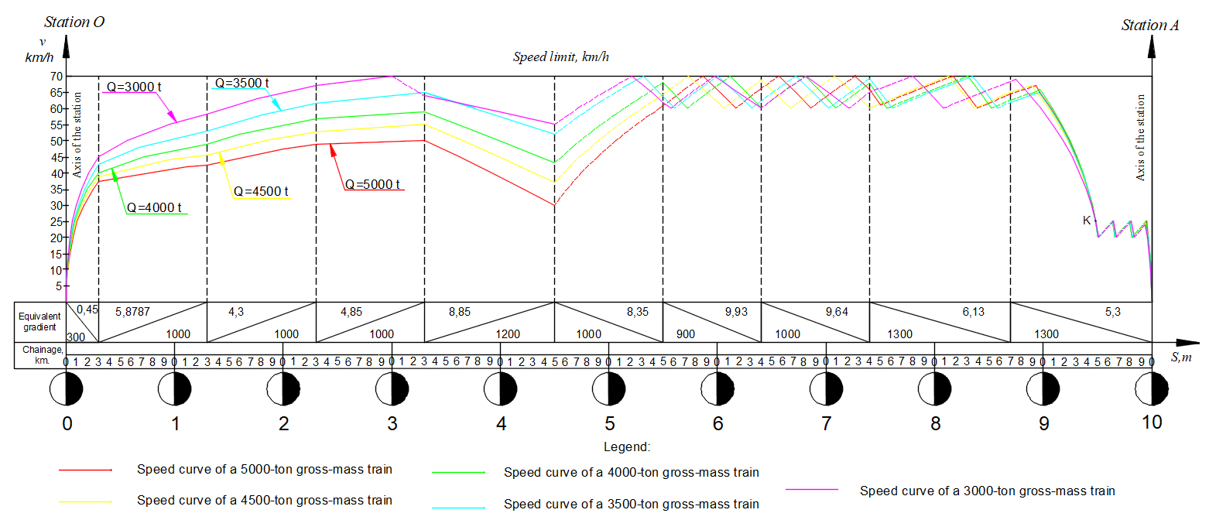
FIGURE 3. Speed v(s) curves of trains with different masses

The inter-station running time was determined graphically based on the speed v(s) curves of trains with different masses shown in Figure 3. The time t(s) curves of five trains, formed according to different mass standards and operating on the “O-A” section, are illustrated in Figure 4.

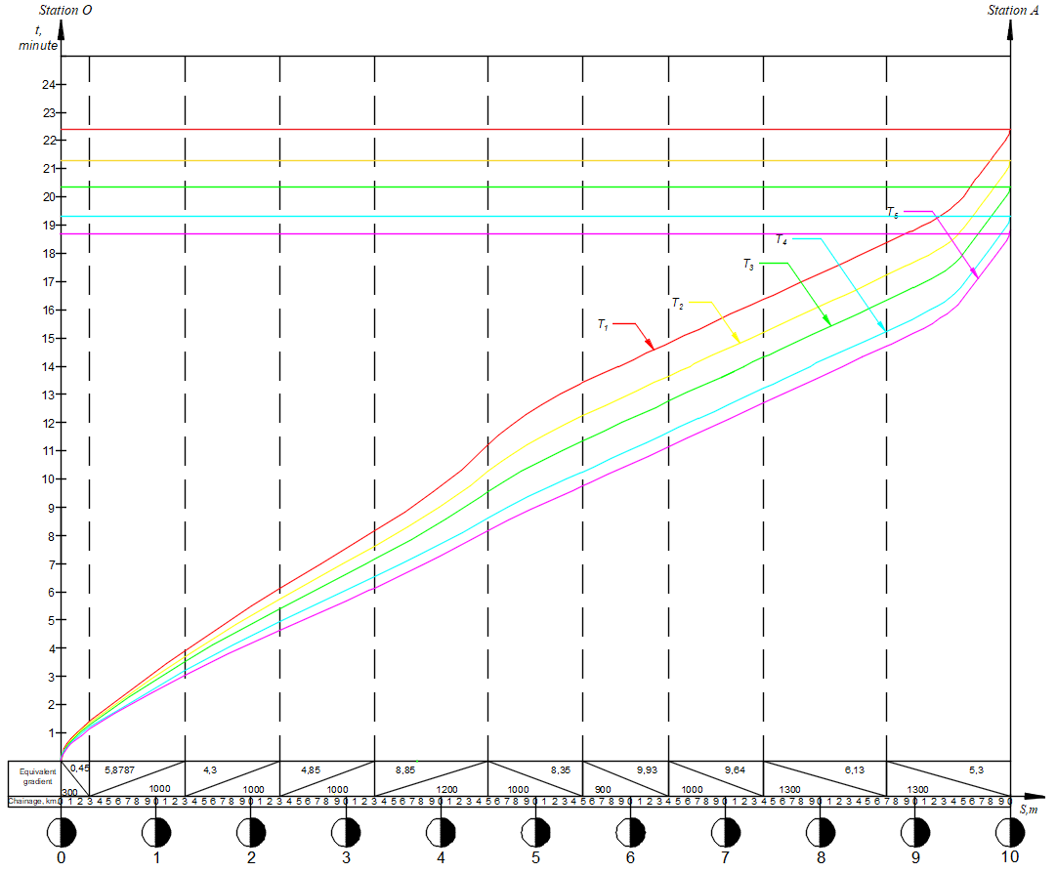
FIGURE 4. Time t(s) graph of trains with different masses
RESEARCH RESULTS
The results obtained from determining the inter-station running time and fuel consumption of trains with different masses using the locomotive’s maximum traction power in position 15 are presented in table 2.

TABLE 2. Traction calculation results for trains with different standard weights
Gross mass of the train | Traction mode | Coasting mode | Braking mode | Inter-station interval | Reduction of the inter-station interval | Fuel consumption
Q, t. | T_{t.r.,} min. | T_{c.m.,} min. | T_{b.m.,} min. | T_{i.s.,} min. | % | kg
5000 | 11.2 | 6.6 | 4.7 | 22.5 | 0 | 209.6
4500 | 10.3 | 7.3 | 4.0 | 21.5 | 4.4 | 193.1
4000 | 9.6 | 7.2 | 3.7 | 20.5 | 8.8 | 180.1
3500 | 8.6 | 6.7 | 4.2 | 19.5 | 13.3 | 161.9
3000 | 7.7 | 6.5 | 4.3 | 18.5 | 17.8 | 145.4

According to the traction calculations, the inter-station running time of a freight train on the first movement trajectory with a mass norm of Q=5000 tons was found to be the maximum compared to the remaining four trajectories, amounting to t₁=22.5 minutes. As the train’s weight decreases, the acceleration and deceleration times are reduced, and the time to reach the designated speed becomes faster. This leads to an increase in the buffer time shown in Figure 2. As a result, the running time of the trains is reduced by up to 17.8% compared to the first movement trajectory, while fuel consumption is saved by 30.6%. Thus, during the movement of trains that are not structured according to the maximum mass norm, additional buffer time is created when they intersect with trains traveling in the opposite direction on the section. However, such a situation is not taken into account in the timetable of standard trains. In practice, these buffer times are either used at crossing points to increase the dwell time of trains or, without considering the potential for energy savings, are distributed across the inter-station running time. These buffers can be utilized to organize the train movement trajectory in an energy-efficient manner.
In the movement trajectories with reduced nominal weight, the energy consumption also decreases, due to the fact that less force is required for the train’s acceleration and deceleration compared to the trajectory with the maximum weight. The dependence of energy efficiency on the reduction of train mass, obtained from the traction calculations shown in Figure 4, is illustrated in Figure 5.
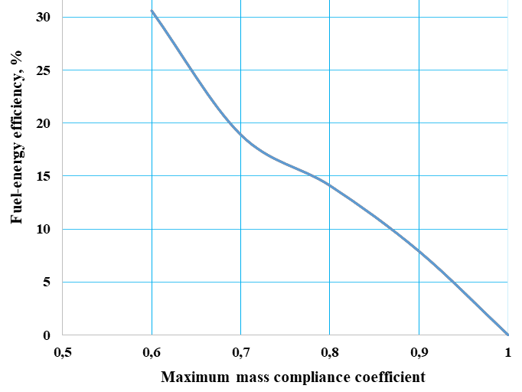
FIGURE 5. The effect of reducing the train mass on energy efficiency

The effect of reducing the train mass on energy efficiency, shown in Figure 5, demonstrates that the fuel-energy resources consumed for traction of trains on the 10-kilometer “O – A” section can be saved by 7.9-30.6%.
CONCLUSIONS
Based on traction calculations, taking into account that the inter-station running time of trains is determined according to the section’s maximum mass norm, the inter-station running time of freight trains not structured according to the maximum mass norm is reduced by 4.4-17.8% compared to the time indicated on the graph, depending on the section profile. As a result, it has been scientifically substantiated based on traction calculations that fuel-energy resources used for train traction can be saved by 7.9-30.6%. The reduction in the scheduled running time creates inter-station buffer time, which in turn increases the dwell time at the crossing stations for trains traveling in opposite directions. It has been shown that by using this buffer time for inter-station running, it is possible to further reduce the excess fuel-energy consumption of trains. The savings in fuel-energy resources used for train traction significantly reduce the emission of carbon dioxide (CO₂) into the atmosphere and mitigate the harmful environmental impact of railways.
REFERENCES
- Y. Ding, Study on Train Movement Calculation and Operation Optimization Simulation System, Ph.D. thesis, Beijing Jiaotong University (2005).
- International Union of Railways (UIC), Technologies and Potential Developments for Energy Efficiency and CO₂ Reductions in Rail Systems (UIC, Paris, 2016), 187 pp., available at https://uic.org/IMG/pdf
- I. P. Milroy, Aspects of Automatic Train Control, Ph.D. dissertation, Loughborough University, UK (1980).
- V. Negrey, V. Ovchinnikov, S. Pozhidaev, V. Skrezhendevsky, N. Shvets, and E. Shkrabov, “Increasing the energy efficiency of the transportation process on the Belarusian Railway,” Transport Systems and Transportation Technologies 3, 81–86 (2012).
- R. Liu and I. M. Golovitcher, “Energy-efficient operation of rail vehicles,” Transportation Research Part A: Policy and Practice 37(10), 917–932 (2003).
- P. G. Howlett, P. J. Pudney, et al., “Local energy minimization in optimal train control,” Automatica 45(11), 2692–2698 (2009).
- Q. Gu, T. Tang, and Y.-D. Song, “A survey on energy-saving operation of railway transportation systems,” Measurement and Control 43(7), 209–211 (2010); https://doi.org/10.1177/002029401004300704.
- M. Masharipov, N. Adilova, Sh. Suyunbayev, O. Ablyalimov, and U. Khusenov, “Investigation of the dependence of the basic resistivity of movement on the type of rolling stock,” Vehicles and Roads 1, 85–97 (2023).
- M. Masharipov, M. Rasulov, S. Suyunbayev, N. Adilova, O. Ablyalimov, and A. Lesov, “Investigation of train movement parameters,” E3S Web of Conferences 383, 04096 (2023); https://doi.org/10.1051/e3sconf/202338304096.
- U. Khusenov, S. Suyunbaev, D. Umirzakov, M. Tokhtakhodjayeva, and I. Adizov, “Assessment of the effect of train traction by locomotives of different types on the quality indicators of the train schedule,” E3S Web of Conferences 583, 03018 (2024); https://doi.org/10.1051/e3sconf/202458303018.
- D. Nazhenov, U. Khusenov, A. Yusupov, and S. Suyunbaev, “Substantiation of the influence of the number of shunting locomotives on the working fleet of freight cars and other qualitative indices of railway transportation operations,” AIP Conference Proceedings 3331(1), 040002 (2025); https://doi.org/10.1063/5.0306962.
- N. Aripov, M. Arpabekov, S. Suyunbaev, M. Masharipov, and U. Khusenov, “Development of a mathematical model of sequential arrangement of a group of wagons along station tracks,” in Lecture Notes in Networks and Systems (Springer, 2024); https://doi.org/10.1007/978-3-031-53488-1_2.
- S. Bykadorov, M. Arpabekov, S. Khudayberganov, S. Suyunbayev, U. Khusenov, and M. Makhmudovna, “About the model of railway transport management in Russia,” E3S Web of Conferences 389, 05024 (2023); https://doi.org/10.1051/e3sconf/202338905024.
- A. Z. Abdurakhmanov, S. Khudayberganov, U. Khusenov, and S. Jumayev, “Mathematical model of criteria for a comprehensive assessment of the state of railway transport infrastructure,” E3S Web of Conferences 402, 06006 (2023); https://doi.org/10.1051/e3sconf/202340206006.
- D. Butunov, S. Abdukodirov, Sh. Buriyev, and M. Akhmedova, “Development factor model of train movement graph indicators,” E3S Web of Conferences 531, 02008 (2024); https://doi.org/10.1051/e3sconf/202453102008.
- G. Ibragimova, Z. Mukhamedova, S. Khudayberganov et al., “Assessment of options for the location of railway infrastructure facilities,” Discover Applied Sciences 7, 364 (2025); https://doi.org/10.1007/s42452-025-06869-7.
- U. Khusenov and Sh. Suyunbayev, “Methodology for assessing the impact of the main comparative resistance to movement of various wagons on the weight of the freight train,” Journal of Transport 2(1), 146–150 (2025); https://doi.org/10.56143/2181-2438-2025-1-146-150.
- Traction Calculation Rules for Train Operation (Transport, Moscow, 1985), 289 pp.

