Use of alcohol waste in the synthesis of anti-smoke additives for diesel fuel and energy saving
Usmonali Sodikov, Ibragimjon Domuladjanov ^{a)}, Alisher Jumaboev, Shakhlo Domuladjanova, Umida Kurbanova
Fergana State Technical University, Fergana, Uzbekistan
^{a)} Corresponding author: domuladjanovi@mail.ru
Abstract. The article develops innovative ways to produce diesel fuel. In the world, research is being conducted on the synthesis of additives with the participation of organic esters and metal salts to reduce smoke during the combustion of diesel fuels. In the proposed technology, research is being conducted on the synthesis of additives, using waste from alcohol production, and on its basis, a technology for obtaining anti-smoke additives for diesel fuels is being developed. These include the selection of raw materials for the production of anti-smoke additives, the determination of the physicochemical properties of raw materials necessary for the modification of diesel fuel with the help of lubricating oil, complex esters and heavy metal salts.
INTRODUCTION
Currently, great attention is paid to the production of smokeless diesel fuels in the world. The cetane number in the composition of diesel fuel is one of the most important quality indicators, and in the production of new generation engines, the cetane number is required to be from 51 to 55. Improving the performance of motor fuels is currently impossible without highly effective additives. For this, various complex esters are obtained by modifying them with heavy metal organic salts. In order to obtain diesel fuels that meet the requirements of the Euro-5 standard, it is important to synthesize the necessary additives in order to reduce the amount of aromatic and naphthenic hydrocarbons in the composition and increase the amount of normal paraffins.
In the world, research is being conducted on the synthesis of additives with the participation of organic esters and metal salts to reduce smoke during the combustion of diesel fuels. In this regard, special attention is paid to studying the chemical composition of diesel fuels, their physicochemical properties; obtaining anti-smoke additives by modifying complex esters with metal sulfonates; determining the physic-chemical, technological, physic-mechanical properties of the obtained anti-smoke additive; developing a technology for synthesizing anti-smoke additives for seasonal diesel fuels [1-14].
In oil refining in our republic, great attention is paid to the localization of the raw material base, reducing the number of high-molecular paraffins in diesel fuels, and the production of products aimed at synthesizing anti-smoke additives, and certain results are being achieved. The third direction of the Development Strategy of New Uzbekistan aimed at further development of the Republic of Uzbekistan sets out such important tasks as “Introduction of market mechanisms in the supply of natural gas with guarantees of social protection through acceleration of transformation processes in the oil and gas sector”.
The implementation of the tasks set out in the Decree of the President of the Republic of Uzbekistan No. PF-5646 dated February 1, 2019 “On measures to radically improve the management system of the fuel and energy industry of the Republic of Uzbekistan”, Resolutions No. PP-4265 dated April 3, 2019 “On measures to further reform the chemical industry and increase its investment attractiveness”, Decree No. PF-60 dated January 28, 2022 “On the Development Strategy of New Uzbekistan for 2022-2026” aimed at further development of the Republic of Uzbekistan, and other regulatory legal acts related to this activity are indicated in this article.

EXPERIMENTAL RESEARCH
The research consists in developing a technology for obtaining anti-smoke additives for diesel fuels based on residues generated during the production of ethyl alcohol. These include the selection of raw materials for obtaining anti-smoke additives, determination of the physicochemical properties of raw materials necessary for modification with the help of lubricating oil, esters and heavy metal salts necessary for obtaining anti-smoke additives for diesel fuels [15-28].
In addition: obtaining additives for anti-smoke diesel fuels using esters and heavy metal salts; determination of the composition of the obtained anti-smoke additive; determination of the effect of the obtained anti-smoke additive on diesel fuels; determination of the effectiveness of the developed additive in terms of the quality indicators of diesel fuels; determination of the composition of improved diesel fuels; comparative analysis of the effectiveness of the developed and foreign anti-smoke additives; development of a technology for obtaining additives to reduce the smoke emitted during the combustion of diesel fuels.
RESEARCH RESULTS - RESEARCH RESULTS
Therefore, the research objects are used in the production of ethyl alcohol.
The residues (lubricating oil), the initial boiling point fraction -95°C separated from the distillation residue, as well as sulfuric acid, barium hydroxide and benzene were obtained.
The esterification of alcohols, metal sulfonates can be used as anti-smoke additives. The use of lubricating oils and barium benzo sulfonate as raw materials for the production of anti-smoke additives is of interest.
As shown by the analysis of ethyl alcohol production residues, the composition of lubricating oils includes a series of alcohols with molecular weights from 74 to 130, with carbon atoms from 3 to 9, as well as ethers.

TABLE 1. Component composition of lubricating oils
Component naming | compound, %
spittoon: | 55,79
- ppoponal-1 | 3,87
- 2-methylpopanol-1 | 2,85
- 2-methylbutanol-1 | 3,97
- 2-methylhexanol-3 | 4,39
- heptanol-4 | 2,71
- 2-ethyl-3-hexenol-1 | 12,47
- 2-ppopylpentanol-1 | 18,08
- 2-ethyl-2-hexanol-1 | 5,71
-mypakkab spittlap | 1,74
-ephipps: | 41,43
- bytilbythionate | 2,90
- 1,1-dibutyloxybutane | 16,43
- mypakkab efiplap | 22,10
ketolap: | 2,78
Total: | 100,00

Due to the large number of components of the residues of ethyl alcohol production, it was necessary to determine which components of the initial potential raw material could be most rationally used to obtain anti-smoke additives by salvation of the leaves.
The interaction of alcohol with inorganic acids occurs with the formation of esters by the esterification reaction, therefore, for example, 2-methylpropanol-1-alcohol sulfate contained in the raw material interacts with the acid, forming 2-methylpropylsulfate according to the following scheme:

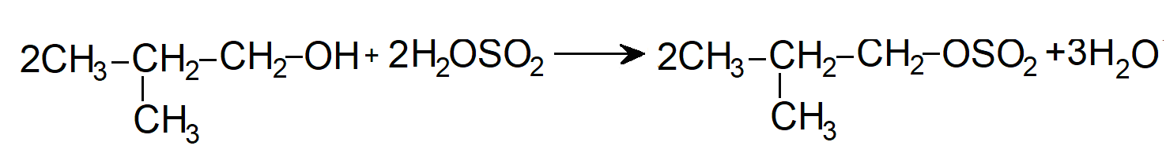
2-methylpropanol 2-methylpropyl sulfate
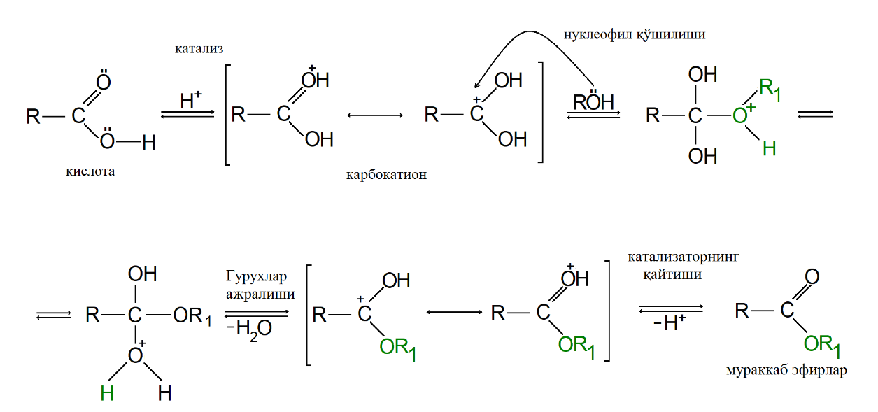
FIGURE 1. Mechanism of the esterification reaction

Without the participation of catalysts, esterification usually proceeds very slowly, therefore, in many cases, the reaction of carboxylic acids with alcohols cannot be carried out without substances that accelerate the reaction. Various types of compounds are used as catalysts: acids, ion-exchange resins, salts, oxides, etc. The esterification reaction can be carried out in the liquid or vapor phase, with or without the presence of an inert organic solvent, at elevated temperatures and pressures. The increase in the positive charge of the carbon in the carbonyl group increases the rate of esterification of the carboxylic acid. Uncompleted organic acids, including formic, oxalic, and pyruvic acids, react very quickly even in the absence of a catalyst.
The complete component composition of the initial boiling point fraction of 95°C was determined by chromatographic-mass spectrometry and is shown.

TABLE 2. Physicochemical properties of lubricating oils
Multiplier designation | Mark it
Faction found, °С:
- initial boiling point, not less than | 95
- 50% fractional composition | 138
- 96% fractional composition | 186
- maximum boiling point, not higher | 195
Flash point in a closed cup, °C, | 75
Water content, %, not less | 0,2
Density at 20 °C, kg/m³ | 820-840

Below is the complete component composition of the initial fraction with a boiling point of 95°C, determined by chromatographic mass spectrometry.
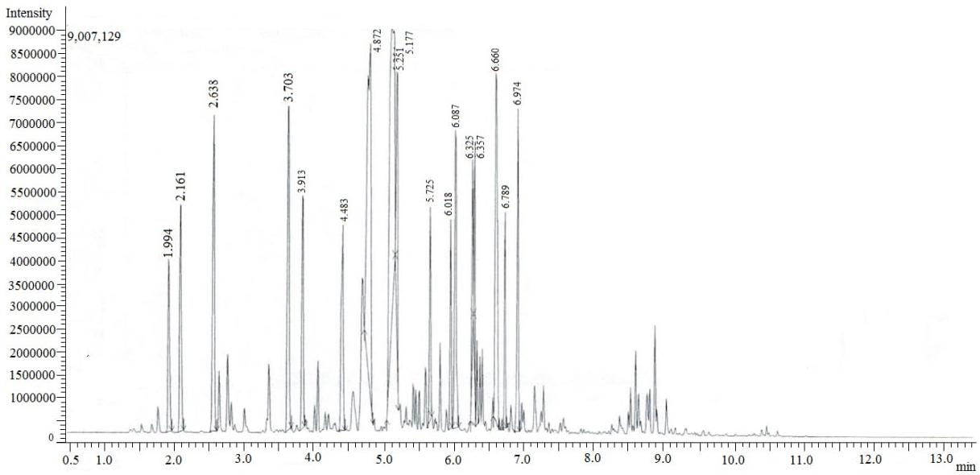
FIGURE 2. Chromatogram of the NK-95oC ESICK fraction

Hydrotreated diesel fuel produced by Fergana Oil Refinery LLC was used as the main diesel fuel; the physicochemical properties are presented below.

TABLE 3. Physicochemical composition of diesel fuel hydrotreated at "Fergana Oil Refinery" LLC.
Indicator name | Diesel fuel ychyn Evpo 3 meyoplapi | Multiplier value list
Cetane number | Not less than 51.0 | 51,0
Density at 15°C, kg/m3 | 820-860 | 830
Composition of polycyclic aromatic hydrocarbons, %. | Not less than 8.0 | 5,5
Sulfur content, mg/kg, for fuel: type 1 | Not more than 50-(0.5) | 27-(0,27)
Flash point in a closed cup, °C | More than 40 | 48
Coke 10% distillation residue, % | Not more than 0.30 | 0,065
Ash content, % | Not more than 0.01 | 0,0027
Water content, mg/kg | Not available | Not available
Amount of mechanical impurities, mg/kg | Not available | Not available
Corrosion of copper plate (3 hours at 50°C), units on the scale | 1 синф | 1 синф
Oxidation resistance: Total amount of sediment, g/m³ | Not available | Not available
Lubricity: Diameter of the adjusted spot at 60°C, μmμ | Not more than 460 | 565
Kinematic viscosity for 40°C, mm²/s | 2,00-4,50 | 2,49
Fraction composition:
-50% fraction exit temperature ºC, | Not more than 290 | 264
-90% fraction exit temperature ºC | Not more than 360 | 352
Limited filtration temperature, ºC | Not less than 3.0 | 4,2
CONCLUSIONS
The main scientific and practical results of the research are as follows:
- Barium benzo sulfonate was obtained in the presence of barium hydroxide, benzene and sulfuric acids. The composition of the residue obtained in the production of ethyl alcohols was analyzed, the initial (95°C) and high boiling points (195°C) of the residue were determined. The high boiling point products of the residue obtained in the production of ethyl alcohols and the relative mixtures of barium sulfonates (10:0.1) allow the use of diesel fuel as an anti-smoke additive without processing.
- "Fergana Oil Refinery" LLC, based on the results of the research on the development of a technology for obtaining anti-smoke additives for diesel fuel - the production of anti-smoke additives for diesel fuel "Fergana Oil Refinery" LLC is developing a reference book. As a result, it allowed to reduce (0.287 mg/dm3) the permissible level of smoke (0.3 mg/dm3) when burning diesel fuel;
As a result, it allowed to increase the effectiveness of the cetane number;
As a result, when diesel fuel is burned, smoke can be reduced by 25% compared to the initial state.
-A study of the effectiveness of an anti-smoke additive developed for diesel fuel showed that the value of the soot spot diameter of diesel fuel is reduced by 30%.
REFERENCES
- T. N. Mitusova, E. V. Polina, and M. V. Kalinina, Modern Diesel Fuels and Additives (Technika, Moscow, 2002), 64 p.
- GOST R 52368–2005, Diesel Fuel Euro. Technical Conditions (Standartinform, Moscow, 2005).
- Technical Regulation of the Customs Union TR TS 013/2011, Requirements for Automotive and Aviation Gasoline, Diesel and Marine Fuel, Jet Engine Fuel and Fuel Oil (2011).
- U. Sodikov and B. Khamidov, “Obtaining anti-smoke additives for diesel fuel,” Universum: Chemistry and Biology 9(99), Part 2, 48–52 (2022).
- U. Kh. Sadikov, B. N. Khamidov, A. G. Zumaboev, and Sh. Sh. Ismailov, “Effects of anti-smoke additives on diesel fuels,” Harvard Educational and Scientific Review 2(3), 25–29 (2022).
- U. Kh. Sadikov, B. N. Khamidov, and S. B. Ubaidullaeva, “Effect of smoke-free additives on diesel fuel quality indicators,” Scientific and Technical Journal of NamIET 7(3), 39–43 (2022).
- U. Kh. Sodikov and V. N. Khamidov, “Improving the quality of diesel fuel by increasing the degree of combustion,” Scientific and Technical Journal of FerPI, Special Issue 3, 159–163 (2022).
- U. Kh. Sodikov and A. G. Jumaboev, “Improvement of diesel fuel characteristics and the range of influence on engine performance,” Scientific and Technical Journal of FerPI, Special Issue 3, 83–86 (2022).
- O. Sadikov, “Production of diesel fuel from gas condensate and quality indicators,” in Proceedings of the International Conference on Innovations in Applied Sciences, Education and Humanities (Barcelona, Spain, 2022), pp. 1–4.
- U. Kh. Sodikov, “Increasing the combustion level of diesel fuel,” in Proceedings of the IX International Scientific and Practical Conference ‘Problems and Prospects of Commodity Chemistry and Folk Medicine’ (Andijan, 2022), pp. 63–65.
- U. Kh. Sodikov, B. N. Khamidov, and A. G. Jumaboev, “Effect of additives on the combustion of diesel fuels,” in Proceedings of the Republican Scientific and Practical Conference ‘Actual Problems of the Chemistry of Complex Compounds and Analytical Chemistry’ (2022), p. 365.
- U. Kh. Sodikov, “Synthesis of anti-wear additives for diesel fuel based on rapeseed oil and n-butyl alcohol,” in Proceedings of the Republican Scientific and Practical Conference ‘Innovative Technologies of Processing of Mineral and Technogenic Raw Materials’ (Tashkent, 2022), pp. 526–527.
- A. G. Jumabaev, U. Kh. Sodikov, and B. M. Kasymaliev, “Increase in the level of diesel fuel combustion by improving its quality,” Izvestiya of the National Academy of Sciences of the Kyrgyz Republic 5, 317–321 (2022).
- I. Kh. Domuladjanov, Sh. I. Domuladjanova, M. I. Latipova, and Yu. M. Kholmirzaev, “Textile complex ‘DEU Textile Company’ located in Kushtepin district,” Universum: Technical Sciences 7(76), Part 1, 30–33 (2020).
- I. Kh. Domuladjanov, A. M. Teshaboev, Sh. I. Domuladjanova, and M. I. Latipova, “Atmospheric pollution from emissions of LLC ‘A-Service’,” Universum: Technical Sciences 7(76), Part 1, 6–9 (2020).
- I. Kh. Domuladjanov, A. M. Teshabaev, and Sh. I. Domuladjanova, Technologies for Producing Quicklime from JSC ‘Ferganazot’ Waste (LAP Lambert Academic Publishing, 2020), 72 p.
- I. Kh. Domuladjanov, M. I. Latipova, and F. N. Nasretdinova, “Geomorphology, relief, and geological structure in the development of environmental standards,” EPRA International Journal of Research and Development 5(6), 136–139 (2020).
- I. Kh. Domuladjanov, Sh. I. Domuladjanova, M. I. Latipova, and M. R. Dadakuziev, “Impact of an object on the acoustic regime of a territory,” Universum: Technical Sciences 3–1(84) (2021).
- I. Domuladjanov, O. Ibragimov, and Sh. Domuladjanova, “Especially hazardous pesticides in Uzbekistan,” Journal of Survey in Fisheries Sciences 10(Special Issue), 2068–2072 (2023).
- B. O. Ibragimov and I. Kh. Domuladjanov, “Formation of cotton leaf surface depending on sowing time and varietal characteristics,” in Proceedings of the International Scientific and Practical Internet Conference ‘Improvement of Driver Modernization of APK and Climate Change Conditions’ (Novocherkassk, 2020), pp. 34–36.
- B. O. Ibragimov and O. O. Ibragimov, “Influence of sowing dates and varietal characteristics on cotton growth and development,” in Proceedings of the International Scientific and Practical Internet Conference ‘Improvement of Driver Modernization of APK and Climate Change Conditions’ (Novocherkassk, 2020), pp. 37–40.
- O. O. Ibragimov and I. Kh. Domuladjanov, “Prospective tasks of peasants, farmers, and households,” Scientific and Technical Journal of FerPI 24(Special Issue 1), 61–67 (2020).
- O. O. Ibragimov and I. Kh. Domuladjanov, “Let’s talk about agriculture of Uzbekistan,” in Proceedings of the International Conference ‘Process Management and Scientific Developments’ (Birmingham, UK, 2020), pp. 187–195.
- O. O. Ibragimov and I. Kh. Domuladjanov, “On the issue of growing agricultural crops,” NeuroQuantology 20(12), 3051–3057 (2022); https://doi.org/10.14704/NQ.20.12.NQ77304.
- R. A. Kulmatov, I. Kh. Domuladjanov, and Sh. I. Domuladjanova, “Modern research methods,” Scientific and Technical Journal of FerPI 24(6), 164–172 (2020).
- I. Kh. Domuladjanov, Sh. I. Domuladjanova, and O. O. Ibragimov, “Industrial waste of enterprises in Fergana region,” Scientific and Technical Journal of FerPI 26(Special Issue 8), 160–162 (2022).
- O. O. Ibragimov and I. Kh. Domuladjanov, “Reducing poverty by developing agriculture as an urgent task,” Scientific and Technical Journal of FerPI 26(1), 128–135 (2022).
- O. O. Ibragimov and I. Kh. Domuladjanov, “On the way to achieving strategic goals,” Universum: Economics and Jurisprudence 1(88), 34–39 (2022).
- O. O. Ibragimov and I. Kh. Domuladjanov, “On the way to supporting international relations,” Universum: Economics and Jurisprudence 1(88), 39–44 (2022).

