Analysis of the Spatial Distribution of Gold-Platinum Mineralization and Geological-Structural Controls in the Kaspaktao Prospective Area Using Digital Remote Sensing Data
Nafisa Umarova ^{a)}, Odiljon Achilov, Fazliddin To‘rayev, Shahzod Ahmedov
University of Geological Sciences, Tashkent, Uzbekistan
^{a)} Corresponding author: umarovanafisa45@gmail.com
Abstract. This study investigates the spatial characteristics and structural controls of gold–platinum mineralization within the Kaspaktao prospective area of the Navoi region, Uzbekistan, through the application of advanced Remote Sensing (RS) and Geographic Information System (GIS) techniques. Multispectral satellite datasets acquired from Landsat-8 OLI, Sentinel-2 MSI, and ASTER sensors were processed using spectral enhancement, Principal Component Analysis (PCA), Intensity–Tone–Saturation (ITS) transformation, and directional edge-detection filtering. These methods enabled the extraction of lithological contrasts, tectonic lineaments, and hydrothermal alteration features that govern ore localization. The results demonstrate a strong correlation between mineralized zones and dominant structural elements, particularly synclinal axes and associated fracture networks. The applied methodological framework significantly improves the reliability of early-stage mineral prospecting in arid and structurally complex regions.
INTRODUCTION
The rapid advancement of satellite - based remote sensing technologies has fundamentally transformed modern geological exploration. High - resolution multispectral data now allow for detailed interpretation of surface lithology, structural frameworks, and alteration processes over extensive territories. When integrated with GIS platforms, these datasets provide a powerful analytical environment for identifying ore-controlling factors with high spatial accuracy.
The Central Kyzylkum region of Uzbekistan is recognized for its metallogenic potential and complex tectonic evolution. Within this region, the Kaspaktao prospective area exhibits pronounced synclinal structures, fault systems, and hydrothermal alteration zones, which collectively influence the formation and distribution of gold - platinum mineralization. Conventional field - based exploration methods in such environments are often limited by accessibility and cost, highlighting the importance of RS and GIS approaches for preliminary assessment and targeting.
The aim of this research is to evaluate the geological and structural conditions of the Kaspaktao area using integrated RS and GIS techniques, and to delineate zones with elevated potential for gold - platinum mineralization.

EXPERIMENTAL RESEARCH
The study area is situated within the Uchkuduk district of the Navoiy region and encompasses approximately 20 km². From a geological perspective, it includes the Main Syncline, the Promezhutochnaya Anticline, and adjacent mineral occurrences such as Blijnee and Peschanoe. The lithological assemblage primarily consists of siliceous - carbonate formations, flysch - type sequences, and basaltoid rocks, which are frequently associated with mineralization in the Central Kyzylkum.
For instance, within the Central Kyzylkum region, the ore-bearing zones are spatially and genetically associated with hydrothermal alteration and kaolinitization processes (Goipov et al., 2024). The geological and structural framework of the area is distinctly reflected in the geophysical fields (Goipov, Akhmadov, and Yusupov, 2024), exhibiting a well-defined correlation with the identified alteration zones and mineralization patterns (Goipov, Ashurov, and Atabaev, 2024). The mapped magnetic anomalies reflect zones of progressive regional metamorphism, which collectively determined the location of gold ore mineralization (Goipov et al., 2025).

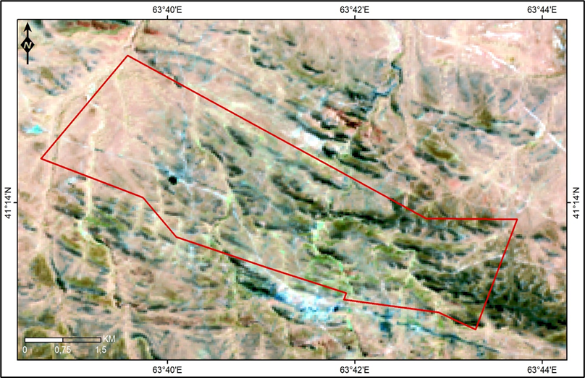
Figure.1. Space image of the study area in channels 5/3/2 (Landsat-8)

Multisource satellite data were employed in this study, including Landsat-8 OLI imagery with 30 m spatial resolution, Sentinel - 2 MSI data with 10 - 20 m resolution, and ASTER imagery with 15 m resolution, particularly suited for mineralogical analysis. All datasets underwent standard radiometric and geometric corrections using ERDAS IMAGINE software to ensure spatial and spectral consistency.
Subsequently, selected spectral band combinations were applied to enhance lithological contrasts. PCA and ITS transformations were performed to isolate dominant spectral components related to geological structures and alteration zones. Directional Kirsch filtering was utilized to detect linear features indicative of faults and fracture systems. The resulting datasets were integrated within the ArcGIS environment to conduct spatial overlay analysis and identify prospective mineralization zones.
RESEARCH RESULTS AND DISCUSSION
The spectral enhancement of Landsat - 8 and Sentinel - 2 data revealed distinct surface anomalies associated with iron oxide enrichment and hydrothermal alteration. PCA (Principal Component Analysis) results effectively differentiated rock units of varying composition and age, while simultaneously emphasizing structurally controlled alteration patterns. False-color composite images from Landsat TM were utilized, created by combining spectral bands assigned to the primary color channels as follows:
Band 5 (Infrared) – assigned to the Red (R) channel
Band 4 (Red and Near-Infrared) – assigned to the Green (G) channel
Band 2 (Visible – from Yellow to Blue) – assigned to the Blue (B) channel
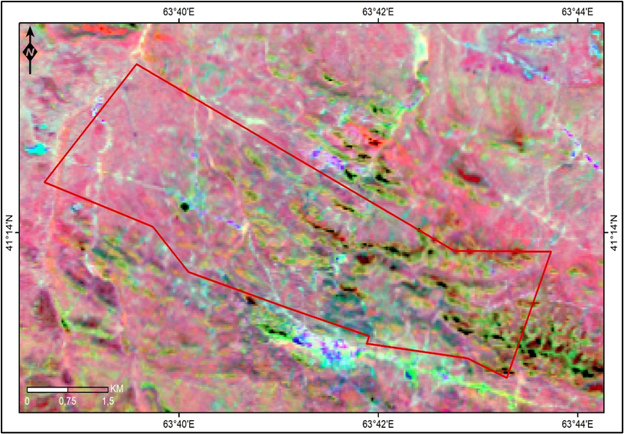
Figure 3. Result of processing using the PCA method

The formation of a seven-band composite satellite image is carried out using the “Layer Selection and Stacking” module in ERDAS IMAGINE 2014. The algorithm of this module is illustrated in Figure 2.
This procedure enables the integration of multiple spectral bands into a single multispectral image, which serves as the foundation for subsequent visual interpretation and quantitative analysis.
Directional filtering highlighted several major lineament systems extending over distances exceeding 1 km. These lineaments predominantly follow the orientation of the Main Syncline and intersect known mineral occurrences, suggesting their critical role in controlling fluid migration and ore deposition.

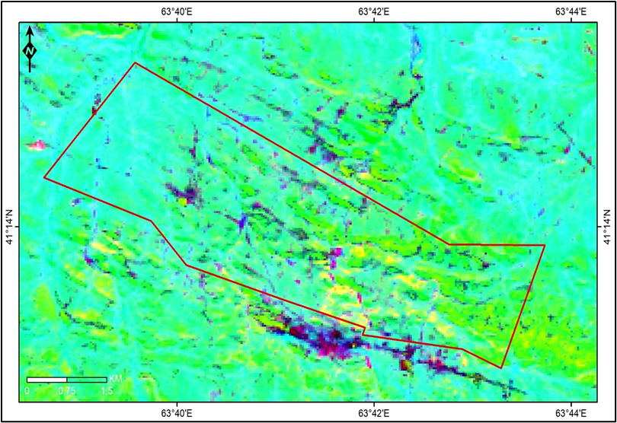

Figure 2. Result of processing by the Mineral Composition method

GIS - based overlay analysis integrating spectral, structural, and geological layers enabled the delineation of four prospective ore-bearing zones. Among these, the areas corresponding to the Blijnee and Peschanoe occurrences exhibited the highest mineralization potential. The observed spatial relationships confirm that gold–platinum mineralization in the Kaspaktao area is strongly influenced by tectonic architecture and hydrothermal processes.
The results obtained are consistent with findings from comparable metallogenic provinces, indicating that the applied RS - GIS methodology provides a robust framework for early-stage exploration in arid and structurally complex terrains.
CONCLUSIONS
The integrated application of Remote Sensing and GIS techniques enabled a comprehensive assessment of the geological and structural framework of the Kaspaktao prospective area. The main conclusions are as follows:
- Multispectral satellite data effectively delineate ore-controlling structures and lithological variations.
- PCA and ITS transformations are highly efficient in identifying hydrothermal alteration zones associated with gold–platinum mineralization.
- Structural lineament analysis reveals a strong spatial correlation between mineralized zones and major tectonic elements.
- The proposed methodological approach is suitable for guiding further detailed exploration and drilling programs in the study area.
All satellite datasets used in this study, including Landsat-8, Sentinel-2, and ASTER imagery, are publicly accessible through the United States Geological Survey (USGS) and the European Space Agency (ESA) data repositories.
REFERENCES
1. Abrams, M. (2000). The Advanced Spaceborne Thermal Emission and Reflection Radiometer (ASTER): Data products for the high spatial resolution era. International Journal of Remote Sensing, 21(5), 847 - 859.
2. Carranza, E. J. M. (2009). Geochemical anomaly and mineral prospectivity mapping in GIS. Elsevier.
3. Goipov, A. B., Akhmadov, S. I., Tevelev, A. V., et al. (2024). Application of innovative spectral and structural interpretation methods in mineral exploration. Moscow University Geology Bulletin, 79(6), 798 - 809.
4. Goipov, A. B., Akhmadov, S. I., Yusupov, V. R. (2024). Geophysical indicators of mineralization in the Bukantau Mountains. ANAS Transactions, Earth Sciences, (2), 77 - 91.
5. Goipov, A., Małolepszy, Z., Isokov, M., et al. (2025). Three-dimensional geological and geophysical model of the Myutenbay gold deposit. Geological Quarterly. https://doi.org/10.7306/gq.1809
6. Liu, Y., Sun, X., Chen, J. (2022). Detection of mineralized zones using PCA and band ratio techniques based on Sentinel - 2 data. Remote Sensing Applications: Society and Environment, 26, 100750.
7. Pour, A. B., Hashim, M. (2015). ASTER data for geological mapping and mineral exploration. International Journal of Applied Earth Observation and Geoinformation, 38, 254 -277.
8. Rajesh, H. M. (2008). Application of Remote Sensing and GIS in mineral resource mapping. Journal of African Earth Sciences, 50(2), 217 - 226.
9. Rowan, L. C., Mars, J. C. (2003). Hydrothermal alteration mapping using ASTER data. Economic Geology, 98(5), 1047 - 1057.
10. Sabins, F. F. (1999). Remote sensing for mineral exploration. Ore Geology Reviews, 14(3 -4), 157 - 183.

