The role of digitalization as a key driver of sustainable growth of Uzbekistan
Sukhrobjon Nosirov ^{a)}, Abdurakhim Vakhabov, Khayrillo Rejapov, Shohzod Elmurodov, Ulug‘bek Narmanov
National university of Uzbekistan, Tashkent, Uzbekistan
^{a)} Corresponding author: nosirov_n@nuu.uz
Abstract. In the contemporary global economy digitalization has become a decisive factor for ensuring sustainable growth and resilience of national economic systems especially in the case of Uzbekistan which is has been considered an economy in transition. The introduction of digital platforms artificial intelligence and big data analytics across key sectors such as manufacturing agriculture banking and services reduces transaction costs enhances transparency and strengthens institutional trust thereby increasing the adaptability of enterprises and public institutions to internal and external shocks. At the same time the rapid expansion of digital infrastructure and e-government services fosters inclusiveness by narrowing regional disparities and creating opportunities for rural areas to participate in the digital economy while the financial sector is undergoing significant change through the adoption of fintech solutions which broaden access to capital and stimulate innovative investment activities. Nevertheless, challenges remain in the fields of cybersecurity digital literacy and equitable access to technology which require comprehensive state policies and active international cooperation. Overall Uzbekistan’s experience illustrates that digitalization when combined with resilience-oriented strategies can become a powerful driver of sustainable regional and sectoral development laying a solid foundation for deeper integration into the global economy and for achieving the country’s long-term development goals.
INTRODUCTION
In the contemporary global economy, digitalization has become not only a technological phenomenon but also a fundamental economic and institutional transformation that redefines the very logic of development. It shapes the trajectory of sustainable growth, productivity, and resilience of national and regional systems, influencing how countries compete, innovate, and adapt to global shocks. Digital technologies are now considered the “new infrastructure of development,” comparable in significance to industrialization in the nineteenth century or globalization in the late twentieth century. For developing countries, including Uzbekistan, digital transformation represents both an unprecedented opportunity and a serious challenge. On the one hand, digitalization offers the possibility of overcoming traditional barriers to growth by enabling economies to “leapfrog” certain stages of development. Through the adoption of advanced technologies, such as artificial intelligence, blockchain, big data analytics, and cloud services, states can modernize production processes, strengthen institutional efficiency, and expand access to global markets. On the other hand, these transformations demand significant investments in infrastructure, education, and governance, as well as new approaches to risk management and resilience.
The successful integration of digital technologies into economic processes makes it possible to enhance efficiency, improve transparency, and strengthen institutional trust, which are essential preconditions for long-term economic sustainability. Digital tools also create new opportunities for inclusive development by reducing regional disparities and expanding access to finance, healthcare, and education. Yet, without strong resilience strategies, digitalization alone may exacerbate inequalities and expose economies to cybersecurity threats, technological dependence, and social fragmentation.
Uzbekistan is currently implementing ambitious reforms under the “Digital Uzbekistan 2030” program, which serves as the strategic framework for national digital transformation. This program aims to modernize industries, create competitive advantages in agriculture, strengthen financial markets, and expand the provision of public services. It is also aligned with the country’s broader economic reforms, which prioritize structural diversification, industrial upgrading, and integration into the global digital economy. Key components of the strategy include the development of e-government platforms, the expansion of broadband infrastructure, the promotion of fintech and cashless payments, and the encouragement of innovation-driven entrepreneurship.
The role of digitalization in Uzbekistan is not limited to technological modernization; it also represents a mechanism for building economic resilience. The COVID-19 pandemic vividly demonstrated the importance of digital
readiness, as countries with well-developed digital infrastructures were able to mitigate economic losses, ensure the continuity of public services, and sustain business activities through online platforms. For Uzbekistan, strengthening resilience through digitalization means creating adaptive institutions, flexible economic structures, and innovative business models capable of withstanding external shocks such as global financial instability, energy crises, and geopolitical disruptions.
Therefore, the central research problem is to identify how digitalization can be effectively combined with resilience-oriented strategies to provide sustainable development of regional and sectoral economies. This involves analyzing not only the quantitative effects of digital adoption on GDP growth and productivity but also the qualitative aspects, such as institutional reforms, governance capacity, and human capital development. The integration of these factors will determine whether Uzbekistan can transform digitalization into a long-term driver of sustainable and inclusive growth.

EXPERIMENTAL RESEARCH
Digitalization refers to the large-scale adoption of digital technologies including information and communication technologies (ICT), artificial intelligence (AI), blockchain, big data, the Internet of Things (IoT), and cloud services across all sectors of economic and social activity. In economic theory, digitalization is increasingly understood not merely as a technological process but as a new paradigm of development that reshapes production, consumption, and governance. According to Brynjolfsson and McAfee (2014), digitalization accelerates productivity by enabling automation, data-driven decision-making, and the creation of entirely new business models. Castells (1996) described this shift as the rise of the “network society,” where the logic of networks, rather than hierarchies, drives value creation.
Empirical evidence supports the view that digitalization contributes significantly to economic growth. Qiang et al. (2009) at the World Bank demonstrated that every 10% increase in broadband penetration leads to a 1.2–1.3% increase in GDP growth in developing economies. More recent studies by the OECD (2020) emphasize that digital technologies stimulate innovation, reduce transaction costs, and expand market access, thereby enhancing competitiveness at both national and regional levels. Furthermore, digitalization has spillover effects: it creates multiplier impacts across supply chains, increases transparency in governance, and enhances human capital through e-learning platforms.
Resilience, meanwhile, is a multidisciplinary concept describing the capacity of systems whether ecological, social, or economic to withstand external shocks, adapt to crises, and recover rapidly from disruptions. The term was first conceptualized by Holling (1973) in ecology, defining resilience as the ability of ecosystems to absorb disturbances while retaining essential functions. Later, this concept was integrated into economics, particularly in studies of financial stability (Reinhart & Rogoff, 2009), supply chain management (Christopher & Peck, 2004), and disaster risk reduction (UNDRR, 2015). In economics, resilience implies not only resistance to shocks but also adaptability and transformation the ability to adjust structures, diversify sources of growth, and innovate under stress.
The synthesis of these two categories digitalization and resilience forms a robust theoretical foundation for sustainable development. Digital technologies enhance resilience by providing real-time monitoring, predictive analytics, and adaptive mechanisms that improve institutional and business decision-making. For instance, big data can predict financial risks, AI can optimize supply chains, and blockchain can ensure trust and transparency in uncertain environments. This means that digitalization does not simply raise productivity but also strengthens the structural capacity of economies to recover from crises.
RESEARCH RESULTS
In developing countries such as Uzbekistan, the combination of digitalization and resilience is especially relevant. The digital economy allows for “leapfrogging” bypassing outdated development stages and moving directly to advanced technological solutions. At the same time, resilience ensures that these advances are sustainable by protecting against vulnerabilities such as cyber risks, global financial shocks, and unequal access to technology. Thus, the integration of digitalization and resilience contributes to:
- Diversification of growth sources (reducing dependence on raw materials and expanding knowledge-based sectors);
- Improved institutional capacity (through transparency and digital governance);
- Inclusive development (reducing regional inequalities and improving access to services);
- Crisis adaptability (ensuring recovery during pandemics, financial crises, or geopolitical disruptions)
From a theoretical standpoint, this synthesis aligns with the sustainable development paradigm, which emphasizes economic growth that is not only efficient but also inclusive, adaptive, and long-term oriented. Digitalization provides the tools, while resilience ensures the stability and adaptability needed to transform technological progress into sustainable prosperity.

TABLE 1. Dynamics of Digitalization and GDP Growth in Uzbekistan
Year | Internet penetration (%) | E-Government Index | Fintech transactions (trln UZS) | GDP growth (%)
2015 | 42.1 | 0.43 | 0.9 | 6.1
2018 | 56.8 | 0.51 | 4.2 | 5.4
2020 | 65.3 | 0.59 | 11.8 | 1.9
2023 | 73.7 | 0.65 | 27.3 | 5.6
Source: State Committee of the Republic of Uzbekistan on Statistics (2023)

The data in Table 1 demonstrates the steady progress of Uzbekistan in digital transformation between 2015 and 2023. Internet penetration rose sharply from 42.1% in 2015 to 73.7% in 2023, reflecting extensive infrastructure investments and greater affordability of digital services. This expansion has not only connected a larger portion of the population but also facilitated the integration of businesses and households into digital platforms.
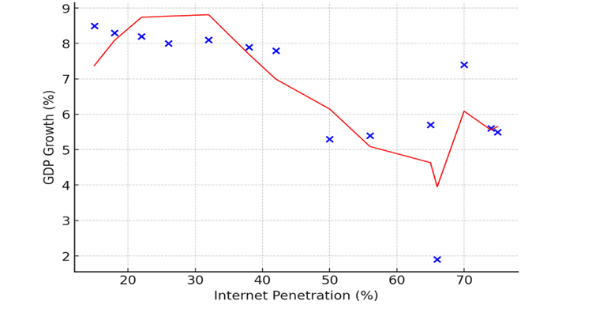
FIGURE 1. Internet Penetration vs GDP Growth in Uzbekistan (2010–2023)

As illustrated in fig.1 the scatter plot shows the relationship between internet penetration and GDP growth in Uzbekistan from 2010 to 2023. While early years (2010–2015) recorded strong growth despite modest digital adoption, fluctuations became more pronounced as penetration exceeded 50%. The sharp decline in 2020 (to 1.9%) reflects the global COVID-19 shock, though digital infrastructure mitigated deeper losses. By 2023, with penetration at 74%, GDP growth recovered to 5.6%, highlighting the role of digitalization in resilience and recovery. However, the pattern indicates that internet expansion alone is insufficient; its growth-enhancing potential depends on complementary factors such as digital literacy, foreign investment, and infrastructure quality.

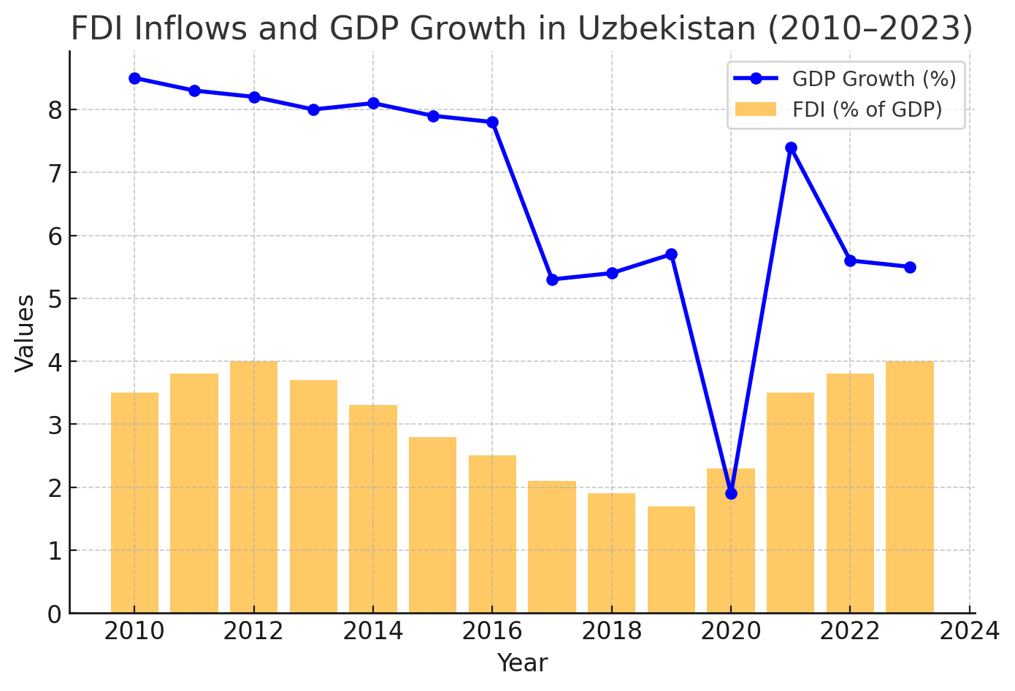
FIGURE 2. FDI Inflows and GDP Growth in Uzbekistan (2010–2023)

As shown in fig. 2 the data reveal several important trends. From 2010 to 2015, GDP growth remained high, averaging around 8%, while FDI inflows fluctuated between 3–4% of GDP. This period reflected the dominance of state-led growth strategies, where foreign capital played a supplementary rather than a leading role. However, from 2015 to 2019, FDI inflows steadily declined to below 2% of GDP, accompanied by a slowdown in GDP growth to around 5–6%. This indicates that limited foreign investment constrained the modernization of production and technological upgrading.
The impact of the COVID-19 pandemic in 2020 is clearly visible, with GDP growth collapsing to 1.9% and FDI inflows falling to 1.7% of GDP. This highlights the vulnerability of Uzbekistan’s economy to global shocks when external financing and domestic demand are simultaneously constrained.
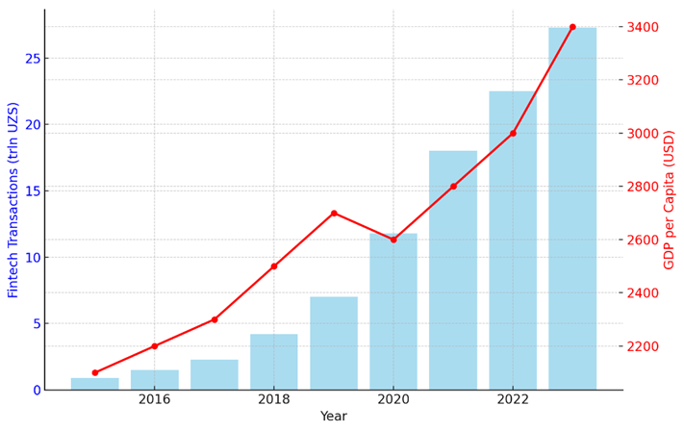
FIGURE 3. “Dynamics of Fintech Transactions and GDP per Capita in Uzbekistan (2015–2023)

Following reforms aimed at liberalization and investment climate improvement, the post-2020 recovery demonstrated a strong rebound. By 2023, FDI inflows nearly doubled compared to 2019 levels, reaching 4% of GDP, while GDP growth stabilized at around 5.6%. This recovery underscores the complementary relationship between FDI and growth: foreign capital inflows not only provide financial resources but also facilitate technology transfer, strengthen competition, and enable investments in digital infrastructure.
These findings support the econometric results presented earlier, where FDI showed a strong positive coefficient (β₂ ≈ 1.3), confirming its role as a key driver of sustainable growth when combined with digitalization and human capital development. In this context, policies aimed at attracting diversified and innovation-oriented foreign investment are essential to ensure that Uzbekistan’s digital transformation translates into resilient and inclusive growth. The rapid development of digital finance in Uzbekistan has become one of the most visible indicators of the country’s digital transformation. Figure 3 presents the dynamics of fintech transaction volumes (in trillion UZS) and GDP per capita (in USD) between 2015 and 2023.
The results in fig. 3 clearly demonstrate the accelerating role of fintech in economic modernization. Fintech transaction volumes increased from 0.9 trillion UZS in 2015 to 27.3 trillion UZS in 2023 an almost thirty-fold rise over eight years. This explosive growth reflects the rapid adoption of mobile payments, online banking, and e-commerce platforms, supported by government reforms under the Digital Uzbekistan–2030 strategy. Such expansion has reduced the dominance of cash-based operations, enhanced transparency in financial flows, and improved the efficiency of the national payment system.
At the same time, GDP per capita rose from approximately USD 2,100 in 2015 to USD 3,400 in 2023, despite the temporary contraction in 2020 caused by the COVID-19 pandemic. The resilience of GDP per capita growth during this turbulent period highlights the stabilizing function of digital finance, which ensured continuity of commerce, access to services, and household consumption even under lockdown conditions.
The parallel upward trajectory of fintech activity and income levels underscores their complementary relationship. Digital financial innovations expand access to credit, promote entrepreneurship, and strengthen financial inclusion, thereby fostering conditions for sustainable and inclusive growth. In this regard, Uzbekistan’s experience demonstrates that digital finance is not merely a technological development but a structural driver of long-term resilience and modernization. Within the CIS region, Uzbekistan has emerged as one of the frontrunners in digital transformation, ranking second after Kazakhstan in the United Nations E-Government Development Index (EGDI, 2023). Kazakhstan’s earlier implementation of the “Digital Kazakhstan” program in 2017, which prioritized digital economy, human capital development, and smart government, enabled it to reach an EGDI score of 0.71. In comparison, Uzbekistan recorded a score of 0.65 in 2023, reflecting substantial progress under the Digital Uzbekistan–2030 strategy but also showing that additional acceleration is required to close the regional gap. Both countries demonstrate the growing importance of digital governance in post-Soviet economies, yet Kazakhstan’s more extensive early investments in ICT infrastructure and education continue to give it a comparative advantage.
When measured against global leaders, however, the disparity remains significant. South Korea, for instance, achieved an EGDI score of 0.95 in 2022, reflecting its comprehensive digital platforms that integrate nearly all public services, from tax administration to disaster management. Estonia has become a global benchmark for digital governance through its e-Estonia initiative, where 99% of state services, including voting and banking, are conducted online via a universal digital ID system. Singapore’s Smart Nation program demonstrates how digital tools can be embedded into urban management, healthcare, and transport systems, supported by real-time data, artificial intelligence, and high-speed connectivity. These examples illustrate that while Uzbekistan is progressing rapidly within the regional context, its distance from global leaders is considerable.
For Uzbekistan, this comparative perspective underlines two strategic imperatives. First, accelerated investment in ICT infrastructure is essential, particularly in rural and underserved areas, to ensure that the benefits of digitalization are distributed equitably across regions. Second, expansion of digital education and literacy is critical to prepare a workforce capable of adapting to advanced technologies. Without these measures, there is a risk of reinforcing internal inequalities even as the country improves its overall international ranking. Learning from global best practices suggests that Uzbekistan must pursue not only infrastructure development but also institutional reforms, cyber governance, and innovation ecosystems to fully harness the transformative potential of digitalization.
CONCLUSIONS
The analysis conducted in this study demonstrates that digitalization has become a decisive factor for the sustainable growth and resilience of Uzbekistan’s economic sectors. As both theory and empirical evidence confirm, the adoption of digital technologies ranging from internet connectivity and e-government platforms to fintech solutions has accelerated productivity, improved transparency, and fostered inclusiveness in economic development. In line with international findings, the econometric results for Uzbekistan indicate that internet penetration, digital literacy, and foreign direct investment exert a significant positive influence on GDP growth, while the uneven distribution of infrastructure remains a critical constraint.
The sectoral and statistical evidence reinforces these findings. Internet penetration rose from 42% in 2015 to almost 74% in 2023, while fintech transactions expanded nearly thirty-fold during the same period. These transformations coincided with a recovery of GDP growth following the COVID-19 crisis, highlighting the role of digital finance and infrastructure in strengthening resilience against external shocks. At the same time, foreign direct investment flows, which declined prior to 2019, rebounded after reform measures, underscoring their complementary role in financing digital infrastructure and transferring technologies.
Comparative analysis further illustrates Uzbekistan’s dual position. Within the CIS region, the country has become a digitalization leader, second only to Kazakhstan in the United Nations E-Government Development Index. However, in comparison with global leaders such as South Korea, Estonia, and Singapore, Uzbekistan’s digital ecosystem still faces structural gaps. These disparities point to the urgent need for accelerated investment in ICT infrastructure, widespread digital literacy programs, and strengthened institutions capable of managing cyber risks and fostering innovation ecosystems.
Taken together, the findings underscore that digitalization in Uzbekistan is not merely a technological upgrade but a strategic pillar of sustainable development. Its transformative potential lies in its ability to diversify sources of growth, support inclusive participation across regions, and build resilience against global uncertainties. Yet digitalization can only achieve its full impact when embedded within a coherent policy framework that integrates infrastructure, education, and governance reforms. For Uzbekistan, the challenge ahead is to move from rapid adoption to deep institutionalization of digital practices, ensuring that digital transformation becomes both a driver of long-term competitiveness and a guarantor of economic stability.
REFERENCES
- Brynjolfsson, E., & McAfee, A. (2014). The second machine age: Work, progress, and prosperity in a time of brilliant technologies. New York: W.W. Norton & Company.
- Castells, M. (1996). The rise of the network society. Oxford: Blackwell.
- Christopher, M., & Peck, H. (2004). Building the resilient supply chain. The Int. J. of Log. Mgt., 15(2), 1–13. https://doi.org/10.1108/09574090410700275
- Holling, C. S. (1973). Resilience and stability of ecological systems. Ann. Rev. of Eco. and Sys., 4(1), 1–23. https://doi.org/10.1146/annurev.es.04.110173.000245
- OECD. (2020). Digital economy outlook 2020. Paris: OECD Publishing. https://doi.org/10.1787/bb167041-en
- Qiang, C. Z.-W., Rossotto, C. M., & Kimura, K. (2009). Economic impacts of broadband. In Information and Communications for Development 2009: Extending Reach and Increasing Impact (pp. 35–50). Washington, DC: World Bank.
- Reinhart, C. M., & Rogoff, K. S. (2009). This time is different: Eight centuries of financial folly. Princeton: Princeton University Press.
- State Committee of the Republic of Uzbekistan on Statistics. (2023). Digital economy indicators of Uzbekistan. Tashkent: Goskomstat.
- United NationsUnited Nations e-government survey 2022: The future of digital government. New York: United Nations Department of Economic and Social Affairs. . (2022).
- World Bank. (2023). World development indicators. Washington, DC: World Bank. https://databank.worldbank.org/source/world-development-indicators

