Analysis of deformations during energy transmission in the impact system of pneumatic rock drills

Bakhrom Otajonov^{a)}, Tulkin Annakulov, Kamiljon Temirov, Makhmud Norkulov
Tashkent state technical university named after Islam Karimov, Tashkent, Uzbekistan
^{a)} Corresponding author: Bahrom9097@yandex.ru

Abstract. The article analyzes the deformations that occur during the process of energy transmission in the impact system of pneumatic rock drills. The mechanisms of local contact deformations generated at the moment of impact, as well as the propagation of longitudinal elastic waves along the wave-transmitting rod, are investigated from theoretical, experimental, and numerical modeling perspectives. The obtained results make it possible to assess ways to improve the efficiency of impact energy transfer to the rock mass.

INTRODUCTION
The continuous development of new mineral deposits and the expansion of industrial production capacities have led to a steady increase in mining volumes. The extraction and processing of hard minerals, the construction of underground facilities, and the production of construction materials are associated with the necessity of breaking large volumes of rock mass. Rock fragmentation, in turn, requires significant labor, time, energy, and financial resources. At present, a considerable portion of the rock mass is processed using drilling-and-blasting methods, where one of the main operations is the drilling of blast holes and boreholes. This operation represents one of the most labor-intensive and demanding stages of the mining cycle. Therefore, improving drilling equipment remains a highly relevant and important task. [1-3]
The highest efficiency in rock fragmentation is achieved through the application of impact loading. Based on this principle, a wide range of mining machines has been developed, particularly those used for drilling blast holes and boreholes.
Improving the efficiency of blast-hole drilling using pneumatic rock drills in hard rock formations can be achieved by enhancing the methods employed for rock mass. The impact–rotary drilling method remains a universal approach that allows drilling of very hard rocks, albeit with relatively low drilling rates. Increasing the productivity of pneumatic rock drills not only reduces the cost of drilling operations by decreasing drilling time, but also improves the overall efficiency of underground mining and tunneling works.
The main requirements for modern pneumatic rock drills include ensuring maximum transfer of impact energy from the striker piston to the drill rod, increasing the number of impacts to the highest possible level within a short time interval, and providing ergonomic convenience for the operator. The rock drill should be lightweight and characterized by low noise and vibration levels. To mitigate these drawbacks, various technical solutions are applied, such as equipping rock drills with additional vibration-damping structures and regulating the compressed air pressure.[4,5]

EXPERIMENTAL RESEARCH
The relevance of improving impact systems intended for technological applications is determined by the substantial economic benefits associated with increasing drilling productivity and reducing the energy consumption required for drilling operations.
A schematic diagram of a typical impact system is shown in Fig 1. The operating principle of such a system is as follows. The energy supplied by the drive is converted into the kinetic energy of the reciprocating impact element (1), namely the striker piston. At the end of its motion, the striker collides with the tail section of the waveguide (2), which is typically realized in the form of a rod. As a result of this interaction, the kinetic energy of the striker is partially transformed into the useful energy of longitudinal vibrations of the waveguide, while the remaining portion is dissipated into other forms of energy.
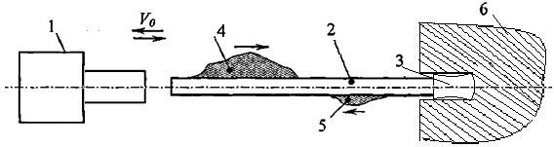
Fig.1. Schematic diagram of a technological impact system.

The longitudinal vibrations generated by the striker piston are referred to as the incident impact pulse (4) and usually propagate along the waveguide, which is terminated by a tool at its end. The amplitude and duration of the pulse depend on the material, shape, and dimensions of the colliding bodies.
Under the action of the impact pulse, the tool is displaced, creating conditions for the fragmentation of the processed medium (6), and penetrates into this medium to a certain depth. At the same time, a significant portion of the energy returns to the impact system in the form of a reflected pulse (5), which is typically dissipated by the system itself [6-9].
The calculation of impact systems intended for technological applications involves solving problems related to the formation and propagation of elastic deformation pulses during the collision of the striker piston with the waveguide, as well as the transmission of the impact pulse along the waveguide into the processed medium and the conversion of its energy into fracture work. Solving these problems makes it possible to determine the loads acting within the system, perform strength calculations, and evaluate the system performance.
The impact system of a pneumatic rock drill is considered as a mechanical system consisting of a striker piston and a wave-transmitting rod. The kinetic energy accumulated due to the motion of the striker piston is transmitted to the rod through the striker.

$E_{k}=\frac{m_{p}∙v_{p}^{2}}{2}$ (1)
$m_{p}$— piston mass,$v_{p}$ — piston velocity at the moment of impact.
In the impact system of pneumatic perforators, the process of energy transmission is characterized by high-speed dynamic interactions, during which various types of deformations arise as a result of changes in the form and direction of mechanical energy. During impact, the kinetic energy $E_{k}$ generated by the piston is transmitted through the piston–striker to the wave-transmitting rod, and this process occurs simultaneously with contact and wave-induced deformations [10-12].
At the initial stage of impact, the collision between the piston and the striker leads to the formation of localized elastic compression deformations in the contact zone. These deformations are characterized by the occurrence of high stress values within a very short time interval and depend on the elastic–mechanical properties of the materials, the geometry of the contact surfaces, and the impact velocity. Local contact deformations temporarily store a portion of the impact energy in the form of elastic potential energy and have a significant influence on the formation of the impact impulse.
Following the contact stage, the main portion of the energy $E_{k}$propagates along the rod in the form of longitudinal elastic waves. These waves generate alternating compression and tensile deformations within the rod material, thereby transferring energy from the impact point to the working medium. The propagation velocity and amplitude of elastic waves are determined by the density and elastic modulus of the rod material. At the same time, the interaction of waves with boundary conditions at the rod ends leads to the formation of reflected waves, which further increase the complexity of the deformation process. If the characteristic parameters of the deformations are not optimally selected, a significant portion of the energy may be dissipated due to internal losses [13,15].
To date, numerous scientific studies have been conducted on the design of impact hammers and piston–strikers, as well as on their influence on the formation of the impact impulse. One of the most effective and fundamental investigations in this field was carried out by I. A. Zhukov, in which a striker with a semi-catenoid geometric shape capable of forming an optimal impact impulse was studied.
The generating curve of the catenoid shape is represented in a Cartesian coordinate system by the hyperbolic cosine function;

$y=\frac{a}{2}\left(e^{\frac{x}{a}}+e^{-\frac{x}{a}}\right)=a·ch\frac{x}{a },$ (2)
Here, a denotes the catenary parameter.
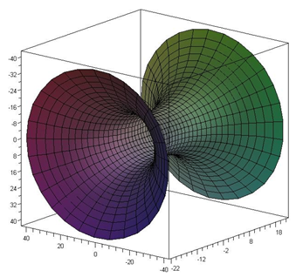 | 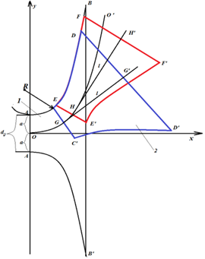
a) b)
Fig.2. Formation of catenoid shapes in the coordinate system: (a) catenoid of revolution;
(b) methods for generating various catenoid geometries.

It should be noted that, to date, the practical application of semi-catenoid (half-catenoid) geometric-shaped strikers, described by the given mathematical expression, in technological impact systems has not been widely developed. One of the main reasons for this is that when this equation is directly used to form the striker geometry, a rapid increase in its radial dimensions is observed. This, in turn, leads to the formation of large-sized structures that are unsuitable for practical application in the mining and construction industries.
At the same time, it is possible to overcome this limitation associated with the constructive implementation of semi-catenoid-shaped strikers. The essence of this approach lies in the use of individual segments of a catenary, defined in a Cartesian coordinate system, shifted relative to the initial position and rotated by a certain angle, as the generating curves for forming the curved surfaces of the strikers (Fig. 2b).
As a result, the obtained strikers differ in terms of geometric shape and length, even when their masses are kept identical. This leads to the formation of elastic impact impulses in waveguides that differ in shape and duration. Each of these impulses can be adapted (optimized) for the efficient fragmentation of media with different strength characteristics [6,14,18].
The studies conducted by I. A. Zhukov included a comparative analysis of impact impulses generated by strikers of various geometric shapes, which revealed the following important results:
- the impact impulse generated by a semi-catenoid-shaped striker exhibits an intensity that increases over time on the leading front, which fully corresponds to the fundamental requirements for an optimal impact impulse;
- the ratio of the maximum amplitude of the impact impulse to the amplitude of the impulse generated by a striker with a constant cross-sectional area equal to that of the rod exceeds 2, and this value is significantly higher than those obtained for strikers of other geometric shapes.
Based on these results, it can be theoretically assumed that the impact impulse generated by a semi-catenoid-shaped striker possesses a time-increasing intensity, and its maximum amplitude may be higher than that of impulses generated by strikers of other shapes described analytically using the shank rod model of the impact process [16,17,19].

RESEARCH RESULTS
This observation indicates that the semi-catenoid shape is expedient to be applied not only in impact hammers, but also in the impact piston–strikers of pneumatic perforators. In order to verify and substantiate this hypothesis, the energy transfer processes were numerically simulated using the ANSYS software package for three different striker configurations: a cylindrical-shaped piston–striker of the ПП-63 perforator (Fig. 3a), a conical-shaped piston–striker of the YT-29 perforator (Fig. 3b), and the proposed piston–striker with a semi-catenoid geometric shape (Fig. 3c).
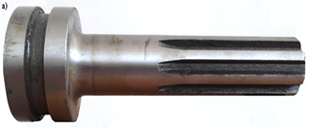 | 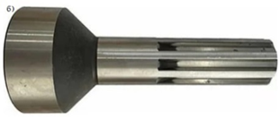 | 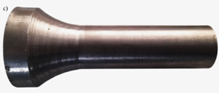
a) | b) | c)
Fig. 3. General view of the piston strikers of pneumatic perforators: (a) ПП-63; (b) YT-29; (c) proposed semi-catenoid-shaped piston–striker.

During the numerical modeling, identical initial conditions were adopted for all variants. Specifically, the impact (drilling) velocity was set to 8 m/s, the same material properties corresponding to 45 steel (C45) were used, and identical geometric dimensions were assumed: a total length of 200 mm, an impact-end diameter of 44 mm, and a maximum diameter of 75 mm. Only the shape of the piston–striker was varied.
As a result, using the ANSYS software package, the distributions of deformations arising during the impact energy transfer process, as well as their temporal evolution, were determined (Figs. 4a–c).

а)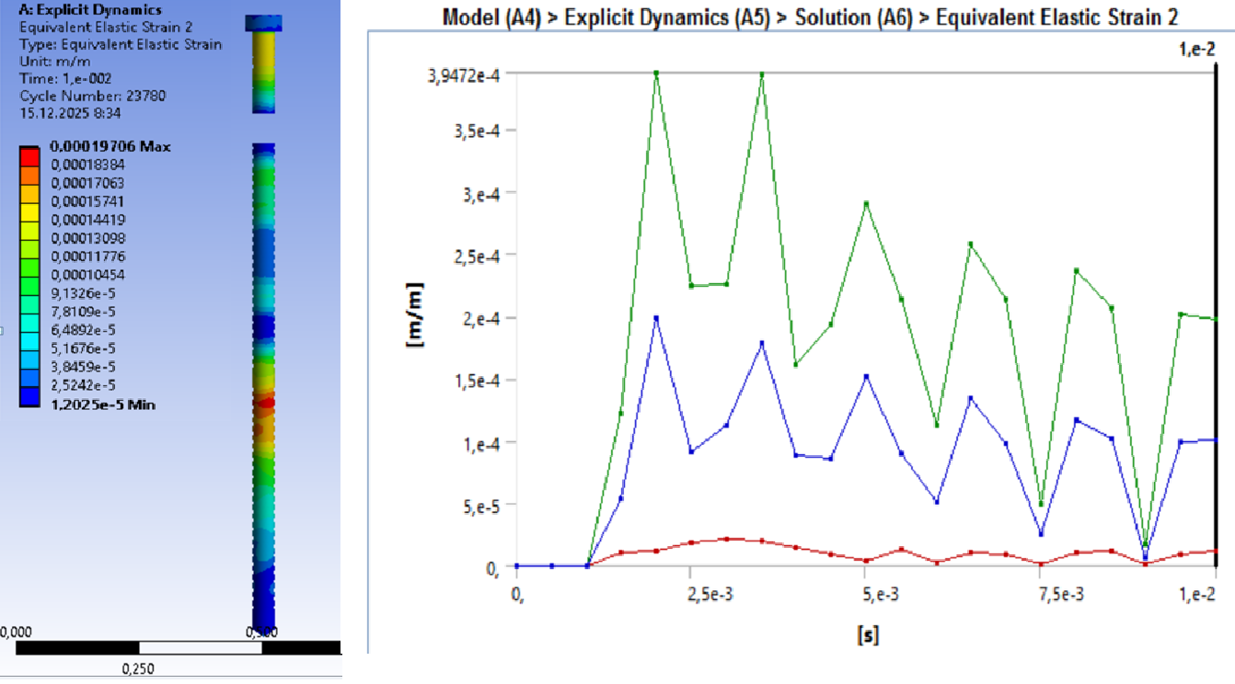
b) 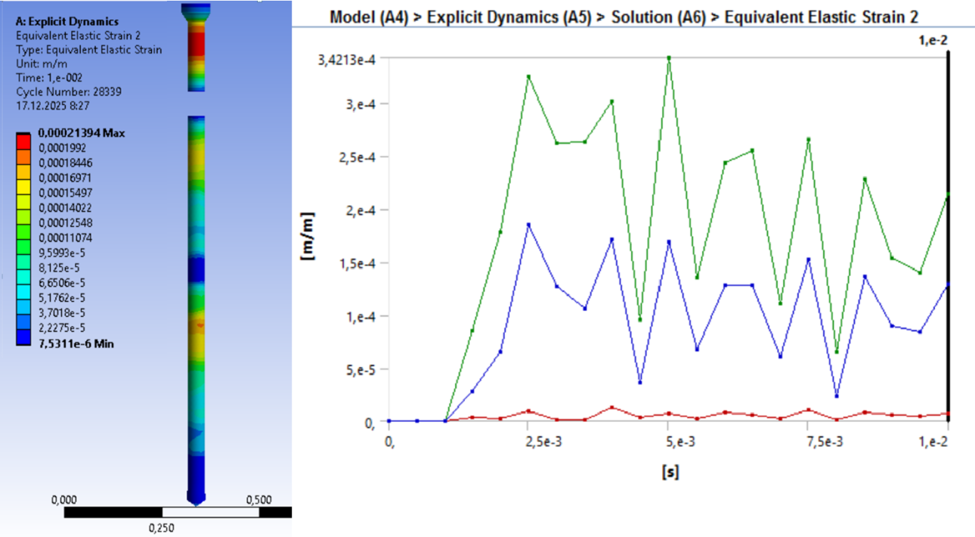

c) 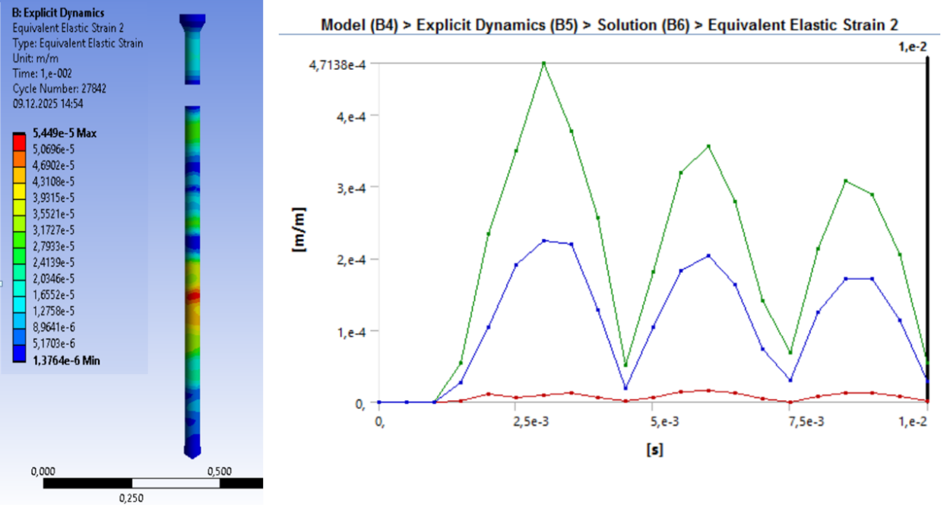
Fig. 4. Deformations arising as a result of impact generated by piston strikers of various shapes:
(a) cylindrical; (b) conical; (c) semi-catenoid.

In this study, an analytical investigation was carried out to determine how the geometric shape of strikers used in the impact system of pneumatic perforators affects the deformation states that arise during the impact process.[20]
In the plotted diagrams, the green curves represent the elastic deformation of the drill bit after impact, the blue curves correspond to the deformation of the rock mass, and the red curves indicate the elastic deformation of the piston–striker.
The evaluation of the deformation state of the strikers was performed based on several key criteria. The first criterion was the maximum equivalent elastic deformation ($ε$). This parameter characterizes the level of elastic strain generated in the striker material during impact and makes it possible to assess the structural strength reserve of the design.
The second criterion involved the analysis of the time-dependent evolution of deformation. This approach made it possible to identify the initial stage of impact, the moment of reaching maximum deformation, and the subsequent damping phase, thereby enabling a comparison of the dynamic response of strikers with different geometries.
The smoothness of the deformation–time curves or the presence of pronounced oscillations is of significant importance for assessing the stability of the impact process.
The third criterion considered was the distribution of deformation along the striker length. This criterion makes it possible to identify the regions of the striker where impact loads are concentrated. A non-uniform deformation distribution may lead to stress concentration, which can result in a reduction in the structural reliability of the system.
The fourth criterion was related to the stability of deformation oscillations, where the amplitude and damping rate of elastic vibrations arising during the impact process were evaluated. Stable vibrations with rapid attenuation contribute to improved energy transfer efficiency and extend the service life of the striker and its associated components.[21]
First, an analysis of the results obtained for the cylindrical striker was performed. The equivalent elastic deformation plots and corresponding contour maps for the cylindrical-shaped striker revealed the following features:
- The deformation amplitude in the drill bit was observed within the range of $ε$ = (3.4–3.9) ⋅ 10⁻⁴ m/m, indicating that a significant portion of the impact energy is concentrated directly in the working tool.
- The deformation in the rock mass (ε) (blue curve) was considerably lower than that in the drill bit, which indicates the presence of energy losses during the transmission process.
- The deformation in the piston–striker (ε) (red curve) was very small, confirming that the striker possesses sufficient structural strength from a mechanical standpoint.
Based on the above observations, it can be concluded that the cylindrical shape ensures a sharp transfer of impact energy; however, it does not provide maximum activation of deformation within the rock mass. This behavior can be explained by the flat contact surface and the relatively uniform stress distribution. The high degree of localization of stresses and deformations limits the effectiveness of this design from the perspective of structural reliability.
The analysis of the results obtained for the conical-shaped striker revealed several findings of significant scientific interest. The deformation process of this striker exhibits a more complex and dynamic behavior, which is fundamentally different from that of the cylindrical configuration. The plots clearly demonstrate a change in the ratio between the deformations of the drill bit and the rock mass compared to the cylindrical case.
- The maximum equivalent elastic deformation in the drill bit was $ε$ = (3.0–3.2) ⋅ 10⁻⁴ m/m, which represents the lowest value among the considered configurations, while the oscillation amplitude exhibited a more pronounced and abrupt character.
- The deformation values in the rock mass ($ε$) were higher than those observed for the cylindrical striker, indicating a more efficient transfer of impact energy to the rock.
- The deformation ($ε$) along the piston–striker was distributed relatively uniformly, resulting in minimal local stress concentration.
Compared to the cylindrical striker, the conical-shaped striker transfers impact energy to the rock mass more efficiently, leading to a higher level of deformation in the rock. In this case, the formation of a more optimal impact impulse ensures a uniform propagation of elastic waves, thereby enhancing the overall mechanical stability of the striker.
The deformation results obtained for the proposed semi-catenoid-shaped piston–striker are characterized by the following features:
- The deformation in the drill bit reached the highest maximum values, namely $ε$ = (4.5–4.7)⋅10⁻⁴ m/m, while the impact impulses propagated in a relatively smoother form.
- The deformation in the rock mass was significantly higher than in the other two cases, indicating that the most optimal energy transfer regime is achieved with this geometry.
- The deformation in the piston–striker remained minimal, confirming the mechanical reliability of this shape.
The semi-catenoid geometry enables optimal guidance of impact energy through wave propagation, reduces the reflection of elastic impulses, and maximizes the accumulation of deformation energy within the rock mass. As a result, the most favorable conditions are created for the initiation and propagation of microcracks in the rock.[22,23]

CONCLUSIONS
The generalized graph developed within the Excel environment enables a comparative analysis of the temporal variations in equivalent elastic deformations occurring in the burr under the impact of strikers with three distinct geometric profiles. As illustrated by the graph, the impact process exhibits an impulsive behavior across all cases, with deformation values characterized by recurring peaks over time.
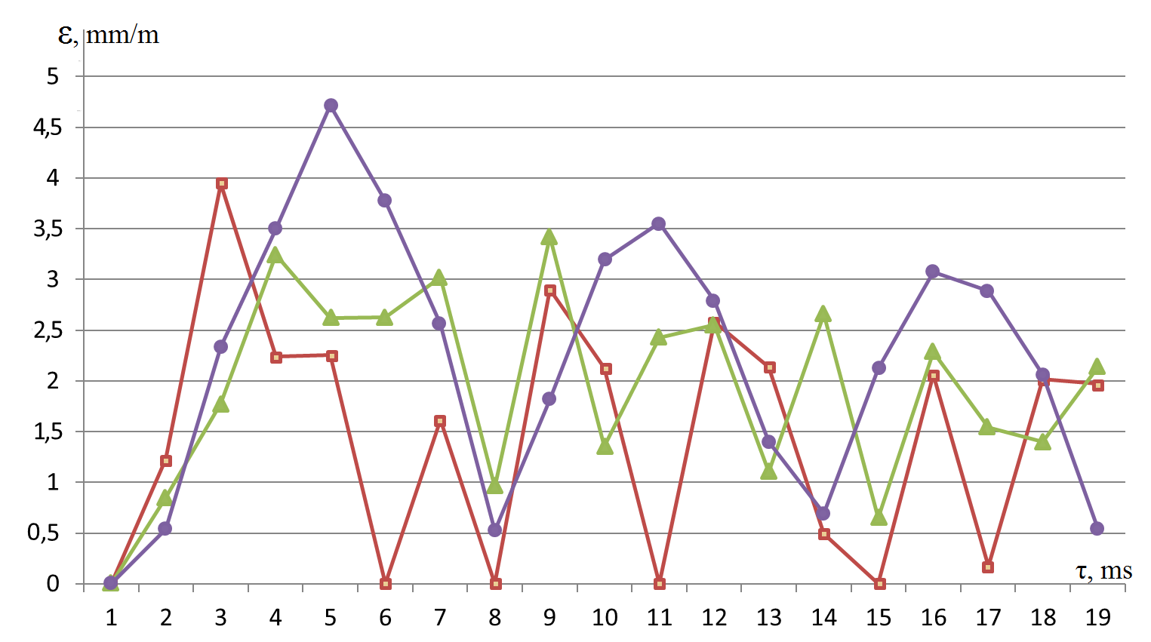
Fig. 4. Temporal variation of equivalent elastic deformation in the burr under the impact of piston-strikers with various geometric shapes: cylindrical (green); conical (red); and semi-catenoid (purple).

An analysis based on average values indicates that the maximum equivalent elastic deformation in the burr exhibits higher values for cylindrical and semi-catenoid strikers compared to the conical striker. Furthermore, the semi-catenoid striker is characterized by an increased level of deformation when compared to the cylindrical striker. Detailed quantitative comparison results are presented in Table 1.

Table 1. Mean elastic deformation values and their percentage comparisons for different striker profiles.
Piston-striker type Percentage difference | Mean value of elastic deformation | Comparison bases of mean values | Percentage difference
Cylindrical | 3.65⋅10⁻⁴ | Cylindrical ↔ Conical | 18 %
Conical | 3.10⋅10⁻⁴ | Semi-catenoid ↔ Cylindrica | 26%
Semi-catenoid | 4.60⋅10⁻⁴ | Semi-catenoid ↔ Conical | 48%

The simulation results conducted via ANSYS Explicit Dynamics demonstrate that the maximum equivalent elastic deformation in the burr is approximately 18% higher for the cylindrical striker and 48% higher for the semi-catenoid striker compared to the conical striker. Furthermore, the semi-catenoid striker increases the deformation level by 26% relative to the cylindrical shape.
Consequently, local contact elastic compression deformations occurring in the impact systems of pneumatic drills, along with longitudinal elastic waves propagating along the rod, are the primary factors determining the mechanism of impact energy transfer to the working medium. A profound analysis of the quantitative and qualitative indicators of these deformations serves as a critical scientific foundation for optimizing impact systems, reducing energy losses, and enhancing the efficiency of rock fragmentation processes.
Therefore, the semi-catenoid profile is recommended as the most promising geometric solution for mining and drilling equipment, as well as impact mechanisms.
REFERENCES
- D. Shibanov, A. Agaguena, and T. Annakulov, “Extraction of inclined exit ledges in coal mines in presence of mobile crushing and conveyor complexes,” International Journal of Engineering, Transactions B: Applications 37(8), 1658–1666 (2024); https://doi.org/10.5829/ije.2024.37.08b.17.
- T. Annakulov, S. Gaibnazarov, A. Askarov, and L. Mamadieva, “Prospects for the use of cyclic-flow technology for the transportation of rocks at the Yoshlik-1 quarry of JSC Almalyk Mining and Metallurgical Combine,” E3S Web of Conferences 414, 06007 (2023); https://doi.org/10.1051/e3sconf/202341706007.
- V. V. Gabov and Yu. V. Lykov, Design of Drilling Machines for Underground Works (Saint Petersburg, 2010).
- O. A. Mishchenko and V. P. Tishchenko, Life Safety (Pacific State University Publishing House, 2014), 338 p.
- V. L. Krupenin, “Impact and vibro-impact machines and devices,” Bulletin of Scientific and Technical Development 4(20) (2009).
- L. T. Dvornikov and I. A. Zhukov, “Semi-catenoid of revolution as a universal striker for impact systems for technological purposes,” Mining Informational and Analytical Bulletin 4, 282–287 (2008).
- T. J. Annakulov, S. B. Gaibnazarov, O. A. Kuvandikov, F. O. Otajonov, and B. O. Otajonov, “Development of a methodology for determining the economic efficiency of cyclic-flow technology schemes for rock mining using mobile crushing and reloading-conveyor complexes,” AIP Conference Proceedings 2432, 030115 (2022); https://doi.org/10.1063/5.0089668.
- V. I. Baburov and V. F. Gorbunov, Causes of Vibration in Handheld Pneumatic Hammers and Methods of Combating It (Tomsk Polytechnic University, 1966).
- O. D. Alimov and I. G. Lyapichev, Study of Rotary-Impact Drilling (1998).
- V. O. Krasovsky, G. G. Maksimov, and L. B., Hygienic Assessment of Industrial Vibrations (Ufa, 2014), 181 p.
- D. Shibanov, A. Agaguena, and T. Annakulov, “Extraction of inclined exit ledges in coal mines in presence of mobile crushing and conveyor complexes,” International Journal of Engineering, Transactions B: Applications 37(8), 1658–1666 (2024); https://doi.org/10.5829/ije.2024.37.08b.17.
- T. Annakulov, N. Ziyadov, and F. Abdikarimov, “Analysis of overburden transportation by conveyor transport as part of a cyclic-flow technology,” E3S Web of Conferences 414, 06006 (2023); https://doi.org/10.1051/e3sconf/202341706006.
- T. Annakulov, S. Gaibnazarov, A. Askarov, and L. Mamadieva, “Prospects for the use of cyclic-flow technology for the transportation of rocks at the Yoshlik-1 quarry of JSC Almalyk Mining and Metallurgical Combine,” E3S Web of Conferences 414, 06007 (2023); https://doi.org/10.1051/e3sconf/202341706007.
- G. Bulatov and T. Annakulov, “Investigation of the width of the entry of an excavator when loading a mobile crushing plant in the conditions of the Angren coal mine of Uzbekistan,” IOP Conference Series: Earth and Environmental Science 937(4), 042088 (2021); https://doi.org/10.1088/1755-1315/937/4/042088.
- T. Annakulov, “Development of technological schemes for open-pit mining of deposits using mobile crushing-reloading-conveyor complexes,” E3S Web of Conferences 201, 01010 (2020); https://doi.org/10.1051/e3sconf/202020101010.
- T. J. Annakulov, K. M. Temirov, B. O. Otajonov, J. F. Yunusov, and Sh. N. Norimonov, “Justification of equipment parameters for mobile crushing-reloading-conveyor complexes in open-pit mining,” Mining Informational and Analytical Bulletin 12-3, 5–22 (2025); https://doi.org/10.25018/0236_1493_2025_123_0_5.
- M. Rabatuly, S. A. Myrzathan, J. B. Toshov, J. Nasimov, and A. Khamzaev, “Views on drilling effectiveness and sampling estimation for solid ore minerals,” Complex Use of Mineral Resources 336(1) (2026); https://doi.org/10.31643/2026/6445.01.
- J. B. Toshov, M. Rabatuly, Sh. Khaydarov, A. A. Kenetayeva, A. Khamzayev, M. Usmonov, and A. T. Zheldikbayeva, “Methods for analysis and improvement of dynamic loads on the steel wire rope holding the boom of excavators,” Complex Use of Mineral Resources 339(4), 87–96 (2026); https://doi.org/10.31643/2026/6445.43.
- O. U. Zokhidov, O. O. Khoshimov, and Sh. Sh. Khalilov, “Experimental analysis of micro-GES installation for existing water flows in industrial plants,” E3S Web of Conferences (2023); https://doi.org/10.1051/e3sconf/202346302023.
- O. U. Zokhidov, O. O. Khoshimov, and S. Z. Sunnatov, “Selection of the type and design of special water turbines based on the nominal parameters of Navoi Mining and Metallurgical Combine engineering structures,” AIP Conference Proceedings 3331, 050022 (2025); https://doi.org/10.1063/5.0306554.
- A. A. Khamzaev, A. Mambetsheripova, and N. Arislanbek, “Thyristor-based control for high-power and high-voltage synchronous electric drives in ball mill operations,” E3S Web of Conferences 498, 01011 (2024); https://doi.org/10.1051/e3sconf/202449801011.
- B. R. Toshov and A. A. Khamzaev, “Development of technical solutions for the improvement of the smooth starting method of high-voltage and powerful asynchronous motors,” AIP Conference Proceedings 2552, 040018 (2023); https://doi.org/10.1063/5.0116131.
- B. R. Toshov, A. A. Khamzaev, M. E. Sadovnikov, B. Rakhmatov, and U. Abdurakhmanov, “Automation measures for mine fan installations,” SPIE Proceedings 12986, 129860R (2024); https://doi.org/10.1117/12.3017728

