Investigation of the deformed state of the varzik earth dam under the action of self-weight
Pakhriddin Matkarimov ^{a)}, Zokirjon Kholboyev, Dostonbek Kupaysinov, Odiljon Fozilov
Namangan state technical university, Namangan, Uzbekistan
^{a)} Corresponding author: mpaxridin@gmail.com
Abstract. This scientific paper presents the computational scheme, mathematical model, and numerical algorithm for evaluating the deformation behavior of the Varzik earth dam—characterized by a complex geometrical configuration—under the action of self-weight within the conditions of plane strain. Using the PLAXIS 2D software package, which is widely applied in the construction and geotechnical engineering fields, numerical analyses were performed considering the complex structural features of the dam. The obtained results describing the deformed state of the dam are presented. Due to the inclined configuration of the core screen and the transition zone, as well as the presence of a tooth (key), a complex deformation pattern was observed in the upper supporting prism.
INTRODUCTION
In recent years, water scarcity has been escalating into a global challenge. In addressing this issue, the role of reservoirs is exceptionally significant, as dams constitute the primary structures in their construction. Considering this, hydraulic structures of various scales—constructed and operated in seismic regions—are required to remain reliable, safe, and stable under different types of loads (static, dynamic, and seismic). In particular, to ensure the strength and operational reliability of hydraulic structures subjected to hydraulic influences, it is essential to conduct extensive research on their static behavior, taking into account the mechanical properties of soils as well as the actual geometric configuration and structural characteristics of the structures.
According to general theoretical foundations presented in numerous scientific sources [1,2,3], the structural features of earth dams, their stability, and deformation processes have been extensively studied. Specifically, works [4,5] provide a comprehensive analysis of the theoretical bases of hydraulic structures, including strength-related issues of earth dams. The study in [6] describes the physical and mechanical properties of soils, their deformation behavior, and relevant methods of analysis within the framework of stress–strain theory.
The complex problem described above can be thoroughly and accurately solved using numerical methods such as the finite element method (FEM) or the finite difference method (FDM), while considering the actual geometric shape and structural parameters of earth dams [7,8]. Numerous researchers have investigated the stress–strain state (SSS) of earth dams based on structural features, geometric characteristics, and different computational models, providing corresponding conclusions [9,10].
In recent years, special attention has been given to the investigation of stress–strain behavior of earth dams under water pressure and self-weight using numerical software. In particular, studies presented in [11,12,13,14] modeled the deformation processes of earth dams subjected to hydraulic flow and pressure.
The analysis of scientific literature shows that the stress–strain state of earth dams has not been sufficiently studied considering their detailed structural characteristics and realistic working conditions, which highlights the scientific relevance of conducting research in this direction.
Based on the above, developing and substantiating mathematical models and computational methods for evaluating the stress–strain state of earth dams—considering their structural features, geometric dimensions, physical–mechanical properties of soils, and the geotechnical conditions of the region in which the structure is located—is one of the important and urgent problems of continuum mechanics.

EXPERIMENTAL RESEARCH
We examine the plane-strain model of the Varzik earth dam, which is located on an irregular terrain and has a total volume expressed as V=V₁+V₂+V₃+V₄ (Figure 1). In the figure, V₁, V₃ - represent the upper and lower supporting prisms, respectively; V₂ - denotes the core screen, V₄ - indicates the transition zone. The dam is assumed to be rigidly fixed along the foundation surface Σ_{u}. The surfaces Σ₁, Σ₃ corresponding to the upstream and downstream slopes, as well as the crest surface Σ₂, are considered free from external loading. The analysis focuses on the plane-strain deformation state of the Varzik earth dam under the action of its self-weight.
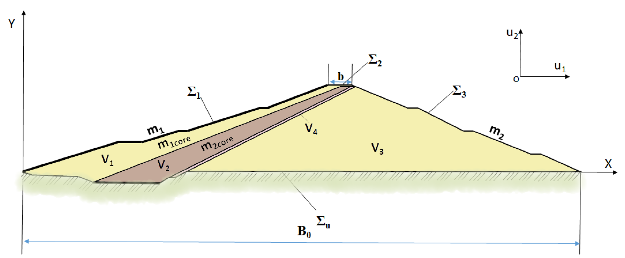
FIGURE 1. Plane-strain model of the Varzik earth dam. Here: b – crest width of the dam; B₀ – width of the dam foundation; m₁ and m₂ – slope coefficients of the upstream and downstream prisms; m_{1core} and m_{2core} – slope coefficients of the dam’s core screen.

To evaluate the processes occurring in the plane-strain system (Figure 1), we employ the following variational equation and boundary conditions based on the principle of possible displacements, wherein the sum of virtual work performed by active forces is equal to zero [1]:
$$δA=-\int_{V_{1}}^{ }{σ_{ij}δε_{ij}dV_{1}-}\int_{V_{2}}^{ }{σ_{ij}δε_{ij}dV_{2}-}\int_{V_{3}}^{ }{σ_{ij}δε_{ij}dV_{3} -\int_{V_{4}}^{ }{σ_{ij}δε_{ij}dV_{4}}+}$$  $$+\int_{V_{1}}^{ }{\vec{f}δ\vec{u}dV_{1}+}\int_{V_{2}}^{ }{\vec{f}δ\vec{u}dV_{2}+}\int_{V_{3}}^{ }{\vec{f}δ\vec{u}dV_{3}}+\int_{V_{4}}^{ }{\vec{f}δ\vec{u}dV_{4}}=0 i, j=1,2$$ | (1)
The boundary conditions for the dam foundation are formulated as follows:
$\vec{x}∈\sum_{u}{ }; y=0; δ\vec{u}=0$ (2)
In this variational equation, the stress and strain tensors, which reflect the physical and mechanical properties of the material in each part of the system, are related to each other using the generalized Hooke’s law, i.e., [6]:
$$\left.\begin{matrix}σ_{11}=\frac{E_{n}\left(1-ν_{n}\right)}{\left(1+ν_{n}\right)\left(1-{2ν}_{n}\right)}ε_{11}+\frac{{ν_{n}E}_{n}}{\left(1+ν_{n}\right)\left(1-{2ν}_{n}\right)}ε_{22} \\ σ_{22}=\frac{E_{n}\left(1-ν_{n}\right)}{\left(1+ν_{n}\right)\left(1-{2ν}_{n}\right)}ε_{22}+\frac{{ν_{n}E}_{n}}{\left(1+ν_{n}\right)\left(1-{2ν}_{n}\right)}ε_{11} \\ σ_{12}=\frac{E}{2\left(1+ν_{n}\right)}ε_{12}\end{matrix}\right\}$$ | (3)
The relationship between the strain tensors and the displacement vectors is expressed through the following Cauchy relations:
$$ε_{11}=\frac{∂u_{1}}{∂x_{1}} ; ε_{22}=\frac{∂u_{2}}{∂x_{2}} ; ε_{12}=\frac{∂u_{1}}{∂x_{2}}+\frac{∂u_{2}}{∂x_{1}}$$ | (4)
Here: $\vec{u}$, $ε_{ij}$, $σ_{ij}$ are the components of the displacement vectors, strain tensors, and stress tensors, respectively; $δ\vec{u}$, $δε_{ij}$ represent the virtual variations of the displacement vectors and strain tensor components; $\vec{f}$ is the vector of body (mass) forces; $E_{n}$ and$ν_{n}$ ​ are the elastic parameters of the n-th element of the dam; $\vec{u}=\{u_{1}, u_{2}\}=\{u,v\}$ – are the components of the displacement vector at a point in the dam; $\vec{x}=\{x_{1}, x_{2}\}=\{x,y\}$ are the coordinates of the dam points. In the plane-strain problem, the indices $i,j = 1, 2$.
In formulating this problem, for any virtual displacement $δ\vec{u}$, it is necessary to determine the unknown displacement and stress components in the dam body under the action of the external load vector $\vec{f}$ ​, which satisfy equations (1)–(4).
By applying the finite element method, the variational equations (1)–(4) and associated relations for the considered domains are reduced to a system of second-order, inhomogeneous algebraic equations equivalent to the mathematical model described above:
$$\left[K\right]\left\{u\right\}=\left\{F\right\}.$$ | (5)
Here, $\left[K\right]$ is the stiffness matrix of the system (Figure 1), {u} represents the unknown displacements to be determined, and $\left\{F\right\}$ denotes the external forces (including body forces, etc.). The plane-strain problem is solved using the PLAXIS 2D software package.
RESEARCH RESULTS
In this study, the deformation behavior of the Varzik earth dam, constructed in Chust district, Namangan region, was investigated under the action of its self-weight in a plane-strain condition. Using the previously described mathematical model, methodology, and algorithm, the deformation state of the dam was analyzed, taking into account the soil’s physical and mechanical properties, structural characteristics, complex geometric parameters, and the irregularity of the underlying terrain.
The Varzik earth dam studied in this research has supporting prisms V₁ and V₃ composed of gravel, compacted in layers. The upstream slope of the dam is covered with a 20 cm thick concrete layer. The dam core V₂ consists of a sand–clay mixture (suglinka). Between the core and the lower supporting prism, a 3-meter-thick transition zone of sandy gravel was constructed. The maximum height of the dam is H=40 m and the slope coefficients of the supporting prisms are m₁= 3,2 and m₂ = 2,5. The crest width is b=10 meter, and the dam length is L=550 meter.

a) $u_{1}$, [*10⁻³m]
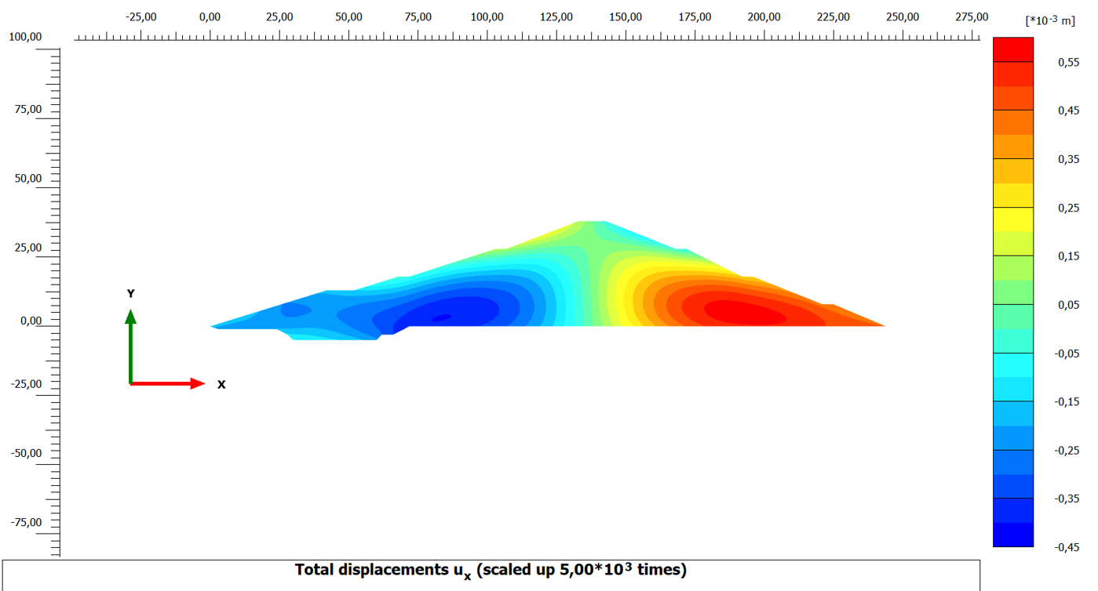
b) $u_{1}$, [*10⁻³m]
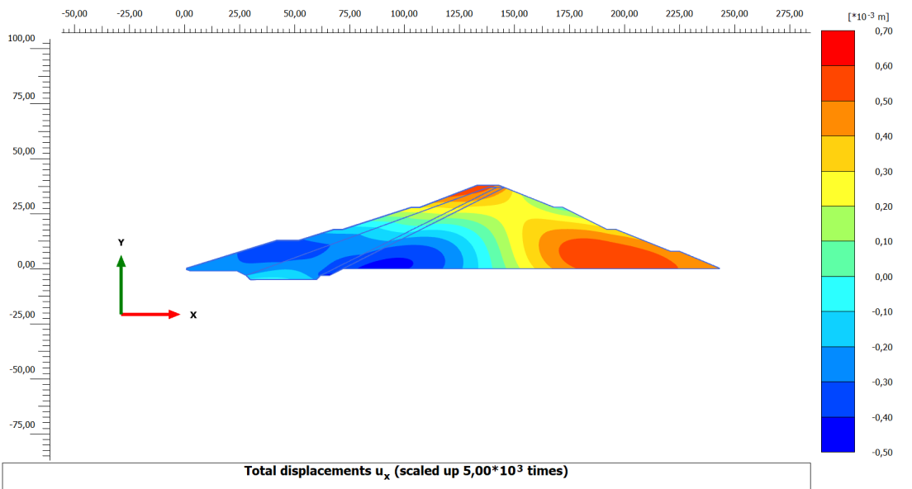

FIGURE 2. Iso-contours of horizontal displacements u₁ of the Varzik earth dam under self-weight:
(a) homogeneous dam, (b) dam with core and transition zone

Numerical analysis allowed the determination of the horizontal u₁ and vertical u₂ displacement components for all points of the structure, and iso-contours of these displacements throughout the dam body were constructed. The study was initially conducted for a homogeneous dam and subsequently for the dam considering the core and transition zone. The results were compared, and appropriate conclusions were drawn.
Analysis of the results shows that, when the dam body is assumed to be made of a homogeneous material, the horizontal displacement u₁ is zero at the symmetry axis of the dam body and reaches its maximum at the centers of the supporting prisms, decreasing with distance from the center (Figure 2a). Accounting for the core and transition zone significantly alters the state of the upper prism, resulting in a complex deformation pattern observed around the core and the key (tooth). Moreover, due to the influence of the core, the symmetry of the horizontal displacement u₁ is lost, and the point where u₁ approaches zero shifts toward the center of the lower supporting prism (Figure 2b). The presence of the dam key at the base of the upper prism further contributes to the complex deformation pattern of the structure. The vertical displacements u₂ along the dam cross-section increase proportionally with the dam height, reaching their maximum at the crest (Figure 3). Approaching the dam foundation, the displacement values gradually decrease and approach zero. If the dam foundation is uniform, the iso-contours are nearly symmetric. From Figure 3a, it can be observed that when the dam is made of a homogeneous material, the vertical displacement values exhibit symmetry.
A comparison of the results shown in Figures 3a and 3b demonstrates that the core and transition zone have a significant impact on the deformation behavior of the earth dam. In particular, accounting for the core and transition zone leads to a complex pattern of displacement iso-contours on the upstream slope, reflecting the non-uniform deformation state induced by the structural heterogeneity.

a) $u_{2}$, [*10⁻³m]
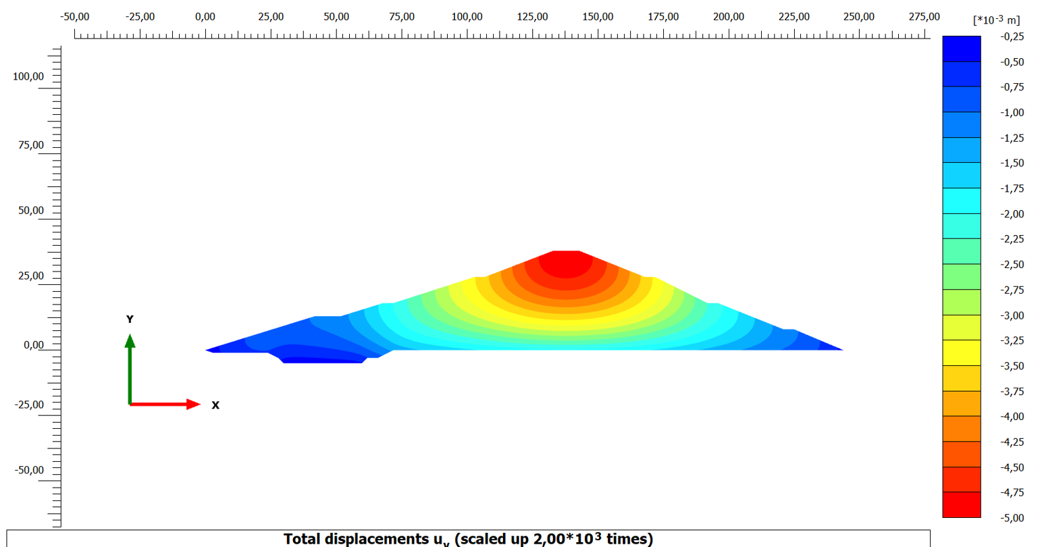
b) $u_{2}$, [*10⁻³m]
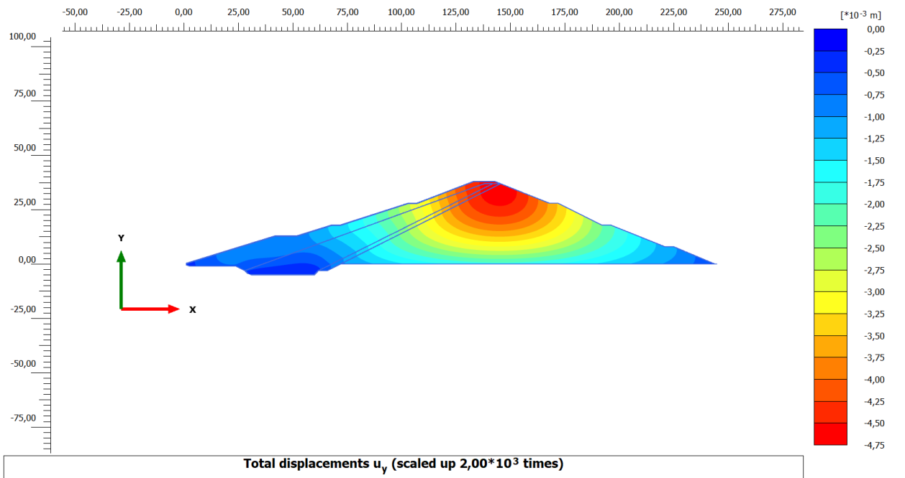

FIGURE 3. Iso-contours of vertical displacements u₂ along the cross-section of the Varzik earth dam under self-weight: (a) homogeneous dam, (b) dam with core and transition zone.
CONCLUSIONS
1. A two-dimensional mathematical model, computational method, and algorithm were developed to study the deformation behavior of earth dams with complex geometric parameters under the action of self-weight, considering heterogeneous (non-homogeneous) material properties.
2. The experimental findings showed that the continuation of the excessive larger percentage of lightweight aggregate below the optimal point causes the excessive increase in the cement intake in order to reach the desired mechanical strength at the expense of the technological efficiency and economic viability of the concrete.
3. The investigation revealed that the horizontal (u₁) and vertical (u₂) displacements within the dam body depend on the dam’s self-weight, the homogeneity or heterogeneity of the soil material, and that the presence of a core and a key (tooth) in the dam structure significantly affects the distribution pattern of vertical displacements (u₂) along the cross-section.
REFERENCES
1. Mirsaidov M.M., Matkarimov P.J., Juraev D.P., “Three-Dimensional Stress State of Earth Dams Under Static Loads,” in Lecture Notes in Civil Engineering Proceedings 335, edited by N. Vatin et al. (Springer Nature, Switzerland, 2023) pp. 1-11
2. Bogoslavchik, P. M., Medvedeva, Yu. A., Nemerovets, O. V. Earth Dams: A Study Guide for Students of the Specialty 1-70 04 01 “Water Resources Construction”. Minsk: Belarusian National Technical University (BNTU), 2022. 74 p.
3. Mirsaidov, M. M., Sultanov, T. Z., Yuldoshev, B. Sh. Methods for Assessing the Stress State of Earth Dams Considering the Moisture Properties of Soil. Tashkent: Adabiyot Uchqunlari Publishing House, 2020. 156 p.
4. Matkarimov, P. Zh. Investigation of the Stress–Strain State of Earth Structures with Consideration of Structural Features and Their Actual Performance. Monograph. Fergana: SUNRISE-PRO, 2024. 164 p.
5. Bakiyev, M. R., Rakhmatov, N. Operation of Hydraulic Structures. Textbook. Surkhandarya: Fidokor Yosh Avlod Publishing House, 2021. 202 p.
6. Timoshenko S. P., Goodier J. N. “Theory of Elasticity” Moscow: Nauka, Main Editorial Office of Physical and Mathematical Literature, 1979. 560 p. (in Russian)
7. Matkarimov P.J., Juraev D.P., “Stress-strain state and strength of earth dams under static loads,” in IV International Scientific Conference “Construction Mechanics, Hydraulics and Water Resources Engineering”, E3S Web of Conferences 365, edited by D. Bazarov (EDP Sciences - Web of Conferences, France, 2023), 03008
8. Potts, D. M., Zdravković, L. “Finite Element Analysis in Geotechnical Engineering: Theory”. – London: Thomas Telford Ltd, 1999. – 440 p.
9. Khoei A.R., Azami A.R., Haeri S.M. Implementation of Plasticity Based Models in Dynamic Analysis of Earth and Rockfill Dams: A Comparison of Pastor–Zienkiewicz and Cap Models // Computers and Geotechnics. 2004. July Vol.31, Issue 5. Pp.384–409
10. Martin Wieland. Features of seismic hazard in large dam projects and strong motion monitoring of large dams. //Frontiers of Architecture and Civil Engineering in China. March 2010. - Volume 4. - Issue 1. - pp 56-64.
11. Mirsaidov M. “Strength of earth dams considering the elastic-plastic properties of soils” E3s Web of Conferences 365, 03001 (2023). Https://Doi.Org/10.1051/E3sconf/202336503001
12. P.J.Matkarimov , D.P.Jurayev “Stress-strain state and strength of earth dams under static loads” E3s Web of Conferences 365, 03008 (2023) Conmechydro – 2022 Https://Doi.Org/10.1051/E3sconf/202336503008
13. Kholboev Z., Matkarimov P., Mirzamakhmudov A.Investigation of dynamic behavior and stress-strain state of soil dams taking into accountphysically Non-linear properties of soils //E3S Web of Conferences. – EDP Sciences, 2023. – Т.452. – С. 02009. https://doi.org/10.1051/e3sconf/202345202009
14. Arifjanov A. et al. Analysis results of data obtained in natural field research in mountain river Sokhsoy //E3S Web of Conferences. – EDP Sciences, 2023. – Т. 365. – С. 03017. https://doi.org/10.1051/e3sconf/202336503017

