Effects of aggregate replacement on strength and density of lightweight concrete
Odiljon Fozilov ^{a)}, Abdurasul Martazaev, Ravshanbek Mavlonov, Sobirjon Razzakov, Kamoliddin Muminov, Zokirjon Kholboyev
Namangan state technical university, Namangan, Uzbekistan
^{a)} Corresponding author: odiljon690.21.03@gmail.com
Abstract. The presented article explores the lightweight concrete, namely, the decreased density, enhanced thermal performance, and cost efficiency whereby ceramsite is partially replaced by an aggregate. This paper looks at the influence of varying concentrations of ceramsite on concrete mechanical properties. Aggregate ratios of cubic specimens were done at compressive strength of 7, 14, and 28 days. Findings have shown that the content of ceramsite has great dependence on concrete strength and density. The L+H-7 mix that is composed of 60 ceramsite and 40 crushed stone and sand was found to be the best mix, meeting the structural strength and unit weight and at the same time economical and technological efficiency. Reduction in the content of ceramsite will demand too much cement without the correspondingly enhanced strength. The research results provide a viable model on how to manufacture lightweight concrete of high quality.
INTRODUCTION
Lightweight concrete is an emerging material in the contemporary construction industry owing to its low density, better thermal performance, and financial advantages. The partial replacement of ordinary aggregates with expanded clay aggregate (ceramsite) is one of the best techniques of producing lightweight concrete. Ceramsite has a number of benefits, such as low density, high insulation capacity and adequate mechanical strength that makes it applicable in structural and non-structural use. Nonetheless, the best ratio of ceramsite to be replaced is the key to attaining the necessary balance between the strength, durability and weight reduction. The inappropriate proportions could result in either excessive porosity, lower compressive strength, or low workability. Accordingly, the determination of the most suitable ceramsite content is one of the major stages in the development of the high-quality lightweight concrete mixtures. This paper examines how the content of different proportions of ceramsite can be used to replace the natural aggregates in order to determine the best proportion that would offer desirable mechanical properties, better performance and general efficiency of the material.
The studies on the use of lightweight concrete using lightweight expanded clay aggregate (LECA) conducted recently have brought a great contribution to the knowledge of mechanical characteristics, decrease in density, and thermal characteristics of modified concrete blends. Uysal et al. [1] made an elaborate experimental research on LECA concrete using 13 mixture designs and 234 test specimens to examine density, porosity, compressive strength, splitting tensile strength and modulus of elasticity. The compressive strengths were 18-38 MPa dry and on average, moist specimens were 9-percent weaker compressively, which depicts how LECA concrete is sensitive to the environment of moisture. When the specimens were dried in the oven, the modulus of elasticity reduced by about 26% indicating that porous aggregates significantly reduced stiffness. In addition, the authors indicated that the current models of prediction were always exaggerated in their estimates of modulus of elasticity hence the new prediction model that the authors came up with was more appropriate in LECA concrete design.
Xiaogang Wu et al. organized a research to examine the failure properties (both static and dynamic) of ceramsite concrete based on lightweight shale. The specimens were prepared in the lightweight aggregates of 650-880 kg/m 3, a maximum aggregate size of 15 mm, and compressive strength of 31 MPa which had to be pre-soaked in water over a 24 hour period in order to guarantee sufficient quality of concrete. Fresh concrete mixtures were poured to molds, demolded after 24 hours and cured under controlled environment (relative humidity of the mixture was 95 percent and temperature of 20-degree centigrade) after 28 days. Strict geometric tolerances of parallelism between top and bottom surfaces (within 0.02 mm), and that of verticality deviation (less than 0.002 mm) were also adhered to in the preparation of cylindrical specimens. Hopkinson bar, which was invented in 1914 and enhanced in 1949 by Kolsky, was utilized to perform dynamic tests that would define the stressstrain behavior of impact loading. The propagation velocity of waves and an indirect method of measuring the extent of the material damage were established by using ultrasonic measurements. Computed tomography (CT) was used to study internal microstructural characteristics (e.g. voids, defects, aggregate distribution) that were not observable through conventional observation. The results of the experimental tests of the Hopkinson tests were computed based on two assumptions; one-dimensional propagation of waves and homogeneous stress distribution. The one dimensional assumption helped to simplify the analysis, which was mainly done by reducing the effects of dispersion of waves by altering the specimen geometry, or by placing a medium- soft material between the impact bar and the specimen [2].
Ningampalli et al. tested enhanced lightweight self-compacting concrete (LWSCC) beams where LECA is used to substitute natural coarse materials (LWSCC) (525 percent). The compressive strength reduced to 32.73 MPa at 25 per cent LECA (LECA) weight loss in comparison with compressive strength at 44.56 MPa (control) thereby showing that there is a definite strength compromise with increase in LECA content. On the same note, bifurcation of tensile and flexural strengths exhibited a decreasing pattern as there was an increase in LECA. The width of cracks increased at 25% LECA by about 2 mm as compared to a control of about 1 mm and the general density reduced. Flexural performance analysis also revealed decreased ultimate load capacity and increased deflection with proportion of LECA, which still showed an improvement in the ductility indices, which suggested a possibility of greater flexibility with inclusion of LECA [3].
The performance assessment of LECA concrete by Murugan and Palaniappan studied the mixes of 0, 25, 50, 75, and 100 LECA replacement in M25 concrete. They found compressive, split tensile and flexural strength remained under the influence of LECA content steadily, mainly because of increased porosity and water absorption of LECA which influenced density and mechanical performances. Moreover, LECA concrete demonstrated a higher water uptake, sorptivity ratio, chloride ion diffusion, and mass loss during durability experiment, highlighting the issue of durability at increased levels of LECA replacement. Porous aggregate behaviour that affects the performance degradation was confirmed by microstructural analyses [4].
Though by no means the newest, this work is commonly used in the study of LECA: researchers have prepared 120 cubic specimens with LECA and different levels of silica fume (SF) (0 to 25 percent) and kept w/c constant (0.37). It was found that compressive strength increased significantly with increasing silica fume content over 7-42 days of curing showing that mineral additives can be used to offset the degradation of strength caused by the porosity of LECA (e.g. mixes of 10-20% SF had significant strength gains relative to control mixes). This proves the efficiency of additive cementitious materials in improving the LECA concrete performance [5].
Abdullah Basil Raheem [6] tested the shear behavior of fibrous I-beams produced using normal and lightweight concrete with almost same compressive strength (approximately 30 MPa). The coarse aggregate was substituted with 75% substitute by Bonza stone hence the production of lightweight concrete. Fourteen I-beams (1000 210 175 mm) were separated into two groups one reinforced with steel fibers and the other with glass fibers at a concentration of 0.5, 1 and 1.5 percent of the volume of the mix. The findings showed that the addition of 1 percent fibers gave maximum increment of shear strength to both normal and lightweight concrete. Steel fibers improved shear strength up to 13.5% with glass fibers increasing it to 0.5 and 1.0 but reduced it to 1.5. In general, it was found that 1% of fiber addition is the most effective ration that should be used to optimize shear performance with both types of concrete. Similar observations have been reported for lightweight concrete beams [7,8,9,10]. Overall, the findings indicate that fiber-reinforced lightweight concrete exhibits shear strength performance comparable to that of conventional normal-weight concrete, thereby confirming its structural reliability and supporting its potential application in modern construction practices [10,11].

EXPERIMENTAL RESEARCH
According to the consideration of the available data, this paper has set the necessity to define the optimal percentage and ratio of coarse and fine ceramsite materials used in lightweight concrete, and to also determine the issues affecting its strength performance. Based on these observations, experiments were launched to allow a systematic research into the ability of different aggregate composition to affect the mechanical performance of the final lightweight concrete and overall quality. In the experimental tests, coarse aggregates were crushed stone and ceramsite whereas fine aggregates were made of sand. Binders used were Portland cement, water and superplasticizers. In the production of the new generation of lightweight concretes, Portland cement of grade PS450K32.5 by the requirements of GOST 10178-85 [14] was used as the only binder with no other admixtures. Lightweight coarse aggregates and normal weight sands were combined in the manufacturing of light weight concrete. Such a mixture does not only affect the density and strength of the concrete but also its thermal conductivity and is dependent on the market price of the aggregates. In the case of the prepared test specimens, the fine aggregates were sand found in the river in Uychi district, Namangan region, and the properties of which are normally used in ordinary concrete, whereas the coarse aggregates were granite crushed stone of density of 2665 kg/m³ and particle size of 5 to 20 mm. Figure 2.1 indicates the appearance of the fine and coarse aggregates used to make the cube specimens [11].
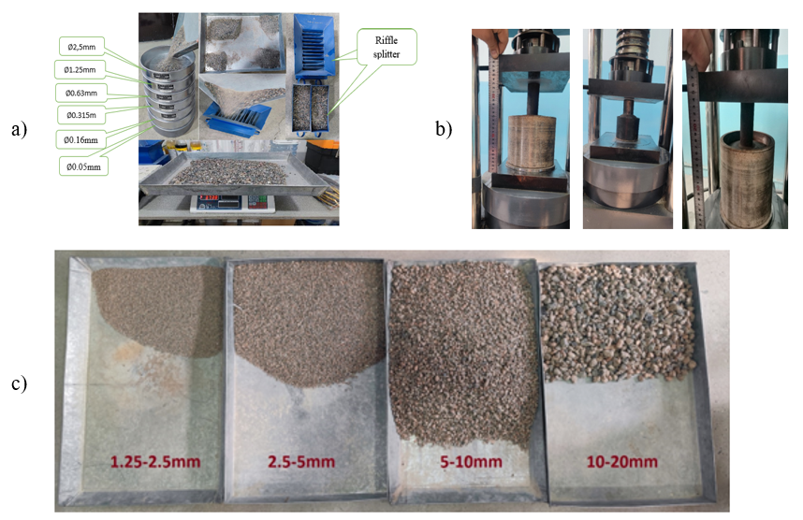
FIGURE 1. Procedures to ascertain the properties of aggregates to be used in lightweight concrete. Here: a – determination of granularity indicators of normal weight fillers; b – determination of compressive strength of lightweight aggregates in a standard cylinder; c – types of lightweight expanded clay by fractions.

During the research, small, medium and large-sized expanded clay produced by “Junior Business-Trade” LLC was used as a lightweight aggregate. The properties of this expanded clay were determined according to GOST 9758-2012 [13] and the results are presented in Table 1.

Table 1. Properties of light weight aggregates
№ | Properties | Unit of measurement | Dimensions, mm
№ | Properties | Unit of measurement | 5-10 | 10-20 | 5-20
1 | Bulk density | kg/m³ | 880 | 720 | 730
2 | Cylinder compressive strength | MPa | 2.6 | 2.3 | 2.4
3 | Water absorption | % | 14 | 17 | 16
4 | Cold resistance | cycle | 25 | 25 | 25

During the experiments, 11 series of 100x100x100 mm cubic specimens with normal and lightweight fillers and cylinders with a diameter of 100 mm and a height of 200 mm were prepared in accordance with the requirements of GOST 10181-2014, replacing the fillers in heavy concrete with lightweight aggregate fractions (in parts L100/H0, L90/H10, L80/H20, L70/H30, L60/H40, L50/H50, L40/H60, L30/H70, L20/H80, L10/H90, L0/H100). The composition of concrete of class B30 was calculated according to the purpose. A concrete mixture was prepared according to the composition in Table 3. During this experimental study, the lightweight aggregate expanded clay added to the concrete was soaked in water for a day before use to prevent it from absorbing moisture from the concrete mix and thus negatively affecting the quality and strength of the concrete. One hour before preparing the concrete mix, it was removed from the water to dry the moisture on the surface. When preparing concrete samples, the concrete composition in the required masses was prepared by replacing the small and large aggregates with expanded clay according to the size of the concrete [11].
Cube samples were prepared in standard molds for different lightweight concrete compositions and stored under normal conditions. The compressive strength of the cube samples after 7, 14 and 28 days was determined according to the results of the press test. The prepared cube samples and their testing processes are presented in Figure 2.
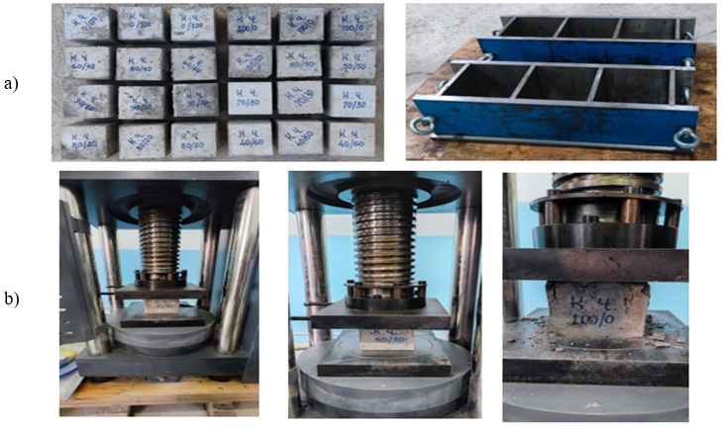
FIGURE 2. The prepared cube samples and their testing processes. Here: a – molds and cube samples prepared for testing processes; b – compression testing process of cube specimens.
RESEARCH RESULTS
Due to the experimental research, valuable scientific findings of practical value were achieved. The analysis of the obtained data was conducted in the form of analytical assessments, the generalized findings of which are shown in Figure 3. 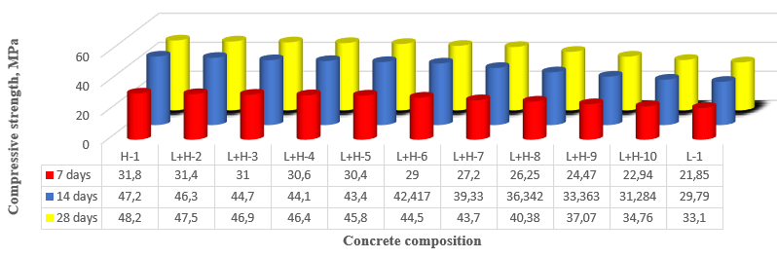
FIGURE 3. Compressive strength of various concrete compositions
Compressive strength of cubic test specimen was also established and results analysis indicated that cube strength of concrete depended on the extent of replacing aggregates in the concrete ceramite. Figur 4 is a representation of the overall state of the cube specimens after testing.

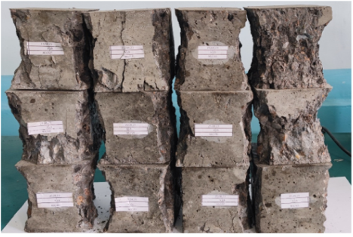
FIGURE 3. General view of the tested lightweight concrete cube specimens.
Upon completion of the tests, the tested cube specimens were taken off and were cleaned off the loose fragments. By looking at the appearance, it was possible to note that the shape of the failure patterns of the specimens was mainly pyramidal, which implies that the testing procedures were performed in accordance with the recommendations of DAST 10180-2012 [12].
After thoroughly examining all the results of the experimental research, the choice was made of the L+H-7 mix composition as the most effective concreteness mix. The mix in this composition is made of 60 percent of lightweight aggregate (ceramsite), and the rest 40 percent made of crushed stone and sand. It was established that the proportion meets the requirement of lightweight concrete in terms of strength and unit weight quite adequately. Results of the experiment show that this particular blend offers the most optimal ratio between mechanical performance and density to ensure the concrete properties are stable and reliable.
Moreover, the findings also indicated that, at a lower ratios than this optimum ratio, a larger portion of lightweight aggregate is required to attain the required concrete strength and density by an excessive increase in cement content. Nonetheless, adding cement beyond the normal levels does not result in corresponding and lasting enhancement of concrete strength and instead would decrease the technological and economic benefits of the mixture. Thus, the L+H-7 composition was determined as technically and cost-effective solution to the lightweight concrete production.
CONCLUSIONS
1. The mix composition of L+H-7 that is made up of 60 percent lightweight aggregate and 40 percent crushed stone and sand was identified to fulfill the necessary strength and unit weight requirement of lightweight concrete, thus can be suggested as the best mix proportion.
2. The experimental findings showed that the continuation of the excessive larger percentage of lightweight aggregate below the optimal point causes the excessive increase in the cement intake in order to reach the desired mechanical strength at the expense of the technological efficiency and economic viability of the concrete.
3. The chosen mix composition of L+H-7 is the best balance of the strength and density, which proves its technical stability and cost-effectiveness in terms of lightweight concrete production of the structure.
REFERENCES
1. Uysal, O.; Uslu, İ.; Aktaş, C.B.; Chang, B.; Yaman, İ.Ö. Physical and Mechanical Properties of Lightweight Expanded Clay Aggregate Concrete. Buildings 2024, 14, 1871. https://doi.org/10.3390/buildings14061871.
2. Wu X. et al. Damage characteristics and constitutive model of lightweight shale ceramsite concrete under static-dynamic loading //Engineering Fracture Mechanics. – 2022. – Т. 259. – С. 108137. https://doi.org/10.1016/j.engfracmech.2021.108137
3. Ningampalli, Ramanjaneyulu; Rao, M. V. Seshagiri; and Desai, V. Bhaskar (2024) "Flexural and cracking behavior of reinforced lightweight self-compacting concrete beams made with LECA aggregate," Journal of Sustainable Construction Materials and Technologies: Vol. 9: Iss. 2, Article 8. https://doi.org/10.47481/jscmt.1500907
4. Murugan, K. and Palaniappan, M. Sustainable integration of lightweight expanded clay aggregate (LECA) in concrete for environmental resilience: A performance evaluation. Indian Journal of Engineering and Materials Sciences, 2025, Vol. 32, Iss. 2, p.256-272, 10.56042/ijems.v32i02.12337
5. M. Mortazavi and M. Majlessi, “Evaluation of Silica Fume Effect on Compressive Strength of Structural Lightweight Concrete Containing LECA as Lightweight Aggregate,” Adv. Mater. Res., vol. 626, pp. 344–349, Dec. 2012, http://dx.doi.org/10.4028/www.scientific.net/AMR.626.344
6. Raheem, A.B. and Klak, F.S., “Shear strength of conventional and lightweight concrete I-beams with fibrous webs,” Engineering, Technology & Applied Science Research, vol. 14, no. 5, pp. 16486–16491, 2024.
7. A. Martazaev and S. Khakimov, “Dispersed reinforcement with basalt fibers and strength of fiber-reinforced concrete beams,” AIP Conf. Proc., vol. 3256, p. 030011, 2025, https://doi.org/10.1063/5.0266797
8. R. Mavlonov and S. Razzakov, “Numerical modeling of combined reinforcement concrete beam,” E3S Web Conf., vol. 401, p. 03007, 2023, https://doi.org/10.1051/e3sconf/202340103007
9. S. Razzakov and A. Martazaev, “Mechanical properties of concrete reinforced with basalt fibers,” E3S Web Conf., vol. 401, p. 05003, 2023, https://doi.org/10.1051/e3sconf/202340105003
10. R. Mavlonov, S. Razzakov, and S. Numanova, “Stress-strain state of combined steel-FRP reinforced concrete beams,” E3S Web Conf., vol. 452, p. 06022, 2023, https://doi.org/10.1051/e3sconf/202345206022
11. S. J. Razzakov and O. Q. Fozilov, “New generation of lightweight concrete and its strength,” Construction and Education, no. 2, 2025. Available: CyberLeninka, https://cyberleninka.ru/article/n/yengil-betonning-yangi-avlodi-va-uning-mustahkamligi (accessed: Dec. 13, 2025).
12. State Standard 10180-2012. Concretes. Methods for determining compressive strength by control samples. Tashkent, 2012.
13. State Standard 9758—2012. Inorganic porous aggregates for construction work. Test methods. – Interstate standard. – Introduced 2013-07-01. – Moscow: Standartinform, 2013. – 28 p.
14. State Standard GOST 10178–85. Portland cement and slag Portland cement. Specifications. Moscow: IPK Publishing House of Standards, 1986. — 24 p.

