Design and Development of an On-Board Hydrogen Generator for Auxiliary Hydrogen Supply to Internal Combustion Engines of Passenger Vehicles
Jumaniyez Ismatov¹, Javohirbek Asqarov ^{2,a)}
¹ Tashkent state technical university named after Islam Karimov, Tashkent, Uzbekistan
² Kokand state technical university, Kokand, Uzbekistan
^{a)} Corresponding author: javohirasqarov2297@gmail.com
Abstract. Global economic development is closely associated with the reliable supply of fuel for transport vehicles, as well as with ensuring the sustainable, safe, and efficient operation of transportation systems. In this context, increasing attention is being paid in the automotive sector to the rational and efficient use of energy resources and to enhancing their environmental performance. One of the key directions in addressing fuel and energy challenges in internal combustion engines, which constitute the primary power units of road vehicles, is the reduction of dependence on fossil petroleum-based fuels. Accordingly, hydrogen is considered a promising alternative energy carrier due to its high energy potential, environmental friendliness, and inexhaustible nature. The utilization of hydrogen as a supplementary fuel offers significant prospects for improving engine efficiency and reducing harmful exhaust emissions, thereby contributing to the sustainable development of the transport sector.
INTRODUCTION
Due to the rapid growth in the number of vehicles worldwide, increasing attention is being paid to reducing toxic and harmful emissions released during fuel combustion and to the use of alternative energy sources. In this context, conducting scientific research in this field is of significant importance. In many countries, alternative fuels such as biofuels are produced on an industrial scale as substitutes for gasoline; however, their share in the overall fuel balance does not exceed 0.3%. Therefore, research aimed at reducing transportation costs and minimizing the negative environmental impact of vehicles is considered a priority. At the same time, numerous foreign research centers affiliated with engine manufacturing companies are actively engaged in studies focused on fuel savings and the replacement of conventional liquid hydrocarbon fuels with new types of energy carriers, particularly hydrogen fuel, which is regarded as one of the most pressing research directions.
The use of gasoline–hydrogen fuel mixtures in vehicles in our country expands opportunities for improving the economic efficiency of road transport. Simultaneously, comprehensive and systematic measures are being implemented to promote the rational use of environmentally friendly, highly efficient, and renewable energy sources. This is clearly evidenced by the adoption of several regulatory and legal documents aimed at ensuring the environmental and energy security of road transport, as well as stimulating scientific research and methodological activities in this field. In particular, the Development Strategy of New Uzbekistan for 2022–2026 defines specific objectives such as “…ensuring uninterrupted supply of oil and gas products to economic sectors and the population” and “…studying the impact of Uzbekistan’s accession to the World Trade Organization on the metallurgical, textile, food, and automotive industries” [1, 2].
Hydrogen production in this study is carried out using a hydrogen generator. With the help of the hydrogen generator, water is decomposed into two gases: H₂ (hydrogen) and O₂ (oxygen). The resulting gas mixture, known as HHO gas (Brown’s gas), passes through an HHO filter and is then supplied through the air intake system to the engine intake manifold. In the intake manifold, it mixes with air and fuel, and when the intake valve opens, the mixture enters the engine cylinder, where it is pre-mixed during the compression process. Subsequently, ignition is initiated by the spark plug in the combustion chamber. Due to the high diffusivity of hydrogen, the combustion process is accelerated, detonation is reduced, and the kinetic energy of the fuel in the combustion chamber is increased. As a result, near-complete fuel combustion is achieved with minimal residual combustion products. In simple terms, the hydrogen generator produces a gaseous additive from water and supplies it to the fuel–air mixture, activating it and enabling complete combustion without leaving harmful residues. This facilitates the generation of the same amount of kinetic energy in an internal combustion engine while using a smaller quantity of conventional fuel [3, 4, 5].
For reference, only about 30–50% of the energy supplied by the fuel to generate kinetic energy in the combustion chamber (which drives the rotation of the crankshaft in an internal combustion engine) is effectively utilized, depending on the engine model. The remaining portion is dissipated through exhaust gases, even after passing through catalytic converters and neutralization systems, leaving unburned hydrocarbon particles that contribute to atmospheric pollution.
RESEARCH METHOD
The process occurring in the hydrogen generator involves passing an electric current through water (H₂O) in order to obtain diatomic hydrogen (H₂⁺) and oxygen (O⁻) gases. At the positive electrode (anode), diatomic hydrogen (H₂⁺) is generated, while at the negative electrode (cathode), monatomic oxygen (O⁻) is formed. Together, these gases constitute HHO gas, also referred to as Brown’s gas. This gas is characterized by high combustion temperature and speed (similar to an explosive reaction), high efficiency (up to 30 times higher than that of conventional organic fuels), and excellent miscibility with other gases and fuels whose main components are hydrogen and oxygen.
Various hydrogen generator designs were developed in this study, including plate-type, cylindrical, and spring-type cathode and anode configurations. These designs differ in their operational characteristics (Figures 1–3).
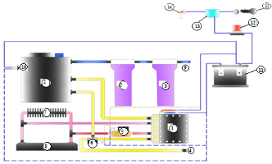
Figure 1. Schematic diagram of a plate-type hydrogen generator. 1 – electrolyzer; 2 – circulation tank; 3 – filter; 4 – cap; 5 – valve; 6 – temperature sensor; 7 – radiator; 8 – vehicle body; 9 – gas inlet to the air intake manifold; 10 – electrolyte level sensor connector; 11 – battery; 12 – fuse; 13 – relay; 14 – ground (earth); 15 – switch.

The schematic diagram of the hydrogen generator developed in this study is shown in Figure 1. Its operation is as follows: after the vehicle is started, an electric current is obtained from components such as the fuel pump, and the current intensity and voltage are regulated by the Electronic Control Unit (ECU) and the Voltage Control Unit (VCU) before being supplied to the hydrogen generator. Under the influence of the supplied current, water in the hydrogen generator is electrolyzed at the cathodes and anodes, producing hydrogen and oxygen gases. The separated hydrogen and oxygen are directed to a reservoir. From the reservoir, the gas passes through a water vapor trap and then enters the vehicle’s intake manifold, from where it is delivered to the engine cylinders. The ECU controls the gas supply to the hydrogen generator based on signals from the sensor installed on the accelerator pedal, adjusting the current according to vehicle speed and the position of the gas pedal [6, 7].

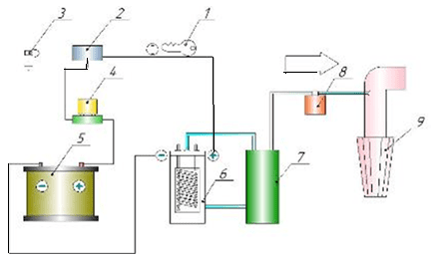
Figure 2. Schematic diagram of a spring-type electrolyzer hydrogen generator.
1 – switch; 2 – relay; 3 – ground (earth); 4 – fuse; 5 – battery; 6 – generator; 7 – reservoir; 8 – water vapor trap;
9 – air filter.

To increase the hydrogen production of the generator, a throttle sensor, Electronic Control Unit (ECU), voltage control unit, and accelerator mechanism were integrated. Based on the operating mode of the vehicle and the position of the accelerator pedal, the ECU regulates the current supplied to the hydrogen generator through the accelerator mechanism. During operation, hydrogen is released from the surfaces of the generator plates in the form of bubbles. The accelerator mechanism accelerates the circulation of the liquid within the hydrogen generator and the reservoir, which ensures that the hydrogen bubbles are separated more rapidly from the plate surfaces. In addition, when the switch is turned on but the engine is not running, the ECU shuts down the hydrogen generator to ensure safe operation. The hydrogen generator produces hydrogen only when the engine is running.
The production capacity of the hydrogen generator is 3 liters per minute.

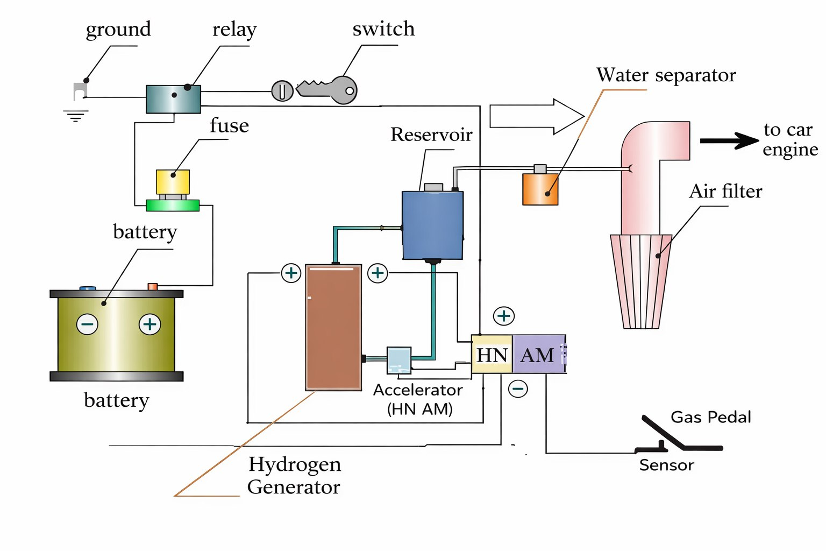
Figure 3. The schematic diagram of the hydrogen generator.
The hydrogen generator is designed to produce hydrogen and oxygen atoms (Braun gas) used to ensure the complete combustion process in internal combustion engines. Complete combustion significantly saves fuel and increases engine power. Another advantage of this system is the reduction of toxic and harmful emissions from the engine, which greatly contributes to preventing environmental pollution.
The hydrogen generator consists of an electrolyzer (with electrodes made of a special grade of stainless steel resistant to acid and electrochemical treatment), a circulation tank, a control system (modulator), and a fuel mixture optimizer. Gas is separated using the hydrogen generator. The circulation tank is designed to efficiently separate gas from water and supply the generator with electrolyte. The electrolysis reaction occurs in the hydrogen generator, where hydrogen and oxygen (Braun gas) are released from a special electrolyte composed of distilled water and a catalyst. Our catalyst is chemically structured so that it does not leave with the gas but remains in the water, preventing it from entering the engine.
The produced gas exits through a tube at the top of the hydrogen generator and is directed into a separate container, a water-filled vessel. The gas enters from the bottom of the water vessel, is cleaned from foam, and rises as gas from the water surface. From there, it passes through a moisture-retaining filter and a check valve into the air collector, and then to the combustion chamber. Water from the vessel also returns to the hydrogen generator through a second tube at the bottom, circulating the liquid throughout the entire system [8, 9, 10, 11].
RESEARCH RESULTS
As a result of hydrogen gas combustion, dry water vapor is produced, which in turn cleans the valve-piston group from carbon deposits and improves heat transfer between the valve seat and the valve, thereby extending the engine’s service life. Additionally, due to reduced fuel consumption, the maintenance interval of fuel injectors is extended, engine oil contamination is decreased, and overall service intervals are prolonged.
The production of Braun gas is automatically controlled by the Automatic Modulator (AM) depending on the number of engine crankshaft rotations and the electrolyzer temperature. The modulator is an intelligent electronic device that utilizes resonance phenomena in the electrolyzer.
By modulating the current, the system achieves maximum efficiency. When the number of crankshaft rotations decreases, both energy consumption and gas production are reduced. This feature prevents battery discharge and ensures that the vehicle’s electric generator can operate without additional load. In modern vehicles, reducing energy consumption during normal operation leads to lower fuel consumption because increasing engine power to maintain nominal crankshaft rotations requires supplying more fuel.
Considering that adding hydrogen to the air-fuel mixture improves combustion, it is recommended to adjust the fuel mixture for maximum fuel efficiency without reducing engine power compared to normal operation. For this purpose, a fuel mixture optimizer was developed. When operating on gasoline-hydrogen fuel, the optimizer helps the engine reach its most optimal operating mode, thereby achieving maximum fuel efficiency. From every liter of water, 1,866 liters of combustible hydrogen-oxygen gas mixture are produced.
CONCLUSIONS
An experimental setup was created to conduct scientific research, in particular to study engine operation on gasoline and gasoline-hydrogen fuel.
The hydrogen generator for hydrogen production was improved.
Methodologies for laboratory, experimental, and field tests were developed to improve engine performance on gasoline and gasoline-hydrogen fuel.
Adding hydrogen to the air-fuel mixture enhances combustion. To achieve maximum fuel efficiency, it is recommended to adjust the fuel mixture without reducing engine power compared to normal operation. Therefore, a fuel mixture optimizer was developed.
REFERENCES
- Decree PF-60 of the President of the Republic of Uzbekistan dated January 28, 2022, “On the Development Strategy of the New Uzbekistan for 2022–2026.”
- Resolution PQ-5063 of the President of the Republic of Uzbekistan dated April 9, 2021, “On Measures to Develop Renewable and Hydrogen Energy in the Republic of Uzbekistan.”
- Talda G.B. Improving Fuel Efficiency and Reducing the Toxicity of Gasoline Engines by Adding Hydrogen to Gasoline. Moscow, 2007, p. 214.
- Smolensky V.V., Smolenskaya N.M. The Effect of Adding H₂ to Compressed Natural Gas on NOx Concentration in ICE Exhaust with Spark Ignition. Natural and Technical Sciences, 2013, No. 4, pp. 39–44.
- Bortnikov L.N., Pavlov D.A., Rusakov M.M., Smolensky V.V. Using Hydrogen as a Combustion Activator to Improve Spark-Ignition ICE Performance During Start and Warm-Up Modes. Natural and Technical Sciences, 2013, No. 1 (63), pp. 341–345.
- Patrakhaltsev N.N. Improving the Economic and Environmental Qualities of Internal Combustion Engines Based on the Use of Alternative Fuels. Moscow: RUDN Publishing, 2008, 267 pp.
- Jumaniyez Ismatov, Javlon Djalilov, Zakirjon Musabekov, Jamshid Khakimov, Abduxalil Ismatov. Improvement of the Exploitation Performance of Light Vehicle Internal Combustion Engines by Addition of Hydrogen Fuel. Research Article | February 24, 2025. AIP Conf. Proc. 3268, 020054 (2025). https://doi.org/10.1063/5.0258047
- Zakirjon Musabekov, Ismatov Jumaniyez, Jamshid Khakimov, Usen Usipbaev, Gabit Bekbolatov. Mathematical Model of Combustion and Heat Release of the Engine Operating Cycle on Advanced Fuels. Research Article | November 04, 2025. AIP Conf. Proc. 3331, 070017 (2025). https://doi.org/10.1063/5.0305775
- J. Ismatov, F. Matmurodov, M. Fayziev, J. Djalilov. Provision of Carbon-Free Emission of Exhaust Gases on Vehicles. E3S Web of Conferences 419, 01009 (2023). https://doi.org/10.1051/e3sconf/202341901009
- Jumaniyez Ismatov, Jamshid Khakimov, Saydulla Kalauov, Abduxalil Ismatov. Evaluation of the Efficiency of Thermal Insulation of the Combustion Chamber According to the Load Characteristics of a Diesel Engine. AEGIS-III-2023, IOP Conf. Series: Earth and Environmental Science 1231 (2023) 012013. https://doi.org/10.1088/1755-1315/1231/1/012013
- Javohir Asqarov. Academic Journal of Science, Technology and Education. Vol 1. № 4 (2025). Achievements and future prospects for the use of hydrogen fuel in automobiles. https://scholar.google.com/scholar?oi=bibs&cluster=4028034148448131690&btnI=1&hl=en

