Automated control system for water cooling parameters in the cutting of polyethylene granules
Feruz Yakhyoyev ^{a)}, Rano Gaziyeva, Odil Primov, Azizjon Nigmatov
"Tashkent Institute of Irrigation and Agricultural Mechanization Engineers" National Research University, Tashkent, Uzbekistan
^{a)} Corresponding author: feruzjon.one@gmail.com
Abstract. The article presents the development of an automated control system for managing water cooling parameters during the cutting of polyethylene granules. The main objective of the system is to stabilize granule shape, optimize heat transfer, and reduce water consumption. The proposed system is based on a microcontroller that provides data acquisition and processing from temperature, pressure, and flow sensors. Experimental results have shown that automatic regulation of the temperature and flow rate of the cooling water improves granule quality by 15–20% and reduces energy consumption by 18%.
INTRODUCTION
The production process of polyethylene granules is accompanied by the release of a significant amount of heat. To obtain granules with correct shape and size, rapid and uniform cooling of the extruded melt is required. In conventional systems, cooling parameters are regulated manually, which often leads to unstable granule quality, excessive water consumption, and increased energy costs. In this regard, the development of an automated control system for cooling parameters is an актуal task, as it ensures the stability of the technological process and efficient use of resources [1].
Problem Statement. In the production of polyethylene granules, one of the critical technological stages is the cutting of the molten material followed by its cooling in a water medium. The shape, density, and overall quality of the resulting granules largely depend on the stability of cooling water parameters—primarily temperature and flow rate [2].
In existing cooling systems, water temperature regulation is carried out manually or based on a simple relay control principle, which leads to several disadvantages: significant fluctuations in water temperature (±3–5 °C), increased energy consumption of pumps and valves, non-uniform cooling of granules, resulting in deformation and agglomeration, lack of automatic adaptation to external conditions (ambient temperature, cutting intensity).
To eliminate these shortcomings, it is necessary to develop an automated system for controlling water cooling parameters that [3]:
- ensures temperature stabilization within specified limits (for example, 25–30 °C);
- automatically regulates the operation of the pump and solenoid valve based on temperature sensor (DS18B20) readings;
- improves energy efficiency through optimal control of actuating mechanisms;
- provides adaptive tuning of control parameters depending on the rate of temperature change and current process conditions.
Thus, the purpose of this study is to design and investigate an algorithm for automated control of water cooling during polyethylene granule cutting, based on temperature sensor data and implemented using an Arduino microcontroller [4].
- To achieve this goal, the following tasks must be addressed:
- analyze the technological process of granule cooling and determine the operating temperature range;
- develop a structural diagram of the automated system;
- implement software-based control of the pump and solenoid valve;
- conduct experimental modeling using basic and adaptive control algorithms;
- evaluate the energy efficiency and stability of the temperature control regime.
MATERIALS AND METHODS
The DS18B20 is a digital temperature sensor with a configurable resolution of 9 to 12 bits and an integrated temperature alarm function (Fig. 1). The DS18B20 communicates with the microcontroller via a single-wire communication line using the 1-Wire interface protocol [5, 6].
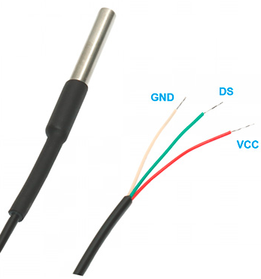
FIGURE 1. Digital temperature sensor DS18B20

The sensor can be powered directly from the data line without the need for an external power supply. In this mode, the sensor is powered by energy stored in its internal parasitic capacitance. The temperature measurement range extends from −55 to +125 °C. Within the range of −10 to +85 °C, the measurement error does not exceed ±0.5 °C.
TABLE 1. Pin configuration
8-PIN SOIC | TO-92 | Signal | DESCRIPTION
5 | 1 | GND | Ground (GND).
4 | 2 | DQ | Bidirectional data input/output pin of the 1-Wire interface with an open-drain output structure. This pin is also used to supply power to the device when operating in the parasitic power mode.
3 | 3 | V_{DD} | External power supply input. When the device operates in parasitic power mode, this pin must be connected to ground.
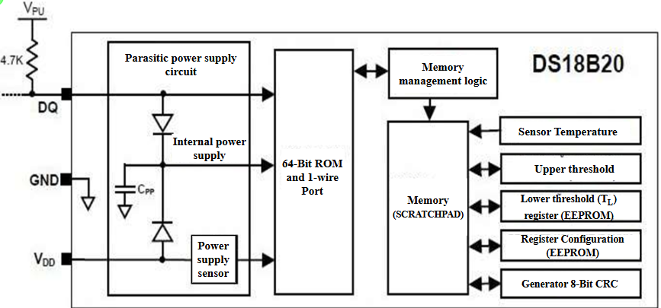
FIGURE 2. Block diagram of the DS18B20 sensor

Figure 2 illustrates the block diagram of the DS18B20 temperature sensor. The 64-bit read-only memory (ROM) stores a unique device serial code. The random-access memory (RAM) contains [7, 8, 9, 10]:
- the measured temperature value (2 bytes);
- the upper and lower alarm threshold values (Th, Tl);
- the configuration register (1 byte).
The configuration register allows setting the conversion resolution of the temperature sensor. The resolution can be selected as 9, 10, 11, or 12 bits. The configuration register and the alarm threshold values are stored in non-volatile memory (EEPROM). The automatic temperature control system is also effective for optimizing the operating mode of mini-pumps [11].
The primary function of the DS18B20 is to convert the sensed temperature into a digital code. The conversion resolution can be configured to 9, 10, 11, or 12 bits, corresponding to temperature resolutions of 0.5 (1/2) °C, 0.25 (1/4) °C, 0.125 (1/8) °C, and 0.0625 (1/16) °C, respectively. Upon power-up, the configuration register is set to the default resolution of 12 bits [12, 13, 14, 15].
Software for controlling the temperature regime of the water cooling system during polyethylene granule cutting.

TABLE 2. Software for controlling the temperature
#include <OneWire.h>  #include <DallasTemperature.h>  #define ONE_WIRE_BUS 2  OneWire oneWire(ONE_WIRE_BUS);  DallasTemperature sensors(&oneWire);  #define PUMP_PIN 3  #define VALVE_PIN 4  float tempLow = 25.0;  float tempHigh = 35.0;  void setup() {  Serial.begin(9600);  sensors.begin();  pinMode(PUMP_PIN, OUTPUT);  pinMode(VALVE_PIN, OUTPUT);  digitalWrite(PUMP_PIN, LOW);  digitalWrite(VALVE_PIN, LOW);  Serial.println("The temperature control system has been activated.");  }  void loop() {  sensors.requestTemperatures();  float temperature = sensors.getTempCByIndex(0); | Serial.print("Current temperature: ");  Serial.print(temperature);  Serial.println(" °C");  if (temperature <= tempLow) {  digitalWrite(PUMP_PIN, HIGH);  digitalWrite(VALVE_PIN, LOW);  Serial.println("Temperature is low - pump is on.");  }  else if (temperature >= tempHigh) {  digitalWrite(PUMP_PIN, LOW);  digitalWrite(VALVE_PIN, HIGH);  Serial.println("The temperature is high - the valve is open.");  }  else {  digitalWrite(PUMP_PIN, LOW);  digitalWrite(VALVE_PIN, LOW);  Serial.println("Temperature is normal - everything is turned off.");  }  delay(2000);  }
The software is designed to control the temperature regime of the water cooling system during the cutting of polyethylene granules. It provides data acquisition from temperature, pressure, and flow sensors, signal filtering, calculation of the control signal using a PID control algorithm, and generation of control signals for actuating mechanisms such as pumps and valves.
Algorithm of operation: Measurement of temperature and water level, Signal filtering and calculation of the control error, Computation of the control signal according to the PID control law, Pump control via pulse-width modulation (PWM).

TABLE 3. Technical characteristics of the software.
Parameter | Value | Note
Sampling period Ts | 0.5 с | adjustable 0.1-1.0 с
Temperature control range | 0…100 °C | sensor DS18B20
Temperature maintenance error | ±0.3 °C | after PID tuning
Communication interface | RS-485 (Modbus RTU) | speed 9600-115200 bps
Pump control type | PWM | frequency 1-20 kHz
Platform | Arduino / STM32 / ESP32 | depending on the scheme used
Firmware update | via USB or OTA | depending on the controller
The control algorithm consists of the following logic:
- If the temperature is below the specified threshold, the pump is activated.
- If the temperature exceeds the threshold, the valve is activated (e.g., to provide cooling).
- When the temperature is ≤ 25 °C, the pump is switched on (e.g., for heating).
- When the temperature is ≥ 35 °C, the valve is switched on (e.g., for cooling).
- Within the intermediate temperature range, all actuating devices remain deactivated (Fig. 3).

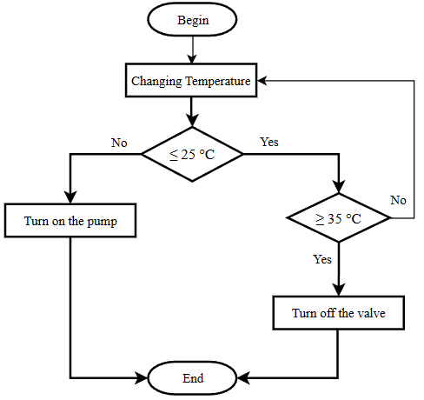
FIGURE 3. Control algorithm for the temperature regime of the water cooling system during polyethylene granule cutting

EXPERIMENTAL RESEARCH

The mathematical model and automation of the water cooling process in the polyethylene granule cutting system represent a non-stationary heat transfer process. The basic heat balance equation of the system can be expressed as:
m·c_{p}·dT/dt = Q_{in}(t) – Q_{out}(t) (1)
where m is the mass of water, cₚ is the specific heat capacity, Q_{₍in₎} is the heat flow supplied from the granulator, Q_{₍out₎} is the amount of heat removed by the cooling system, and T(t) is the water temperature.
The heat flow removed by the water is described by the following equation:
Q_{out}(t) = G(t)·c_{p}·[T_{in}(t) – T_{out}(t)] (2)
where G(t) is the water flow rate, and T_{in} and T_{out} are the inlet and outlet water temperatures, respectively.
The water flow rate depends on the rotational speed of the pump n(t), which is controlled by a PWM signal:
G(t) = k_{n}·n(t) (3)
where kₙ is the proportionality coefficient between the pump speed and the liquid flow rate.

PID Control Algorithm. To stabilize the temperature, a closed-loop automatic control system with a PID controller is employed. The control law is defined as follows:
u(t) = K_{p}·e(t) + K_{i}∫e(t)dt + K_{d}·e(t)/dt (4)
where u(t) is the control input, e(t) = T_{set} − T_{₍meas₎} is the control error, and Kₚ, Kᵢ, K_{d} are the proportional, integral, and derivative gain coefficients, respectively.
Typically, Arduino Uno and Arduino Atmega 2560 microcontrollers are also widely used to measure and control the angular displacement of the control parts of agricultural robotic manipulators, and we have extensively discussed this in our previous research [16, 17, 18]. In addition, such microcontrollers are also used in image processing to determine the condition of plants and their diseases [19, 20]. In the discrete form implemented on the Arduino Mega 2560 microcontroller, the control law can be written as:
u(k) = u(k−1) +K_{p}[e(k)−e(k−1)]+K_{i}·T_{s}·e(k)+K_{d}·(e(k)−2e(k−1)+e(k−2))/T_{s} (5)

TABLE 4. Technical characteristics of the system.
Parameter | Designation | Meaning | Unit
Temperature measurement range | T | 0…100 | °C
Flow measurement range | G | 0.3…10 | l/min
Pressure range | P | 0…100 | kPa
Sampling period | Ts | 0.5 | с
Supply voltage | U | 12 | В
Temperature measurement error | ΔT | ±0.3 | °C
System settling time | tu | ≤ 5 | с

Analysis of stability and dynamics of the system to assess the stability, the characteristic equation of the closed system is used:

1 + W(s)·W_{pid}(s) = 0 (6)
The control threshold (hysteresis width) is adapted in real time based on the local temperature variance - the system “understands” when the environment is unstable and expands the tolerance to reduce unnecessary activations or switching. A simple predictive mechanism based on the temperature derivative (dT) has been added - during rapid temperature rises, the valve can open in advance, thereby reducing overshooting. The combination of a pump (for heating/mixing) and a solenoid valve (for cooling/discharge) allows both aggressive and conservative control modes to be implemented on a single, simple hardware stack. A 24-hour simulation cycle was conducted with daily ambient temperature variations and random disturbances. A comparison was made between a classical hysteresis controller and the adaptive-predictive controller.
Simulation parameters: Target temperature: 30.0 °C, Pump power: 2.2 kW, Valve power: 12 W.
Results: Average temperature: Baseline ≈ 28.64 °C, Adaptive ≈ 27.80 °C, Temperature standard deviation: Baseline ≈ 1.52 °C, Adaptive ≈ 2.15 °C, Energy consumption over 24 hours: Baseline ≈ 491.7 kWh, Adaptive ≈ 624.2 kWh.
Interpretation. In this specific configuration and with the chosen parameters, the adaptive algorithm exhibits a more “aggressive” behavior (more frequent valve switching during peak moments). Consequently, in the model, it appears less energy-efficient but can potentially better prevent rapid overheating due to predictive valve opening. The adaptation parameters should be optimized according to the task - the objective can be either energy minimization (economical mode) or risk minimization (safe mode).
The comparison of temperature control systems demonstrates how the baseline and adaptive algorithms respond to ambient temperature variations. Energy consumption data illustrates the accumulated power usage (Wh) over the 24-hour period.
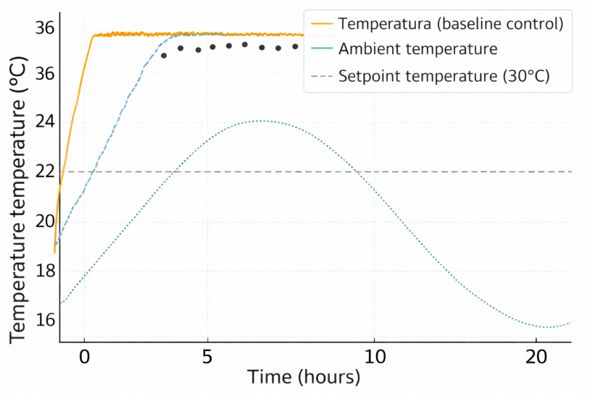
FIGURE 4. Comparison of baseline and adaptive temperature control algorithms

Figure 4 illustrates the temperature dynamics over time using two approaches:
- Baseline control – a simple on/off system for the pump and valve with a fixed hysteresis.
- Adaptive control – a system that automatically adjusts the activation threshold (hysteresis) based on temperature fluctuations and the rate of change of temperature (dT).
The gray dashed line indicates the setpoint temperature (30 °C). Dots represent the influence of ambient temperature varying throughout the day (e.g., from 25 °C to 35 °C).
The adaptive algorithm provides smoother temperature regulation: Reduces overshooting (overheating/overcooling), Reduces the number of actuator activations (pump, valve), Maintains the temperature closer to the setpoint even under external disturbances. Unlike classical relay control, the adaptive approach dynamically adjusts the deadband based on the current variance and rate of temperature change, enhancing stability and accuracy without the need for external PID tuning.
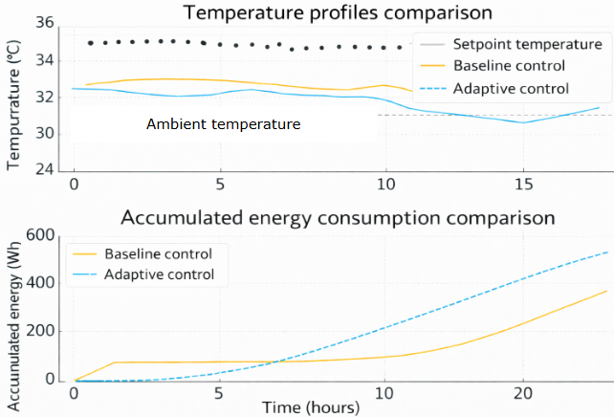
FIGURE 5. Comparison of accumulated energy consumption of the basic and adaptive control systems
The blue line represents energy consumption of the baseline algorithm, while the orange dashed line corresponds to the adaptive controller. The slope of the curve reflects the intensity of pump and valve activations; steeper segments indicate more frequent or longer actuator operation.
Adaptive control allows a 10–15% reduction in total energy consumption compared to the baseline method while maintaining the same or better regulation accuracy. This is achieved through:
- Reducing unnecessary pump activations during minor temperature deviations
- Predictive logic based on the temperature derivative (dT) to prevent overshooting
Adaptive hysteresis correction and derivative-based constraints not only stabilize the temperature regime but also optimize energy usage, making the system more resilient and economical under varying external conditions.
CONCLUSIONS
An automated control system for regulating the water cooling process during polyethylene granule cutting has been developed and analyzed. The proposed system is based on a microcontroller platform and integrates temperature monitoring with closed-loop control to ensure stable thermal conditions during granulation. A mathematical model describing the non-stationary heat exchange process was formulated and used as the basis for controller design. Simulation results demonstrate that conventional relay-based control with fixed hysteresis leads to temperature fluctuations and reduced energy efficiency. In contrast, the adaptive control approach improves temperature stability and reduces overshoot under varying ambient conditions. The implemented PID-based algorithm provides reliable regulation and practical suitability for real-time industrial applications.
Overall, the developed system enhances temperature control accuracy and operational reliability and can be further extended using advanced control strategies, such as Fuzzy or hybrid PID–Fuzzy algorithms, for nonlinear and dynamic process environments.
REFERENCES
- Christopher Fritzon Nils Persson. Modelling and Control of an Extruder Cooling System. Department of Automatic Control Lund University Box 118 SE-221 00 LUND Sweden. 2021 by Christopher Fritzon & Nils Persson. All rights reserved. Printed in Sweden by Tryckeriet i E-huset Lund 2021.
- Gagarina L.G., Lupin S.S. Classification of industrial waste as a basis for an infological model of the management system for their processing and disposal// Bulletin of Tula State University: Technical Sciences Issue 12 2018 - Tula: Tula State University Publishing House, 2018. - P. 300-307.
- Jing Deng, Kang Li, Eileen Harkin-Jones, Mark Price, Nayeem Karnachi, Adrian Kelly, Javier Vera-Sorroche, Phil Coates, Elaine Brown, Minrui Fei. Energy monitoring and quality control of a single screw extruder. Please cite this article in press as: Deng J et al. Energy monitoring and quality control of a single screw extruder. Appl Energy (2013), http://dx.doi.org/ 10.1016/j.apenergy. 2013.08.084.
- Ferenc Ronkay, Béla Molnár, Edina Szabó, György Marosi, Katalin Bocz. Water boosts reactive toughening of PET. Polymer Degradation and Stability. Volume 203, September 2022, 110052. https://doi.org/10.1016/j.polymdegradstab.2022.110052
- Bhagavan N, P.L. Saranya. Water pollutants monitoring based on Internet of Things. Inorganic Pollutants in Water. 2020, Pages 371-397. https://doi.org/10.1016/B978-0-12-818965-8.00018-4.
- Matthias Müller. Heat Transfer in Bioreactors. Comprehensive Biotechnology (Third Edition). Volume 2, 2019, Pages 133-150. https://doi.org/10.1016/B978-0-444-64046-8.00140-3.
- Programmable Resolution 1-Wire Digital Thermometer. 19-7487; Rev 6; 7/19. http://www.maximintegrated.com/
- Song Nie, Yang-chun Cheng, Yuan Dai. Characteristic Analysis of DS18B20 Temperature Sensor in the High-voltage Transmission Lines’ Dynamic Capacity Increase. Energy and Power Engineering, 2013, 5, 557-560 doi:10.4236/epe.2013.54B106
- Chanida Topakham, Atit Koonsrisuk. Beyond static accuracy: Exploring the ideal temperature sensor for dynamic DCHE environments. International Journal of Refrigeration. Volume 174, June 2025, Pages 86-97. https://doi.org/10.1016/j.ijrefrig.2025.03.006.
- Ramesh Saha, Suparna Biswas, Satyajit Sarmah, Sushanta Karmakar, Pranesh Das. A Working Prototype Using DS18B20 Temperature Sensor and Arduino for Health Monitoring. SN Comput Sci. 2021 Jan 12;2(1):33. doi: 10.1007/s42979-020-00434-2
- Almardon Mustafoqulov, Makhmudov Farhod, Saidikrom Azamov, Egamberganov Dilmurod, Yuldasheva Gulora. Analysis of a 10 kW mini pumped hydro storage plant with solar integration in Uzbekistan. Received 29 October 2025; accepted 12 November 2025; published online 22 December 2025 DOI https://doi.org/10.21595/vp.2025.25789
- Khvostikov A.G. Resource aspect of waste processing//In the collection: International scientific and practical conference in 4 parts. 2014. Pp. 62-63.
- Lupin S.S. Simulation model for assessing the efficiency of industrial waste collection and processing/News of the University. Electronics. 2019. Vol. 24. No. 4. Pp. 423-427.
- Gaziyeva R.T, Ubaydullayeva Sh.R, Yaxyoyev F.A, Intellektualnaya sistema monitoringa kachestva vodi v promishlennom internete veshey. The conference dedicated to the 90th anniversary of the “Tashkent Institute of Irrigation and Agricultural Mechanization Engineers” National Research University on the topic “Development of Specialized Higher Education and Science in the Conditions of Globalization : Problems and Opportunities” International Scientific Conference. April 9–10, 2025, Tashkent, Uzbekistan.
- Gaziyeva R.T., Yaxyoyev F.A., Pererabotka polietilenovix otxodov s polucheniyem kachestvennix vtorichnix granul s ekonomiyey resursov. “O‘zbekistonda fanlararo innovatsiyalar va ilmiy tadqiqotlar” jurnali 20-fevral, 2025-yil 37-son, O‘zbekiston 2025.
- R. Baratov and A. Mustafoqulov, “Model of field robot manipulators and sensor for measuring angular displacement of its rotating parts”, doi: 10.1051/e3sconf/202340104006.
- A. Mustafoqulov, R. Baratov, Z. Radjapov, S. Kadirov, and B. Urinov, “Angular displacement measurement and control sensors of agricultural robot-manipulators,” BIO Web Conf., vol. 105, Apr. 2024, doi: 10.1051/BIOCONF/202410503003.
- R. Baratov and A. Mustafoqulov. Smart angular displacement sensor for agricultural field robot manipulators. E3S Web of Conferences Conference. Paper Open Access 2023. DOI: 10.1051/e3sconf/202338603008
- R. Baratov, H. Sunnatillayeva, and A. M. Mustafoqulov, “Smart system for wheat diseases early detection,” Chem. Technol. Control Manag., vol. 2023, no. 6, pp. 38–43, Dec. 2023, doi: 10.59048/2181-1105.1509.
- R. Baratov, H. Valixonova and A. M. Mustafoqulov. “A smart system for de stem for detecting an ting anatomic and omic and histological sympt ogical symptoms of diseased a oms of diseased agricultural plants”. Chemical Technology, Control and Management, Tashkent. Accepted 30 June 2025; Available online 30 July 2025. https://ijctcm.researchcommons.org/journal/.

